Assignment 2

System Programming



Teacher | Bibi Areej Khan
Student Name | Muhammad Ahmad Khan
Registration No | 23JZBCS0238

Department of CS&IT
University of Engineering and Technology Peshawar
(Jalozai Campus)

Q1: Sequential vs Parallel (Pthreads)

1. Sequential C Program
#include <stdio.h>

int main() {
int arr[5] = {10, 20, 5, 40, 15};
int n = 5;

int sum = 0;
int max = arr[0];

for (int i = 0; i < n; i++) {
sum = sum + arr[i];

if (arr[i] > max) {
max = arr[i];
}
}

float avg = (float)sum / n;

printf("Sum = %d\n", sum);
printf("Average = %.2f\n", avg);
printf("Max = %d\n", max);

return 0;
}

2. Parallel C Program using POSIX Thread
#include <stdio.h>
#include <pthread.h>

int arr[5] = {10, 20, 5, 40, 15};

int sum1 = 0, sum2 = 0;
int max1, max2;

void* part1(void* arg) {
max1 = arr[0];

for (int i = 0; i < 2; i++) {
sum1 = sum1 + arr[i];

if (arr[i] > max1) {
max1 = arr[i];
}
}

return NULL;
}

void* part2(void* arg) {
max2 = arr[2];

for (int i = 2; i < 5; i++) {
sum2 = sum2 + arr[i];

if (arr[i] > max2) {
max2 = arr[i];
}
}

return NULL;
}

int main() {
pthread_t t1, t2;

// Create threads
pthread_create(&t1, NULL, part1, NULL);
pthread_create(&t2, NULL, part2, NULL);

// Wait for threads to finish
pthread_join(t1, NULL);
pthread_join(t2, NULL);

int total_sum = sum1 + sum2;

int max;
if (max1 > max2)
max = max1;
else
max = max2;

float avg = (float)total_sum / 5;

printf("Sum = %d\n", total_sum);
printf("Average = %.2f\n", avg);
printf("Max = %d\n", max);

return 0;
}

3. Block Diagram – Sequential Approach

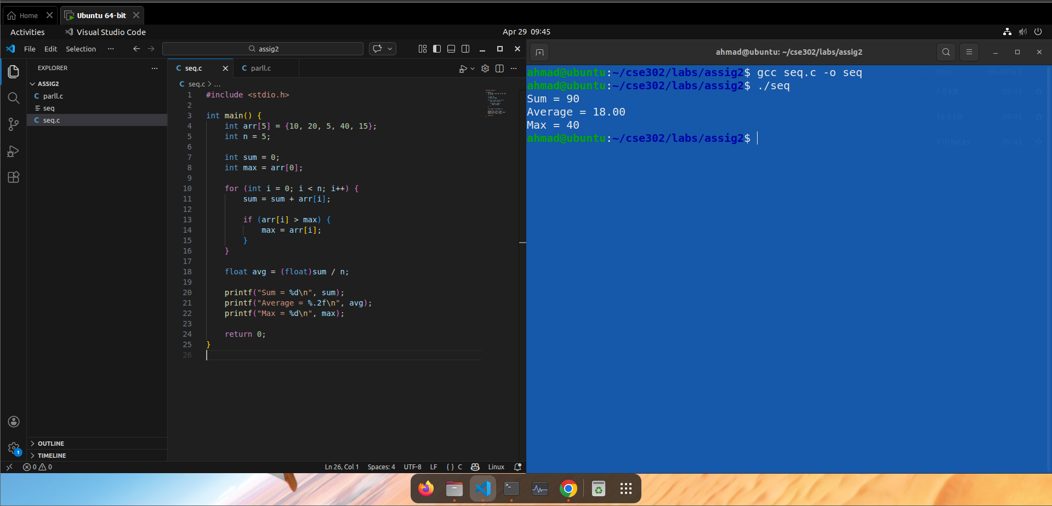

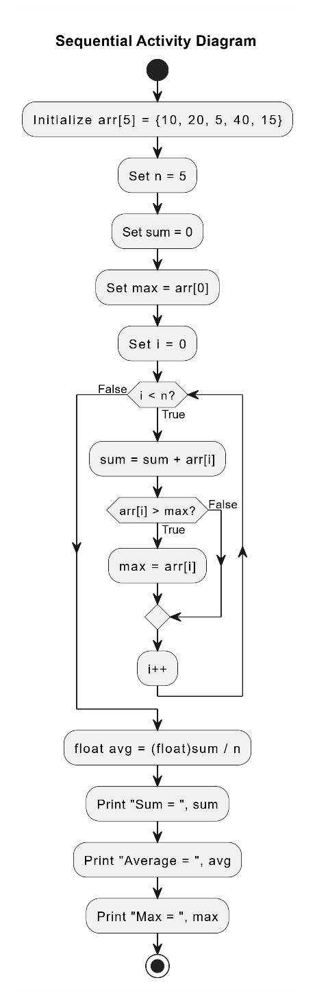

4. Block Diagram – Parallel (Pthreads) Approach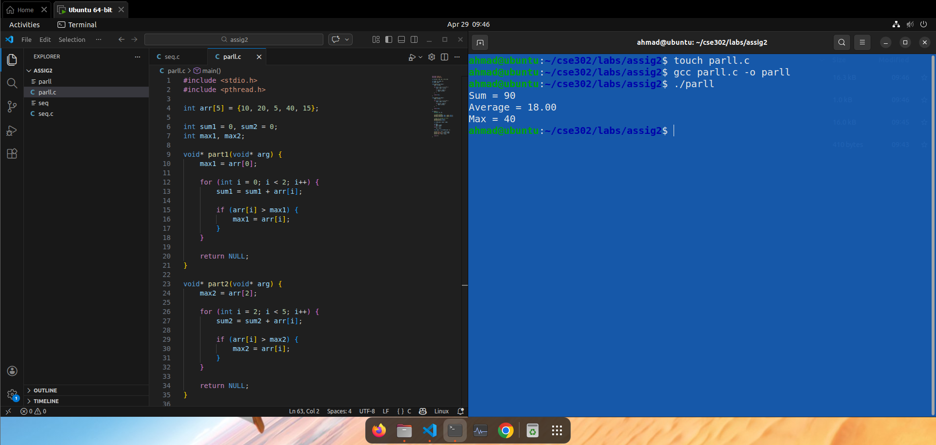
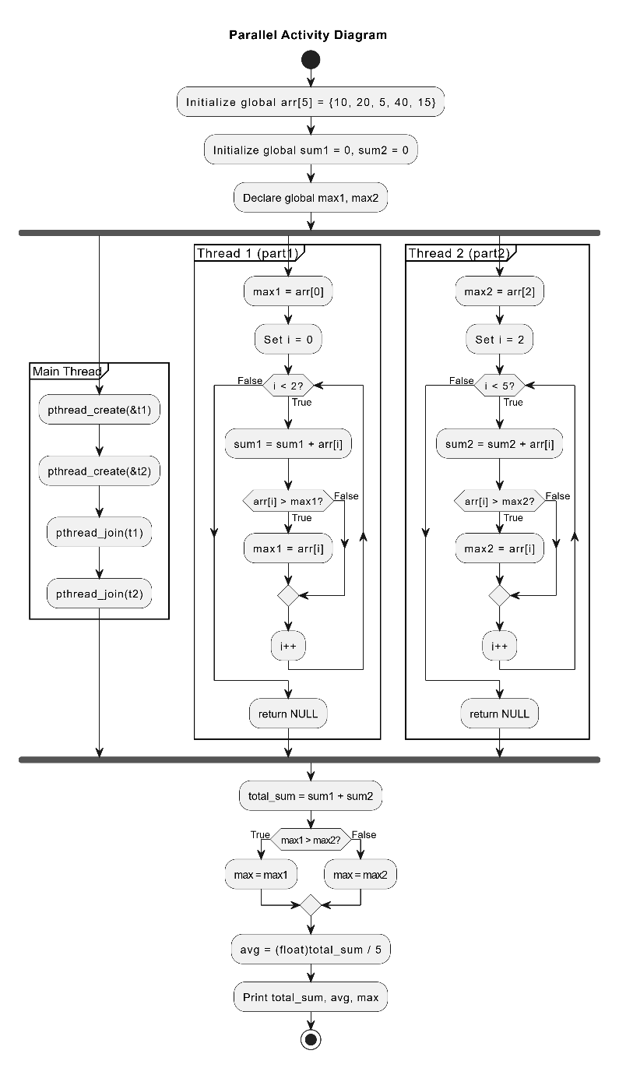

5. Comparison Between Sequential and Parallel Approaches
Feature | Sequential | Parallel (Pthreads)
Execution | Single thread | Multiple threads
Performance | Slower | Faster on multi-core systems
Complexity | Simple | Moderate
CPU Utilization | One core | Multiple cores
Overhead | Low | Higher (thread management)
Conclusion:
The parallel approach improves performance by utilizing multiple cores, but introduces additional complexity and overhead.

Q2: Multi-Process File Copy

1. C Program using fork, wait, exec

Main Program
#include <stdio.h>
#include <unistd.h>
#include <sys/wait.h>

int main() {
pid_t pid;

pid = fork();

if (pid < 0) {
printf("Fork failed\n");
return 1;
}
else if (pid == 0) {
execl("./copy", "copy", "source.txt", "dest.txt", NULL);
printf("Exec failed\n");
}
else {
wait(NULL);
printf("File copy completed by child process\n");
}

return 0;
}

Copy Program
#include <stdio.h>

int main(int argc, char *argv[]) {
FILE *src, *dest;
char ch;

if (argc < 3) {
printf("Usage: %s source destination\n", argv[0]);
return 1;
}

src = fopen(argv[1], "r");
dest = fopen(argv[2], "w");

if (!src || !dest) {
printf("File error\n");
return 1;
}

while ((ch = fgetc(src)) != EOF) {
fputc(ch, dest);
}

fclose(src);
fclose(dest);

return 0;
}

2. Block Diagram – Multi-Process Model
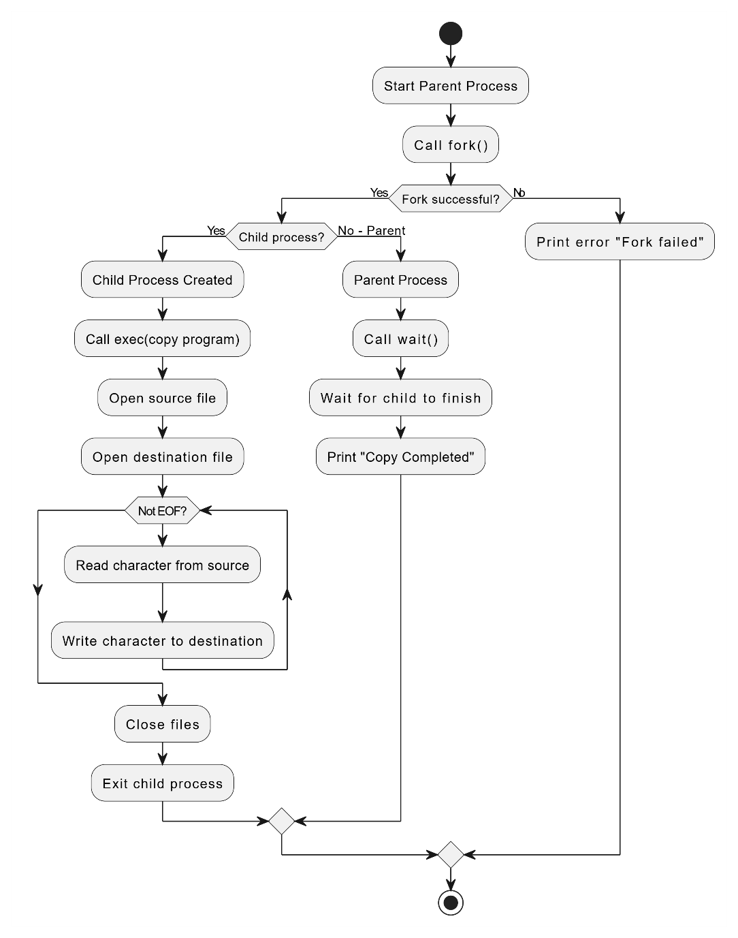
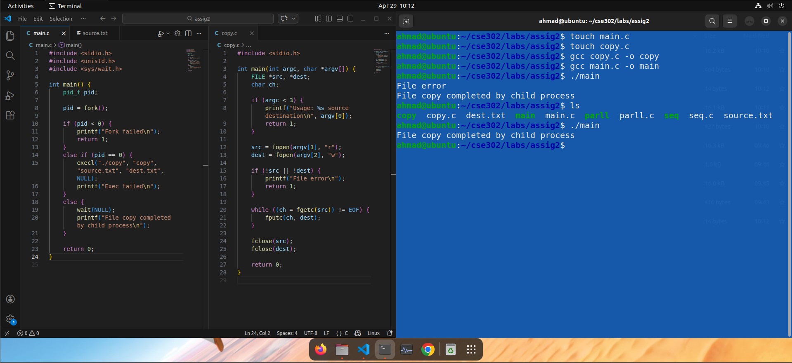

3. Process Distribution Across CPU Cores

When a program calls fork(), the operating system creates a separate child process with its own address space. Both parent and child become independent schedulable entities.

Key Mechanism
- Modern operating systems (e.g., Linux) use a scheduler (like CFS – Completely Fair Scheduler).
- The scheduler assigns ready processes to available CPU cores.
- If multiple cores exist, processes can run truly in parallel.

Execution Flow
- After fork():
  - Parent and child are placed in the ready queue
- Scheduler decides:
  - Which process runs on which core
  - Based on load balancing and fairness

Possible Scenario (Dual-Core CPU)
- Core 0 → Parent process
- Core 1 → Child process (file copy)

This leads to:
- Concurrent execution
- Better CPU utilization

Important Insight
- The programmer does not manually assign cores
- The OS scheduler automatically distributes processes
- More processes → better utilization (up to hardware limits)

4. Analysis: Sequential vs Multi-Process

Sequential Approach
- Single process performs entire file copy
- Executes on one CPU core only
- Steps are strictly linear (no overlap)

Advantages
- Simple implementation
- No process creation overhead
- Efficient for small files

Disadvantages
- Cannot utilize multiple cores
- Slower for large data

Multi-Process Approach (fork + exec)
- Work is handled by separate processes
- OS may run them on different CPU cores
- Enables parallel execution

Advantages
- Better CPU utilization
- Faster for:
  - Large files
  - Multiple file operations
- True parallelism (unlike single-threaded execution)

Disadvantages
- Overhead of:
  - fork() (process creation)
  - exec() (program loading)
- More complex design
- For small tasks, overhead may reduce performance

