Lab # 01

System Programming



Teacher | Bibi Areej Khan
Student Name | Muhammad Ahmad Khan
Registration No | 23JZBCS0238

Department of CS&IT
University of Engineering and Technology Peshawar (Jalozai Campus)

Objectives
- To know the fundamentals of Linux commands and directory.
- To master how to build files, directories and links in Linux.
- To learn about file permissions and umask.
- To experiment with pipes and text-processing instructions.
- To write and implement basic bash scripts.
Theory
Linux is a UNIX based, open-source operating system which offers command line tools to manage the system effectively. If a user has access to the Linux terminal, then it is possible to effectively manage files, administer permissions, track processes and automate tasks with shell scripting. Ls, stat, who, ps, and other tools such as awk, grep and wc command services enable the user to retrieve and manipulate system information. File permissions and umask help in enforcing security using the control of file access, and scripting allows the automation of routine tasks.
Lab 1: Directories & Files
Step 1: Create Lab Folder and Go into It
mkdir -p ~/cse302/labs/lab1
cd ~/cse302/labs/lab1
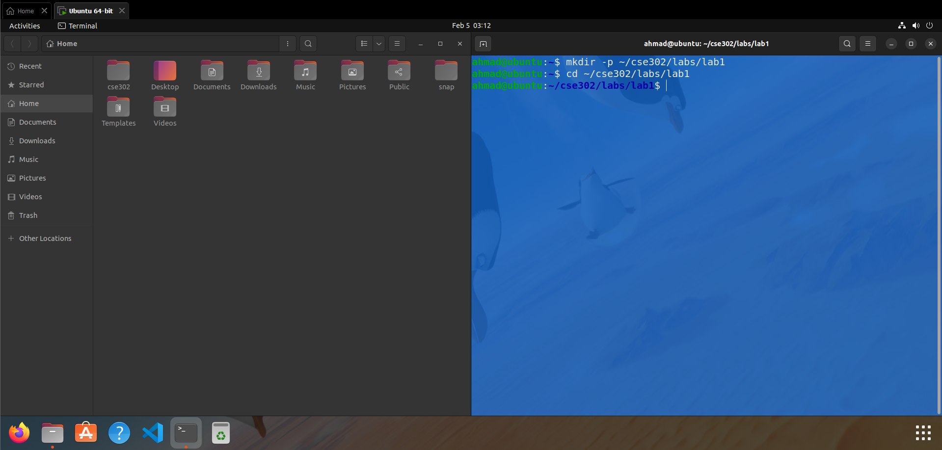Step 2: Create a File and Add Text
touch myfile
echo "Hello Linux" > myfile
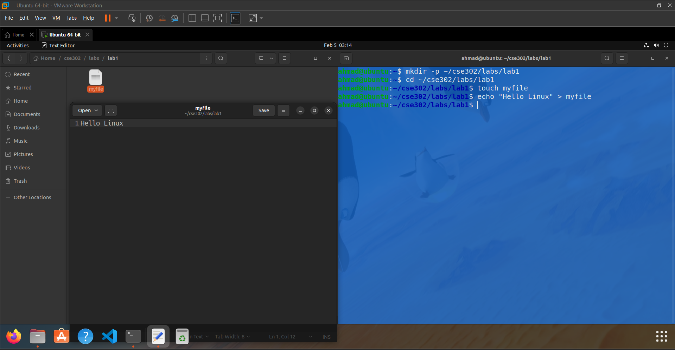
Step 3: Create Soft and Hard Links
ln -s myfile soft_link
ln myfile hard_link
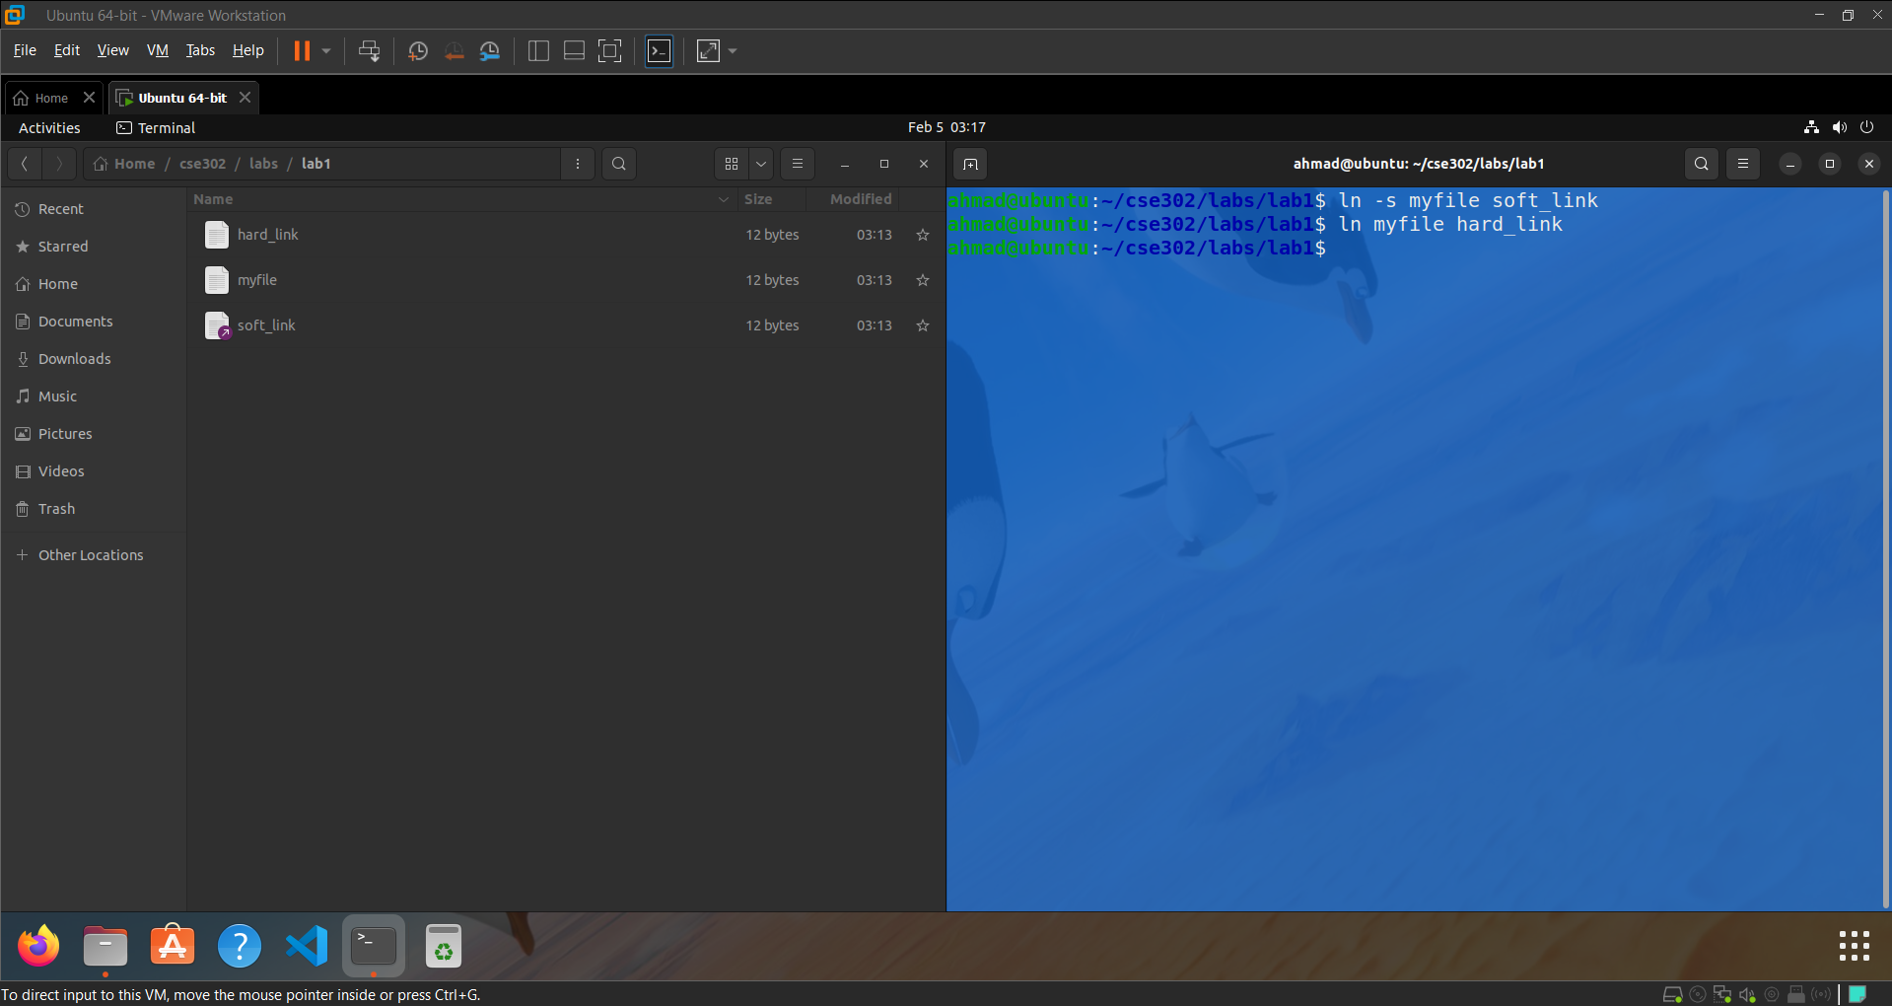
Step 4: Check File Details and Compare
ls -l
stat myfile
stat soft_link
stat hard_link
Difference: A soft link is directed to the name of the original file becomes invalid if the original file is deleted. Hard link has the same inode as the original file thus the data can still be accessed even after the original file has been deleted.
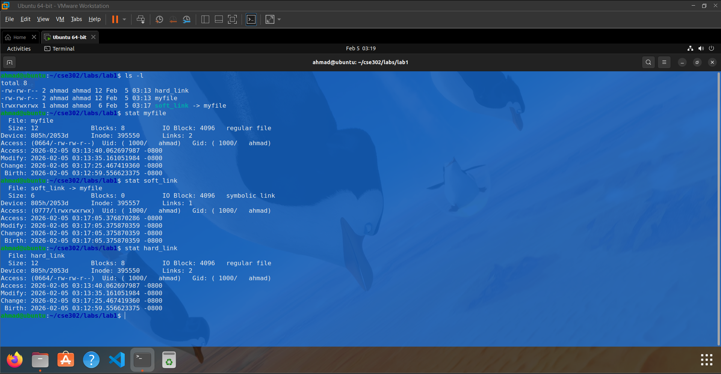

Lab 2: File Permissions (umask)
Step 1: Check Current umask
umask
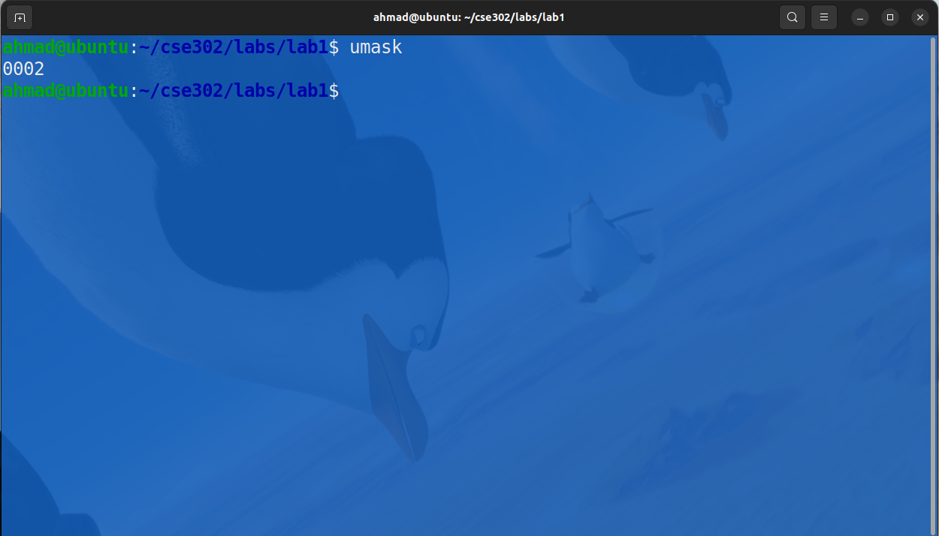
Step 2: Change umask to restrict group/others
umask 0077
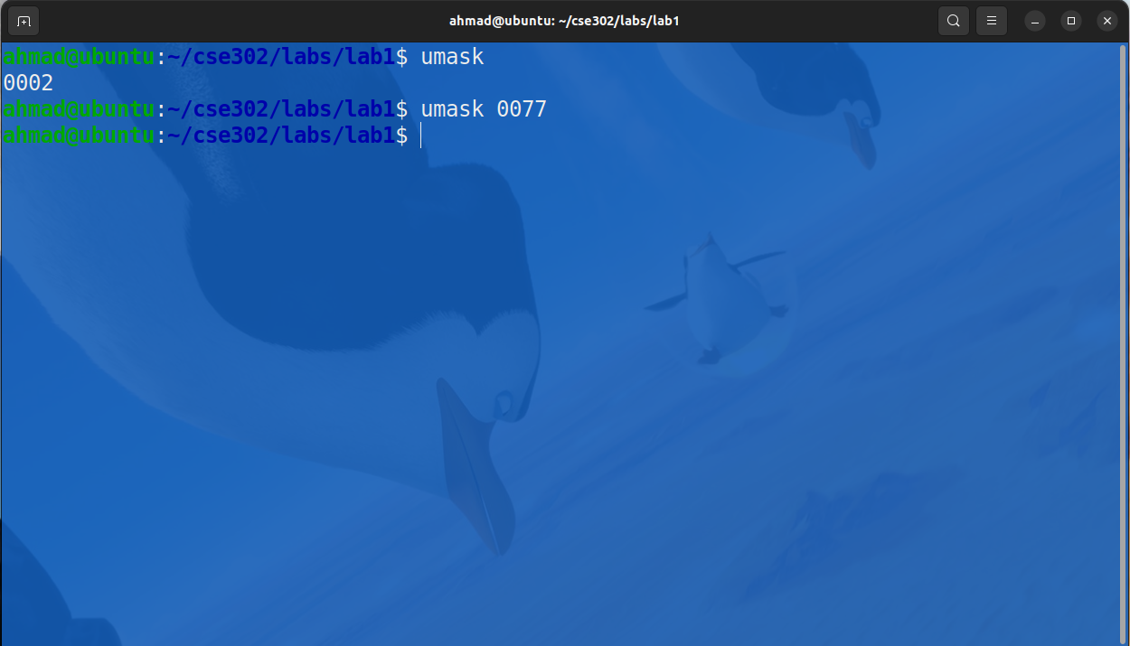
Step 3: Create New File and Verify Permissions
touch secret.txt
ls -l secret.txt
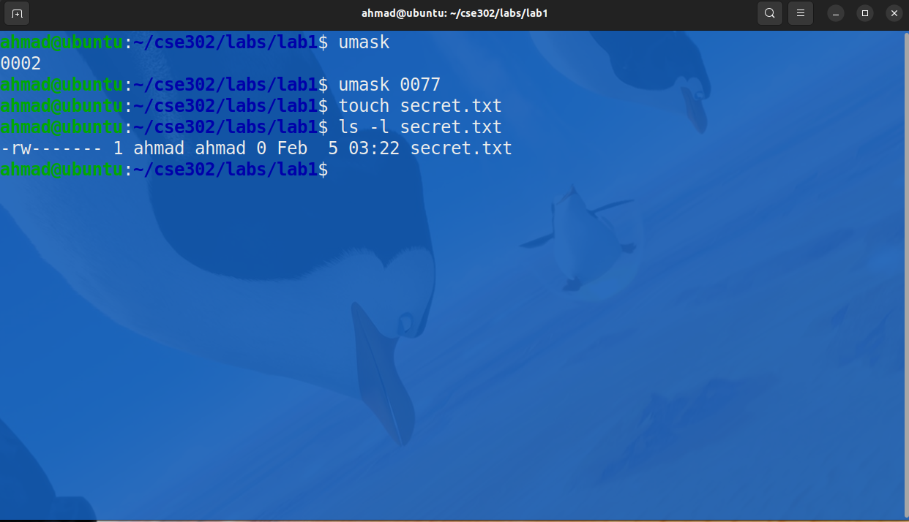

Step 4: Make Permanent in .bash_profile
nano ~/.bash_profile
Add line: umask 0077
source ~/.bash_profile
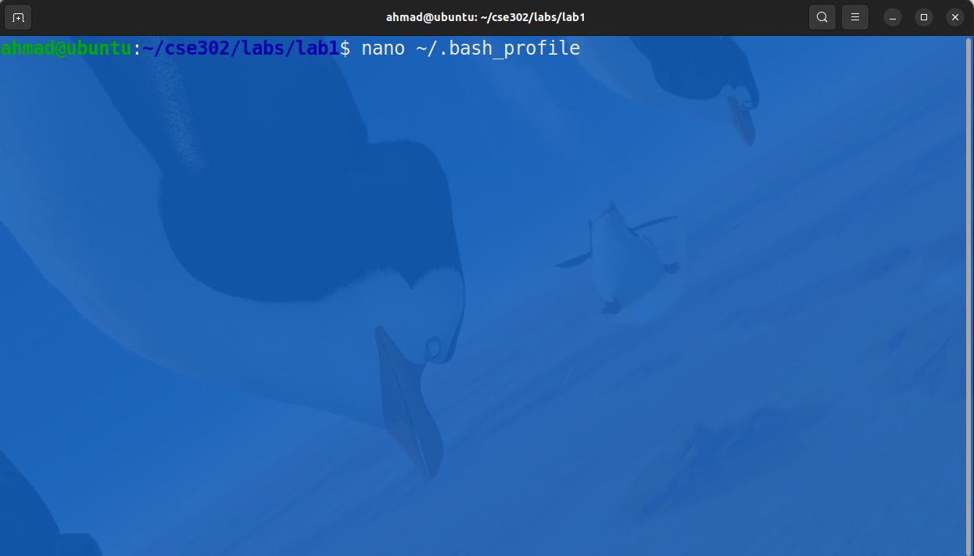
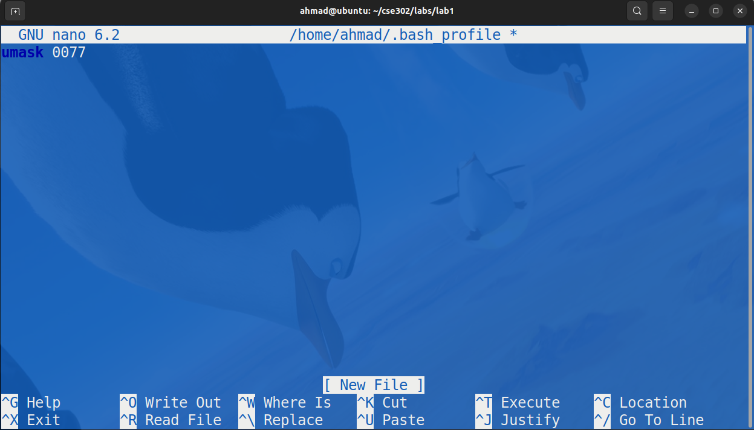
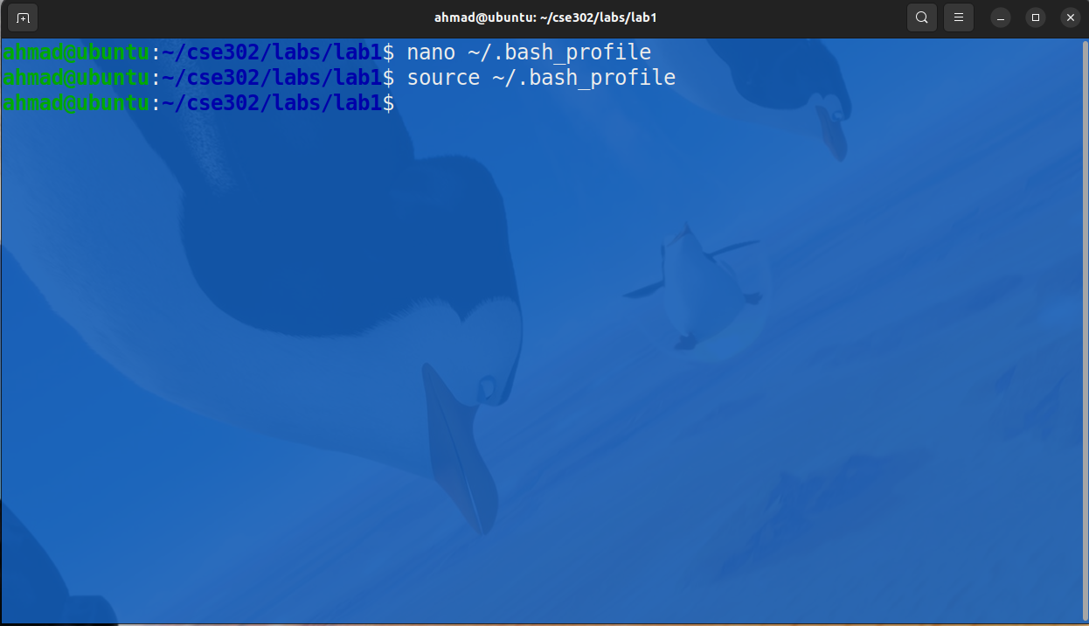
Lab 3: Count Logged-in Users
Step 1: List Logged-in Users
who
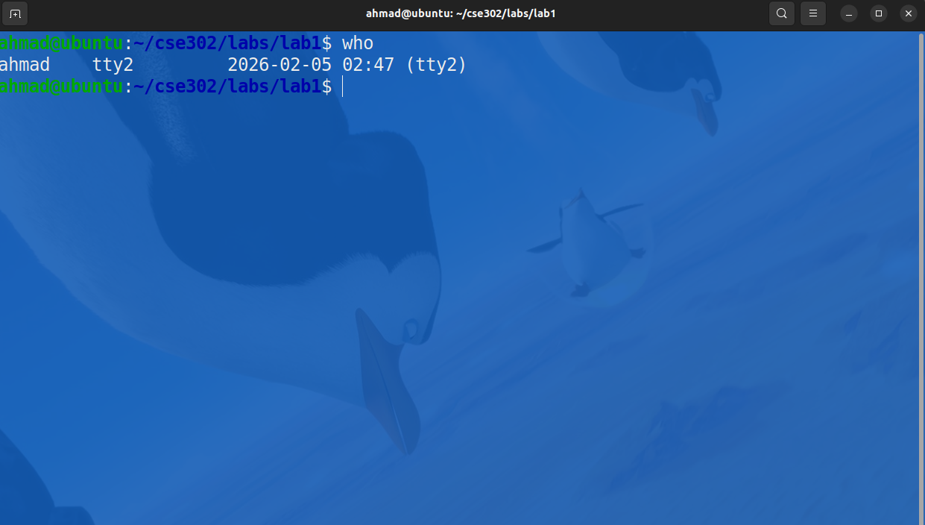

Step 2: Count Unique Users
who | awk '{print $1}' | sort | uniq | wc -l
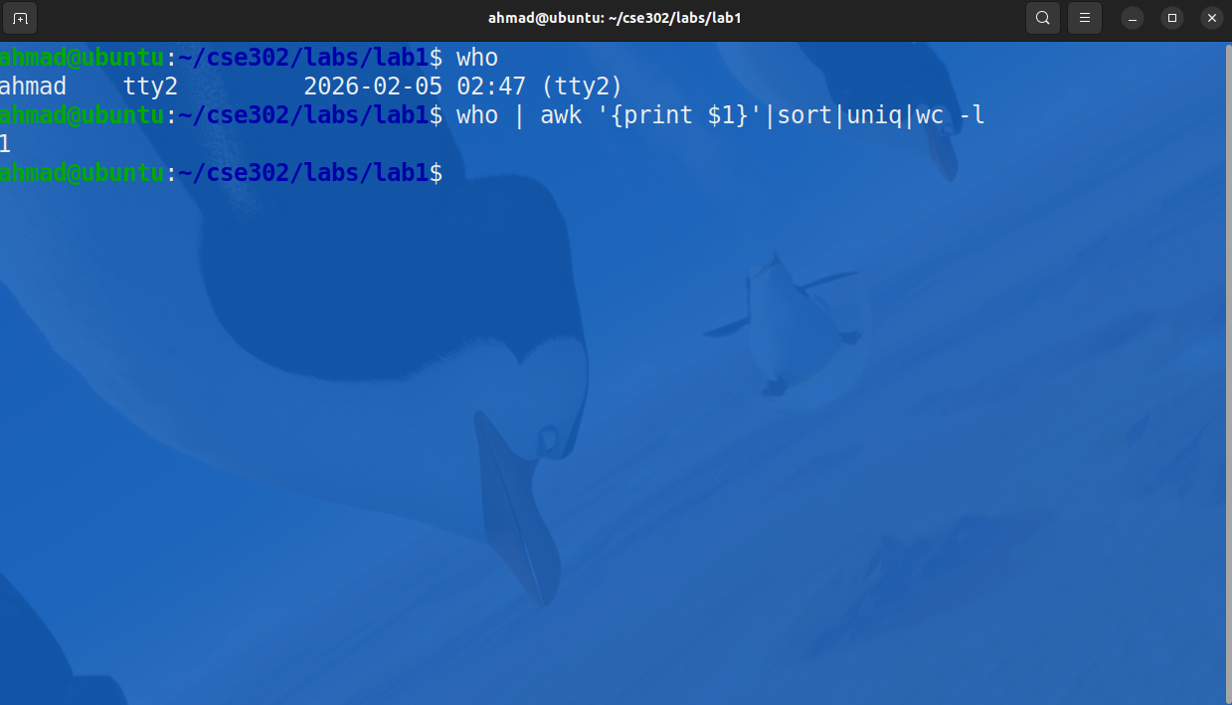
Step 3: Create Script count_users.sh
nano count_users.sh
Script content:
#!/bin/bash

echo "Users:"
who | awk '{print $1}' | sort | uniq
echo "Total users:"
who | awk '{print $1}' | sort | uniq | wc -l

Step 4: Make Executable and Run
chmod +x count_users.sh
./count_users.sh
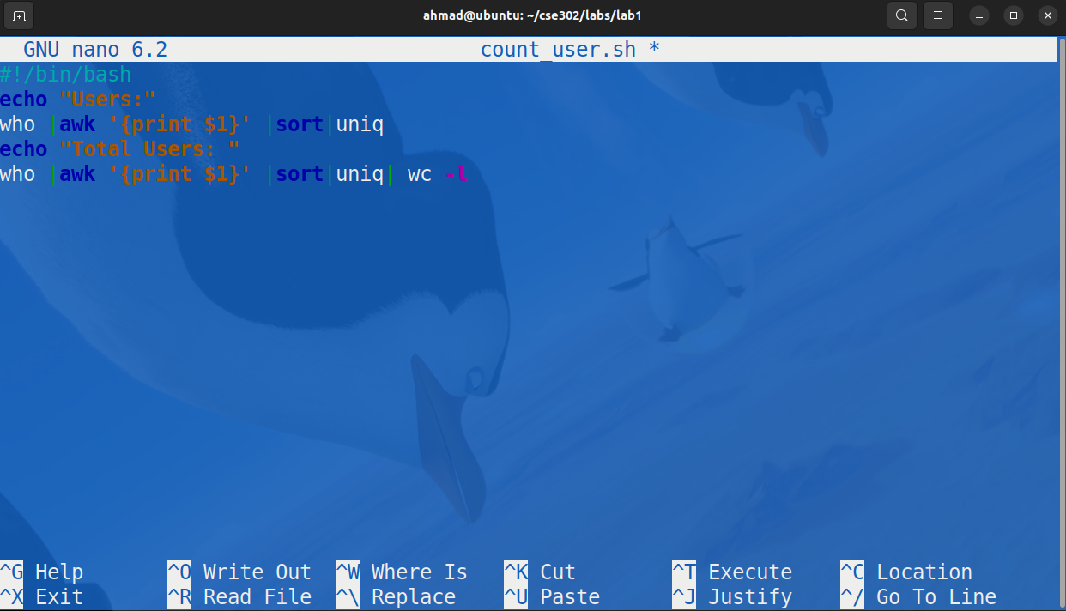
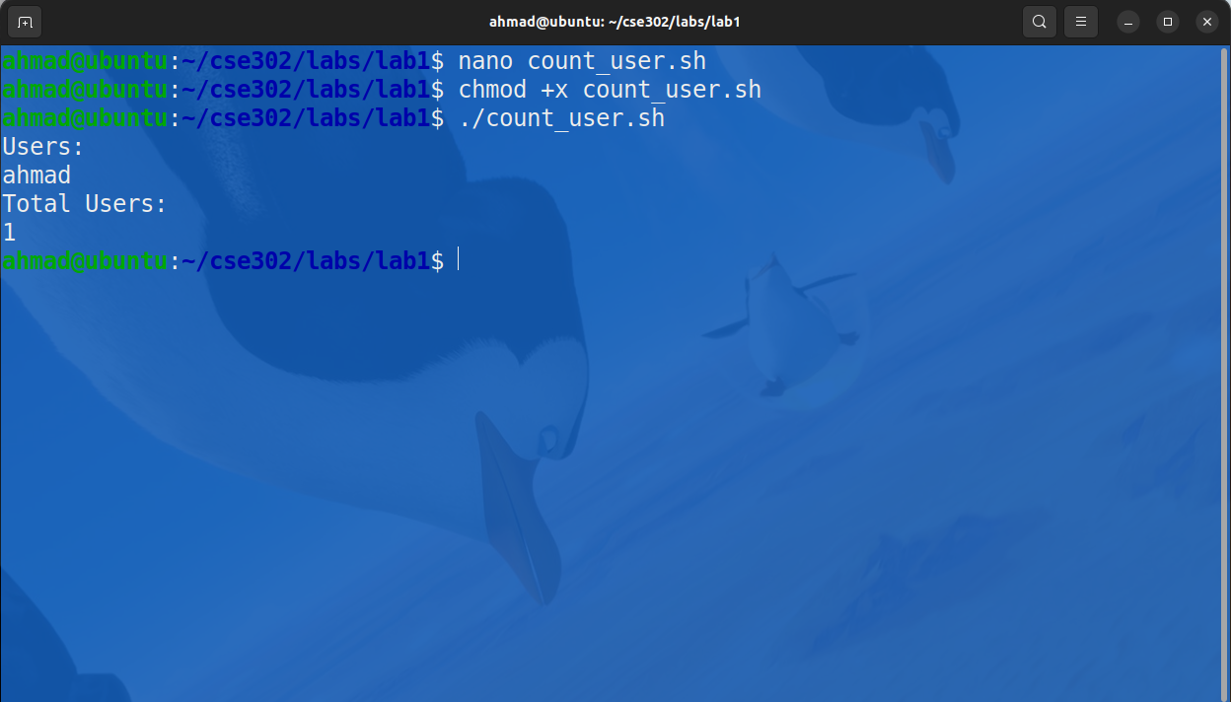
Lab 4: Root Processes
Step 1: List All Processes
ps -ax
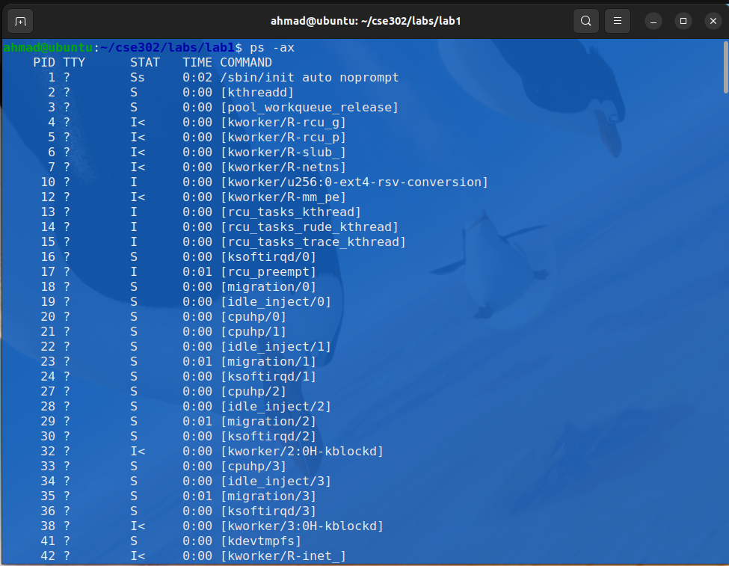
Step 2: List Root PIDs in One Line
ps -u root -o pid= | tr '\n' ',' | sed 's/,$//'
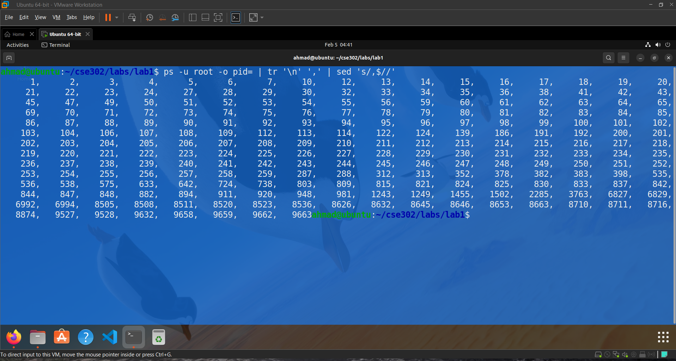
Lab 5: Numbered & Sorted Users
Step 1: List Logged-in Users
who
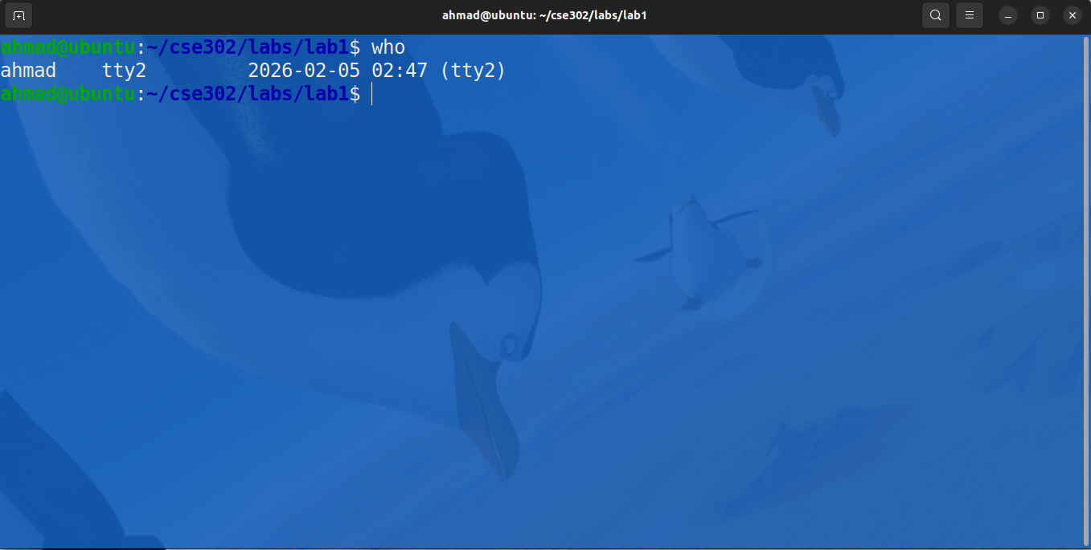Step 2: Extract Username and Login Time
who | awk '{print $1, $3, $4}'
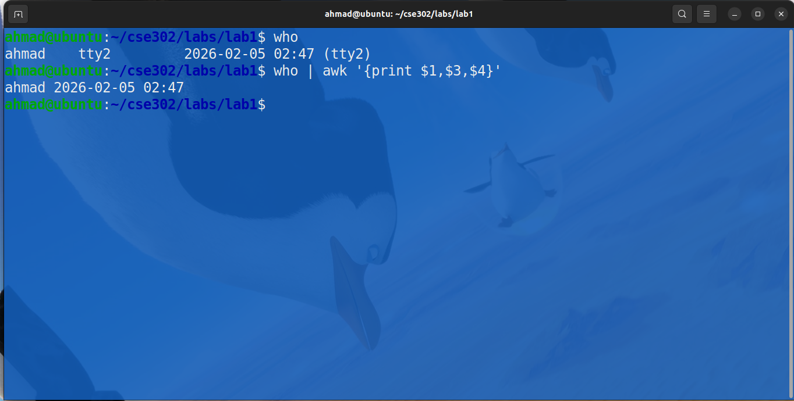Step 3 & 4: Sort Alphabetically and Number Lines
who | awk '{print $1, $3, $4}' | sort | nl
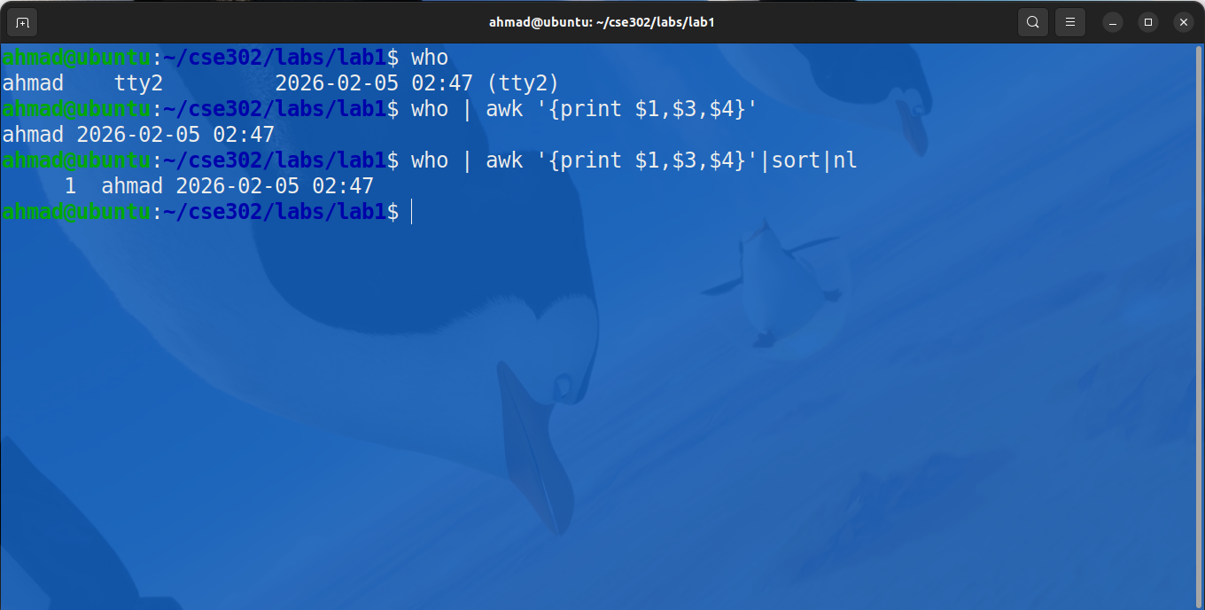
Conclusion
The essential Linux commands and concepts that we studied in this lab were directory and file management, links, file permissions, process monitoring, and user management. We were able to learn how to use pipes and text-processing tools to extract useful information out of system requests and how we can automate based on shell scripts. This lab served as a solid ground in the effective and safe functioning within the Linux setting.

