Lab # 02

System Programming



Teacher | Bibi Areej Khan
Student Name | Muhammad Ahmad Khan
Registration No | 23JZBCS0238

Department of CS&IT
University of Engineering and Technology Peshawar (Jalozai Campus)

Objectives
- To understand the structure of a C program.
- To learn how executable programs are stored in memory (Program Image).
- To understand static variables and their effect on executable size.
- To learn about Linux system calls and return values.
- To handle errors using errno, perror() and strerror().
- To analyze return values of system calls like close() and wait().
Theory
When a C program runs, it is loaded into memory as a program image. The program image consists of:
- Text Section → Stores executable instructions.
- Data Section → Stores initialized static/global variables.
- BSS Section → Stores uninitialized static/global variables.
- Heap → Dynamic memory (malloc).
- Stack → Function calls, local variables.
Static variables affect executable size because:
- Initialized static variables go to data section.
- Uninitialized static variables go to BSS section.
In Linux, system calls return:
- –1 on failure (and set errno)
- >= 0 on success
Error handling tools:
- errno → Stores error number.
- perror() → Prints error message using errno.
- strerror() → Converts error number to string.

Task 1: Print Your Name
Code: name.c
#include <stdio.h>

int main() {
printf("Muhammad Ahmad Khan\n");
return 0;
}

Compile:
gcc name.c -o name
Run:
./name
Expected Output:
Muhammad Ahmad Khan
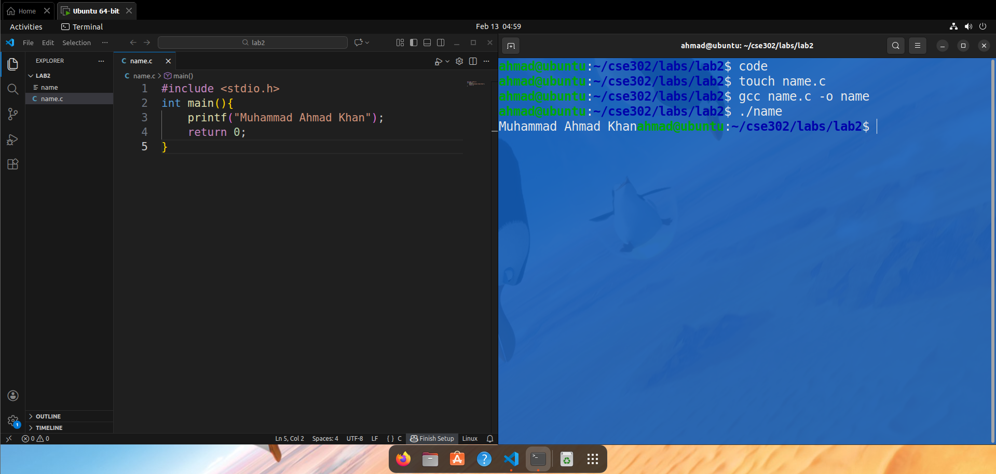
Task 2: Effect of Static Variables on Executable Size
Case 1: Without Static Variables
File: nostatic.c
#include <stdio.h>

int main() {
printf("Hello World\n");
return 0;
}

Compile:
gcc nostatic.c -o nostatic
Check Size:
ls -l nostatic
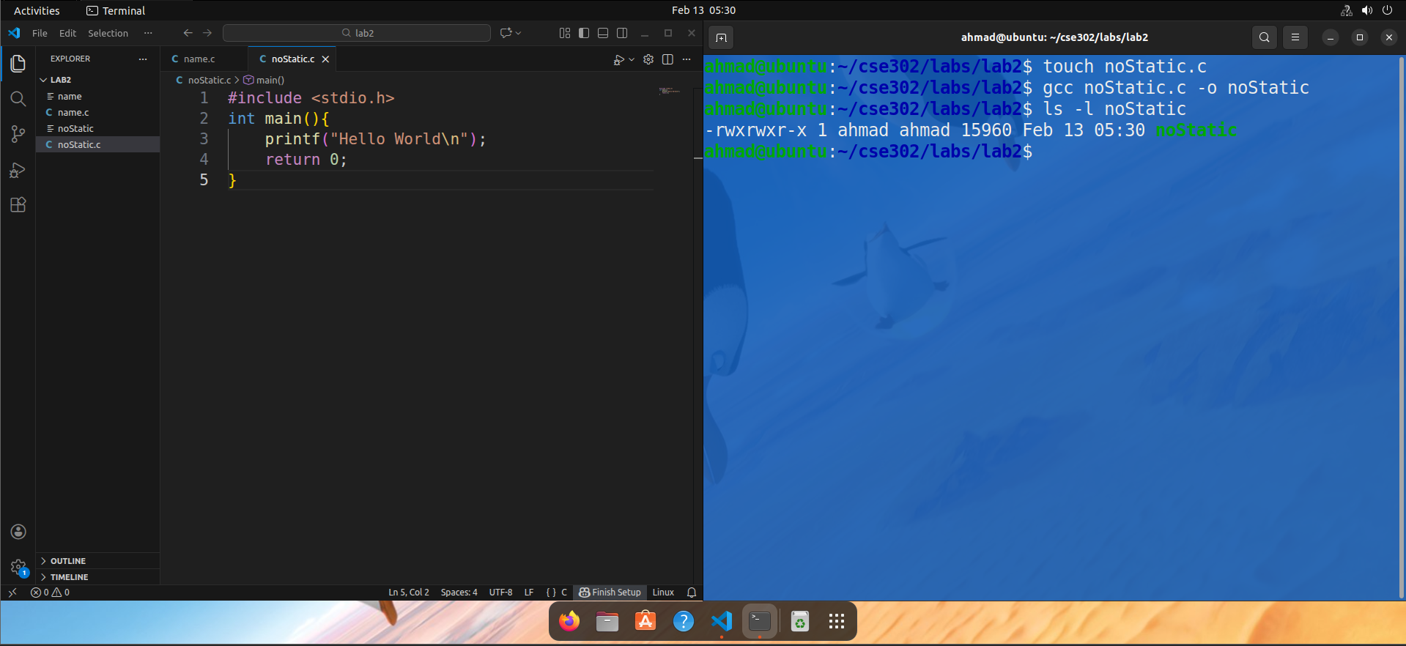
Case 2: With Static Variables
File: withstatic.c
#include <stdio.h>

static int a = 10;
static int b;

int main() {
printf("Hello World\n");
return 0;
}
Compile:
gcc withstatic.c -o withstatic
Check Size:
ls -l withstatic
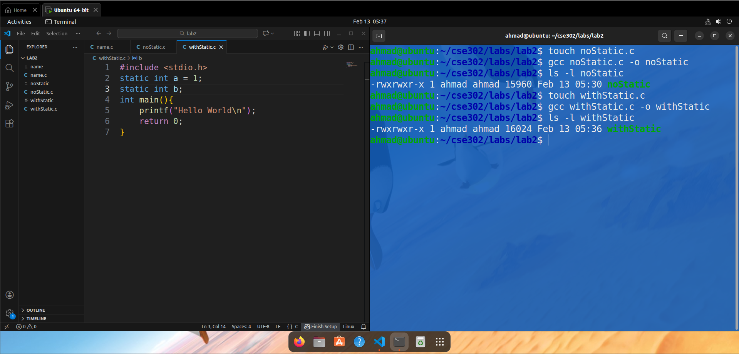
Observation:
Program | Executable Size (bytes)
Without static (noStatic) | 15960
With static (withStatic) | 16024
The executable size increased by 64 bytes after adding static variables. This shows that static variables are stored in the program’s data sections (Data/BSS), which slightly increases the binary size.

Task 3: Generate Error and Handle It
Example: Using close(-1)
File: error_demo.c
#include <stdio.h>
#include <unistd.h>
#include <errno.h>
#include <string.h>

int main() {

if (close(-1) == -1) {
printf("Error number: %d\n", errno);
perror("close error");
printf("Using strerror: %s\n", strerror(errno));
}

return 0;
}

Compile:
gcc error_demo.c -o error_demo
Run:
./error_demo

Expected Output:
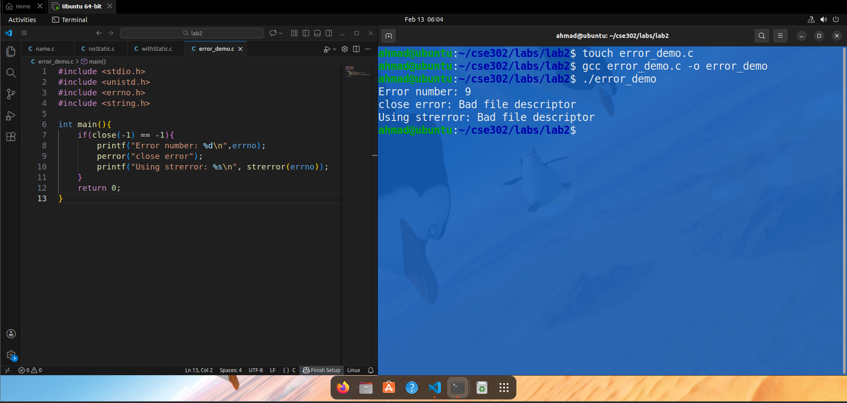

Observation:
Function | What It Does
errno | Stores error number
perror() | Prints formatted error message
strerror() | Returns error message as string

Task 4: Analyze close() System Call
Code:
#include <stdio.h>
#include <unistd.h>
#include <fcntl.h>
#include <errno.h>
#include <string.h>

int main() {

int fd;
int result;

printf("SUCCESS CASE\n");

fd = open("test.txt", O_CREAT | O_RDWR, 0644);
result = close(fd);

printf("Return value: %d\n", result);
printf("Errno: %d\n", errno);
printf("Using strerror: %s\n", strerror(errno));
perror("Using perror");

printf("FAILURE CASE\n");

result = close(-1);

printf("Return value: %d\n", result);
printf("Errno: %d\n", errno);
printf("Using strerror: %s\n", strerror(errno));
perror("Using perror");

return 0;
}

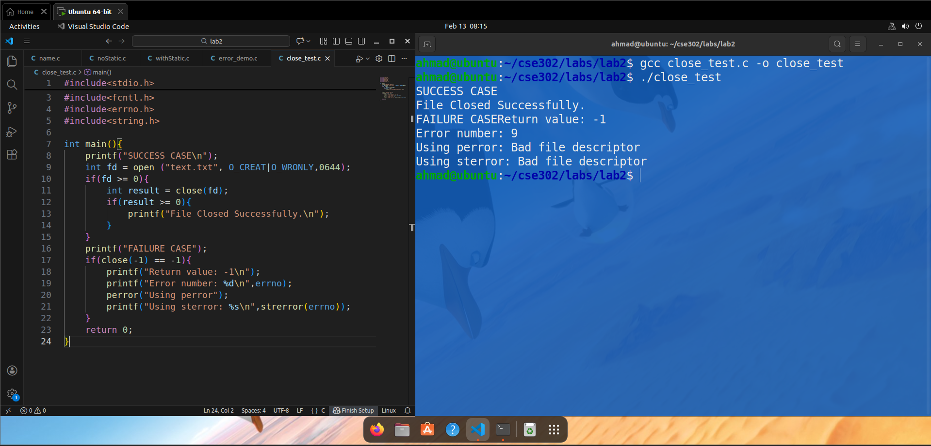Function Prototype
#include <unistd.h>
int close(int fildes);

Success Case
If a valid file descriptor is closed:
Return value:
>= 0
Meaning:
- File closed successfully
- errno not used

Failure Case
Example:
close(-1);
Return value:
-1
errno:
EBADF (Bad file descriptor)
Using perror()
if(close(-1) == -1)
perror("close failed");
Output:
close failed: Bad file descriptor
Using strerror()
if(close(-1) == -1)
printf("%s\n", strerror(errno));
Output:
Bad file descriptor
Conclusion
In this lab, we studied how a C program is structured in memory and understood the concept of the program image. We analyzed the effect of static variables on executable size and learned how Linux system calls return values and set error numbers. We practiced error handling using errno, perror(), and strerror(). This lab helped us understand how to write robust and reliable Linux programs that properly manage errors.

