Lab # 03

System Programming



Teacher | Bibi Areej Khan
Student Name | Muhammad Ahmad Khan
Registration No | 23JZBCS0238

Department of CS&IT
University of Engineering and Technology Peshawar (Jalozai Campus)

Objective
- To understand the difference between programs, processes, and threads.
- To learn how to create and manage foreground and background processes.
- To observe process relationships such as parent, child, orphan, and zombie processes.
- To understand multithreading using POSIX threads in C.
- To learn how to check system disk usage and memory usage.
Theory
Program
A program is an executable file stored on disk. It contains instructions but does nothing until executed.
Example:
Sleep
ls
python

Process
A process is a running instance of a program. When a program executes, it becomes a process.
Each process has:
- PID (Process ID)
- PPID (Parent Process ID)
- Memory and system resources
Example:
sleep 10
Thread
A thread is the smallest unit of execution within a process. Multiple threads share the same memory and resources of the process.
Threads allow parallel execution of tasks.
Foreground Process
- Runs in the terminal
- Blocks terminal until finished
- Takes input from keyboard
Example:
sleep 10
Terminal is blocked for 10 seconds.
Background Process
- Runs independently
- Terminal remains free
- Does not block terminal
Example:
sleep 30 &
Parent and Child Process
Parent process creates child process.
Example:
bash → sleep
bash = parent
sleep = child
Orphan Process
Occurs when parent process terminates before child.
Child is adopted by init/systemd (PID = 1)
Zombie Process
Occurs when child process finishes but parent does not read exit status.
Zombie remains in process table.
Daemon Process
Background service process.
Characteristics:
- Runs continuously
- No terminal (TTY = ?)
- Example: cron, systemd
Lab Tasks and Observations

Lab 1: Programs vs Processes
Task 1: List all running processes
Command:
ps -e
Observation:
Displays all running processes with PID and process name.
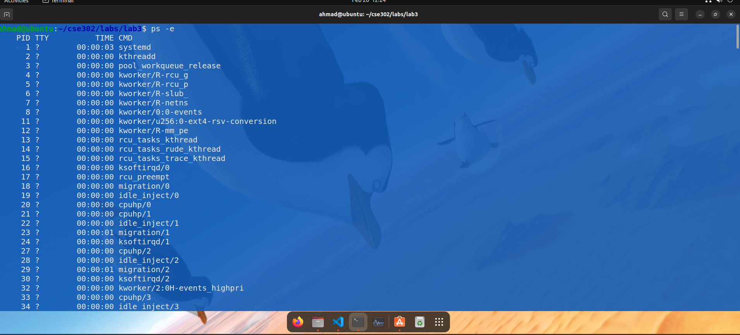
The command displayed all currently running processes along with their Process IDs (PID) and process names. Each process represents a running instance of a program, such as bash, sleep, systemd, and other system services.
Task 2: Run sleep in foreground
Command:
sleep 10
Observation:
Terminal becomes blocked for 10 seconds. No other command can run until completion.
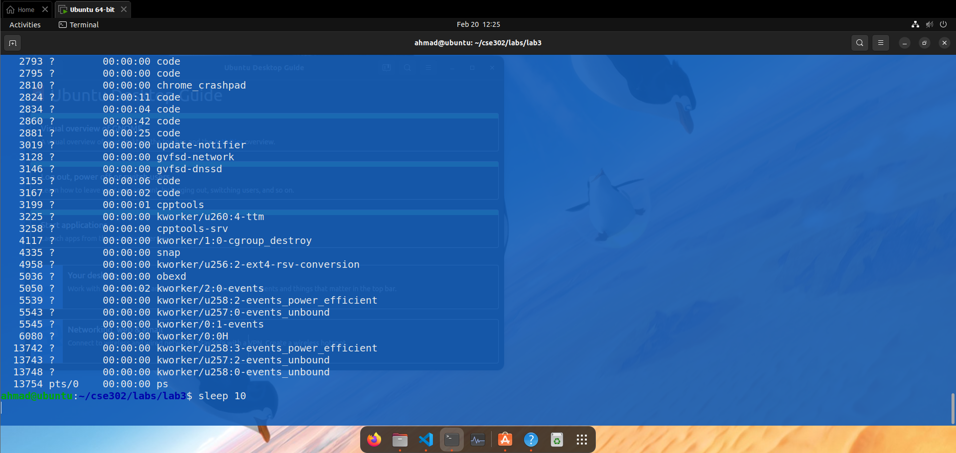
When the sleep program was executed in the foreground, the terminal became blocked for 10 seconds. During this time, no other commands could be entered or executed until the sleep process completed.
Task 3: Find PID and PPID
Command:
ps -f
Observation:
Shows detailed process information including:
- UID
- PID
- PPID
- CMD
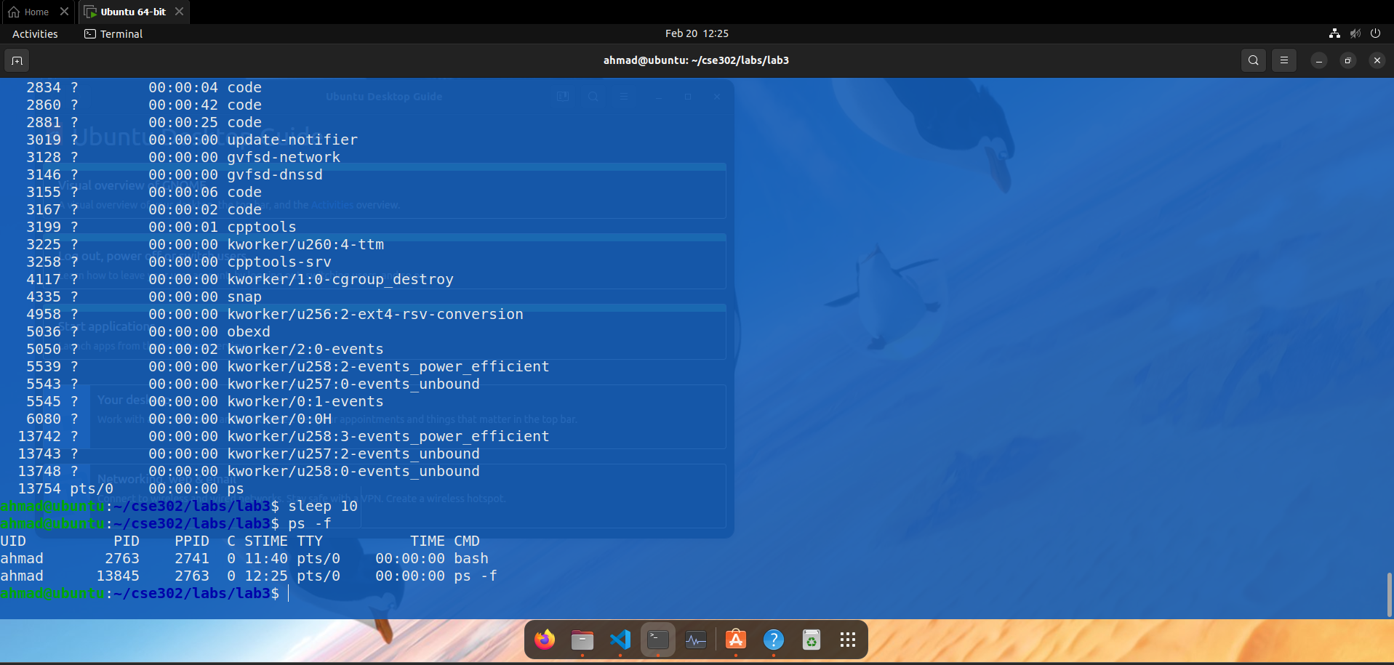
The output displayed detailed process information including PID (Process ID) and PPID (Parent Process ID). The sleep process had its own unique PID, and its PPID was the bash shell, which created the process.
Lab 2: Foreground and Background Processes
Task 1: Run foreground process
Command:
sleep 15
Observation:
Terminal is blocked until process finishes.
Q1. Run a process in the foreground. Can you run another command while it executes?
No, it was not possible to run another command while the process was executing in the foreground. The terminal remained busy and blocked until the process finished execution.
Task 2: Run background process
Command:
sleep 30 &
Observation:
Process runs in background and terminal remains free.
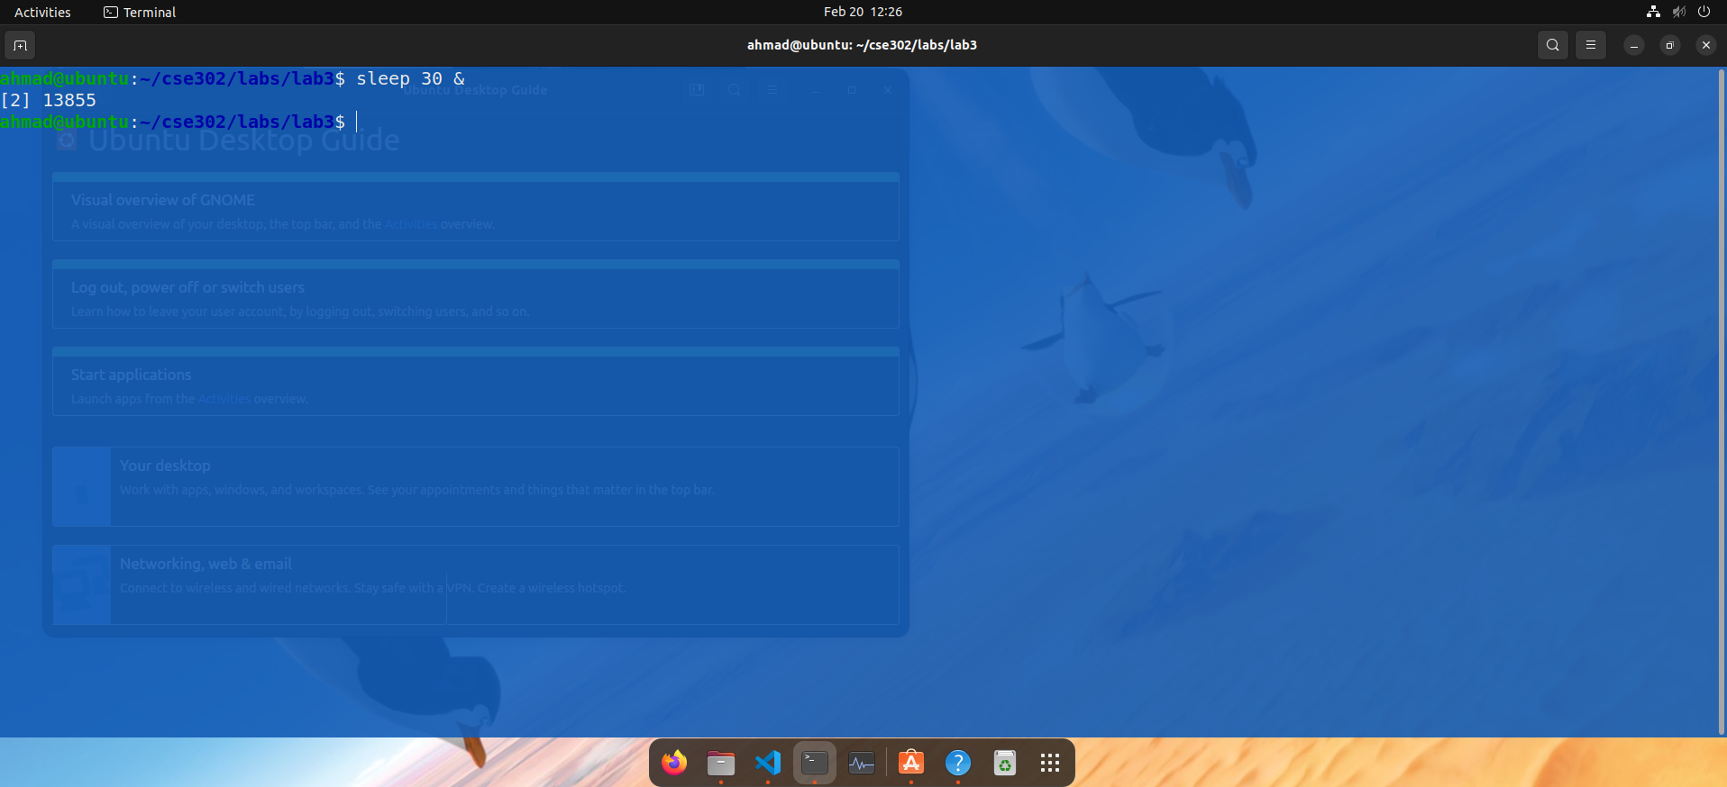
Q2. Run a process in the background. Does the terminal remain free?
Yes, the terminal remained free. The process started in the background, and the terminal allowed execution of other commands immediately. 1234 is the PID of the background process.
Task 3: List background jobs
Command:
jobs
Observation:
Shows background jobs with job number and status.
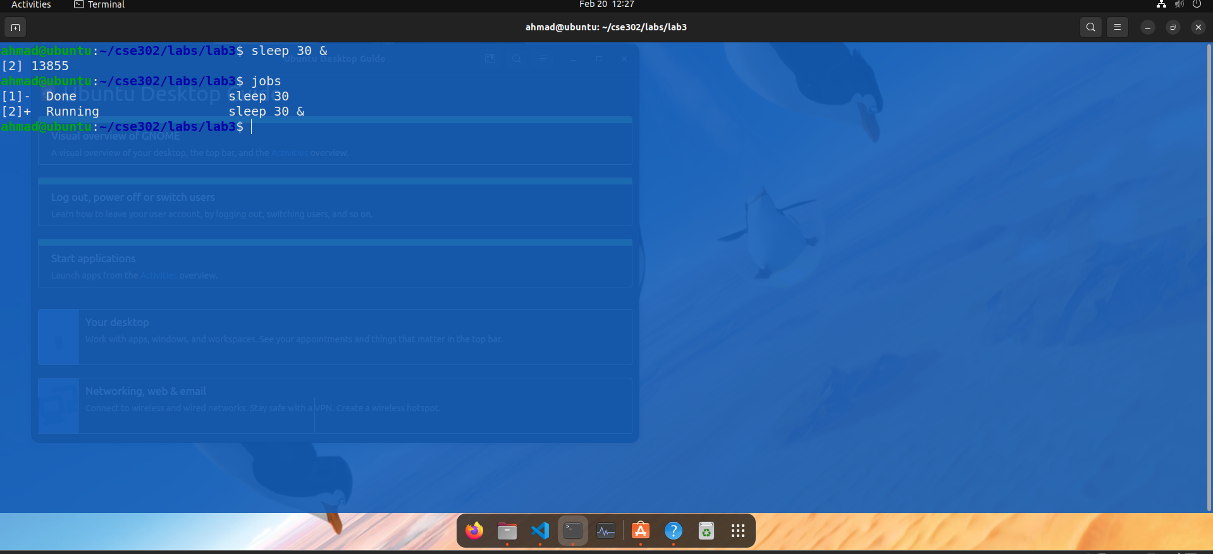
Command:
ps -f
Shows PID and PPID.
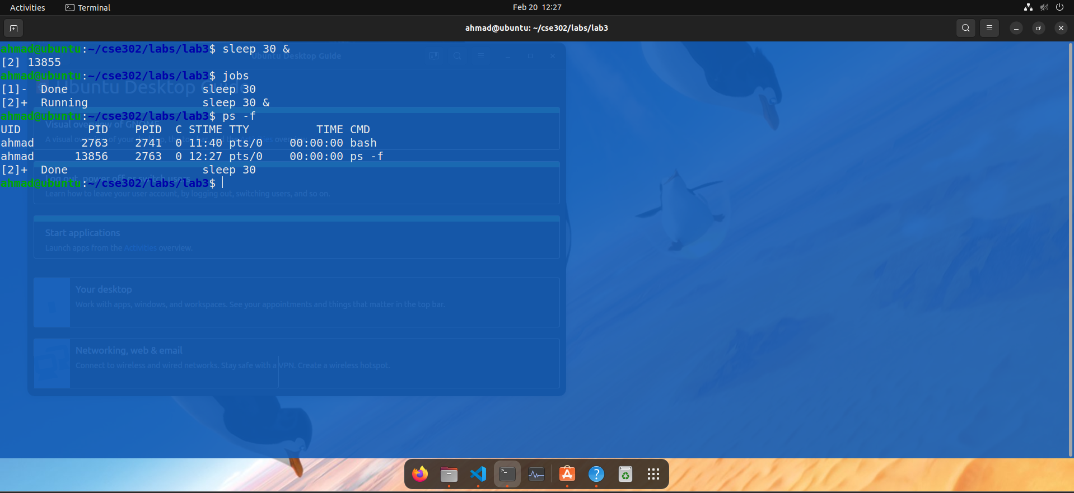
Q3. List all background jobs. Identify their PIDs.
The jobs command displayed all background jobs with job numbers and their status. The PID of each job was identified using the ps command.
Example:
[1]+ Running sleep 30 &
PID was identified using:
ps -f

Lab 3: Parent, Child, Orphan, Zombie, and Daemon
Task 1: Create child process
Command:
(sleep 10; echo "Child done") &
Observation:
Sleep runs as child process.
Check using:
ps -f
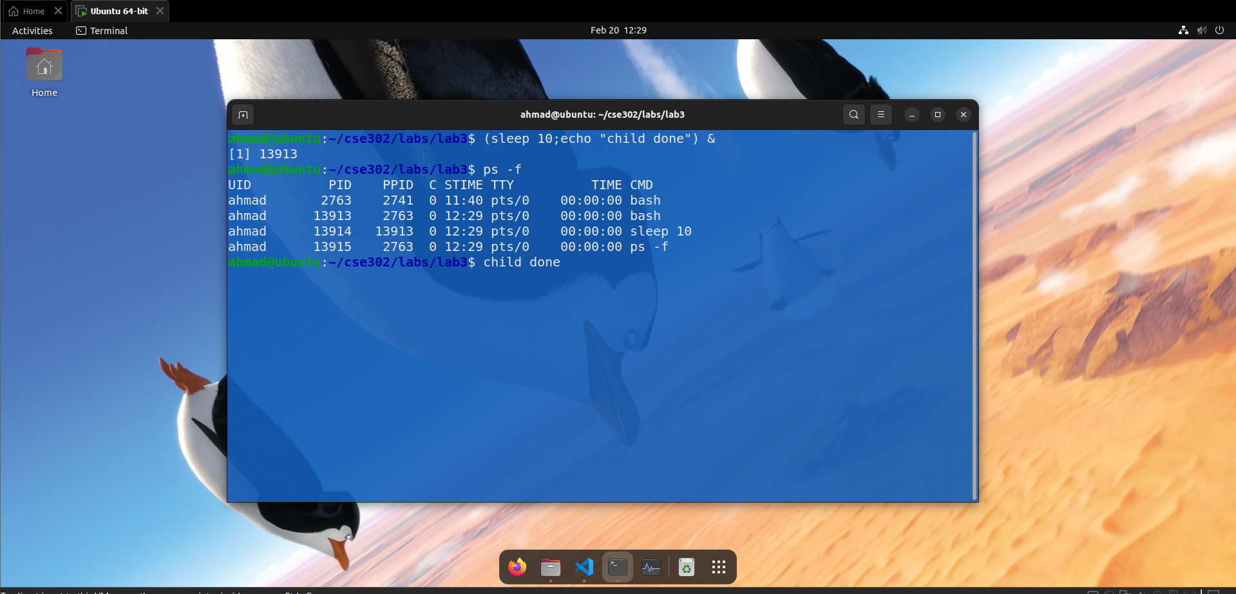
Q1. Create a child process using sleep. What are its PID and PPID?
Answer:
The sleep process was created as a child process. It had its own PID, and its PPID was the bash shell process that created it.
Example:
PID = 2345
PPID = 1234
Task 2: Create orphan process
Command:
(sleep 60 &) ; exit
Observation:
Child process continues running.
PPID becomes:
1
Adopted by init/systemd.
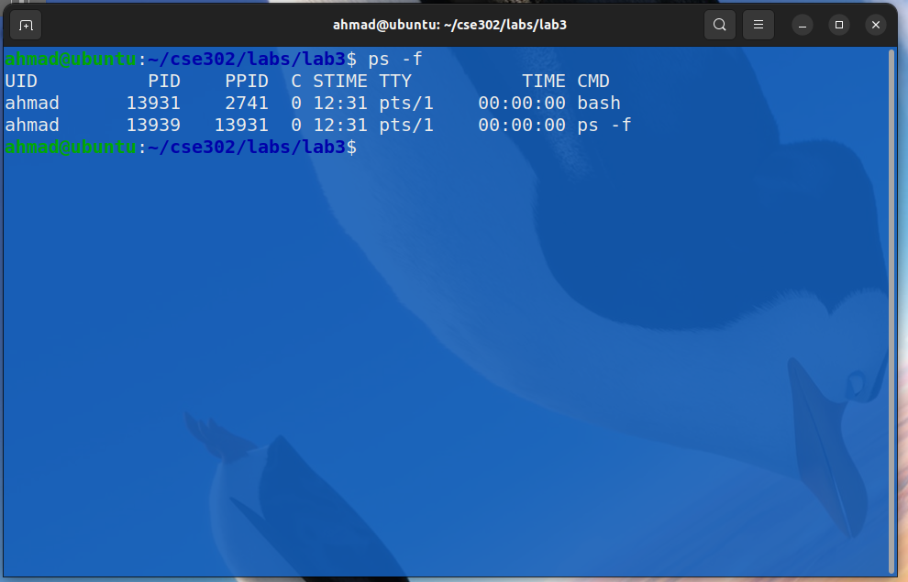
When the parent process exited, the child process became an orphan process. Its PPID changed to 1, which belongs to the init/systemd process. This means the orphan process was adopted by the system.
Task 3: Identify zombie process
Command:
bash -c "sleep 5 &"
ps aux | grep Z
Observation:
Zombie process appears with status:
Z
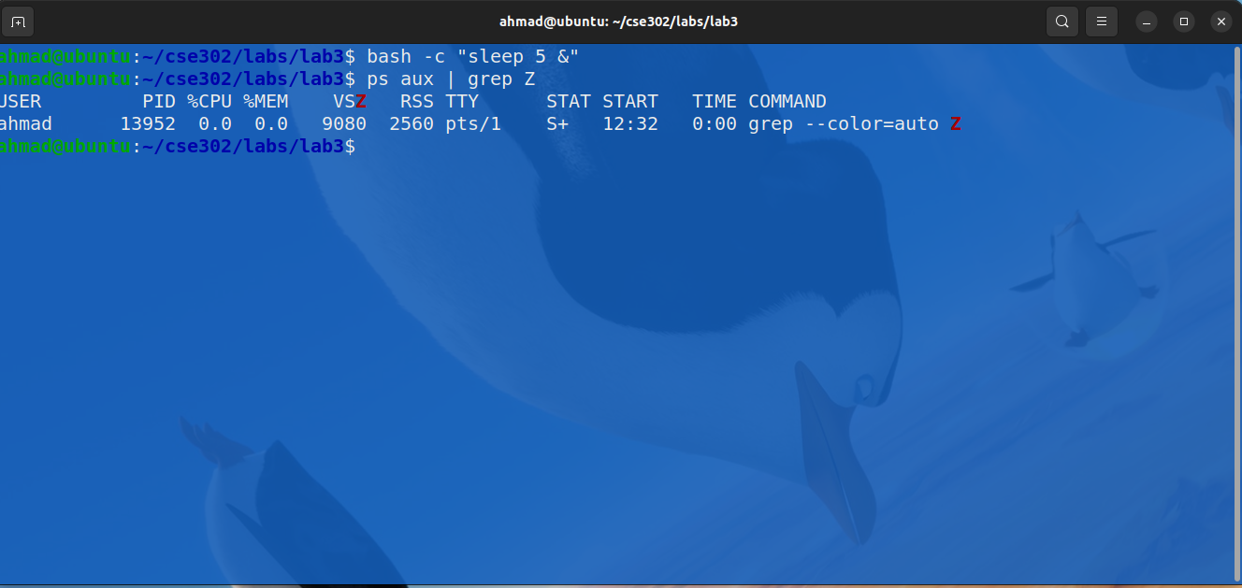
Q3. Create a zombie process. Can you identify it in the process list?
Answer:
Yes, the zombie process was visible in the process list. It appeared with status Z, indicating that the process had finished execution but still existed in the process table.
Example:
user 2345 0.0 0.0 Z sleep
Z indicates zombie state.
Task 4: Identify daemon process
Command:
ps -ef | grep cron
Observation:
Daemon process has:
TTY:
?
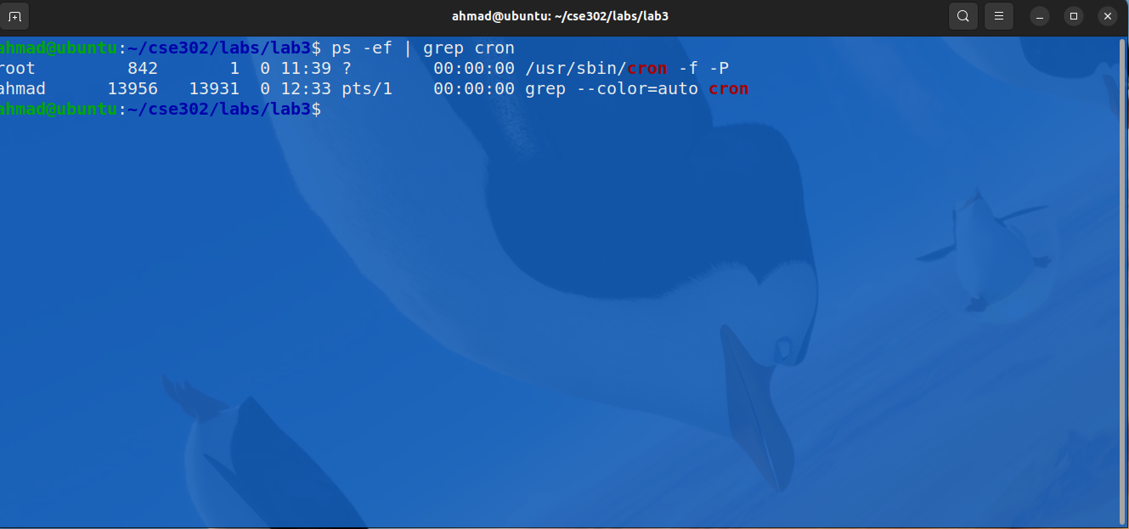
Daemon processes were identified by observing the TTY column. Daemon processes had TTY marked as "?".
Example:
root 1023 1 0 ? cron
TTY = ? indicates daemon process.

Lab 4: Threads in C
Program:
#include <stdio.h>
#include <pthread.h>
#include <unistd.h>

void* task1(void* arg) {
for(int i=0;i<3;i++){
printf("Task 1 running\n");
sleep(1);
}
return NULL;
}

void* task2(void* arg) {
for(int i=0;i<3;i++){
printf("Task 2 running\n");
sleep(1);
}
return NULL;
}

int main() {

pthread_t t1, t2;

pthread_create(&t1,NULL,task1,NULL);
pthread_create(&t2,NULL,task2,NULL);

pthread_join(t1,NULL);
pthread_join(t2,NULL);

return 0;
}

Compile:
gcc thread.c -o thread -pthread
Run:
./thread
Observation:
Output example:
Task 1 running
Task 2 running
Task 1 running
Task 2 running
Q2. Are the outputs of the threads interleaved? Why?
Yes, the outputs were interleaved. This happened because both threads executed concurrently, and the CPU switched between them during execution.
pthread_join waits for threads to finish.
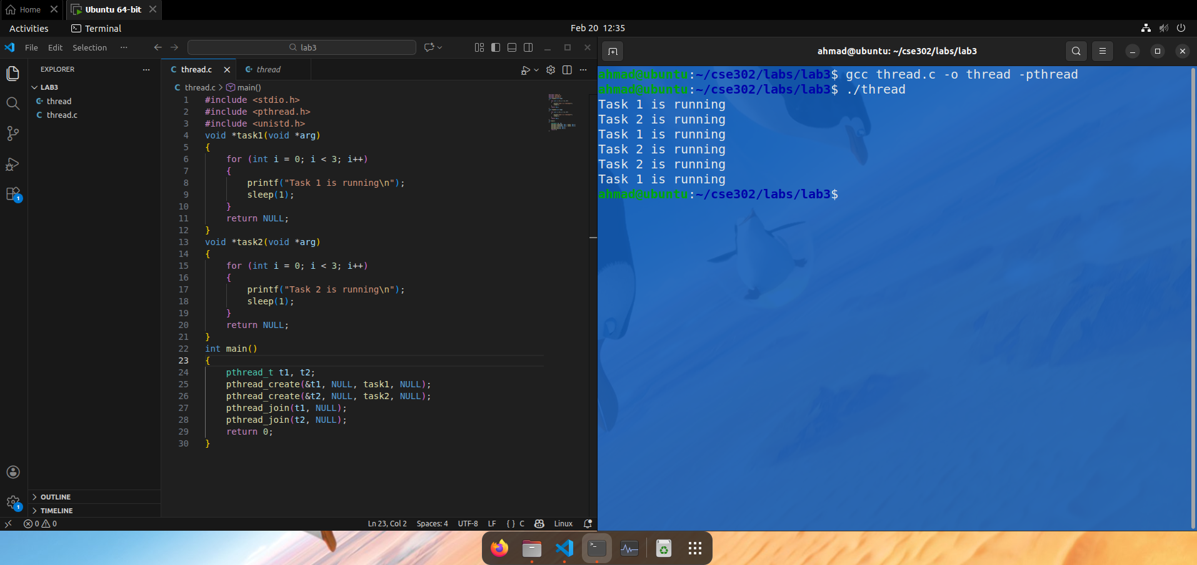
Q3. How can you make the main program wait until both threads finish execution?
Answer:
The pthread_join() function was used to make the main program wait for both threads to complete.
Example:
pthread_join(t1, NULL);
pthread_join(t2, NULL);

Lab 5: Disk and Memory Commands
Task 1: Check disk usage
Command:
df -h
Observation:
Displays disk usage of file systems.
Example:
Filesystem Size Used Avail Use%
/dev/sda1 50G 20G 30G 40%
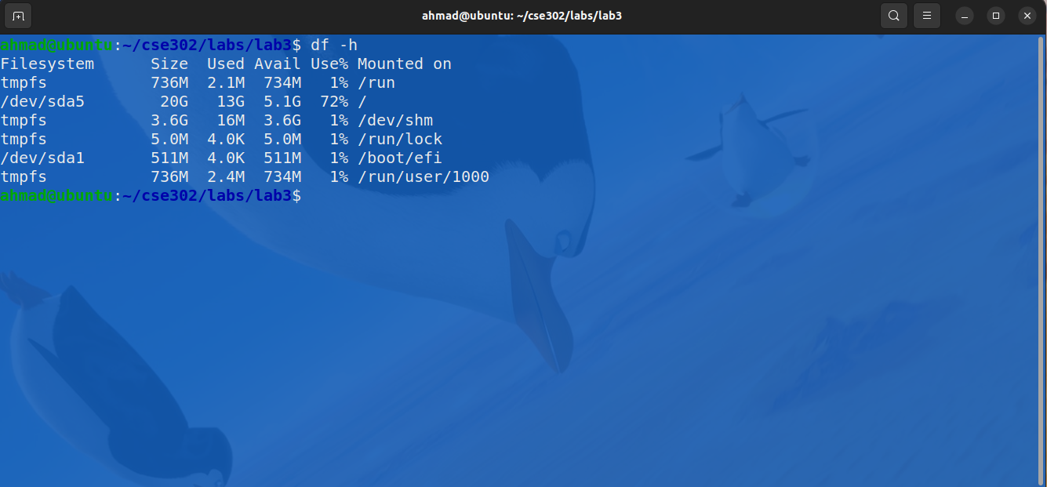
Task 2: Check memory usage
Command:
free -h
Observation:
Shows memory usage.
Example:
Total: 8GB
Used: 3GB
Free: 5GB
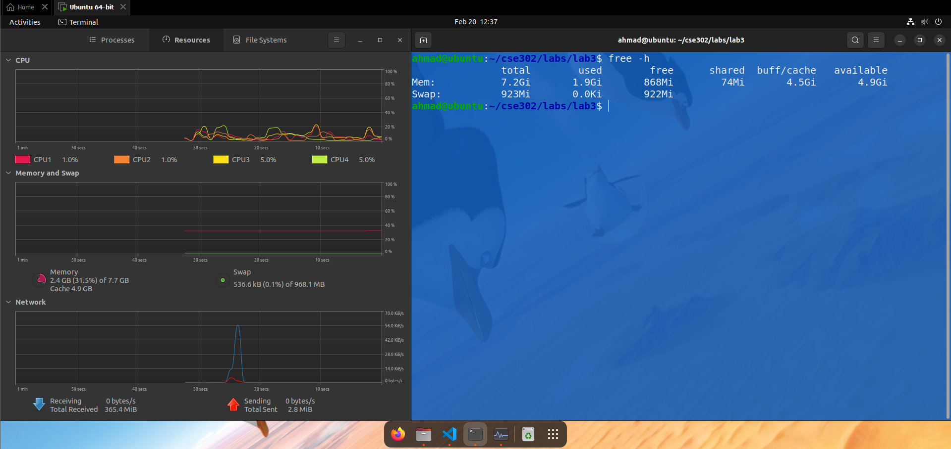
Q1. Check the disk usage of all file systems. Which file system is using the most space?
Answer:
The df command displayed disk usage of all file systems. The file system with the highest value in the Use% column was using the most space.
Example:
Filesystem Size Used Avail Use%
/dev/sda1 50G 20G 30G 40%
Q2. Check memory usage. How much free and used memory is available on your system?
Answer:
The free command displayed total, used, and free memory.
Example:
Total memory: 8GB
Used memory: 3GB
Free memory: 5GB
This showed the current memory usage of the system.

Conclusion
In this lab, we learned the difference between programs, processes, and threads. We observed how processes run in foreground and background and how to manage them using Linux commands. We studied parent, child, orphan, zombie, and daemon processes and understood their behavior. We also created threads using POSIX threads and observed concurrent execution. Finally, we used system commands to monitor disk and memory usage. This lab helped us understand process management and multithreading in Linux.

