Lab # 04

System Programming



Teacher | Bibi Areej Khan
Student Name | Muhammad Ahmad Khan
Registration No | 23JZBCS0238

Department of CS&IT
University of Engineering and Technology Peshawar
(Jalozai Campus)

1. Objectives
The objectives of this lab are:
- To understand process creation in Linux using fork().
- To analyze Parent–Child relationships using PID and PPID.
- To implement process synchronization using wait() and waitpid().
- To prevent orphan and zombie processes.
- To implement parallel processing using multiple child processes.
- To apply inter-process communication (IPC) using pipe().

2. Theory

2.1 Process Creation using fork()
fork() is a system call in UNIX/Linux used to create a new process. The newly created process is called the child, and the original process is the parent. After the call, both processes execute the same program but can be distinguished by the return value of fork().
#include <unistd.h>
pid_t fork(void);
Return Values:
- 0 → Returned in the child process
- > 0 → Returned in the parent (Child’s PID)
- -1 → Error occurred

2.2 Process Synchronization using wait()
The wait() and waitpid() system calls allow the parent process to wait for termination of child processes.
#include <sys/wait.h>
pid_t wait(int *status);
pid_t waitpid(pid_t pid, int *status, int options);
These calls:
- Prevent zombie processes.
- Allow parent to collect child exit status.
- Ensure proper process synchronization.

2.3 Orphan and Zombie Processes
- Zombie Process:
A child process that has terminated but whose exit status has not been collected by the parent.
- Orphan Process:
A child process whose parent terminates before it finishes execution.
When a process becomes orphan, it is adopted by PID 1, which is:
- systemd (modern Linux systems)
- init (traditional UNIX systems)

3. Lab Tasks

Lab Task 1: Process Chain Using fork()

Objective
To create a chain of processes using fork() without using wait(), and display:
- Iteration value (i)
- Process ID (PID)
- Parent Process ID (PPID)
- Child PID

Source Code
#include <stdio.h>
#include <stdlib.h>
#include <unistd.h>

int main(int argc, char *argv[]) {

if (argc != 2) {
printf("Usage: %s <number_of_processes>\n", argv[0]);
return 1;
}

int n = atoi(argv[1]);
pid_t pid;

for (int i = 1; i <= n; i++) {

pid = fork();

if (pid < 0) {
perror("Fork failed");
exit(1);
}

printf("i=%d | PID=%d | PPID=%d | Child PID=%d\n",
i, getpid(), getppid(), pid);

if (pid > 0)
break; // Ensures chain formation
}

return 0;
}

Compilation and Execution
gcc lab1.c -o lab1
./lab1 5

Output
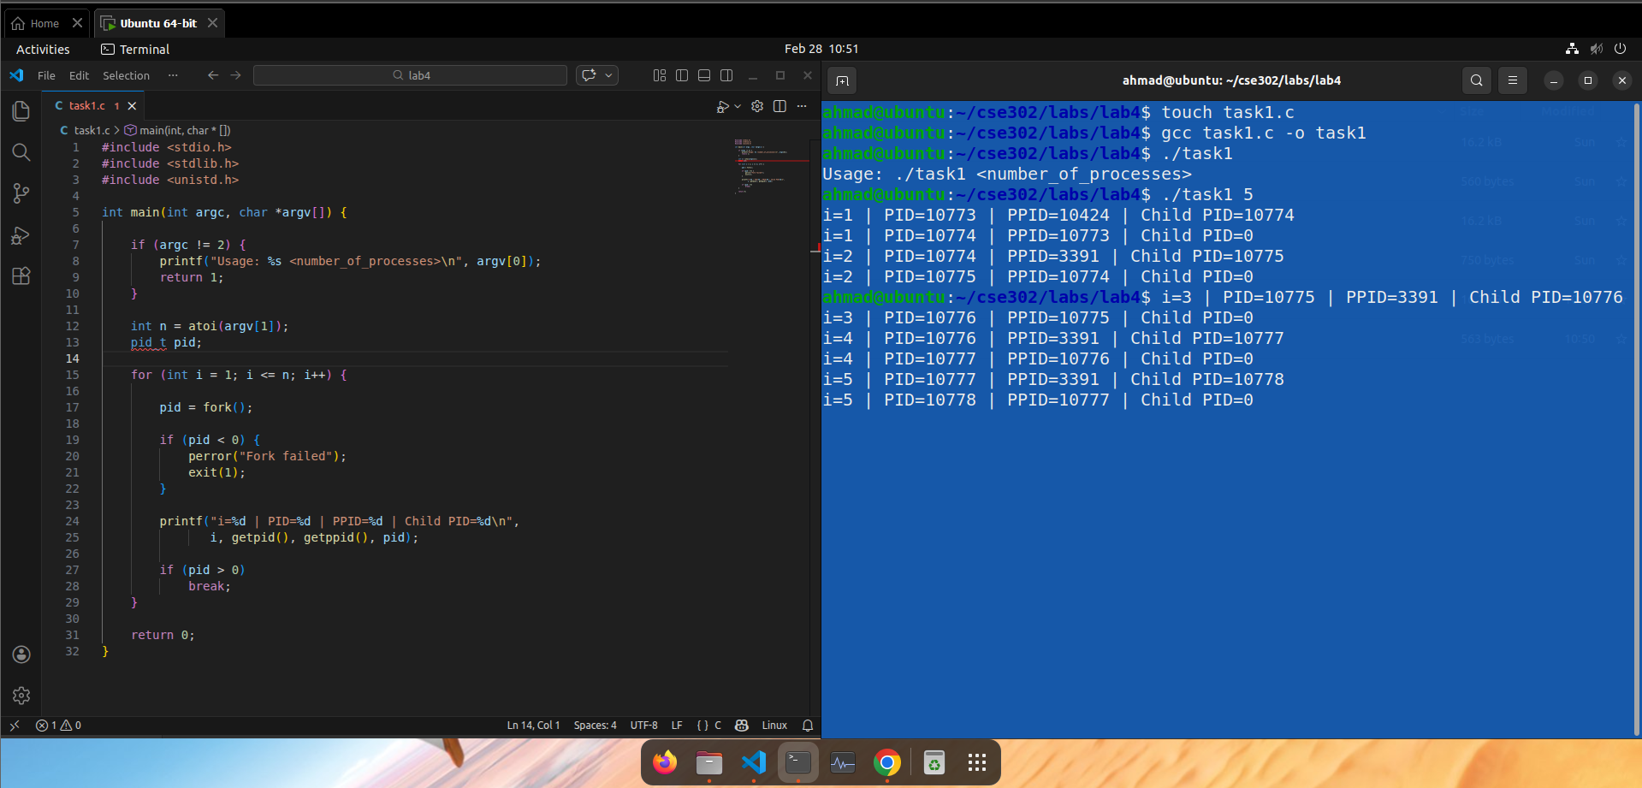

Explanation of PPID = 1
Since wait() is not used, the parent may terminate before the child completes execution. In such cases, the child becomes an orphan process. The Linux kernel reassigns orphan processes to PID 1 (systemd or init). Therefore, some processes may display PPID = 1.

Lab Task 2: Factorial Using Multiple Child Processes

Objective
- Accept N integers as command-line arguments.
- Create one child process per integer.
- Each child computes the factorial.
- Ensure no zombie or orphan processes exist.

Source Code
#include <stdio.h>
#include <stdlib.h>
#include <unistd.h>
#include <sys/wait.h>

long factorial(int n) {
if (n <= 1)
return 1;

long fact = 1;
for (int i = 2; i <= n; i++)
fact *= i;

return fact;
}

int main(int argc, char *argv[]) {

if (argc < 2) {
printf("Usage: %s <num1> <num2> ...\n", argv[0]);
return 1;
}

for (int i = 1; i < argc; i++) {

pid_t pid = fork();

if (pid == 0) {
int num = atoi(argv[i]);
long result = factorial(num);

printf("Number=%d | PID=%d | Factorial=%ld\n",
num, getpid(), result);

exit(0);
}
}

for (int i = 1; i < argc; i++)
wait(NULL);

return 0;
}

Compilation and Execution
gcc lab2.c -o lab2
./lab2 5 3 -2 0 6
Output
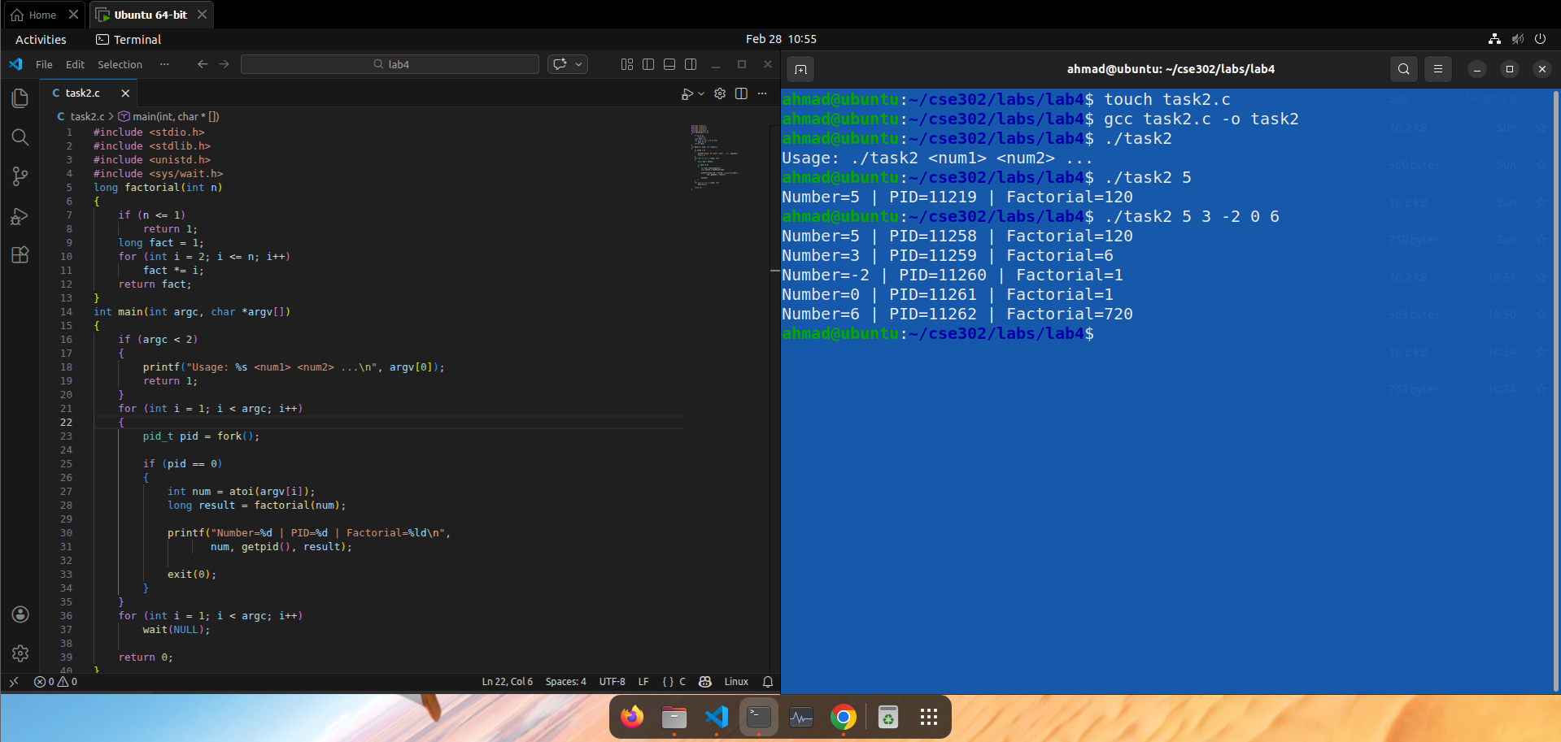

Lab Task 3: Parallel Array Sum Using fork()

Objective
- Create an array of 100 random integers.
- Create 10 child processes.
- Each child computes sum of 10 elements.
- Parent collects partial sums.
- Prevent zombie processes using wait().

Source Code
#include <stdio.h>
#include <stdlib.h>
#include <unistd.h>
#include <sys/wait.h>
#include <time.h>

#define SIZE 100
#define CHILDREN 10

int main() {

int arr[SIZE];
int pipefd[2];
pipe(pipefd);

srand(time(NULL));

for (int i = 0; i < SIZE; i++)
arr[i] = rand() % 100;

for (int i = 0; i < CHILDREN; i++) {

pid_t pid = fork();

if (pid == 0) {

close(pipefd[0]);

int start = i * 10;
int sum = 0;

for (int j = start; j < start + 10; j++)
sum += arr[j];

write(pipefd[1], &sum, sizeof(sum));
close(pipefd[1]);
exit(0);
}
}
close(pipefd[1]);
int total = 0, partial;
for (int i = 0; i < CHILDREN; i++) {
read(pipefd[0], &partial, sizeof(partial));
total += partial;
}
close(pipefd[0]);
for (int i = 0; i < CHILDREN; i++)
wait(NULL);
printf("Final Total Sum = %d\n", total);
return 0;
}

Compilation and Execution
gcc lab3.c -o lab3
./lab3

Output
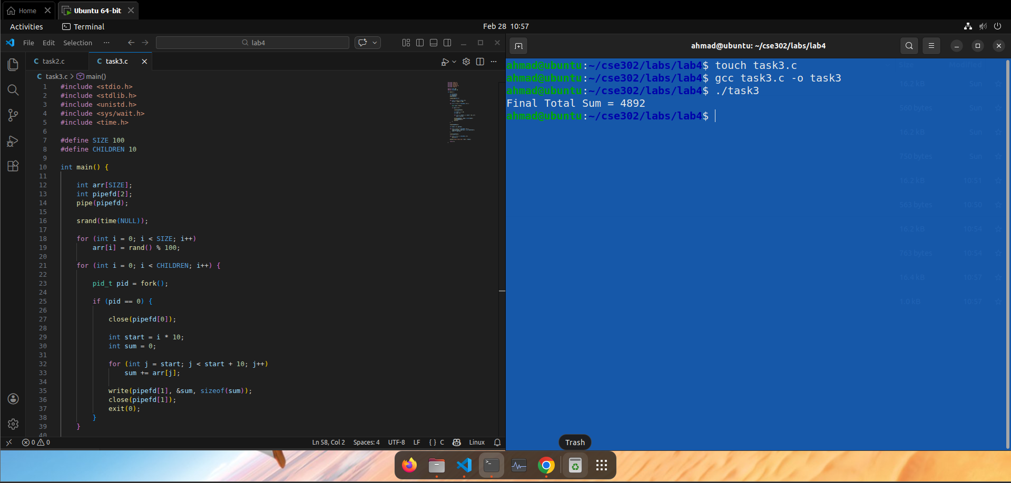

4. Conclusion
In this lab, we implemented process creation and synchronization mechanisms in Linux using fork(), wait(), and pipe(). We observed the behavior of process chains, process hierarchies, and orphan adoption by PID 1 (systemd/init).
Additionally, we applied parallel processing concepts to compute factorials and array summations using multiple child processes. The lab strengthened our practical understanding of:
- Process lifecycle
- Parent–child relationships
- PID and PPID behavior
- Prevention of zombie and orphan processes
- Inter-process communication using pipes
This lab provided hands-on experience with core Linux process management concepts essential for system-level programming.

