Lab # 05

System Programming



Teacher | Bibi Areej Khan
Student Name | Muhammad Ahmad Khan
Registration No | 23JZBCS0238

Department of CS&IT
University of Engineering and Technology Peshawar
(Jalozai Campus)

1. Objectives
The objectives of this lab are:
• To understand the concept of process creation in Linux using fork()
• To learn how the exec() family of functions replaces a running program with another program
• To practice inter-process program execution
• To execute different programs using child processes
• To understand how command-line arguments are passed between programs
• To learn process synchronization using wait()

2. Theory
In Linux, a process is a running instance of a program. A process can create another process using the fork() system call.
When fork() is executed:
- A child process is created
- The child process is almost identical to the parent process
- Both processes continue execution independently
However, sometimes the child process needs to run a completely different program. For this purpose, Linux provides the exec() family of functions.
The exec() function replaces the current process image with a new program. After a successful exec() call:
- The previous program code is replaced
- The Process ID (PID) remains the same
- The new program starts execution
- If exec() succeeds, it does not return
The most common pattern in Linux process management is:
fork() → child process created
exec() → child runs another program
wait() → parent waits for child to finish
This technique is widely used in Linux shells, compilers, and system utilities.

3. Lab Task 1

Min–Max Using exec()

Objective
To create two child processes where one calculates the minimum value and the other calculates the maximum value of an array using separate programs.

Program 1: min.c
#include <stdio.h>
#include <stdlib.h>

int main(int argc, char *argv[]) {

int min = atoi(argv[1]);

for(int i=2;i<argc;i++)
{
int num = atoi(argv[i]);

if(num < min)
min = num;
}

printf("Minimum value = %d\n",min);

return min;
}

Explanation
This program:
- Takes numbers as command line arguments
- Converts them using atoi()
- Finds the minimum value
- Prints the result.

Program 2: max.c
#include <stdio.h>
#include <stdlib.h>
int main(int argc, char *argv[]) {
int max = atoi(argv[1]);
for(int i=2;i<argc;i++)
{
int num = atoi(argv[i]);

if(num > max)
max = num;
}

printf("Maximum value = %d\n",max);

return max;
}

Explanation
This program:
- Reads integers from the command line
- Compares them
- Finds the maximum value

Program 3: minmax.c
#include <stdio.h>
#include <stdlib.h>
#include <unistd.h>
#include <sys/wait.h>

int main(int argc, char *argv[])
{
pid_t pid1,pid2;
int status;

pid1 = fork();

if(pid1 == 0)
{
execv("./min", argv);
perror("exec failed");
exit(1);
}

pid2 = fork();

if(pid2 == 0)
{
execv("./max", argv);
perror("exec failed");
exit(1);
}

wait(&status);
wait(&status);

printf("Min and Max calculation completed\n");

return 0;
}

Explanation
The program:
- Creates two child processes
- First child executes min.c
- Second child executes max.c
- Parent waits for both processes
- Displays completion message

Compilation Commands
gcc min.c -o min
gcc max.c -o max
gcc minmax.c -o minmax

Run Command
./minmax 10 5 7 3 20
Output

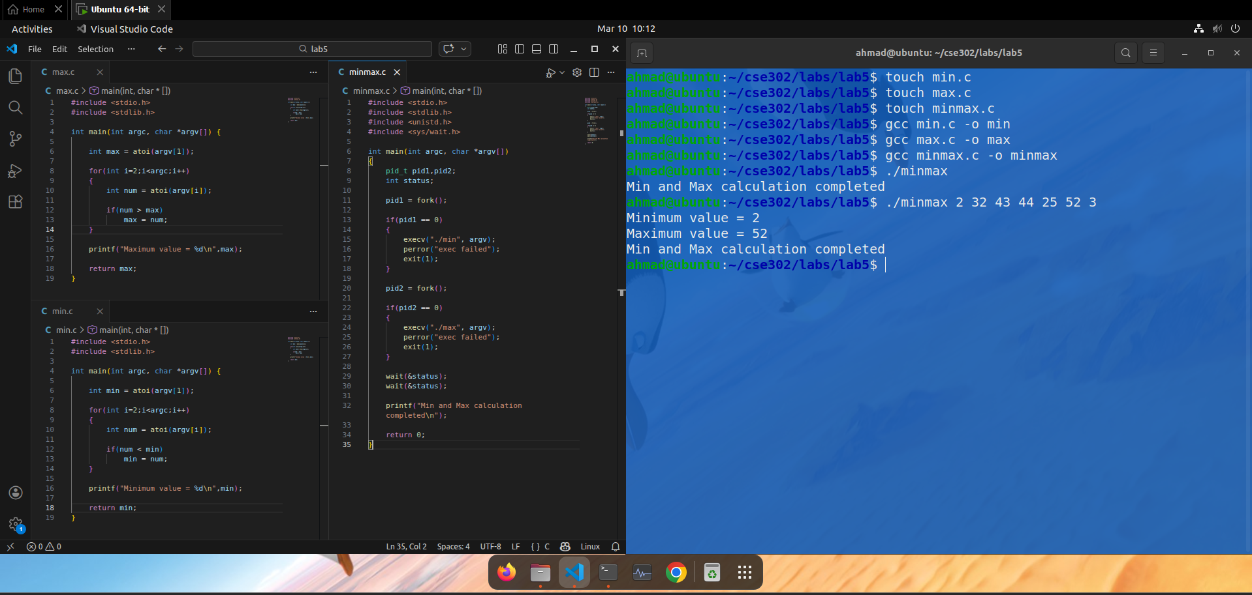4. Lab Task 2

Sum of Squares Using Child Process

Objective
To create a child process that calculates the sum of squares of integers and returns the result to the parent.

Program: sumsquare.c
#include <stdio.h>
#include <stdlib.h>
#include <unistd.h>
#include <sys/wait.h>

int main(int argc, char *argv[])
{
pid_t pid;
int sum = 0;

pid = fork();

if(pid == 0)
{
for(int i=1;i<argc;i++)
{
int num = atoi(argv[i]);
sum += num * num;
}

printf("Child: Sum of Squares = %d\n",sum);
exit(sum);
}
else
{
int status;
wait(&status);

if(WIFEXITED(status))
{
printf("Parent received result = %d\n",WEXITSTATUS(status));
}
}

return 0;
}

Compilation
gcc sumsquare.c -o sumsquare

Execution
./sumsquare 2 3 4
Example Output

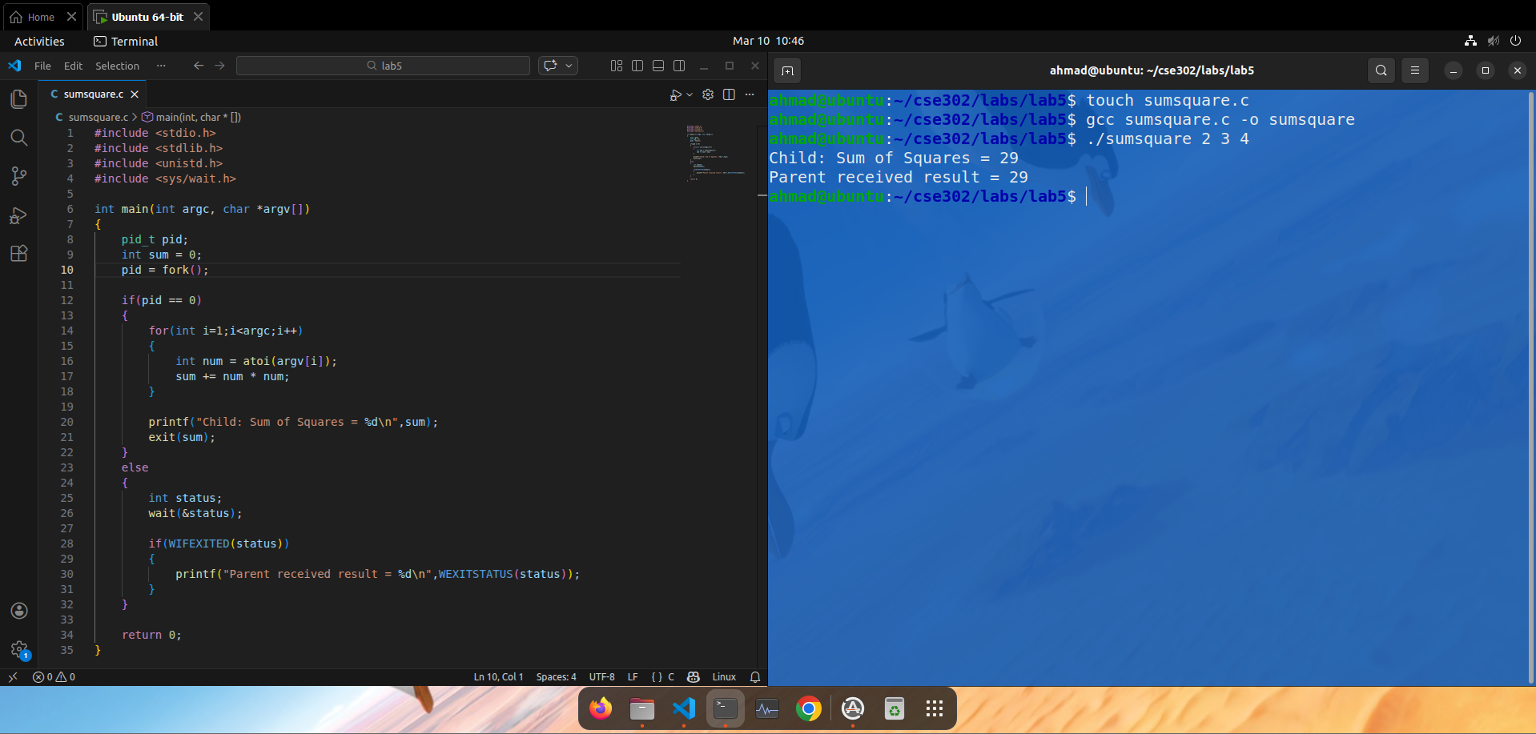Explanation
- Parent creates a child process
- Child calculates square of each number
- Adds them together
- Returns result using exit()
- Parent receives result using wait()

5. Lab Task 3

Demonstration of exec() Functions

Objective
To demonstrate different exec() functions with multiple child processes.

Program: execdemo.c
#include <stdio.h>
#include <stdlib.h>
#include <unistd.h>
#include <sys/wait.h>

int main()
{
pid_t pid1,pid2;

pid1 = fork();

if(pid1 == 0)
{
char *env[] = {"MYVAR=HELLO",NULL};
execle("/usr/bin/env","env",NULL,env);
perror("execle failed");
exit(1);
}

pid2 = fork();

if(pid2 == 0)
{
execlp("ls","ls","-l",NULL);
perror("execlp failed");
exit(1);
}

wait(NULL);
wait(NULL);

printf("Both child processes finished\n");

return 0;
}

Compilation
gcc execdemo.c -o execdemo

Run
./execdemo
Example Output

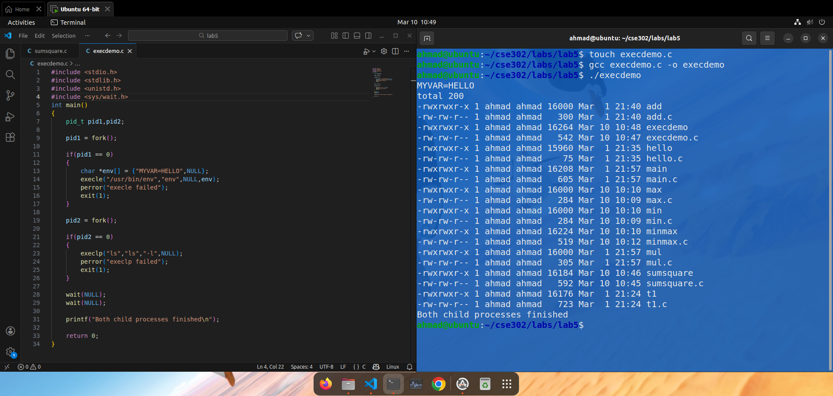Explanation
The program:
Child 1:
- Executes env command
- Uses execle()
- Passes a custom environment variable
Child 2:
- Executes ls command
- Uses execlp()
- Searches command using system PATH
Parent process waits for both children to complete.

Conclusion
In this lab, we studied process creation and execution in Linux using fork() and exec() functions. We learned how a child process can replace its program using different exec() functions. We implemented programs for minimum and maximum calculation, sum of squares, and execution of Linux commands using child processes.
The lab demonstrated how multiple processes can work together and how the parent process can synchronize with children using wait(). These concepts are essential for understanding process management, program execution, and multitasking in Linux systems.

