System Software

There are two broad categories of software: System Software and Application Software.
System Software is a set of programs that manage the resources of a computer system. System Software is a collection of system programs that perform a variety of functions. Such as File Editing, Resource Accounting, I/O Management, Storage, Memory Management, and Access management.
System Software can be broadly classified into three types as: 1. System Control Programs 2. System Support, and 3. System development Program.
- System control programs controls the execution of programs, manage the storage processing resources of the computer & perform other management & monitoring function. The most important of these programs is the operating system. Other examples are database management systems (DBMS) & communication monitors.
- System support programs provide routine service functions to the other computer programs & computer users: E.g. Utilities, libraries, performance monitors & job accounting.
- System development programs assists in the creation of application programs. E.g., language translators such as BASIC interpreter & application generators.
Application Software:
It performs specific tasks for the computer user. Application software is a program which program written for, or, by, a user to perform a particular job. Languages already available for microcomputers include Clout, Q & A and Savvy ret rival (for use with Lotus 1-2-3).The use of natural language touches on expert systems, computerized collections of the knowledge of many human experts in a given field, and artificial intelligence, independently smart computer systems. General-purpose application software such as electronic spreadsheet has a wide variety of applications. Specific – purpose application s/w such as payroll & sales analysis is used for the application for which it is designed Application programmer writes these programs. Application programmer writes these programs.
How does the user interact with computer?
Generally computer users interact with application software. Application and system software act as interface between users & computer hardware. If an application & system software become more capable, people find computer easier to use.
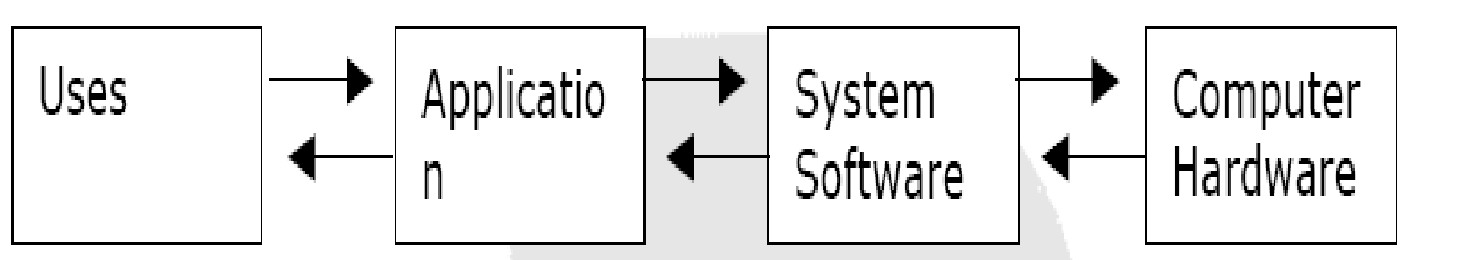

The Interaction between Users, Application Software, System Software & Computer Hardware:

System Software controls the execution of the application software & provides other support functions such as data storage. E.g. when you use an electronic spreadsheet on the computer, MS-DOS, the computer’s Operating System, handles the storage of the worksheet files on disk.
The language translators and the operating system are themselves programs. Their function is to get the users program, which is written, in a programming language to run-on the computer system. All such Programs, which help in the execution of user programs, are called system programs (SPs). The collection of such SPs is the “System Software” of a particular computer system. Most computer systems have support software, called Utility Programs, which perform routine tasks. These programs sort data, copy data from one storage medium to another, control data from a storage medium to printer & perform other tasks.
The data execution at a specified starting address.

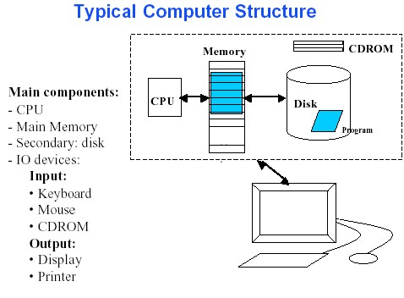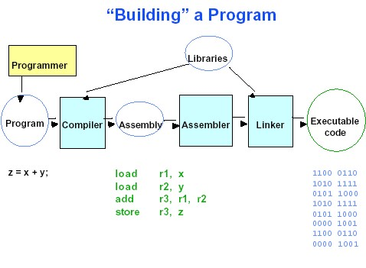
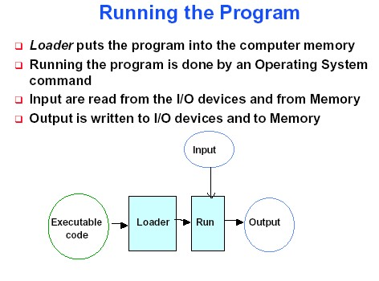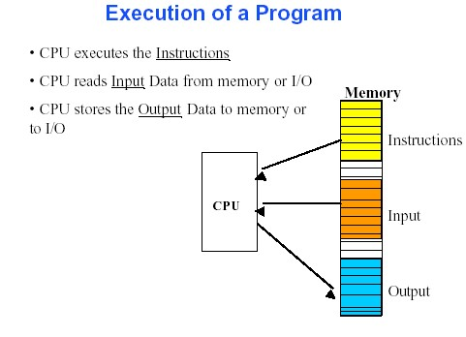
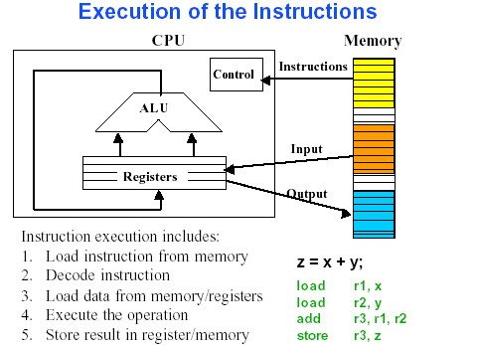

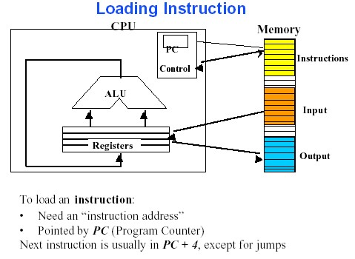

System Development Software:
System Development Software assists a programmer in developing & using an application program.
E.g. Language Translators, Linkage Editors, and Application generators
Language Translators:
A language translator is a computer program that converts a program written in a procedural language (PL) such as BASIC into machine language that can be directly executed by the computer. Computers can execute only machine language programs. Programs written in any other language must be translated into a machine language load module, which is suitable for loading directly into primary storage. Subroutine or subprograms, which are stored on the system residence device to perform a specific standard function. E.g. if a program required the calculation of a square root, Programmer would not write a special program. He would simply call a square root, subroutine to be used in the program.
Translators for a low-level programming language were assemblers
Language processors: Language Processing activities arise due to the differences between the manner in which a software designer describes the ideas concerning the behavior of a software and the manner in which these ideas are implemented in a computer system. The interpreter is a language translator. This lead to many similarities between Translators and interpreters. From a practical viewpoint many differences also exist between them. The absence of a target program implies the absence of an output interface in the interpreter. Thus the language processing activities of an interpreter cannot be separated from its program execution activities. Hence we say that an interpreter 'executes' a program written in a procedural language (PL).
Problem Oriented and Procedure Oriented Languages:
The three consequences of the semantic gap mentioned at the start of this section are in fact the consequences of a specification gap. Software systems are poor in quality and require large amounts of time and effort to develop due to difficulties in bridging the specification gap. A classical solution is to develop a PL such that the PL domain is very close or identical to the application domain. Such PLs can only be used for specific applications; hence they are called problem-oriented languages. They have large execution gaps, however this is acceptable because the gap is bridged by the translator or interpreter and does not concern the software designer.
A procedure-oriented language provides general purpose facilities required in most application domains. Such a language is independent of specific application domains.
The fundamental language processing activities can be divided into those that bridge the specification gap and those that bridge the execution gap. We name these activities as 1. Program generation activities and 2. Program execution activities.
A program generation activity aims at automatic generation of a program. The source languages specification language of an application domain and the target language is typically a procedure oriented PL. A Program execution activity organizes the execution of a program written in a PL on computer system. Its source language could be a procedure-oriented language or a problem oriented language. Program Generation
The program generator is a software system which accepts the specification of a program to be generated, and generates a program in the target PL. In effect, the program generator introduces a new domain between the application and PL domains we call this the program generator domain. The specification gap is now the gap between the application domain and the program generator domain. This gap is smaller than the gap between the application domain and the target PL domain.
Reduction in the specification gap increases the reliability of the generated program. Since the generator domain is close to the application domain, it is easy for the designer or programmer to write the specification of the program to be generated. The harder task of bridging the gap to the PL domain is performed by the generator. This arrangement also reduces the testing effort. Proving the correctness of the pro-gram generator amounts to proving the correctness of the transformation. This would be performed while implementing the generator. To test an application generated by using the generator, it is necessary to only verify the correctness of the specification input to the program generator. This is a much simpler task than verifying correctness of the generated program. This task can be further simplified by providing a good diagnostic (i.e. error indication) capability in the program generator, which would detect inconsistencies in the specification.
It is more economical to develop a program generator than to develop a problem-oriented language. This is because a problem oriented language suffers a very large execution gap between the PL domain and the execution domain whereas the program generator has a smaller semantic gap to the target PL domain, which is the domain of a standard procedure oriented language. The execution gap between the target PL domain and the execution domain is bridged by the compiler or interpreter for the PL.
Program Execution: Two popular models for program execution are translation and interpretation.
Program translation: The program translation model bridges the execution gap by translating a program written in a PL, called the source program (SP), into an equivalent program in the machine or assembly language of the computer system, called the object program or target program (TP). Characteristics of the program translation model are:
A program must be translated before it can be executed.
- The translated program may be saved in a file. The saved program may be executed repeatedly.
- A program must be retranslated following modifications.
Program interpretation
The interpreter reads the source program and stores it in its memory. During interpretation it takes a source statement, determines its meaning and performs actions which implement it. This includes computational and input-output actions. The CPU uses a program counter (PC) to note the address of the next instruction to be executed. This instruction is subjected to the instruction execution cycle consisting of the following steps:
- Fetch the instruction: Fetch the statement
- Decode the instruction to determine the operation to be performed, and also its operands. Analyze the statement and determine its meaning, viz. the computation to be performed and its operands.
- Execute the instruction.
At the end of the cycle, the instruction address in PC is updated and the cycle is repeated for the next instruction. Program interpretation can proceed in an analogous manner. Thus, the PC can indicate which statement of the source program is to be interpreted next. This statement would be subjected to the interpretation cycle, which could consist of the following steps:
- Execute the meaning of the statement from this analogy, we can identify the following characteristics of interpretation: The source program is retained in the source form itself, i.e. no target program form exists, A statement is analyzed during its interpretation.
- Comparison: A fixed cost (the translation overhead) is incurred in the use of the program translation model. If the source program is modified, the translation cost must be incurred again irrespective of the size of the modification. However, execution of the target program is efficient since the target program is in the machine language. Use of the interpretation model does not incur the translation overheads. This is advantageous if a program is modified between executions, as in program testing and debugging.
FUNDAMENTALS OF LANGUAGE PROCESSING
- Lexical rules, which govern the formation of valid lexical units in the source language.
- Syntax rules which govern the formation of valid statements in the source language.
- Semantic rules which associate meaning with valid statements of the language.
The analysis phase uses each component of the source language specification to determine relevant information concerning a statement in the source program. Thus, analysis of a source statement consists of lexical, syntax and semantic analysis.
The synthesis phase is concerned with the construction of target language statement(s) which have the same meaning as a source statement. Typically, this consist of two main activities: • Creation of data structures in the target program • Generation of target code.
We refer to these activities as memory allocation and code generation, respectively
Lexical Analysis (Scanning)
Lexical analysis identifies the lexical units in a source statement. It then classifies the units into different lexical classes e.g. id’s, constants etc. and enters them into different tables. This classification may be based on the nature of string or on the specification of the source language. (For example, while an integer constant is a string of digits with an optional sign, a reserved id is an id whose name matches one of the reserved names mentioned in the language specification.) Lexical analysis builds a descriptor, called a token, for each lexical unit. A token contain two fields— class code, and number in class, class code identifies the class to which a lexical unit belongs, number in class is the entry number of the lexical unit in the relevant table.
Syntax Analysis (Parsing)
Syntax analysis processes the string of tokens built by lexical analysis to determine the statement class, e.g. assignment statement, if statement, etc. It then builds an IC which represents the structure of the statement. The IC is passed to semantic analysis to determine the meaning of the statement.
Semantic analysis
Semantic analysis of declaration statements differs from the semantic analysis of imperative statements. The former results in addition of information to the symbol table, e.g. type, length and dimensionality of variables. The latter identifies the sequence of actions necessary to implement the meaning of a source statement. In both cases the structure of a source statement guides the application of the semantic rules. When semantic analysis determines the meaning of a sub tree in the IC. It adds information a table or adds an action to the sequence. It then modifies the IC to enable further semantic analysis. The analysis ends when the tree has been completely processed.
FUNDAMENTALS OF LANGUAGE SPECIFICATION
A specification of the source language forms the basis of source program analysis. In this section, we shall discuss important lexical, syntactic and semantic features of a programming language. Programming Language Grammars
The lexical and syntactic features of a programming language are specified by its grammar. This section discusses key concepts and notions from formal language grammars. A language L can be considered to be a collection of valid sentences.
Each sentence can be looked upon as a sequence of words, and each word as a sequence of letters or graphic symbols acceptable in L. A language specified in this manner is known as a. formal language. A formal language grammar is a set of rules which precisely specify the sentences of L. It is clear that natural languages are not formal languages due to their rich vocabulary. However, PLs are formal languages.
Terminal symbols, alphabet and strings
The alphabet of L, denoted by the Greek symbol Z, is the collection of symbols in its character set. We will use lower case letters a, b, c, etc. to denote symbols in Z.
A symbol in the alphabet is known as a terminal symbol (T) of L. The alphabet can be represented using the mathematical notation of a set, e.g. Σ {a, b, ...z, 0,1....9} Here the symbols {, ',' and} are part of the notation. We call them met symbols to differentiate them from terminal symbols. Throughout this discussion we assume that met symbols are distinct from the terminal symbols. If this is not the case, i.e. if a terminal symbol and a met symbol are identical, we enclose the terminal symbol in quotes to differentiate it from the Meta symbol. For example, the set of punctuation symbols of English can be defined as {:,;’,’-,...} Where ',' denotes the terminal symbol 'comma'. A string is a finite sequence of symbols. We will represent strings by Greek symbols-α β γ, etc. Thus α = axy is a string over Σ. The length of a string is the Number of symbols in it. Note that the absence of any symbol is also a string, the null string. The concatenation operation combines two strings into a single string.
To evaluate an HLL program it should be converted into the Machine language. A compiler performs another very important function. This is in terms of the diagnostics. I.e. error – detection capability.
The important tasks of a compiler are: Translating the HLL program input to it.
Providing diagnostic messages whenever specifications of the HLL
Compilers
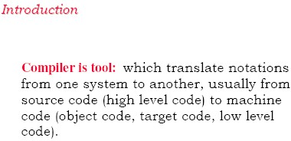
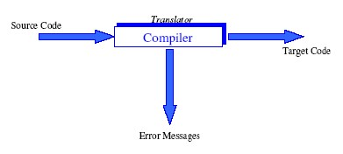

- A compiler is a program that translates a sentence
  - from a source language (e.g. Java, Scheme, LATEX)
  - into a target language (e.g. JVM, Intel x86, PDF)
  - while preserving its meaning in the process
- Compiler design has a long history (FORTRAN 1958)
  - lots of experience on how to structure compilers
  - lots of existing designs to study (many freely available)
  - take the course “Compiler Design” for some of the details. . .
We use natural language to communicate and we use programming languages to speak with computers.
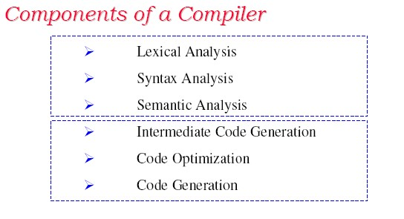

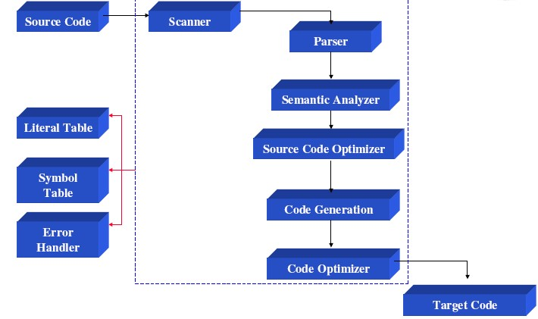
The Scanner: (a). performs Lexical Analysis (b) Collect character sequences into tokens. Example:
a [index] = 4+2, to convert this statement into token by the Scanner is:
Tokens: a identifier
[ left bracket
Index identifier
] right bracket
= equal sign
4 number
+ plus sign
2 number
The scanner may also:
- enter identifiers into the symbol tables
- enter literals (numeric constants and strings) into the literals tables
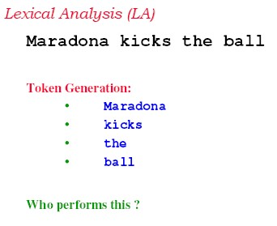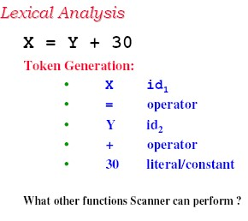

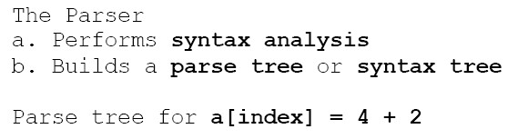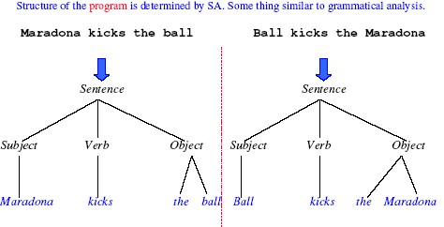



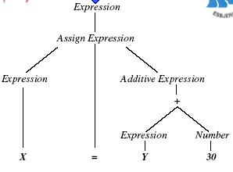

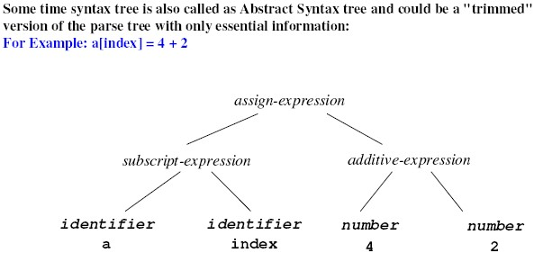

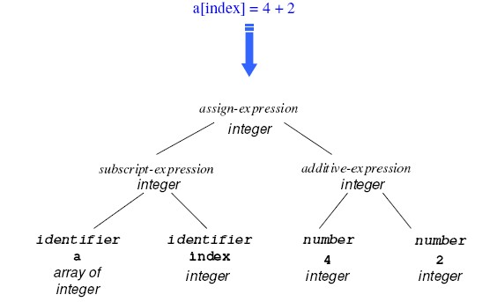

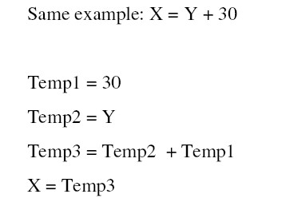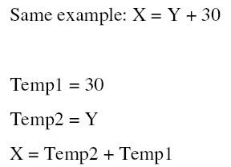

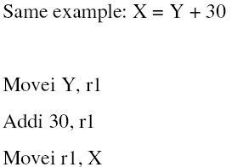

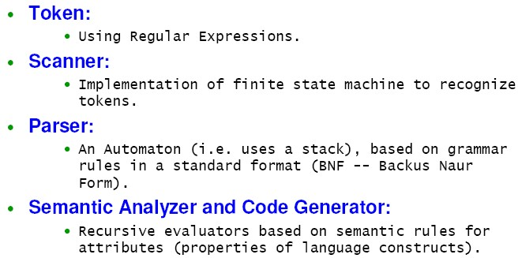

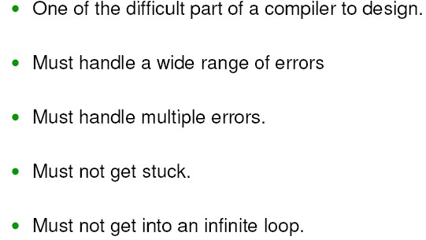

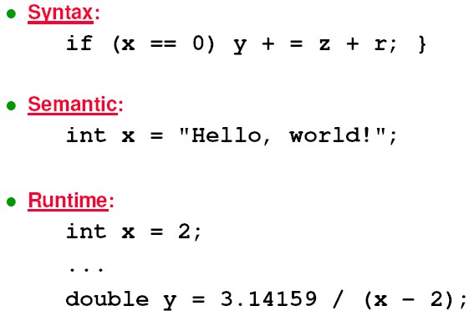

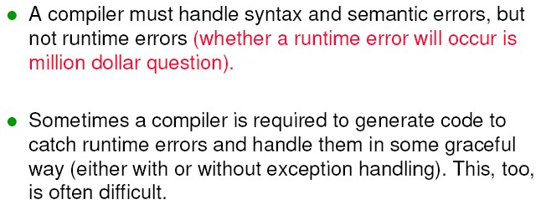

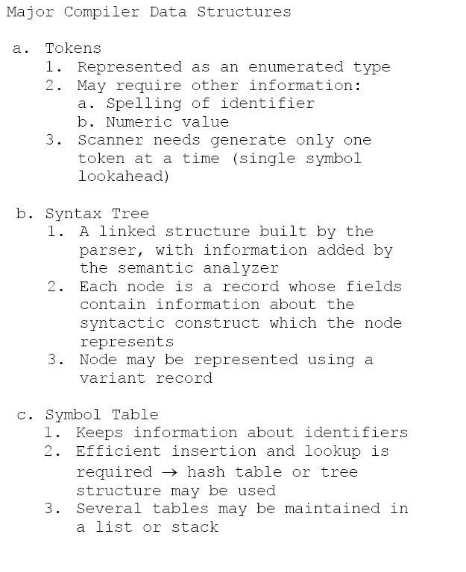

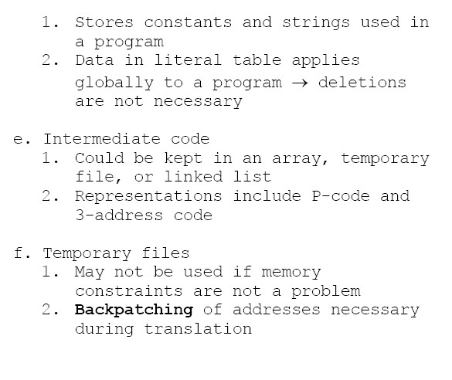

Introduction to Assemblers and Assembly Language

Encoding instructions as binary numbers is natural and efficient for computers. Humans, however, have a great deal of difficulty understanding and manipulating these numbers. People read and write symbols (words) much better than long sequences of digits. This lecture describes the process by which a human-readable program is translated into a form that a computer can execute, provides a few hints about writing assembly programs, and explains how to run these programs on SPIM,
What is an assembler?
A tool called an assembler translates assembly language into binary instructions. Assemblers provide a friendlier representation than a computer’s 0s and 1s that simplifies writing and reading programs. Symbolic names for operations and locations are one facet of this representation. Another facet is programming facilities that increase a program’s clarity.
An assembler reads a single assembly language source file and produces an object file containing machine instructions and bookkeeping information that helps combine several object files into a program. Figure (1) illustrates how a program is built. Most programs consist of several files—also called modules— that are written, compiled, and assembled independently. A program may also use prewritten routines supplied in a program library. A module typically contains References to subroutines and data defined in other modules and in libraries. The code in a module cannot be executed when it contains unresolved References to labels in other object files or libraries. Another tool, called a linker, combines a collection of object and library files into an executable file, which a computer can run.

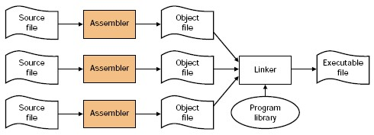
FIGURE 1: The process that produces an executable file. An assembler translates a file of assembly language into an object file, which is linked with other files and libraries into an executable file.
- Assembler = a program to handle all the tedious mechanical translations

- Allows you to use:
  - symbolic opcodes
  - symbolic operand values
  - symbolic addresses

- The Assembler
  - keeps track of the numerical values of all symbols
  - translates symbolic values into numerical values

4) Time Periods of the Various Processes in Program Development

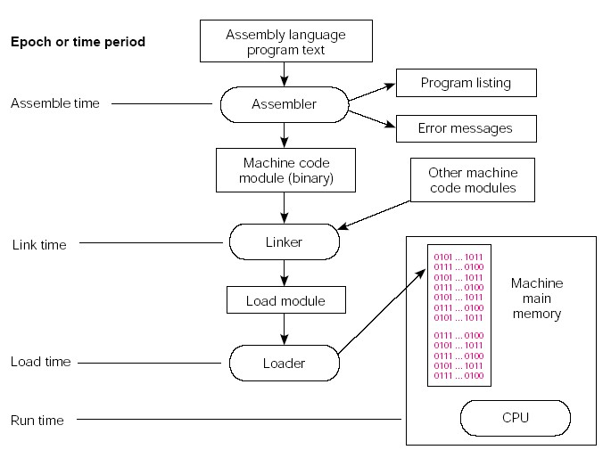

5) The Assembler Provides:
- Access to all the machine’s resources by the assembled program. This includes access to the entire instruction set of the machine.
- A means for specifying run-time locations of program and data in memory.
- Provide symbolic labels for the representation of constants and addresses.
- Perform assemble-time arithmetic.
- Provide for the use of any synthetic instructions.
- Emit machine code in a form that can be loaded and executed.
- Report syntax errors and provide program listings
- Provide an interface to the module linkers and program loader.
- Expand programmer defined macro routines.

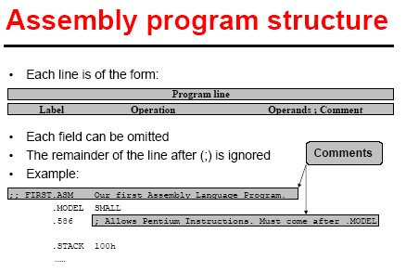

Disadvantages of Assembly
- Programmer must manage movement of data items between memory locations and the ALU.
- Programmer must take a “microscopic” view of a task, breaking it down to manipulate individual memory locations.
- Assembly language is machine-specific.
- statements are not English-like (Pseudo-code)

Linker & Loader
A software processor, which performs some low level processing of the programs input to it, produces a ready to execute program form. The basic loading function is that of locating a program in an appropriate area of the main store of a computer when it is to be executed. A loader often performs the two other important functions.
The loader, which accepts the program form, produced by a translator & certain other program forms from a library to produce one ready – to – execute machine language program. A unit of input to the loader is known as an object program or an object module. The process of merging many object modules to from a single machine language program is known as linking.
The function to be performed by: Assigning of loads the storage area to a program. Loading of a program into the assigned area. Relocations of a program to execute properly from its load-time storage area. Linking of programs with one another. Loader, linking loaders, linkage editors are used in software literature
LOADER:
The loader is program, which accepts the object program decks, prepares this program for execution by the computer and initializes the execution. In particular the loader must perform four functions: Allocate space in memory for the program (allocation). Resolve symbolic references between objects decks (linking). Adjust all address dependent locations, such as address constants, to correspond to the allocated space (relocation). Physically place the machine instructions and data into memory (loading).
Operating System

Evolution of OS Functions
Functions of OS: Operating System: “An operating system provides interface between the user & the hardware.” It can be basically classified into: 1. Resource Allocation & Related Functions. 2. User Interface Functions.
The Resource Allocation function implements resources sharing by the users of a computer system. Basically it performs binding of a set of resources with the requesting program-that is it associates resources with a program. The related functions implement protection of users sharing a set of resources against mutual interference.
Resource Allocation & Related Functions:
The resource allocation function allocates resources for use by a user’s computation. Resources can be divided into two types: 1. System Provided Resources – like CPU, memory and IO devices 2 User created Resources – like files etc.
Resource allocation depends on whether a resource is a system resource or a user created resource. There are two popular strategies for resource allocation: 1. Partitioning of resources Allocation from a pool: Using resource partition approach, OS decides priori what resources should be allocated to a user computation. This is known as static allocation as the allocation is made before the execution of the program starts.
2. Using pool allocation approach, OS maintains a common pool & allocates resources from this pool on a need basis. This is called dynamic allocation because it takes place during the execution of program. It can lead to better utilization of resources because the allocation is made when a program request a resource.
An OS can use a resource table as a central data structure for resource allocation. The table contains an entry for each resource unit in the system. The entry contains the name or address of the resource unit and its present system i.e whether it is free or allocated to some program. When a program raises a request for a resource, the resource should be allocated to it if it is presently free.
In the partition resource allocation approach, the OS decides on the resources to be allocated to a program based on the number of the program in the system. For Example, an OS may decide that a program can be allocated 1 MB of memory, 200 disk blocks and a monitor. Such a collection of resources is referred to as a partition. The resource table can have an entry for each resource partition. When a new program is to be started, an available partition is allocated to it.
User Interface Functions:
Its purpose is to provide the use of OS resources for processing a user’s computational requirements. OS user interfaces use command languages. For this, the user uses Command to set up an appropriate computational structure to fulfill his computational requirements.
An OS can define a variety of computational structures. A sample list of computational structures is as follows:
- A single program
- A sequence of single program
- A collection of programs
The single program consist the execution of a program on a given set of data. The user initiates execution of the program through a command. Two kinds of program can exist – Sequential and concurrent. A sequential program is the simplest computational structure. In concurrent program the OS has to be aware of the identities of the different parts, which can execute concurrently.
Evolution of OS Functions:
Operating System functions have evolved in response to the following considerations and issues.
- Efficient utilization of computing resources
- New features in computer Architecture
- New user requirements.
Different operating systems address these issues in different manner, however most operating system contains components, which have similar functionalities. For example, all operating systems contain components for functions of memory management, process management and protection of users from one another. The techniques used to implement these functions may vary from one OS to another, but the fundamental concept is same.
Process: A process is execution of a program or a part of a program.
Job: A job is computational structure, which is a sequence of program.
Types of Operating Systems:

- Batch Processing system
- Multiprogramming system
- Time sharing system
- Real time operating system
- Distributed systems
Batch Processing Systems: When Punch cards were used to record user jobs, processing of a job involved physical actions by the system operator e.g. loading a deck of cards into the card reader, pressing switches on the computer’s console to initiate the job. These actions wasted a lot of CPU time. BP was introduced to avoid this wastage. A batch is a sequence of user jobs. A computer operator forms a batch by arranging user jobs in a sequence and inserting special marker cards to indicate the start and end of the batch. After forming a batch, the operator submits it to the batch processing operating system. The primary function of the BP system is to implement the processing of the jobs in a batch. Batch processing is implemented by locating a component of the BP system called the batch monitor or supervisor, permanently in one part of the computer’s memory.
The remaining memory is used to process a user job the current job in the batch. The batch monitor is responsible for implementing the various function of the batch processing system. It accepts a command from the system operator for initiating the processing of a batch and sets up the processing of the first job of the batch. At the end of the job, it performs job termination processing and initiates execution of the batch; it performs batch termination processing system and awaits initiation of the next batch by the operator.
The part of memory occupied by the batch monitor is called the system area and the part occupied by the user job is called the user area.
User Service: A user evaluates the performance of an os on the basis of the service accorded to his or her job. The notion of turn-around time is used to quantity user service in a batch processing system. Note: The turnaround time of a user job is the time since its submission to the time its results become available to the user
Batch processing does not guarantee improvements in the turnaround time of jobs. Batch processing does not aim at improving user services-it aims at improving CPU utilization.
Batch Monitor Functions: The basic task of the batch monitor is to exercise effective control Over the BP environment. This task can be classified into the following three functions. (a) Scheduling (b) Memory Management and (c) Sharing and Protection
The batch monitor performs two functions before initiating the execution of a job. The third function is performed during the execution of a job. In Batch Processing System, The CPU Of The Computer System Is The Server And The User Jobs Are The Service Requests. The Nature Of Batch Processing Dictates The Use Of The First Come First Serve(FCFS) Scheduling. The Batch Monitor Performs Scheduling By Always Selecting The Next Job In The Batch For Execution.
Scheduling Does Not Influence The User Services In The BP System Because The Turn Around Time Of Each Job In A Batch Is Subject To Some Other Factors.
At any time during a BP system’s operation, the memory is divided into the system area and the user area. The user area of the memory is sequentially shared by the jobs in the batch.
Multiprogramming System: Early computer systems implemented IO operation as CPU instructions. It sent a signal to the card reader to read a card and waited for the operation to complete before initiating the next operation. However the speeds of operation of IO devices were much lower than the speed of the CPU. Programs took long to complete their execution. A new feature was introduced in the machine architecture when this weakness was realized. This feature permitted the CPU to delink itself from an IO operation so that it could execute instructions while an IO operation was in progress. Thus the CPU and the IO device could now operate concurrently. If many user programs exist in the memory, the CPU can execute instructions of one program while the IO subsystem is busy with an IO operation for another program. The term multiprogramming is used to describe this arrangement. At any moment the program corresponding to the current job step of each job is in execution. The IO device and memory are allocated using the partitioned resource allocation approach. At any time, the CPU and IO subsystem are busy with programs belonging to different jobs. Thus they access different areas of memory. In principle the CPU and IO subsystem could operate on the same program. Each job in the memory could be current job of a batch of jobs. Thus one could have both batch processing and multiprogramming supervisor. Analogous to a BP supervisor, the MP supervisor also consists of a permanently resident part and a transient part.
The multiprogramming arrangement ensures concurrent operation of the CPU and the IO subsystem without requiring a program to use the special buffering techniques. It simply ensures that the CPU is allocated to a program only when it is not performing an IO operation.
Functions of the Multiprogramming Supervisor: (a) Scheduling (b) Memory Management and (c) IO management.
The MP supervisor uses simple techniques to implement its functions. Function like scheduling implies sharing of the CPU between the jobs existing in the MP system. This function is performed after servicing every interrupt using a simple priority based scheme described in the next section. The allocation of memory and IO devices is performed by static partitioning of resources. Thus a part of memory and some IO devices are allocated to each job. It is necessary to protect the data and IO operations of one program from interference by another program. This is achieved by using memory protection hardware and putting CPU in non-privileged mode while executing a user program. Any effort by a user program to access memory locations situated outside its memory area now leads to an interrupt. The interrupting processing routines for these interrupts simply terminates the program causing the interrupt.
Scheduling: The goal of multiprogramming is to exploit the concurrency of operation between the CPU and IO subsystem to achieve high levels of system utilization. A useful characterization of system utilization is offered by throughput of a system.
1. Throughput: The throughput of a system is the number of programs processed by it per unit time.
Throughput = Number of programs completed
Total time taken to optimize the throughput, a MP system uses the following concepts:
A proper mix of programs: For good throughput it is important to keep both the CPU and IO subsystems busy. A CPU bound program is a program involving a lot of computation and very little IO. It uses the CPU for a long time. An IO bound program is a program involving very little computation and a lot of IO.
2. Preemptive and priority based scheduling: Scheduling is priority based that is the CPU is always allocated to the highest priority programs. The Scheduling is preemptive the is a low priority program executing on the CPU is preempted if a higher priority program wishes to use the CPU.
3. Degree of multiprogramming: Degree of multiprogramming is the number of programs existing simultaneously in the system’s memory.
Deadlocks: Processes compete for physical and logical resources in the system (e.g. disks or files). Deadlocks affect the progress of processes by causing indefinite delays in resource allocation. Such delays have serious consequences for the response times of processes, idling and wastage of resources allocated to processes, and the performance of the system. Hence an OS must use resource allocation policies, which ensure an absence of deadlocks. This chapter characterizes the deadlock problem and describes the policies an OS can employ to ensure an absence of deadlocks.
DEFINITIONS
We define three events concerning resource allocation:
- Resource request: A user process requests a resource prior to its use. This is done through an OS call. The OS analyses the request and determines whether the requested resource can be allocated to the process immediately. If not. The process remains blocked on the request till the resource is allocated.
- Resource allocation: The OS allocates are source to a requesting process. The resource status information is updated and the state of the process is changed to ready. The process now becomes the holder of the resource.
- Resource release: After completing resource usage, a user process releases the resource through an OS call. If another process is blocked on the resource, OS allocates the resource to it. If several processes are blocked on the resource, the OS uses some tie-breaking rule, e.g. FCFS allocation or allocation according to process priority, to perform the allocation.
Deadlock: A deadlock involving a set of processes D is a situation in which 1.Every process pi in D is blocked on some event ei Event ei can only be caused by some process (es) in D. If the event awaited by each process in D is the granting of some resource, it results in a resource deadlock. A communication deadlock occurs when the awaited events pertain to the receipt of inter-process messages, and synchronization deadlock when the awaited events concern the exchange of signals between processes. An OS is primarily concerned with resource deadlocks because allocation of resources is an OS responsibility. The other two forms of deadlock are seldom tackled by an OS.
HANDLING DEADLOCKS
Two fundamental approaches used for handling deadlocks are: 1 Detection and resolution of deadlocks and 2. Avoidance of deadlocks.
In the former approach, the OS detects deadlock situations as and when they arise. It then performs some actions aimed at ensuring progress for some of the deadlocked processes. These actions constitute deadlock resolution. The latter approach focuses on avoiding the occurrence of deadlocks. This approach involves checking each resource request to ensure that it does not lead to a deadlock. The detection and resolution approach does not perform any such checks. The choice of the deadlock handling approach would depend on the relative costs of the approach, and its consequences for user processes.
DEADLOCK DETECTION AND RESOLUTION
The deadlock characterization developed in the previous section is not very useful in practice for two reasons. First, it involves the overheads of building and maintaining an RRAG. Second, it restricts each resource request to a single resource unit of one or more resource classes. Due to these limitations, deadlock detection cannot be implemented merely as the determination of a graph property. For a practical implementation, the definition can be interpreted as follows: A set of blocked processes
D is deadlocked if there does not exist any sequence of resource allocations and resource releases in the system whereby each process in D can complete. The OS must determine this fact through exhaustive analysis.
Deadlock analysis is performed by simulating the completion of a running process. In the simulation it is assumed that a running process completes without making additional resource requests. On completion, the process releases all resources allocated to it. These resources are allocated to a blocked process only if the process can enter the running state. The simulation terminates in one of two situations—either all blocked processes become running and complete, or some set B of blocked processes cannot be allocated their requested resources. In the former case no deadlock exists in the system at the time when deadlock analysis is performed, while in the latter case processes in B are deadlocked. Deadlock Resolution
Given a set of deadlocked processes D, deadlock resolution implies breaking the deadlock to ensure progress for some processes {pi} £ D. This can be achieved by satisfying the resource request of a process pi in one of two ways:
1. Terminate some processes {pj} e D to free the resources required by pi. (We call each pj a victim of deadlock resolution.) 2. Add a new unit of the resource requested by pi. Note that deadlock resolution only ensures some progress for pi. It does not guarantee that a pi would run to completion. That would depend on the behaviour of processes after resolution.
CP/M
Control Program/Microcomputer. An operating system created by Gary Kildall, the founder of Digital Research. Created for the old 8-bit microcomputers that used the 8080, 8085, and Z-80 microprocessors. Was the they may be dynamically reassigned among a collection of active programs in different stages of execution.
Several variations of both serial and multiprogrammed operating systems exist.
Characteristics of mainframe systems
- The first computers used to tackle various applications and still found today in corporate data centers.
- Room-sized, high I/O capacity, reliability, security, technical support.
- Mainframes focus on I/O bound business data applications. Mainframes provide three main functions:
- Batch processing: insurance claims, store sales reporting, etc.
- Transaction processing: credit card, bank account, etc. c. Time-sharing: multiple users querying a database. Batch Systems
- Some computer systems only did one thing at a time. They had a list of instructions to carry out and these would be carried out one after the other. This is called a serial system. The mechanics of development and preparation of programs in such environments are quite slow and numerous manual operations involved in the process.
- Batch operating system is one where programs and data are collected together in a batch before processing starts. A job is predefined sequence of commands, programs and data that are combined into a single unit called job.
- Memory management in batch system is very simple. Memory is usually divided into two areas: Operating system and user program area. Resident portion
- Scheduling is also simple in batch system. Jobs are processed in the order of submission i.e. first come first served fashion.
- When a job completes execution, its memory is released and the output for the job gets copied into an output spool for later printing.
- Spooling an acronym for simultaneous peripheral operation on line. Spooling uses the disk as a large buffer for outputting data to printers and other devices. It can also be used for input, but is generally used for output. Its main use is to prevent two users from alternating printing lines to the line printer on the same page, getting their output completely mixed together. It also helps in reducing idle time and overlapped I/O and CPU.
- Batch system often provides simple forms of file management. Access
·to file is serial. Batch systems do not require any time critical device management.
- Batch systems are inconvenient for users because users can not interact with their jobs to fix problems. There may also be long turnaround times. Example of this system is generating monthly bank statement.

Spooling:
- Acronym for simultaneous peripheral operations on line. Spooling refers to putting jobs in a buffer, a special area in memory or on a disk where a device can access them when it is ready.
- Spooling is useful because device access data at different rates. The buffer provides a waiting station where data can rest while the slower device catches up.
- Computer can perform I/O in parallel with computation, it becomes possible to have the computer read a deck of cards to a tape, drum or disk and to write out to a tape printer while it was computing. This process is called spooling.
- The most common spooling application is print spooling. In print spooling, documents are loaded into a buffer and then the printer pulls them off the buffer at its own rate.
- Spooling is also used for processing data at remote sites. The CPU sends the data via communications path to a remote printer. Spooling overlaps the I/O of one job with the computation of other jobs.
- One difficulty with simple batch systems is that the computer still needs to read the deck of cards before it can begin to execute the job. This means that the CPU is idle during these relatively slow operations. • Spooling batch systems were the first and are the simplest of the multiprogramming systems.
Advantages of Spooling:
- The spooling operation uses a disk as a very large buffer.
- Spooling is however capable of overlapping I/O operation for one job with processor operations for another job.
Advantages of Batch System:
- Move much of the work of the operator to the computer.
- Increased performance since it was possible for job to start as soon as the previous job finished.
Disadvantages of Bach System:
- Turnaround time can be large from user standpoint.
- Difficult to debug program.
- A job could enter an infinite loop.
- A job could corrupt the monitor, thus affecting pending jobs.
- Due to lack of protection scheme, one batch job can affect pending jobs.

Multiprogramming Operating System: When two or more programs are in memory at the same time, sharing the processor is referred to the multiprogramming operating system. Multiprogramming assumes a single processor that is being shared. It increases CPU utilization by organizing jobs so that the CPU always has one to execute.
- The operating system keeps several jobs 111 memory at a time. This set of jobs is a subset of the jobs kept in the job pool. The operating system picks and begins to execute one of the job in the memory.
- Multiprogrammed systems provide an environment in which the various system resources are utilized effectively, but they do not provide for user interaction with the computer system.
- Jobs entering into the system are kept into the memory. Operating system picks the job and begins to execute one of the jobs in the memory. Having several programs in memory at the same time requires some form of memory management.
- Multiprogramming operating system monitors the state of all active programs and system resources. This ensures that the CPU is never idle unless there are no jobs.
Advantages
- High CPU utilization.
- It appears that many programs are allotted CPU almost simultaneously. Disadvantages
- CPU scheduling is required.
- To accommodate many jobs in memory, memory management is required.

Time Sharing Systems:
- Time sharing system supports interactive users. Time sharing is also called multitasking. It is logical extension of multiprogramming. Time sharing system uses CPU scheduling and multiprogramming to provide an economical interactive system of two or more users.
- In time sharing, each user is given a time-slice for executing his job in round-robin fashion. Job continues until the time-slice ends.
- Time sharing systems are more complex than multiprogramming operating system. Memory management in time sharing system provides for isolation and protection of co-resident programs.
- Time sharing uses medium-term scheduling such as round-robin for the foreground. Background can use a different scheduling technique.
- Time sharing system can run several programs at the same time, so it is also a multiprogramming system. But multiprogramming operating system is not a time sharing system.
- Difference between both the systems is that, time sharing system allows more frequent context switches. This gives each user the impression that the entire computer is dedicated to his use. In multiprogramming system a context switch occurs only when the currently executing process stalls for some reason.
Desktop System: During the late 1970, computers had faster CPU, thus creating an even greater disparity between their rapid processing speed and slower I/O access time. Multiprogramming schemes to increase CPU use were limited by the physical capacity of the main memory, which was a limited resource and very expensive. These system includes PC running MS window and the Apple Macintosh. The Apple Macintosh OS support new advance hardware i.e. virtual memory and multitasking with virtual memory, the entire program did not need to reside in memory before execution could begin.
- Linux, a unix like OS available for PC, has also become popular recently. The microcomputer was developed for single users in the late 1970. Physical size was smaller than the minicomputers of that time, though larger than the microcomputers of today.
- Microcomputer grew to accommodate software with large capacity and greater speeds. The distinguishing characteristics of a microcomputer is its single user status. MS-DOS is an example of a microcomputer operating system.
- The most powerful microcomputers used by commercial; educational, government enterprises. Hardware cost for microcomputers are sufficiently low that a single user (individuals) have sole use of a computer. Networking capability has been integrated into almost every system.
Multiprocessor System:
- Multiprocessor system have more than one processor in close communication. They share the computer bus, system clock and inputoutput devices and sometimes memory. In multiprocessing system, it is possible for two processes to run in parallel.
- Multiprocessor systems are of two types: symmetric multiprocessing and asymmetric multiprocessing.
- In symmetric multiprocessing, each processor runs an identical copy of the operating system and they communicate with one another as needed. All the CPU shared the common memory. Figure below shows the symmetric multiprocessing system.
Symmetric multiprocessing system (shared memory)
- In asymmetric multiprocessing, each processor is assigned a specific task. It uses master-slave relationship. A master processor controls the system. The master processor schedules and allocates work to the slave processors. Figure below shows the asymmetric multiprocessor.
Asymmetric multiprocessors (NO shared memory)
Features of multiprocessor systems
- If one processor fails, then another processors should retrive the interrupted process state so that executation of the process can continue.
- The processors should support efficient context switching operation.
- Multiprocessor system supports large physical address space & large virtual address sapce.
- The IPC mechanism should be provided & implemented in hardware as it becomes efficient & easy.
Distributed System: Distributed operating systems depend on networking for their operation. Distributed as runs on and controls the resources of multiple machines. It provides resource sharing across the boundaries of a single computer system. It looks to users like a single machine as. Distributing as owns the whole network and makes it look like a virtual uniprocessor or may be a virtual multiprocessor.
• Definition: A distributed operating system is one that looks to its users like an ordinary operating system but runs on multiple, independent CPU.
Advantages of distributed OS:
- Resource sharing: Sharing of software resources such as software libraries, database and hardware resources such as hard disks, printers and CDROM can also be done in a very effective way among all the computers and the users.
- Higher reliability: Reliability refers to the degree of tolerance against errors and component failures. Availability is one of the important aspect of reliability. Availability refers to the fraction of time for which a system is available for use. Availability of a hard disk can be increased by having multiple hard disks located at different sites. If one hard disk fails or is unavailable, the program can use some other hard disk.
- Better price performance ratio. Reduction in the price of microprocessor and increasing computing power gives good priceperformance ratio.
- Shorter responses times and higher throughput.
- Incremental growth: To extend power and functionality of a system by simply adding additional resources to the system.
Difficulties in distributed OS are:
- There are no current commercially successful examples.
- Protocol overhead can dominate computation costs.
- Hard to build well.
- Probably impossible to build at the scale of the Internet. Cluster System:
- It is a group of computer system connected with a high speed communication link. Each computer system has its own memory and peripheral devices. Clustering is usually performed to provide high availability. Clustered systems are integrated with hardware cluster and software cluster. Hardware cluster means sharing of high performance disks. Software cluster is in the form of unified control of the computer system in a cluster.
- A layer of software cluster runs on the cluster nodes. Each node can monitor one or more of the others. If the monitoring machine fails, the monitoring machine can take ownership of its storage and restart the application that were running on the failed machine.
- Clustered system can be categorized into two groups: asymmetric clustering and symmetric clustering.
- In asymmetric clustering, one machine is in hot standy mode while the other is running the applications. Hot standy mode monitors the active server and sometimes becomes the active server when the original server fails.
- In symmetric clustering mode, two or more than two hosts are running applications and they are monitoring each other.
- Parallel clusters and clustering over a WAN is also available in clustering.
Parallel clusters allow multiple hosts to access the same data on the shared storage. A cluster provides all the key advantages of distributed systems. A cluster provides better reliability than the symmetrical multiprocessor system.
- Cluster technology is rapidly changing. Clustered system use and features should expand greatly as storage area networks. Storage area network allows easy attachment of multiple hosts to multiple storage units.

Real Time System:
- Real time systems which were originally used to control autonomous systems such as satellites, robots and hydroelectric dams. A real time operating system is one that must react to inputs and responds to them quickly. A real time system can not afford to be late with a response to an event.
- A real time system has well defined, fixed time constraints.
Deterministic scheduling algorithms are used in real time systems. Real time systems are divided into two groups : Hard real time system and soft real time system.
- A hard real time system guarantees that the critical tasks be completed on time. This goal requires that all delay in the system be bounded. Soft real time system is a less restrictive type. In this, a critical r.eal time task gets priority over other tasks, and retains that priority until it completes. • Real time operating system uses priority scheduling algorithm to meet the response requirement of a real time application.
- Memory management in real time system is comparatively less demanding than in other types of multiprogramming systems. Timecritical device management is one of the main characteristics of real time systems. The primary objective of file management in real time system is usually speed of access, rather than efficient utilization of secondary storage.

Comparison between Hard and Soft Real Time System
- Hard real time system guarantees that critical tasks complete on time. To achieve this, all delays in the system must be bounded i.e. the retrieval of stored data to the time that it takes the operating system to finish any request made of it. Soft real time system are less restrictive than the hard real time system. In soft real time, a critical real time task gets priority over other tasks and retains that priority until it complete.
- Time constraints are the main properties for the hard real time systems. Since none of the operating system support hard real time system, Kernal delays need to be bounded in soft real time system. Soft real time systems are useful in the area of multimedia, virtual reality and advance scientific projects. Soft real time systems cannot be used in -robotics and industrial control because of their lack of deadline support. Soft real time system requires two conditions to implement. CPU scheduling must be priority based and dispatch latency must be small.
- Handheld System:
- Personal Digital Assistants (PDA) is one type of handheld systems. Developing such device is the complex job and many challenges will face by developers. Size of these system is small i.e. height is 5 inches and width is 3 inches.
- Due to the limited size, most handheld devices have a small amount of memory, include slow processors and small display screen. Memory of handheld system is in the range of 512 kB to 8 MB. Operating system and applications must manage memory efficiently. This includes returning all allocated memory back to the memory manager once the memory is no longer needed. Developers are working only on confines of limited physical memory because any handheld devices not using virtual memory.
- Speed of the handheld system is major factor. Faster processors require for handheld systems. Processors for most handheld devices often run at a fraction of the speed of a processor in a Pc. Faster processors require more power. Larger battery requires for faster processors.
- For mimimum size of handheld devices, smaller, slower processors which consumes less power are used. Typically small display screen is available in these devices. Display size of handheld device is not more than 3 inches square.
- At the same time, display size of monitor is up to 21 inches. But these handheld device provides the facility for reading email, browsing web pages on smaller display. Web clipping is used for displaying web page on the handheld devices.
- Wireless technology is also used in handheld devices. Bluetooth protocol is used for remote access to email and web browsing. Cellular telephones with connectivity to the Internet fall into this category.
Computing Environments:
- Different types of computing environments are:
a.Traditional computing
b.Web based computing
c. Embedded computing
- Typical office environment uses traditional computing. Normal PC is used in traditional computing.
- Web technology also uses traditional computing environment. Network computers are essentially terminals that understand web based computing. In domastic application, most of user had a single computer with Internet connection. Cost of the accessing Internet is high.
- Web based computing has increased the emphasis on networking. Web based computing uses PC, handheld PDA and cell phones. One of the features of this type is load balancing. In load balancing, network connection is distributed among a pool of similar servers.
- Embedded computing uses realtime operating systems. Application of embedded computing is car engines, manufacturing robots to VCR and microwave ovens. This type of system provides limited features.

Architecture and Organization
• Architecture is the design of the system visible to the assembly level programmer.
- What instructions
- How many registers
- Memory addressing scheme
• Organization is how the architecture is implemented.
- How much cache memory
- Microcode or direct hardware
- Implementation technology

(8086 Architecture)

1. Hardware Organization

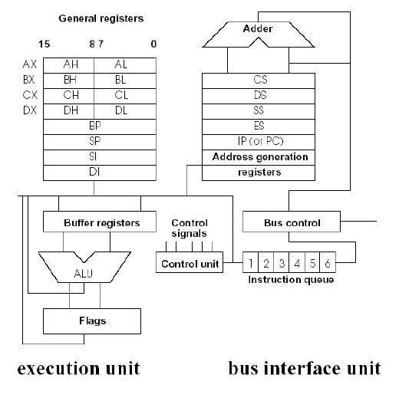

On the structural scheme of the i8086 processor we can see two separate asynchronous processing units.
The execution unit (EU) executes instructions; the bus interface unit (BIU) fetches instructions, reads operands, and writes results. The two units can operate almost independently of one another and are able, under most circumstances, to extensively overlap instruction fetch with execution. The result is that, in most cases, the time normally required to fetch instructions "disappears" because the EU executes instructions that have already been fetched by BIU. Of course nothing special, but remember the time when i8086 was designed.
Execution Unit
The execution unit consists of general registers, buffer registers, control unit, arithmetic/logic unit, and flag register. The ALU maintains the CPU status and control flags and manipulates the general registers and instruction operands. The EU is not connected to the system bus. It obtains instructions from a queue maintained by the BIU. Likewise, when an instruction requires access to memory or to a peripheral device, the EU requests the BIU to obtain or store the data. The EU manipulates only with 16-bit addresses (effective addresses). An address relocation that enables the EU access to the full megabyte is performed by BIU.
Bus Interface Unit
The bus interface unit performs all bus operations for the EU. Data is transferred between the CPU and memory or I/O devices upon demand from the EU. During periods when the EU is busy executing instructions, the BIU fetches more instructions from memory. The instructions are stored in an internal RAM array called the instruction stream queue. The 8086 queue can store up to six instruction bytes. This allows the BIU to keep the EU supplied with prefetched instructions under most conditions. The BIU of 8086 does not initiate a fetch until there are two empty bytes in its queue. The BIU normally obtains two instruction bytes per fetch, but if a program transfer forces fetching from an odd address, the 8086 BIU automatically reads one byte from the odd address and then resumes fetching two-byte words from the subsequent even addresses. Under most circumstances the queue contains at least one byte of the instruction stream and the EU does not have to wait for instructions to be fetched. The instructions in the queue are the next logical instructions so long as execution proceeds serially. If the EU executes an instruction that transfers control to another location, the BIU resets the queue, fetches the instruction from the new address, passes it immediately to the EU, and then begins refilling the queue from the new cation. In addition, the BIU suspends instruction fetching whenever the EU requests a memory or I/O read or write (except that a fetch already in progress is completed before executing the EU's bus request).
The Details of the Architecture
Registers
The general registers of the 8086 are divided into two sets of four 16-bit registers each. The data registers and the pointer and index registers. The data registers' upper and lower halves are separately addressable. In other words, each data register can be used interchangeably as a 16-bit register or as two 8-bit registers. The data registers can be used without constraint in most arithmetic and logic operations. Some instructions use certain registers implicitly thus allowing compact yet powerful encoding. The pointer and index registers can be used only as 16-bit registers. They can also participate in most arithmetic and logic operations. In fact all eight general registers fit the definition of "accumulator" as used in first and second generation microprocessors. The pointer and index registers (except BP) are also used implicitly in some instructions. The segment registers contain the base addresses of logical segments in the 8086 memory space. The CPU has direct access to four segments at a time. The CS register points to the current code segment; instructions are fetched from this segment. The SS points to the current stack segment; stack operations are performed on locations in this segment. The DS register points to the current data segment; it generally contains program variables. The ES points to the current extra segment; which also is typically used for data storage. The IP (instruction pointer) is updated by the BIU so that it contains the offset of the next instruction from the beginning of the current code segment. During normal execution IP contains the offset of the next instruction to be fetched by the BIU; whenever IP is saved on the stack, however, it is first automatically adjusted to point to the next instruction to be executed. Programs do not have direct access to the IP.
There are eight 16-bit general registers.

The data registers:
AX ( AH and AL)
BX ( BH and BL)
CX ( CH and CL )
DX ( DH and DL )

The pointer and index registers: BP, SP, SI, DI
The upper and lower halves of the data registers are separately addressable. Memory space is divided into logical segments up to 64k bytes each. The CPU has direct access to four segments at a time; their
base addresses are contained in the segment registers CS, DS, SS, ES. CS = code segment;
DS = data segment; SS = stack segment;
ES = extra segment;
Flags are maintained in the flag register depending on the result of the arithmetic or logic operation. A group of instructions is available that allows a program to alter its execution depending on the state of the flags, that is, on the result of a prior operation. There are:
- AF (the auxiliary carry flag) used by decimal arithmetic instructions. Indicates carry out from the low nibble of the 8-bit quantity to the high nibble, or borrow from the high nibble into the low nibble.
- CF (the carry flag) indicates that there has been carry out of , or a borrow into, the high-order bit of the result.
- OF (the overflow flag) indicates that an arithmetic overflow has occurred.
- SF (the sign flag) indicates the sign of the result (high-order bit is set, the result is negative).
- PF (the parity flag) indicates that the result has an even parity, an even number of 1-bits.
- ZF (the zero flag) indicates that the result of the operation is 0. Three additional control flags can be set and cleared by programs to alter processor operations:
- DF (the direction flag) causes string instructions to auto-decrement if it is set and to auto-increment if it is cleared.
- IF (the interrupt enable flag) allows the CPU to recognize external interrupts.
- TF (the trap flag) puts the processor into single-step mode for debugging.

Memory Organization
The 8086 can accommodate up to 1,048,576 bytes of memory. From the storage point of view, the memory space is organized as array of 8-bit bytes. Instructions, byte data and word data may be freely stored at any byte address without regard for alignment. The Intel convention is that the most-significant byte of word data is stored in the higher memory location. A special class of data (pointers) is stored as double words. The lower addressed word of a pointer contains an offset value, and the higher-addressed word contains a segment base address. Each word is stored following the above convention. The i8086 programs "view" the megabyte of memory space as a group of segments that are defined by the application. A segment is a logical unit of memory that may be up to 64k bytes long. Each segment is made up of contiguous memory locations and is an independent separately addressable unit. The software must assign to every segment a base address, which is its starting location in the memory space. All segments begin on 16-byte memory boundaries called paragraphs. The segment registers point to the four currently addressable segments. To obtain code and data from other segments, program must change the content of segment registers to point to the desired segments. Every memory location has its physical address and its logical address. A physical address is the 20-bit value that uniquely identifies each byte location in the memory space. Physical addresses may range from 0H to FFFFFH. All exchanges between the CPU and memory components use physical addresses. However, programs deal with logical rather than physical addresses. A logical address consists of a segment base and offset value. The logical to physical address translation is done by BIU whenever it accesses memory. The BIU shifts segment base by 4 to the left and adds the offset to this value. Thus we obtain 20-bit physical address and get the explanation for 16-byte memory boundaries for the segment base beginning. The offset of the memory variable is calculated by the EU depending on the addressing modes and is called the operand's effective address (EA). Stack is implemented in memory and is located by the stack segment register and the stack pointer register. An item is pushed onto the stack by decrementing SP by 2 and writing the item at the new top of stack (TOS). An item is popped off the stack by copying it from TOS and then incrementing SP by 2. The memory locations 0H through 7FH are dedicated for interrupt vector table, and locations FFFF0H through FFFFFH are dedicated for system reset.
Input/Output
The 8086 I/O space can accommodate up to 64k 8-bit ports or up to 32k 16-bit ports. The IN and OUT instructions transfer data between the accumulator and ports located in I/O space. The I/O space is not segmented; to access a port, the BIU simply places the port address on the lower 16 lines of the address bus. I/O devices may also be placed in the 8086 memory space. As long as the devices respond like the memory components, the CPU does not know the difference. This adds programming flexibility, and is paid by longer execution of memory oriented instructions.
Processor Control and Monitoring
The interrupt system of the 8086 is based on the interrupt vector table which is located from 0H through 7FH (dedicated) and from 80H through 3FFH (user available). Every interrupt is assigned a type code that identifies it to the CPU. By multiplying (type * 4), the CPU calculates the location of the correct entry for a given interrupt. Every table entry is 4 bytes long and contains the offset and the segment base (pointer) of the corresponding interrupt procedure that should be executed. After system reset all segments are initialized to 0H except CS which is initialized to FFFFH. Since, the processor executes the first instruction from absolute memory location FFFF0H. This location normally contains an intersegment direct JMP instruction whose target is the actual beginning of the system program.
Software Organization
Instruction Set
The 8086 instruction set from programmer's point of view contains about 100 instructions. However the number of machine instructions is more then 3800. For example MOV instruction has 28 different machine forms.
On the functional level we can divide the instruction set on :
- Data transfer instructions (MOV, XCHG, LEA, ...),
- Arithmetic instructions (ADD, SUB, INC, DEC, ...),
- Bit manipulation instructions (AND, SHR, ROR, ...),
- String instructions (MOVS, LODS, REP, ...),
- Program transfer instructions (CALL, JMP, JZ, RET, ...),
- Interrupt instructions (INT, INTO, IRET),
- Processor control instructions (CLC, STD, HLT, ...).
Data Memory Addressing Modes:
The 8086 offers a wide variety of addressing; we will condense it into six basic operation. These options are:
- Immediate
- Direct
- Direct, Indexed
- Implied
- Base Relative
- Stack
Immediate Memory Addressing:
In this form of addressing, one of the operands is present in the byte(s) immediately following the instruction object code (op-code). If addressing bytes follow the op-code, then the immediate data will follow the addressing bytes. For example:
ADD AX, 3064H
Requests the assembler to generate an ADD instruction which will add 3064 to the AX register. This may be illustrated as follows:
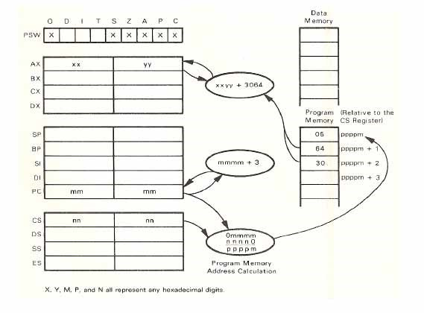

Note that the 16-bit immediate operand, when stored in program memory, has the low-order byte preceding the high-order byte. This is consistent with the way the 8086A stores immediate operands in program memory. In addition, this is consistent with the way the 8086 stores 16-bit operands in data memory. When a 16-bit store is performed, the loworder 8 bits of data are stored into the low-order memory byte, and the high-order 8 bits of data are stored into the succeeding memory byte. In this example, the two bytes immediately following the op-code for the ADD to AX instruction are added to the AX register.
Direct Memory Addressing:
The 8086 implements straight forward direct memory addressing by adding a 16-bit displacement, provided by two object code bytes, to the data segment register. The sum becomes the actual memory address. This may be illustrated as follows:
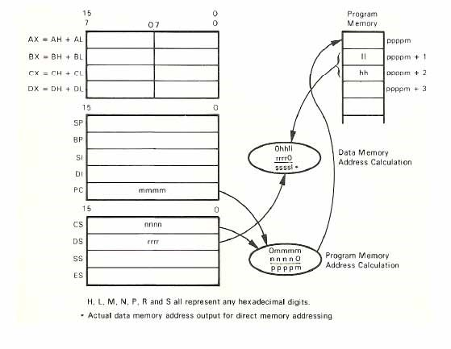

Note that a 16-bit address displacement, when stored in program memory, has the low-order byte preceding the high-order byte. This is consistent with the way the 8080A stores addresses in program memory.
DS must provide the segment base address when addressing data memory directly, as illustrated above.
Direct, Indexed Memory Addressing:
Direct, indexed addressing is allowed by specifying the SI or DI register as an index register. You have the option of adding an 8-bit or 16-bit displacement to the contents of the specified index register in order to generate the effective address. A16-bit displacement is stored in two object code bytes; the low-order byte of the displacement precedes the high-order byte of the displacement, as illustrated for direct memory addressing. If an 8-bit displacement is specified, then the high-order bit of the low-order byte is propagated into the high-order byte to create a 16bit displacement this may be illustrated a follows:
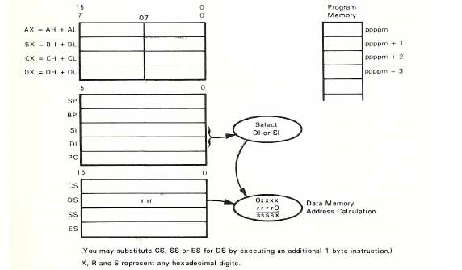

Implied Memory Addressing:
Implied memory addressing is implemented on the 8086 as a degenerate version of a direct, indexed memory addressing. If you do not specify a displacement when using the direct, index addressing mode, then you have, in effect, implied memory addressing via the SI or DI register. The may be illustrated as follows:
Base Relative Addressing:
The 8086 implements base relative addressing in two ways:
- Data memory base relative addressing, which is within the DS segment (data memory)
- Stack base relative addressing, which is in the SS segment (stack memory)
Data memory base relative addressing uses the BX register contents to provide the base for the effective address. All of the data memory addressing options thus far described, with the exception of immediate addressing ,are available with base relative data memory addressing. In effect, base relative data memory addressing merely adds the contents of the BX register to the effective memory address which would otherwise have been generated. Here, for example, is an illustration of base relative direct addressing:
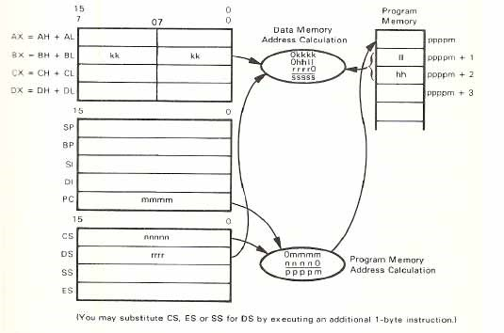

Simple, direct addressing, which we described earlier, always generated a 16-bit displacement. Base relative, direct addressing allows the displacement, illustrated above as HHLL, to be a 16-bit displacement, an 8-bit displacement with sign extended, or no displacement at all. Base relative implied memory addressing simply adds the contents of the BX register to the selected index register in order to compute the effective memory address. This may be illustrated as follows:
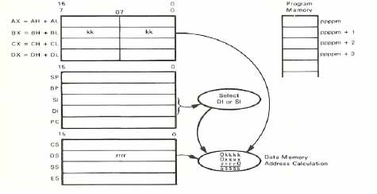
Base relative, direct, indexed data memory addressing may appear to be complicated, but in fact it is not. We simply add the contents of the BX register to the effective memory address, as computed for normal direct, indexed addressing. Thus, base relative, direct, indexed data memory addressing may be illustrated as follows:
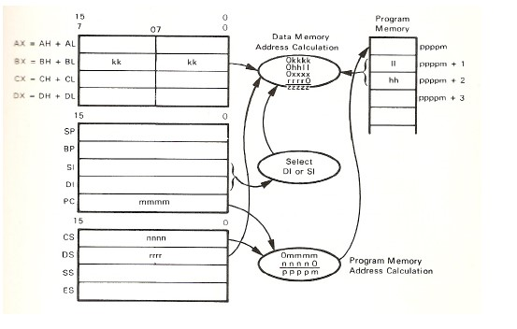

The index xxxx in the illustration above is optional. Base relative, direct memory addressing is also available. In this instance neither SI nor DI will contribute to the address computation, and 0xxxx must be remove from the illustration.
Stack Memory Addressing:The 8086 also has stack memory addressing variations of the base relative, data memory addressing options just described. In this case, however, the BP register is used as the base register. Here, for example, is base relative, direct stack addressing:
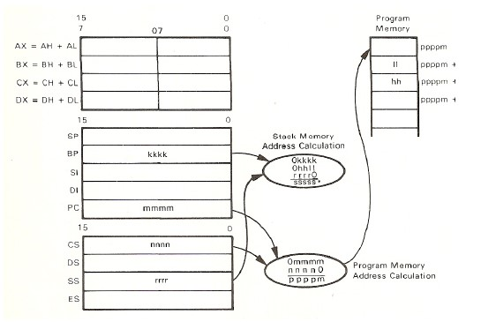

In the illustration above, the displacement HHLL is present, either as a 16-bit displacement or as 8-bit displacement with sign extended. Base relative stack memory addressing requires a displacement be specified, even if zero.
The more commonly used instructions:
1. Arithmetic instructions:
These instructions are used for arithmetic operation on the source and destination operands.
*ADD ac , data (add immediate data to AX register)
This instruction is used to add the immediate data present in the succeeding program memory byte (s) to the AL (8-bit operation) or AX (16-bit operation) register.
*ADD mem/reg , data (add immediate data to register or memory location).
*ADC mem/reg1,mem/reg2
Add data with carry from .register to register .register to memory .memory to register
Add the contents of the register or memory location specified by mem/reg2 and the carry status to the contents of the register or memory location specified by mem/reg1. An 8- or 16-bit operation may be specified. Either mem/reg1 or mem/reg2 may be a memory operand, but one of the operand must be a register operand.
*DIV mem/reg
Divide AH:AL or DX:AX registers by register or memory location
Divided the AH:AL (8-bit operation) or DX:AX (16-bit operation) register by the contents of the specified 8- or 16-bit register or memory location, considering both operands as unsigned binary numbers.
- IDIV mem/reg
Divided AH:AL or DX:AX by register or memory location * IMUL mem/reg
Multiply AL or AX register by register or memory location Multiply the specified register or memory location contents by contents by the AL (8-bit operation) or AX (16-bit operation).
- MUL mem/reg
Multiply AL or AX register by register or memory location Multiply the specified register or memory location contents by the AL (8-bit operation) or AX (16-bit operation) register, considering both operands as unsigned number, i.e., a simple binary multiplication. If an 8-bit operation is performed, the low- order eight bits of the result are stored in the AL register, the high-order eight bits of the result are stored in the AH register. If a 16-bit operation is performed, the low-order 16 bits of the result is stored in the AX register, the high-order 16 bits of the result are stored in the DX register.
- SBB ac,data
Subtract immediate from AX or AL register with borrow. Subtract the immediate data in the succeeding program memory byte (s) from the AL (8-bit operation) or AX (16-bit operation) register with borrow.
*SUB ac,data
Subtract immediate data from the AL or AX register
This instruction is used to subtract immediate data from the AL (8-bit operation) register.
2- Logical Instructions:
These instructions are used for logical operations on the operands.
*AND ac, data
AND immediate data with the AL or AX register
This instruction is used to AND immediate data present in the succeeding program memory byte(s) with the (8-bit operation) or AX (16-bit operation) register contents.
*AND mem/reg , data
AND immediate data with register or memory location.
*NEG mem/reg
Negate the contents of register or memory location
This instruction performs a twos complement subtraction of the specified operand from zero. The result is stored in the specified operand. An 8- or 16-bit operand may be specified.
*NOT mem/reg
Ones complement of register or memory location
Complement the contents of the specified register or memory location.
*OR ac,data
OR immediate data with the AX or AL register
OR the immediate data in the succeeding program memory byte(s) with AL (8-bit operation) or AX (16-bit operation) register.
*TEST ac,data
Test immediate data with AX or AL register
AND the immediate data in the succeeding program memory byte(s) with the contents of the AL (8-bit operation) or AX (16-bit operation) register, but do not return the result to the register.
*XOR
XOR immediate data with AX or AL register
This instruction exclusive-ORs 8- or 16-bit data elements with AL(8-bit) or AX(16-bit) register via immediate addressing.
3- Movement Instructions:
*MOV mem/reg1,mem/reg2
Move data from register to register or memory to register or register to memory.
This instruction is used to move 8- or 16-bit data elements between a register and a register or memory location.
*MOVS (MOVSB) (MOVSW)
Move byte or word from memory to memory
Move 8 or 16 bits from the memory location pointed to by the SI register to the memory location pointed to by the DI register. The SI and DI register are incremented / decremented depending on the value of the DF flag.
4- Loading Instructions:
*LODS (LODSB)(LODSW)
Load from memory into AL or AX register
Move from the memory location addressed by the SI register to the AL (8-bit operation) or the AX (16-bit operation) register. The SI register is incremented / decremented depending on the value of the DF flag.
*LDS reg,mem
Load register and DS from memory
Load the contents of the specified memory word into the specified register. Load the contents of the memory word following the specified memory word into the DS register. 5- Jumping Instructions:
*JCXZ disp jump if CX=0
*JE dispjump if equal *JZ disp jump if zero
*JG disp jump if greater
*JNLE disp jump if not less nor equal
*JGE disp jump if greater than or equal
*JNL disp jump if not less
*JL disp jump if less
*JNGE disp jump if not greater than or equal
*JLE disp jump if less than or equal
*JNG disp jump if not greater
*JMP addr jump to the instruction identified in the operand
*JNE disp jump if not equal *JNZ disp jump if not zero
*JNO disp jump if not overflow
*JNP disp jump if not parity
*JPO disp jump if parity odd
*JNS disp jump if not sign
*JO disp jump if overflow
*JP disp jump if parity even
*JPE disp jump if parity even *JS disp jump if sign status is one 6- Looping Instructions:
*LOOP disp
Decrement CX register and jump if not zero
This instruction decrements the CX register (not affecting the flsgs) and then functions in the same manner as the JMP disp instruction, except that if the CX register has not been decremented to 0, then the jump is executed; otherwise the next instruction is executed.
*LOOPZ disp
LOOPE disp
Decrement CX register and jump if CX=0 and ZF=1
This instruction decrements the CX register (not affecting the flags) and then functions in the same manner as the JMP disp instruction, except that if the CX register has not been decremented to 0 and the zero flag is 1 then the jump is executed; otherwise the next instruction is executed.
*LOOPNZ disp
LOOPNE disp
Decrement CX register and jump if CX!=0 and ZF=0
This instruction decrements the CX register (not affecting the flag) and then functions in the same manner as the JMP disp instruction, except that if the CX register has not been decremented to 0 and the zero flag is 0, then the jump is executed; otherwise the next instruction is executed.
7- Stack Instructions:
*POP reg
Read from the top of the stack
Pop the two top stack bytes into the designated 16-bit register.
*POPF
Read from the top of the stack into flags register.
*PUSH reg
Write to the top of the stack
This instruction pushes the contents of the specified 16-bit register into the top of stack.
*PUSHF
Write the flags register to the top of stack.
8- Count Instructions:
*DEC mem/reg
Decrement register or memory location
Subtract 1 from the contents of the specified register or memory location.
An 8- or 16-bit operation may be specified.
*INC mem/reg
Increment register or memory location
Add 1 to the contents of the specified register or memory location. An 8- or 16-bit operation may be specified.
9-Compare Instructions:
*CMP ac,data
Compare immediate data with accumulator
This instruction is used to compare immediate data present in the succeeding program memory byte(s) with the AL register (8-bit operation) or the AX register (16-bit operation). The comparison is performed by subtracting the data in the immediate byte(s) from the specified register, thus no registers are affected, only the statuses.
*CMP mem/reg,data
Compare immediate data with register or memory
*CMP mem/reg1,mem/reg2
*CMPS (CMPSB)(CMPSW)
Compare memory with memory
Compare the contents of the memory location addressed by the SI register with the contents of memory location addressed by the DI register. The comparison is performed by subtracting the contents of memory location addressed by the DI register from the contents the memory location addressed by SI register and using the result to set the flags.
10-Flag Instructions:
*CLC Clear the carry status
*CLD Clear the direction flag
*CLI Clear the interrupt flag
*CMC Complement the carry status
*STC Set the carry flag
*STD Set the direction flag *STI Set the interrupt flag

