Process and Thread Management
Definition: A process is a program in execution.
- We are assuming a multiprogramming OS that can switch from one process to another.
- Sometimes this is called pseudoparallelism since one has the illusion of a parallel processor.
- The other possibility is real parallelism, in which two or more processes are actually running at once because the computer system is a parallel processor, i.e., has more than one processor.
- We do not study absolute parallelism (parallel processing, distributed systems, multiprocessors, etc) in this course.

2.1.1: The Process Model
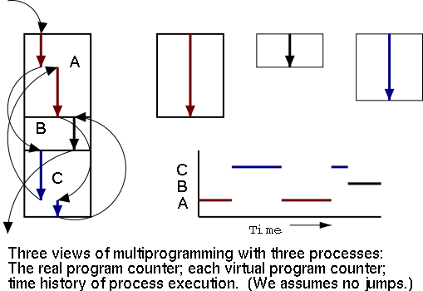
Even though many processes are running simultaneously, the OS gives each process the illusion that it is running alone.

- Virtual time: The time used by just this processes. Virtual time progresses at a rate independent of other processes. Actually, this is false, the virtual time is typically incremented a little during systems calls used for process switching; so if there are more other processors more ``overhead'' virtual time occurs.
- Virtual memory: The memory as viewed by the process. Each process typically believes it has a contiguous chunk of memory starting at location zero. Of course this can't be true of all processes (or they would be using the same memory) and in modern systems it is actually true of no processes (the memory assigned is not contiguous and does not include location zero).
Think of the individual modules that are input to the linker. Each numbers its addresses from zero; the linker eventually translates these relative addresses into absolute addresses. That is the linker provides to the assembler a virtual memory in which addresses start at zero.
Virtual time and virtual memory are examples of abstractions provided by the operating system to the user processes so that the latter ``sees'' a more pleasant virtual machine than actually exists. Process Creation
From the users or external viewpoint there are several mechanisms for creating a process.
- System initialization, including daemon processes.
- Execution of a process creation system call by a running process.
- A user request to create a new process.
- Initiation of a batch job.
But looked at internally, from the system's viewpoint, the second method dominates. Indeed in unix only one process is created at system initialization (the process is called init); all the others are children of this first process.
Why have init? That is why not have all processes created via method 2?
Ans: Because without init there would be no running process to create any others.

2.1.3: Process Termination
Again from the outside there appear to be several termination mechanism.
- Normal exit (voluntary).
- Error exit (voluntary).
- Fatal error (involuntary).
- Killed by another process (involuntary).
And again, internally the situation is simpler. In Unix terminology, there are two system calls kill and exit that are used. Kill (poorly named in my view) sends a signal to another process. If this signal is not caught (via the signal system call) the process is terminated. There is also an ``uncatchable'' signal. Exit is used for self termination and can indicate success or failure.

2.1.4: Process Hierarchies
Modern general purpose operating systems permit a user to create and destroy processes.
- In unix this is done by the fork system call, which creates a child process, and the exit system call, which terminates the current process.
- After a fork both parent and child keep running (indeed they have the same program text) and each can fork off other processes.
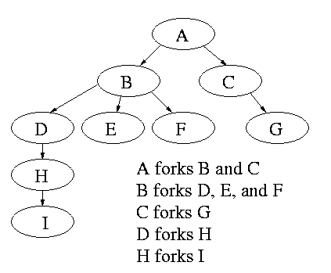

- A process tree results. The root of the tree is a special process created by the operating system (OS) during the startup process.
- A process can choose to wait for children to terminate. For example, if C issued a wait() system call, it would block until G finished.
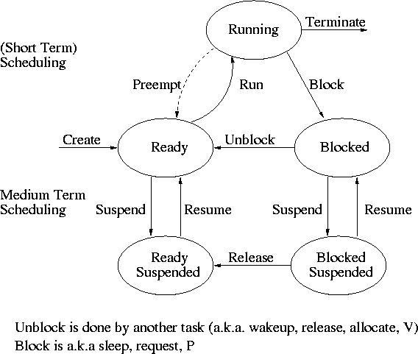
Old or primitive operating systems, such as MS-DOS, are not multiprogrammed; therefore, when one process starts another, the first process is automatically blocked and waits until the second process is finished.

2.1.5: Process States and Transitions

The diagram on the right contains a wealth of information.
- Consider a running process P that issues an I/O request
  - The process blocks
  - At some later point, a disk interrupt occurs, and the driver detects that P's request is satisfied.
  - P is unblocked, i.e. is moved from blocked to ready
  - At some later time, the operating system looks for a ready job to run and picks P.

- A preemptive scheduler has the dotted line preempt.
A non-preemptive scheduler doesn't.
- The number of processes changes only for two arcs: create and terminate.
- Suspend and resume are medium-term scheduling
  - Done on a longer time scale.
  - Involves memory management as well.
  - Sometimes called two-level scheduling.
One can organize an OS around the scheduler.
- Write a minimal ``kernel'' consisting of the scheduler, interrupt handlers, and IPC (interprocess communication)
- The rest of the OS consists of kernel processes (e.g. memory, filesystem) that act as servers for the user processes (which, of course, act as clients.
- The system processes also act as clients (of other system processes).
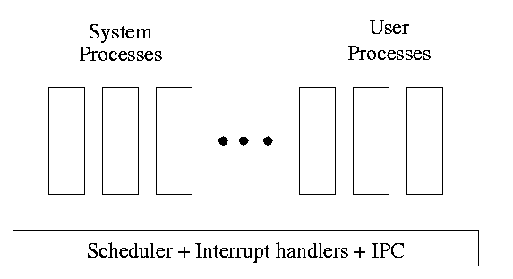
- The above is called the client-server model and is one Tanenbaum likes. His ``Minix'' operating system works this way.
- Indeed, there was reason to believe that the client-server model would dominate OS design. But that hasn't happened.
- Such an OS is sometimes called server-based.
- Systems like traditional Unix or Linux would then be called self-service since the user process serves itself.
  - That is, the user process switches to kernel mode and performs the system call.
  - To repeat: the same process changes back and forth from/to user<-->system mode and services itself.

2.1.6: Implementation of Processes
The OS organises the data about each process in a table, naturally called the process table. Each entry in this table is called a process table entry (PTE) or process control block.
- One entry per process.
- The central data structure for process management.
- A process state transition (e.g., moving from blocked to ready) is reflected by a change in the value of one or more fields in the PTE.
- We have converted an active entity (process) into a data structure (PTE). Finkel calls this the level principle ``an active entity becomes a data structure when looked at from a lower level.
- The PTE contains a great deal of information about the process. For example,
  - Saved the value of registers when the process is not running
  - Stack pointer
  - CPU time used
  - Process id (PID)
  - Process id of parent (PPID)
  - User id (uid and euid)
  - Group id (gid and egid)
  - Pointer to text segment (memory for the program text)
  - Pointer to data segment
  - Pointer to stack segment
  - UMASK (default permissions for new files)
  - Current working directory
  - Many others

An aside on Interrupts
In a well-defined location in memory (specified by the hardware), the OS stores an interrupt vector, which contains the address of the (first-level) interrupt handler.
- Tanenbaum calls the interrupt handler the interrupt service routine.
- One can have different priorities of interrupts, and the interrupt vector contains one pointer for each level. This is why it is called a vector.
Assume a process P is running and a disk interrupt occurs for the completion of a disk read previously issued by process Q, which is currently blocked. Note that interrupts are unlikely to be for the currently running process (because the process waiting for the interrupt is likely blocked).
- The hardware saves the program counter and some other registers (or switches to using another set of registers; the exact mechanism is machine-dependent).
- Hardware loads the new program counter from the interrupt vector.
  - Loading the program counter causes a jump.
  - Steps 1 and 2 are similar to a procedure call. But the interrupt is asynchronous.
  - As with a trap (poof), the interrupt automatically switches the system into privileged mode.
- Assembly language routine saves registers.
- The assembly routine sets up a new stack.
  - These last two steps can be referred to as setting up the C environment.
- Assembly routine calls C procedure (Tanenbaum forgot this one).
- C procedure does the real work.
  - Determines what caused the interrupt (in this case, a disk completed an I/O)
    - How does it figure out the cause?
      - Which priority interrupt was activated?
      - The controller can write data in memory before the interrupt
      - The OS can read registers in the controller
  - Mark process Q as ready to run.
    - That is, move Q to the ready list (note that again we are viewing Q as a data structure).
    - The state of Q is now ready (it was blocked before).
    - The code that Q needs to run initially is likely to be OS code. For example, Q probably needs to copy the data just read from a kernel buffer into user space.
  - Now we have at least two processes ready to run: P and Q
- The scheduler decides which process to run (P or Q or something else). Let us assume that the decision is to run P.
- The C procedure (that did the real work in the interrupt processing) continues and returns to the assembly code.
- Assembly language restores P's state (e.g., registers) and starts P at the point it was when the interrupt occurred.

2.2: Threads
Per process items | Per thread items
Address space | Program counter
Global variables | Machine registers
Open files | Stack
Child processes
Pending alarms
Signals and signal handlers
Accounting information
The idea is to have separate threads of control (hence the name) running in the same address space. Each thread is somewhat like a process (e.g., it is scheduled to run) but contains less state (the address space belongs to the process in which the thread runs.

2.2.1: The Thread Model
A process contains several resources such as address space, open files, accounting information, etc. In addition to these resources, a process has a thread of control, e.g., program counter, register contents, and stack. The concept of threads allows multiple threads of control to execute within a single process. This is often referred to as multithreading, and threads are often referred to as lightweight processes because the threads within a process share a significant amount of state; switching between them is significantly less expensive than switching between separate processes.
Individual threads within the same process are not entirely independent. For example, there is no memory protection between them. This is typically not a security problem as the threads are cooperating and all are from the same user (indeed, the same process). However, the shared resources do make debugging harder. For example, one thread can easily overwrite data needed by another, and if one thread closes a file, other threads can't read from it.

Thread in Operating System

A thread is a single sequence stream within a process. Threads are also called lightweight processes as they possess some of the properties of processes. Each thread belongs to exactly one process.
- In an operating system that supports multithreading, the process can consist of many threads. However, threads can be effective only if the CPU is more than one; otherwise, two threads would have to context switch for that single CPU.
- All threads belonging to the same process share the code section, data section, and OS resources (e.g. open files and signals)
- But each thread has its own (thread control block) - thread ID, program counter, register set, and a stack
- Any operating system process can execute a thread. We can say that a single process can have multiple threads.

Why Do We Need Threads?
- Threads run in a concurrent manner that improves the application's performance. Each such thread has its CPU state and stack, but they share the process's address space and environment. For example, when we work on Microsoft Word or Google Docs, we notice that while we are typing, multiple things happen together (formatting is applied, the page is changed, and auto save happens).
- Threads can share common data, so they do not need to use inter-process communication. Like processes, threads also have states such as ready, executing, and blocked.
- Priority can be assigned to the threads just like the process, and the highest priority thread is scheduled first.
- Each thread has its own Thread Control Block (TCB). Similarly, a context switch occurs for the thread, and its register contents are saved in the TCB. As threads share the same address space and resources, synchronisation is also required for the various activities of the thread.

Components of Threads
These are the basic components of the Operating System.
- Stack Space: Stores local variables, function calls, and return addresses specific to the thread.
- Register Set: Hold temporary data and intermediate results for the thread's execution.
- Program Counter: Tracks the current instruction being executed by the thread.

Types of Thread in Operating System
Threads are of two types. These are described below.
- User Level Thread
- Kernel Level Thread

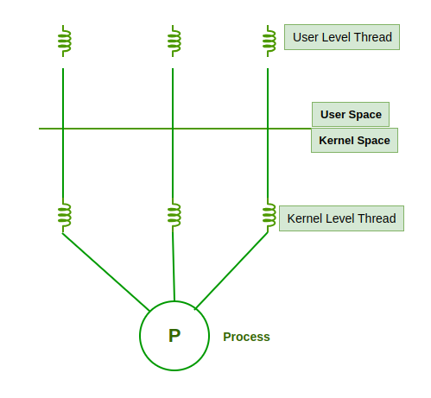
Threads

1. User Level Thread
A user-level thread is a type of thread that is not created using system calls. The kernel has no work in the management of user-level threads. The user can easily implement user-level threads. In case when user-level threads are single-handed processes, kernel-level thread manages them. Let's look at the advantages and disadvantages of User-Level Threads.

Advantages of User-Level Threads
- Implementation of the User-Level Thread is easier than Kernel Level Thread.
- Context Switch Time is less in a User-Level Thread.
- User-Level Thread is more efficient than Kernel-Level Thread.
- Because of the presence of only the Program Counter, Register Set, and Stack Space, it has a simple representation.

Disadvantages of User-Level Threads
- The operating system is unaware of user-level threads, so kernel-level optimisations, like load balancing across CPUs, are not utilised.
- If a user-level thread makes a blocking system call, the entire process (and all its threads) is blocked, reducing efficiency.
- User-level thread scheduling is managed by the application, which can become complex and may not be as optimised as kernel-level scheduling.

2. Kernel-Level Threads
- A kernel-level thread is a type of thread that can recognise the Operating system easily. Kernel-level threads have their thread table where they keep track of the system. The operating System Kernel helps in managing threads. Kernel Threads have a somewhat longer context switching time. Kernel helps in the management of threads.
- Advantages of Kernel-Level Threads
- Kernel-level threads can run on multiple processors or cores simultaneously, enabling better utilisation of multicore systems.
- The kernel is aware of all threads, allowing it to manage and schedule them effectively across available resources.
- Applications that block frequency are to be handled by the Kernel-Level Threads.
- The kernel can distribute threads across CPUs, ensuring optimal load balancing and system performance.

Disadvantages of Kernel-Level threads
- Context switching between kernel-level threads is slower compared to user-level threads because it requires mode switching between user and kernel space.
- Managing kernel-level threads involves frequent system calls and kernel interactions, leading to increased CPU overhead.
- A large number of threads may overload the kernel scheduler, leading to potential performance degradation in systems with many threads.
- Implementation of this type of thread is a little more complex than a user-level thread.

Difference Between Process and Thread
The primary difference is that threads within the same process run in a shared memory space, while processes run in separate memory spaces. Threads are not independent of one another, unlike processes. As a result, threads share their code section, data section, and operating system (OS) resources (such as open files and signals) with other threads. However, like a process, a thread has its program counter (PC), register set, and stack space.
For more, refer to the Difference Between Process and Thread.

What is Multi-Threading?
A thread is also known as a lightweight process. The idea is to achieve parallelism by dividing a process into multiple threads. For example, in a browser, multiple tabs can be different threads. MS Word uses multiple threads: one thread to format the text, another thread to process inputs, etc. The following section discusses additional advantages of multithreading.
Multithreading is a technique used in operating systems to improve the performance and responsiveness of computer systems. Multithreading allows multiple threads (i.e., lightweight processes) to share the same resources of a single process, such as the CPU, memory, and I/O devices.
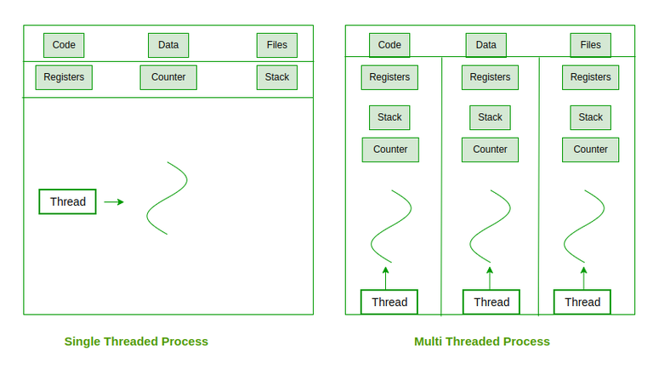Single Threaded vs Multi-Threaded Process
Multithreading can be done without OS support, as seen in Java's multithreading model. In Java, threads are implemented using the Java Virtual Machine (JVM), which provides its own thread management. These threads, also called user-level threads, are managed independently of the underlying operating system.
The application itself manages the creation, scheduling, and execution of threads without relying on the operating system's kernel. The application contains a threading library that handles thread creation, scheduling, and context switching. The operating system is unaware of User-Level threads and treats the entire process as a single-threaded entity.

Benefits of Threads in Operating Systems
- Responsiveness: If the process is divided into multiple threads, if one thread completes its execution, then its output can be immediately returned.
- Faster context switch: Context switch time between threads is lower compared to the process context switch. Process context switching requires more overhead from the CPU.
- Effective utilization of multiprocessor system: If we have multiple threads in a single process, then we can schedule multiple threads on multiple processors. This will make process execution faster.
- Resource sharing: Resources like code, data, and files can be shared among all threads within a process. Note: Stacks and registers can't be shared among the threads. Each thread has its own stack and registers.
- Communication: Communication between multiple threads is easier, as the threads share a common address space. while in the process we have to follow some specific communication techniques for communication between the two processes.
- Enhanced throughput of the system: If a process is divided into multiple threads, and each thread function is considered as one job, then the number of jobs completed per unit of time is increased, thus increasing the throughput of the system.

