

Final Year Project Proposal
Semester and Academic Year

GoalBuddy App:
Fun Football Basics for Kids

Ahmad Adli bin Mursidi
214761
Supervisor: Prof. Madya Ts. Dr. Lili Nurliyana Abdullah

Table of Contents
INTRODUCTION 1
1.1 Problem Statements 3
1.2 Objectives 3
1.3 Project Scope 4
1.3.1 System Scope 4
1.3.2 User Scope 4
LITERATURE REVIEW 6
2.1 Importance of Motor Development in Early Childhood 6
2.2 Football as a Catalyst for Motor Development 7
2.3 Game-Based Learning and Gamification in Children's Education and Training 7
2.4 Role of Mobile Applications and Technology 8
2.5 Parental Supervision and Engagement 10
2.6 Literature Review Matrix 11
METHODOLOGY 14
3.1 Software Development Model: Agile 14
3.2 User requirement gathering via pre-survey 15
3.2.1 General Questions Respondents Summary 15
3.2.2 Parents Questions Respondents Summary 15
3.2.3 Non-Parent Questions Respondents Summary 16
3.2.4 Feature Validation Respondents Summary 16
3.3 System Design 16
3.3.1 Use Case Diagram 17
3.3.2 Parent and Child User Flow 18
3.3.3 Admin User Flow 19
3.4 Tools and Programming Languages 20
3.4.1 Hardware Requirements 20
3.4.2 Software and Programming Tools 20
3.5 Gantt Chart and Timeline 21
3.5.1 Overview of Gantt Chart 21
3.5.2 Agile Methodology Implementation 21
3.5.3Timeline Summary 22
3.6 Expected Output 23
3.6.1 A Gamified Mobile App for Football Basics 23
3.6.2 Integrated Motor Skill Development Features 23
3.6.3 Parental Monitoring and Engagement System 23
3.6.4 Expected Output Interface (Low-Fidelity) 24
Reference 25

CHAPTER 1

INTRODUCTION
In recent years, there has been a significant increase in screen-based activities among children, especially in the post-pandemic era. According to Qi et al. (2023), school-aged children between 6 and 14 years spend an average of 2.77 hours per day on screens, with nearly half (46.4%) exceeding the recommended limit of 2 hours per day. The majority of this screen time is dedicated to entertainment such as watching videos, playing games, or using social media, rather than educational or physically engaging content.

This trend raises concerns about the impact of excessive sedentary screen use on children’s physical and cognitive development. Prolonged screen exposure has been linked to myopia, obesity, sleep disturbances, and reduced physical activity levels (Qi et al., 2023). As a result, there is a growing need to develop digital tools that not only capture children's attention but also promote active learning, motor development, and physical engagement.

On the other hand, research by Moreno et al. (2021) demonstrates how mobile applications can be effectively used to assess and enhance motor skills in children. Their study introduced a mobile app designed to evaluate fine motor coordination through interactive tracing exercises involving straight lines, curves, and zigzag paths. The application successfully captured objective, quantifiable data on children’s movement precision, error rates, and overall coordination abilities. This approach highlights the potential of gamified mobile apps to serve as both diagnostic tools and therapeutic interventions for developmental coordination disorders.

Motor coordination plays a crucial role in early childhood development, influencing everything from handwriting and balance to participation in sports and social interaction. Research indicates that children who struggle with motor coordination may face long-term academic, emotional, and social challenges if left unaddressed (Moreno et al., 2021). Therefore, integrating motor skill development into everyday digital experiences offers a promising avenue for supporting holistic child growth.

Additionally, recent studies have reported low levels of motor development among children aged 3 to 10, with the majority falling into very poor to low-average categories for locomotion, manipulation, and overall motor competence (Hurtado-Almonacid et al., 2024). These deficits are especially concerning given that early childhood is a sensitive period for acquiring fundamental movement skills—skills that are crucial for physical activity, social integration, and lifelong health. The same study highlighted that despite slight variations in performance between boys and girls, overall motor age often lags behind chronological age, emphasizing the urgent need for early intervention in accessible, engaging ways.

Football, being one of the most popular global sports, provides a natural framework for developing gross motor skills, including running, kicking, balancing, and spatial awareness. As described by Weil and Joy (2025), football (also known as soccer) is not only the world’s most widely viewed and played team sport but also one of the simplest to adapt for all ages. Its rules are easy to learn, and it requires minimal equipment, making it a universally accessible sport. Football promotes dynamic physical activity, such as rapid direction changes, foot-eye coordination, and strategic thinking, all of which are highly beneficial to a child’s physical and cognitive development.

Moreover, football can foster essential life skills such as teamwork, communication, and goal-setting, making it a holistic tool for education and development. Its widespread cultural presence and global appeal enhance its potential as a medium for engaging children in physical activity across different socioeconomic and geographic backgrounds (Weil & Joy, 2025).

However, traditional football coaching often requires access to structured environments and trained instructors, which may not be available to all children. Educational technology offers a scalable solution by delivering interactive, gamified football training modules directly to children’s devices.

The integration of child-friendly design, progressive difficulty levels, and performance tracking will ensure that the app is both educationally valuable and engaging. Ultimately, this project seeks to transform screen time into a productive and health-enhancing experience, promoting both digital literacy and physical development among young learners.

1.1 Problem Statements

- Lack of Age-Appropriate Football Learning Resources
Most existing football training programs and digital tools are designed for older children or adults, using complex instructions and advanced gameplay mechanics. As a result, younger children under 8 often struggle to understand and engage with such materials. This lack of developmentally appropriate content creates a significant barrier to early sports education and skill acquisition.

- Missed Opportunities for Early Motor and Social Development
Physical activity during early childhood is crucial for developing both fine and gross motor skills, balance, coordination, and social competencies like teamwork and communication. However, many children do not have access to structured or engaging platforms that integrate physical movement with educational content, particularly in sports contexts.

- Low Engagement Due to Lack of Gamified, Interactive Content
Children’s attention spans are short, and traditional instructional formats often fail to maintain their interest. Many existing football learning apps rely on passive video tutorials or static quizzes, which do not align with the natural learning preferences of young children who benefit from play-based, exploratory, and gamified experiences.

1.2 Objectives

- To design and develop football learning resources specifically tailored for children under 8, using age-appropriate language, visuals, and achieve better engagement with gameplay mechanics to support early understanding and skill development.

- To create a structured yet playful platform that promotes both physical activity and social interaction, aiming to support the development of motor skills, coordination, and teamwork in young children through sport-based activities.

- To increase engagement by incorporating gamified and interactive elements into football learning, ensuring content is exploratory, play-based, and aligned with the attention span and learning style of early childhood learners.

1.3 Project Scope

1.3.1 System Scope
The GoalBuddy application is designed as a mobile learning platform tailored to teach fundamental football skills to children under the age of eight. The system will feature interactive and developmentally appropriate learning modules that focus on enhancing basic motor skills such as kicking, dribbling, and coordination. Gamification elements will be integrated throughout the platform, including experience points (XP), digital badges, streak tracking, and daily or weekly goals to motivate continued engagement and participation. A core feature of the system is the parent-child account linking mechanism, which allows parents to oversee their child’s progress, set learning objectives, and send motivational messages. The application will also include child-friendly user interface design, utilizing large buttons, vivid colors, audio prompts, and simplified navigation to accommodate the cognitive and motor abilities of young users.
Additionally, a backend system will be developed for administrators or developers to manage content and ensure system functionality. This includes uploading new football training modules, monitoring application usage and performance, addressing technical issues, and managing user accounts. Developers will also be responsible for analyzing usage data to refine app features and ensure compliance with data privacy and child safety standards. By incorporating administrative controls and content management tools, the GoalBuddy system will remain adaptable, secure, and scalable for future educational enhancements.

1.3.2 User Scope
The GoalBuddy app is intended to serve three main user groups: children, parents, and system administrators or developers. Children will use the application to participate in football-based learning activities that are both fun and educational. These activities are designed to support the development of gross motor skills through play, while the use of gamified incentives such as points, badges, and progress tracking will keep them engaged. The child users will interact with the app through simple touch-based controls and receive immediate visual or auditory feedback for their actions, encouraging self-paced learning and motivation.
Parents act as supervisory users who create accounts for their children, set activity goals, monitor learning progress, and send motivational prompts. Through a dedicated parent dashboard, they can access reports, adjust activity schedules, and receive alerts about their child’s achievements and streaks. This supports a collaborative learning environment where parents can play an active role in their child's physical and educational development.
Administrators or developers, on the other hand, are responsible for maintaining the technical and functional integrity of the application. Their responsibilities include updating the football learning modules, configuring gamification settings, resolving bugs, and monitoring system analytics. They also ensure that the app complies with data protection guidelines and remains responsive to user feedback for ongoing improvements. Together, these three user types interact within the ecosystem of GoalBuddy to promote active, gamified, and parent-supported football learning for young children.

CHAPTER 2

LITERATURE REVIEW
The Goalbuddy App is conceptualized to facilitate the practice of football skills and fundamental motor development in children under the age of 8, under the supervision of their parents. This endeavor aligns with critical developmental theories emphasizing the significance of early childhood for motor skill acquisition (Hurtado-Almonacid et al., 2024) and addresses the increasing integration of digital technology into children’s learning and physical activity routines (Semartiana et al., 2022). This literature review will systematically explore the evidence underpinning the Goalbuddy app, examining the crucial role of motor development in early childhood, the benefits of utilizing football as a developmental vehicle, the effectiveness of game-based learning and gamification, the utility and implications of mobile application technology, and the indispensable role of parental involvement.

2.1 Importance of Motor Development in Early Childhood
Basic motor skills, also widely referred to as fundamental movement skills (FMS) (Zhang et al., 2024), are recognized as the foundational movements that enable children to interact with their environment. These skills serve as the basic structure upon which more complex movements are built (Hurtado-Almonacid et al., 2024), and their acquisition involves continuous modification during childhood through interplay between neuromuscular maturation, growth, and new motor experiences. FMS are broadly categorized into locomotor skills (e.g., running, galloping, hopping, jumping, sliding), manipulative or object control skills (e.g., kicking, catching, throwing, striking), and non-locomotor stability skills. The period from 0 to 6 years is deemed particularly crucial for their development, often highlighted as a "critical window of opportunity" or a "sensitive period" for motor construction due to higher neuronal plasticity, which makes adaptation to stimuli and motor learning more effective (Moreno et al., 2021).
The acquisition of FMS is essential for a child's overall physical, cognitive, emotional, and social development (Hurtado-Almonacid et al., 2024). Children who achieve higher scores in motor development tests tend to advance more academically. Furthermore, these skills are recognized as precursors to lifelong physical activity and can influence the adoption of sedentary lifestyles. Unfortunately, field observations and previous research indicate a concerning trend: many children do not master basic movements expected for their age. For instance, one study found that only 65.5% of students had good non-locomotor basic motion, 43% for locomotor, and 41.7% for manipulative movements, meaning almost 50% more children had poor basic movements (Conra et al., 2021). In the same paper, it reported that more than 60% of first-grade elementary school children were in the poor category for locomotor basic motion. This widespread poor mastery of basic movements is often attributed to a lack of sufficient and appropriate movement activity or errors in previous exercise programs. Consequently, early intervention is fundamental to address and mitigate potential motor coordination difficulties.

2.2 Football as a Catalyst for Motor Development
Football, being one of the most popular sports globally (Emam et al., 2023), offers an accessible and engaging platform for children to fulfill their physical activity needs (Grygus et al., 2024). Its dynamic nature inherently involves a variety of basic motion activities, making it an effective medium to promote the increase of fundamental movements in children. For children aged 6 to 10 years, FIFA's grassroots development program designates this period as the "Fun Phase". The primary goal during this stage is to foster joy and love for the sport, with training content focusing on basic movement training through a playing approach and fundamental football techniques (Conra et al., 2021). The approach emphasizes holistic development, where basic movement training receives a significant portion, and specialized exercises have smaller portions. Intensive training sessions and complex tactics are deemed unsuitable for this age group. This methodology ensures that children improve their fundamental basic movements through soccer training adapted to their age characteristics. Moreover, playing football through fun game activities allows children to improve their basic movements and physical development without realizing they are practicing. Research confirms that football club activities help compensate for insufficient physical activity and promote health in young people (Grygus et al., 2024).

2.3 Game-Based Learning and Gamification in Children's Education and Training
To effectively address the problem of poor basic movement mastery, game-based football training models have been developed and proven effective. Research supports that game-based training for 4-10 year olds leads to better engagement and skill development compared to traditional drills (Grygus et al., 2024). Gamification, defined as the application of game-design elements and game principles in non-gaming contexts, leverages children's natural inclination to play (Vergianda et al., 2024). For children, the primary purposes of gamification are to increase motivation, engagement, enjoyment, and learning performance (Semartiana et al., 2022).
Several game elements are frequently and effectively utilized in gamified learning environments for children:
- Points: Serve as indicators of user performance and incentivize continued engagement . They also improve the effectiveness of interventions by encouraging healthy challenges (Semartiana et al., 2022).
- Levels: Represent progress and achievements within the game or learning process. They can indicate behavioral changes in children (Semartiana et al., 2022).
- Leaderboards: Foster motivation by allowing users to track their progress relative to others (Semartiana et al., 2022).
- Badges and Rewards: Provide tokens of achievement that trigger motivation and a desire to continue learning and improve skills. Rewards can be used to motivate children to learn regional languages (Vergianda et al., 2024).
- Challenges: Encourage users to undertake new tasks and earn rewards.
- Other common elements include progress bars, stories/themes, and feedback (Semartiana et al., 2022).
The integration of game-based exercises in football training for younger age groups (4-10 years) has been found to lead to better engagement and more effective motor skill development compared to traditional drill-based approaches. This approach makes the learning process more enjoyable and comfortable, boosting confidence and interest in lessons (Grygus et al., 2024).

2.4 Role of Mobile Applications and Technology
Digital technology, including mobile applications, is an increasingly pervasive part of children's everyday lives (Diekhoff & Greve, 2023. This trend has driven the development of new learning styles that combine elements of fun and learning. Mobile applications are commonly used for gamification in children's learning processes, with 55% of reviewed articles on gamification for children utilizing mobile apps. Children generally prefer interacting with mobile applications because they are attractive and offer innovative game experiences, thereby increasing their motivation to learn (Semartiana et al., 2022).
Beyond engagement, technology offers practical tools for motor skill development and assessment:
- Pose Estimation and Video Analysis: Systems can monitor training processes by extracting human skeleton coordinates from video input . This technology, using tools like OpenPose and Mediapipe , can provide real-time feedback on the correctness of techniques (Suzuki et al., 2020). For football, it can classify actions such as juggling, inside-of-the-foot pass, and fake shot double tap. Such systems have achieved high accuracy, with the SVM algorithm reaching 90% accuracy in classifying football actions (Emam et al., 2023). In educational settings, video tagging in physical education classes, where students film and tag game situations, can enhance reflection and discussion about tactical situations (Diekhoff & Greve, 2023).
- Motor Skill Evaluation Apps: Mobile applications can be designed to evaluate fine motor development by allowing children to track objects on screen and recording objective data on movement precision, rather than just execution time or number of errors . Such apps can detect differences in motor performance across age groups, showing that error decreases as age advances. This allows for the establishment of valuable reference values for identifying motor problems. It is also suggested that children may be developing "new fine motor skills" through the use of touch screen devices, highlighting the growing necessity of new technologies in education and rehabilitation (Moreno et al., 2021).
However, the increasing screen time among school-aged children (aged 6-14) is a public health concern. Studies show the average screen time is 2.77 hours per day, with 46.4% of children exceeding the recommended 2 hours daily. This prolonged screen time has negative effects on physical and mental health, including eyesight, obesity, depression, and sleep disorders. The main purpose of screen time for children is often entertainment. Therefore, interventions must aim to reduce non-essential screen use (primarily entertainment) and promote replacement with outdoor and physical activities (Qi et al., 2023). Teachers and developers must balance the benefits of digital tools with the need to ensure children remain physically active.

2.5 Parental Supervision and Engagement
Parents are pivotal influencers and "gatekeepers" of children's physical development. Research consistently indicates that with appropriate support, parents can significantly improve their children's fundamental motor skills (FMS) (Conra et al., 2021;Zhang et al., 2024). Mobile applications like MiniMovers, which provide developmentally appropriate activities and instructional videos, empower parents to facilitate physical development at home. Studies have shown that when parents engage consistently with such apps, children demonstrate significant improvements in motor skills like running, jumping, kicking, and throwing (Zhang et al., 2024).
Qualitative findings from studies involving parents using motor development apps reveal several positive outcomes (Zhang et al., 2024):
- Enjoyment: Both parents and children report high levels of enjoyment from the app activities, making consistent engagement more likely. Parents also reported enjoying being more active with their children.
- Independence: Children quickly learn to set up and adapt activities independently, fostering self-organized play and increasing opportunities for physical activity .
- Parent Knowledge: Parents gain a better understanding of the importance of motor competence and learn how to support their children's development. This includes recognizing progress and modifying activities or equipment as needed, such as altering equipment or adding obstacles.
- Social Interaction: Apps can facilitate increased social interaction between parents and children during physical activities. Parents also noted feeling less sedentary .
- Confidence: Children's improved motor skills, observed by parents, can lead to increased confidence).
These findings underscore the immense potential of apps to bridge the gap between motor development theory and parental practice, fostering a supportive home environment for physical development (Zhang et al., 2024).
The literature strongly supports the foundational concepts behind the Goalbuddy app for children under 8. Early childhood is a critical period for developing fundamental motor skills, which are crucial for a child's holistic development and future physical activity levels. Football, especially when presented through a game-based, "fun phase" approach, is an excellent medium for this development. Gamification is highly effective for children's learning, boosting motivation, engagement, and enjoyment through elements like points, levels, and challenges. Mobile applications provide an accessible, interactive, and technologically advanced platform to deliver these game-based experiences, enabling real-time feedback and objective assessment of motor skills. Crucially, parental involvement and supervision are vital for the success of such initiatives, as parents act as primary facilitators in the home environment and gain valuable knowledge and enjoyment from the process. By combining these elements effectively while being mindful of screen time concerns, Goalbuddy holds significant promise as a tool to enhance football skills and motor development in young children, contributing positively to their physical well-being and fostering a lifelong love for movement

2.6 Literature Review Matrix
Author(s), Year | Title | Research Questions | Methodology | Key Findings | Relevance to Project | Limitations
Muhammad Alvin Conra et al., 2021 | A GAME-BASED SOCCER TRAINING MODELS FOR CHILDREN AGED 6–8 YEARS | Develop and test game-based soccer training for 6–8-year-olds | R\&D method (Borg & Gall), qualitative & quantitative, TGMD-2 test, 30 children | 33 models improved locomotor and manipulative motion significantly | Directly supports game-based models for young learners | Focus on specific age and models only
Henrike Diekhoff & Steffen Greve, 2023 | Digital technology in game-based football PE | Student perspectives on video tagging | Qualitative, 131 students, TGfU method, Videocatch app | Tablets useful for conflict resolution; role of “camera child” mixed | Shows real-world use of video tools in PE | Context-specific; lacks performance data
Ahmed M.E.O. Tarek Ali & Ayman Atia, ~2022 | Football activities classification | Classify football techniques using video + feedback | Mediapipe + ML models (SVM, KNN, RFE), 5 adult participants | SVM accuracy 90%; real-time feedback possible | Demonstrates AI-based skill feedback | Adult dataset, not validated on children
Igor Grygus et al., 2024 | Methodological aspects of motor skill training by age | How to train football motor skills by age & integrate AI | Literature review (2014–2024), PRISMA, expert input | Age-specific training better; games essential for young kids | Framework for age-specific, tech-enhanced training | Tech needs more empirical testing
TABLE 1: Football-Focused Articles

Author(s), Year | Title | Research Questions | Methodology | Key Findings | Relevance to Project | Limitations
Satoshi Suzuki et al., 2020 | Deep learning assessment of child gross-motor | Build GM database and assess with DL | Two-stage DL using OpenPose, CNN, TGMD-3, 24 children | 99.6% accuracy in assessing 13 GM motions | Demonstrates AI potential in motor skill assessment | Not a general diagnostic tool yet
Juan Hurtado-Almonacid et al., 2024 | Development of Basic Motor Skills from 3–10 Years | Compare motor development by sex and age | Cross-sectional, 328 children, TGMD-2 | Motor age lower than actual age, highlights intervention need | Validates early football training need | Small, local sample; lacks wider context
Nia Semartiana et al., 2021 | Gamification for Children | Game elements, purposes, and technologies | Systematic Literature Review (20 articles, 4 databases) | Gamification increases motivation; common elements: points, levels, leaderboards | Informs gamification features for app design | Limited year range and child-focused features
Yajie Zhang et al., 2024 | MiniMovers: Mobile App for Motor Skills | App impact on motor skills & parent support | Mixed-methods pilot with 8 kids, TGMD-3, interviews | Skill improvements, positive parent-child feedback | Validates app use for home motor development | Very small sample, no control group
Jingbo Qi et al., 2023 | Screen time in children 6–14 | Screen usage patterns in kids | Systematic review (53 studies from 2016–2021) | Avg screen time 2.77 hrs/day, mostly entertainment | Helps plan app use considering digital habits | Inconsistent data; language and age range limits
Marisa Karsen, ~2024 | Gamification in Sport Apps | How gamification improves sports app use | Survey of 432 respondents, SOR model, SmartPLS | Gamification drives motivation and usage intention | Supports gamified app structure for sports | Focused on adults; needs child-specific follow-up
David M. Naya et al., 2021 | App for Motor Skill Evaluation | Evaluate fine motor skills with an app | Android app tested with 45 kids, MABC-2 | Accuracy improves with age; app user-friendly | Shows tech for fine motor skill analysis | Only fine motor; not generalizable to gross motor
TABLE 2: Motor Development & Gamification-Focused Articles

CHAPTER 3

METHODOLOGY

3.1 Software Development Model: Agile
The development of the GoalBuddy app follows the Agile software development model, which emphasizes flexibility, collaboration, and continuous progress. This approach is well-suited for educational mobile applications, especially those designed for young children, where frequent feedback and evolving user needs play an important role. Agile is organized into short development cycles known as sprints, typically lasting one to two weeks. Each sprint focuses on delivering specific outcomes, such as building a football training module, testing a user interface element, or integrating a reward system. At the end of each cycle, a working version of the app is produced and reviewed, allowing for continuous improvements over time.
A key aspect of this project is child-centric design testing. Both children and parents are involved early in the development process to provide feedback on usability, engagement, and design clarity. Their input helps ensure that the app remains fun, intuitive, and appropriate for the target age group.The Agile model supports ongoing enhancement of the app through continuous iteration. Core features such as basic football drills are developed first, followed by the gradual introduction of additional elements like scoring systems, customizable avatars, and voice-guided tutorials. This allows the app to grow steadily while maintaining focus on what matters most at each stage.
User feedback remains central to the process. Input from parents, testers, and supervisors is collected regularly and used to refine the app’s features and functionality. This feedback-driven approach helps align the development with real-world expectations and ensures that the app stays relevant and effective. Agile supports the creation of a responsive and user-friendly football learning app. By breaking the development into smaller cycles and continuously adapting based on user experience, GoalBuddy can offer a high-quality, engaging platform that meets the learning needs of young children.

3.2 User requirement gathering via pre-survey
To better understand the needs, preferences, and readiness of potential users for the GoalBuddy app, a pre-survey was conducted among a diverse group of adult respondents. The survey aimed to gather insights related to their own physical activity habits, experiences with sports during childhood, perceptions of digital learning tools for children, and openness toward a mobile app that promotes football basics among young kids.

3.2.1 General Questions Respondents Summary
The respondents represented a broad age range, with 38.5% aged between 36–50, followed by 30.8% in the 18–25 group, 23.1% aged 26–35, and only 7.7% above 50. In terms of physical activity, 53.8% reported engaging in sports sometimes, while 23.1% said they often do, and another 23.1% indicated rarely. A strong majority, 69.2%, had regular involvement in sports during childhood, while the rest had some exposure.
Most participants (84.6%) believed that mobile apps could be effective tools for teaching physical activities to children, and 92.3% supported the idea of an app that teaches basic sports skills in a fun and safe manner. Preferences for children’s app types were diverse, with 30.8% favoring a mix of games, educational, and AR/VR apps, while other combinations such as games only, games plus storytelling, and interactive features varied between 7.7% to 23.1%. Only 15.4% had ever used a sports-focused app for children, with mentioned apps including Nike and Relive.

3.2.2 Parents Questions Respondents Summary
Among the respondents, 53.8% were caregivers of children under 8 years old. When asked about football frequency, 57.1% of parents said their children rarely played, 28.6% noted occasional play (once or twice a week), and only 14.3% reported frequent sessions (three or more times a week). Regarding willingness to use an app for football training, 57.1% agreed with supervision, and 42.9% were fully supportive.
Children most commonly had access to smartphones (42.9%) or smartphones paired with smart TVs (28.6%), with fewer having tablets. Screen time was typically limited to 1–2 hours daily for 42.9% of respondents, with 30 minutes to 1 hour allowed by 28.6%. Smaller portions allowed more than 2 hours or less than 30 minutes. All parents (100%) rated physical activity as critically important for their child’s development, believed a football basics app could be helpful, and were willing to recommend it to others.

3.2.3 Non-Parent Questions Respondents Summary
When asked whether fun and interactive digital tools could motivate children to be more active, 50% of participants agreed, while 33.3% responded “maybe,” and 16.7% disagreed. Regarding trust in child-focused apps, answers were varied but mostly emphasized good reviews, educational value, and safety features such as ad-free environments and parental controls. Each suggestion was selected by 16.7% of respondents, indicating a range of concerns and values.

3.2.4 Feature Validation Respondents Summary
The proposed augmented reality (AR) feature received strong interest, with 46.2% rating it as very useful, 30.8% assigning moderate usefulness, and 23.1% rating it slightly below top value. As for motivation features, 53.8% believed a daily or weekly streak system would encourage consistent use, and 46.2% said it might help.
All app functions were rated positively, with 100% of respondents labeling skill challenges, video tutorials, progress tracking, and voice guidance as useful. The parent dashboard was supported by 92.3%, while 7.7% found it unnecessary. Similarly, encouraging sounds and customizable avatars received 92.3% support. Most users (92.3%) preferred short daily activities over long lessons. Final comments were brief and neutral, with some noting the difference between virtual and real physical activity.

3.3 System Design
The design phase outlines the interaction flows and system functionality for the GoalBuddy app. This stage focuses on visualizing user interactions with the system through structured diagrams including use case and flowcharts, representing the functional behavior of the app for three primary user roles: parent, child, and admin.

3.3.1 Use Case Diagram
The GoalBuddy use case diagram illustrates the features accessible to each user type. Parents are responsible for creating an account, registering their child, and setting daily goals or playtime limits. They also monitor progress, send encouragement, and provide feedback. The child user interacts with the app by starting daily goals, completing football learning modules and mini-games, earning experience points (XP) and badges, maintaining streaks, and customizing their avatar. On the administrative side, the admin is tasked with managing user accounts, updating learning content, monitoring app analytics, ensuring system security and privacy, and resolving technical issues.
This structure promotes a collaborative ecosystem where parental involvement enhances motivation while the child engages in gamified learning. The admin ensures the app runs smoothly and securely, maintaining system integrity.

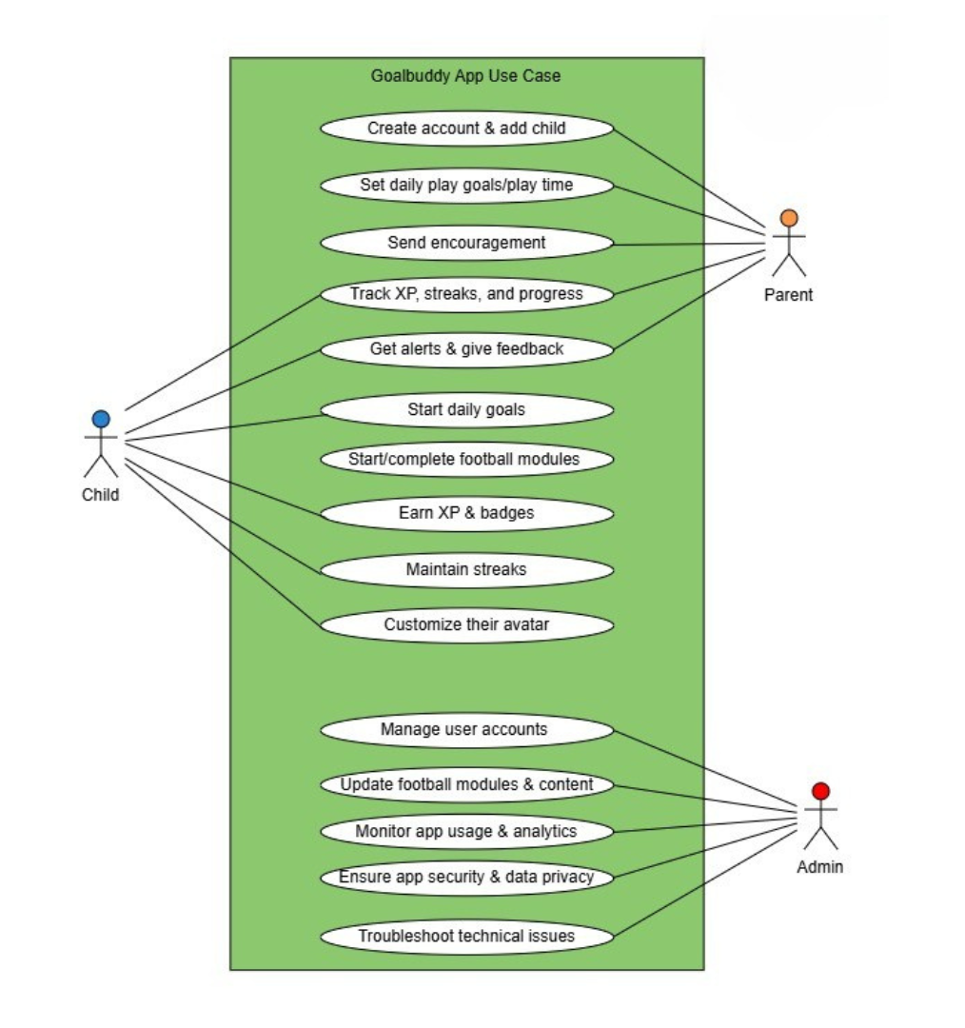
Diagram 1: GoalBudddy Use Case Diagram

3.3.2 Parent and Child User Flow
The second diagram details the application flow from both the parent and child perspectives. Upon launching the app, users are prompted to either register or log in. Parents are directed to register their child and set learning goals or playtime limits. They also send encouragement, which the child receives alongside their daily goals. Child users are guided to view their daily goal and then choose between learning modules or mini-games. Upon completing modules, they earn XP, unlock badges for meeting milestones, and view their progress. Notifications and encouragement from parents further motivate continued engagement. At the end of each cycle, parents can review performance and provide feedback, completing a feedback loop that reinforces learning and accountability.
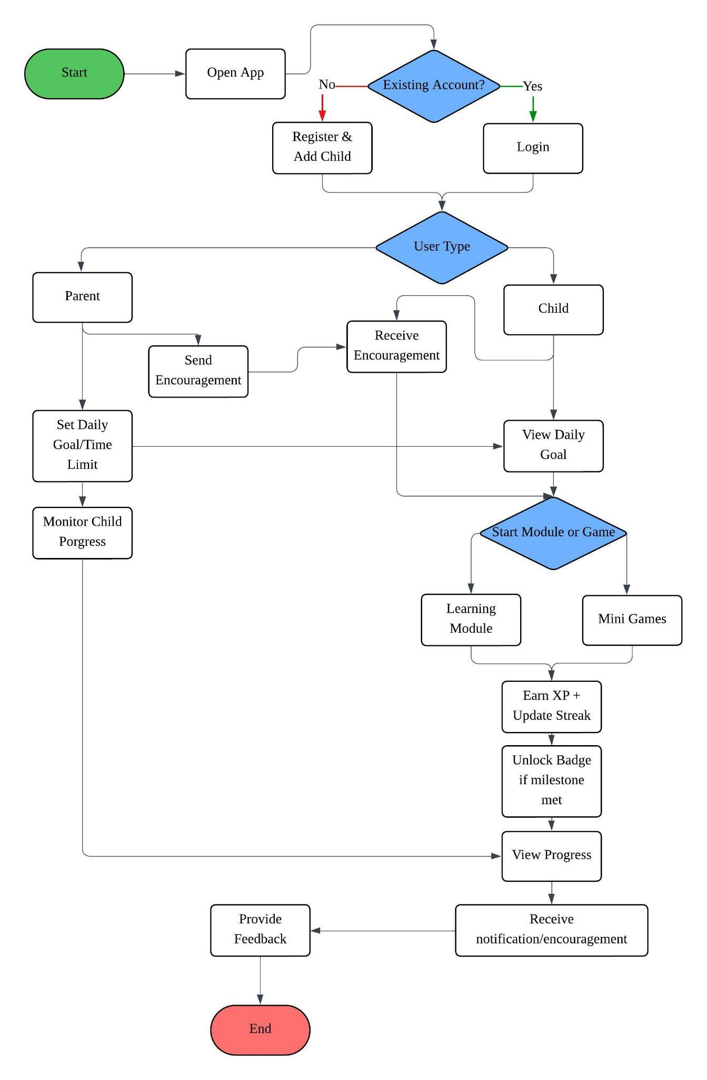
This flow supports a motivational framework through clear roles, interactive learning experiences, and positive reinforcement between parent and child.
Diagram 2:Parent and Child User Flowchart Diagram

3.3.3 Admin User Flow
The third flowchart outlines the admin’s system access and responsibilities. After a successful login, admins gain access to several key functionalities, including content management, system status monitoring, app analytics, user account management, and issue handling. Each of these tasks supports app stability, educational content updates, and secure data handling. After performing the necessary duties, the admin logs out to end the session.
The admin workflow emphasizes backend efficiency and smooth user experiences by maintaining app performance, accuracy, and security.
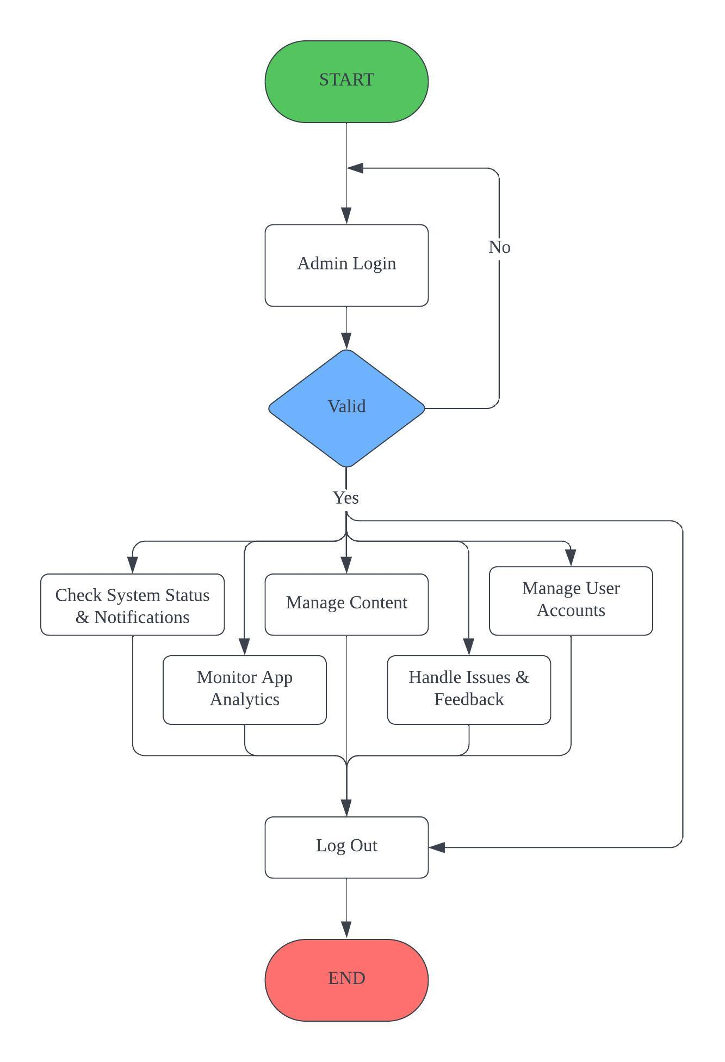
Diagram 3:Admin User Flowchart Diagram

3.4 Tools and Programming Languages
This project utilizes a range of hardware and software tools to support the development and design of the GoalBuddy App. The selection of tools was based on compatibility, ease of integration, and support for cross-platform development.

3.4.1 Hardware Requirements
The development process requires standard computing hardware and mobile devices for both development and testing purposes. The tools include:
- Desktop Computer: Used for coding, UI/UX design, and app building.
- Mobile Device (Android Smartphone): Utilized for testing the mobile application in a real-world environment to ensure responsiveness and functionality.

3.4.2 Software and Programming Tools
A variety of software tools were employed throughout the project for coding, designing, testing, and managing the mobile application. These include:
- Flutter & Dart: Flutter is the primary framework used for building the mobile app. Dart, its associated language, offers fast performance and native-like UI across Android and iOS platforms.
- Firebase: Used for cloud-based backend services such as user authentication, database management, and analytics.
- Android Studio: The official IDE for Flutter app development, used for building, debugging, and testing the app.
- Visual Studio Code: A lightweight source code editor used for Dart/Flutter scripting and project structure management.
- Figma: A collaborative UI/UX design tool used to prototype and design user interfaces for the app.
- Canva: Utilized for producing presentation materials and graphic assets in a simple and visually appealing format.
- Aseprite: A pixel art tool used to create custom illustrations, sprites, or icons used in the app, particularly for gamified content.
This combination of tools ensures a streamlined workflow from ideation to deployment, facilitating both technical implementation and design innovation.

3.5 Gantt Chart and Timeline
The development of the GoalBuddy mobile application follows a structured timeline distributed over two academic semesters (SKM4950A and SKM4950B), spanning approximately 28 weeks excluding the semester break. The project is divided into multiple phases, beginning with initial planning and ending with final presentation and testing.

3.5.1 Overview of Gantt Chart
The Gantt chart outlines ten key phases:
- PlanningRequirement and Design
- Proposal and Presentation
- Submission
- Skill and Prototype Preparation
- Sprint 1: Core App Structure + Daily Goal System
- Sprint 2: Learning Module + Feedback Integration
- Sprint 3: Mini-Games + Badge System
- Sprint 4: Refinement & Final Testing
- Final Report and Presentation
Each task is color-coded and sequenced clearly by week to demonstrate progressive development. Early phases emphasize documentation, research, and design, while later phases focus heavily on iterative development and testing.

3.5.2 Agile Methodology Implementation
This project adopts the Agile development model, where the application is developed through a series of sprints:
- Sprint 1 focuses on core app functionality, such as navigation and daily goal systems.
- Sprint 2 introduces football learning modules and basic feedback systems.
- Sprint 3 integrates gamified elements like mini-games and badge unlocking.
- Sprint 4 refines the system based on testing, including interface polishing and user experience optimization.
Each sprint incorporates user testing and feedback, promoting continuous improvement and ensuring that development remains user-centered.

3.5.3Timeline Summary
- Weeks 1–7 (SKM4950A): Emphasis on planning, requirement gathering, and UI/UX design.
- Weeks 8–14: Proposal preparation, defense, and submission.
- Semester Break: Tool learning and early UI prototyping begin.
- Weeks 1–13 (SKM4950B): Full-scale Agile development across four sprints, followed by final testing, reporting, and presentation in Week 14.
This timeline ensures balanced workload distribution and sufficient time for iterative improvement through sprint reviews and refinements.
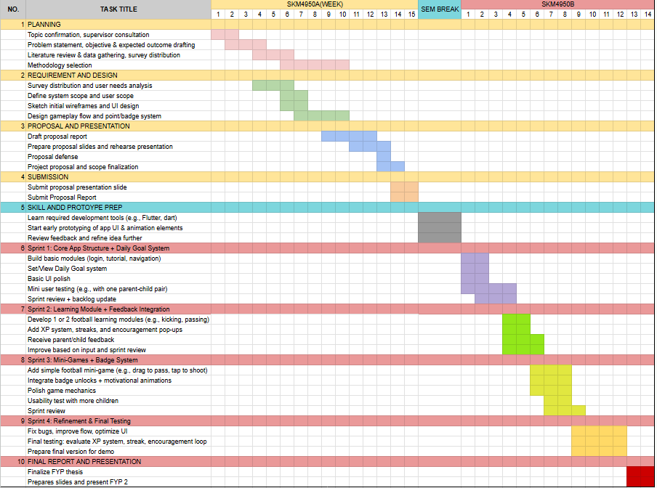
Diagram 4:Project Gantt Chart

3.6 Expected Output
The GoalBuddy project aims to produce a functional mobile application designed to support football skill development among children under the age of 8. The app is developed with gamification principles, educational content, and parental engagement features to ensure a holistic and engaging learning experience. The expected output can be described through three key deliverables:

3.6.1 A Gamified Mobile App for Football Basics
The core output of this project is a fully operational mobile application that simplifies football learning for young users. The app includes structured learning modules covering basic movements, drills, and skill-based mini-games. These modules are designed to be accessible and enjoyable for children, with progression elements such as XP (experience points), badges, and interactive challenges to sustain engagement.

3.6.2 Integrated Motor Skill Development Features
Each learning module within the app is designed to improve children’s gross motor skills through interactive gameplay. Movements such as dribbling, passing, and shooting are broken down into simplified exercises. The app provides real-time feedback and tracks user progress to measure improvements in physical performance over time. These features align with motor development frameworks, helping users build fundamental movement skills in a digital yet physically responsive manner.

3.6.3 Parental Monitoring and Engagement System
Another significant component of the app is the parental dashboard. This system enables parents to create and manage child profiles, set daily goals or playtime limits, and monitor progress across skill areas. Parents receive notifications and can send encouragement, making them active participants in their child’s development. This enhances motivation and provides a support system for continuous learning.

3.6.4 Expected Output Interface (Low-Fidelity)
A low-fidelity prototype of the app interface has been designed to visualize the expected structure and flow. Key screens include:
- Login Page: Allows account creation and secure access.
- Main Dashboard: Displays the child’s soccer journey, badges earned, and daily goal status.
- Skill Practice Module: Offers a selection of drills such as dribbling, passing, and shooting
- Rewards Page: Gamifies the learning process through achievements and redeemable items.
- Parent Dashboard: Presents child’s progress through data visualizations, skill breakdowns, and control features such as time settings.
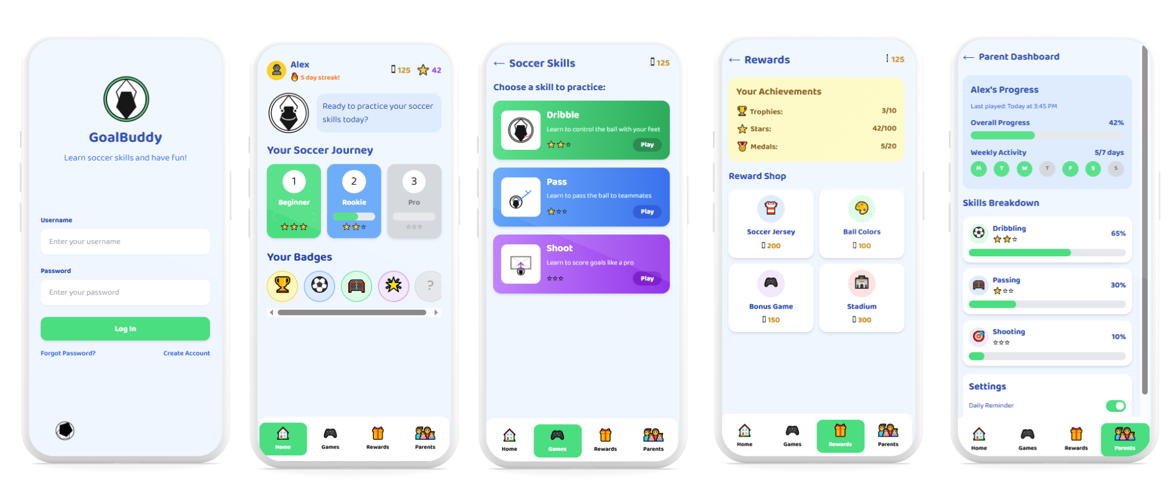
These interfaces demonstrate a child-friendly, intuitive design combined with informative components for parents. The overall output is intended to be both fun and educational, bridging digital interactivity with real-world skill development.
Diagram 5: Expected Output Interface

Reference
Qi, J., Yan, Y., & Yin, H. (2023). Screen time among school-aged children of aged 6–14: A systematic review . Global Health Research and Policy, 8(12), 1–19. https://doi.org/10.1186/s41256-023-00297-z

Moreno, D. M. N., Vázquez-Araújo, F. J., Castro, P. M., Costa, J. V., Dapena, A., & Doniz, L. G. (2021). Utilization of a Mobile Application for Motor Skill Assessment in Children . Applied Sciences, 11(2), 663. https://doi.org/10.3390/app11020663

Semartiana, N., Putri, A., & Rosmansyah, Y. (2022). A systematic literature review of gamification for children: Game elements, purposes, and technologies. International Conference on Information Science and Technology Innovation (ICoSTEC), 1(1), 72–76. https://doi.org/10.35842/icostec.v1i1.12

Vergianda, R., Fernando, R., Xiao, S., & Karsen, M. (2024). The impact of Gamification on Sport Application. 2024 International Conference on Computer Engineering, Network, and Intelligent Multimedia (CENIM), 1–6. https://doi.org/10.1109/cenim64038.2024.10882732

Conra, M. A., Marlina Siregar, N., & Setiakarnawijaya, Y. (2021). Game-based soccer training models for children aged 6-8 years. Gladi : Jurnal Ilmu Keolahragaan, 12(04), 281–290. https://doi.org/10.21009/gjik.124.07

Diekhoff, H., & Greve, S. (2023). Digital technology in game-based approaches: Video tagging in football in PE. Physical Education and Sport Pedagogy, 1–13. https://doi.org/10.1080/17408989.2023.2256758
Suzuki, S., Amemiya, Y., & Sato, M. (2020). Deep Learning Assessment of Child gross-motor. 2020 13th International Conference on Human System Interaction (HSI), 189–194. https://doi.org/10.1109/hsi49210.2020.9142684

Hurtado-Almonacid, J., Reyes-Amigo, T., Yáñez-Sepúlveda, R., Cortés-Roco, G., Oñate-Navarrete, C., Olivares-Arancibia, J., & Páez-Herrera, J. (2024). Development of Basic Motor Skills from 3 to 10 Years of Age: Comparison by Sex and Age Range in Chilean Children. Children, 11(6), 715. https://doi.org/10.3390/children11060715

A. M. Emam, O. Tarek Ali and A. Atia. (2023) "Football activities classification," 2023 Intelligent Methods, Systems, and Applications (IMSA), Giza, Egypt,, pp. 520-525, https://doi.org/10.1109/IMSA58542.2023.10217464

Grygus, I., Gamma, T., Godlevskyi, P., Zhuk, M., & Zukow, W. (2024). Methodological aspects of developing motor skills in children of different ages during football club activities. Journal of Education Health and Sport, 64, 55525. https://doi.org/10.12775/jehs.2024.64.55525
Zhang, Y., Wainwright, N., Goodway, J. D., John, A., Stevenson, A., Thomas, K., Jenkins, S., Layas, F., & Piper, K. (2024). MiniMovers: An initial pilot and feasibility study to investigate the impact of a mobile application on children’s motor skills and parent support for physical development. Children, 11(1), 99. https://doi.org/10.3390/children11010099

