SCALABLE E-COMMERCE
BIG DATA ENGINEERING PLATFORM
End-to-End Data Lake, Spark ETL, Dimensional Modeling, and Hive Analytics

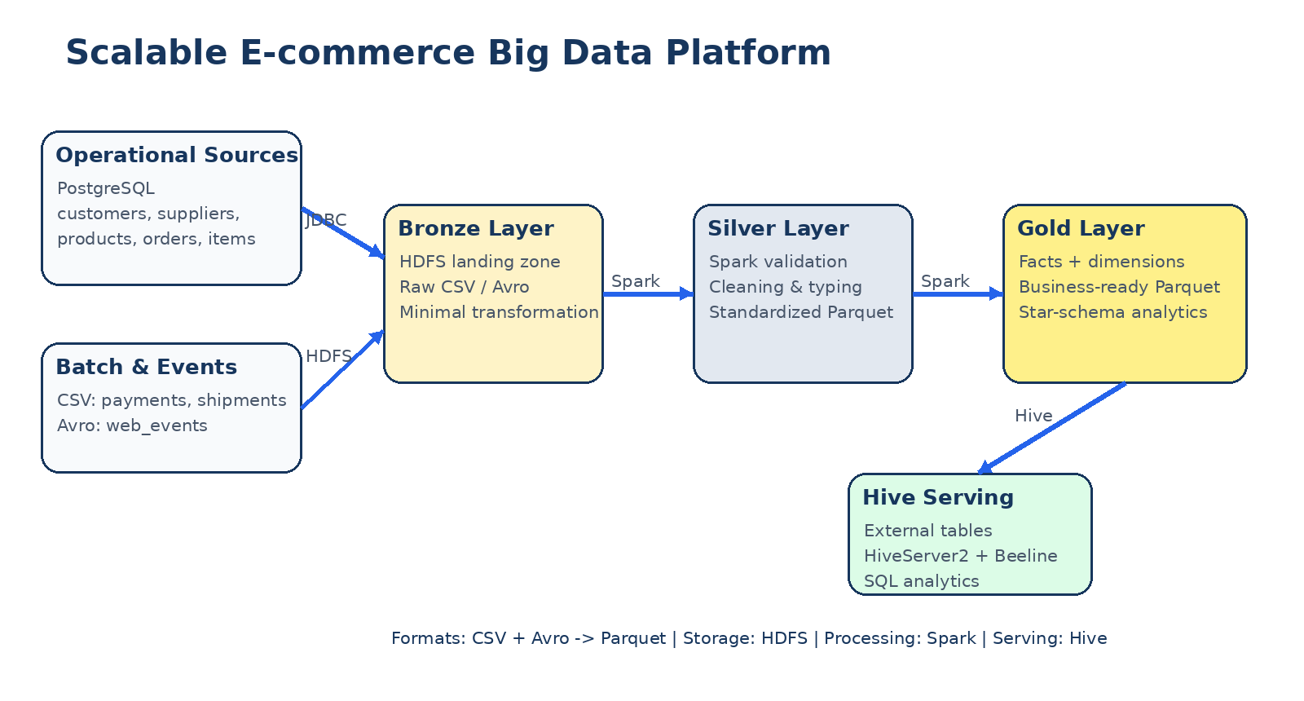
Portfolio Project Documentation
Technologies: PostgreSQL • Docker • Hadoop HDFS • Apache Spark • PySpark • Avro • Parquet • Apache Hive • SQL • Linux

Table of Contents
1. Executive Summary
2. Project Objectives
3. Technology Stack
4. End-to-End Architecture
5. Synthetic Data Generation
6. Environment and Connectivity
7. Bronze Layer
8. Silver Layer
9. PostgreSQL JDBC Ingestion
10. Gold Layer and Dimensional Model
11. Hive Serving Layer
12. Validation and Scale Results
13. Analytical Workloads
14. Engineering Challenges Solved
15. Repository Structure
16. How to Reproduce the Project
17. Portfolio Achievements
18. Future Improvements
19. Conclusion

1. Executive Summary
This project implements a production-style e-commerce Big Data platform that generates, ingests, cleans, standardizes, models, stores, and analyzes tens of millions of synthetic records across multiple source systems and file formats. The implementation demonstrates the complete lifecycle of a data engineering pipeline from source generation to SQL analytics.
- Operational data is generated into PostgreSQL: customers, suppliers, products, orders, and order_items.
- Batch data is generated as CSV: payments and shipments.
- Behavioral event data is generated as Avro: web_events.
- Raw batch and event files are stored in an HDFS Bronze landing layer.
- Apache Spark performs validation, cleaning, type normalization, and Parquet conversion in the Silver layer.
- Large PostgreSQL tables are ingested with partitioned JDBC reads for parallelism.
- Spark builds a Gold layer containing dimensions and fact tables for analytical workloads.
- Apache Hive exposes the Gold Parquet datasets as external tables through HiveServer2/Beeline.
- The final fact_sales table contains 15,004,502 rows and supports multi-dimensional SQL analysis.

2. Project Objectives
- Design a complete multi-source Big Data pipeline rather than a single ETL script.
- Work with a dataset large enough to exercise Spark, HDFS, Parquet, Hive, and parallel JDBC ingestion.
- Demonstrate Medallion-style Bronze, Silver, and Gold data layers.
- Preserve data relationships and realistic e-commerce business logic across generated sources.
- Introduce controlled data-quality noise to make validation and cleaning meaningful.
- Build fact and dimension tables suitable for SQL analytics and BI-style use cases.
- Produce a reproducible portfolio project with measurable scale and documented evidence.

3. Technology Stack
Layer / Capability | Technology
Data generation | Python, Faker-style synthetic generation logic
Operational database | PostgreSQL in Docker
Distributed storage | Apache Hadoop HDFS
Processing engine | Apache Spark 4.1.1 / PySpark
File formats | CSV, Avro, Parquet
Data warehouse / SQL serving | Apache Hive 4.2.1, HiveServer2, Beeline
Execution / query engine support | Apache Tez
Connectivity | JDBC, TCP network connectivity
Environment | Linux VM on VMware + Windows host
Languages | Python, SQL, Scala shell for inspection, Bash

4. End-to-End Architecture
Figure 1. End-to-end architecture of the e-commerce Big Data platform.
The architecture separates raw storage, standardized data, business-ready data, and query serving. The separation makes the pipeline easier to reason about, rerun, validate, and extend.
PostgreSQL + CSV + Avro
↓
Bronze Layer (HDFS Landing)
↓
Apache Spark Validation / Cleaning
↓
Silver Layer (Standardized Parquet)
↓
Spark Joins / Business Logic / Dimensional Modeling
↓
Gold Layer (Facts + Dimensions)
↓
Hive External Tables
↓
SQL Analytics

5. Synthetic Data Generation
A custom Python generator was built to create a coherent e-commerce workload across database tables and external files. The generator maintains key relationships between customers, orders, products, payments, shipments, and events while also injecting controlled quality issues.

5.1 Generated Datasets
Dataset | Source type | Scale
customers | PostgreSQL | 1,000,000
suppliers | PostgreSQL | 5,000
products | PostgreSQL | 50,000
orders | PostgreSQL | 5,000,000
order_items | PostgreSQL | 15,004,502 observed
payments | CSV | ~4.4 million
shipments | CSV | ~3.6 million
web_events | Avro | ~17 million

5.2 Controlled Data Quality Noise
- Whitespace variations
- Case variations
- Optional null fields
- Duplicate web events
- Late-arriving events
This design makes the pipeline more realistic by requiring explicit cleaning and validation instead of processing perfectly clean synthetic data.

6. Environment and Connectivity
The platform spans two environments. PostgreSQL runs inside Docker on the Windows host while the Hadoop/Spark/Hive stack runs inside a Linux VM. This required explicit network connectivity and JDBC configuration.
Component | Address / Port
Windows host / PostgreSQL endpoint | 192.168.161.1:5433
Hadoop/Spark VM | 192.168.161.128
PostgreSQL database | ecommerce
HiveServer2 | localhost:10000
nc -zv 192.168.161.1 5433
# Result: Connected to 192.168.161.1:5433
The PostgreSQL container was exposed on host port 5433 because another PostgreSQL environment already occupied the default 5432 port.

7. Bronze Layer
The Bronze layer is the raw HDFS landing area. CSV and Avro files are copied into HDFS with minimal transformation. This preserves source fidelity and creates a reproducible ingestion boundary.
/data/ecommerce/landing/
├── avro/web_events/
└── csv/
├── payments/
└── shipments/
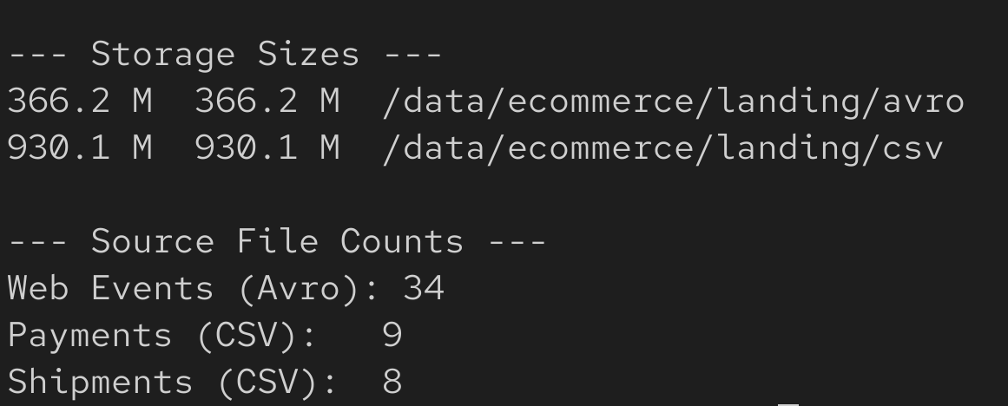
Figure 2. Bronze layer summary showing raw storage size and source file counts.
Observed Bronze storage: 366.2 MB of Avro and 930.1 MB of CSV data, totaling approximately 1.27 GB. The landing layer contains 34 Avro event files, 9 payment CSV files, and 8 shipment CSV files.

8. Silver Layer
The Silver layer contains cleaned, standardized, typed Parquet datasets. Spark reads raw CSV/Avro data and PostgreSQL tables, applies validation and normalization, and writes analytics-friendly Parquet output.

8.1 Standardization Operations
- Trim string fields and normalize selected categorical fields with upper-case transformations.
- Convert raw timestamps to Spark timestamp types.
- Validate primary identifiers and required foreign-key-like references.
- Reject invalid records into a separate rejected area where applicable.
- Convert source data into Parquet for columnar analytical access.
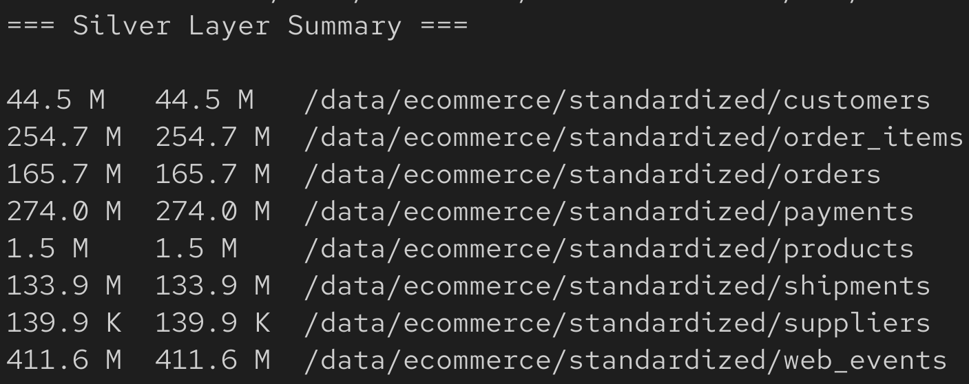
Figure 3. Silver layer HDFS datasets and storage sizes.
Silver dataset | HDFS size
customers | 44.5 MB
order_items | 254.7 MB
orders | 165.7 MB
payments | 274.0 MB
products | 1.5 MB
shipments | 133.9 MB
suppliers | 139.9 KB
web_events | 411.6 MB
The Silver layer is approximately 1.26 GB and provides a consistent Parquet-based foundation for downstream transformations.

9. PostgreSQL JDBC Ingestion

9.1 Connectivity and Driver
jdbc:postgresql://192.168.161.1:5433/ecommerce
spark-submit \
--packages org.postgresql:postgresql:42.7.7 \
postgres_ingestion.py
The initial connectivity test successfully loaded the entire customers table and returned 1,000,000 rows through Spark JDBC.

9.2 Parallel JDBC for Large Tables
The large orders and order_items tables were not left as single-stream JDBC reads. Spark JDBC range partitioning was used to create multiple database read partitions and improve ingestion scalability.
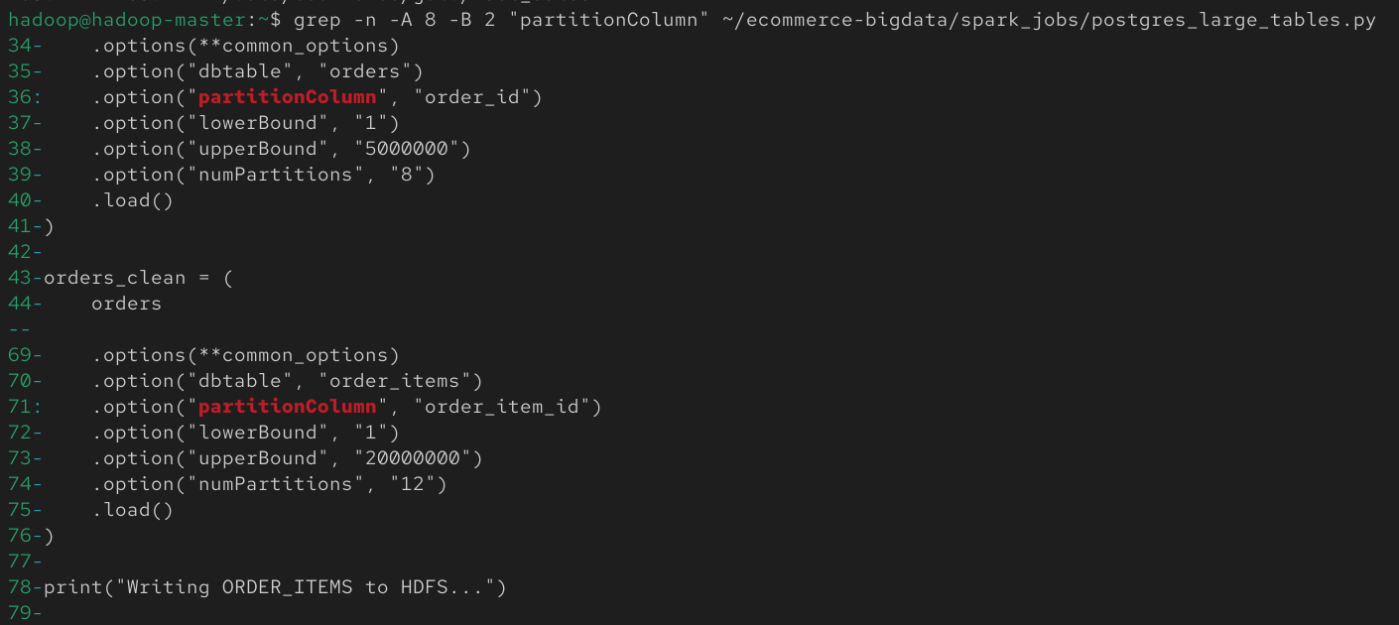
Figure 4. Parallel JDBC configuration: 8 partitions for orders and 12 for order_items.
- orders: partitioned by order_id across 8 Spark JDBC partitions.
- order_items: partitioned by order_item_id across 12 Spark JDBC partitions.
- fetchsize was configured to reduce round trips during JDBC reads.

10. Gold Layer and Dimensional Model
The Gold layer transforms standardized records into business-ready analytical structures. It contains dimension tables for descriptive context and fact tables for measurable business processes.
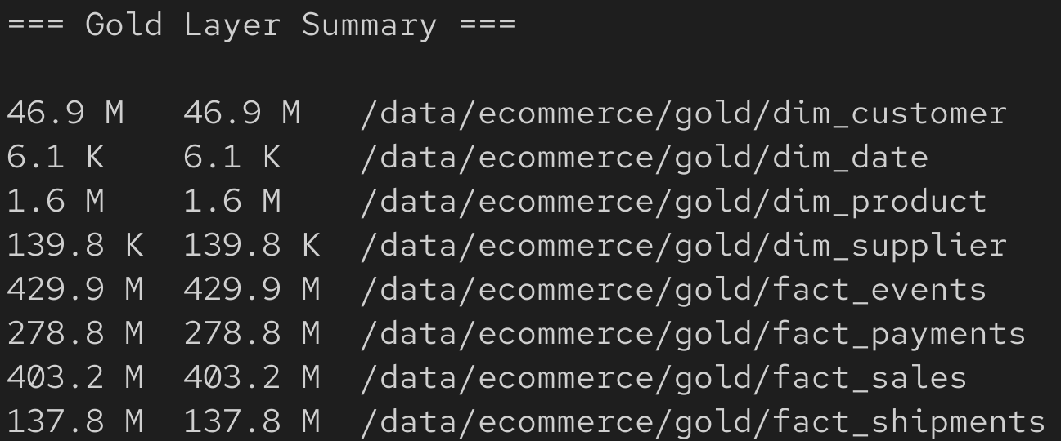
Figure 5. Gold layer HDFS datasets and storage sizes.

10.1 Gold Tables
Dimensions | Fact tables
dim_customer | fact_sales
dim_product | fact_payments
dim_supplier | fact_shipments
dim_date | fact_events

10.2 fact_sales Design
fact_sales is built by joining order_items with orders and products. It carries dimension keys and core measures such as quantity, unit_price, and line_total.
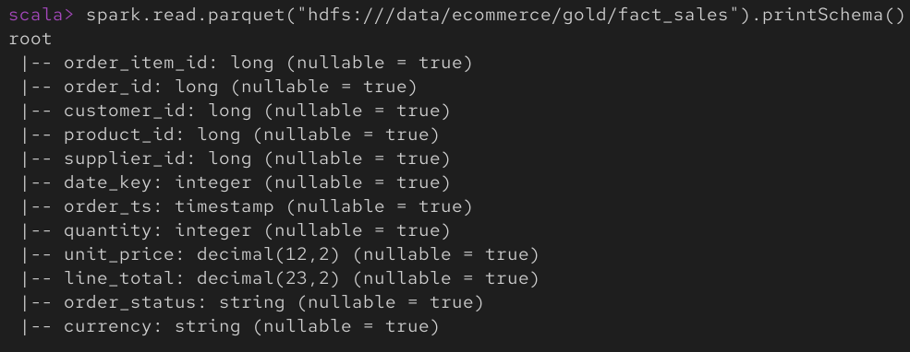
Figure 6. Spark schema of the Gold fact_sales Parquet dataset.
line_total = quantity × unit_price
date_key format = YYYYMMDD

11. Hive Serving Layer
Hive provides the SQL serving layer over the Gold Parquet data. External tables were created, which means Hive stores metadata while the physical data remains in HDFS. This avoids unnecessary duplication.
CREATE DATABASE ecommerce_dw;
USE ecommerce_dw;
CREATE EXTERNAL TABLE fact_sales (...)
STORED AS PARQUET
LOCATION '/data/ecommerce/gold/fact_sales';
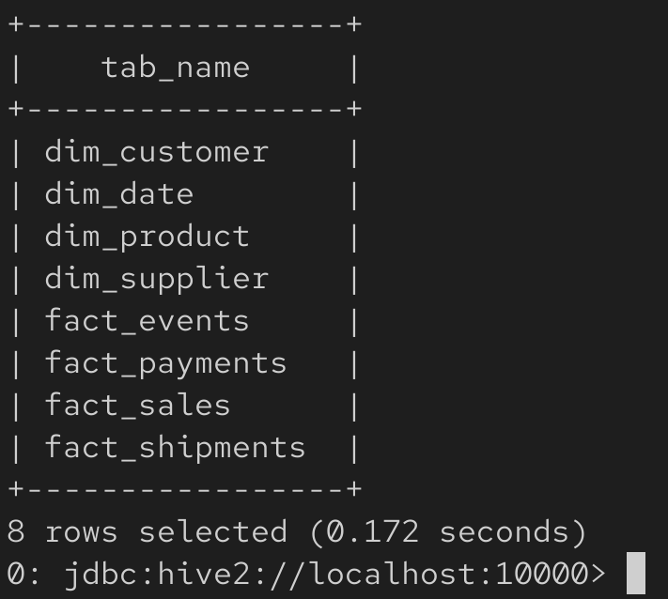
Figure 7. Hive ecommerce_dw database with all eight Gold external tables registered.
- dim_customer
- dim_date
- dim_product
- dim_supplier
- fact_events
- fact_payments
- fact_sales
- fact_shipments

12. Validation and Scale Results
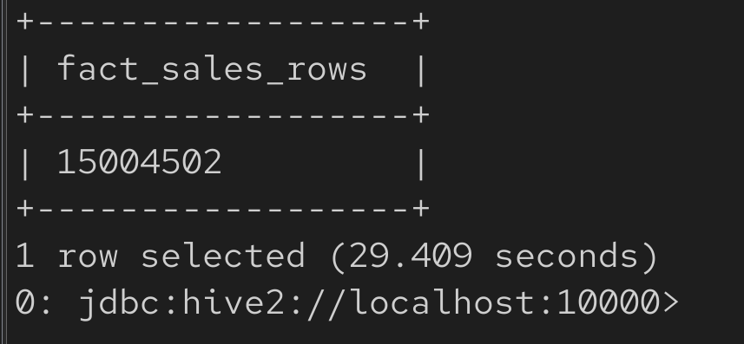
Figure 8. Hive validation query confirming 15,004,502 rows in fact_sales.
Validation checkpoint | Result
PostgreSQL network connectivity | Passed
Spark JDBC connectivity | Passed
Customers loaded through JDBC | 1,000,000 rows
CSV ingestion | Passed
Avro ingestion | Passed
Silver Parquet generation | Passed
Gold transformation | Passed
HiveServer2 connectivity | Passed
Hive external tables | 8 tables created
fact_sales Hive row count | 15,004,502

13. Analytical Workloads
The completed platform supports multi-dimensional SQL analytics directly from Hive. A representative workload aggregates sales by year and month, returning revenue, units sold, and order counts.
SELECT
d.year,
d.month,
ROUND(SUM(f.line_total), 2) AS total_revenue,
SUM(f.quantity) AS units_sold,
COUNT(DISTINCT f.order_id) AS orders_count
FROM fact_sales f
JOIN dim_date d ON f.date_key = d.date_key
GROUP BY d.year, d.month
ORDER BY d.year, d.month;
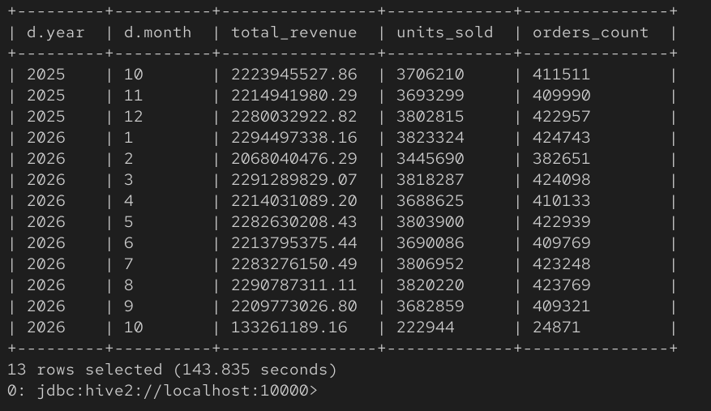
Figure 9. Monthly sales analysis executed in Hive across the 15M-row sales fact table.
The query returned 13 monthly periods and demonstrates a join between a large fact table and the date dimension, aggregation of decimal revenue, unit totals, and distinct order counts.

14. Engineering Challenges Solved
Challenge | Implemented solution
Multi-source ingestion | Integrated PostgreSQL, CSV, and Avro in one pipeline.
Host/VM networking | Connected Spark in a Linux VM to PostgreSQL in Docker on Windows.
PostgreSQL port conflict | Mapped the e-commerce database to host port 5433.
Spark Avro dependency | Loaded the Spark Avro module matching Spark 4.1.1 / Scala 2.13.
Large JDBC tables | Introduced partitioned JDBC reads for orders and order_items.
Storage efficiency | Converted data into Parquet for Silver and Gold layers.
Analytical modeling | Built dimensions and fact tables rather than exposing operational schemas directly.
SQL serving | Registered Gold data as Hive external tables without duplicating HDFS data.

15. HDFS Data Lake Structure
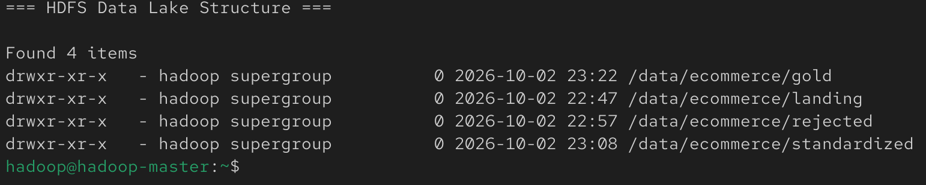
Figure 10. HDFS project structure showing landing, rejected, standardized, and gold areas.
/data/ecommerce/
├── landing/ # Bronze
├── rejected/ # Invalid / rejected records
├── standardized/ # Silver
└── gold/ # Business-ready facts and dimensions

16. Repository Structure
ecommerce-bigdata-pipeline/
├── README.md
├── .gitignore
├── data-generator/
│ ├── config/
│ ├── docker/
│ ├── sql/
│ ├── src/
│ ├── requirements.txt
│ ├── run.py
│ └── validate_generated_data.py
├── spark/
│ ├── ingestion.py
│ ├── postgres_ingestion.py
│ ├── postgres_large_tables.py
│ └── gold_transform.py
├── hive/
│ ├── create_gold_tables.hql
│ └── analytics_queries.hql
├── sample-data/
└── docs/
└── screenshots/
Large raw datasets should normally be excluded from the Git repository. The repository should contain source code, reproducible generator logic, a small representative sample, SQL/Hive definitions, architecture material, and screenshots.

17. How to Reproduce the Project
- Start PostgreSQL with Docker and generate the synthetic source data.
- Start HDFS and YARN using start-dfs.sh and start-yarn.sh.
- Create Bronze landing directories in /data/ecommerce/landing.
- Upload generated CSV and Avro files to HDFS.
- Run Spark ingestion with the spark-avro package to create Silver Parquet datasets for CSV/Avro sources.
- Run PostgreSQL JDBC ingestion and the parallel JDBC job for orders/order_items.
- Validate the Silver layer with hdfs dfs -du -h /data/ecommerce/standardized.
- Run gold_transform.py to build dimensions and facts.
- Start HiveServer2 and connect using Beeline.
- Create the ecommerce_dw database and Gold external tables.
- Run validation and analytical SQL queries.

18. Portfolio Achievements
- Built an end-to-end Big Data platform spanning source generation, data lake storage, distributed ETL, dimensional modeling, and SQL analytics.
- Processed more than 40 million logical records across operational, batch, and event sources.
- Ingested a 5-million-row orders table and ~15-million-row order_items table using partitioned JDBC reads.
- Implemented Bronze, Silver, and Gold layers in HDFS.
- Integrated CSV, Avro, PostgreSQL, Parquet, Spark, and Hive in one reproducible workflow.
- Created a business-ready star-style analytical model with four dimensions and four fact tables.
- Validated a 15,004,502-row sales fact table through Hive.
- Executed multi-dimensional monthly revenue and volume analytics through HiveServer2.

19. Future Improvements
- Incremental ingestion and high-watermark processing instead of full overwrite jobs.
- CDC for PostgreSQL sources and Kafka for event streaming.
- Spark Structured Streaming for near-real-time event ingestion.
- Workflow orchestration with Apache Airflow.
- Partitioned Gold fact tables by date and file compaction for improved query performance.
- Automated data-quality checks with rejection reasons and quality metrics.
- Canonical normalization of business dimensions such as product category casing.
- Open table formats such as Apache Iceberg, Delta Lake, or Hudi.
- BI dashboards and cloud/object-storage deployment.
- CI/CD, automated tests, data lineage, and metadata catalog integration.

20. Conclusion
The project successfully demonstrates the core responsibilities of a Big Data / Data Engineer: creating and understanding source systems, moving data across environments, designing scalable ingestion, validating and standardizing data, choosing efficient storage formats, building analytical models, and exposing data through a SQL serving layer. The final implementation is not only a set of isolated exercises; it is a connected end-to-end platform with measurable scale, reproducible code, and documented evidence of successful execution.
Generate → Ingest → Store → Validate → Standardize → Transform → Model → Serve → Analyze

