SUPERSTORE ELT PIPELINE
Full Technical Documentation
Apache Airflow (Astronomer Astro) • dbt • DuckDB • Python
Dataset: Sample Superstore | 9,994 records | 21 source columns
Project status: End-to-end pipeline successfully executed in Airflow
Prepared: 02 October 2026

Document Control
Item | Details
Project | Superstore ELT Pipeline
Purpose | Build and orchestrate a local analytical data pipeline using DuckDB, dbt, and Apache Airflow.
Source | Superstore.xlsx / raw_superstore.csv
Warehouse | DuckDB (dev.duckdb)
Transformation | dbt Core with dbt-duckdb adapter
Orchestration | Apache Airflow 3.x running through Astronomer Astro CLI and Docker Desktop
Final validation | Airflow DAG completed successfully: load → dbt debug → dbt build

Contents
- 1. Executive Summary
- 2. Project Objectives and Scope
- 3. Technology Stack
- 4. Source Dataset
- 5. System Architecture
- 6. Data Ingestion and ODS Layer
- 7. dbt Transformation Layer
- 8. Data Warehouse Model
- 9. Data Quality and Testing
- 10. Airflow / Astro Orchestration
- 11. Windows and Docker Setup
- 12. Issues Encountered and Resolutions
- 13. Execution and Validation Evidence
- 14. Operating Procedure
- 15. Project Structure
- 16. Key SQL and Validation Queries
- 17. Deliverables and Conclusion

1. Executive Summary
This project implements a complete local ELT (Extract, Load, Transform) pipeline for the Sample Superstore dataset. The pipeline loads the source data into DuckDB, transforms and validates it with dbt, models it as an analytical star schema, and orchestrates the workflow with Apache Airflow running through Astronomer Astro and Docker Desktop.
The final workflow was executed successfully from the Airflow user interface. All three orchestration tasks completed with a success state: loading the source into DuckDB, validating the dbt environment and database connection, and building all dbt models and tests.
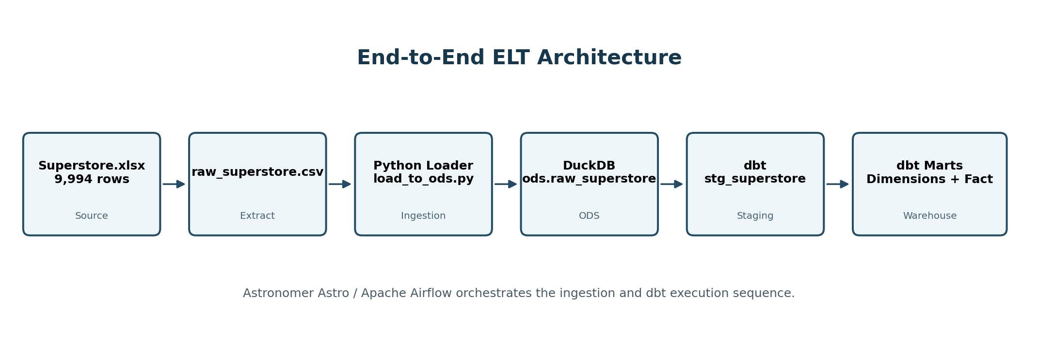
Figure 1. End-to-end architecture of the Superstore ELT pipeline.

2. Project Objectives and Scope

2.1 Objectives
- Replace the original project dataset with the Sample Superstore dataset.
- Use DuckDB as the local analytical database and persistent warehouse file.
- Implement transformations in dbt rather than embedding business logic in the ingestion script.
- Create a clean staging layer and a dimensional warehouse model.
- Add automated data-quality tests for keys, required fields, and relationships.
- Use Apache Airflow to orchestrate the ingestion and transformation steps.
- Run Airflow in Docker using Astronomer Astro for a reliable Windows development workflow.

2.2 Scope
The implementation is a local development pipeline. It focuses on reproducible ingestion, SQL transformation, dimensional modeling, testing, and orchestration. Production cloud deployment, user authentication, data catalog integration, and BI dashboard development are outside the current scope.

3. Technology Stack
Technology | Role | Version observed | Why it is used
Python | Ingestion script and local runtime | 3.12.10 locally; container runtime uses Python 3.14.x | Executes the loader and supporting commands.
DuckDB | Embedded analytical database | 1.5.6 | Fast local OLAP engine stored as a single file.
dbt Core | Transformation, modeling and tests | 1.12.5 | Turns SQL transformations into managed, testable data models.
dbt-duckdb | dbt adapter for DuckDB | 1.11.0 | Connects dbt to dev.duckdb.
Apache Airflow | Workflow orchestration | 3.x (Astro Runtime) | Controls task order, retries, logs, status and manual execution.
Astronomer Astro CLI | Local Airflow development | 1.45.0 observed | Builds and runs Airflow using Docker containers.
Docker Desktop / Compose | Container runtime | Docker 29.7.2; Compose v5.5.0 | Provides a Linux environment on Windows for Airflow.

4. Source Dataset
The source workbook contains one worksheet named “Sample - Superstore”. The first row contains 21 source fields and the workbook contains 9,994 data records (9,995 worksheet rows including the header).
Group | Source columns | Use in warehouse
Order / logistics | Row ID, Order ID, Order Date, Ship Date, Ship Mode | Fact grain, date keys and shipping analysis
Customer | Customer ID, Customer Name, Segment | Customer dimension
Geography | Country, City, State, Postal Code, Region | Location dimension
Product | Product ID, Category, Sub-Category, Product Name | Product dimension
Measures | Sales, Quantity, Discount, Profit | Fact measures and profitability metrics

5. System Architecture
The solution uses a layered architecture so that ingestion, cleaning, dimensional modeling, and orchestration are separated. This makes the project easier to test, explain, rerun, and extend.
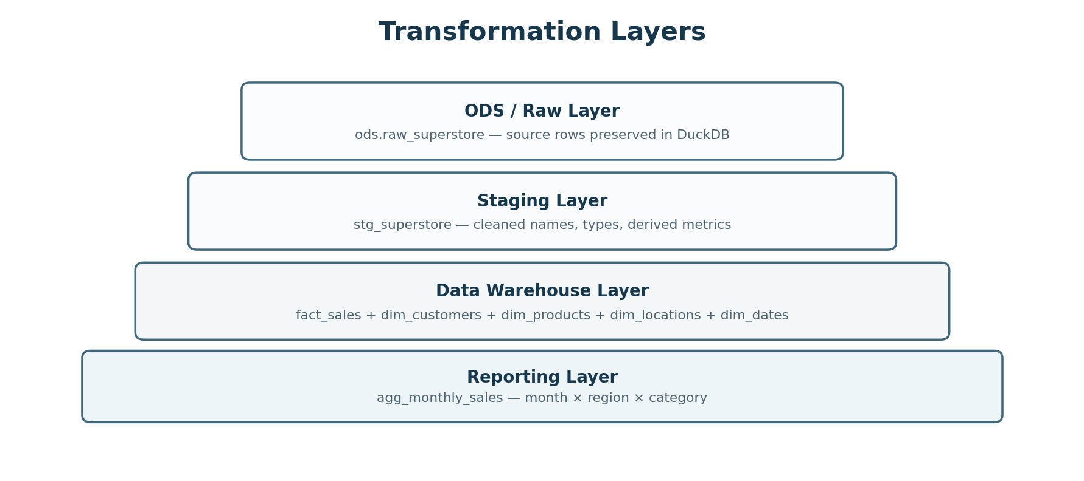
Figure 2. Logical data layers used in the project.

5.1 Processing Flow
- The source workbook is represented by a stable CSV extract for deterministic ingestion.
- A Python loader creates or replaces the raw DuckDB ODS table.
- dbt reads the ODS table through a declared source and builds a cleaned staging view.
- dbt materializes dimensional tables, a fact table, and a monthly aggregate table.
- Airflow orchestrates the sequence and captures execution status and logs.

6. Data Ingestion and ODS Layer

6.1 Loader Script
The ingestion script is scripts/load_to_ods.py. It connects to dev.duckdb in the project root, creates the ods schema if required, reads the CSV with DuckDB read_csv_auto, and replaces ods.raw_superstore. The script then counts the loaded rows and prints the result.
PROJECT_ROOT = Path(__file__).resolve().parent.parent
DB_PATH = PROJECT_ROOT / "dev.duckdb"
CSV_PATH = PROJECT_ROOT / "data" / "raw" / "raw_superstore.csv"

con = duckdb.connect(str(DB_PATH))
con.execute("CREATE SCHEMA IF NOT EXISTS ods")

CREATE OR REPLACE TABLE ods.raw_superstore AS
SELECT *
FROM read_csv_auto(<csv_path>, header = true, sample_size = -1)
Observed successful load result: “Loaded ods.raw_superstore: 9994 rows”. This confirms that the ODS row count matches the 9,994 source records.

6.2 Why an ODS Layer is Used
- Preserves a raw-like copy of the source before business transformations.
- Creates a stable dbt source object inside the database.
- Separates extraction/loading concerns from SQL transformation logic.
- Allows the raw table to be reloaded independently from downstream models.

7. dbt Transformation Layer

7.1 dbt Project Configuration
The dbt project is named superstore and uses the superstore profile. The staging folder is configured as views, while the marts folder is configured as tables. The DuckDB profile points to ../dev.duckdb and uses four threads.
models:
superstore:
staging:
+schema: stg
+materialized: view
marts:
+schema: dwh
+materialized: table

7.2 Staging Transformations
stg_superstore standardizes the raw source. The transformation intentionally keeps one row per original Superstore line item while improving names, types and analytical usability.
Transformation | Example | Purpose
Rename to snake_case | "Order ID" → order_id | Consistent SQL naming convention.
Explicit type casting | Sales → DECIMAL(18,4); Quantity → INTEGER | Prevents ambiguous source typing.
Text normalization | TRIM on IDs, names, category, region, etc. | Removes surrounding whitespace.
Postal-code handling | Pad numeric postal code to 5-character text | Preserves leading zeros.
Shipping duration | date_diff(day, order_date, ship_date) | Creates shipping_days.
Profitability flag | profit > 0 | Creates is_profitable Boolean.
Profit margin | profit / sales, rounded to 4 decimals | Creates reusable profit_margin metric; zero sales returns NULL.

8. Data Warehouse Model
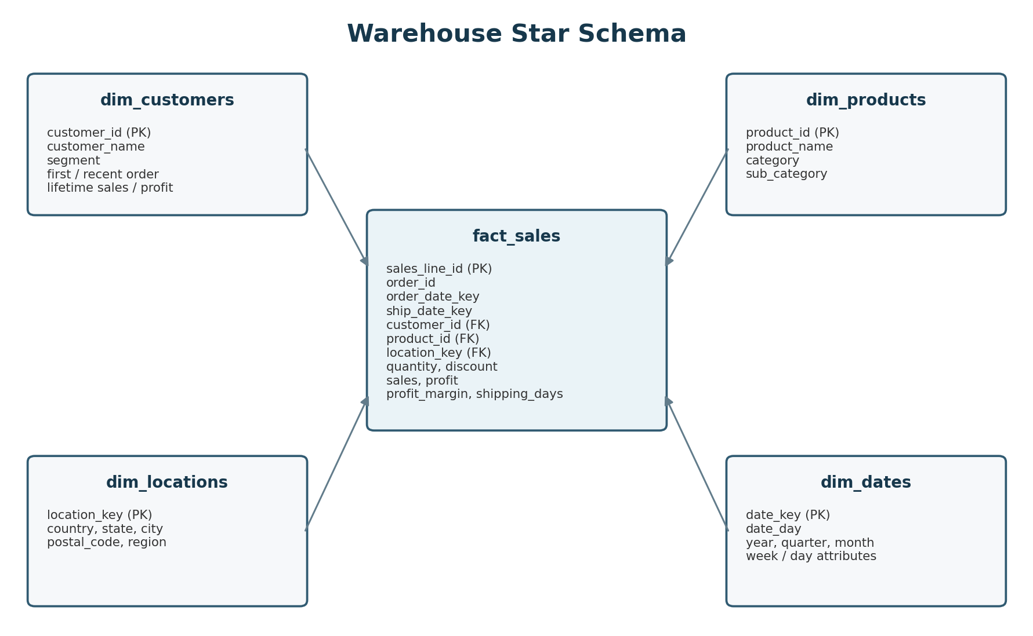
Figure 3. Star-schema model produced by dbt.

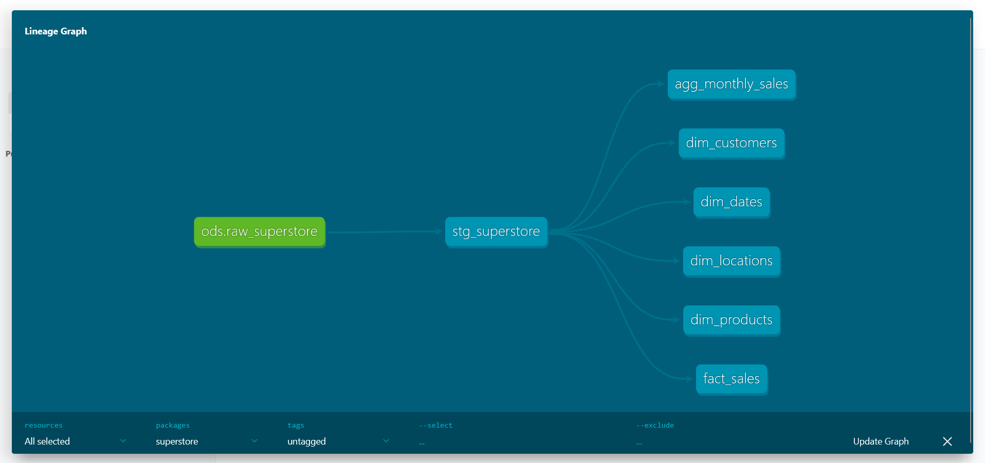

8.1 fact_sales
The fact table is at sales-line grain. sales_line_id is derived from the original Row ID and is used as the unique row identifier. It includes order identifiers and date keys, foreign keys to customer, product and location dimensions, logistics attributes, and quantitative measures.
- Measures: quantity, discount, sales, profit, profit_margin and shipping_days.
- Flags: is_profitable.
- Keys: customer_id, product_id, location_key, order_date_key and ship_date_key.

8.2 dim_customers
One row per customer_id. In addition to customer name and segment, the model derives first order date, most recent order date, number of distinct orders, lifetime sales and lifetime profit.

8.3 dim_products
One row per product_id with representative product name, category and sub-category attributes.

8.4 dim_locations
One row per unique geographic combination. The primary key is an MD5 hash of country, state, city, postal code and region, which provides a stable compact location_key for fact-table joins.

8.5 dim_dates
A generated calendar covering the earliest order date through the latest ship date. date_key follows YYYYMMDD integer format and exposes year, quarter, month, month name, day-of-month, day-of-week and week-of-year attributes.

8.6 agg_monthly_sales
A reporting-oriented aggregate grouped by month, region and category. It contains distinct order count, units sold, total sales, total profit and aggregate profit margin. This table reduces repeated grouping work for common monthly reporting queries.

9. Data Quality and Testing
dbt tests are defined as part of the model metadata and run during dbt build. The successful manual build discovered 7 models, 23 data tests and 1 source. The completed run reported PASS=30, WARN=0, ERROR=0, SKIP=0.
Test type | Applied to | What it protects
not_null | Staging IDs/dates/sales and warehouse keys | Required analytical fields are present.
unique | row_id, customer_id, product_id, location_key, date_key, sales_line_id | Dimension/fact keys remain unique.
relationships | fact_sales.customer_id/product_id/location_key → dimensions | Prevents orphan foreign keys and validates referential integrity.

10. Airflow / Astro Orchestration
Apache Airflow is run through Astronomer Astro rather than installed natively on Windows. Astro builds a Linux container environment through Docker Desktop, giving Airflow a supported Linux runtime and isolating its dependencies from the Windows virtual environment.
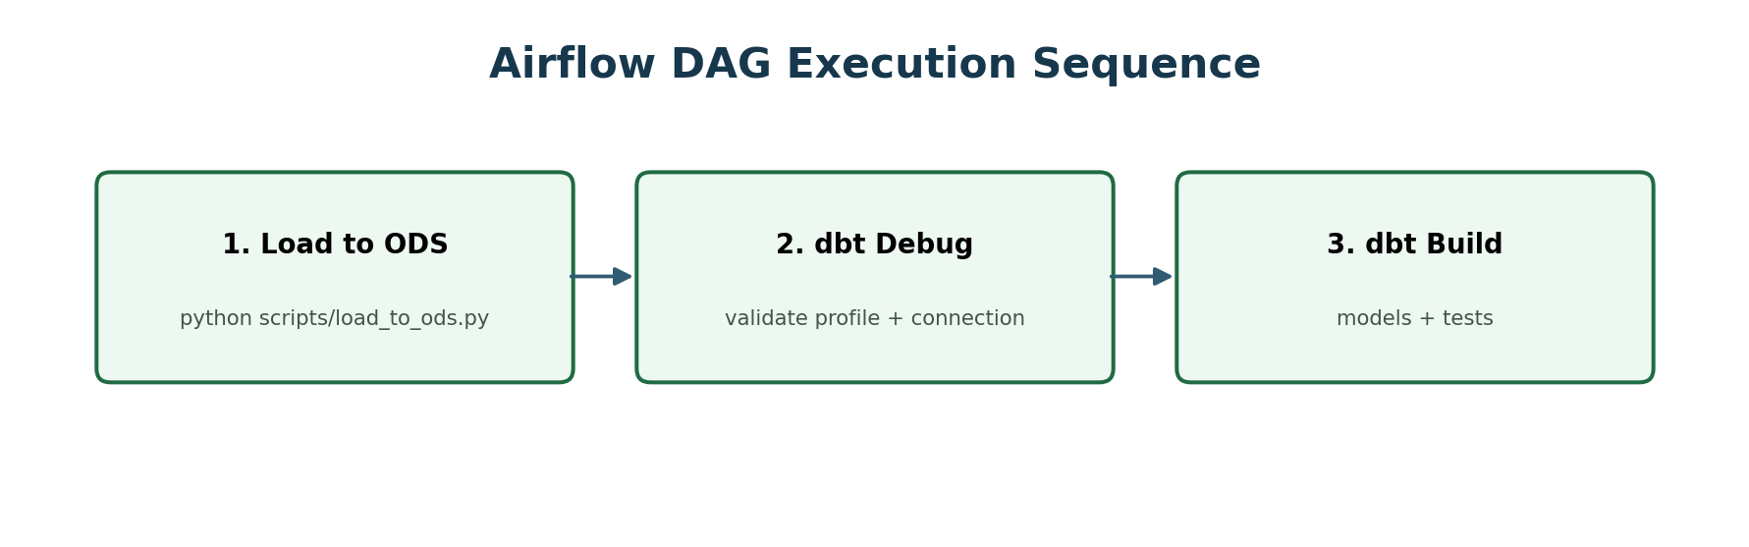
Figure 4. Final Airflow task dependency sequence.

10.1 Final DAG Logic
The final development DAG uses three BashOperator tasks in sequence:
- load_superstore_to_duckdb — executes the Python ingestion script and refreshes the ODS table.
- dbt_debug — validates profiles.yml, dbt_project.yml, adapter setup, git availability, and DuckDB connectivity.
- dbt_build — executes all dbt models and tests.

10.2 dbt Runtime Paths in Airflow
Inside the Astro container, dbt initially failed because the copied project directory was not writable for dbt logs. The DAG was updated to route dbt log and target output to writable /tmp locations using DBT_LOG_PATH and DBT_TARGET_PATH.
mkdir -p /tmp/dbt_logs /tmp/dbt_target
DBT_LOG_PATH=/tmp/dbt_logs DBT_TARGET_PATH=/tmp/dbt_target dbt build --profiles-dir .

11. Windows and Docker Setup
The project was developed from Windows PowerShell. dbt and DuckDB were first validated in a Python virtual environment, while Airflow was run in Linux containers through Docker Desktop and Astro CLI.

11.1 Local Python / dbt Setup
py -m venv .venv
.\.venv\Scripts\Activate.ps1
python -m pip install duckdb openpyxl dbt-duckdb
python -c "import duckdb; print(duckdb.__version__)"
dbt --version

11.2 Astro Setup
astro dev init
astro dev start
The Astro project uses an Astro Runtime image (observed Dockerfile base: astrocrpublic.azurecr.io/runtime:3.3-8). The local Airflow UI is available at http://localhost:8080 while the Astro environment is running.

11.3 Container Dependencies
Python dependencies are listed in requirements.txt (DuckDB, dbt-duckdb and openpyxl). The package git was added to packages.txt because dbt debug checks for a Git executable inside the container.

12. Issues Encountered and Resolutions
Issue | Symptom | Root cause | Resolution
Pandas DLL blocked | ImportError: Application Control policy blocked pandas algos DLL | Windows application-control policy | Avoided pandas in the operational pipeline; DuckDB loads CSV directly and openpyxl remains available for Excel handling.
Docker engine unavailable | Astro could not connect to dockerDesktopLinuxEngine | Docker Desktop Linux engine was not running | Started Docker Desktop / Linux engine, then reran astro dev start.
CSV COPY not found during image build | Dockerfile COPY raw_superstore.csv failed | File was not at the expected build-context root and Astro already copies the project context | Simplified Dockerfile to rely on Astro base-image ONBUILD copy behavior / aligned project files with the container context.
dbt log permission denied | Permission denied: dbt_superstore/logs/dbt.log | Copied project directory inside container was not writable for dbt logging | Set DBT_LOG_PATH and DBT_TARGET_PATH to writable /tmp folders.
git missing in container | dbt debug: Could not find command git | Astro runtime did not include git in PATH | Added git to packages.txt and rebuilt/restarted the Astro environment.

13. Execution and Validation Evidence

13.1 Manual Pipeline Validation
Before orchestration, the project was validated manually. The loader successfully created ods.raw_superstore with 9,994 rows. dbt debug completed successfully on the local environment, and dbt build completed all 30 model/test actions with no warnings or errors.
Loaded ods.raw_superstore: 9994 rows
...
Finished running 6 table models, 23 data tests, 1 view model
Completed successfully
PASS=30 WARN=0 ERROR=0 SKIP=0 TOTAL=30

13.2 Airflow End-to-End Success
The final Astro/Airflow run shows all three tasks in green. The DAG run itself is marked Success and completed in approximately 14.7 seconds in the captured execution. This is the final proof that ingestion, dbt validation, and dbt model/test execution are orchestrated successfully.
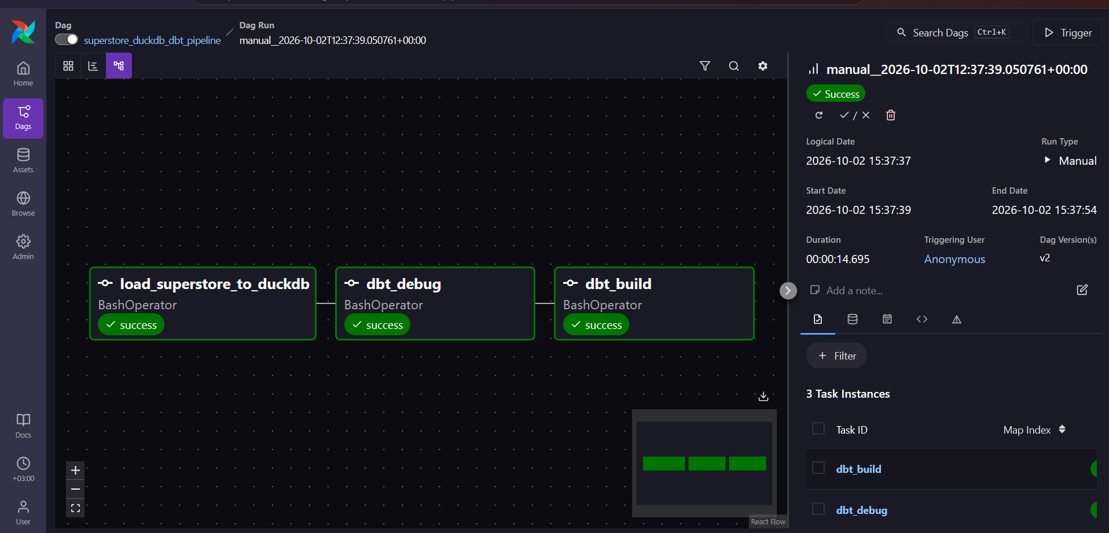
Figure 5. Airflow UI showing a successful end-to-end DAG run: load_superstore_to_duckdb → dbt_debug → dbt_build.

14. Operating Procedure

14.1 Run Without Airflow
# From the project root
python scripts\load_to_ods.py
cd dbt_superstore
dbt debug --profiles-dir .
dbt build --profiles-dir .

14.2 Run Through Airflow
- Start Docker Desktop and confirm the Linux engine is running.
- Open PowerShell in the Astro project root.
- Run astro dev start.
- Open http://localhost:8080.
- Locate superstore_duckdb_dbt_pipeline.
- Trigger the DAG manually.
- Verify that all three tasks become green.
- Open individual task logs if a task fails.

14.3 Stop the Environment
astro dev stop

15. Project Structure
superstore_pipeline/
|-- dags/
| `-- superstore_pipeline.py
|-- scripts/
| `-- load_to_ods.py
|-- dbt_superstore/
| |-- dbt_project.yml
| |-- profiles.yml
| `-- models/
| |-- staging/
| | |-- sources.yml
| | |-- schema.yml
| | `-- stg_superstore.sql
| `-- marts/
| |-- dim_customers.sql
| |-- dim_products.sql
| |-- dim_locations.sql
| |-- dim_dates.sql
| |-- fact_sales.sql
| |-- agg_monthly_sales.sql
| `-- schema.yml
|-- data/raw/
| |-- Superstore.xlsx
| `-- raw_superstore.csv
|-- dev.duckdb
|-- Dockerfile
|-- requirements.txt
|-- packages.txt
`-- airflow_settings.yaml

16. Key SQL and Validation Queries
The following checks are useful when demonstrating the project or validating a rerun:
-- Raw row count
SELECT COUNT(*) FROM ods.raw_superstore;

-- Fact row count
SELECT COUNT(*) FROM main_dwh.fact_sales;

-- Monthly reporting output
SELECT *
FROM main_dwh.agg_monthly_sales
ORDER BY month, region, category
LIMIT 20;

-- Example profitability by category
SELECT p.category,
ROUND(SUM(f.sales), 2) AS sales,
ROUND(SUM(f.profit), 2) AS profit
FROM main_dwh.fact_sales f
JOIN main_dwh.dim_products p
ON f.product_id = p.product_id
GROUP BY p.category
ORDER BY sales DESC;

17. Deliverables and Conclusion

17.1 Deliverables
- Source dataset and stable CSV extract.
- DuckDB ODS and analytical warehouse database.
- Python ingestion script.
- dbt staging model, four dimensions, fact table and monthly aggregate.
- dbt schema tests for uniqueness, non-null values and relationships.
- Astronomer Astro / Airflow DAG that orchestrates the complete pipeline.
- Successful end-to-end Airflow execution evidence.

17.2 Conclusion
The project successfully demonstrates a modern, lightweight analytical data-engineering workflow on a local Windows machine. DuckDB provides a compact analytical warehouse, dbt provides maintainable SQL transformations and automated testing, and Airflow provides visible, repeatable orchestration. The final successful Airflow run confirms that the full pipeline can be executed as one controlled workflow rather than as separate manual commands.
The architecture can be extended later with scheduled ingestion, incremental dbt models, additional quality tests, documentation generation, a BI layer, or deployment to a persistent Airflow environment without changing the core separation of ingestion, transformation, testing and orchestration.

Appendix A — Core dbt Model Catalog
Model | Layer | Materialization | Purpose
stg_superstore | Staging | View | Clean, type and enrich source order-line records.
dim_customers | Mart | Table | Customer attributes and lifetime metrics.
dim_products | Mart | Table | Product descriptive attributes.
dim_locations | Mart | Table | Unique geographic combinations with hashed key.
dim_dates | Mart | Table | Generated calendar dimension.
fact_sales | Mart | Table | Sales-line fact table with measures and foreign keys.
agg_monthly_sales | Reporting mart | Table | Month × region × category aggregate for reporting.

Appendix B — Final Success Criteria
Criterion | Evidence | Status
ODS load | 9,994 source rows loaded into ods.raw_superstore | Passed
dbt connectivity | DuckDB connection validated by dbt debug | Passed
dbt transformations | 7 dbt models discovered and built | Passed
dbt tests | 23 data tests executed | Passed
Manual build result | PASS=30, WARN=0, ERROR=0 | Passed
Airflow orchestration | All three DAG tasks green | Passed
Overall DAG run | Success | Passed

