GADA ELECTRONICS- Report

Developed by- Ahmad Memon

COSC 304 Introduction to Database

TABLE OF CONTENTS

Mission Statement……………………………………………………3

Executive Summary………………………………………………… 4

Installation and Running Instructions ……………………………….5

Feature List…………………………………………………………...6

Walkthrough………………………………………………………….8

# Mission Statement

“Gada Electronics aims towards empowering customers with the latest high-end tech products at unbeatable prices, seamless shipping, and exceptional service”.

# Executive Summary

GADA Electronics is dedicated to becoming the go-to destination for technology enthusiasts by offering the latest high-end tech products across categories such as smartphones, laptops, accessories, and smart home devices. We differentiate ourselves by providing customers with unbeatable prices, making premium technology more accessible without compromising quality.

Our platform is designed for a seamless shopping experience, combining user-friendly navigation, advanced search features, and personalized product recommendations. Customers benefit from a smooth purchase process, including secure payment options, reliable and fast shipping, and comprehensive after-sales support.

At GADA Electronics, we understand the importance of staying ahead in the ever-evolving tech landscape. By consistently updating our product offerings and embracing innovative features, we ensure that every customer finds solutions tailored to their needs. With a focus on excellence and affordability, GADA Electronics is committed to setting new standards in the world of online tech retail.

# Installation and Running Instructions

1. Access the GitHub link i.e <https://github.com/ahmadmemon/Lab10> and download the zip file.
2. Make sure you have docker desktop installed.
3. Unzip the compressed file and open the folder into an IDE.
4. Open a new terminal and “docker compose up -d”
5. The website should run on the local host provided in the yml file.

Development Project Features List Template

|  |  |  |  |  |
| --- | --- | --- | --- | --- |
| **Final Overall System Features** | **Category** | **Possible Points** | **Points** | **Comments / Code Files** |
| **Documentation (15 total points)** | | | | |
| Executive Summary (up to 1 page) | Core | 2 |  |  |
| System Features (2 pages) | Core | 2 |  |  |
| List of Web and AI sources used | Core | 3 |  |  |
| Walkthrough with screenshots (up to 15 pages) | Core | 8 |  |  |
|  | | | | |
| **Hosting (10 total points)** | | | | |
| Running on cloud server | Advanced | 10 |  | We can access this by running the link - [http://164.92.94.219/shop/index](http://164.92.94.219/shop/index.jsp).jsp |
|  | | | | |
| **Main/Home Page (up to 14 total points)** | | | | |
| Search for a product by name | Core | 1 |  | listprod.jsp |
| Browse products by category | Core | 1 |  | listprod.jsp |
| List products (by search/browse) | Core | 1 |  | listprod.jsp |
| List products with image | Core | 1 |  | listprod.jsp |
| Page header with menu | Basic | 1 |  | listprod.jsp/header/jsp |
| Page header shows current logged in user | Basic | 1 |  | header.jsp |
| Dynamic products on page based on sales | Basic | 2 |  |  |
| Improved UI (user-friendly, images, etc.) | Basic | 2 |  | Both the images and UI  changes are there for a good customer experience.  CSS was used |
| Product recommendation based on user | Advanced | 4 |  |  |
|  | | | | |
| **Shopping Cart (up to 8 total points)** | | | | |
| Add to shopping cart | Core | 1 |  | showcart.jsp |
| View shopping cart | Core | 1 |  | showcart.jsp |
| Update quantity (with data validation) | Basic | 1 |  | showcart.jsp |
| Remove item from shopping cart | Basic | 1 |  | showcart.jsp |
| Improved formatting/UI (e.g. in header bar) | Basic | 1 |  | Both the images and UI  changes are there for a good customer experience. CSS was  used |
| Cart stored in database between sessions | Basic | 3 |  |  |
|  | | | | |
| **Checkout (up to 9 total points)** | | | | |
| Checkout with customer id | Core | 1 |  | checkout.jsp |
| Checkout with payment/shipment info | Basic | 2 |  | checkout.jsp/payment.jsp |
| Checkout with data validation | Basic | 2 |  | Credit card details are only a  pplied through a proper format  Payment.jsp |
| Multiple shipments per order supported | Advanced | 2 |  | Note: Requires DB change. |
| Calculate taxes/shipping (by items/state) | Advanced | 2 |  | Note: Requires DB change. |
|  | | | | |
| **Product Detail Page (up to 2 total points)** | | | | |
| Product detail page and item description | Core | 1 |  | product.jsp |
| Product detail has an image from database | Core | 1 |  | product.jsp |
|  | | | | |

|  |  |  |  |  |
| --- | --- | --- | --- | --- |
| **User Accounts/Login (up to 12 total points)** | | | | |
| Create user account page | Basic | 2 |  | Customer.jsp |
| Create account with data validation | Basic | 2 |  | Customer information fields follow a proper format. Customer.jsp |
| Edit user account info (address, password) | Basic | 2 |  | Editaccount.jsp |
| Login/logout | Core | 1 |  | Auth.jsp,login.jsp,logout.jsp |
| Register user/Forgot password email | Advanced | 4 |  | createAccount.jsp Registering the user implemented |
| Page listing all orders for user | Core | 1 |  | Listorder.jsp |
|  | | | | |
| **Product Reviews (up to 5 total points)** | | | | |
| Ability to enter a review on a product | Basic | 2 |  | Review.jsp |
| Display product review on product detail page | Basic | 1 |  | Review.jsp/product.jsp |
| Restrict to one review per user on item purchased | Advanced | 2 |  | Review.jsp/product.jsp |
|  | | | | |
| **Warehouses/Inventory (up to 5 total points)** | | | | |
| Display item inventory by store/warehouse | Basic | 2 |  |  |
| Edit item inventory by store/warehouse | Advanced | 3 |  |  |
|  | | | | |
| **Administrator Portal (up to 19 total points)** |  |  |  |  |
| Secured by login | Core | 1 |  | Admin.jsp/auth.jsp |
| List all customers | Core | 1 |  | Listcustomer.jsp |
| List report showing total sales/orders | Core | 1 |  | Admin.jsp |
| Report with a graph | Advanced | 3 |  |  |
| Add new product | Basic | 2 |  |  |
| Update/delete product | Basic | 2 |  |  |
| Change order status/ship order | Basic | 1 |  |  |
| Upload a photo to file system for product | Advanced | 2 |  |  |
| OR: Upload a photo to database for product | Advanced | 4 |  |  |
| Database restore with SQL script | Basic | 2 |  |  |
| Add/update warehouse, customer | Basic | 2 |  |  |
|  |  |  |  |  |
| **Database System/General** |  |  |  |  |
| Implement some validation using triggers | Advanced | 2 |  |  |
| Use AJAX for some pages | Advanced | 4 |  |  |
| User interface and navigation/usability |  | Up to 5 |  |  |
| *Others (your suggestions)* |  | Up to 5 |  |  |
|  |  |  |  |  |
|  |  |  |  |  |
|  |  |  |  |  |
|  |  |  |  |  |
| **Total: (out of 50 with maximum of 10 bonus marks. i.e. 60 points out of 50 is max.)** |  |  |  |  |

Walkthrough

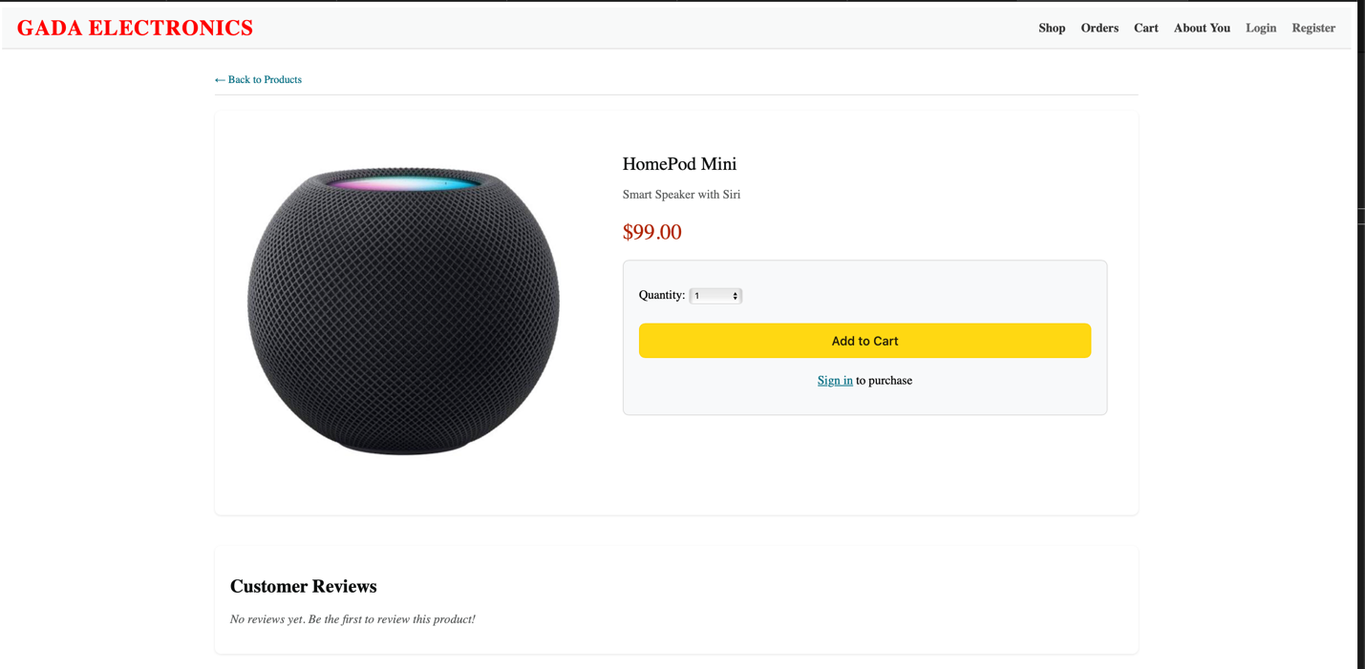Customer Putting in a Review   
 1. Customer can only review the product when logged in

2. Customer can only review the product if they have already bought the product, and they cannot review the product again if they already have

3. Other users should be able to see the product when they log in with their own account and the reviews should be there when the website is reloaded, and the reviews should be added to the database/SQL server.

Registering And Editing the Logged in Account

1. A screenshot of a computer

   Description automatically generatedWhen a user is logged in there is an option of editing their account

1. The form that the editing option provides has the password, email restrictions to be in a specific format and would work successfully if the format is worked.

1. Similarly, when there is no user logged in, we will have an option to register a new account that lets a new user make an account and those edited account and the new user should be update successfully in the Database/ SQL server. The create account has the same restrictions in the crucial fields.

Figure 3New Customer and the edited information updated in the database

Customer’s Overall Experience Throughout

1. The customer can begin shopping and can see wide range of products available in the store and those products we can search by name and filter by category.

- 2Filtering by Category

1. A screenshot of a phone

   Description automatically generatedA customer can access the product details when they click that product, where they will have the description of that product, the feature to write the review and add the product into the cart.
2. A screenshot of a computer

   Description automatically generatedAfter adding the product to the cart, there we get a variety of options to update, remove the item from the cart and the total amount updates accordingly.
3. A screenshot of a checkout

   Description automatically generatedAfter the customer is done shopping, they proceed to checkout, where they have two options, checking out by customer id or checking out by payment and shipping

- 3 customer choosing the option of customerid

- 4when the customer chooses the credit card options it follows the credit card format as well

1. After the payment is successful the order summary can be displayed, and the respective order is then listed in the list order

All the orders placed after successfully checking out

Hosting the Website to Run on the cloud Server

1. A screenshot of a computer

   Description automatically generatedUsing Digital Ocean to create a droplet and connecting the GitHub Repo to allow us to host a website on the link [- http://164.92.94.219/shop/index.jsp](http://164.92.94.219/shop/index.jsp) this allows us to run on a public server rather that a local host.

Sources Used

-Use of AI assistance (like ChatGPT and Cursor Ai was used) to help improve the UI and over all development of the project.