Task: Build a Product Card
Implement the interface shown in the image below using HTML and CSS, matching its appearance and behavior as closely as possible.
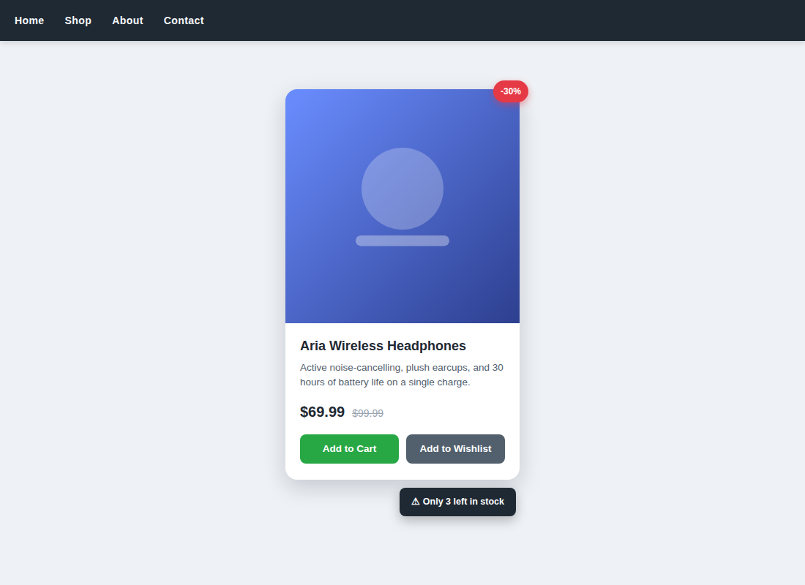
Points to keep in mind:
- A top navigation bar that stays visible while scrolling.
- A product card with rounded corners and a discount badge sitting on the corner.
- The product image reveals an effect on hover.
- Show the discounted price alongside the original price struck through.
- Two buttons: Add to Cart and Add to Wishlist.
- A fixed notification indicating low stock.
- A responsive layout that works well on small screens.
No further technical details beyond what's shown in the image — how you implement it is up to you.

