Methodology report

Study design and overview
This report documents the full analytical pipeline used to construct matched comparison groups for a staggered Difference-in-Differences (DiD) analysis of the road-safety impact of Clean Air Zones (CAZ) and Low Emission Zones (LEZ) in England and Scotland. The pipeline covers data linkage, covariate construction, pre-matching data transformation, two-stage matching, and quality diagnostics. It concludes with an overview of the outcome model structure and planned sensitivity analyses.

Research Questions and Objectives
The study addresses two primary research questions:
- Does the introduction of a CAZ or LEZ reduce the number of road traffic injuries — disaggregated by injury severity (KSI and slight) and road user mode (pedestrian, cyclist, car/van occupant, other) — on road links within the intervention zone?
- Are any effects heterogeneous across injury severity, road user mode, city context, or scheme design?

- Estimate average and dynamic treatment effects of CAZ/LEZ policies on RTIs
- Assess whether observed effects reflect geographic displacement of injuries or modal redistribution across different road users.
- Explore variation in policy impacts across city schemes and contexts

Unit of analysis
The primary unit of analysis is the road link by calendar quarter. A road link is a unique segment of the road network defined in OS Open Roads and identified by its Topographic Identifier (TOID). A road link represents a stretch of road between two junctions, and is the smallest consistently defined spatial unit in the national road network.
Each observation represents a unique road segment (identified by a persistent TOID) in a given quarter, with associated injury counts by mode and severity, an indicator of treatment status, and road-link-level characteristics. This resolution allows the analysis to capture localised changes in injury risk attributable to the CAZ/LEZ while controlling for time-stable, road-specific characteristics through road-link fixed effects.
Matching, however, is conducted at the Output Area (OA) level — the smallest Census geography for which the sociodemographic and road-network covariates needed for comparison-group construction are available. Once the matched set of control OAs is identified, all road links within those OAs are carried forward into the DiD estimation. The OA is therefore a design-stage unit; the road link remains the unit of analysis in the outcome models.

Core design of the research (staggered Difference-in-Difference)
The causal identification strategy is a staggered difference-in-differences (DiD) design. The study exploits variation in the timing of CAZ/LEZ implementation across UK cities: because different schemes were introduced at different times, each city’s treated road links can be compared to matched control road links both before and after the policy came into effect.
The core identifying assumption is parallel trends: in the absence of the intervention, injury rates on treated road links would have followed the same trajectory as those on matched control road links. The two-stage matching procedure (Section 3) is designed to maximise the credibility of this assumption by selecting controls with similar pre-treatment road structures and injury dynamics.
The design proceeds in three linked stages: (1) Injury-to-road linkage — STATS19 injury records are spatially matched to their nearest plausible road link using a class-prioritised nearest-neighbour algorithm, creating a road link–level injury dataset (Section 2.1). (2) Control area selection — OAs surrounding CAZ/LEZ schemes are matched to structurally and trajectory-comparable control OAs from other large cities using two-stage Mahalanobis distance matching (Section 3). (3) DiD estimation — road link × quarter injury counts are modelled using a staggered DiD estimator, comparing pre- and post-implementation injury trends between treated and matched control road links across multiple policy cohorts.
London is excluded from the analysis. The city introduced a Low Emission Zone in 2008 — well before other UK cities — and has undergone multiple overlapping expansions, leaving no well-defined pre-intervention window. Its scale, transport mix, and baseline injury patterns also differ substantially from other cities, which would undermine comparability.

High-level linkage: injuries to road links. Intervention/control area selection. And then road links to CAZ.
Road links are first assigned to Output Areas (OAs) to support the matching design (Section 3). However, the difference-in-differences estimation itself operates directly at the road link × quarter level, exploiting within-link variation in injury counts over time as the policy is introduced.

This report documents the matching pipeline used to construct comparison groups for a staggered Difference-in-Differences (DiD) analysis of the road-safety impact of CAZ/LEZ at the road-link level.
All road links within matched control OAs are then carried into staggered DiD estimation. All matching decisions are made using pre-treatment covariates and pre-treatment injury data only. Post-treatment outcomes are never examined during the matching stage, preserving the separation between design and analysis (King et al., 2019; Rubin, 2008).

Data sources
- I think here it makes sense to add a table of data sources:
- STATS19 road traffic injury records (time period, geography, variables, source)
- Road network data (geography, definition of TOIDs, key attributes – length, classification, source)
- Output areas (maybe why we use them, the demographic variables we have at OA level [i.e. not the derived stuff we create], source)
- Clean air zones (each listed in study, date of implementation, size (km2), source)
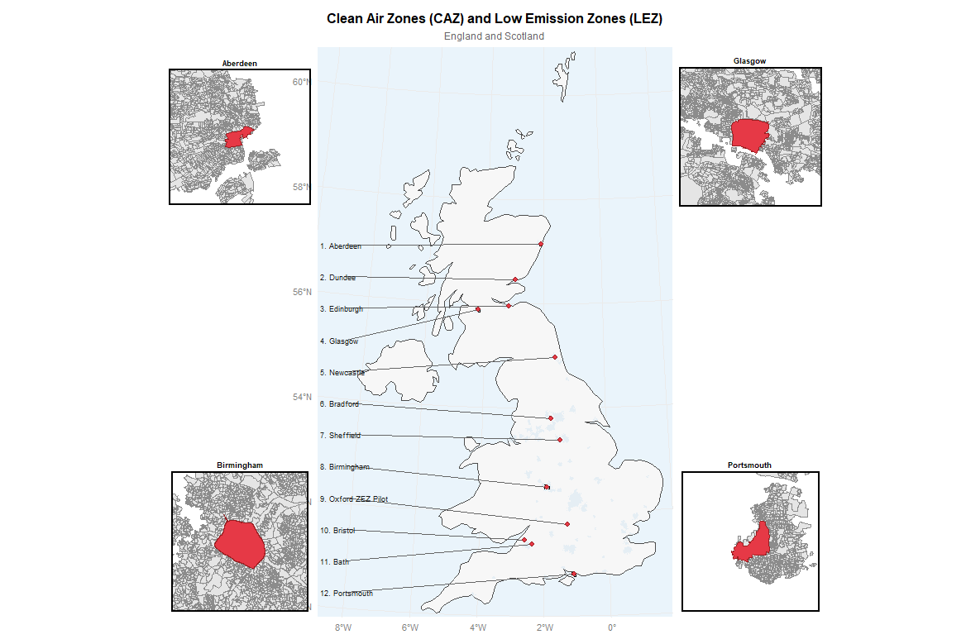
London was excluded due to its different policy timeline and urban context, which complicates comparability and identification. London introduced a Low Emission Zone in 2008—well before other UK cities (from 2021)—and has since undergone multiple expansions, leaving no clearly aligned pre-intervention period. London has also been exposed to several overlapping interventions making it difficult to isolate the effect of any single policy. In addition, its scale, transport mix, and baseline injury trends differ considerably from those of other cities. Excluding London therefore improves internal validity and allows for more comparable and less-studied settings.
- Census 2021/2022: population, sociodemographic, and socioeconomic characteristics at the OA level.

Data linkage and construction

Linking injuries to road links
Injury records were spatially linked to a national road network to enable analysis at the road segment level. Injury data were provided as point geometries, while the road network comprised line features with unique segment identifiers. To ensure comparability between datasets, road classifications were harmonised into four categories: Motorway, A, B, and minor, with “C” and “Unclassified” roads grouped as minor. All spatial operations were conducted in the OSGB36 / British National Grid coordinate system, allowing distances to be measured in metres.
A hierarchical nearest-neighbour matching approach was used. For each injury, the nearest road segment of the same class was first identified using a nearest-feature algorithm. If this segment was located within 50 metres, the injury was assigned to that road (“same-class match”). Where no same-class segment was found within this threshold, a fallback procedure was applied, assigning the injury to the nearest road segment of any class within 100 metres (“any-class match”). Injuries with no road segment within 100 metres were excluded from further analysis. These thresholds were chosen to reflect typical positional uncertainty in police-recorded injury locations and the spatial offset between recorded points and road centrelines.
Of 413,454 unique injuries entering the linkage process, 413,339 (99.97%) were successfully matched to a road segment, with only 115 (0.03%) excluded due to exceeding the maximum distance threshold. The majority of matches (405,874; 98.2%) were to a road segment of the same class, while a small proportion (7,465; 1.8%) were assigned using the fallback procedure. Matching distances were small, with a mean of 2.37 metres, median of 1.52 metres, and 90th percentile of 4.67 metres; the maximum observed distance was 99.8 metres. These diagnostics indicate a high level of spatial precision in the linkage.
The final analytical dataset comprised injury-level observations linked to unique road segment identifiers, along with match-type indicators and distance measures. This structure allows aggregation of injuries to the road segment level and supports subsequent analyses of injury rates and trends. While the linkage approach minimised data loss and prioritised class-consistent matches, a small degree of misclassification may remain, particularly among fallback matches in dense urban environments where multiple road segments are in close proximity.

Assigning road links to Output Areas: why OAs?
- First we intersected OAs with our intervention areas to create a pool of intervention OAs (and associated road links)
- We then used Built-up-Areas (reference or add to data table at beginning) to identify BUAs in England with populations of over 100k. This essentially captures towns/cities with towns above this population size. This threshold was used because we want to ensure that our control areas come from cities of a broadly similar population size to our intervention cities.
- In Scotland, we used the same approach but used population estimates for settlements and localities from 2020 (https://www.nrscotland.gov.uk/publications/population-estimates-for-settlements-and-localities-in-scotland-mid-2020)
- We then spatially intersected OAs with the >100k towns and cities in England/Scotland. This creates a pool of OAs (and associated road links) from which control areas can be drawn. OAs within the same LA as the intervention area were excluded from this pool (as there could be spillover effects of the CAZ).
- 1km buffer OAs were created by…
- Road links were intersected with intervention Oas, buffer OAs and potential control OAs so that we had a road-link level dataset with each road link assigned.

An OA–level dataset of 71,068 OAs was constructed from road network data covering large urban areas (population >100,000) in England and Scotland. Road links were spatially intersected with OA boundaries and assigned to a single OA based on the largest share of their length within that OA. OA-level road characteristics were then derived by aggregating these assigned road links. OAs were assigned to categories shown in the table below.
Assignment | N | Description
Treated | 1,066 | OAs with ≥50% of their area located within CAZ/LEZ
Potential Controls | 66,509 | OAs in the same local authority of CAZ/LEZ and outside the intervention and buffer zones
1 km buffer | 3,493 | OAs with ≥50% of their area within a 1 km buffer surrounding the CAZ,

The matching process

Why matching
CAZ/LEZ policies are not randomly assigned; they are implemented in large urban centres that differ systematically from other areas in terms of traffic volume, road network structure, population density, and sociodemographic composition. Using all untreated areas as controls—whether from the same local authority or from other cities—risks violating the parallel trends assumption because many areas have different baseline injury volumes, pre-treatment trends, and structural characteristics. Selecting controls from a single other city centre may improve comparability on some dimensions, but can still result in poor matches and may introduce biases related to possible other interventions. Pooling controls across multiple cities can mitigate and reduce such biases.
The matching address this and serves two functions:
Sample restriction: Narrowing the full control pool to a structurally comparable donor set, ensuring treated and control OAs inhabit similar structural contexts.
Trajectory alignment: Selecting matched controls whose pre-treatment injury trajectories most closely resemble those of treated OAs, providing the strongest available design-stage support for parallel trends.
Pre-treatment outcomes were defined as scheme-specific due to staggered adoption: for each treated OA, all calendar quarters before CAZ/LEZ implementation were classified as pre-treatment. Because the pre-treatment outcome trajectory is the most critical input for the parallel trends assumption, we employed two-stage sequential matching:
Stage 1: matches on structural and sociodemographic characteristics to narrow the 65,020-OA control pool to OAs with similar road network, urban, and population contexts. This step ensures that the candidate control pool for Stage 2 is structurally homogeneous with treated OAs, preventing trajectory matching from being confounded by fundamental structural differences
Stage 2: matches within the Stage 1 pool based on pre-treatment injury trajectories and baseline injury levels, directly supporting the parallel trends assumption required by DiD. By conditioning on pre-treatment injury history, Stage 2 reduces systematic differences in injury dynamics between treated and control OAs.
Separating structural matching from trajectory matching reduces the risk of diluting the effects of pre-treatment injury trends and allows for appropriate weighting.

Why two stages rather than one?
A natural question is whether the structural and trajectory variables could simply be included together in a single matching stage. There are three reasons this would be suboptimal.
First, variable masking. In a single high-dimensional match, a control OA can achieve a low overall distance by being very similar on some dimensions while being very different on others. Concretely, an OA in a small market town could match a CAZ-treated OA closely on pre-treatment injury trends simply by chance, while being structurally nothing like it — different road network, different population density, different urban form. Structural plausibility is a minimum precondition for a valid comparison, not something that can be traded off against trajectory similarity. Establishing it in a dedicated first stage ensures that the controls entering trajectory matching already inhabit the same structural context as the treated OAs.
Second, scale. Stage 1 reduces the candidate control pool from 65,020 to approximately 4,269 OAs — a 93% reduction. Running the computationally intensive trajectory-based Mahalanobis matching on all 65,020 candidate controls simultaneously would be expensive, and the vast majority of computation would be spent on structurally implausible comparisons that would never be selected anyway.
Third, the two stages require different covariance structures. Stage 1 uses a pooled covariance matrix — computed from both treated and control units — to define global structural comparability across the full candidate pool. Stage 2 uses a treated-only covariance matrix, which anchors the distance metric to the distribution of treated OAs, consistent with the focus of average treatment effect on the treated (ATT) estimation. A single-stage approach cannot apply these two different scalings simultaneously.
The two-stage design therefore reflects a deliberate priority ordering: structural plausibility first, pre-treatment trajectory alignment second. Stage 1 defines who could plausibly serve as a control; Stage 2 selects which of those candidates best supports the parallel trends assumption.

Exclusions from matching

Buffer OAs
Buffer OAs (n = 3,493) are excluded from the control pool to remove contamination risk — they are immediately adjacent to treated areas and may have experienced spillover effects from the CAZ/LEZ intervention. This could be in any direction: traffic displacement (increased injuries) or traffic evaporation (fewer journeys of non-compliant vehicles travelling in the wider area).

Zero-road OAs
Of 71,068 OAs, 1,752 (2.47%) contain zero mapped roads and were excluded from matching.

Zero-injury Treated OAs
Within the analytic sample, 242 treated OAs record zero injuries throughout the entire pre-treatment period (191 after excluding zero-road OAs). Many of these are city centre OAs with very few roads at all. Analysis revealed that they are structurally distinct from injury-exposed OAs: they have higher population density (17,681 vs 10,985 persons/km², Standardised Mean Difference (SMD) = −0.81), more minor roads (96.1% vs 83.0%, SMD = −0.73), and shorter road length (0.24 vs 1.10 km, SMD = 0.86).
However, at the road-link level, the DiD analysis will drops road links with zero injuries throughout the study period. After removing zero-injury road links, zero-injury OAs account for only 0.02% of road links and 0.05% of total injuries in the analysis sample, contributing less than 0.1% of total pre-period injuries. Removing these road links is therefore highly unlikely to drive ATT estimates.
Therefore, the analysis excludes the zero-injury treated OAs. The final analytic dataset contains 65,834 OAs: 814 treated and 65,020 controls.

Covariate Construction and Transformation

Stage 1 Variables: Structural and Sociodemographic Characteristics
Stage 1 matching uses 15 variables covering road network characteristics, urban geography, and sociodemographic composition. These represent the stable structural features of an OA that determine suitability as a comparison.
Variable | Description
Road density (m/km²) | Total road length per km² of OA area
Road length (km) | Total road length in km within OA
% A-road | Percentage of road length classified as A-road
% B-road | Percentage of road length classified as B-road
% minor road | Percentage of road length classified as minor road
Distance to city centre (m) | Distance in metres from OA centroid to city centre
Population density (persons/km²) | Resident population per km²
IMD | Index of Multiple Deprivation score
% households with no car | Percentage of households with no car or van
% commuting by car | Percentage of working residents commuting by car
% commuting on foot | Percentage of working residents commuting on foot
% commuting by bicycle | Percentage of working residents commuting by bicycle
% aged 65+ | Percentage of residents aged 65+
% aged 5–19 | Percentage of residents aged 5–19
% aged 20–24 | Percentage of residents aged 20–24

Stage 2 Variables: Pre-Treatment Injury Trajectories and Levels
Stage 2 matching uses pre-treatment injury history to ensure treated and control OAs follow similar pre-intervention trends in the key outcome. Two types of variables are used:
Trend variables:
Estimated as slope coefficients from OA-level quasi-Poisson regression models of quarterly injury counts on a time index. Models use a log link, and the coefficient represents the log change in injury counts per quarter. Trends are estimated separately for total injuries and by mode (car/van, cyclist, pedestrian, other) and severity (adjusted KSI and slight), yielding nine variables. Additional rate-adjusted trends are estimated using the same models with a log road-length offset, representing changes in injuries per road-kilometre.
Level variables: Defined as mean quarterly injury counts over the pre-treatment period (including zero-injury quarters), computed for total injuries and by mode and severity (nine variables). Corresponding injury rates per road-km are also calculated by dividing mean counts by total road length.

Variable transformations

Winsorisation
All Stage 1 variables were winsorised at the 1st and 99th percentiles using quantiles computed from the full pooled dataset (treated and control OAs combined). Winsorisation is applied before any other transformation.
Stage 2 variables were winsorised at the 1st and 99th percentiles using quantiles computed from the treated distribution only, then applied to both treated and control OAs. This anchors the winsorisation to the treated OA range, ensuring that covariate scaling reflects the support of the treated group, which is the target population for ATT estimation (Abadie & Imbens, 2006).

Log Transformation
Log1p transformation (log(1 + x)) was applied after winsorisation to variables that remained highly right-skewed to reduce skewness and improve Mahalanobis distance computation. Percentage and bounded variables were not log-transformed, as log transformation distorts bounded scales. Trend variables were not transformed as they are already log-slopes.
Variable | Skew (winsorised) | Skew (log1p) | Improvement
Road length (km) | 5.23 | 2.11 | Yes
Population density (persons/km²) | 1.82 | −1.83 | Marginal (magnitude similar)
Distance to city centre (m) | 0.88 | −0.65 | Yes
Mean: car KSI per km | 2.74 | 2.69 | Marginal
Mean: car slight injuries per km | 1.76 | 1.52 | Yes
Mean: cycling KSI per km | 2.71 | 2.68 | Marginal
Mean: cycling slight injuries per km | 2.08 | 2.00 | Yes
Mean: pedestrian KSI per km | 1.97 | 1.92 | Marginal
Mean: pedestrian slight injuries per km | 1.77 | 1.68 | Yes
Mean: other KSI per km | 2.64 | 2.61 | Marginal
Mean: other slight injuries per km | 2.16 | 2.10 | Yes
Mean total injuries per km | 1.45 | 1.10 | Yes

Population density (persons/km²) and injury KSI rate variables show near-equal skewness magnitude after transformation (direction reversed), indicating their distributions are approximately symmetric after winsorisation. Log transformation is retained for consistency and to handle the long right tail from extreme observations.

Matching Method

Distance Metric: Mahalanobis Distance Matching
Matching was conducted using Mahalanobis Distance Matching (MDM), which scales covariate differences by the inverse of the variance–covariance matrix of the matching variables. This approach directly balances multiple continuous covariates, including pre-treatment outcome levels and trends, while accounting for differences in scale and correlation across variables (Ho et al., 2007; King et al., 2019).
Matching is performed with replacement: a control OA may be matched to multiple treated OAs. Replacement is appropriate here because:
- The number of treated OAs is small relative to the number of control OAs.l
- treated OAs in dense urban areas may have few close structural comparators
- Forcing unique matches would introduce distance penalties for isolated treated OAs.
Matching with replacement reduces bias at the cost of increased variance, which is acceptable given the large control pool.
Exact matching on country (England/Scotland) was enforced at both stages to prevent cross-country matching.

Covariance Matrix Specification
Stage 1: The covariance matrix was computed using all units included in the matching procedure (treated and candidate controls), providing a global scaling of covariates.
Stage 2: A covariance matrix based on the treated units was used to scale Mahalanobis distances, aligning the metric with the distribution of the treated group, consistent with the focus of ATT estimation (Abadie & Imbens, 2006).

Stage 1 Matching: Structural and Sociodemographic Balance

Design
Stage 1 matching was conducted using nearest-neighbour Mahalanobis Distance Matching on all structural, urban and socio-demographic characteristics of OAs. The Mahalanobis distance metric was used to account for differences in scale and correlation across variables, with a pooled covariance matrix estimated from the combined treated and control pool to define global structural comparability. Matching was performed with replacement and a 1:10 ratio, incorporating an exact constraint on country (England/Scotland) to ensure geographic consistency. The purpose of Stage 1 is not to achieve full covariate balance, but to reduce the 65,020-OA control pool to a manageable subset with improved overlap in structural characteristics, from which more refined matching is conducted in Stage 2. 1:10 was chosen to retain a sufficiently large and diverse candidate pool while the Stage 2 distance distribution confirms adequate structural filtering (4,269 unique controls from 65,020).
Summary Statistics
Metric | Value
Treated OAs | 814
Total OA control pool before matching | 65,020
Total OA control pool after Stage 1 | 4,269
Mean |SMD| before matching | 0.686
Mean |SMD| after matching | 0.165
SMD reduction | 76%
Structurally isolated OAs (95th percentile threshold) | 41 / 814 (5%)
95th percentile Mahalanobis distance threshold | 12.91

The 76% reduction in mean SMD represents the improvement in structural comparability. Ten variables remain above SMD = 0.10 after Stage 1, reflecting genuine structural differences between treated and control OAs: treated OAs are located in areas with lower car ownership (% commuting by car, SMD = −0.63), higher walking rates (% commuting on foot, SMD = 0.23), more minor roads, and younger age profiles. This residual imbalance is expected, as Stage 1 is designed to restrict the control pool rather than fully eliminate these differences.The final balance is evaluated after Stage 2 matching. Any residual imbalance after stage 2 will be addressed through covariate adjustment in the outcome model.

Covariate Balance: Stage 1
Variable | SMD Before | SMD After | Balanced (<0.10)
log1p_Road length (km) | -0.117 | -0.084 | Yes
log1p_Population density (persons/km²) | 0.672 | 0.007 | Yes
log1p_Distance to city centre (m) | -0.399 | 0.181 | No
Road density (m/km²) | 0.679 | 0.112 | No
% A-road | 0.375 | 0.144 | No
% B-road | 0.086 | 0.086 | Yes
% minor road | -0.381 | -0.174 | No
IMD | 0.474 | -0.133 | No
% households with no car | 1.531 | 0.375 | No
% commuting by car | -2.468 | -0.635 | No
% commuting on foot | 1.172 | 0.231 | No
% commuting by bicycle | 0.168 | -0.078 | Yes
% aged 65+ | -1.371 | -0.208 | No
% aged 5–19 | -0.051 | -0.015 | Yes
% aged 20–24 | 0.938 | 0.180 | No
country_Scotland | 0.086 | 0.000 | Yes

Table 6. Stage 1 covariate balance (standardised mean differences

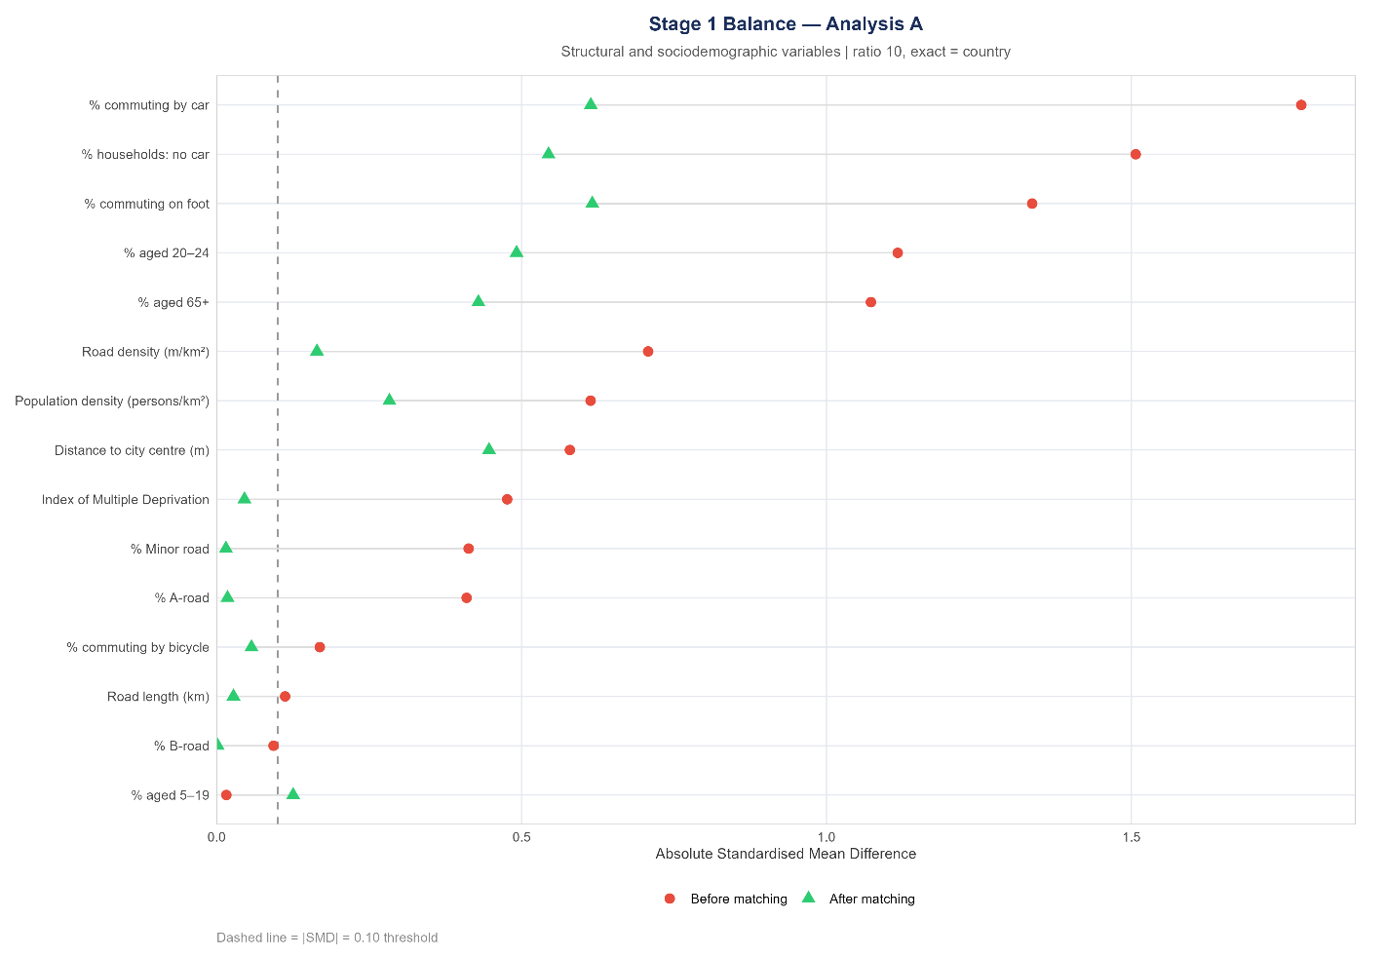
Love plot of standardised mean differences before (red circles) and after (green triangles) Stage 1 matching. Dashed line at |SMD| = 0.10.
Before matching, imbalance was very high across most variables: the highest pre-matching SMDs are observed for % commuting by car (2.47), % households with no car (1.53), % aged 65+ (1.37), and % commuting on foot (1.17), reflecting the concentration of CAZ/LEZ in dense, transit-served urban areas where car use is low, and walking is common. After Stage 1 matching, the mean |SMD| reduction was 63%, falling from 0.69 to 0.26.
In the Love plot, the shift from red circles (pre-match) to green triangles (post-match) illustrates this improvement visually: almost all covariates move closer to the zero line after matching. Six variables achieve full balance (|SMD| < 0.10) after Stage 1: Road length (km), % A-road, % B-road, % minor road, Index of Multiple Deprivation, and % commuting by bicycle. Residual imbalance persists for variables that reflect the urban nature of treated areas — notably % commuting by car (SMD = 0.635), % commuting on foot (0.231), and % aged 20–24 (0.180) — indicating that even the closest structural matches from the control pool retain systematic differences in car dependence and active travel mode relative to treated OAs. This residual imbalance is expected and is partly addressed by the stage 2 matching and by covariate adjustment in the DiD outcome model.

Stage 1 Covariate Space Overlap Diagnostics Using Mahalanobis Distance
The 95th percentile of the minimum Stage 1 Mahalanobis distance across treated OAs is used as a diagnostic threshold (12.91 units) to identify treated units with weak overlap in the structural covariate space. Treated OAs above this threshold are flagged as structurally isolated, indicating limited comparability to the available control distribution based on pre-treatment structural characteristics
Statistic | Value | Interpretation
Minimum | 0.47 | Closest treated-control pair
Q1 | 2.28 | 25% of treated OAs within this distance
Median | 4.19 | Typical structural distance
Mean | 5.51
Q3 | 6.98
95th percentile | 12.91 | Common support threshold
Maximum | 102.30 | Most isolated treated OA
Isolated OAs (>95th pct) | 41 | Flagged for sensitivity analysis
41 treated OAs exhibited weak overlap with controls in the Stage 1 covariate space, as indicated by large minimum Mahalanobis distances. These OAs were flagged to be excluded in a sensitivity analysis.

Stage 2 Matching: Pre-Treatment Trajectory Balance

Design Parameters
Matching was performed using nearest-neighbour Mahalanobis Distance Matching on 18 covariates (9 trend variables and 9 level variables). Distances were computed using a Mahalanobis metric with a treated-only covariance matrix to align scaling with the target population.

Ratio Selection
The optimal matching ratio was selected by evaluating the maximum trend |SMD| across ratios 1:1 to 1:10. The ratio controls the trade-off between control pool size (more controls = more variance reduction in DiD) and trend balance (smaller ratio = closer trajectory matches). The selected ratio minimises the maximum trend |SMD| across specifications, with ties broken in favour of larger control samples.
Ratio | N Controls (unique) | Max Trend |SMD| | Mean Trend |SMD|
1:1 | 645 | 0.0484 | 0.0257
1:2 | 1,101 | 0.0460 | 0.0240
1:3 | 1,460 | 0.0449 | 0.0225
1:4 | 1,744 | 0.0506 | 0.0237
1:5 | 1,995 | 0.0442 | 0.0233
1:6 | 2,190 | 0.0481 | 0.0232
1:7 | 2,341 | 0.0504 | 0.0228
1:8 | 2,477 | 0.0481 | 0.0221
1:9 | 2,598 | 0.0488 | 0.0217
1:10 | 2,691 | 0.0500 | 0.0216

The table above shows that the maximum trend curve is not monotone, thus justifying the use of the global minimum criterion. All ratios produced maximum trend |SMD| well below the 0.10 threshold. Ratio 1:5 was selected as it achieves the best balance and the largest control pool simultaneously, |SMD| (0.060) with 1,995 controls. More controls provide variance reduction in the DiD estimator at the cost of trend balance.

Stage 2 Balance Results
The overall Stage 2 balance for the two primary specifications is presented in the table below. Both specifications pass the parallel trends balance criterion (max trend |SMD| < 0.10). Excluding structurally isolated treated OAs identified in stage 1 did not improve balance in pre-treatment trends; thus, the main specification retains these OAs.
Specification | Treated | Controls | Mean |SMD| | Max Trend |SMD|
all treated OAs | 814 | 1,995 | 0.112 | 0.044
Sensitivity: Stage 1 outliers OAs excluded | 773 | 1,966 | 0.107 | 0.044

Covariate Balance Stage 2
After stage two, matching all nine trend variables achieved |SMD| below 0.10, providing strong design-stage support for the parallel trends assumption. This indicates that the 1:5 ratio achieves strong balance in pre-treatment trends across all mode-severity combinations.
Variable | SMD Before | SMD After | Balanced (<0.10)
Trend: car KSI per km | 0.019 | -0.0179 | True
Trend: car slight injuries per km | -0.0914 | 0.002 | True
Trend: cycling KSI per km | 0.0685 | 0.0553 | True
Trend: cycling slight injuries per km | -0.0798 | -0.0419 | True
Trend: pedestrian KSI per km | -0.0449 | -0.0572 | True
Trend: pedestrian slight injuries per km | -0.0704 | -0.058 | True
Trend: other KSI per km | 2e-4 | 0.0165 | True
Trend: other slight injuries per km | -0.0897 | -0.0166 | True
Trend: total injuries per km | -0.1059 | -0.0173 | True
Mean: car KSI per km | 0.2104 | 0.1001 | False
Mean: car slight injuries per km | 0.3735 | 0.2558 | False
Mean: cycling KSI per km | 0.2555 | 0.0721 | True
Mean: cycling slight injuries per km | 0.4026 | 0.2177 | False
Mean: pedestrian KSI per km | 0.449 | 0.2419 | False
Mean: pedestrian slight injuries per km | 0.5802 | 0.3989 | False
Mean: other KSI per km | 0.1644 | 0.0426 | True
Mean: other slight injuries per km | 0.2469 | 0.1719 | False
Mean total injuries per km | 0.6293 | 0.4748 | False

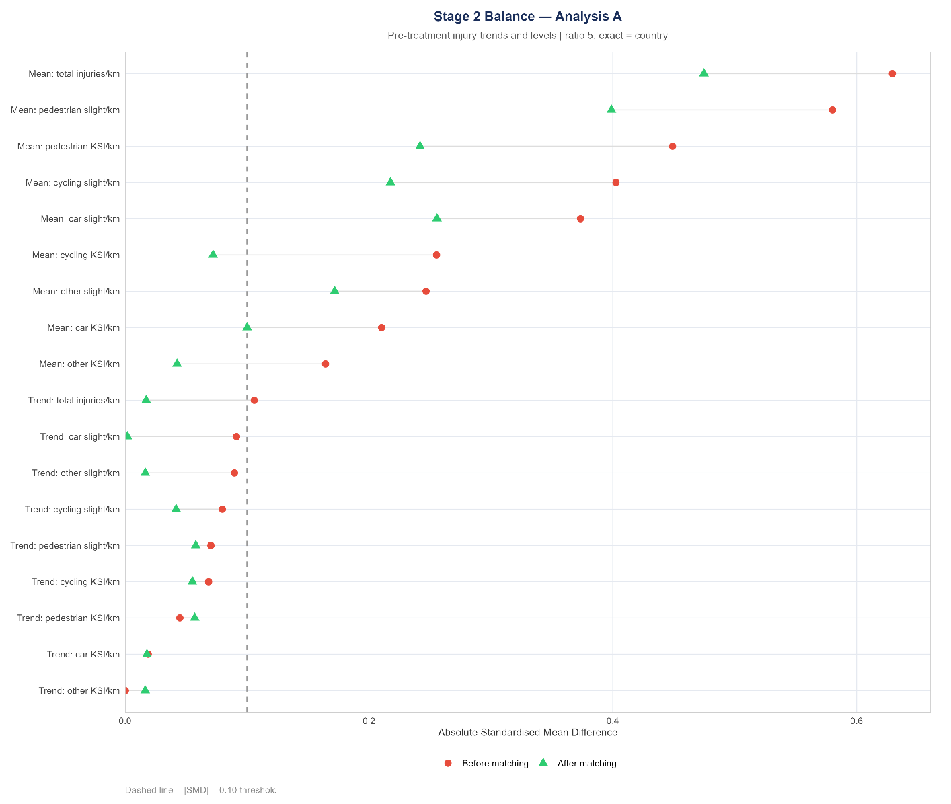
The level variable balance table reveals a consistent pattern of positive SMDs across all nine injury-level outcomes. Treated OAs have systematically higher pre-treatment injury rates per road-kilometre than their matched controls. The largest gaps are for total injuries per km (SMD = 0.411), pedestrian slight injuries per km (0.312), and car slight injuries per km (0.226).
CAZ/LEZ schemes are implemented in high-traffic, high-injury urban centres. KSI-rate variables (for car, cycling, pedestrian, and other modes) all show smaller SMDs (0.123–0.195) than their slight-injury counterparts, suggesting that the relative level imbalance is somewhat smaller for KSI than for slight injuries. The consistency of imbalance direction across all nine variables - all positive, none near zero - further confirms that this is systematic selection rather than noise. Covariate adjustment in the outcome model will be considered.

Stage 2 Mahalanobis Distance Quality
The table below shows the distribution of the stage 2 Mahalanobis distances for treated OAs.
Statistic | 814 treated OAs
Minimum | 0.00
Q1 | 1.22
Median | 4.40
Mean | 6.40
Q3 | 9.06
P90 | 15.95
P95 | 20.08
Maximum | 53.99
N > 20 | 43
N > 30 | 11
N > 50 | 1

The median distance (4.4), well below the mean (6.4), indicates that most treated OAs have relatively close matches. The tail is characterised by 43 OAs with distance greater than 20 and 11 with distance greater than 30 — these are treated OAs whose pre-treatment injury trajectories are less well-represented in the control pool. Only 1 treated OA has a distance exceeding 50 (maximum = 53.99). These tail OAs are the 41 flagged at Stage 1 plus a small number identified by the Stage 2 distance itself. All 814 treated OAs, including those with larger distances, are retained in the primary analysis: the maximum trend |SMD| of 0.060 confirms that even OAs with larger trajectory distances are not materially degrading overall trend balance. The figure below shows the distribution of the distances graphically.
The figure below shows how well each treated OA was matched in trajectory space. The upper panel is an Empirical Cumulative Distribution Function (ECDF) - for any distance value on the x-axis, the y-axis tells you what share of treated OAs found a match within that distance. The ECDF shows that around half of treated OAs have matches within distance 5, around three-quarters within 10, and 95% within 20. Scotland (purple) consistently shows larger distances than England (blue) because exact country matching restricts Scottish treated OAs to the smaller Scottish control pool. The lower histogram confirms this. Overall, the figure shows that the vast majority of treated OAs are well-matched in trajectory space, with the tail driven by pool size constraints.
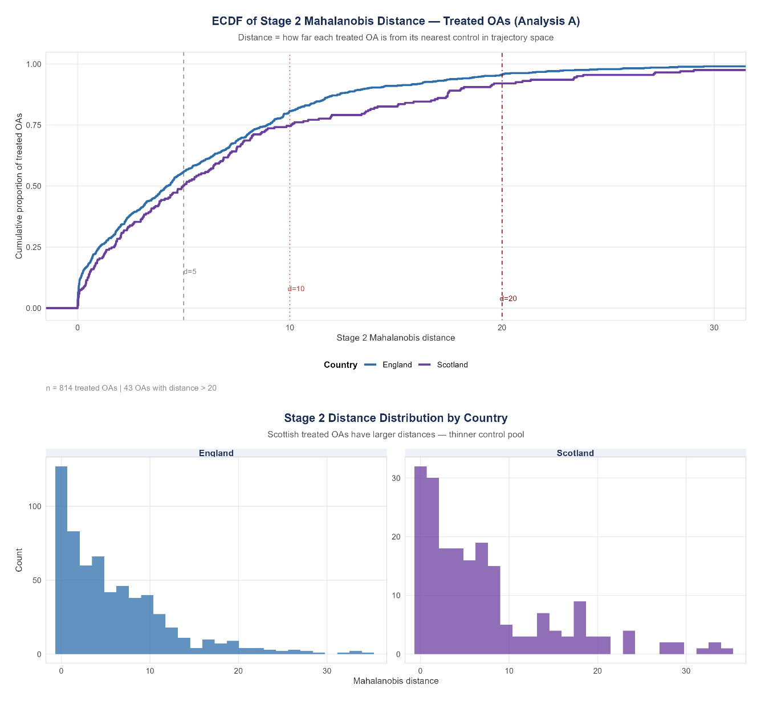

Weight Distribution by Country
Matching with replacement generates frequency weights for control OAs, equal to the number of times each control is used as a match. Table 12 shows the weight distribution by country. Overall, the weight distribution is well balanced, and the effective N (1,087 from 1,993 nominal controls) reflects an efficiency of 60.6%, indicating reasonable control pool diversity with some concentration in high-weight Scottish controls.

Country | N Controls | Mean Weight | Max Weight | Effective N
England | 1,727 | 0.87 | 10.29 | 982
Scotland | 268 | 1.84 | 7.35 | 178
Overall | 1,995 | — | 10.29 | 1,087 (eff.)

Table 12 shows the weight distribution for the 1,993 control OAs used in the final matched sample. England contributes 1,725 controls (87%) and Scotland 268 (13%). English controls have a mean weight of 0.87 and a maximum of 10.29. The mean weight is below 1 because many controls in the candidate pool were not selected at all, while a small number were selected multiple times, with a small number used up to ten times. Scottish controls show a higher mean weight (1.84) and a maximum of 7.35, suggesting greater concentration. The effective N of 1,207 (out of 1,993 nominal controls) reflects a weighting efficiency of 60.6% (effective N 1,207 / Nominal N 1,993). This indicates some concentration of weights but retaining substantial diversity in the matched control group.

Descriptive statistics of the matched data

Treated vs Matched Controls
The table below compares treated OAs to their matched controls after matching using all variables used in the matching process. Overall, the matched controls resemble the treated group reasonably well across many dimensions, particularly for trend variables, where means and medians are very close. The near-identical trends confirm the Stage 2 balance results: the matching has produced trajectory alignment between treated and control groups.
However, some differences remain in baseline levels of outcomes and area characteristics. Treated areas still exhibit slightly higher injury rates across most measures. Differences are also visible in urban and socio-demographic features: treated areas are generally more central, denser, less car-dependent, and have higher proportions of younger populations (particularly ages 20-24), while matched controls have higher car use and are located further from city centres.
Despite these residual differences, the distributions (means, medians, and standard deviations) are broadly comparable, indicating that the matching has produced a control group that is similar, though not identical, to the treated group. The matched sample improved comparability, while still motivating further adjustment in outcome models to account for remaining differences.
Variable | Label | Treated Mean | Matched Mean | Treated SD | Matched SD | Treated Median | Matched Median
Mean: car KSI per km | Car KSI/km | 0.0152 | 0.0074 | 0.0553 | 0.0176 | 0 | 0
Mean: car slight injuries per km | Car slight/km | 0.1969 | 0.1107 | 0.4747 | 0.1285 | 0.0882 | 0.0712
Mean: cycling KSI per km | Cycling KSI/km | 0.0122 | 0.0065 | 0.0411 | 0.0162 | 0 | 0
Mean: cycling slight injuries per km | Cycling slight/km | 0.0524 | 0.0288 | 0.1033 | 0.0460 | 0.0061 | 0
Mean: other KSI per km | Other KSI/km | 0.0113 | 0.0066 | 0.0433 | 0.0157 | 0 | 0
Mean: other slight injuries per km | Other slight/km | 0.0341 | 0.0199 | 0.0748 | 0.0359 | 0 | 0
Mean: pedestrian KSI per km | Pedestrian KSI/km | 0.0351 | 0.0169 | 0.0777 | 0.0283 | 0 | 0
Mean: pedestrian slight injuries per km | Pedestrian slight/km | 0.0960 | 0.0428 | 0.1778 | 0.0573 | 0.0454 | 0.0223
Mean total injuries per km | Total injuries/km | 0.4533 | 0.2580 | 0.5922 | 0.2347 | 0.3001 | 0.1825
Trend: car KSI per km | Trend car KSI | 0.0049 | 0.0055 | 0.1044 | 0.0663 | 0 | 0
Trend: car slight injuries per km | Trend car slight | -0.0236 | -0.0250 | 0.1300 | 0.1081 | 0 | 0
Trend: cycling KSI per km | Trend cycling KSI | 0.0051 | 0.0008 | 0.0888 | 0.0612 | 0 | 0
Trend: cycling slight injuries per km | Trend cycling slight | -0.0150 | -0.0120 | 0.1330 | 0.1055 | 0 | 0
Trend: other KSI per km | Trend other KSI | 0.0002 | -0.0006 | 0.1022 | 0.0672 | 0 | 0
Trend: other slight injuries per km | Trend other slight | -0.0149 | -0.0128 | 0.1183 | 0.0891 | 0 | 0
Trend: pedestrian KSI per km | Trend pedestrian KSI | -0.0042 | 0.0008 | 0.1205 | 0.0853 | 0 | 0
Trend: pedestrian slight injuries per km | Trend pedestrian slight | -0.0147 | -0.0087 | 0.1320 | 0.0987 | 0 | 0
Trend: total injuries per km | Trend total injuries | -0.0225 | -0.0206 | 0.1173 | 0.0903 | -0.0176 | -0.0144
% A-road | % A-road | 13.24 | 12.50 | 19.42 | 17.50 | 0 | 0
% B-road | % B-road | 3.78 | 3.50 | 11.54 | 10.06 | 0 | 0
% minor road | % minor roads | 82.62 | 83.34 | 22.02 | 20.14 | 91.01 | 90.91
Road density (m/km²) | Road density | 22090 | 20442 | 9633 | 8382 | 20804 | 19023
Road length (km) | Road length | 1.10 | 1.14 | 1.40 | 1.44 | 0.72 | 0.81
% commuting by bicycle | % cycling commute | 1.63 | 1.75 | 2.28 | 1.99 | 0.74 | 1.12
% commuting by car | % car commute | 18.44 | 24.23 | 8.37 | 9.84 | 17.82 | 23.39
IMD | Deprivation index | 35.63 | 36.43 | 18.81 | 18.23 | 30.50 | 34.70
% commuting on foot | % walking commute | 22.15 | 13.93 | 13.96 | 8.51 | 19.05 | 11.17
% aged 20–24 | % age 20–24 | 20.28 | 12.99 | 15.84 | 11.24 | 13.89 | 7.89
% aged 5–19 | % age 5–19 | 17.20 | 17.96 | 11.84 | 8.85 | 15.57 | 18.15
% aged 65+ | % age 65+ | 7.43 | 10.70 | 7.53 | 8.01 | 5.50 | 9.27
% households with no car | % no car | 54.03 | 44.16 | 18.41 | 15.71 | 54.63 | 44.74
Distance to city centre (m) | Distance to centre | 7853 | 6264 | 3943 | 3140 | 8642 | 5798
Population density (persons/km²) | Population density | 11764 | 8921 | 10926 | 6285 | 9112 | 7466

Pre-treatment trend slopes
The figure below compares the distributions of pre-treatment trend slopes (estimated from pseudo-Poisson regressions) for treated areas and their matched controls across multiple injury outcomes. Each panel shows a strong concentration of slopes around zero for both groups, indicating that, on average, injury rates were relatively stable before treatment.
The treated and matched control distributions overlap closely in nearly all panels, with similar shapes, centres, and spread. This is evident for total injuries and most mode-specific outcomes, where the density curves are almost indistinguishable. There are minor differences in the tails for some outcomes (e.g., slight injuries); these are small relative to the overall overlap. Crucially, neither group shows a strong positive or negative trend prior to treatment — the concentration of density around zero confirms that neither treated nor control OAs were on a distinctive secular trajectory in the pre-treatment period. The near-identical trajectory distributions across all nine mode-severity combinations provide direct graphical evidence to support the parallel trends assumption.
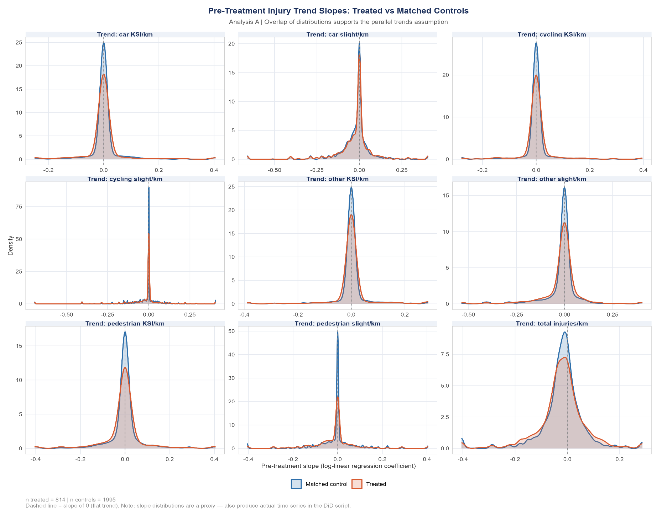

Summary
The two-stage matching procedure produces a high-quality matched sample that meets the design-stage requirements for credible difference-in-differences estimation. Stage 1 substantially reduced structural imbalance, narrowing the control pool from 65,020 to 4,269 unique OAs. Stage 2 then selected the 1,995 closest trajectory matches, achieving a maximum trend |SMD| of 0.060 across all nine mode–severity combinations, well below the 0.10 threshold.
Graphical inspection of pre-treatment slope distributions further confirms strong overlap between treated and matched control OAs. While residual differences remain in baseline injury levels and some structural characteristics, these are expected given the targeting of CAZ/LEZ schemes in dense urban areas. Under a difference-in-differences framework, such level differences do not bias estimates provided that pre-treatment trends are parallel.
The final analytic dataset comprises all road links within 814 treated OAs and 1,995 matched control OAs. Outcome models include covariate adjustment for pre-treatment injury levels and any remaining imbalanced structural characteristics (|SMD| > 0.10) to account for residual baseline differences.

Defining treatment
how links are classified as inside CAZ, control (or buffer), and timing – pre/post. How do we handle staggered introduction

final dataset structure
- road link * quarter with outcomes (injury counts by severity/mode) and exposure (intervention/control)

Outcome and key variables
- This could be v short but just an overview that we have: a) total injuries; 2) KSIs; 3) mode. Treatment var = binary with timing (or 0,1,2 with buffer included).
- Control variables: time fixed effects, road link FE?, anything else?

Statistical modelling
- Main model: DiD approach, fixed effects, why design is appropriate
- Assumptions: parallel trends, no major concurrent interventions (excplain this is one reason behind our approach of synthetic controls)
- Robustness and sensitivity analyses (alternative control groups e.g. vs the rest of the same city? Stratification by zero injury vs non zero injury roads, different model specs – to discuss)

Limitations
Maybe this ends up in discussion of paper but good just to have something written now:
- Injury under-reporting (stats19 – this is a common issue)
- Potential residual confounding (e.g. unaccounted for factors that could be influencing injuries e.g. other interventions!).
- Which relates to major point: urban city centres are dynamic spaces etc. with lots of policy interventions. We cannot account for this. Research rests on parallel trends assumption.

Conclusion

