Bug Board

Test Case Generator
The test cases generated by Bugboard provided satisfactory coverage, though slightly less than GPT. They included positive, negative, edge, performance, security, and compatibility scenarios. The output contained columns for title, steps, expected, and actual results. Additionally, a CSV export option is available.

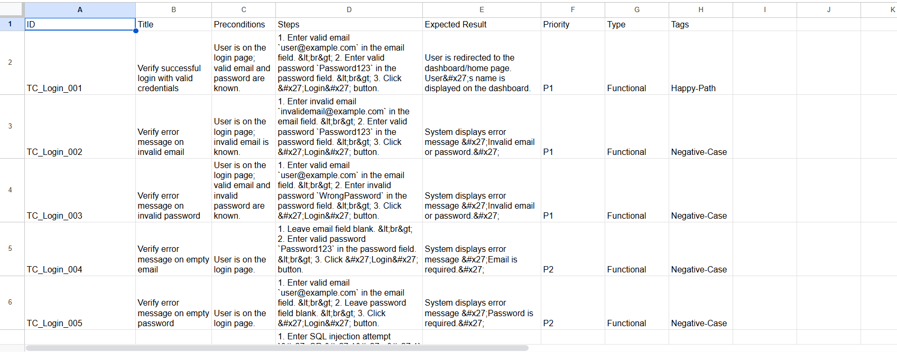

Screenshot Bug Explainer
In the screenshot bug explainer, I provided two screenshots containing functional errors along with the related user stories. However, the analyzer failed to detect these issues and instead reported mainly UI-related errors. None of the findings were critical.
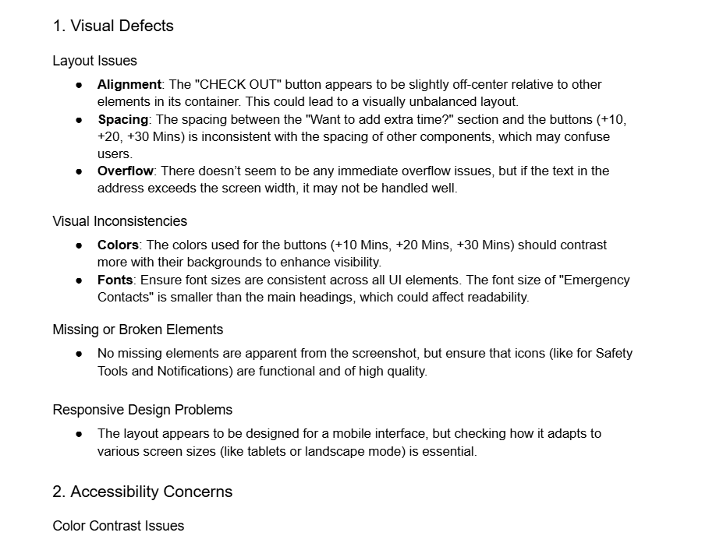

Test Execution Summary
In the test execution summary, I provided details such as the total tests executed, number of bugs identified, and total failures. The tool then generated a structured bug report with sections including Executive Summary, Coverage Metrics, Results Overview, and Recommendations.
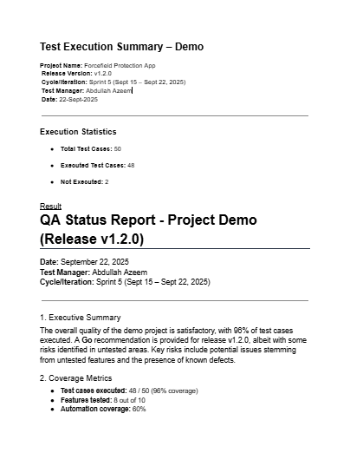

Bug Report Enhancer
In the bug report, I documented a few bugs along with their descriptions. The tool generated a properly formatted report including test case title, description, steps to reproduce, expected result, and actual result.
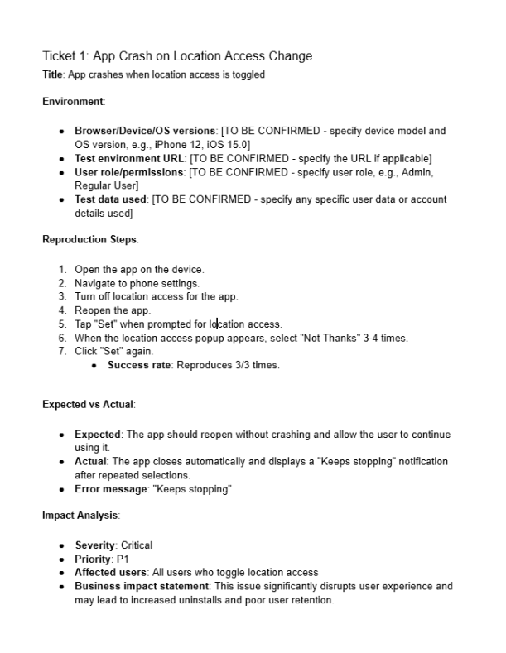

What’s Missing analyzer
In the Missing Analyzer, I intended to provide a file with missing test cases, but it did not support CSV input and only accepted test cases in a specified format, making copy-paste infeasible. Instead, I provided a single test case along with a related user story, and the tool generated recommendations for additional test cases to fill the gaps.
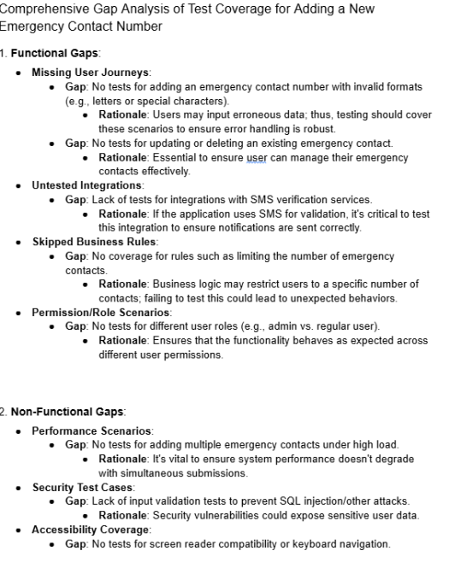

Test Case Duplicator
In the Test Case Duplicator, I provided two test cases with identical coverage but different wording. The analyzer successfully detected the redundancy and eliminated one of the duplicates.
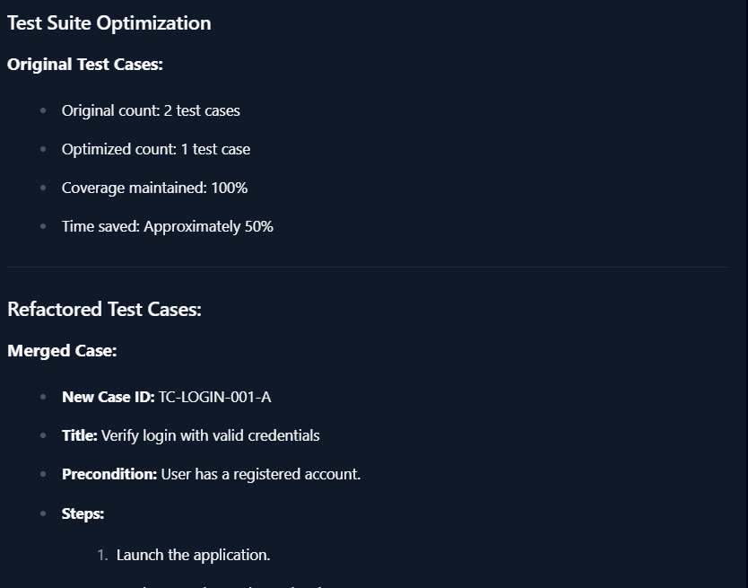

Test Data Generator
Not working

