Task: Add header name and try to find it in the nginx site.

Starting by install nginx using this command (sudo apt install nginx)

After that you can start the nginx:



Know we go to check the list of files and directories in the nginx to know what is happening,

Use this command (cd /etc/nginx) and then, (ls) we find that there are many files in there, so what we need to check is the one called (nginx.conf).

Note: open it using root permission, so you can read, write and execute.



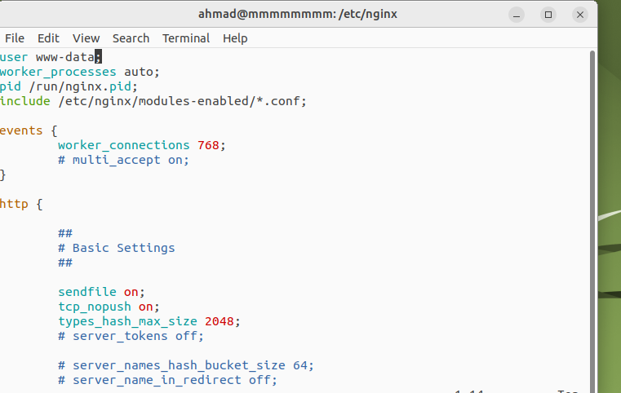

As we can see here, a bunch of information such as: (server name, port number, …etc).

Now we can not edit in here, so I created a file named (ah.conf) and added my configuration in it.

(cd /etc/nginx/conf.d)

Now list create our file in here where we can add the configuration we need to use to find the header name in (nginx website).





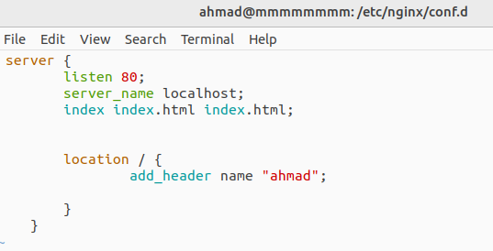

Note: After any edit in the script file, we have to check if it works successful or no by using this command.



And then reload it as well.



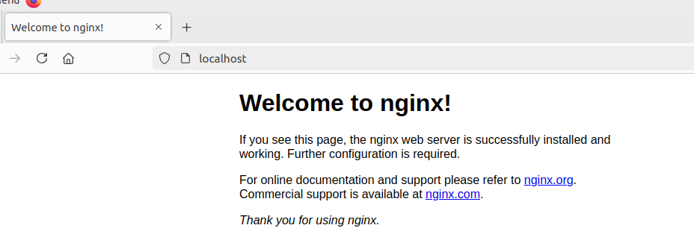

After locating our website by searching (<http://localhost>), now go to Inspect -> Network -> Headers.

