Downloading nginx image (type/version) 1.28 from Docker hub: 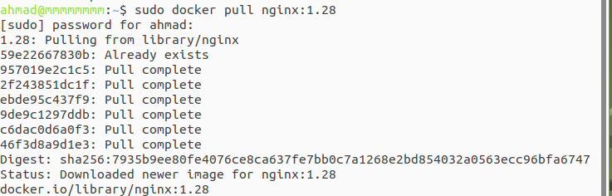

Using the command below to run the docker on 10000 port number:

“

sudo docker run –name nginx128 -p 10000:80 nginx:1.28

“

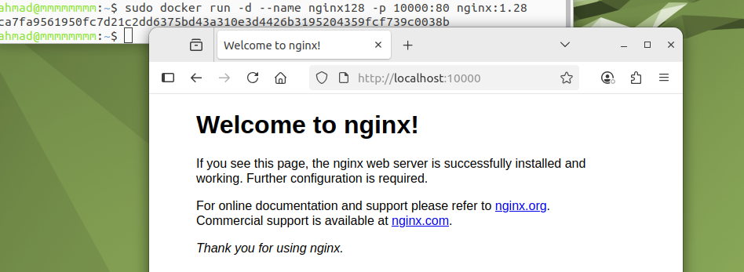

Now let’s make a new directory and create tow text files (dockerfile, index.html):

This is to print (Hi Ahmad) on the screen (web page) after locating the site:

“” mkdir nginxxx “”

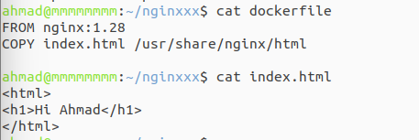

Build a docker (nginx-hi):

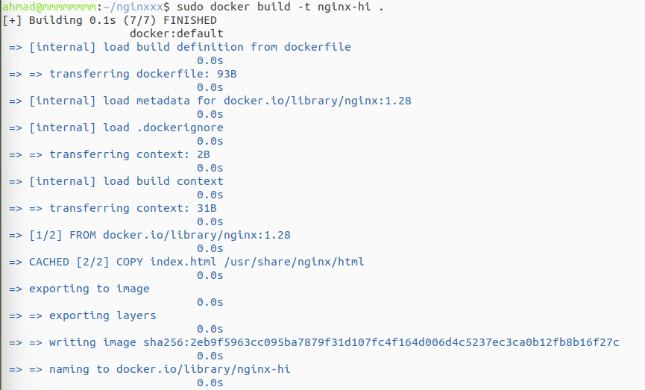

Run:



Checking if we are listening on port (10000):



