Installing Docker

pulling and running nginx docker image locally on port 10000

First, Installation:

Using this command: “

curl -fsSL https://test.docker.com -o test-docker.sh

sudo sh test-docker.sh

“

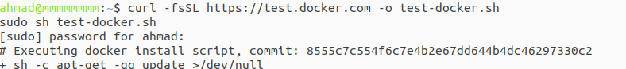

Checking: “

sudo docker version

“

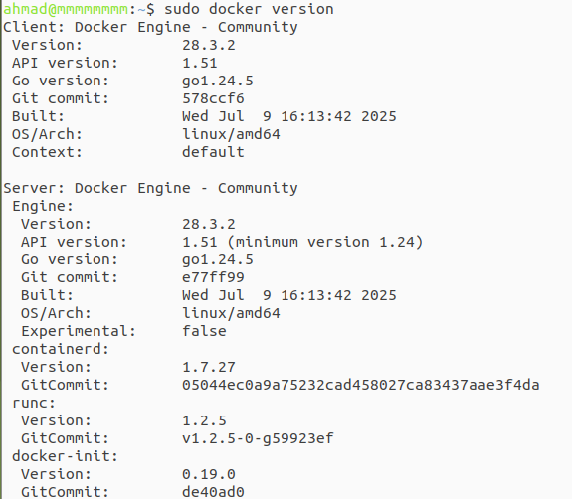

Now Pulling an image

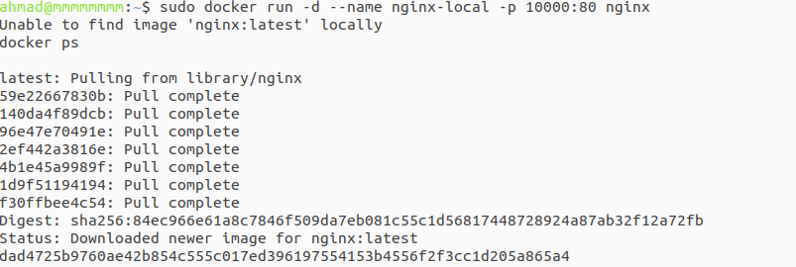

Checks the connection layer and the port:

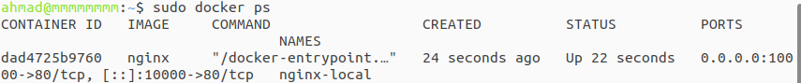

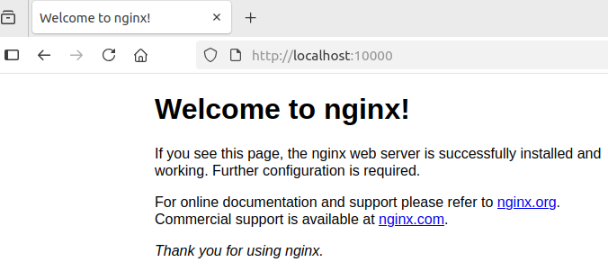

A reference link that could help while studying dockers and some related fields:

<https://www.docker.com/blog/how-to-use-the-official-nginx-docker-image/>

<https://docs.docker.com/engine/install/ubuntu/#install-using-the-convenience-script>