Changing the port number:

Using:

1. Nginx
2. Proxy Pass
3. Python app.

In this task, we successfully configured NGINX to reverse proxy traffic from port 9090 to a local Flask application running on port 5000. We installed Flask, wrote a minimal Python web app, and created a dedicated NGINX site configuration using proxy_pass. During setup, we encountered common issues such as port conflicts, proxy errors, and Flask not listening properly. These were resolved by carefully checking port bindings, adjusting NGINX site configs, and ensuring the Flask app was always running. In the end, the Flask app was accessible in the browser via http://localhost:9090 through the configured NGINX proxy.

Let’s go step by step:

1. **Installing Flask:**

pip install flask

1. **Create the flask application:**

nano ~/app.py

* Script:

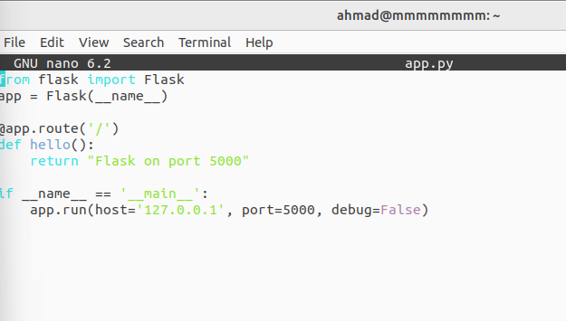

python3 ~/app.py

1. **Linking (creating) reverse nginx proxy configuration:**

sudo nano /etc/nginx/sites-available/flask_app

sudo ln -s /etc/nginx/sites-available/flask_app /etc/nginx/sites-enabled/

* You may need to remove the default Nginx site to avoid conflicts on the same port using this command: (sudo rm /etc/nginx/sites-enabled/default)

1. **Testing and Reload the config. (Nginx):**

This should be successful and ok.

sudo nginx -t

sudo systemctl reload nginx

1. **Checking Port in use (Avoiding conflicts):**

sudo lsof -i :80

sudo lsof -i :xxxx

This command helps us to know if there is any connection on the port we are looking for.

1. **Test (Flask and Nginx):**

curl <http://127.0.0.1:>xxxx

curl <http://localhost:yyyy>

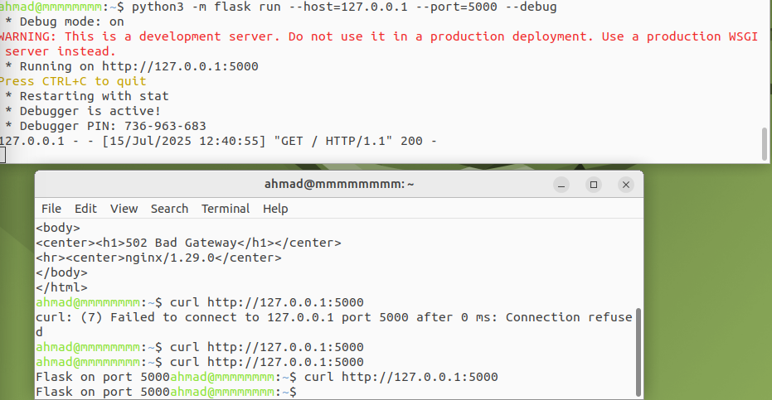

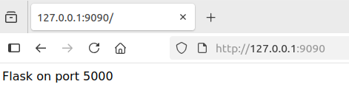

**Problems that I faced during this task:**

|  |  |
| --- | --- |
| 502 Bad Gateway from NGINX: | Flask server was not running – we restarted Flask properly. |
| port 80 already in use | Another service (old NGINX config) was using it – we changed ports. |
| conflicting server name "localhost" warning | Two NGINX configs used same port and name – we changed one of them to port 8080. |
| Flask app not reachable via curl | Flask was stopped or exited – we re-ran it and kept it running. (Then we can reach it from a new terminal window). |