1. Run MySQL container  
2. Run ubuntu container `docker run --name ubuntu ubuntu:latest sleep 3600`  
3. Connect to the MySQL container from inside the ubuntu container.

MySQL connection command:  
mysql -u <USERNAME> -p -h <MYSQL_CONTAINER_IP>

Download the images:

Ubunto:

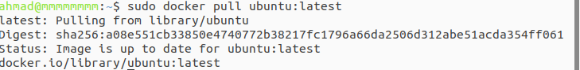

MySql:

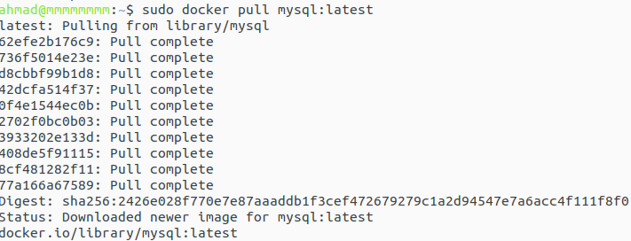

Create a custom network:

---(in this way the container can connect easily).



The command in this case (using the custom network) will be by just adding ( --network my-network). Run MySql command:

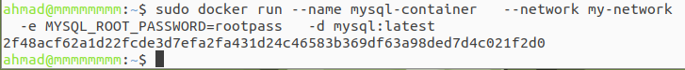

Run the Ubuntu container:

----(Within the same network)

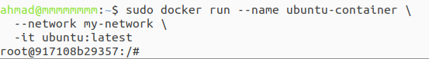

In a new terminal window (checking for the ip address):

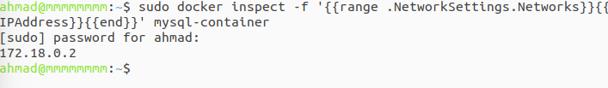

Now back to our network to start the connection:

