**ELEC 4700 Assignment 1**

**Monte-Carlo Modeling of Electron Transport**

**Ahmad Osman 101070948**

**February 7th, 2021**

Part 1: Electron Modelling

The following plots display the final electron paths and their concurrent temperature which they cause. The thermal velocity and free path mean are given as approx. 187000 and 7.74e-08 due the legend in the second figure.

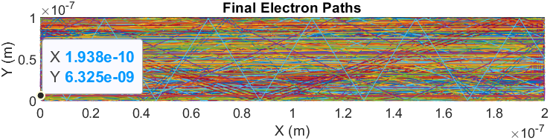

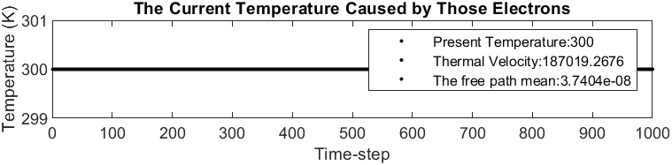

Part 2: Collisions with Mean Free Path (MFP)

The average temperature over time fluctuates greatly.

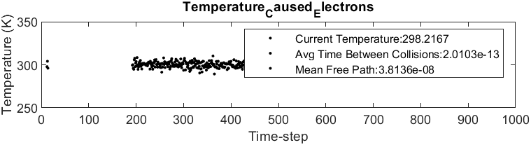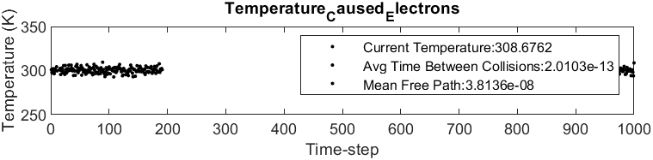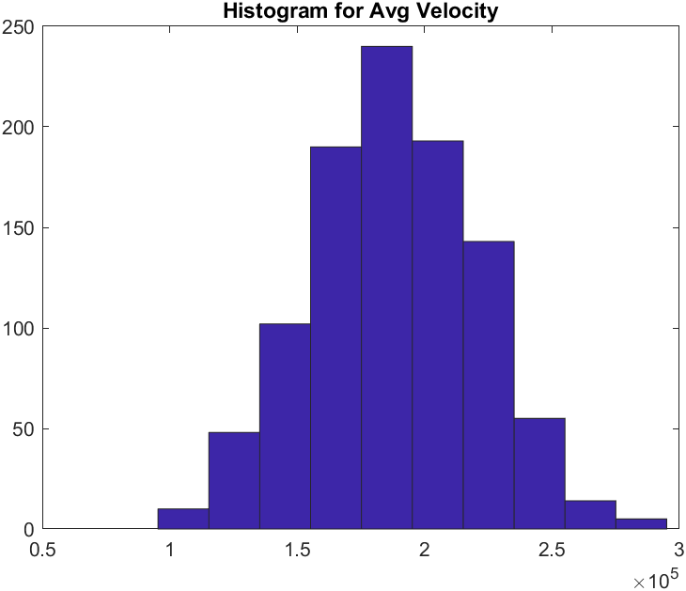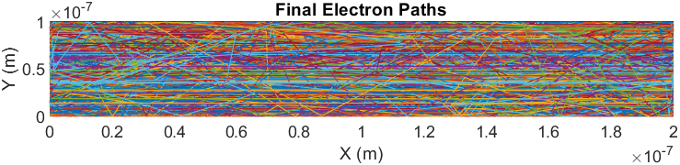

Part 3: Enhancements

