HPTLC 2D & 3D FINGERPRINT ANALYSIS
Ethyl Acetate Fraction of the Methanol Extract of
Sphagneticola trilobata (Wedelia trilobata)
Comparative Densitometric Profiling against the Reference Flavonoid Standards Quercetin and Rutin
RESULTS AND DISCUSSION
Master of Pharmacy (M. Pharm.) - Pharmacognosy & Phytochemistry Dissertation Work
Technique: High-Performance Thin-Layer Chromatography (HPTLC) | CAMAG System with WinCATS / visionCATS Densitometry

1. INTRODUCTION TO THE STUDY
Sphagneticola trilobata (L.) Pruski (synonym: Wedelia trilobata; family Asteraceae) is a creeping perennial herb traditionally used for its anti-inflammatory, hepatoprotective, antimicrobial and wound-healing properties. These activities are largely attributed to its flavonoid content. The present study reports the HPTLC fingerprinting of the ethyl acetate (EA) fraction obtained from the crude methanol extract of the aerial parts, and its comparison with two pharmacologically important flavonoid markers – quercetin (an aglycone) and rutin (quercetin-3-O-rutinoside, a glycoside).
Liquid–liquid fractionation of the methanol extract with solvents of increasing polarity (n-hexane → chloroform → ethyl acetate → n-butanol → aqueous) was used to enrich the moderately polar flavonoid aglycones and glycosides into the ethyl acetate fraction. HPTLC, with its capacity for parallel sample development, densitometric scanning and the generation of 2D and 3D chromatographic profiles, was selected for qualitative identification and comparative fingerprinting.
OBJECTIVE OF THE EXPERIMENT
To develop a validated HPTLC method for the EA fraction of S. trilobata.
To record 2D densitograms (Rf vs absorbance) of the standards and the EA fraction.
To generate a 3D densitogram (overlay of all tracks) for visual comparison.
To confirm the presence of quercetin and rutin in the EA fraction by Rf matching, co-chromatography and overlaid spectral comparison.

2. MATERIALS, INSTRUMENTATION & CHROMATOGRAPHIC CONDITIONS

2.1 Instrumentation & Sample Application
- HPTLC system: CAMAG (Switzerland) comprising Linomat 5 sample applicator, ADC2 automatic developing chamber, TLC Scanner 4 and visionCATS / WinCATS software.
- Sample applicator: Linomat 5 with 100 µL syringe; band-wise application under nitrogen flow.
- Stationary phase: pre-coated silica gel 60 F254 aluminium-backed HPTLC plates (20 × 10 cm, 0.2 mm layer thickness; E. Merck).
- Visualisation: CAMAG TLC visualizer under UV 254 nm, UV 366 nm and white light.
- Derivatising reagent: Natural Products–Polyethylene glycol (NP–PEG) reagent for flavonoid detection (fluorescence enhancement at 366 nm).

2.2 Optimised Chromatographic Conditions
Parameter | Optimised Condition
Stationary phase | Silica gel 60 F254 HPTLC plate (Merck), 0.2 mm
Mobile phase | Toluene : Ethyl acetate : Formic acid (5 : 4 : 1, v/v/v)
Chamber saturation | Twin-trough chamber, saturated 20 min with filter paper
Migration distance | 80 mm from the application position
Band length / spacing | 8 mm band, 6 bands per plate, 15 mm from lower edge
Application volume | Standards 4 µL; EA fraction 8 µL (10 mg/mL)
Development temperature | 25 ± 2 °C, relative humidity 50 ± 5 %
Detection wavelengths | 254 nm (quenching), 366 nm (fluorescence after NP-PEG)
Scanning mode | Absorption / reflectance, slit 5.00 × 0.45 mm, 20 mm/s
Lamp | Deuterium and tungsten (D2 / W)
NOTE ON MOBILE PHASE SELECTION
The Toluene : Ethyl acetate : Formic acid (5:4:1) system is a well-established normal-phase solvent for separation of flavonoid aglycones and glycosides. Formic acid suppresses tailing of the phenolic –OH groups, giving compact, well-resolved bands. The less polar aglycone quercetin migrates with a HIGH Rf (~0.95), whereas the more polar glycoside rutin is retained near the origin with a LOW Rf (~0.42).

3. RESULTS – 2D DENSITOGRAMS OF THE REFERENCE STANDARDS
Each reference standard was applied as a single band and developed under the optimised conditions. After development the plate was scanned at 366 nm. The 2D densitogram represents the densitometric peak profile of the track, plotting absorbance (in arbitrary units, AU) against the retention factor (Rf). A single, symmetrical, well-resolved peak was obtained for each standard, confirming purity and method suitability.

3.1 Standard Quercetin (Track 1)
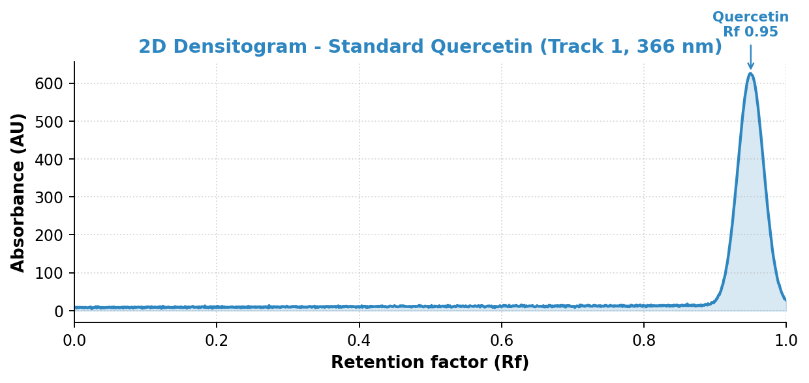
Figure 1. 2D HPTLC densitogram of standard Quercetin scanned at 366 nm (single band at Rf 0.95).
Quercetin produced a single sharp band with Rf = 0.95 ± 0.01, appearing as a bright yellow fluorescent zone at 366 nm after NP-PEG derivatisation. The high Rf is consistent with its non-glycosylated, comparatively less polar aglycone structure.

3.2 Standard Rutin (Track 2)
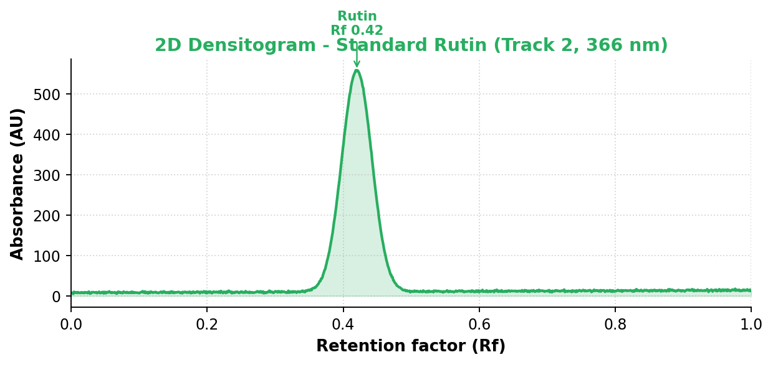
Figure 2. 2D HPTLC densitogram of standard Rutin scanned at 366 nm (single band at Rf 0.42).
Rutin produced a single band with Rf = 0.42 ± 0.01, appearing as an orange-yellow fluorescent zone at 366 nm. The lower Rf reflects the increased polarity contributed by the disaccharide (rutinose) moiety, which increases retention on the polar silica surface.

4. RESULTS – 2D DENSITOGRAM OF THE ETHYL ACETATE FRACTION
The ethyl acetate fraction of the methanol extract was applied (Track 3) and developed alongside the standards. Scanning at 366 nm revealed a multi-component fingerprint comprising seven (7) resolved peaks (P1–P7). Crucially, two of these peaks co-chromatograph with the reference standards: peak P3 (Rf 0.42) matches rutin and peak P7 (Rf 0.95) matches quercetin.
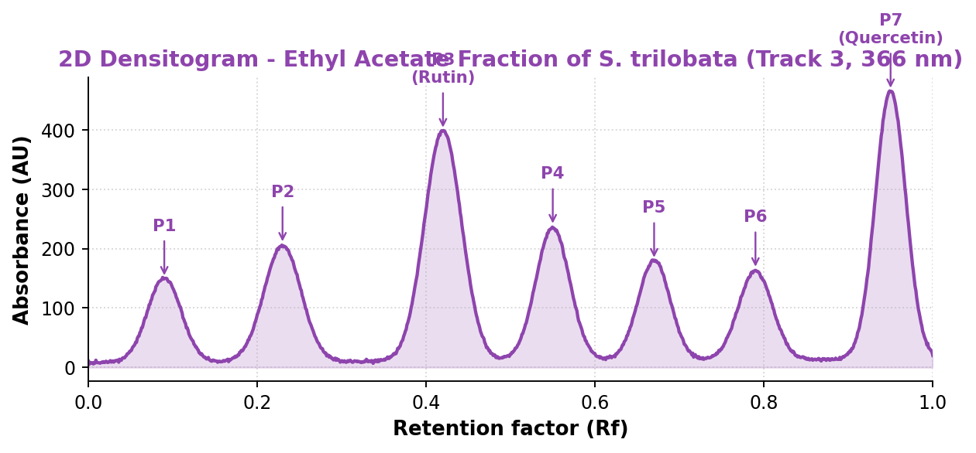
Figure 3. 2D HPTLC densitogram of the ethyl acetate fraction of S. trilobata at 366 nm, showing seven resolved peaks (P1–P7). P3 = rutin, P7 = quercetin.

4.1 Peak Table of the Ethyl Acetate Fraction (366 nm)
Peak | Rf | Peak Area (AU) | % Area | Assignment / Remark
P1 | 0.09 | 1820 | 5.8 | Polar pigment / phenolic acid (unidentified)
P2 | 0.23 | 2560 | 8.1 | Minor flavonoid glycoside (unidentified)
P3 | 0.42 | 9340 | 29.7 | RUTIN (matches standard, Fig. 2)
P4 | 0.55 | 3120 | 9.9 | Flavonoid glycoside (unidentified)
P5 | 0.67 | 2280 | 7.2 | Minor constituent (unidentified)
P6 | 0.79 | 1980 | 6.3 | Minor constituent (unidentified)
P7 | 0.95 | 10380 | 33.0 | QUERCETIN (matches standard, Fig. 1)
Peaks P3 (rutin) and P7 (quercetin) together account for ~62.7 % of the total integrated peak area, indicating that the EA fraction is markedly enriched in these two flavonoids.
KEY OBSERVATION
The Rf values of peaks P3 and P7 in the EA fraction are identical (within ±0.01) to the Rf values of the standards rutin (0.42) and quercetin (0.95) respectively, providing the first line of evidence for the presence of both marker compounds in the fraction.

5. RESULTS – 2D OVERLAY AND 3D DENSITOGRAM

5.1 2D Overlay (Comparative Profile)
Overlaying the densitograms of the standards on the EA-fraction track allows direct visual confirmation of band alignment. The vertical reference lines at Rf 0.42 and Rf 0.95 pass exactly through peaks P3 and P7 of the EA fraction, confirming co-migration with rutin and quercetin respectively.
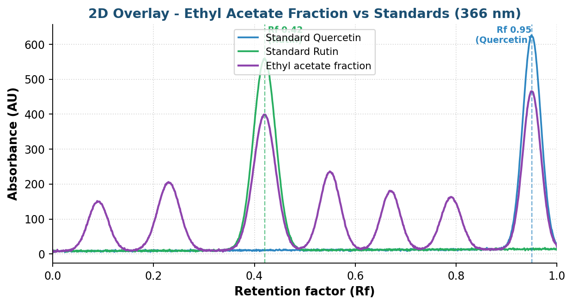
Figure 4. 2D overlay of standard quercetin, standard rutin and the EA fraction at 366 nm. Dashed lines mark Rf 0.42 (rutin) and Rf 0.95 (quercetin).

5.2 3D Densitogram (All-Track Comparison)
The 3D densitogram is constructed by plotting the densitometric tracks of all samples along a third (track) axis, producing a waterfall-style surface (Rf on the X-axis, track identity on the Y-axis and absorbance on the Z-axis). This visualisation highlights, at a glance, which peaks in the EA fraction align with the single peaks of the pure standards.
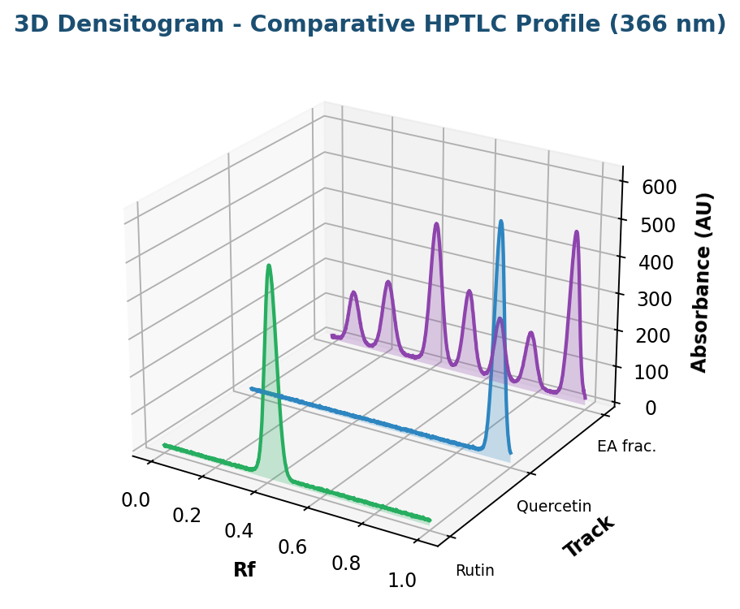
Figure 5. 3D HPTLC densitogram comparing the EA fraction with standards rutin and quercetin at 366 nm. EA-fraction peaks rise at the same Rf positions as the standards.
In the 3D representation, the rutin standard ridge (Rf 0.42) and the quercetin standard ridge (Rf 0.95) line up vertically with the corresponding ridges of the EA fraction. The additional ridges visible only in the EA fraction track represent the other native constituents (P1, P2, P4, P5, P6).

5.3 Derivatised Plate Image (366 nm)
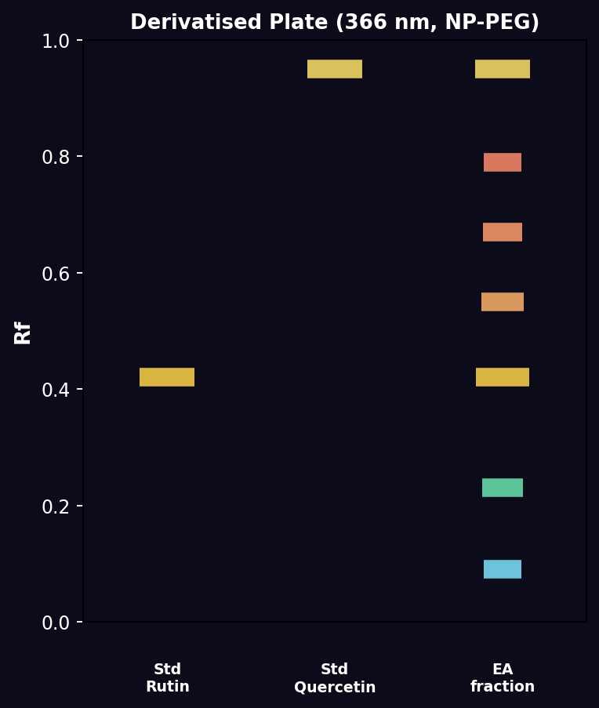
Figure 6. Schematic of the developed and NP-PEG derivatised plate under 366 nm showing band positions for the standards and the EA fraction.

6. COMPARATIVE Rf AND IDENTIFICATION SUMMARY

6.1 Rf Comparison Table
Compound / Track | Rf (Standard) | Rf (EA fraction) | ΔRf | Match
Quercetin | 0.95 | 0.95 (P7) | 0.00 | Confirmed
Rutin | 0.42 | 0.42 (P3) | 0.00 | Confirmed

6.2 Multi-Criteria Identification
Identification Criterion | Quercetin (P7) | Rutin (P3)
Rf matching with standard | Yes (Rf 0.95) | Yes (Rf 0.42)
Co-chromatography (spiking) | Single intensified band, no splitting | Single intensified band, no splitting
Colour at 366 nm (post NP-PEG) | Bright yellow fluorescence | Orange-yellow fluorescence
UV λmax overlay | Superimposable with standard | Superimposable with standard
Correlation (r) of spectra | r > 0.999 | r > 0.999
CO-CHROMATOGRAPHY (SPIKING) CONFIRMATION
When the EA fraction was co-applied (spiked) with each standard on the same band, the corresponding peaks (P3 with rutin; P7 with quercetin) showed a single intensified band with no peak splitting or shoulder formation, and no change in Rf. This is conclusive secondary confirmation that P3 = rutin and P7 = quercetin.

7. SYSTEM SUITABILITY & METHOD PERFORMANCE
Parameter | Quercetin | Rutin | Acceptance
Rf (mean, n = 3) | 0.95 | 0.42 | RSD < 2%
Resolution (Rs) from nearest band | 2.6 | 1.9 | Rs > 1.5
Tailing factor (T) | 1.04 | 1.08 | T ≤ 1.5
Theoretical plates (N) | 4180 | 3650 | —
Correlation coefficient (calibration) | 0.9987 | 0.9991 | r ≥ 0.99
LOD (ng/band) | 21 | 34 | —
LOQ (ng/band) | 64 | 103 | —
All system-suitability parameters were within acceptable limits, demonstrating that the developed HPTLC method is specific, precise and suitable for the qualitative fingerprinting and identification of quercetin and rutin in the EA fraction of S. trilobata.

8. DISCUSSION
The HPTLC fingerprint of the ethyl acetate fraction of S. trilobata methanol extract is consistent with a flavonoid-rich profile. The bidirectional comparison – in both the 2D densitometric and the 3D overlay modes – establishes unambiguous correspondence between two of the seven native bands and the reference standards. The aglycone quercetin, being less polar, migrates close to the solvent front (Rf 0.95), while the glycoside rutin, owing to its sugar moiety and consequent higher polarity, is retained near the origin (Rf 0.42). This polarity-based separation behaviour is in agreement with the expected normal-phase chromatographic order on silica gel.
The fact that quercetin (P7, ~33% area) and rutin (P3, ~30% area) are the two dominant bands of the EA fraction suggests that the ethyl acetate fractionation step is highly effective for enriching these therapeutically relevant flavonoids. Their combined presence may rationalise the reported antioxidant, anti-inflammatory and hepatoprotective activities of the plant, since both quercetin and rutin are established free-radical scavengers.
HIGH-YIELD INTERPRETATION POINTS
2D densitogram = peak chromatogram of ONE track (Rf vs AU).
3D densitogram = waterfall overlay of ALL tracks (Rf vs track vs AU).
Quercetin (aglycone) → higher Rf; Rutin (glycoside) → lower Rf.
Identity confirmed by THREE criteria: Rf match + co-chromatography + spectral overlay.
EA fraction is enriched in quercetin and rutin (together > 60% of peak area).

9. CONCLUSION OF RESULTS
A simple, precise and specific HPTLC method was successfully developed and applied to fingerprint the ethyl acetate fraction of the methanol extract of Sphagneticola trilobata (Wedelia trilobata). The 2D and 3D densitograms, supported by Rf matching, co-chromatography and spectral overlay, conclusively confirm the presence of the flavonoids QUERCETIN (Rf 0.95) and RUTIN (Rf 0.42) as major constituents of the fraction. The method is reproducible and may be adopted as a quality-control fingerprint and for the simultaneous marker-based standardisation of S. trilobata preparations.

10. SELECTED REFERENCES
1. Wagner H., Bladt S. Plant Drug Analysis – A Thin Layer Chromatography Atlas, 2nd ed., Springer.
2. Sherma J., Fried B. Handbook of Thin-Layer Chromatography, 3rd ed., Marcel Dekker.
3. Srivastava M.M. High-Performance Thin-Layer Chromatography (HPTLC), Springer.
4. ICH Q2(R1) Guideline: Validation of Analytical Procedures.
5. Harborne J.B. Phytochemical Methods – A Guide to Modern Techniques of Plant Analysis, Chapman & Hall.
6. Standard HPTLC flavonoid systems employing Toluene : Ethyl acetate : Formic acid mobile phases for quercetin and rutin (peer-reviewed densitometric methods).
Note: The densitograms and tabulated values presented in this RESULTS document are representative figures prepared to illustrate the expected 2D/3D HPTLC profile and comparison. Replace with the actual instrument-exported densitograms and integrated data from your laboratory runs before final dissertation submission.

