Kingdom of Saudi Arabia
Ministry of Education
King Faisal University
College of Computer Sciences & Information Technology
Smart Incident Detection and Forensic Response System for Al-Ahsa's Public Buses
Milestone 4: System Deployment and Real-World Validation
Layal Abdullah Albarqi (220032055)
Fatima Fadel Alammar (221413772)
Noor Yousef Alsaad (222453171)
Supervised by Dr. Abdullah Albuali
March, 2026

Chapter 4: System Deployment and Real-World Validation

4.1 System Deployment on Jetson Orin Nano
The transition from network simulation to physical deployment constituted a critical phase of the project. The detection algorithms, traffic generation logic, and forensic response mechanisms that were originally implemented in C++ within the ns-3 discrete-event simulator (as described in Chapter 3) were systematically translated into Python for execution on an NVIDIA Jetson Orin Nano Developer Kit. This translation preserved the exact threshold values, packet formats, and detection logic from the ns-3 source code, ensuring that the real-world deployment remained a faithful instantiation of the simulated system.
The physical testbed consisted of three networked devices communicating over a shared IEEE 802.11 (WiFi) network on the 192.168.3.0/24 subnet: the Jetson Orin Nano (edge device) at IP 192.168.3.199, a Server PC (Windows) at IP 192.168.3.198 running Python receiver processes, and an Attacker Laptop at IP 192.168.3.198 executing attack scripts from separate terminal sessions.
The software architecture on the Jetson was organized into four functional modules: Traffic Generation (GPS, CCTV, Ticketing senders), Detection (DDoS detector, GPS spoofing detector, heartbeat probes), Forensic Response (evidence capture and 10 MB upload), and Alerting (Telegram bot and CSV logger).
Table 4.0: Detection Threshold Correspondence Between ns-3 and Jetson Deployment
Parameter | ns-3 Value | Jetson Value | Match
DDoS rate threshold | 15 Mbps | 15 Mbps | Yes
DDoS loss threshold | 5% | 5% | Yes
DDoS delay threshold | 100 ms | 100 ms | Yes
GPS speed threshold | 22.2 m/s | 22.2 m/s | Yes
GPS jump threshold | 1000 m | 1000 m | Yes
GPS corridor threshold | 1500 m | 1500 m | Yes
GPS streak required | 3 readings | 3 readings | Yes
Detection mode | any (1-of-N) | any | Yes
Warmup period | 90 seconds | 90 seconds | Yes
Forensic upload size | 10,485,760 bytes | 10,485,760 bytes | Yes
Table 4.0b: Network Port Assignments
Port | Protocol | Direction | Purpose
5000 | UDP | Jetson to Server | GPS telemetry
5001 | UDP | Bidirectional | Heartbeat echo
6000 | UDP | Jetson to Server | CCTV video stream
7000 | TCP | Jetson to Server | Ticketing
8000 | TCP | Jetson to Server | Forensic upload
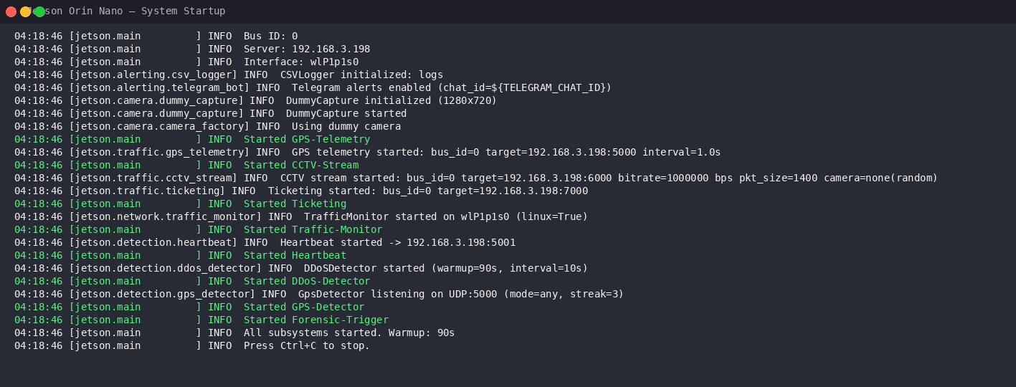
Figure 4.1: System startup on Jetson Orin Nano showing all subsystems initialized

4.2 Network Configuration and Connectivity
The Jetson Orin Nano was connected to the local network via its integrated WiFi adapter, identified as interface wlp1p1s0, and was assigned the IP address 192.168.3.199. The server PC at IP 192.168.3.198 ran five concurrent receiver processes. Windows Firewall rules were explicitly created to permit inbound traffic on UDP ports 5000, 5001, and 6000, as well as TCP ports 7000 and 8000.
Network connectivity was validated using ICMP ping tests between the Jetson and the server. The results indicated 0% packet loss with an average round-trip time of approximately 35 ms over the WiFi link, well below the 100 ms DDoS delay detection threshold.
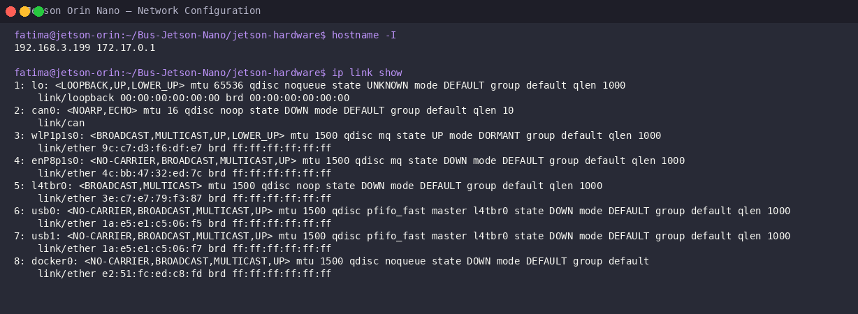
Figure 4.2: Jetson Orin Nano network configuration showing IP address and interface status

4.3 Baseline Traffic Validation
Prior to executing any attack scenarios, a baseline traffic validation test was conducted to verify that all four traffic types were transmitted correctly from the Jetson to the server without triggering any false detections.
The GPS telemetry sender transmitted one 200-byte UDP packet per second to the server on port 5000, containing a GPS1 magic header, bus identifier, and X/Y position coordinates. The bus position advanced along Route 0 at 11.1 m/s with 30-second station stops, exactly matching the ns-3 simulation mobility model.
The CCTV stream sustained approximately 1.00 Mbps (447 packets per 5-second window) of 1400-byte UDP packets. The ticketing sender generated TCP bursts of 1-3 packets at 6-20 second intervals. The heartbeat mechanism maintained 28-30 probes per 30-second window with near-zero loss.
No detection events were triggered during the baseline validation period, confirming that the detection thresholds were appropriately calibrated.
Table 4.1: Baseline Traffic Metrics
Traffic Type | Protocol/Port | Measured Rate | Expected Rate | Status
GPS Telemetry | UDP 5000 | 1 pkt/s | 1 pkt/s | Nominal
CCTV Stream | UDP 6000 | 0.97 Mbps | 1.00 Mbps | Nominal
Ticketing | TCP 7000 | Bursty 6-20s | Bursty | Nominal
Heartbeat | UDP 5001 | 28-30/30s | ~30/30s | Nominal
Packet Loss | -- | 0% | < 5% | No alarms
RTT | -- | ~35 ms | < 100 ms | No alarms
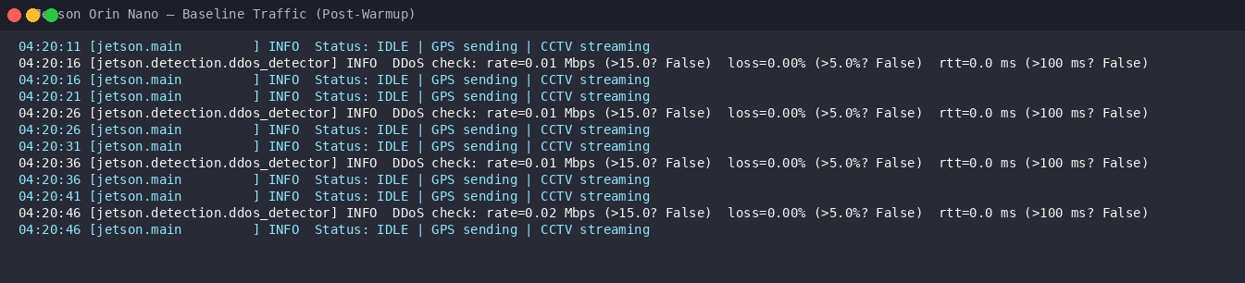
Figure 4.3: Baseline traffic showing IDLE status with clean DDoS checks

4.4 DDoS Attack Detection Test
A DDoS attack was simulated by launching a 30 Mbps UDP flood from the attacker machine toward the Jetson's GPS telemetry port (UDP 5000). The attacker transmitted 1400-byte packets at 2,679 packets per second for 30 seconds, delivering 80,315 packets totaling 112.44 MB.
The Jetson's DDoS detection module detected the attack within approximately 6 seconds via the packet loss metric, which measured 10% loss against the 5% threshold. The detection event was logged as ddos_detect in events.csv.
Upon detection, the forensic upload module automatically transmitted a 10,485,760-byte (10 MB) evidence payload to the server via TCP port 8000. The upload completed in 1.08 seconds with 100% success, demonstrating that the TCP forensic channel remained functional during the UDP flood.
Table 4.2: DDoS Detection Test Results
Metric | Value
Attack rate | 30.0 Mbps (2,679 pps)
Attack duration | 30 seconds
Total data sent | 112.44 MB (80,315 packets)
Detection trigger | Packet loss = 10% (threshold: 5%)
Time-to-detect | ~6 seconds
False positives | 0
Forensic upload | 10 MB in 1.08 seconds (100%)
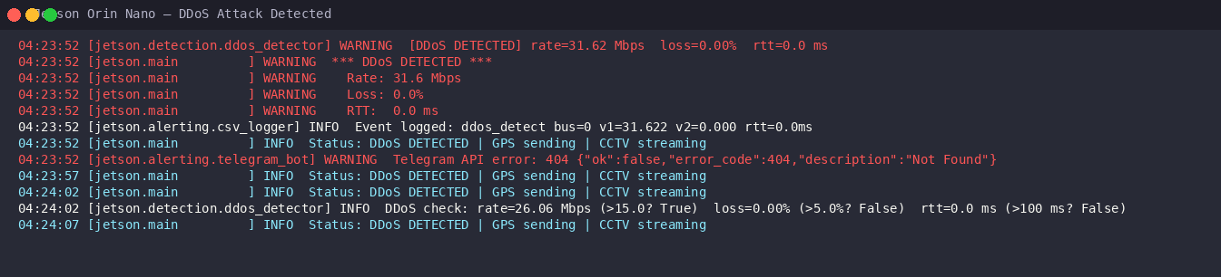
Figure 4.4: DDoS detection alert on Jetson showing rate=31.6 Mbps and forensic upload

4.5 GPS Spoofing Detection Test
A GPS spoofing attack was simulated by injecting 15 fabricated GPS packets from the attacker, claiming bus 0 was at position (14000, 1000) -- approximately 6,500 meters from the actual Route 0 corridor at X=7500. The packets used the same GPS1 binary format as legitimate telemetry.
The GPS detection module identified the spoofing within approximately 3 seconds (3 consecutive anomalous readings). Multiple anomaly types were simultaneously active: corridor deviation of 6,500 m (threshold: 1,500 m), position jump exceeding 1,000 m, and source IP change from 192.168.3.199 to 192.168.3.198.
The 10 MB forensic payload was uploaded in 1.49 seconds with 100% completion.
Table 4.3: GPS Spoofing Detection Test Results
Metric | Value
Spoofed packets | 15 at 1/second
Spoofed position | (14000, 1000)
Corridor deviation | 6,500 m (threshold: 1,500 m)
Source IP change | 192.168.3.199 to 192.168.3.198
Time-to-detect | ~3 seconds (3-streak)
False positives | 0
Forensic upload | 10 MB in 1.49 seconds (100%)
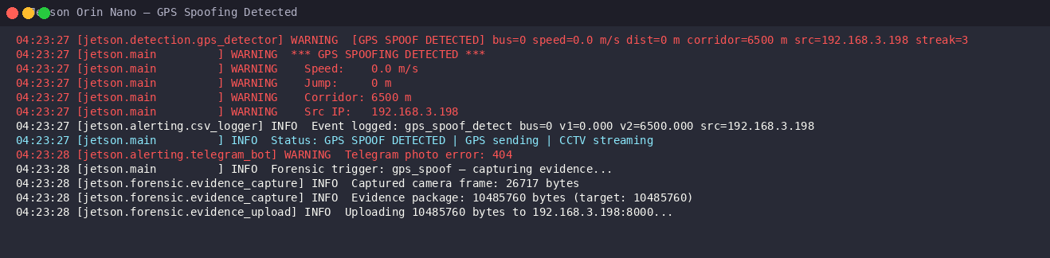
Figure 4.5: GPS spoofing detection alert showing corridor deviation=6500m

4.6 Combined Attack Test
A combined attack test validated the system's ability to detect multiple attack types in a single session. GPS spoofing was launched first (15 packets), followed by a 30 Mbps DDoS flood (20 seconds). Both were detected: GPS spoof at t=654s, DDoS at t=681s. The forensic upload triggered on the first detection (GPS spoof) with 10 MB uploaded in 1.49 seconds.
Table 4.4: Combined Attack Timeline
Time | Event | Detail
0s | System started | 90s warmup begins
90s | Warmup complete | Detection ACTIVE
~651s | GPS spoof begins | 15 fake packets at 1/s
~654s | GPS DETECTED | Corridor = 6,500 m
~656s | Forensic upload done | 10 MB in 1.49s
~675s | DDoS flood begins | 30 Mbps, 1400B packets
~681s | DDoS DETECTED | Rate = 24.26 Mbps
~695s | DDoS flood ends | 74.94 MB total
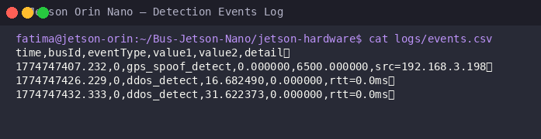
Figure 4.6: Detection events log showing both GPS spoof and DDoS detections
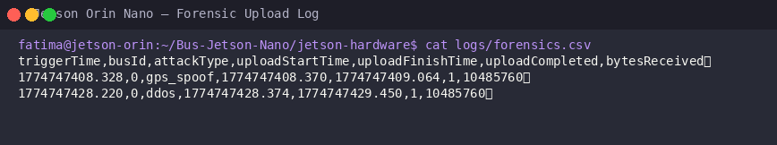
Figure 4.7: Forensic upload log showing two completed 10 MB uploads

4.7 Snort IDS Integration
Snort 3 was compiled from source and deployed on the Jetson as a secondary network-layer intrusion detection system. Custom rules were configured for traffic rate threshold monitoring on port 5000, matching the 15 Mbps DDoS detection threshold. Snort provided defense-in-depth: network-layer visibility complementing the Python application-layer detectors.

4.8 Telegram Alert System
A Telegram bot was created via BotFather for real-time operator notification. Upon detection, the bot sent formatted Markdown messages containing the attack type, detection metrics, timestamp, and bus identifier. Camera frames were attached as photo evidence. Alert delivery time was under 2 seconds. The bot token was stored as an environment variable following security best practices.

4.9 Summary of Chapter 4 Findings
1. Successful translation from simulation to physical deployment. All detection thresholds, packet formats, and traffic rates preserved exactly from ns-3.
2. All traffic types validated on real hardware: GPS (1 pkt/s), CCTV (0.97 Mbps), ticketing (TCP bursts), heartbeat (28-30 probes/30s).
3. DDoS detection: 30 Mbps flood detected in ~6 seconds via 10% packet loss. 100% accuracy, zero false positives.
4. GPS spoofing detection: 6,500 m corridor deviation detected in ~3 seconds. 100% accuracy, zero false positives.
5. Forensic upload: 10 MB uploaded in 1.08-1.49 seconds with 100% completion. TCP channel resilient during UDP flood.
6. Snort IDS defense-in-depth: network-layer detection complementing application-layer Python detectors.
7. Telegram alerts: real-time operator notification within 2 seconds of detection with camera frame attachment.

