**Web programming**

**Lec 2**

**Task 1:**

<!DOCTYPE html>

<html lang="en">

<head>

    <meta charset="UTF-8">

    <meta name="viewport" content="width=device-width, initial-scale=1.0">

    <title>Document</title>

    <style>

        body {

            font-family: Arial, sans-serif;

            background-color: black;

            color: white;

            margin: 0;

            padding: 20px;

            text-align: left;

        }

        .button {

            padding: 16px 5px;

            border-radius: 8px;

            background-color: green;

            font-size: smaller;

            text-align: center;

            color: white;

            border: none;

            cursor: pointer;

        }

    </style>

</head>

<body>

    <h1 style="font-style: normal;">Start CSS Exercises</h1>

    <p>Good luck!</p>

    <button class="button">Start CSS Exercises > </button>

</body>

</html>

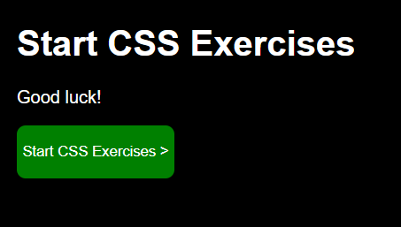

**Task 2:**

<!DOCTYPE html>

<html lang="en">

<head>

  <meta charset="UTF-8">

  <meta name="viewport" content="width=device-width, initial-scale=1.0">

  <title>Registration Form</title>

  <style>

    body {

      font-family: Arial, sans-serif;

      background-color: #4285f4;

      text-align: center;

      margin: 0;

      display: flex;

      justify-content: center;

      align-items: center;

    }

    form {

      max-width: 300px;

      background-color: #4285f4;

      padding: 10px;

      border-radius: 5px;

    }

    label {

      display: block;

      margin-bottom: 8px;

      color: #fff;

    }

    input {

      width: 100%;

      padding: 8px;

      margin-bottom: 12px;

      box-sizing: border-box;

    }

    button {

      width: 100%;

      background-color: red;

      color: #fff;

      padding: 10px;

      border: none;

      border-radius: 5px;

      cursor: pointer;

    }

  </style>

</head>

<body>

  <form>

    <input type="text" placeholder="Name" required>

    <input type="text" placeholder="Username" required>

    <input type="password" placeholder="Password" required>

    <input type="Number" placeholder="Number" required>

    <input type="email" placeholder="Email" required>

    <button type="submit">Register</button>

  </form>

</body>

</html>

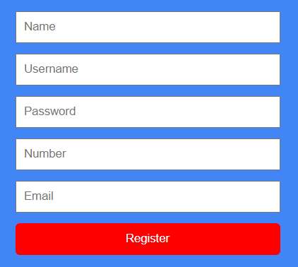

**Task 3:**

<!DOCTYPE html>

<html lang="en">

<head>

  <meta charset="UTF-8">

  <meta name="viewport" content="width=device-width, initial-scale=1.0">

  <title>Minar-e-Pakistan Card</title>

  <style>

    body {

      font-family: Arial, sans-serif;

      margin: 0;

      padding: 0;

      background-color: #f4f4f4; /* Background color for the page */

      display: flex;

      justify-content: center;

      align-items: center;

      height: 100vh;

    }

    .card {

      position: relative;

      width: 300px;

      overflow: hidden;

      border-radius: 10px;

      box-shadow: 0 4px 8px rgba(0, 0, 0, 0.1);

    }

    .card img {

      width: 100%;

      height: auto;

      display: block;

    }

    .overlay {

      position: absolute;

      bottom: 0;

      left: 0;

      width: 100%;

      background-color: rgba(255, 255, 255, 0.8); /* White box overlay with 80% opacity */

      text-align: center;

      padding: 10px;

    }

    .place-name {

      font-size: 18px;

      font-weight: bold;

      color: #333; /* Text color for the place name */

    }

  </style>

</head>

<body>

  <div class="card">

    <img src="minar-e-pakistan.jpg" alt="Minar-e-Pakistan">

    <div class="overlay">

      <div class="place-name">Minar-e-Pakistan</div>

    </div>

  </div>

</body>

</html>

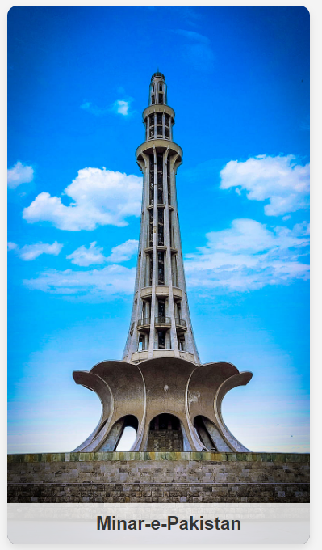

**Task 4:**

<!DOCTYPE html>

<html lang="en">

<head>

  <meta charset="UTF-8">

  <meta name="viewport" content="width=device-width, initial-scale=1.0">

  <title>Minar-e-Pakistan Card</title>

  <style>

    body {

      font-family: Arial, sans-serif;

      margin: 0;

      padding: 0;

      background-color: #f4f4f4; /* Background color for the page */

      display: flex;

      justify-content: center;

      align-items: center;

      height: 100vh;

      overflow: hidden;

    }

    .card {

      position: relative;

      width: 300px;

      overflow: hidden;

      border-radius: 10px;

      box-shadow: 0 4px 8px rgba(0, 0, 0, 0.1);

      animation: slideIn 5s ease-in-out; /* Animation duration: 5 seconds */

    }

    .card img {

      width: 100%;

      height: auto;

      display: block;

    }

    .overlay {

      position: absolute;

      bottom: 0;

      left: 0;

      width: 100%;

      background-color: rgba(255, 255, 255, 0.8); /* White box overlay with 80% opacity */

      text-align: center;

      padding: 10px;

    }

    .place-name {

      font-size: 18px;

      font-weight: bold;

      color: #333; /* Text color for the place name */

    }

    @keyframes slideIn {

      from {

        transform: translateX(-100%);

      }

      to {

        transform: translateX(0);

      }

    }

  </style>

</head>

<body>

  <div class="card">

    <img src="minar-e-pakistan.jpg" alt="Minar-e-Pakistan">

    <div class="overlay">

      <div class="place-name">Minar-e-Pakistan</div>

    </div>

  </div>

</body>

</html>

