**Web programming**

**Lec 3**

**Task 1:**

<!DOCTYPE html>

<html lang="en">

<head>

<meta charset="UTF-8">

<meta name="viewport" content="width=device-width, initial-scale=1.0">

<title>Bootstrap Alert Boxes</title>

<!-- Bootstrap CSS CDN -->

<link rel="stylesheet" href="https://stackpath.bootstrapcdn.com/bootstrap/4.3.1/css/bootstrap.min.css">

</head>

<body class="container mt-5">

<!-- Bootstrap Alert Boxes with Links -->

<div class="alert alert-secondary" role="alert">

<strong>Basic Alert:</strong> <a href="https://www.w3schools.com/bootstrap/bootstrap_ver.asp" class="alert-link">Bootstrap Main Page</a>.

</div>

<div class="alert alert-primary" role="alert">

<strong>Primary Alert:</strong> <a href="https://www.w3schools.com/bootstrap/bootstrap_ver.asp" class="alert-link">Bootstrap Main Page</a>.

</div>

<div class="alert alert-success" role="alert">

<strong>Success Alert:</strong> <a href="https://www.w3schools.com/bootstrap/bootstrap_ver.asp" class="alert-link">Bootstrap Main Page</a>.

</div>

<div class="alert alert-danger" role="alert">

<strong>Danger Alert:</strong> <a href="https://www.w3schools.com/bootstrap/bootstrap_ver.asp" class="alert-link">Bootstrap Main Page</a>.

</div>

<div class="alert alert-warning" role="alert">

<strong>Warning Alert:</strong> <a href="https://www.w3schools.com/bootstrap/bootstrap_ver.asp" class="alert-link">Bootstrap Main Page</a>.

</div>

<div class="alert alert-info" role="alert">

<strong>Info Alert:</strong> <a href="https://www.w3schools.com/bootstrap/bootstrap_ver.asp" class="alert-link">Bootstrap Main Page</a>.

</div>

</body>

</html>

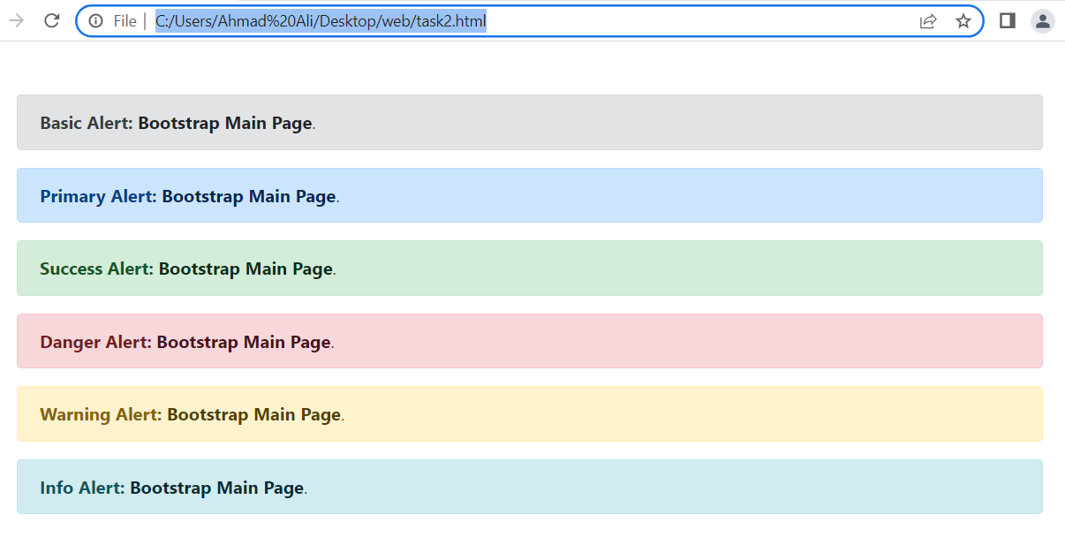

**Task 2:**

<!DOCTYPE html>

<html lang="en">

<head>

<meta charset="UTF-8">

<meta name="viewport" content="width=device-width, initial-scale=1.0">

<title>Button Click Messages</title>

<!-- Bootstrap CSS CDN -->

<link rel="stylesheet" href="https://stackpath.bootstrapcdn.com/bootstrap/4.3.1/css/bootstrap.min.css">

</head>

<body>

<div class="container mt-5">

<div class="btn-group">

<button type="button" class="btn btn-primary" onclick="displayMessage('Button 1 clicked')">Basic</button>

<button type="button" class="btn btn-secondary" onclick="displayMessage('Button 2 clicked')">Default</button>

<button type="button" class="btn btn-success" onclick="displayMessage('Button 3 clicked')">Primary</button>

<button type="button" class="btn btn-danger" onclick="displayMessage('Button 4 clicked')">Success</button>

<button type="button" class="btn btn-warning" onclick="displayMessage('Button 5 clicked')">Info</button>

<button type="button" class="btn btn-info" onclick="displayMessage('Button 6 clicked')">Warning</button>

<button type="button" class="btn btn-light" onclick="displayMessage('Button 7 clicked')">Danger</button>

<button type="button" class="btn btn-white text-dark" onclick="displayMessage('Button 8 clicked')">Link</button>

</div>

</div>

<script>

function displayMessage(message) {

alert(message);

}

</script>

</body>

</html>

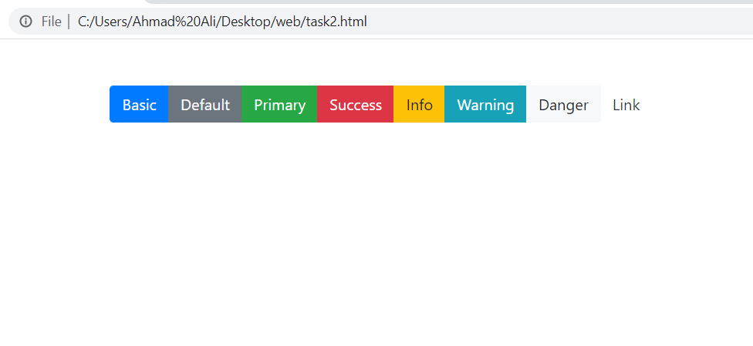

**Task 3:**

<!DOCTYPE html>

<html lang="en">

<head>

<meta charset="UTF-8">

<meta name="viewport" content="width=device-width, initial-scale=1.0">

<title>Calculator</title>

</head>

<body>

<h2>Simple Calculator</h2>

<form id="calculatorForm">

<label>Enter Number 1: <input type="number" id="num1" required></label><br>

<label>Enter Number 2: <input type="number" id="num2" required></label><br>

<button type="button" onclick="calculate()">Calculate</button>

</form>

<h3>Results:</h3>

<p id="result"></p>

<script>

function calculate() {

var num1 = parseFloat(document.getElementById("num1").value);

var num2 = parseFloat(document.getElementById("num2").value);

var result = `Add: ${num1 + num2}, Subtract: ${num1 - num2}, Multiply: ${num1 * num2}, Divide: ${num2 !== 0 ? num1 / num2 : 'Cannot divide by zero'}`;

document.getElementById("result").textContent = result;

}

</script>

</body>

</html>

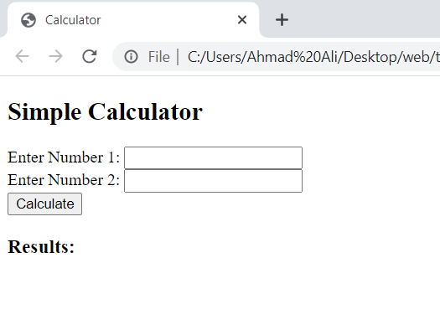

**Task 4:**

<!DOCTYPE html>

<html lang="en">

<head>

<meta charset="UTF-8">

<meta name="viewport" content="width=device-width, initial-scale=1.0">

<title>Month Days Counter</title>

</head>

<body>

<h2>Month Days Counter</h2>

<script>

var monthName = prompt("Enter the month name (e.g., Jan, Feb)").toLowerCase();

var daysInMonth = { jan: 31, feb: 28, mar: 31, apr: 30, may: 31, jun: 30, jul: 31, aug: 31, sep: 30, oct: 31, nov: 30, dec: 31 };

if (daysInMonth[monthName]) {

document.body.innerHTML += `<p>Total days in <span style="color: red;">${monthName.toUpperCase()}</span>: ${daysInMonth[monthName]}</p>`;

} else {

alert("Invalid month name. Please enter a valid month abbreviation (e.g., Jan, Feb).");

}

</script>

</body>

</html>

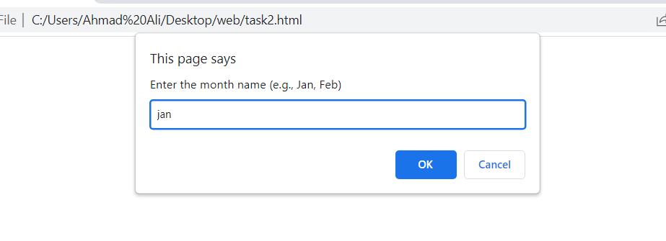

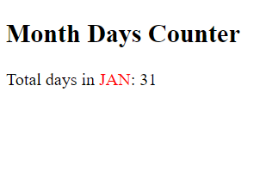

**Task 5:**

<!DOCTYPE html>

<html lang="en">

<head>

<meta charset="UTF-8">

<meta name="viewport" content="width=device-width, initial-scale=1.0">

<title>Multiplication Table</title>

</head>

<body>

<h2>Multiplication Table Generator</h2>

<script>

var num = parseFloat(prompt("Enter a number:"));

if (!isNaN(num)) {

document.write(`<h3>Multiplication Table for ${num}:</h3>`);

for (let i = 1; i <= 10; i++) {

document.write(`${num} * ${i} = ${num * i}<br>`);

}

} else {

alert("Invalid input. Please enter a valid number.");

}

</script>

</body>

</html>

