**Web programming**

**Lecture 6**

**Task 1:**

HTML:

In HTML, comments are used to add notes or reminders to yourself or other developers. They do not appear in the rendered output of the webpage. Comments in HTML are denoted by “<!-- 🡪”

<!-- This is a comment in HTML -->

CSS:

In CSS, comments can be used to explain the purpose of certain styles or to temporarily disable styles. Comments in CSS are denoted by **/* */**

/* This is a comment in CSS */

JAVASCRIPT:

In JavaScript, comments are used to add explanations or notes to your code. Comments in JavaScript can be single-line // OR **/* */**

// This is a single-line comment in JavaScript

/*

This is a

multi-line comment

in JavaScript

*/

**Task 2:**

<!DOCTYPE html>

<html>

<head>

  <title>Welcome to jQuery</title>

  <script src="https://code.jquery.com/jquery-3.6.0.min.js"></script>

</head>

<body>

  <script>

    $(document).ready(function(){

      alert("Welcome to jQuery");

    });

  </script>

</body>

</html>

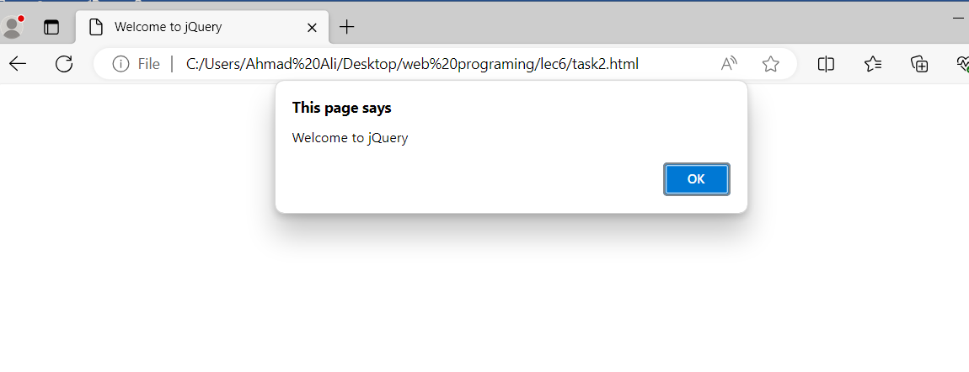

**Task 3:**

<!DOCTYPE html>

<html>

<head>

  <title>Toggle Image Display</title>

  <script src="https://code.jquery.com/jquery-3.6.0.min.js"></script>

</head>

<body>

  <img id="myImage" src="fire.png" style="display:none;" width="40px">

  <button id="toggleButton">Show Image</button>

  <script>

    $(document).ready(function(){

      $("#toggleButton").click(function(){

        $("#myImage").toggle();

        var buttonText = $("#toggleButton").text();

        if (buttonText === "Show Image") {

          $("#toggleButton").text("Hide Image");

        } else {

          $("#toggleButton").text("Show Image");

        }

      });

    });

  </script>

</body>

</html>

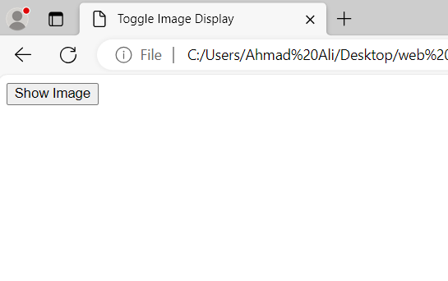

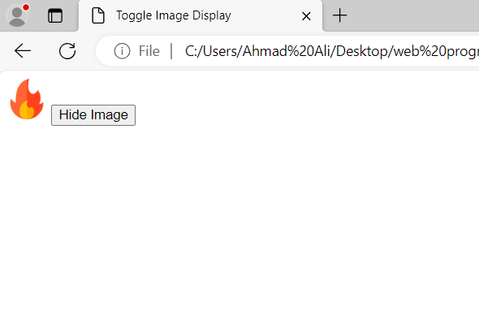

**Task 4:**

<!DOCTYPE html>

<html>

<head>

  <title>Remove Table Row</title>

  <script src="https://code.jquery.com/jquery-3.6.0.min.js"></script>

</head>

<body>

  <table id="myTable" border="1">

    <tr><td>AhmadAli</td><td><button class="removeButton">Remove</button></td></tr>

    <tr><td>bilalkhan</td><td><button class="removeButton">Remove</button></td></tr>

    <tr><td>rajpoot</td><td><button class="removeButton">Remove</button></td></tr>

  </table>

  <script>

    $(document).ready(function(){

      $(".removeButton").click(function(){

        $(this).closest("tr").remove();

      });

    });

  </script>

</body>

</html>

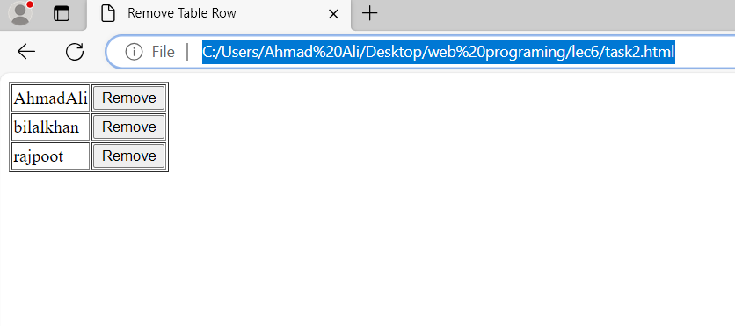

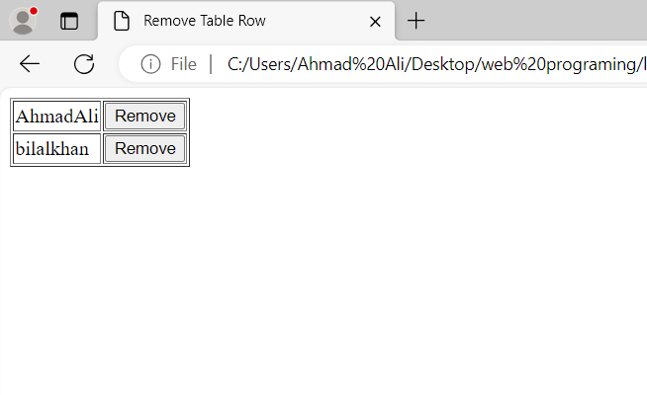

**Task 5:**

<!DOCTYPE html>

<html>

<head>

  <title>Find Class and ID</title>

  <script src="https://code.jquery.com/jquery-3.6.0.min.js"></script>

  <style>

    .myClass {

      color: red;

    }

  </style>

</head>

<body>

  <div id="21f_9268" class="6E">Click Here!</div>

  <script>

    $(document).ready(function(){

      $("#21f_9268").click(function(){

        var clickedClass = $(this).attr("class");

        var clickedId = $(this).attr("id");

        alert("Class: " + clickedClass + "\nID: " + clickedId);

      });

    });

  </script>

</body>

</html>

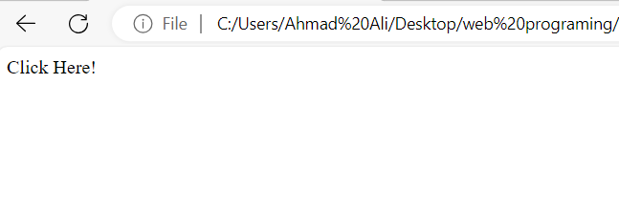

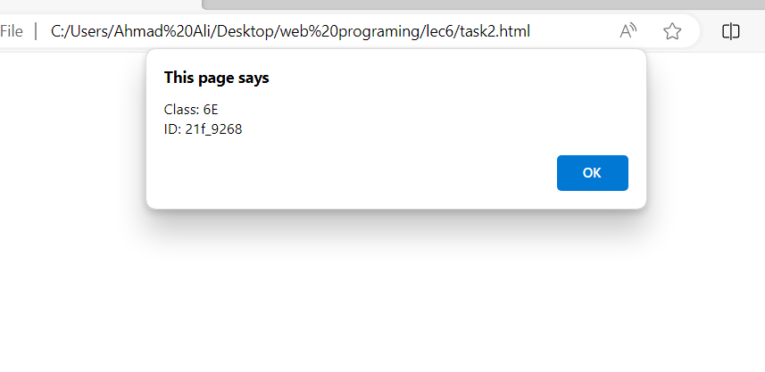

**Task 6:**

<!DOCTYPE html>

<html>

<head>

<script src="https://code.jquery.com/jquery-git.js"></script>

<meta charset="utf-8">

<meta name="viewport" content="width=device-width">

<title>Find total width of an element (including width, padding and border) in jQuery.</title>

<style>

  p {

    padding-top: 50px;

    padding-right: 30px;

    padding-bottom: 50px;

    padding-left: 80px;

    border: 2px solid black;

    width: 200px;

  }

</style>

</head>

<body>

<p id="myText">jQuery Exercises, Practice, Solution</p>

<script>

$(document).ready(function(){

  var totalWidth = $("#myText").outerWidth(true);

  console.log("Total width of the element including width, padding, and border:", totalWidth);

});

</script>

</body>

</html>

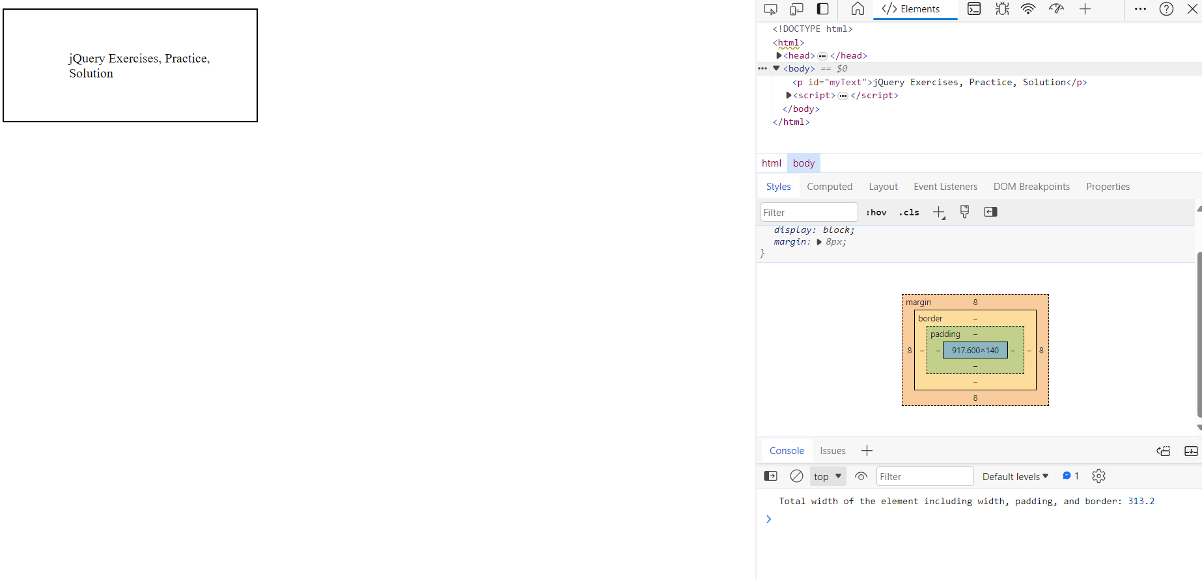

**Task 7:**

<!DOCTYPE html>

<html>

<head>

<script src="https://code.jquery.com/jquery-git.js"></script>

<meta charset="utf-8">

<meta name="viewport" content="width=device-width">

<title>Count child elements using jQuery.</title>

</head>

<body>

<div id="selected">

<p>Red</p>

<p>White</p>

<p>Green</p>

<p>Black</p>

<p>Blue</p>

<p>Orange</p>

</div>

<script>

$(document).ready(function(){

  var pCount = $("#selected").find("p").length;

  console.log("Number of 'p' elements:", pCount);

});

</script>

</body>

</html>

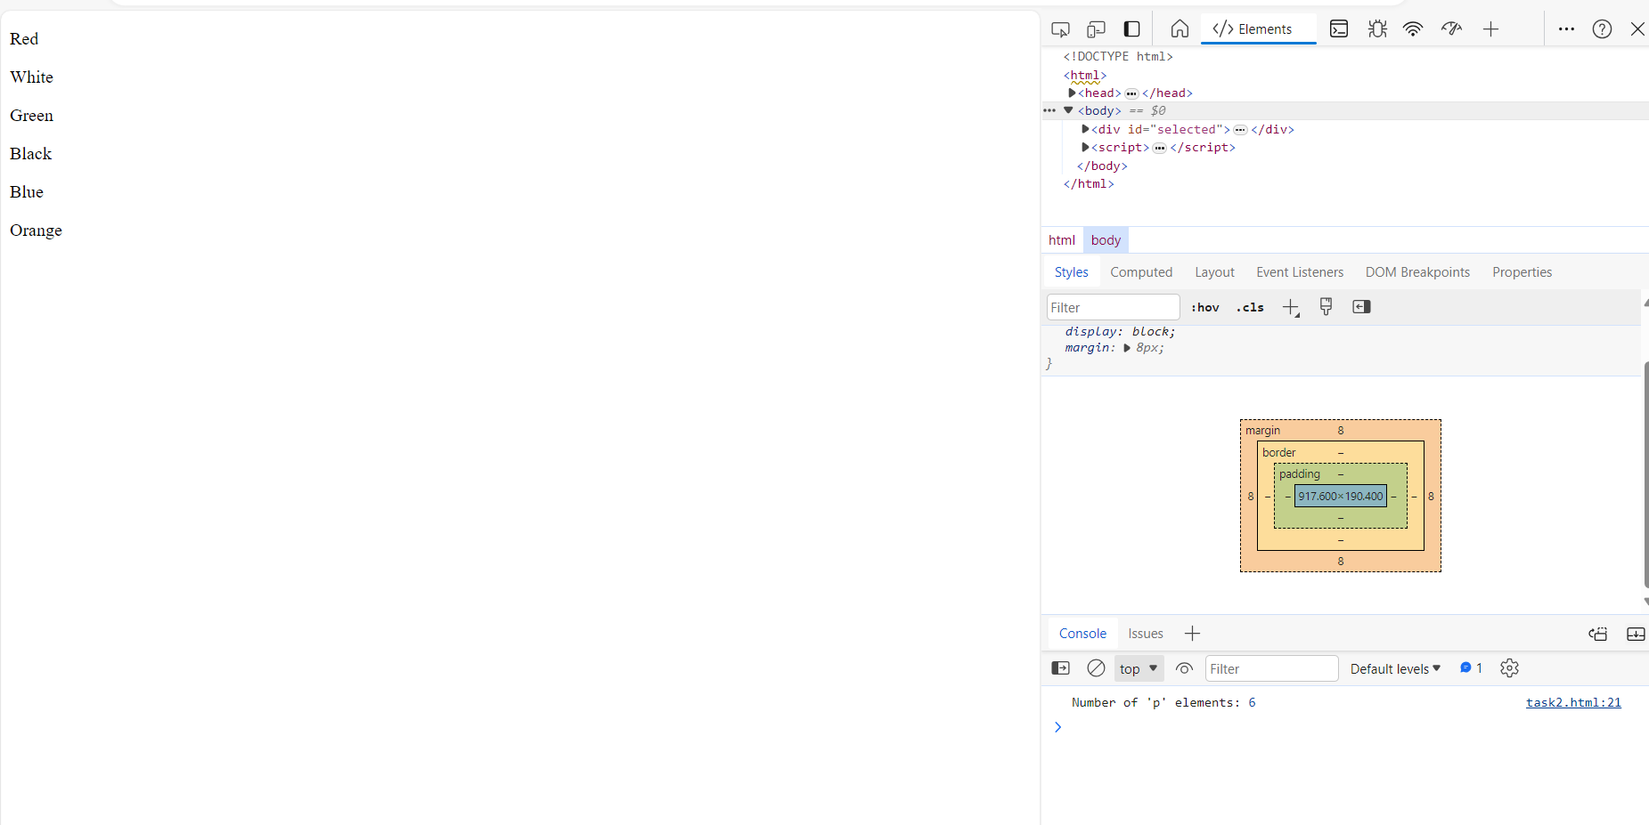

**Task 8:**

<!DOCTYPE html>

<html>

<head>

<script src="https://code.jquery.com/jquery-git.js"></script>

<meta charset="utf-8">

<meta name="viewport" content="width=device-width">

<title>jQuery Animation</title>

<style>

  #animatedDiv {

    width: 100px;

    height: 100px;

    background-color: goldenrod;

    position: relative;

  }

</style>

</head>

<body>

<div id="animatedDiv"></div>

<script>

$(document).ready(function(){

  $("#animatedDiv").animate({left: '500px'}, 8000);

});

</script>

</body>

</html>

