**Artificial Intelligence Lab Task**

**Lab Task: 1**

* **Name: Ahmad Usman**
* **Roll No: 070**
* **Section: Data Science 3-A**
* **Submission Date: 27-08-2025**

# Objective

The aim of this lab is to implement Python code that demonstrates the use of basic programming and object-oriented programming concepts to solve a given task.

# Code Explanation

The code starts by making a class that controls the whole program. Inside this class, I made a list that stores all the tasks. This list is like a box where I can put new tasks or remove old ones.

There’s a function to **add a task**. Whenever I type a new task, it just gets saved in the list.

Another function is used to **show all tasks**. If there are no tasks, it simply says the list is empty. But if tasks are there, it shows them one by one with numbers, so they’re easy to follow.

There’s also a function to **delete a task**. For this, I give the task number, and if it’s a correct number, the program removes that task from the list. If the number is wrong, it just ignores it.

At the end, I create an object of the class and run these functions. This makes the program work like a small to-do list where I can add, check, and delete tasks whenever I want.

# Output Screenshot

Below are the screenshot of the code execution and outputs:

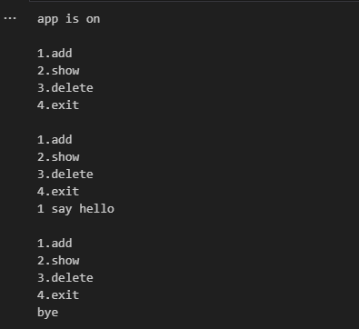

# Conclusion

This lab task helped me understand how to work with classes and objects in Python. I learned how to add, display, and delete data using lists and methods. It improved my understanding of how object-oriented programming makes code cleaner and easier to manage.