Explanation of Python Code

1. Introduction
This Python program performs three separate tasks:
1. Validates a credit card number using the Luhn algorithm.
2. Removes punctuation from a given sentence.
3. Sorts words alphabetically from a given line of text.

2. Luhn Check Function
The function `luhn_check(card_number)` checks whether a credit card number is valid according to the Luhn algorithm. The steps are:
- Extract only digits from the input string.
- Remove the last digit (the check digit).
- Reverse the remaining digits.
- Double every second digit (starting from index 0). If doubling results in a number greater than 9, subtract 9.
- Sum all the digits along with the check digit.
- If the total is divisible by 10, the card number is valid.

3. Card Number Input
The program asks the user to enter a card number. It passes this input to the Luhn check function. If the number is valid, it prints 'Valid'; otherwise, it prints 'Invalid'.

4. Removing Punctuation
The program then asks the user to enter a sentence. It defines a string of common punctuation characters. By using a generator expression, it removes all punctuation from the sentence and prints the cleaned text.

5. Sorting Words
The program asks the user to input a line of text. It splits the line into words, sorts them alphabetically (ignoring case), and prints the sorted result as a single string.

Output SecreenShort
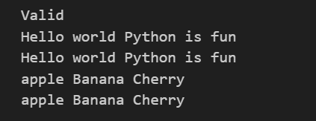

6. Summary
In summary, this program demonstrates string manipulation, sorting, and algorithmic validation. It combines three different functionalities:
- Validating credit card numbers.
- Cleaning text by removing punctuation.
- Sorting words alphabetically.
This helps users practice multiple Python concepts in a single program.

