Library Management System



Session 2025 - 2029

Submitted by:
Muhammad Ahmad 2025-CS-330

Supervised by:
Ma’am Hafsa

Course:
CSC-102 Programming Fundamentals

Department of Computer Science
University of Engineering and Technology
Lahore Pakistan

Short Description of Project
The Library Management System is a console-based application designed to solve the problem of manual book keeping. In traditional manual systems, tracking borrowed books, managing stock, and maintaining student records is time-consuming and prone to human error.
The objective of this project is to automate these processes. It contributes to the field by demonstrating how data persistence (File Handling) and logical algorithms can streamline information flow. The project ensures that book records are secure, inventory is automatically updated upon issuing or returning, and students can view their status independently. The final output is a robust system where Admins can manage the library inventory and Students can borrow/return books efficiently.
Users of Application
- Library Administrator (Admin): The primary controller of the system. The Admin is responsible for adding new books to the database, issuing books to students, accepting returns, and monitoring overdue books.
- Students: The end-users of the library services. Students use the application to view available books, check which books they have currently borrowed, and change their login credentials for security.

Functional Requirements
Below are the functional requirements based on the user stories:
User Story ID | As a | I want to perform | So that I can
1 | Admin | Add a Book | Increase the library inventory and make new titles available.
2 | Admin | Issue a Book | Assign a specific book to a student and decrease available stock.
3 | Admin | View Overdue Books | Identify which books are missing or have not been returned.
4 | Student | View Available Books | See what books are in the library before requesting one.
5 | Student | Return a Book | Return a borrowed item and clear my record.
6 | User | Sign Up/Sign In | Securely access my specific dashboard (Admin or Student).
Wireframes
Figure 1: Main Menu Screen
############################################################
# #
# ██╗ ██╗██████╗ ██████╗ █████╗ ██████╗ ██╗ #
# ██║ ██║██╔══██╗██╔══██╗██╔══██╗██╔══██╗╚██╗ #
# ██║ ██║██████╔╝██████╔╝███████║██████╔╝ ╚██╗ #
# ██║ ██║██╔══██╗██╔══██╗██╔══██║██╔══██╗ ██╔╝ #
# ███████╗██║██████╔╝██║ ██║██║ ██║██║ ██║██╔╝ #
# ╚══════╝╚═╝╚═════╝ ╚═╝ ╚═╝╚═╝ ╚═╝╚═╝ ╚═╝╚═╝ #
# #
# WELCOME TO YOUR LIBRARY SYSTEM #
# #
############################################################

Press Enter to Continue...
Figure 2: Admin Dashboard
-----------------------------
Admin Menu
-----------------------------
1. Add Book
2. Issue Book
3. Return Book
4. Student Records
5. Overdue Books
6. Available Books
7. Exit
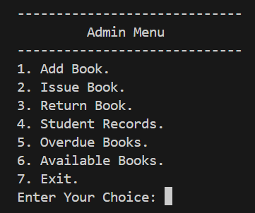
Figure 3: Issue Book Interface
-----------------------------
Issue Book
-----------------------------
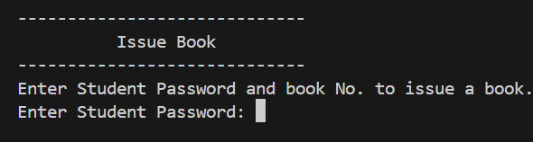
Enter Student Password and Book No. to issue a book
Enter Student Password: ****
Enter Book Number: 2
Figure 4: Login Screen
-----------------------------
LOGIN PAGE
-----------------------------
Enter Username:
Enter Password:
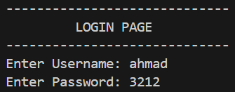
Figure 2: Main Menu
-----------------------------
Main Menu
-----------------------------
1. Admin
2. Student
3. Exit
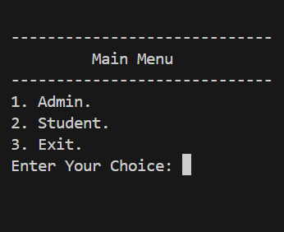
Figure 4: Student Menu
-----------------------------
Student Menu
-----------------------------
1. My Issued Book
2. Return Book
3. View Available Books
4. Change Password
5. Exit
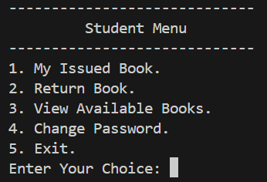

Data Structures (Parallel Arrays)
This project utilizes Parallel Arrays to manage data efficiently. The data for a single entity (like a Book or a Student) is stored across multiple arrays at the same index [i].
- Book Data Structures:
  - string bookName[30] - Stores titles of the books.
  - string authorName[30] - Stores authors of the books.
  - int totalCopies[30] - Stores total inventory count.
  - int availableCopies[30] - Stores currently available copies.
  - Counter: int bookCount - Tracks total number of unique book titles.
- Student Data Structures:
  - string studentId[30] - Stores student usernames.
  - string studentPassword[30] - Stores student login passwords.
  - int allotedBook[30] - Tracks if a student has a book (0 for no, >0 for yes).
  - int bookReference[30] - Stores the index of the book issued to the student.
  - Counter: int studentCount - Tracks total registered students.

- 3. Admin Data Structures:
  - string admin[3] - Stores admin usernames.
  - string password[3] - Stores admin passwords.
  - Counter: int adminCount - Tracks registered admins.
Function Prototypes
// UI Functions
void showOpeningPage();
void showMainMenuPage();
void showAdminMenuPage();
void showStudentMenuPage();
// Student Logic
void studentAuthenticationMenu(int &studentCount, int &bookCount);
void studentSignIn(string studentPassword[], string studentId[], int &bookCount, int studentCount);
int studentSignUp(string studentPassword[], string studentId[], int &studentCount);
void studentMainMenu(int &bookCount, int &studentCount, int index);
void studentIssuedBook(int bookCount, int studentCount, int index);
void studentReturnBook(int bookCount, int studentCount, int index);
// Admin Logic
void adminAuthenticationMenu(int &adminCount, int &bookCount, int &studentCount);
void addBook(int &bookCount);
void issueBook(int studentCount, int bookCount);
void returnBook(int studentCount, int bookCount);
void studentRecord(int studentCount, int bookCount);
// File Handling
void loadAllStudents(int &studentCount);
void loadAllBooks(int &bookCount);
void updateAllBooks(int &bookCount);

Functions Working Flow
The following diagram illustrates the control flow of the application, starting from the main() function.

[ MAIN FUNCTION ]
│
├──► loadAllFiles() (Data Persistence)
│
├──► showOpeningPage()
│
▼
[ MAIN MENU ]
│
├──► Option 1: ADMIN FLOW
│ │
│ ├──► AdminAuthentication (Sign In / Sign Up)
│ │
│ ▼
│ [ ADMIN DASHBOARD ]
│ ├──► addBook() ──────────► updateAllBooks() (File Save)
│ ├──► issueBook() ────────► Updates Arrays & File
│ ├──► returnBook() ───────► Updates Arrays & File
│ ├──► studentRecord()
│ └──► overDueBooks()
│
└──► Option 2: STUDENT FLOW
│
├──► StudentAuthentication (Sign In / Sign Up)
│
▼
[ STUDENT DASHBOARD ]
├──► viewIssuedBook()
├──► returnBook() ───────► updateAllBooks()
├──► availableBooks()
└──► changePassword() ───► updateStudentPassword()

Weakness in the Business Application
- Platform Dependency: The code uses <windows.h> and system("cls"), which means the application only works correctly on Windows operating systems and is not portable to Linux or macOS.
- Fixed Array Size: The system uses static arrays (size 30). If the library acquires the 31st book or the 31st student registers, the program cannot handle the data without recompiling the code.
- Security: Passwords are stored in plain text files (student.txt, admin.txt). In a real-world scenario, this is a security risk as anyone with access to the computer can read the passwords.

Weakness in the Business Application
- Platform Dependency: The code uses <windows.h> and system("cls"), which means the application only works correctly on Windows operating systems and is not portable to Linux or macOS.
- Fixed Array Size: The system uses static arrays (size 30). If the library acquires the 31st book or the 31st student registers, the program cannot handle the data without recompiling the code.
- Security: Passwords are stored in plain text files (student.txt, admin.txt). In a real-world scenario, this is a security risk as anyone with access to the computer can read the passwords.
Future Directions
In the next semester, I plan to improve this application by:
- Implementing Object Oriented Programming (OOP): Replacing parallel arrays with Classes and Objects (e.g., a Book class and a Student class) to make the data more organized and scalable.
- Dynamic Memory Allocation: Using Vectors or Pointers to remove the limit of 30 books/students, allowing the library to grow indefinitely.
- Search Functionality: Adding a search algorithm (like Binary Search) so users can find books by name instead of scrolling through the whole list.
- Password Encryption: Implementing basic encryption (like Caesar Cipher) before saving passwords to the text files for better security.

