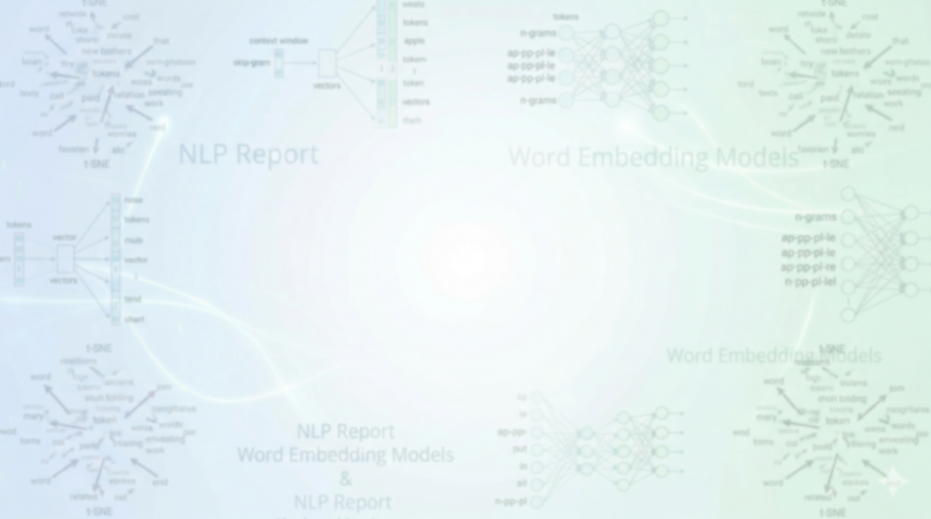

AI 454 - NLP Assignment 1

2026/4/4

Ahmad Hazaimeh ID:162104
Zeid Al-Suleiman ID:166203
ID: 161134

Table 1: Semantic Analogy Test Results (300-dimensional models):
Test # | Test | Expected Answer | GloVe 300 Result | Word2Vec 300 Result | FastText 300 Result
1 | france : paris :: italy : ? | rome | rome | OOV | rome
2 | germany : berlin :: spain : ? | madrid | madrid | OOV | barcelona
3 | japan : tokyo :: china : ? | beijing | beijing | OOV | shanghai
4 | egypt : cairo :: greece : ? | athens | athens | OOV | gtk
5 | india : new delhi :: pakistan : ? | islamabad | OOV | OOV | OOV
6 | brazil : brasilia :: argentina : ? | buenos aires | buenos | OOV | OOV
7 | russia : moscow :: poland : ? | warsaw | warsaw | OOV | prague
8 | canada : ottawa :: australia : ? | canberra | canberra | OOV | melbourne
9 | turkey : ankara :: iran : ? | tehran | tehran | OOV | OOV
10 | netherlands : amsterdam :: portugal : ? | lisbon | lisbon | OOV | barcelona

Table 2: Syntactic Analogy Test Results (300-dimensional models)
Test # | Test | Expected Answer | GloVe 300 Result | Word2Vec 300 Result | FastText 300 Result
1 | kind : kinder :: brave : ? | braver | gentler | braver | braver
2 | smart : smarter :: tall : ? | taller | taller | taller | taller
3 | short : shorter :: strong : ? | stronger | stronger | stronger | stronger
4 | weak : weaker :: quiet : ? | quieter | quieter | quieter | quieter
5 | messy : messier :: calm : ? | calmer | gretzky | calmer | calmer
6 | wise : wiser :: cold : ? | colder | colder | colder | colder
7 | noisy : noisier :: clumsy : ? | clumsier | sillier | cleverer | ham-fisted
8 | lazy : lazier :: bossy : ? | bossier | scheckter | OOV | meaner
9 | young : younger :: old : ? | older | older | older | older
10 | hot : hotter :: small : ? | smaller | smaller | smaller | smaller
Table 3: Analogy Top-1 Accuracy (%)
Analogy Type | GloVe 300 Accuracy | Word2Vec 300 Accuracy | FastText 300 Accuracy
Semantic | 80.00% | 0.00% | 10.00%
Syntactic | 60.00% | 80.00% | 80.00%

Table 4: Analogy Top-5 Accuracy (%)
Analogy Type | GloVe 300 Accuracy | Word2Vec 300 Accuracy | FastText 300 Accuracy
Semantic | 80.00% | 0.00% | 40.00%
Syntactic | 60.00% | 80.00% | 80.00%

Part 2: Intrinsic Evaluation of Word Embeddings: GloVe (50 vs 100 vs 300)

Table 5: GloVe Dimension Comparison (Semantic Analogies):
Test # | Test | Expected Answer | GloVe 50 Result | GloVe 100 Result | GloVe 300 Result
1 | france : paris :: italy : ? | rome | rome | rome | rome
2 | germany : berlin :: spain : ? | madrid | rome | madrid | madrid
3 | japan : tokyo :: china : ? | beijing | beijing | beijing | beijing
4 | egypt : cairo :: greece : ? | athens | athens | athens | athens
5 | india : new delhi :: pakistan : ? | islamabad | OOV | OOV | OOV
6 | brazil : brasilia :: argentina : ? | buenos aires | lima | buenos | buenos
7 | russia : moscow :: poland : ? | warsaw | warsaw | warsaw | warsaw
8 | canada : ottawa :: australia : ? | canberra | brisbane | brisbane | canberra
9 | turkey : ankara :: iran : ? | tehran | tehran | tehran | tehran
10 | netherlands : amsterdam :: portugal : ? | lisbon | lisbon | lisbon | lisbon

Table 6: GloVe Dimension Comparison (Syntactic Analogies):
Test # | Test | Expected Answer | GloVe 50 Result | GloVe 100 Result | GloVe 300 Result
1 | kind : kinder :: brave : ? | braver | przewalskii | schwalbe | gentler
2 | smart : smarter :: tall : ? | taller | taller | taller | taller
3 | short : shorter :: strong : ? | stronger | stronger | stronger | stronger
4 | weak : weaker :: quiet : ? | quieter | calm | subdued | quieter
5 | messy : messier :: calm : ? | calmer | moussa | gretzky | gretzky
6 | wise : wiser :: cold : ? | colder | hotter | cooler | colder
7 | noisy : noisier :: clumsy : ? | clumsier | horrendously | sillier | sillier
8 | lazy : lazier :: bossy : ? | bossier | konchellah | skaife | scheckter
9 | young : younger :: old : ? | older | father | older | older
10 | hot : hotter :: small : ? | smaller | larger | smaller | smaller
Table 7: GloVe Top-1 Accuracy:
Analogy Type | GloVe 50 Accuracy | GloVe 100 Accuracy | GloVe 300 Accuracy
Semantic | 60.00% | 70.00% | 80.00%
Syntactic | 20.00% | 40.00% | 60.00%

Table 8: GloVe Top-5 Accuracy:
Analogy Type | GloVe 50 Accuracy | GloVe 100 Accuracy | GloVe 300 Accuracy
Semantic | 70.00% | 80.00% | 80.00%
Syntactic | 40.00% | 50.00% | 60.00%

Part 3: Visualization of Word Embeddings using GloVe 100 vs Word2Vec 100
1. Design of Word Sets:
- Animals: {cat, dog, lion, tiger, wolf, fox}.
- Fruits: {apple, banana, orange, grape, mango, peach}.
- Vehicles: {car, bus, train, truck, bicycle, motorcycle}.
2. Methodology:
- Obtained 100d embeddings for all words from GloVe and Word2Vec.
- Applied t-SNE to reduce dimensions to 2D for visualization.
- Labeled each word and distinguished sets using specific colors.
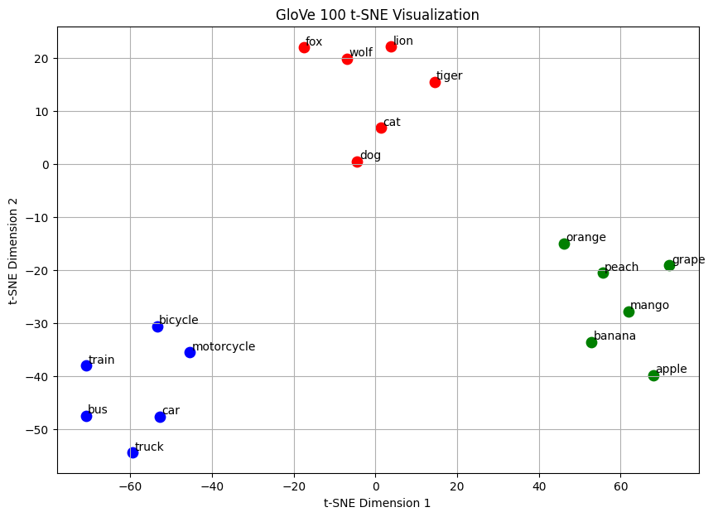
GloVe Visualization:
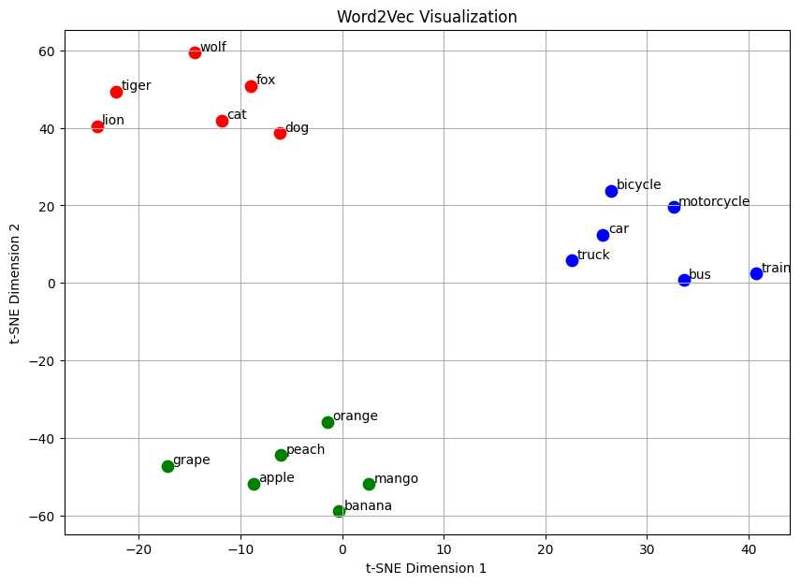
Word2Vec Visualization:

3. Analysis & Comparison:
- Clustering: In both models, related words clustered effectively, and the three sets were well-separated with no overlap.
- Model Comparison: Word2Vec produced slightly better clustering.
- Justification: Word2Vec showed tighter, more compact clusters and larger distances between different categories compared to GloVe.
Final Conclusion:
This assignment evaluated Word2Vec, GloVe, and FastText through analogy tasks and t-SNE visualization. Our results show that GloVe excels in semantic tasks, while Word2Vec and FastText are superior for syntactic patterns. Increasing dimensionality from 50 to 300 improved accuracy but raised computational costs. Visualization confirmed that embeddings capture semantic similarity, with Word2Vec producing the most compact clusters. Ultimately, model selection depends on the specific trade-off between accuracy and efficiency.

