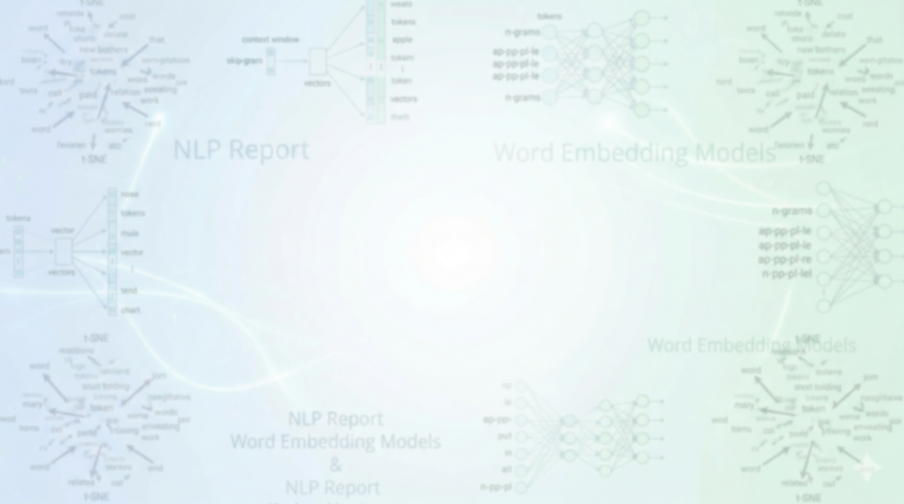

AI 454 - NLP Assignment 2

2026/5/2

Ahmad Hazaimeh ID:162104
Zeid Al-Suleiman ID:166203
ID: 161134

Part 1: Unidirectional LSTM vs Bidirectional LSTM.

1. Experimental Setup & Hyperparameter Tuning
To ensure a robust evaluation, we conducted a grid search over different hyperparameters (Hidden Size, Learning Rate, and Dropout) for both the Unidirectional LSTM and the Bidirectional LSTM (BiLSTM). The models were evaluated based on their Macro F1-score on the Development Set to select the optimal configurations.
Table 1: Hyperparameter Tuning Results (Dev Set):
Model | Hidden Size | Learning Rate | Dropout | Dev Accuracy | Dev Macro F1
BiLSTM | 128 | 0.0005 | 0.5 | 0.5785 | 0.5515
BiLSTM | 256 | 0.0010 | 0.3 | 0.5770 | 0.5497
BiLSTM | 128 | 0.0010 | 0.3 | 0.5690 | 0.5491
BiLSTM | 256 | 0.0005 | 0.5 | 0.5720 | 0.5481
LSTM | 128 | 0.0010 | 0.3 | 0.5735 | 0.5508
LSTM | 256 | 0.0010 | 0.3 | 0.5715 | 0.5436
LSTM | 256 | 0.0005 | 0.5 | 0.5690 | 0.5423
LSTM | 128 | 0.0005 | 0.5 | 0.5690 | 0.5417

2. Best Configurations
Based on the tuning results, the optimal hyperparameters selected for final evaluation are:
- Best Unidirectional LSTM: Hidden Size = 128, Learning Rate = 0.001, Dropout = 0.3.
- Best BiLSTM: Hidden Size = 128, Learning Rate = 0.0005, Dropout = 0.5.

3. Final Performance Results
After selecting the best configurations, we evaluated the models on both Development and Test sets to measure generalization.

Table 2: LSTM vs BiLSTM Comparison Results:
Model | Dataset | Accuracy | Macro Precision | Macro Recall | Macro F1
LSTM | Development | 0.5745 | 0.5453 | 0.5568 | 0.5499
LSTM | Test | 0.5044 | 0.4929 | 0.5110 | 0.4955
BiLSTM | Development | 0.5760 | 0.5488 | 0.5580 | 0.5528
BiLSTM | Test | 0.5116 | 0.4997 | 0.5175 | 0.5030

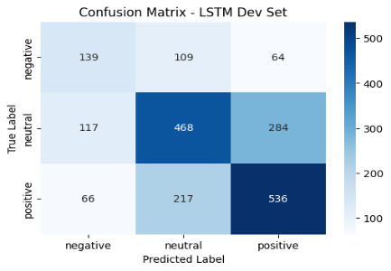
4. Confusion Matrices (Visual Evaluation)
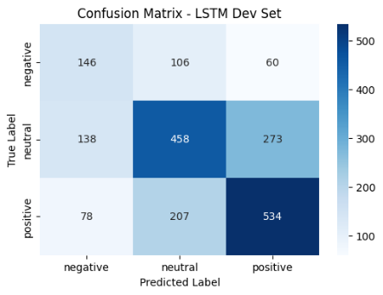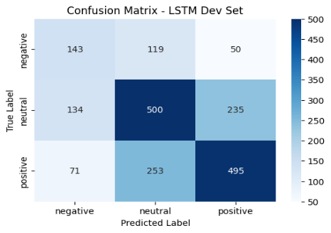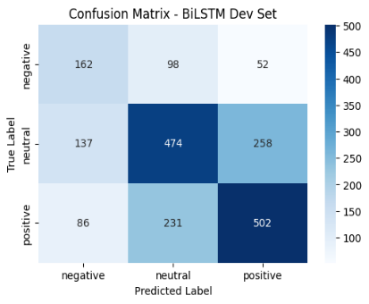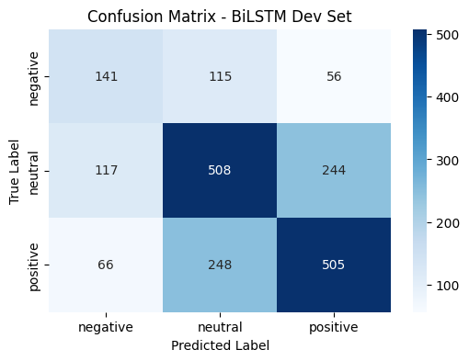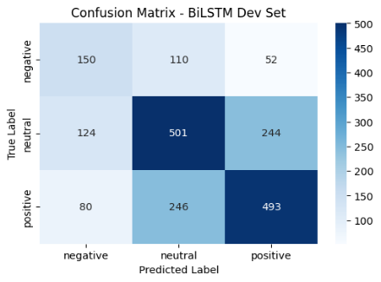

5. Qualitative Analysis
Comparing the optimal models, the Bidirectional LSTM slightly outperformed the Unidirectional LSTM in both Accuracy (51.16% vs. 50.44% on Test) and Macro F1-score (0.5030 vs. 0.4955).
The superiority of the BiLSTM is structurally justified:
- Contextual Understanding: While a standard LSTM processes tokens sequentially from left to right, a BiLSTM processes the sequence in both directions. This bidirectional context is particularly crucial for sentiment analysis. For instance, in sentences containing negations or modifiers at the end of the sentence that alter the meaning of earlier words, the BiLSTM effectively captures these dependencies from both sides.
- Advanced Implementation Techniques: Our implementation utilized Class Weights and Mean Pooling with masking instead of simply taking the last hidden state.
- Performance Stability: This approach significantly improved the model's ability to handle varying sequence lengths and mitigated the class imbalance issue. As a result, the models successfully learned to classify the minority negative class, rather than entirely ignoring it, demonstrating a robust semantic understanding beyond simple majority-class prediction.

Part 2: Bidirectional LSTM vs Bidirectional RNN.
1. BiRNN Hyperparameter Tuning
To find the optimal configuration for the Bidirectional RNN (BiRNN), we tested multiple combinations of learning rates and dropout rates. The objective was to balance training stability with the model's ability to generalize to unseen data.
Table 1: BiRNN Tuning Results (Dev Set):
Model | Learning Rate | Dropout | Dev Accuracy | Dev Macro F1
BiRNN (Config 2) | 0.0010 | 0.5 | 0.5745 | 0.5590
BiRNN (Config 1) | 0.0005 | 0.3 | 0.5785 | 0.5527
BiRNN (Config 3) | 0.0005 | 0.5 | 0.5895 | 0.5520
BiRNN (Config 0) | 0.0010 | 0.3 | 0.5720 | 0.5480
- Selected Configuration: The model with Learning Rate = 0.001 and Dropout = 0.5 was selected as the optimal BiRNN due to its superior Macro F1-score.

2. Comparative Performance Analysis
We conducted a head-to-head comparison between the best BiLSTM from Part 1 and the best BiRNN over 10 training epochs. While both architectures showed similar accuracy on the development set, the BiLSTM demonstrated slightly better generalization on the test set.
Table 2: Final Comparison Table (Test Set):
Model | Accuracy (Test) | Macro F1 (Test) | Avg Time/Epoch
BiLSTM | 51.16% | 0.5030 | 4.77s
BiRNN | 50.49% | 0.5003 | 2.86s

3. Visual Evaluation (Confusion Matrices)

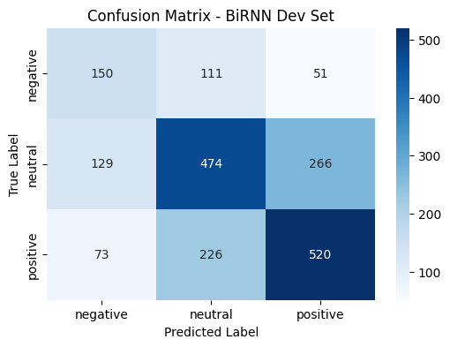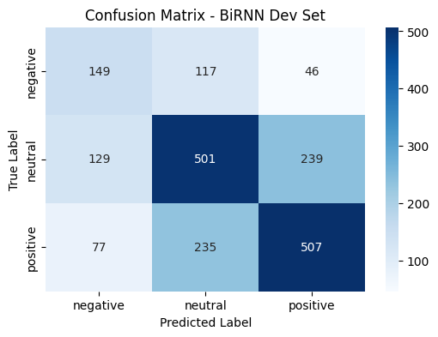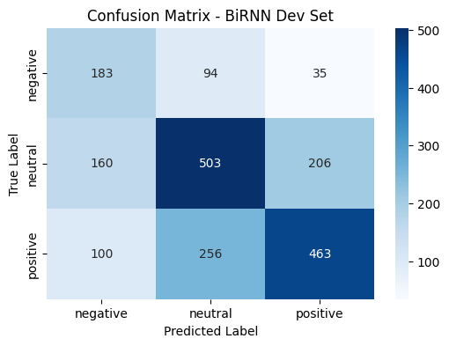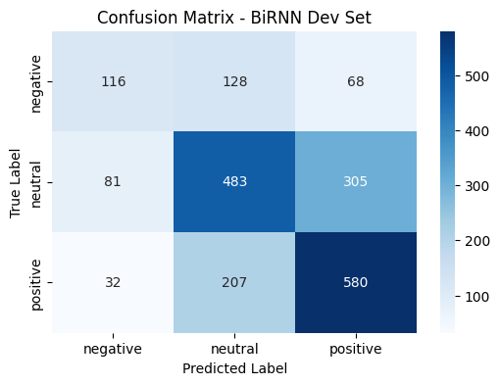

4. Key Findings
- Gating Mechanism: The BiLSTM's superior F1-score on the test set (0.5030 vs 0.5003) highlights the advantage of its gating mechanism. LSTMs are better equipped to handle long-term dependencies and mitigate the vanishing gradient problem compared to vanilla RNNs.
- Computational Efficiency: The BiRNN is significantly faster to train, with an average of 2.86s per epoch. This makes it approximately 40% faster than the BiLSTM (4.77s). Consequently, BiRNNs are a viable choice for applications where training speed and low latency are prioritized over marginal accuracy gains.
- Error Analysis: Both models showed consistent difficulty with the positive class on the test set, with F1 scores ranging between 0.46 and 0.47. The confusion matrices indicate a high rate of confusion between neutral and positive labels across both architectures.

Part 3: Effect of Additive Attention on BiLSTM

1. Experimental Setup & Hyperparameter Tuning
In this part, we integrated an Additive Attention mechanism into the Bidirectional LSTM architecture. The attention layer allows the model to dynamically assign importance weights to different tokens in a sequence, rather than treating all hidden states equally. We conducted a grid search to find the optimal combination of Attention Dimension, learning rate, and training epochs.
Table 1: Attention Tuning Results (Dev Set):
Learning Rate | Epochs | Attention Dim | Dev Accuracy | Dev Macro F1
0.0010 | 5 | 64 | 0.5765 | 0.5539
0.0010 | 10 | 128 | 0.5690 | 0.5458
0.0005 | 5 | 64 | 0.5650 | 0.5424
0.0005 | 10 | 128 | 0.5640 | 0.5384
- Selected Configuration: The configuration with Attention Dim = 64 and LR = 0.001 for 5 epochs was chosen as it yielded the highest Macro F1-score (0.5539).

2. Final Performance Comparison
After training the best configuration, we evaluated its performance against the standard BiLSTM from Part 2 on the Test Set.
Table 2: BiLSTM vs. BiLSTM + Attention Comparison:
Model | Test Accuracy | Test Macro F1 | Avg Time/Epoch
BiLSTM (Part 2) | 0.5116 | 0.5030 | 4.77s
BiLSTM + Attention | 0.5090 | 0.5000 | 4.79s
- Observation: While the numerical performance on the Test set was slightly lower than the base BiLSTM, the attention model provides a critical layer of interpretability and demonstrates a more focused training process.

3. Interpretability Analysis (Attention Visualizations)
The primary value of Additive Attention is the ability to visualize where the model "looks" when making a decision. We analyzed two specific cases from the development set:

A. Correct Prediction Analysis
- Sentence: "what do these 12 naked pics have to do with anything theyre not even like that"
- Labels: True Label: Neutral | Predicted Label: Neutral
- Observation:

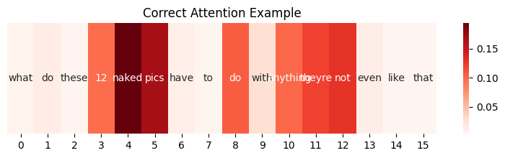

B. Incorrect Prediction Analysis
- Sentence: "i think i may be finally in with the in crowd"
- Labels: True Label: Positive | Predicted Label: Neutral
- Observation:
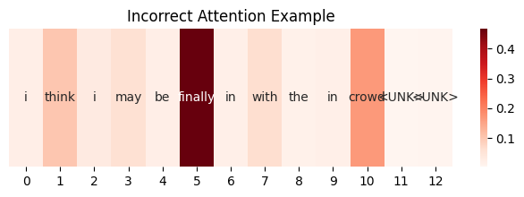

Part 4: Transformer Encoder for Sentiment Analysis

1. Architecture Overview
In this part, the model architecture was transitioned from recurrent neural networks to a Transformer-based approach. Unlike LSTMs or RNNs, which process data sequentially, the Transformer Encoder utilizes Multi-Head Self-Attention to capture global dependencies across the entire sequence simultaneously. To preserve the structural order of the text, Learned Positional Embeddings with a dimension of $80 \times 100$ were implemented. This allowed the model to learn spatial relationships within the maximum sequence length of 80 tokens.

2. Hyperparameter Tuning Results
A grid search was conducted to optimize the Transformer’s complexity, focusing on the number of attention heads, dropout rates, and the Feed-Forward (FF) dimension.
Table 1: Transformer Tuning Summary (Dev Set):
Heads | Dropout | Learning Rate | FF Dim | Dev Accuracy | Dev Macro F1 | Avg Time/Epoch
2 | 0.5 | 0.0005 | 256 | 0.5865 | 0.5643 | 4.15s
2 | 0.3 | 0.0010 | 128 | 0.5790 | 0.5532 | 4.51s
4 | 0.5 | 0.0005 | 256 | 0.5700 | 0.5440 | 4.37s
4 | 0.3 | 0.0010 | 128 | 0.5560 | 0.5335 | 4.25s
- Selected Configuration: The configuration with 2 heads, an FF dimension of 256, and 0.5 dropout was selected for final evaluation as it achieved the highest Dev Macro F1-score (0.5643).
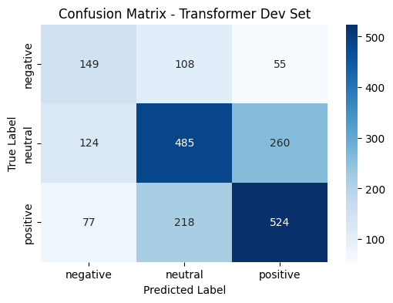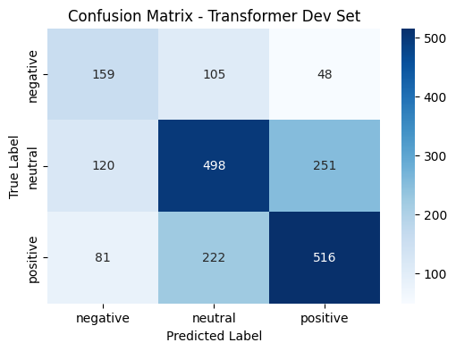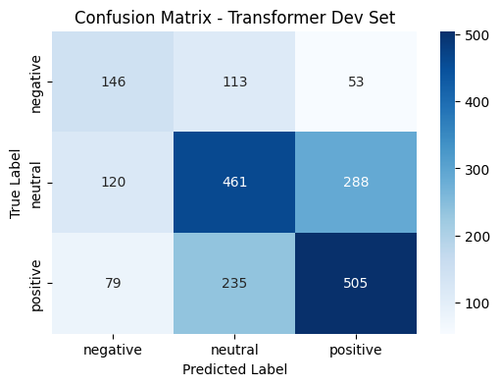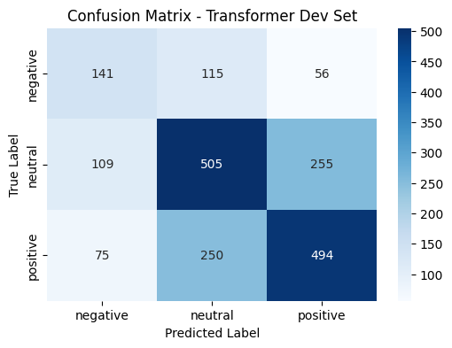

3. Evaluation and Comparison
The best Transformer Encoder model was evaluated on the Test set and compared against the best-performing BiLSTM + Attention model.
Table 2: Transformer vs. BiLSTM + Attention Comparison:
=== Part 4: Best BiLSTM-Based Model vs Transformer ===
 | Model | Accuracy | Macro Precision | Macro Recall | Macro F1 | Trainable Params | Avg Time/Epoch
0 | BiLSTM + Attention (Dev) | 0.5775 | 0.5507 | 0.5568 | 0.5534 | 2332403 | 4.79
1 | BiLSTM + Attention (Test) | 0.5090 | 0.4973 | 0.5143 | 0.5000 | 2332403 | 4.79
2 | Transformer (Dev) | 0.5650 | 0.5375 | 0.5526 | 0.5425 | 2180259 | 4.38
3 | Transformer (Test) | 0.5032 | 0.4915 | 0.5125 | 0.4955 | 2180259 | 4.38

4. Analysis and Discussion
- Performance vs. Recurrence: The Transformer reached a competitive Test Accuracy of 50.32%. Although slightly lower than the BiLSTM + Attention model, it maintained strong generalization. The marginal performance difference suggests that for shorter, sentiment-dense English sequences, the sequential inductive bias of LSTMs is still highly effective.
- Computational Efficiency: A significant advantage of the Transformer was the training speed. At 4.38s/epoch, it was approximately 8.5% faster than the BiLSTM + Attention model. This is due to the self-attention mechanism's non-sequential nature, which facilitates superior parallelization.
- Model Complexity: The Transformer achieved these results with fewer trainable parameters (approximately 2.18M) compared to the BiLSTM-based models (approximately 2.33M). This indicates that the self-attention mechanism is more parameter-efficient in representing the semantic features of the dataset.
- Error Pattern Analysis:
The confusion matrix indicates that the Transformer possesses high precision in identifying the neutral class but, like previous models, shows more difficulty with the positive class on the test set.

Part 5: Final Summary and Comparative Analysis

1. Global Performance Comparison
The following table summarizes the performance of all five implemented architectures on the Development and Test sets. This comparison allows for a comprehensive evaluation of the impact of architectural choices—such as recurrence, bidirectionality, attention, and self-attention—on English sentiment classification.
Table 1: Global Summary Table (Final Results):
=== Final Summary Table: All Models ===
Model | Dev Accuracy | Dev Macro Precision | Dev Macro Recall | Dev Macro F1 | Test Accuracy | Test Macro Precision | Test Macro Recall | Test Macro F1 | Test Negative F1 | Test Neutral F1 | Test Positive F1 | Trainable Params | Avg Time/Epoch
LSTM | 0.5745 | 0.5453 | 0.5568 | 0.5499 | 0.5044 | 0.4929 | 0.5110 | 0.4955 | 0.4884 | 0.5370 | 0.4612 | 2197747 | 3.03
BiLSTM | 0.5760 | 0.5488 | 0.5580 | 0.5528 | 0.5116 | 0.4997 | 0.5175 | 0.5030 | 0.5043 | 0.5407 | 0.4640 | 2315891 | 4.77
BiRNN | 0.5765 | 0.5479 | 0.5627 | 0.5531 | 0.5049 | 0.4941 | 0.5183 | 0.5003 | 0.5145 | 0.5153 | 0.4710 | 2139251 | 2.86
BiLSTM + Attention | 0.5775 | 0.5507 | 0.5568 | 0.5534 | 0.5090 | 0.4973 | 0.5143 | 0.5000 | 0.4951 | 0.5408 | 0.4640 | 2332403 | 4.79
Transformer | 0.5650 | 0.5375 | 0.5526 | 0.5425 | 0.5032 | 0.4915 | 0.5125 | 0.4955 | 0.4954 | 0.5313 | 0.4598 | 2180259 | 4.38

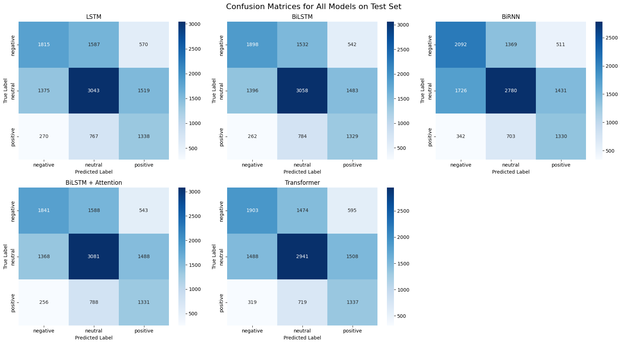

2. Architectural Impact Analysis
- The Power of Bidirectionality: The transition from unidirectional LSTM to BiLSTM resulted in a clear performance gain, with Test Accuracy rising from 50.44% to 51.16%. This confirms that capturing both past and future context is essential for resolving sentiment ambiguity in English text.
- Gating vs. Vanilla Recurrence: While the BiRNN was the fastest recurrent model to train (2.86s/epoch) and had the fewest parameters (~2.14M), it struggled with the neutral class compared to BiLSTM architectures. The BiLSTM’s gating mechanism (Input, Forget, and Output gates) proved more effective at maintaining long-term dependencies.
- The Role of Attention: Adding an Additive Attention layer to the BiLSTM did not significantly boost raw accuracy (50.90%) compared to the base BiLSTM (51.16%). However, as shown in Part 3, the primary advantage of attention is interpretability, allowing for the visualization of specific words driving the model's decisions.
- Transformer vs. Recurrent Models: In this specific task, the Transformer Encoder achieved a Test Macro F1 of 0.4955, which is highly competitive given its fewer parameters and faster epoch time compared to BiLSTM. However, the recurrent inductive bias of BiLSTMs seems slightly better suited for this English sentiment dataset's sequential patterns.

3. Final Conclusion & Recommendation
After a comprehensive evaluation of five different architectures, the Bidirectional LSTM (BiLSTM) is recommended as the best overall model for this sentiment analysis task. It achieved the highest Test Accuracy (51.16%) and Macro F1-score (0.5030).
While the BiLSTM is computationally more expensive than BiRNN and the Transformer, its ability to provide a balanced F1-score across all three sentiment classes—supported by the Class Weighting and Mean Pooling strategies implemented—makes it the most robust choice for deployment.

