
Final Project Report: 2DOF Robotic Manipulator

January 6, 2026.

Ahmad Rashed Hazaimeh ID: 162104
AMRO KHALED MOHAMMED ALJARRAH) ID: 163904

1. Introduction
This project involves the design, modeling, and simulation of a 2-Degree-of-Freedom (2DOF) planar robotic manipulator³. The primary objective is to implement a control system that allows the robot's end-effector to precisely track a square-shaped trajectory within its workspace⁴.

2. Denavit-Hartenberg (DH) Parameters
Based on the physical dimensions provided (L1 = 0.2 and L2 = 0.15), the standard DH parameters were derived to define the robot's geometry:
Link | ai​ (Length) | αi​ (Twist) | di​ (Offset) | θi​ (Angle)
1 | 0.2 | 0 | 0 | θ *1
2 | 0.15 | 0 | 0 | θ *2

3. Kinematics Analysis
- Forward Kinematics: Developed using the DH parameters to calculate the end-effector position (x, y) based on joint angles θ 1 and θ 2.
- Inverse Kinematics: Implemented using the MATLAB Robotics System Toolbox (Rigid Body Tree) to solve for the joint angles required to reach specific Cartesian coordinates.
Verification Results:
For the target point (0.15, 0.01) θ 1 = -44.36 θ 2 = 133.58

4. Path Planning (Square Trajectory)
The manipulator was programmed to move sequentially between the following workspace coordinates to form a square:
Calculating Joint Angles for Square Path:
Point 1 (0.15, 0.01) -> Theta1: -44.36, Theta2: 131.68
Point 2 (0.25, 0.01) -> Theta1: -34.54, Theta2: 89.90
Point 3 (0.25, 0.11) -> Theta1: -8.79, Theta2: 78.37
Point 4 (0.15, 0.11) -> Theta1: -9.30, Theta2: 117.71
Point 5 (0.15, 0.01) -> Theta1: -44.36, Theta2: 131.68

5. Simulation Screenshots
- Simulink Model:
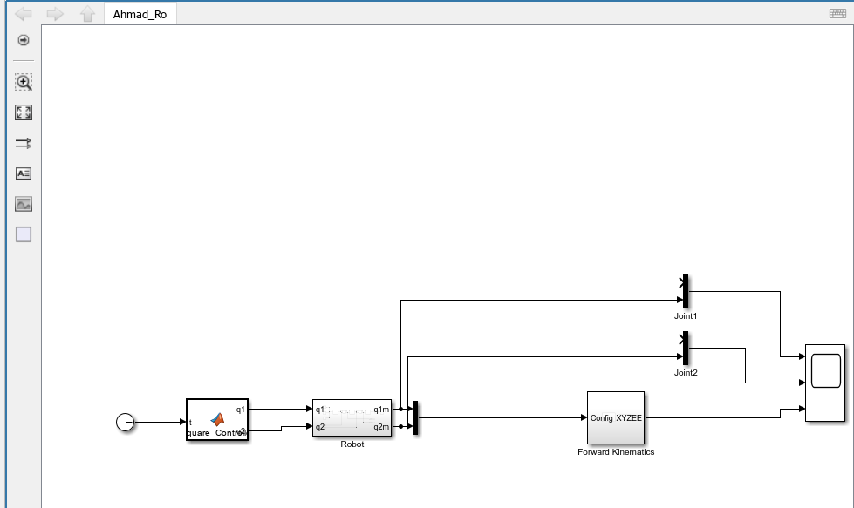

- Simscape Multibody Explorer:
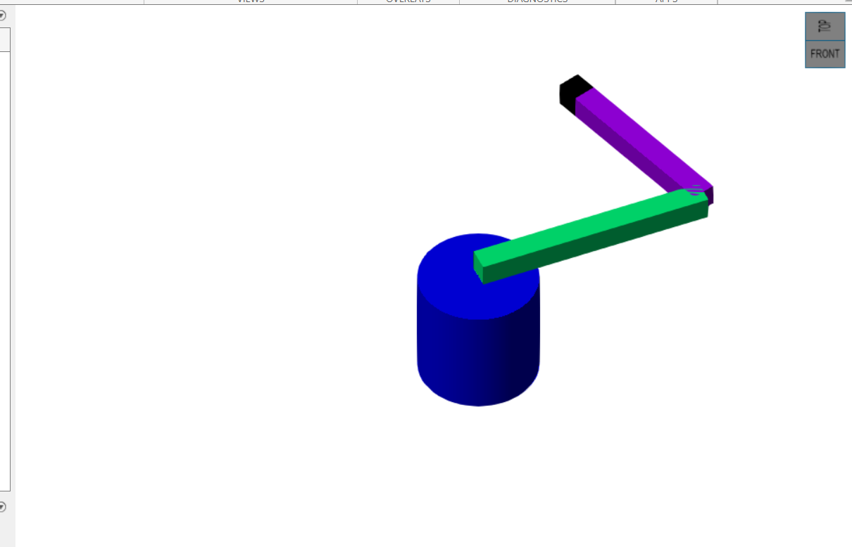

- Command Window Output:
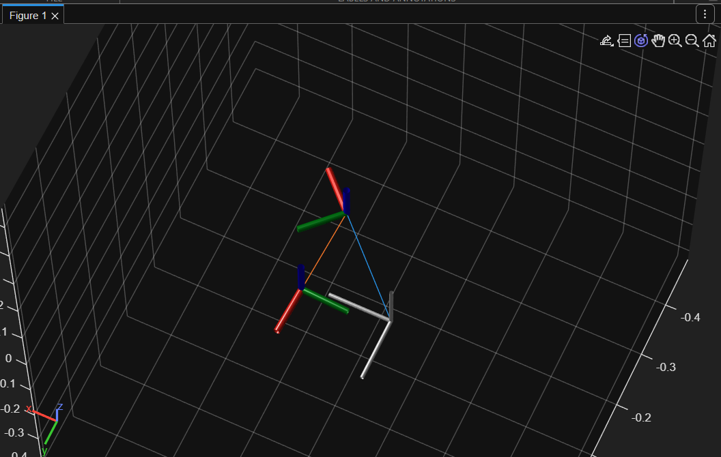
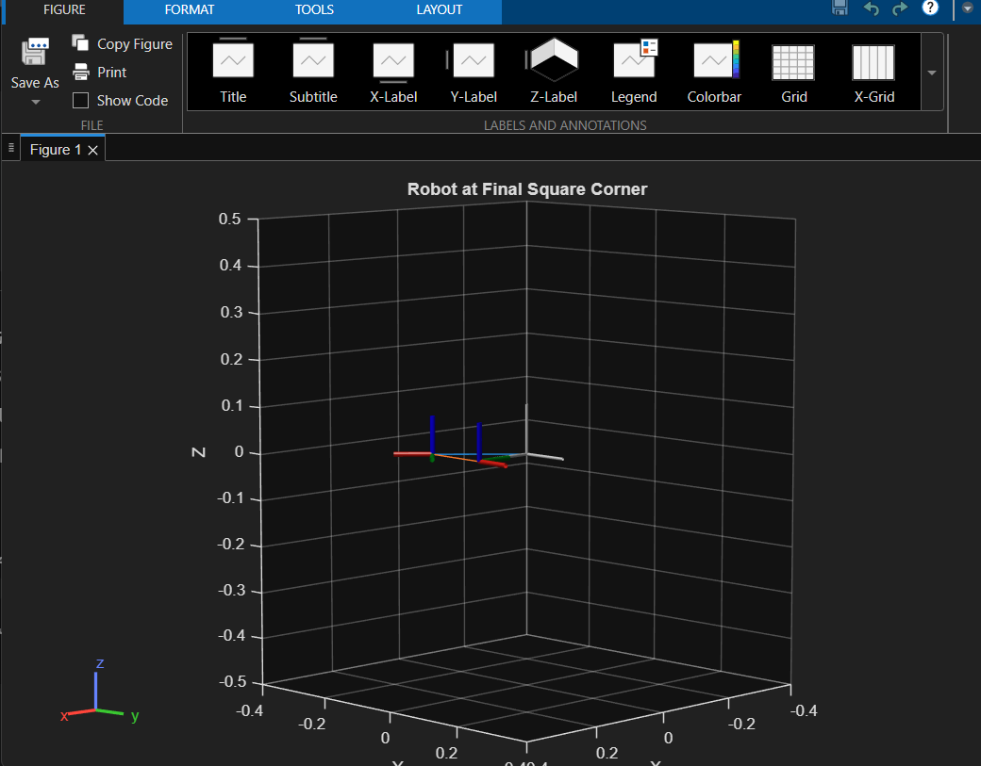

6. Real-Life Applications
- Automated Welding: Robots following precise geometric paths to join metal components in automotive manufacturing.
- 3D Printing (Additive Manufacturing): Moving an extruder head in a 2D plane to layer material and build complex parts.
- Laser/Waterjet Cutting: Navigating a cutting tool along programmed vectors to cut shapes out of flat sheets with high precision.

Thank you

