FITJOIN PLATFORM — TECHNICAL HANDOVER DOCUMENTATION
Backend Architecture & API Specification
Exhaustive Engineering Reference for ASP.NET Core 9 Web API, Entity Framework Core, SQL Server, AI Integrations, and Security Infrastructure.
Platform Name | FitJoin (Backend API: FitMind-API)
Technology Stack | ASP.NET Core 9.0 | EF Core 9.0.8 | SQL Server | JWT | Google OAuth
Target Location | c:\Ahmad Side\CodeByAhmad-Angular\FitMind-Forum
Document Version | 1.0.0 (Production Handover Edition)
Author / Engineering Lead | Ahmad Rasheed (CodeByAhmad)

1. Project Overview & System Purpose
FitJoin (internally named FitMind-API in the backend solution) is an enterprise-grade, community-driven social fitness and knowledge-sharing platform. The backend is designed to provide high-throughput, secure RESTful APIs to power social discussions, multi-media fitness posts, AI-driven visual content moderation, Google Gemini conversational fitness assistance, interactive community polling, multi-tier threaded commenting, real-time user notifications, and administrative platform governance.

1.1 Core Technology Stack
Layer / Subsystem | Technology / Framework | Version / Provider | Key Architectural Purpose
Runtime & Framework | ASP.NET Core Web API | .NET 9.0 | High-performance REST API endpoints with async/await throughout
Data Access / ORM | Entity Framework Core | 9.0.8 | Code-First ORM, SQL Server provider, LINQ queries, schema migrations
Primary Database | Microsoft SQL Server | LocalDB / Express / Azure SQL | Relational persistence across 16 interconnected domain entities
User Authentication | JWT Bearer Authentication | Microsoft.AspNetCore.Authentication.JwtBearer | Stateless bearer token validation for registered public community members
Admin Security | Google OAuth 2.0 + Whitelist | Google.Apis.Auth v1.68.0 | Zero-password OAuth validation restricted strictly to admin email whitelist
Content Moderation | Sightengine REST API | Sightengine API v1.0 | Automated real-time image moderation (nudity, weapons, drugs) and text screening
AI Chatbot | Google Gemini Pro API | Google Gemini Generative AI | Context-aware conversational fitness and nutrition advisory agent
Email Messaging | MimeKit / MailKit SMTP | MailKit v4.11.0 | Automated transactional emails for account verification and password recovery
API Documentation | Swagger / OpenAPI | Swashbuckle.AspNetCore 6.6.2 | Interactive API specification explorer and automated contract generation

1.2 Solution & Directory Structure
The backend solution is organized into clear architectural namespaces under `FitMind-API`:
Top-Level Directory | Namespace / Scope | Description & Contents
Controllers/ | FitMind_API.Controllers | Contains 19 API controllers managing HTTP routing, model binding, and action results.
Data/ | FitMind_API.Data | Contains FMDBContext.cs, configuring Entity Framework Core DbSets and fluent model relationships.
Models/Entities/ | FitMind_API.Models.Entities | Contains 16 domain entities mapped directly to SQL Server database tables.
Models/DTOs/ | FitMind_API.Models.DTOs | Contains 24 Data Transfer Objects defining strict API request and response contracts.
Models/Enums/ | FitMind_API.Models.Enums | Contains domain enums including UserEnums.cs defining account status and visibility flags.
Services/ | FitMind_API.Services | Business logic services (EmailService, SightengineService, GeminiChatService).
Common/ | FitMind_API.Common | Cross-cutting utilities (Utilities.cs) for image byte conversions and hashing.
Migrations/ | FitMind_API.Migrations | EF Core migration classes tracking schema evolutions from genesis to current build.
Properties/ | FitMind_API.Properties | Host environment launch settings (launchSettings.json) for HTTP/HTTPS development ports.

2. System Architecture & Middleware Pipeline
The backend implements a pragmatic, controller-service-context layered architecture. Rather than introducing artificial repository abstractions over EF Core (which is already a Unit of Work and Repository pattern), controllers interact directly with injected services and `FMDBContext` within scoped dependency lifecycles.
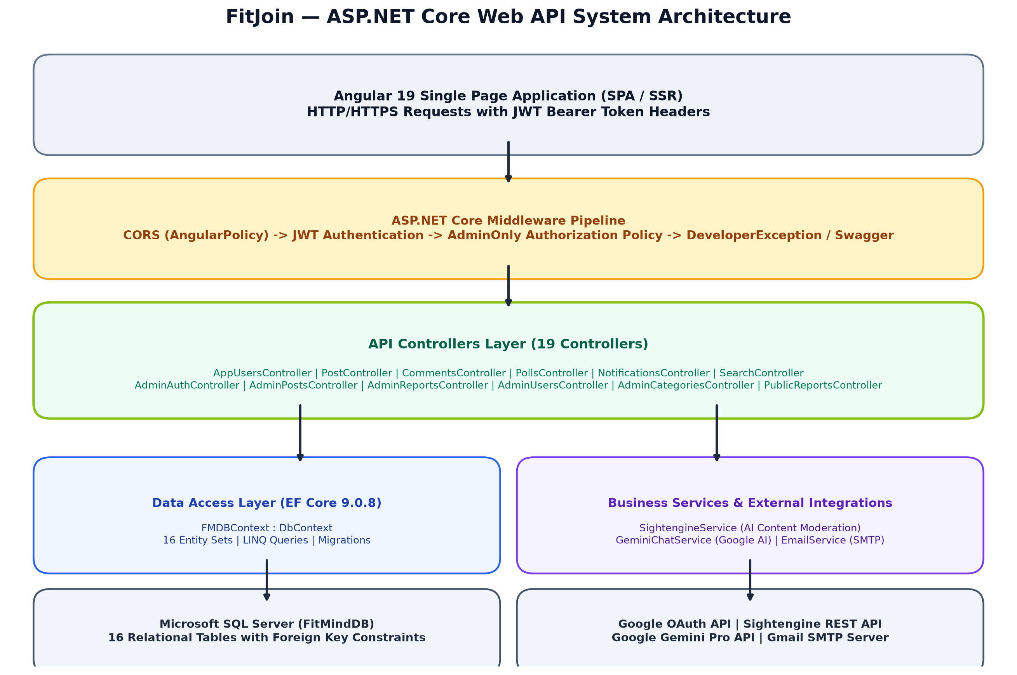
Figure 2.1: FitJoin Backend Layered System Architecture & Data Flow

2.1 Middleware Execution Pipeline
In ASP.NET Core, the order of middleware in `Program.cs` is critical to security and performance. In FitJoin, the request pipeline executes in the following exact sequence:
1. UseCors('AngularPolicy'): Evaluates the Origin header against 'http://localhost:4200' (or production URL), granting AllowAnyMethod and AllowAnyHeader before any authentication checks occur.
2. UseDeveloperExceptionPage(): Enabled in Development environment to render rich exception diagnostics and stack traces.
3. UseSwagger() & UseSwaggerUI(): Serves OpenAPI JSON definitions at '/swagger/v1/swagger.json' with UI mounted at the application root route ('/').
4. UseHttpsRedirection(): Enforces strict TLS/HTTPS transport by issuing HTTP 307/308 redirects for insecure requests.
5. UseAuthentication(): Parses the incoming 'Authorization: Bearer <token>' header, validates signature against SymmetricSecurityKey, checks issuer/audience/expiry, and populates HttpContext.User Principal.
6. UseAuthorization(): Evaluates role claims and policy requirements (e.g. 'AdminOnly' policy verifying role == 'admin').
7. MapControllers(): Routes incoming URL paths and HTTP verbs to their matching controller action methods.
[ARCHITECTURAL RULE] CORS MUST precede UseAuthentication and UseAuthorization in Program.cs. If Auth middleware runs prior to CORS, preflight OPTIONS requests lacking JWT headers will fail with HTTP 401 Unauthorized, crashing client browser requests.

3. Database Architecture & Relational Schema
The database layer is managed through Entity Framework Core 9.0.8 targeting Microsoft SQL Server (`FitMindDB`). The schema comprises 16 domain entities, engineered with explicit foreign key constraints, cascading strategies, and specialized indexes to prevent circular delete locks in SQL Server.
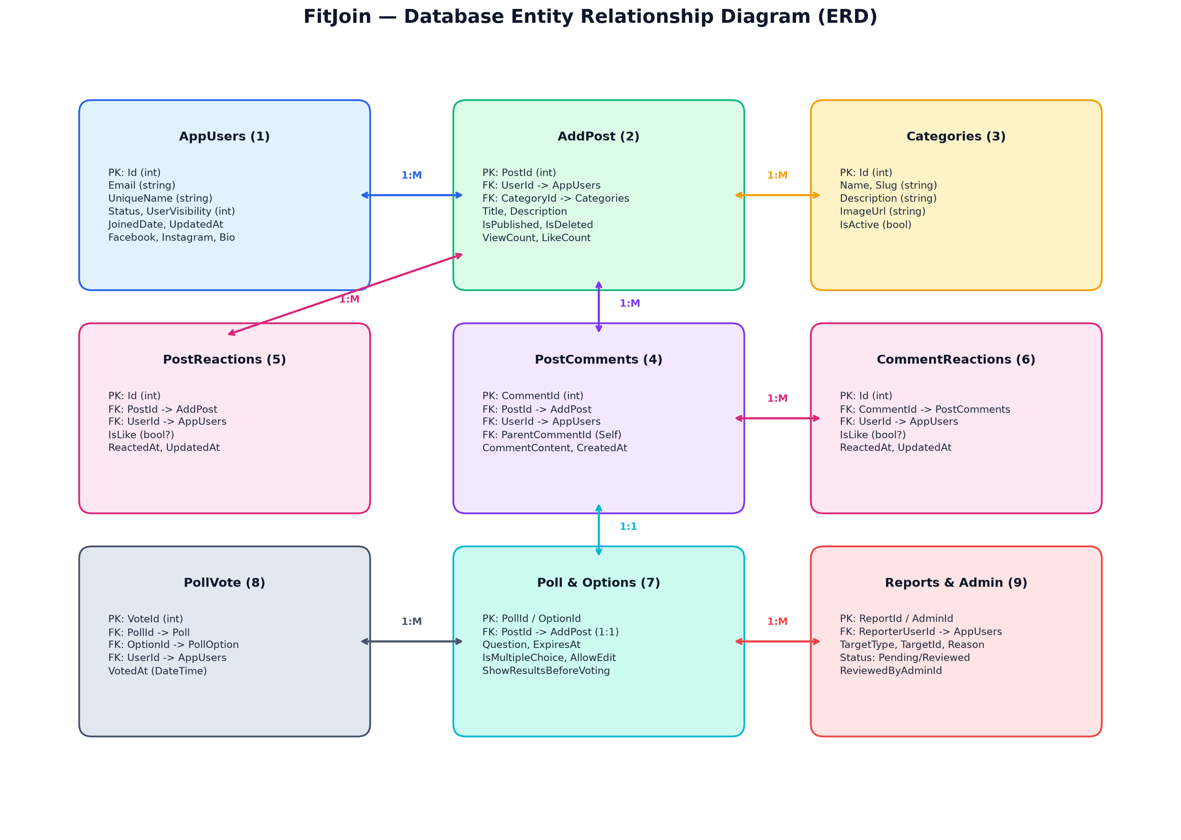
Figure 3.1: FitJoin Entity Relationship Diagram (ERD) & Foreign Key Constraints

3.1 Entity Data Dictionary

Entity: AppUsers
Primary user table storing registered public account profiles, social links, authentication status, and timestamps.
Field Name | Data Type | Constraints / Index | Functional Purpose
Id | int | PK, Identity(1,1) | Unique primary identifier
Email | string (nvarchar(max)) | Required | User email address (must be @gmail.com)
PasswordHash | string (nvarchar(max)) | Required | Hashed password or credentials token
EmailConfirmed | bool | Default false | Flag indicating email token validation
Status | int | Default 1 | Account status flag (Active=1, Suspended=2, Banned=3)
UniqueName | string? | Nullable | User's public display handle / nickname
UserVisibility | int? | Default 1 | Profile privacy level (Public=1, Private=2)
Bio | string? | Nullable | User bio / description
Location | string? | Nullable | User location
JoinedDate | DateTime | Default UtcNow | Account creation timestamp
Followers / Following | ICollection<UserFollower> | Navigation | Self-referencing Many-to-Many follower relationship

Entity: AddPost
Primary content table storing forum discussion threads, category links, author IDs, and publication metadata.
Field Name | Data Type | Constraints / Index | Functional Purpose
PostId | int | PK, Identity(1,1) | Unique post primary key
Title | string | Required | Post thread title
Description | string | Required | Post text description / markdown content
PostImage | byte[]? | Varbinary(max) | Binary payload of uploaded post image attachment
PostImageMimeType | string? | Nullable | MIME type (e.g. image/jpeg, image/png)
IsPublished | bool | Default true | Published flag (true = public feed, false = user draft)
IsDeleted | bool | Default false | Soft delete flag for moderation and author removal
UserId | int | FK -> AppUsers.Id | Author user foreign key (Cascade delete from Post)
CategoryId | int | FK -> Categories.Id | Forum category category foreign key
ViewCount / LikeCount | int | Default 0 | Aggregated analytics counters

Entity: PostComments
Hierarchical comment table storing top-level comments and multi-level nested replies.
Field Name | Data Type | Constraints / Index | Functional Purpose
CommentId | int | PK, Identity(1,1) | Unique comment primary key
CommentContent | string? | Required | Text content of comment
PostId | int | FK -> AddPost.PostId | Target post foreign key (Cascade on post deletion)
UserId | int | FK -> AppUsers.Id | Commenter user foreign key (DeleteBehavior.Restrict)
ParentCommentId | int? | FK -> PostComments.CommentId | Self-referencing parent foreign key for nested replies
CreatedAt | DateTime | Default UtcNow | Comment timestamp
IsDeleted | bool | Default false | Soft delete flag preserving reply tree structure

Entity: Poll & PollOption & PollVote
Interactive polling subsystem enabling single/multiple choice polls attached directly to forum posts.
Field Name | Data Type | Constraints / Index | Functional Purpose
Poll.PollId | int | PK, Identity(1,1) | Unique poll identifier
Poll.PostId | int | FK -> AddPost.PostId (1:1) | Unique 1:1 association to parent AddPost entity
Poll.Question | string | Required | The poll question text
Poll.AllowUserOptions | bool | Default false | Allows community members to add custom poll options
Poll.IsMultipleChoice | bool | Default false | Permits selecting more than one option
Poll.ShowResultsBeforeVoting | bool | Default false | Allows inspecting vote percentages prior to voting
PollOption.OptionId | int | PK | Option identifier (FK PollId -> Poll.PollId)
PollVote.VoteId | int | PK | Recorded vote linking PollId, OptionId, UserId (Unique compound index)

Entity: Report & AdminUser
Community safety reporting and administrator identity tables.
Field Name | Data Type | Constraints / Index | Functional Purpose
Report.ReportId | int | PK | Unique report identifier
Report.TargetType | string | Required | Target type ('Post', 'Comment', 'User', 'Poll')
Report.TargetId | int | Required | ID of reported entity
Report.ReporterUserId | int | FK -> AppUsers.Id | ID of user filing the report (Cascade delete)
Report.Reason | string | Required | Reason description / category selected by reporter
Report.Status | string | Default 'Pending' | Workflow status: 'Pending', 'Reviewed', 'Dismissed', 'Actioned'
AdminUser.AdminId | int | PK | Unique admin identifier
AdminUser.Email | string | Required, Unique | Google OAuth verified email address
AdminUser.IsActive | bool | Default true | Flag permitting access to /admin APIs

3.2 EF Core Migrations History
Migration Timestamp & Name | Schema Changes Applied | Cascade Constraint Decisions
20260719155128_AddCommentReplies | Added ParentCommentId self-referencing foreign key on PostComments. | Configured DeleteBehavior.Restrict to prevent multiple cascade paths in SQL Server.
20260719174713_FixCommentReactions | Introduced CommentReactions table with compound indices. | Cascade delete from Comment, Restrict from User.
20260720165257_AddSavedAndHiddenPosts | Added SavedPosts and HiddenPosts junction tables for user feed filtering. | Cascade from Post, Restrict from User.
20260726070127_AddPollFeature | Created Polls, PollOptions, and PollVotes tables. | 1:1 Cascade from AddPost -> Poll. Cascade Poll -> PollOptions.
20260726111919_FixPollVoteIndex | Enforced unique composite index on (PollId, UserId, OptionId). | DeleteBehavior.NoAction on Poll -> Votes to prevent cycle errors.
20260728115441_AddNotificationSystem | Created AppNotifications table for in-app alert broadcasting. | Cascade delete from AppUsers.
20260801074625_AddUserFollowSystem | Created UserFollowers table with composite primary key (FollowerId, FollowingId). | DeleteBehavior.Restrict on both foreign keys.
20260817105129_AddAdminAndReports | Added AdminUsers and Reports tables with status tracking. | SetNull on ReviewedByAdminId when Admin record is modified.

4. Authentication & Authorization Architecture
FitJoin employs a dual-authentication strategy separating public community members from platform administrators. Public members authenticate via email/password generating stateless JWT tokens, while administrators authenticate exclusively through Google OAuth 2.0 verified against a strict server-side whitelist.
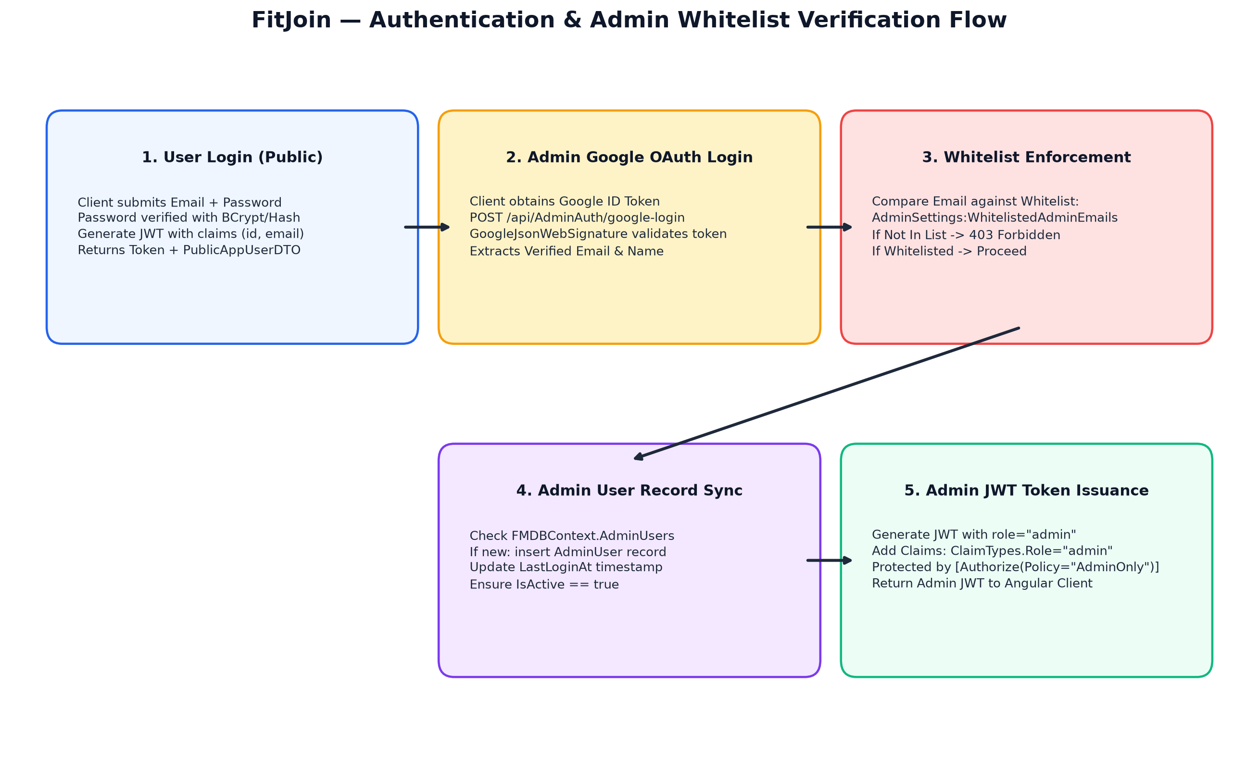
Figure 4.1: Authentication, Token Issuance, and Admin Whitelist Security Workflow

4.1 Public User Authentication Lifecycle
1. Registration Email Verification: Public users initiate registration at POST `/api/EmailSending/send-email`. The server generates a unique cryptographic GUID token stored in `UserRT` with an expiration window of 24 hours and dispatches an HTML email containing the verification link.
2. Token Validation & Account Creation: Navigating to the registration link triggers GET `/api/EmailSending/validate-email-token`. Upon verification, the user submits credentials to POST `/api/AppUsers/add-app-user`. Passwords are encrypted using BCrypt/cryptographic hashing.
3. JWT Bearer Generation: On POST `/api/AppUsers/login-user`, valid credentials produce a signed JWT containing claims: `ClaimTypes.NameIdentifier` (User ID), `ClaimTypes.Email`, and `Role` (`user`). Tokens are signed using HMAC-SHA256 with the secret key configured in `appsettings.json:Jwt:Key`.

4.2 Admin Google OAuth & Whitelist Mechanism
To ensure bulletproof administrative security, administrators cannot create passwords or log in via standard credential forms. Instead:
1. Google Token Submission: The Angular admin client captures a Google OAuth ID Token via Google Identity Services and submits it to POST `/api/AdminAuth/google-login` via `AdminGoogleLoginRequestDTO`.
2. Cryptographic Validation: The backend invokes `GoogleJsonWebSignature.ValidateAsync(idToken, settings)` to cryptographically verify Google's signature and ensure the token was issued for the configured `GoogleOAuth:ClientId`.
3. Whitelist Inspection: The backend inspects `appsettings.json:AdminSettings:WhitelistedAdminEmails`. If the verified email is absent from this array, the API immediately halts execution and returns HTTP 403 Forbidden with payload `{'error': 'Unauthorized admin email'}`.
4. Admin Record Sync & Token Grant: If whitelisted, the user is synced into the `AdminUsers` table with `LastLoginAt` updated, and an Admin JWT is issued containing claim `role = 'admin'`. Endpoints decorated with `[Authorize(Policy = 'AdminOnly')]` accept this token exclusively.

5. API Controller Reference (Exhaustive Directory)
This section documents all 19 ASP.NET Core API controllers in alphabetical order, specifying exact file paths, routing prefixes, authorization policies, dependencies, endpoints, payload DTOs, and internal business logic.

5.1 AdminAuthController.cs
Class Name: FitMind_API.Controllers.AdminAuthController
Route Prefix: `api/AdminAuth`
Authorization: None (Public / Whitelisted)
Dependencies: FMDBContext, IConfiguration, IOptions<AdminSettings>
Description: Handles Google OAuth 2.0 token validation, admin whitelist enforcement, and Admin JWT token issuance.
Verb | Route | Parameters / Payload | Return Type | HTTP Status | Business Logic Summary
POST | google-login | AdminGoogleLoginRequestDTO | IActionResult (Token, Admin info) | 200, 400, 401, 403 | Validates Google ID token via GoogleJsonWebSignature. Compares email against WhitelistedAdminEmails. Upserts AdminUser record. Returns Admin JWT with role='admin'.
GET | check-session | None (Bearer Header) | IActionResult (Status) | 200, 401 | Verifies active admin token validity and returns current admin profile metadata.

5.2 AdminCategoriesController.cs
Class Name: FitMind_API.Controllers.AdminCategoriesController
Route Prefix: `api/admin/categories`
Authorization: [Authorize(Policy = 'AdminOnly')]
Dependencies: FMDBContext
Description: Provides complete CRUD management for forum discussion categories.
Verb | Route | Parameters / Payload | Return Type | HTTP Status | Business Logic Summary
GET |  | None | IEnumerable<Categories> | 200, 401, 403 | Returns all categories including inactive ones with associated thread counts.
POST |  | Categories entity | Categories | 201, 400 | Creates a new category slug and description. Validates uniqueness.
PUT | {id} | int id, Categories entity | IActionResult | 200, 400, 404 | Updates existing category title, slug, image, and active status flag.
DELETE | {id} | int id | IActionResult | 200, 404, 409 | Deletes category if no active posts are assigned; otherwise marks inactive.

5.3 AdminDashboardController.cs
Class Name: FitMind_API.Controllers.AdminDashboardController
Route Prefix: `api/admin/dashboard`
Authorization: [Authorize(Policy = 'AdminOnly')]
Dependencies: FMDBContext
Description: Aggregates platform-wide analytics, key performance indicators (KPIs), and growth trends.
Verb | Route | Parameters / Payload | Return Type | HTTP Status | Business Logic Summary
GET | summary | None | DashboardSummaryDTO | 200, 401, 403 | Calculates total registered users, active posts, total comments, pending reports count, and 7-day registration/activity trends.

5.4 AdminManagementController.cs
Class Name: FitMind_API.Controllers.AdminManagementController
Route Prefix: `api/admin/management`
Authorization: [Authorize(Policy = 'AdminOnly')]
Dependencies: FMDBContext, IOptions<AdminSettings>
Description: Manages administrative staff accounts and synchronizes whitelist entries.
Verb | Route | Parameters / Payload | Return Type | HTTP Status | Business Logic Summary
GET | admins | None | IEnumerable<AdminUser> | 200, 401, 403 | Returns list of all authorized admin users and their last login timestamps.
POST | admins | string email | IActionResult | 200, 400 | Adds a new email address to administrative roster.
PUT | admins/{id}/toggle-status | int id | IActionResult | 200, 404 | Toggles an admin's IsActive status to enable or suspend access.
DELETE | admins/{id} | int id | IActionResult | 200, 404 | Deletes an admin user record from the database.

5.5 AdminPollsController.cs
Class Name: FitMind_API.Controllers.AdminPollsController
Route Prefix: `api/admin/polls`
Authorization: [Authorize(Policy = 'AdminOnly')]
Dependencies: FMDBContext
Description: Administrative moderation and lifecycle governance for community polls.
Verb | Route | Parameters / Payload | Return Type | HTTP Status | Business Logic Summary
GET |  | int page=1, int pageSize=10, string search='' | PagedResult<PollDTO> | 200, 401, 403 | Returns paginated list of all polls with author metadata, options, and total vote tallies.
GET | {id} | int id | PollDTO | 200, 404 | Retrieves complete poll details including individual option distributions.
PUT | {id} | int id, PollUpdateDTO | IActionResult | 200, 400, 404 | Updates poll expiration date, closes poll, or modifies visibility settings.
DELETE | {id} | int id | IActionResult | 200, 404 | Cascades deletion of poll, options, votes, and unpins from parent post.

5.6 AdminPostsController.cs
Class Name: FitMind_API.Controllers.AdminPostsController
Route Prefix: `api/admin/posts`
Authorization: [Authorize(Policy = 'AdminOnly')]
Dependencies: FMDBContext
Description: Administrative moderation of all user-generated forum posts.
Verb | Route | Parameters / Payload | Return Type | HTTP Status | Business Logic Summary
GET |  | int page=1, int pageSize=10, string search='', bool? isPublished | PagedResult<GetAllPostsDTO> | 200, 401, 403 | Returns paginated post feed across all users with moderation flags.
GET | {id} | int id | GetAllPostsDTO | 200, 404 | Fetches single post record including binary image attachment and author stats.
PUT | {id}/toggle-visibility | int id | IActionResult | 200, 404 | Toggles IsPublished flag to hide offensive posts from public feeds.
DELETE | {id} | int id | IActionResult | 200, 404 | Soft-deletes or hard-deletes post and related comments/reactions.
DELETE | comments/{id} | int id | IActionResult | 200, 404 | Forces removal of offensive comment by administrator.

5.7 AdminReportsController.cs
Class Name: FitMind_API.Controllers.AdminReportsController
Route Prefix: `api/admin/reports`
Authorization: [Authorize(Policy = 'AdminOnly')]
Dependencies: FMDBContext
Description: Moderation triage queue for handling user-submitted community reports.
Verb | Route | Parameters / Payload | Return Type | HTTP Status | Business Logic Summary
GET | summary | None | ReportsSummaryDTO | 200, 401, 403 | Returns counts of pending, resolved, and dismissed reports grouped by target type.
GET |  | int page=1, int pageSize=10, string status='Pending', string type='' | PagedResult<ReportDTO> | 200, 401, 403 | Returns paginated report items with target entity previews and reporter details.
GET | {id} | int id | ReportDetailDTO | 200, 404 | Returns full report context including target post/comment/user body.
PUT | {id}/status | int id, string status | IActionResult | 200, 400, 404 | Updates report status to 'Reviewed', 'Dismissed', or 'Actioned'.
POST | {id}/resolve | int id | IActionResult | 200, 404 | Resolves report and marks associated target entity as moderated.
POST | {id}/dismiss | int id | IActionResult | 200, 404 | Dismisses false-positive community report.

5.8 AdminUsersController.cs
Class Name: FitMind_API.Controllers.AdminUsersController
Route Prefix: `api/admin/users`
Authorization: [Authorize(Policy = 'AdminOnly')]
Dependencies: FMDBContext
Description: User account moderation, suspension, banning, and role assignment.
Verb | Route | Parameters / Payload | Return Type | HTTP Status | Business Logic Summary
GET |  | int page=1, int pageSize=10, string search='', int? status | PagedResult<AppUserDTO> | 200, 401, 403 | Returns paginated user list with email, status, post counts, and join dates.
GET | {id} | int id | AppUserDTO | 200, 404 | Fetches single user profile with administrative history and report counts.
PUT | {id}/status | int id, int status | IActionResult | 200, 400, 404 | Updates user status (1=Active, 2=Suspended, 3=Banned).
DELETE | {id} | int id | IActionResult | 200, 404 | Soft-deletes user account and disables login capabilities.

5.9 AppUsersController.cs
Class Name: FitMind_API.Controllers.AppUsersController
Route Prefix: `api/[controller]`
Authorization: Mixed (Public & [Authorize])
Dependencies: FMDBContext, Utilities
Description: Handles public user registration, credential login, profile management, follower graphs, and photo uploads.
Verb | Route | Parameters / Payload | Return Type | HTTP Status | Business Logic Summary
POST | add-app-user | RegistrationAppUserDTO | IActionResult (AppUser) | 200, 400, 409 | Creates user record from validated email token. Hashes password with BCrypt.
POST | login-user | UserLoginDTO | IActionResult (JWT Token, User data) | 200, 400, 401 | Verifies password hash. Emits HMAC-SHA256 signed JWT token.
GET | getAppUser/{userId} | int userId | PublicAppUserDTO | 200, 404 | Retrieves sanitized public profile without sensitive password hashes.
PUT | updateAppUser/{userId} | int userId, UpdateAppUserDTO | IActionResult | 200, 400, 404 | Updates user bio, unique display name, location, and social links.
POST | upload-profile-picture/{userId} | IFormFile file, int userId | IActionResult | 200, 400, 404 | Processes multipart image stream, converts to byte array, stores in UserPhoto.
GET | getProfilePicture/{userId} | int userId | FileContentResult | 200, 404 | Streams binary profile avatar image with appropriate MIME header.
POST | follow/{targetUserId} | int targetUserId (from JWT) | IActionResult | 200, 400, 404 | Creates UserFollower relationship between logged-in user and target.
DELETE | unfollow/{targetUserId} | int targetUserId | IActionResult | 200, 400, 404 | Removes follow relationship from UserFollowers table.
GET | followers/{userId} | int userId | IEnumerable<PublicAppUserDTO> | 200, 404 | Returns list of users following the specified profile.
GET | following/{userId} | int userId | IEnumerable<PublicAppUserDTO> | 200, 404 | Returns list of profiles the specified user is following.

5.10 CategoriesController.cs
Class Name: FitMind_API.Controllers.CategoriesController
Route Prefix: `api/[controller]`
Authorization: AllowAnonymous
Dependencies: FMDBContext
Description: Public category discovery for navigation menus and post filtering.
Verb | Route | Parameters / Payload | Return Type | HTTP Status | Business Logic Summary
GET | getAllCategories | None | IEnumerable<Categories> | 200 | Returns all active categories sorted by display order.
GET | getCategory/{id} | int id | Categories | 200, 404 | Retrieves single category by ID.

5.11 ChatbotController.cs
Class Name: FitMind_API.Controllers.ChatbotController
Route Prefix: `api/[controller]`
Authorization: AllowAnonymous
Dependencies: GeminiChatService
Description: Integrates Google Gemini AI for contextual fitness and nutrition chat.
Verb | Route | Parameters / Payload | Return Type | HTTP Status | Business Logic Summary
POST | chat | ChatRequestDTO | ChatResponseDTO | 200, 400, 500 | Streams conversational history to Gemini Pro API with fitness-tailored system prompt. Returns structured markdown advice.

5.12 CommentsController.cs
Class Name: FitMind_API.Controllers.CommentsController
Route Prefix: `api/[controller]`
Authorization: Mixed
Dependencies: FMDBContext
Description: Threaded commenting, nested reply fetching, and comment reaction toggles.
Verb | Route | Parameters / Payload | Return Type | HTTP Status | Business Logic Summary
GET | getAll/{postId} | int postId | IEnumerable<PostCommentsDTO> | 200 | Fetches root-level comments for post (ParentCommentId == null) with user profiles and reaction tallies.
GET | getReplies/{commentId} | int commentId | IEnumerable<PostCommentsDTO> | 200 | Fetches nested reply comments for specified parent comment ID.
GET | getUserComments/{userId} | int userId | IEnumerable<PostCommentsDTO> | 200 | Returns all comments authored by a specific user across all posts.
POST | add-comment | PostCommentsDTO | IActionResult | 201, 400 | Creates new root comment or nested reply. Triggers author notification.
DELETE | delete/{userId}/{commentId} | int userId, int commentId | IActionResult | 200, 403, 404 | Validates comment ownership and soft-deletes comment content.
POST | {id}/like | int id, int userId | IActionResult | 200, 400, 404 | Toggles or updates comment like reaction. Updates CommentReactions.
POST | {id}/dislike | int id, int userId | IActionResult | 200, 400, 404 | Toggles comment dislike reaction.

5.13 EmailSendingController.cs
Class Name: FitMind_API.Controllers.EmailSendingController
Route Prefix: `api/[controller]`
Authorization: AllowAnonymous
Dependencies: FMDBContext, IEmailService
Description: Dispatches transactional emails for registration and password resets.
Verb | Route | Parameters / Payload | Return Type | HTTP Status | Business Logic Summary
POST | send-email | string receptor | IActionResult | 200, 400, 409 | Validates email format, verifies no duplicate account exists, creates UserRT token, sends verification email.
GET | validate-email-token | string token | IActionResult (Token status) | 200, 400, 404 | Validates unexpired token in UserRT table. Returns validated email address.
POST | send-fp-email | string receptor | IActionResult | 200, 400, 404 | Generates password reset token and dispatches recovery link.
GET | validate-reset-token | string token | IActionResult | 200, 400, 404 | Verifies password reset token validity prior to allowing password update.

5.14 NotificationsController.cs
Class Name: FitMind_API.Controllers.NotificationsController
Route Prefix: `api/[controller]`
Authorization: [Authorize]
Dependencies: FMDBContext
Description: User notification center managing alerts for likes, comments, and follows.
Verb | Route | Parameters / Payload | Return Type | HTTP Status | Business Logic Summary
GET | getMyNotifications/{userId} | int userId | IEnumerable<AppNotification> | 200, 401 | Retrieves recent notification alerts for logged-in user ordered by CreatedAt desc.
PUT | markAsRead/{id} | int id | IActionResult | 200, 404 | Marks single notification alert as read (IsRead = true).
PUT | markAllAsRead/{userId} | int userId | IActionResult | 200 | Batch updates all unread notifications for specified user to read.
DELETE | {id} | int id | IActionResult | 200, 404 | Deletes notification alert.

5.15 PollsController.cs
Class Name: FitMind_API.Controllers.PollsController
Route Prefix: `api/[controller]`
Authorization: Mixed
Dependencies: FMDBContext
Description: Community polling management, user voting, option expansion, and vote tally calculations.
Verb | Route | Parameters / Payload | Return Type | HTTP Status | Business Logic Summary
POST | create | PollCreateDTO | IActionResult | 201, 400 | Creates a new poll associated with parent post. Inserts initial options.
POST | vote | PollVoteDTO | IActionResult | 200, 400, 409 | Records user vote. Enforces single/multi-choice rules and unique index.
POST | add-option | PollOptionCreateDTO | IActionResult | 201, 400 | Appends community option if poll allows user-generated options.
POST | toggle-pin/{pollId} | int pollId | IActionResult | 200, 404 | Pins poll to top of forum feed.
POST | toggle-close/{pollId} | int pollId | IActionResult | 200, 404 | Closes poll to prevent additional votes.
DELETE | {pollId} | int pollId | IActionResult | 200, 403, 404 | Deletes poll and cascades votes/options.

5.16 PostController.cs
Class Name: FitMind_API.Controllers.PostController
Route Prefix: `api/[controller]`
Authorization: [Authorize]
Dependencies: FMDBContext, SightengineService, Utilities
Description: Core forum post lifecycle, multipart image upload, AI moderation, feed retrieval, and drafts.
Verb | Route | Parameters / Payload | Return Type | HTTP Status | Business Logic Summary
GET | getAllPosts | None | IEnumerable<GetAllPostsDTO> | 200 | Retrieves active published feed posts joined with author data, categories, like counts, and poll metadata.
GET | getUserPosts/{userId} | int userId | IEnumerable<GetUserPostsDTO> | 200 | Returns all posts authored by specific user profile.
GET | {id} | int id | GetAllPostsDTO | 200, 404 | Fetches single post details and increments ViewCount.
GET | getPostImage/{userId}/{postId} | int userId, int postId | FileContentResult | 200, 404 | Streams binary post attachment image.
GET | getDrafts/{userId} | int userId | IEnumerable<GetDraftedPostDTO> | 200 | Retrieves unpublished draft posts for author.
POST | add-post | AddPostDTO (Multipart / Form) | IActionResult | 201, 400 | Validates text and image via SightengineService. Rejects offensive content. Persists AddPost entity.
POST | analyze-image | IFormFile file | SightengineDTO | 200, 400 | Standalone image moderation preview endpoint.
POST | analyze-text | string text | SightengineTextModerationDTO | 200, 400 | Standalone text screening endpoint.
PUT | updatePost/{userId} | int userId, UpdatePostDTO | IActionResult | 200, 400, 403 | Updates post title, description, category, and image attachment.
PUT | deletePost/{userId}/{postId} | int userId, int postId | IActionResult | 200, 403, 404 | Soft-deletes post (IsDeleted = true).
POST | savePost/{userId}/{postId} | int userId, int postId | IActionResult | 200, 400 | Adds post to user's SavedPosts bookmarks.
DELETE | unsavePost/{userId}/{postId} | int userId, int postId | IActionResult | 200, 404 | Removes post from SavedPosts.
GET | getSavedPosts/{userId} | int userId | IEnumerable<GetAllPostsDTO> | 200 | Returns user's bookmarked posts.
POST | hidePost/{userId}/{postId} | int userId, int postId | IActionResult | 200, 400 | Adds post to user's HiddenPosts exclusion list.
DELETE | unhidePost/{userId}/{postId} | int userId, int postId | IActionResult | 200, 404 | Removes post from HiddenPosts.
GET | getHiddenPosts/{userId} | int userId | IEnumerable<GetAllPostsDTO> | 200 | Returns user's hidden posts.

5.17 PostReactionsController.cs
Class Name: FitMind_API.Controllers.PostReactionsController
Route Prefix: `api/[controller]`
Authorization: Mixed
Dependencies: FMDBContext
Description: Like and dislike reaction management for forum posts.
Verb | Route | Parameters / Payload | Return Type | HTTP Status | Business Logic Summary
GET | postReactionsCount/{postId} | int postId | PostReactionsCountDTO | 200 | Returns total likes and dislikes count for a post.
POST | addPostReaction | PostReactionsDTO | IActionResult | 200, 400 | Records or updates like/dislike status. Increments LikeCount counter.
PUT | updateReaction | PostReactionsDTO | IActionResult | 200, 400 | Modifies existing user reaction from like to dislike or vice versa.
DELETE | removePostReaction/{userId}/{postId} | int userId, int postId | IActionResult | 200, 404 | Removes reaction and decrements counter.

5.18 PublicReportsController.cs
Class Name: FitMind_API.Controllers.PublicReportsController
Route Prefix: `api/reports`
Authorization: [Authorize]
Dependencies: FMDBContext
Description: Community-facing endpoint allowing authenticated members to report abusive content.
Verb | Route | Parameters / Payload | Return Type | HTTP Status | Business Logic Summary
GET | my-reports | None (from JWT) | IEnumerable<ReportDTO> | 200, 401 | Returns history of reports filed by currently logged-in user.
POST | posts/{id} | int id, ReportCreateDTO | IActionResult | 201, 400 | Files a report against a specific post with selected reason.
POST | polls/{id} | int id, ReportCreateDTO | IActionResult | 201, 400 | Files a report against an abusive poll.
POST | profiles/{id} | int id, ReportCreateDTO | IActionResult | 201, 400 | Files a report against a user profile.

5.19 SearchController.cs
Class Name: FitMind_API.Controllers.SearchController
Route Prefix: `api/[controller]`
Authorization: AllowAnonymous
Dependencies: FMDBContext
Description: Global multi-entity search engine spanning posts, authors, tags, and categories.
Verb | Route | Parameters / Payload | Return Type | HTTP Status | Business Logic Summary
GET |  | string q, string type='', int page=1, int pageSize=5 | SearchResultDTO | 200, 400 | Performs unified database query matching query across post titles/descriptions, user display names/handles, and category titles. Returns structured results grouped by entity type.

6. Business Logic & External Services Layer
FitJoin encapsulates complex external integrations and utility logic into specialized service classes registered as Scoped or Transient services in the ASP.NET Core Dependency Injection container.

6.1 EmailService (IEmailService)
Responsibility: Manages outbound SMTP communication using MimeKit and MailKit. Reads configuration from `appsettings.json:EMAIL_CONFIGRATION` (Host: smtp.gmail.com, Port: 587).
Key Methods: `SendEmailAsync(string toEmail, string subject, string body)`. Constructs `MimeMessage` with HTML body parts and dispatches via authenticated TLS socket.

6.2 SightengineService (AI Content Moderation)
Responsibility: Connects to Sightengine REST API (`https://api.sightengine.com/1.0/`) using a configured `HttpClient` (`ApiUser` and `ApiSecret`).
Key Methods: `CheckImageAsync(byte[] imageBytes)`. Evaluates nudity, weapons, alcohol, drugs, and offensive content scores. If scores exceed threshold (0.65), the service raises a validation error, preventing offensive post creation before binary persistence.

6.3 GeminiChatService (Google Generative AI)
Responsibility: Manages conversational requests to Google Gemini Pro API. Formats multi-turn chat history (`ChatbotDTOs.cs`) into Gemini API schema with strict fitness/nutrition domain system prompts.

6.4 In-Memory LINQ Workarounds & Technical Insights
[LINQ-TO-SQL WORKAROUND] In EF Core 9, complex aggregations involving binary byte[] image fields cannot be translated directly into SQL Server GROUP BY clauses. In PostController.getAllPosts, post records are retrieved with AsNoTracking() and projected in-memory to GetAllPostsDTO to prevent EF translation exceptions.

7. Data Transfer Objects (DTOs) Master Reference
Data Transfer Objects define the strict contract between the ASP.NET Core API and external consumers. The table below catalogs all 24 DTO classes in the solution.
DTO Name | File Location | Key Properties & Types | Consuming Endpoints
AddPostDTO | Models/DTOs/AddPostDTO.cs | Title (string), Description (string), CategoryId (int), IsPublished (bool), PostImage (IFormFile) | POST api/Post/add-post
AdminGoogleLoginRequestDTO | Models/DTOs/AdminGoogleLoginRequestDTO.cs | IdToken (string), Email (string), Name (string) | POST api/AdminAuth/google-login
AppUserDTO | Models/DTOs/AppUserDTO.cs | Id, Email, UniqueName, Status, JoinedDate, PostCount | GET api/admin/users
CommentReactionDTO | Models/DTOs/CommentReactionDTO.cs | CommentId (int), UserId (int), IsLike (bool?) | POST api/Comments/{id}/like
GetAllPostsDTO | Models/DTOs/GetAllPostsDTO.cs | PostId, Title, Description, CreatedAt, ViewCount, LikeCount, CategoryName, AuthorName, HasImage | GET api/Post/getAllPosts
GetDraftedPostDTO | Models/DTOs/GetDraftedPostDTO.cs | PostId, Title, Description, UpdatedAt, CategoryId | GET api/Post/getDrafts
GetUserPostsDTO | Models/DTOs/GetUserPostsDTO.cs | PostId, Title, Description, CreatedAt, LikeCount, CommentCount | GET api/Post/getUserPosts
newPasswordDTO | Models/DTOs/newPasswordDTO.cs | Token (string), NewPassword (string) | POST api/AppUsers/reset-password
PollDTO | Models/DTOs/PollDTO.cs | PollId, PostId, Question, ExpiresAt, IsClosed, Options (List<PollOptionDTO>) | GET api/Polls, GET api/admin/polls
PostCommentsDTO | Models/DTOs/PostComments.cs | CommentId, CommentContent, CreatedAt, UserId, UserName, UserPhoto, ParentCommentId, RepliesCount, LikesCount, IsLikedByCurrentUser | GET/POST api/Comments
PostReactionsCountDTO | Models/DTOs/PostReactionsCountDTO.cs | PostId (int), LikesCount (int), DislikesCount (int), UserReaction (string) | GET api/PostReactions
PublicAppUserDTO | Models/DTOs/PublicAppUserDTO.cs | Id, UniqueName, Email, Bio, Location, JoinedDate, FacebookLink, InstagramLink, FollowersCount, FollowingCount | GET api/AppUsers/getAppUser
RegistrationAppUserDTO | Models/DTOs/RegistrationAppUserDTO.cs | Username, Email, PasswordHash, VerificationToken | POST api/AppUsers/add-app-user
SearchDTOs | Models/DTOs/SearchDTOs.cs | Query (string), Posts (List), Users (List), Categories (List) | GET api/Search
SightengineDTO | Models/DTOs/SightengineDTO.cs | Status, NudityScore, WeaponScore, AlcoholScore, IsApproved | POST api/Post/analyze-image
UserLoginDTO | Models/DTOs/UserLoginDTO.cs | Email (string), HashedPassword (string) | POST api/AppUsers/login-user

8. Packages & Dependencies Inventory
Package Name | Version | Classification | Functional Purpose
Microsoft.AspNetCore.Authentication.JwtBearer | 9.0.0 | NuGet (External) | JWT bearer token authentication handler and security token validation.
Microsoft.EntityFrameworkCore.SqlServer | 9.0.8 | NuGet (External) | SQL Server database provider for Entity Framework Core.
Microsoft.EntityFrameworkCore.Tools | 9.0.8 | NuGet (External) | CLI tools for generating and applying Code-First database migrations.
Google.Apis.Auth | 1.68.0 | NuGet (External) | Cryptographic validation of Google OAuth 2.0 ID tokens for admin whitelist security.
MailKit & MimeKit | 4.11.0 | NuGet (External) | High-performance, MIME-compliant SMTP email generation and dispatching.
BCrypt.Net-Next | 4.0.3 | NuGet (External) | Adaptive cryptographic password hashing and salt generation.
Swashbuckle.AspNetCore | 6.6.2 | NuGet (External) | OpenAPI metadata and interactive Swagger UI explorer generation.
Utilities.cs | Internal | Internal Helper | Static utility methods for image byte manipulation, token hashing, and MIME parsing.

9. Audit Logging & Moderation Workflows
Platform integrity and safety in FitJoin are governed through structured audit trails in the `Report` and `AdminUser` entities:
1. Community Flagging: Authenticated users report abusive posts, comments, or profiles via `PublicReportsController`. Reports record `ReporterUserId`, `TargetType`, `TargetId`, and `Reason` with initial status `Pending`.
2. Administrative Triage: Admins inspect the queue via `AdminReportsController`. Reviewing a report updates `ReviewedByAdminId` and transitions status to `Reviewed`, `Actioned`, or `Dismissed`.
3. Moderation Actions: Actioning a report invokes automated hide or delete actions on target posts (`AdminPostsController`) or issues suspensions on abusive users (`AdminUsersController`).

10. Configuration & Environment Settings
Application configuration is defined in `appsettings.json` and overrides via `appsettings.Development.json`:
Configuration Key / Section | Example / Schema | Purpose & Security Impact
ConnectionStrings:FMDBCS | server=localhost; database=FitMindDB; trusted_connection=true; TrustServerCertificate=true | SQL Server connection string. In production, use Azure Managed Identity or Secret Vault.
AdminSettings:WhitelistedAdminEmails | ["ahmadrasheed8055@gmail.com", "ahmad.r.tec@gmail.com"] | Array of authorized Google emails granted access to admin panel.
GoogleOAuth:ClientId | 258112102687-...apps.googleusercontent.com | Google Cloud Console OAuth 2.0 Web Client ID for signature validation.
Jwt:Key / Issuer / Audience | FitMind$ecurityKey... / http://localhost:5177/ / http://localhost:4200 | HMAC-SHA256 signing secret and audience validation constraints.
Sightengine:ApiUser / ApiSecret | 346534278 / tCxYLL... | Sightengine content moderation API authentication credentials.
Gemini:ApiKey | AQ.Ab8RN6Lt... | Google Gemini Pro API key for chatbot endpoint.
EMAIL_CONFIGRATION:HOST / PORT | smtp.gmail.com / 587 | SMTP host and TLS port for transactional emails.

11. Master API Workflow Cross-Reference Table
This master table provides an end-to-end trace connecting features, routes, authentication requirements, internal services, and touched database tables.
Feature Area | API Route | Verb | Auth Policy | Service / Context | Tables Touched
User Login | api/AppUsers/login-user | POST | Anonymous | FMDBContext, Utilities | AppUsers, UserRT
User Register | api/AppUsers/add-app-user | POST | Anonymous | FMDBContext | AppUsers, UserRT
Admin Google Login | api/AdminAuth/google-login | POST | Anonymous | Google.Apis.Auth, FMDBContext | AdminUsers
Get Feed Posts | api/Post/getAllPosts | GET | Anonymous | FMDBContext | AddPost, Categories, AppUsers, PostReactions
Create Post | api/Post/add-post | POST | [Authorize] | SightengineService, FMDBContext | AddPost, Categories
Threaded Comments | api/Comments/getAll/{postId} | GET | Anonymous | FMDBContext | PostComments, AppUsers, CommentReactions
Add Comment | api/Comments/add-comment | POST | [Authorize] | FMDBContext | PostComments, AppNotifications
Vote on Poll | api/Polls/vote | POST | [Authorize] | FMDBContext | PollVotes, PollOptions, Polls
Community Report | api/reports/posts/{id} | POST | [Authorize] | FMDBContext | Reports
Global Search | api/Search | GET | Anonymous | FMDBContext | AddPost, AppUsers, Categories
AI Chatbot | api/Chatbot/chat | POST | Anonymous | GeminiChatService | None (Stateless External API)
Admin Post Mod | api/admin/posts/{id}/toggle-visibility | PUT | AdminOnly | FMDBContext | AddPost
Admin User Ban | api/admin/users/{id}/status | PUT | AdminOnly | FMDBContext | AppUsers

12. Known Technical Debt & Backend Improvements

Binary Image Storage in SQL Server
Currently, images are stored directly in `AddPost.PostImage` and `AppUsers.UserPhoto` as `varbinary(max)` byte arrays. For high-scale production, images should be offloaded to Azure Blob Storage or AWS S3, storing only CDN URL strings in SQL Server.

JWT Expiration & Refresh Tokens
The current JWT implementation uses fixed expirations without a dedicated refresh token exchange table. Implementing refresh tokens in `UserRT` will allow seamless session renewal without re-entering credentials.

In-Memory LINQ Aggregations
In `PostController`, certain post collections are materialized via `.ToList()` before mapping due to byte array projection constraints. Moving to blob URLs will permit 100% database-side SQL projections.

Cascading Constraints in SQL Server
SQL Server restricts multiple cascading paths on self-referencing tables (`PostComments`). Several relationships use `DeleteBehavior.Restrict`, requiring explicit application-level deletion handling when deleting posts.

