FITJOIN PLATFORM — TECHNICAL HANDOVER DOCUMENTATION
Frontend Architecture & Component Guide
Complete Engineering Reference for Angular 19 Standalone Architecture, SSR Client Hydration, RxJS Reactive State, Skeletons, and Admin Suite.
Platform Name | FitJoin (Frontend Client: FitMind-Forum)
Technology Stack | Angular 19.2 | Standalone Components | SSR Hydration | RxJS 7.8 | Bootstrap 5.3
Target Location | c:\Ahmad Side\CodeByAhmad-Angular\FitMind-Forum
Document Version | 1.0.0 (Production Handover Edition)
Author / Engineering Lead | Ahmad Rasheed (CodeByAhmad)

1. Project Overview & Frontend Technology Stack
FitJoin (client repository `FitMind-Forum`) is a responsive Single Page Application (SPA) built on Angular 19. The application is crafted with high aesthetic fidelity utilizing the `#87BF17` signature lime green brand palette, dark card elements, responsive grid layouts, and instantaneous skeleton loading transitions.

1.1 Core Frontend Frameworks & Libraries
Subsystem / Capability | Library / Framework | Version | Role in Application
Core Framework | Angular Core & Common | 19.2.x | Modular Standalone Component architecture with inject() dependency injection
Rendering Strategy | Angular Server-Side Rendering | @angular/ssr 19.2 | Server-rendered markup with provideClientHydration(withEventReplay()) for optimal SEO
Reactive Streams | RxJS | 7.8.0 | Reactive state management via BehaviorSubject streams for session data and live polling
UI Layout & Grid | Bootstrap 5 | 5.3.3 | Responsive grid, flex utilities, modals, dropdowns, and responsive navigation
Form Controls & Popups | Angular Material CDK | 19.2.1 | MatSnackBar popup notifications and Material form field inputs
Custom Select Dropdowns | Ng-Select | 14.7.0 | Custom search-as-you-type category and tag selector
Icons & Visual Assets | FontAwesome & Bootstrap Icons | 6.x / 1.11.x | Vector iconography across navigation, actions, and reaction buttons
HTTP Network Interceptor | Angular HttpClient Interceptors | Functional | token.interceptor.ts injecting Bearer tokens and managing 401 session expirations

1.2 Folder Hierarchy & Architecture Breakdown
The frontend codebase is structured under `src/app` into logical concerns:
Folder / File Path | Module / Concern | Contents & Purpose
src/app/website/ | Public & User Features | Core community views: navbar, hero, feed posts, threaded comments, polling, search, and user settings.
src/app/admin/ | Admin Governance Module | Comprehensive administrative suite: Google login, analytics dashboard, user moderation, post moderation, and reports.
src/app/Shared/ | Shared Infrastructure | Singleton services (MasterService, AuthService, CommentService, etc.), route guards, and skeleton loaders.
src/app/Model/ | TypeScript Contracts | Data Transfer Objects and TypeScript interfaces matching backend models.
src/app/app.routes.ts | Routing Definitions | Top-level application route table configuring lazy loading and route guard pipelines.
src/app/token.interceptor.ts | Security Interceptor | Functional HTTP interceptor appending Bearer headers and trapping 401 Unauthorized responses.

2. Frontend Architecture & Component Hierarchy
The client application adheres to Angular 19 Standalone Component patterns. Every component explicitly declares its required imports (`imports: [...]`), eliminating legacy NgModules except for lazy-loaded routing wrappers (`AdminRoutingModule`).
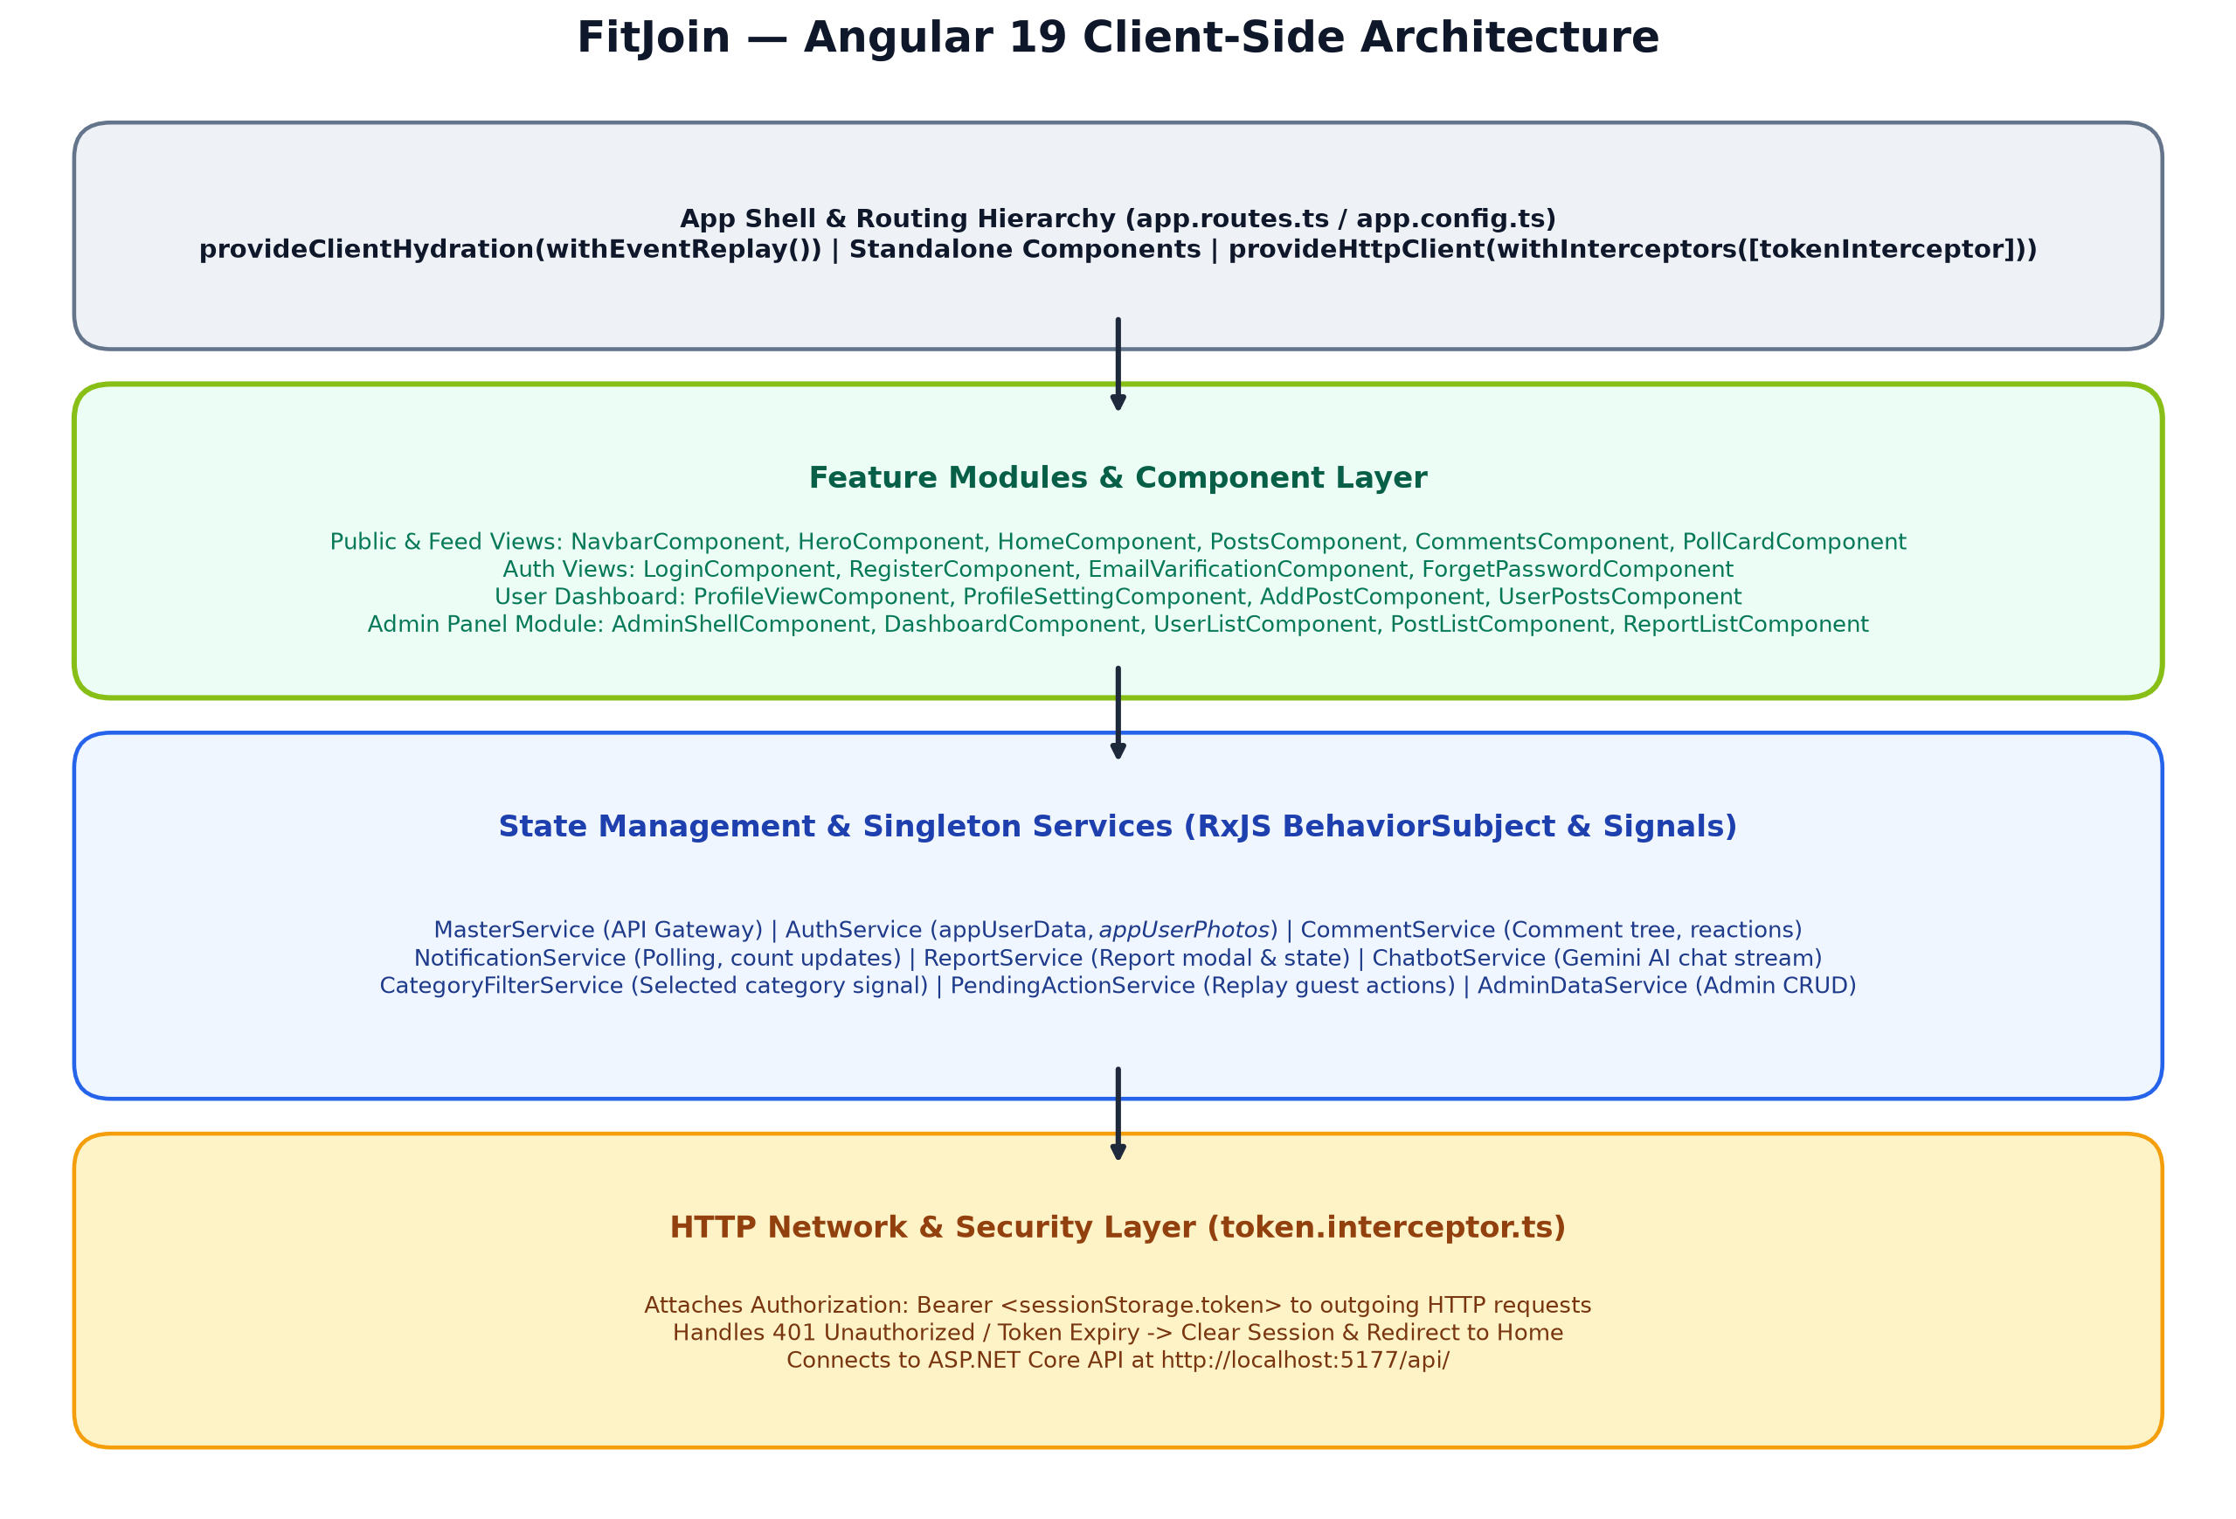
Figure 2.1: FitJoin Angular 19 Architecture & Reactive Data Streams

2.1 Comprehensive Component Tree
The UI component tree is bifurcated into the Public App Shell (`NavbarComponent`) and the Administrative Dashboard Shell (`AdminShellComponent`):
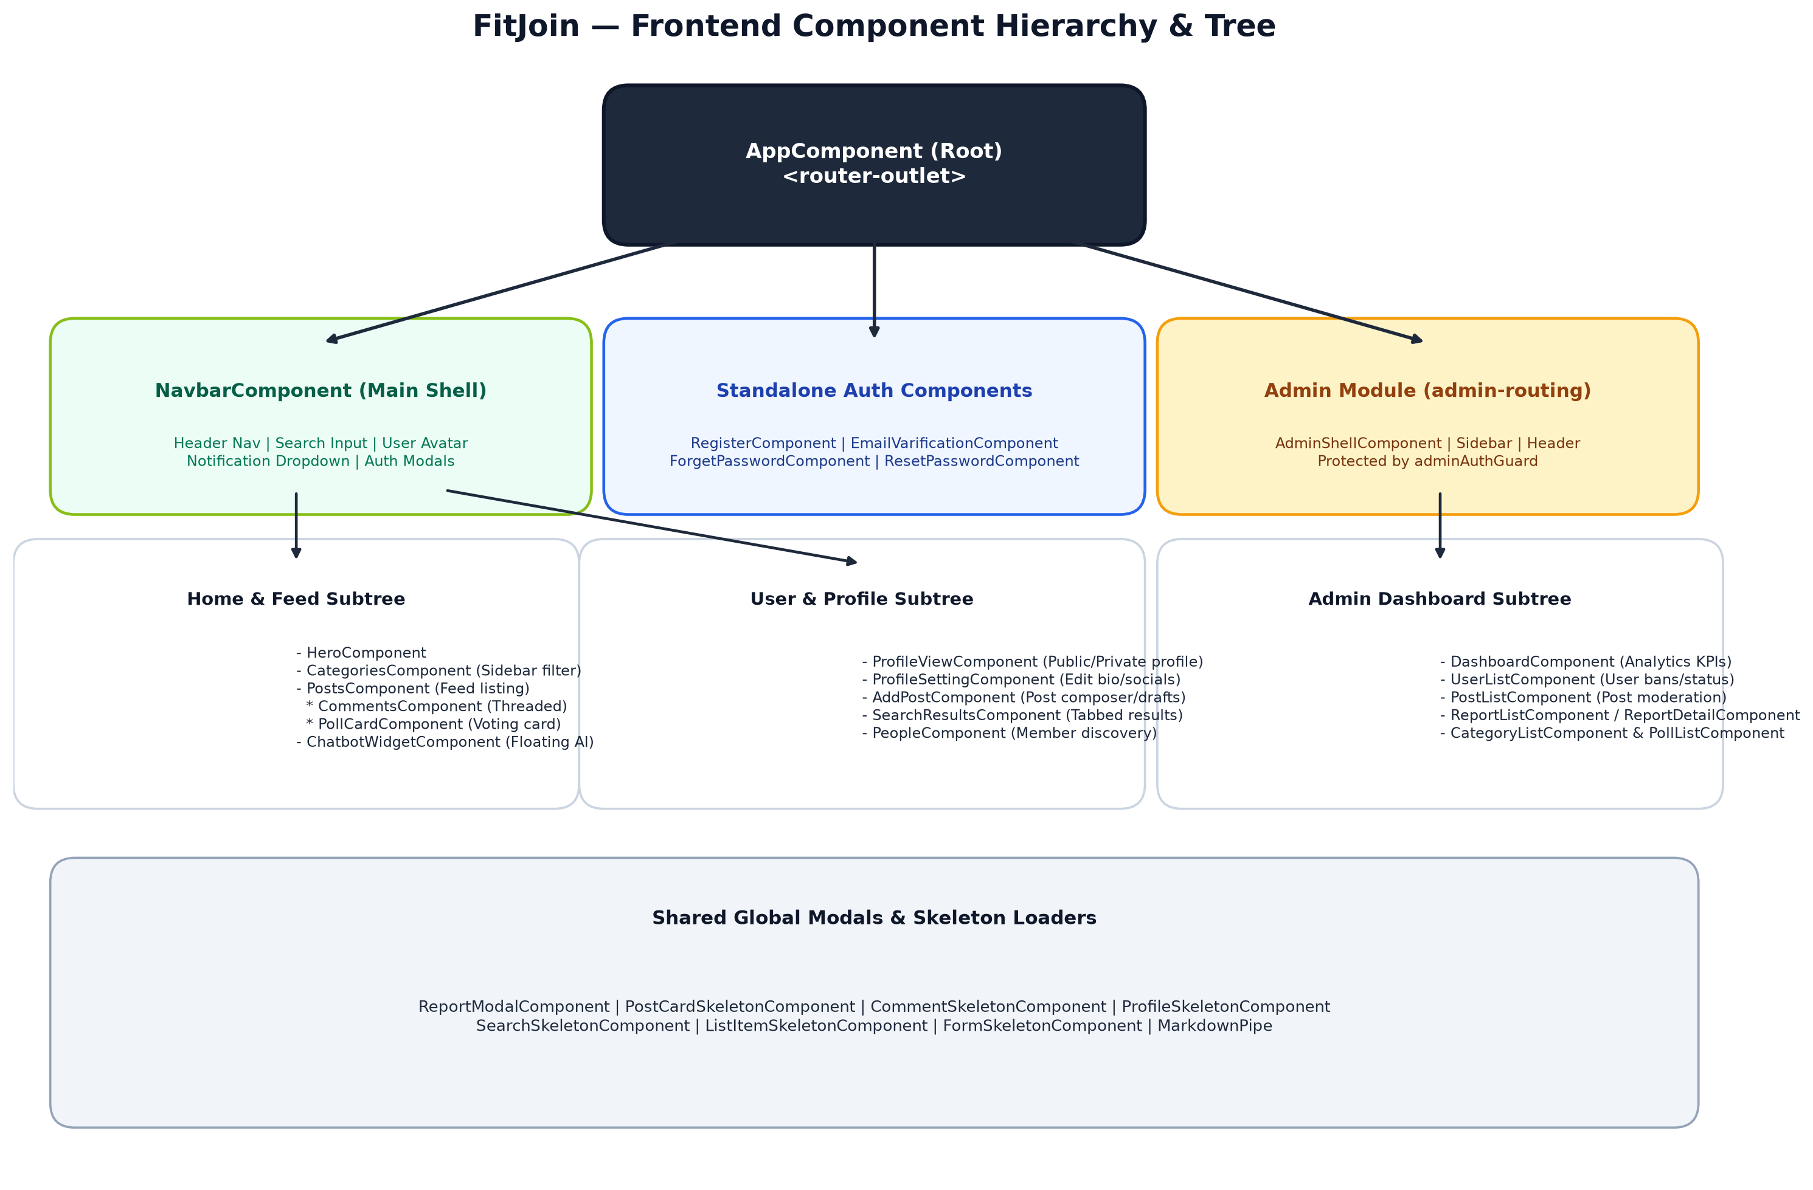
Figure 2.2: FitJoin Frontend Component Hierarchy & Subtree Relationships

2.2 State Management Pattern
FitJoin combines three complementary state management strategies:
1. Reactive Observable Streams (RxJS): Core session and user state reside in `AuthService` using private `BehaviorSubject` instances (`appUser`, `appUserPhotos`). Components subscribe via public observables (`appUserData$`, `appUserPhotos$`) or Angular's `async` pipe, guaranteeing real-time UI updates when profiles change.
2. Signals (Angular 19): Used in modern components for granular reactivity (e.g. `CategoryFilterService` signals for active category filtering without manual subscription unsubscriptions).
3. URL Query Parameter Synchronization: Features like global search (`/search?q=...&type=...`) and category filtering (`/home?category=...`) bind their state directly to URL query parameters, ensuring full deep-linking and browser back/forward support.

3. Routing & Route Guard Pipeline
The application routing is configured in `app.routes.ts` with lazy loading via `loadComponent()` and `loadChildren()`. Protected routes are guarded by functional and class-based route guards.
Route Path | Target Component / Module | Guards Applied | Lazy Loaded | Functional Purpose
/admin | AdminRoutingModule | None (Internal adminAuthGuard on children) | Yes (loadChildren) | Administrative dashboard and governance suite
/register | RegisterComponent | emailTokenGuardGuard | Yes (loadComponent) | New user registration form requiring valid email token
/forget-password | ForgetPasswordComponent | emailTokenGuardGuard | Yes (loadComponent) | Password reset form requiring valid reset token
/reset-password | ResetPasswordComponent | None | Yes (loadComponent) | Password recovery landing page
/error | ErrorComponent | None | Yes (loadComponent) | Generic error and 404/500 diagnostic display
/home | HomeComponent | None | Yes (loadComponent) | Main community discussion feed with categories and polls
/search | SearchResultsComponent | None | Yes (loadComponent) | Global search results page with tabbed views
/people | PeopleComponent | None | Yes (loadComponent) | Community member discovery and follow cards
/profile-setting | ProfileSettingComponent | authGuard | Yes (loadComponent) | User profile editor (bio, avatar, social links)
/profile-view | ProfileViewComponent | authGuard | Yes (loadComponent) | Current authenticated user's private dashboard
/profile/:id | ProfileViewComponent | authGuard | Yes (loadComponent) | Public view of another community member's profile
/add-post | AddPostComponent | authGuard | Yes (loadComponent) | Post composer with AI image screening and drafts editor
/user-posts | UserPostsComponent | authGuard | Yes (loadComponent) | Listing of authenticated user's authored posts
** | Redirect to /error?status=404 | None | N/A | Wildcard catch-all route redirecting unknown paths

3.1 Route Guard Specifications
1. `authGuard` (auth.guard.ts): Inspects `sessionStorage.getItem('token')`. If present, permits navigation. If absent, sets a pending action via `PendingActionService`, opens the login modal on the current page, and halts navigation.
2. `emailTokenGuardGuard` (email-token-guard.guard.ts): Extracts `?token=...` from query parameters. Invokes `MasterService.validateEmailToken(token)`. If valid, stores the validated email in `localStorage` and allows registration; otherwise redirects to error view.
3. `adminAuthGuard` (admin/auth/admin-auth.guard.ts): Validates the presence of an active Admin JWT in storage. If absent, redirects strictly to `/admin/login`.

4. Component Catalog & UI/UX Specifications
This catalog provides an exhaustive breakdown of every standalone and admin component in the frontend application.

4.1 NavbarComponent
File Path: src/app/website/navbar/navbar.component.ts
Component Purpose: Root layout shell providing top navigation bar, live search dropdown, unread notification counter, category shortcuts, and user profile menu.
Inputs / Outputs: Inputs: None | Outputs: None
Injected Services: MasterService, AuthService, NotificationService, Router
Key UI/UX Behavior: - Search debounce (300ms) with instant dropdown
- Real-time notification badge with audio chime
- Dynamic avatar thumbnail loading with fallback initials
- Injects LoginComponent as modal overlay

4.2 HomeComponent
File Path: src/app/website/home/home.component.ts
Component Purpose: Main feed page coordinating the Hero banner, sidebar categories filter, and main posts listing.
Inputs / Outputs: Inputs: None | Outputs: None
Injected Services: CategoryFilterService, MasterService
Key UI/UX Behavior: - Coordinates category selection signal with URL
- Embeds HeroComponent, CategoriesComponent, and PostsComponent

4.3 PostsComponent
File Path: src/app/website/posts/posts.component.ts
Component Purpose: Renders the community thread feed, post cards, image attachments, like/dislike reactions, and bookmark actions.
Inputs / Outputs: Inputs: None | Outputs: None
Injected Services: MasterService, AuthService, PendingActionService, ReportService
Key UI/UX Behavior: - Skeleton loading via PostCardSkeletonComponent
- Optimistic UI updates on post like/dislike
- Embeds CommentsComponent and PollCardComponent
- Handles binary image rendering via ObjectURL streams

4.4 CommentsComponent
File Path: src/app/website/posts/comments/comments.component.ts
Component Purpose: Threaded commenting component managing top-level comments, nested reply accordions, and comment reactions.
Inputs / Outputs: Inputs: postId (number) | Outputs: None
Injected Services: CommentService, AuthService, SnackBarServiceService
Key UI/UX Behavior: - Skeleton loading via CommentSkeletonComponent
- Nested reply recursion with 'View Replies (N)' accordion
- Optimistic comment like/dislike toggles
- Auto-expanding textarea with character counters

4.5 PollCardComponent
File Path: src/app/website/posts/poll-card/poll-card.component.ts
Component Purpose: Interactive polling card rendered inside post cards, displaying question, voting options, and live percentages.
Inputs / Outputs: Inputs: poll (PollDTO), postId (number) | Outputs: voteSubmitted
Injected Services: MasterService, AuthService
Key UI/UX Behavior: - Real-time percentage progress bar animation
- Multi-choice checkbox or single-choice radio modes
- Option to add community options if permitted by poll author

4.6 SearchResultsComponent
File Path: src/app/website/search-results/search-results.component.ts
Component Purpose: Dedicated search results page with tabbed views for All, Posts, People, and Categories.
Inputs / Outputs: Inputs: None | Outputs: None
Injected Services: MasterService, ActivatedRoute, Router
Key UI/UX Behavior: - Reads `?q=` and `?type=` from URL query parameters
- Skeleton loading via SearchSkeletonComponent
- Deep-linking and URL state persistence

4.7 AddPostComponent
File Path: src/app/website/user/add-post/add-post.component.ts
Component Purpose: Rich post composer enabling file upload, category selection, drafting, and real-time AI content screening.
Inputs / Outputs: Inputs: None | Outputs: None
Injected Services: MasterService, AuthService, SnackBarServiceService, Router
Key UI/UX Behavior: - Form validation (Title min 5 chars, Category required)
- FormData multipart packaging for binary image uploads
- Live image preview with crop/clear controls
- Save as draft vs Publish toggle

4.8 ProfileSettingComponent
File Path: src/app/website/user/profile-setting/profile-setting.component.ts
Component Purpose: User profile editor for updating username, bio, location, social links, and uploading custom avatar.
Inputs / Outputs: Inputs: None | Outputs: None
Injected Services: MasterService, AuthService, SnackBarServiceService
Key UI/UX Behavior: - Binary avatar file upload with instant preview
- Form validation with Material input controls
- Updates AuthService reactive stream on save

4.9 ProfileViewComponent
File Path: src/app/website/user/profile-view/profile-view.component.ts
Component Purpose: Full profile dashboard displaying user stats (followers, following, posts count), bio, and authored feed.
Inputs / Outputs: Inputs: None | Outputs: None
Injected Services: MasterService, AuthService, ActivatedRoute
Key UI/UX Behavior: - Supports both private '/profile-view' and public '/profile/:id'
- Follow / Unfollow toggle button with count updates
- Tabbed display of User Posts, Saved Posts, and Hidden Posts

4.10 ChatbotWidgetComponent
File Path: src/app/website/chatbot-widget/chatbot-widget.component.ts
Component Purpose: Floating conversational AI widget powered by Google Gemini Pro.
Inputs / Outputs: Inputs: None | Outputs: None
Injected Services: ChatbotService, MarkdownPipe
Key UI/UX Behavior: - Collapsible bottom-right chat bubble
- Multi-turn conversation history stream
- Markdown formatting for workout tables and bulleted nutrition plans

4.11 AdminShellComponent
File Path: src/app/admin/layout/admin-shell/admin-shell.component.ts
Component Purpose: Administrative dashboard shell providing sidebar navigation, admin header, and session logout.
Inputs / Outputs: Inputs: None | Outputs: None
Injected Services: AdminAuthService, Router
Key UI/UX Behavior: - Responsive collapsing sidebar with brand accents
- Displays active admin email and privileges
- Mounts nested admin child routes

4.12 DashboardComponent (Admin)
File Path: src/app/admin/dashboard/dashboard.component.ts
Component Purpose: Administrative analytics overview featuring KPI metric cards and moderation alerts.
Inputs / Outputs: Inputs: None | Outputs: None
Injected Services: AdminDataService
Key UI/UX Behavior: - Metric KPI cards (Total Users, Active Posts, Pending Reports)
- Quick action shortcuts to moderation queues

4.13 PostListComponent (Admin)
File Path: src/app/admin/posts/post-list/post-list.component.ts
Component Purpose: Administrative post management table with search, category filtering, and visibility toggles.
Inputs / Outputs: Inputs: None | Outputs: None
Injected Services: AdminDataService
Key UI/UX Behavior: - Toggle post visibility (hide offensive posts)
- Hard delete posts and cascade comments
- Direct link to view full post context

4.14 ReportListComponent (Admin)
File Path: src/app/admin/reports/report-list/report-list.component.ts
Component Purpose: Community report triage queue for reviewing flagged posts, comments, and users.
Inputs / Outputs: Inputs: None | Outputs: None
Injected Services: AdminDataService, Router
Key UI/UX Behavior: - Filter by status (Pending, Reviewed, Actioned, Dismissed)
- One-click resolve and dismiss actions

4.15 Skeleton Loaders Suite
File Path: src/app/Shared/skeleton/*
Component Purpose: 7 specialized skeleton placeholder components rendering animated pulsating loading states.
Inputs / Outputs: Inputs: Various (count, type) | Outputs: None
Injected Services: None (Pure Presentation)
Key UI/UX Behavior: - PostCardSkeletonComponent
- CommentSkeletonComponent
- ProfileSkeletonComponent
- SearchSkeletonComponent
- ListItemSkeletonComponent
- FormSkeletonComponent
- SkeletonComponent

5. Frontend Services Reference
Angular services in FitJoin are decorated with `@Injectable({ providedIn: 'root' })`, acting as singletons across the entire application lifecycle.
Service Name | File Path | Key Methods | Core Responsibility
MasterService | Shared/master.service.ts | getAllCategories(), globalSearch(), sendRegistrationEmail(), addAppUser(), loginUser(), getAppUser(), uploadProfilePicture() | Master API client communicating with all general backend controllers.
AuthService | Shared/auth.service.ts | setAppUserId(), setAppUser(), updateUserData(), getStoredUser(), getAppUserPhotos() | Manages session lifecycle, JWT persistence, and reactive BehaviorSubject profile streams.
CommentService | Shared/comment.service.ts | getRootComments(), getReplies(), addComment(), deleteComment(), likeComment(), dislikeComment() | Handles comment tree data retrieval, reply nesting, and optimistic reaction toggles.
NotificationService | Shared/notification.service.ts | startBackgroundPolling(), pollBackendData(), notifyNewPost(), notifyPostReaction() | Manages periodic polling and audio-visual badge alerts for incoming notifications.
ReportService | Shared/report.service.ts | fetchMyReports(), reportPost(), reportPoll(), reportProfile(), isPostReported() | Manages user-side report modal dispatching and prevents duplicate reporting.
ChatbotService | Shared/chatbot.service.ts | openChat(), toggleChat(), askChatbot() | Maintains chatbot widget UI visibility and streams messages to Gemini API.
CategoryFilterService | Shared/category-filter.service.ts | selectCategory(), clearFilter(), updateCounts(), syncUrlParams() | Signal-based category filtering synchronized bidirectionally with URL parameters.
PendingActionService | Shared/pending-action.service.ts | setPendingAction(), hasPendingAction(), openLoginModal() | Stores unauthenticated user interactions (e.g. like, bookmark) and replays after login.
AdminDataService | admin/services/admin-data.service.ts | getDashboardSummary(), getUsers(), getPosts(), getReports(), getCategories(), getPolls(), getAdmins() | Dedicated API client for administrative CRUD and moderation endpoints.

6. Authentication State Handling & Interceptor Layer
1. JWT Storage: On successful login, the JWT string and numeric `userId` are stored in `sessionStorage.setItem('token', ...)`.
2. Token Interceptor: The functional interceptor `token.interceptor.ts` intercepts all outgoing `HttpRequest` instances. If `'token'` exists in storage, it clones the request and appends header `Authorization: Bearer <token>`.
3. 401 Unauthorized Handling: If any API response returns HTTP 401 or status 0 (server offline), the interceptor automatically purges `sessionStorage`, resets `AuthService` observables to `null`, and navigates the user to the `/home` route.
4. SSR Hydration Auth Flash Mitigation: During Server-Side Rendering (SSR), `sessionStorage` is inaccessible on Node.js. To prevent visual flashing where the UI briefly displays logged-out state before flipping to logged-in on client hydration, the app initializes default skeleton states until `afterNextRender()` completes.

7. Master Frontend-Backend API Integration Matrix
This matrix maps every Angular frontend service method directly to the corresponding ASP.NET Core backend endpoint documented in the Backend Specification.
Feature Area | Angular Service Method | Backend API Route | HTTP Verb | Request Payload Shape | Response Shape
User Login | MasterService.loginUser() | api/AppUsers/login-user | POST | UserLoginDTO { Email, HashedPassword } | { token: string, userId: number }
User Register | MasterService.addAppUser() | api/AppUsers/add-app-user | POST | RegisterUserDTO { Username, Email, PasswordHash } | AppUser entity
Send Verify Email | MasterService.sendRegistrationEmail() | api/EmailSending/send-email | POST | Query: ?receptor=user@gmail.com | { message: string }
Get Feed Posts | MasterService.getAllPosts() | api/Post/getAllPosts | GET | None | GetAllPostsDTO[]
Create Post | MasterService.addPost() | api/Post/add-post | POST | FormData (Title, Description, PostImage) | { message: string, postId: number }
Get Root Comments | CommentService.getRootComments() | api/Comments/getAll/{postId} | GET | Path: postId | PostCommentsDTO[]
Add Comment | CommentService.addComment() | api/Comments/add-comment | POST | PostCommentsDTO { PostId, CommentContent } | PostCommentsDTO
Submit Poll Vote | MasterService.votePoll() | api/Polls/vote | POST | PollVoteDTO { PollId, OptionId, UserId } | { message: string }
Global Search | MasterService.globalSearch() | api/Search | GET | Query: ?q=...&type=...&page=1 | SearchResultDTO
File Report | ReportService.reportPost() | api/reports/posts/{id} | POST | ReportCreateDTO { Reason } | { message: string }
Admin Dashboard | AdminDataService.getDashboardSummary() | api/admin/dashboard/summary | GET | None (Admin Bearer Token) | DashboardSummaryDTO
Admin User Ban | AdminDataService.updateUserStatus() | api/admin/users/{id}/status | PUT | Body: { status: 3 } | { message: string }

8. Real-Time Search & URL State Architecture
FitJoin features a dual-mode search engine combining instant navbar dropdown previews with a full-page tabbed search results workspace.
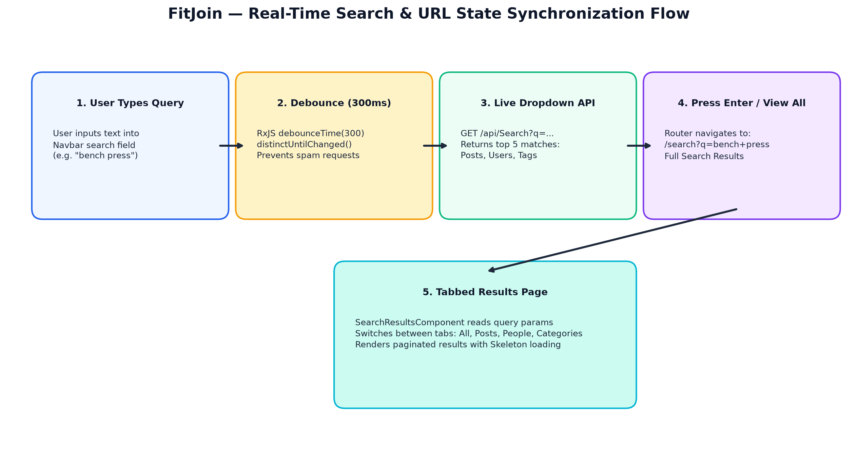
Figure 8.1: Live Search Debounce, API Dispatch, and Tabbed Results Workflow
1. Navbar Live Search: As the user types into the navbar search input, an RxJS `Subject` pipes the input through `debounceTime(300)` and `distinctUntilChanged()`. If the query length $\ge 2$, it invokes `MasterService.globalSearch(query)` and displays the top 5 matches in a floating dropdown.
2. Full Tabbed Results: Pressing Enter or clicking 'View All Results' routes to `/search?q={query}`. `SearchResultsComponent` subscribes to `route.queryParams`, triggers `SearchSkeletonComponent`, and populates categorized tab views (All, Posts, People, Categories) with complete pagination support.

9. Threaded Comment System Architecture
The comment subsystem supports multi-tier discussions with nested reply accordions and optimistic reaction handling.
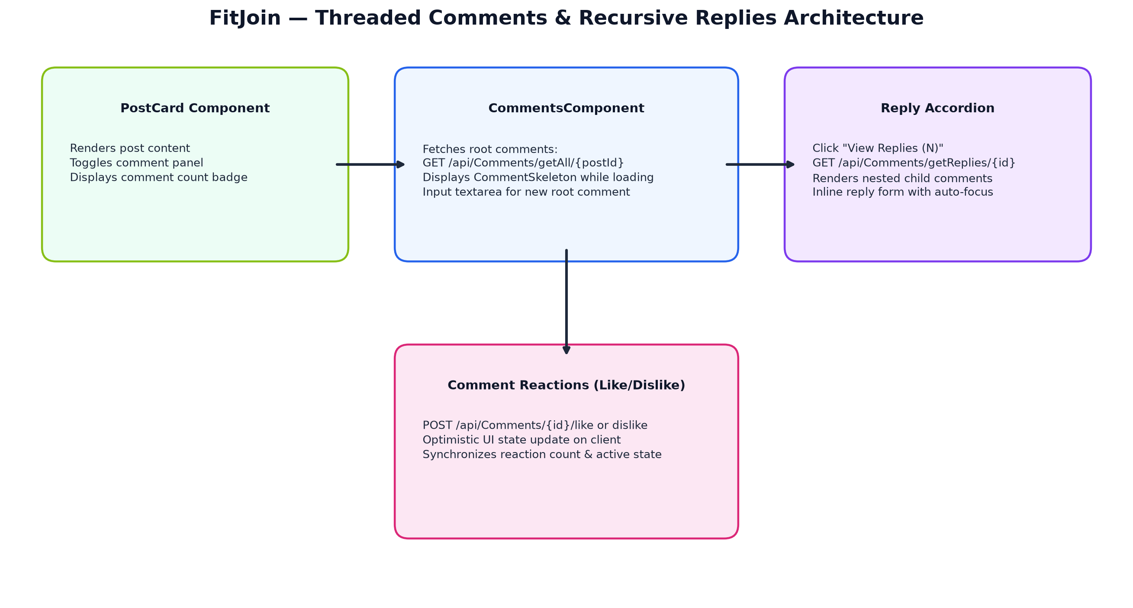
Figure 9.1: Threaded Comment Component Hierarchy and Interaction Flow
1. Root Level Loading: `CommentsComponent` fetches root comments (`ParentCommentId == null`) via `CommentService.getRootComments(postId)`.
2. Nested Reply Accordion: Each comment card includes a 'View Replies' toggle. Clicking expands a sub-panel and dispatches `CommentService.getReplies(commentId)`, rendering child comments recursively.
3. Optimistic Reactions: Clicking Like or Dislike immediately updates the UI counter and active icon color before the HTTP request resolves, rolling back only if the server returns an error.

10. Design System, Styling & Theming
FitJoin implements a custom aesthetic identity centered around the `#87BF17` signature lime green brand color.
1. Color Palette: Primary Accent: `#87BF17` (Lime Green), Surface Backgrounds: `#0F172A` (Navy Dark) and `#FFFFFF` (Card Light), Text Hierarchy: `#1E293B` (Primary Body) and `#64748B` (Muted Subtext).
2. Skeleton Design Pattern: All loading states utilize animated CSS gradient shimmer placeholders instead of jarring spinner wheels, maintaining layout stability during network fetches.
3. Bootstrap 5 Integration: Layouts rely on Bootstrap's 12-column grid system (`container`, `row`, `col-lg-8`, `col-lg-4`) augmented with custom scoped SCSS/CSS component styles.

11. NPM Packages & Dependencies Inventory
Package Name | Version | Classification | Functional Purpose
@angular/core & @angular/common | ^19.2.0 | Core Dependency | Component model, lifecycle hooks, and dependency injection runtime.
@angular/router | ^19.2.0 | Core Dependency | Client-side routing, guard execution, and lazy module loading.
@angular/ssr & @angular/platform-server | ^19.2.0 | SSR Engine | Server-side HTML pre-rendering and client hydration.
@angular/material & @angular/cdk | ^19.2.1 | UI Toolkit | Material SnackBar alerts and accessible form controls.
bootstrap | ^5.3.3 | UI Layout | Responsive CSS framework, modal dialogues, and grid utility classes.
@ng-select/ng-select | ^14.7.0 | UI Control | Searchable multi-select dropdown for tags and categories.
crypto-js | ^4.2.0 | Security Utility | Client-side cryptographic hashing utilities.
rxjs | ~7.8.0 | Reactive Programming | Observables, BehaviorSubjects, and reactive stream operators.

12. Admin Panel Governance Suite (`/admin`)
The administrative portal is an isolated Angular module (`AdminRoutingModule`) designed for platform moderation and oversight.
1. Google OAuth Authentication: Admins log in at `/admin/login` using the Google Identity Services SDK button. The resulting credential token is sent to the backend, returning an Admin JWT.
2. Route Guarding: `adminAuthGuard` protects all `/admin/*` child routes, verifying the admin token before mounting `AdminShellComponent`.
3. Management Submodules: Includes Analytics Dashboard (`/admin/dashboard`), User Management (`/admin/users`), Post Moderation (`/admin/posts`), Community Reports Queue (`/admin/reports`), Category CRUD (`/admin/categories`), Poll Governance (`/admin/polls`), and Staff Whitelist Manager (`/admin/admins`).

13. Known Technical Debt & Frontend Improvements

Direct DOM Manipulation in SSR
Components such as `LoginComponent` and `ProfileSettingComponent` contain direct `document.querySelector('.btn-close').click()` calls. In SSR Node.js environments, `document` is undefined. These should be refactored using template reference variables (`#closeBtn`) or wrapped in `isPlatformBrowser(platformId)` checks.

Server Packages Imported in Client Code
In `register.component.ts`, `response` is imported from `'express'`, and in `profile-view.component.ts`, `debug` is imported from `'node:console'`. These unused imports should be removed to avoid bloating client bundle sizes.

Shared TimeAgo Pipe Duplication
The `timeAgo(date)` calculation method is duplicated verbatim in `PostsComponent` and `ProfileViewComponent`. Moving this logic to a reusable `TimeAgoPipe` will improve maintainability.

Hardcoded UX Timeout in Loader
`ngx-loader.service.ts` employs a hardcoded 1000ms `setTimeout` rather than tracking active HTTP requests via an interceptor counter.

