DATABASE SYSTEMS · LAB REPORT
Joins, Subqueries &
Correlated Subqueries
Practical Oracle SQL tasks with code, execution results and analysis
4  tables in the schema | 3  join queries | 12  subquery tasks | 0  errors on execution

Student name
Registration no.
Course
Instructor
Submission date

Executed and verified on Oracle AI Database 26ai Free · Release 23.26.3.0.0

Contents
1 Introduction 3
1.1 Objectives 3
1.2 How each task is presented 3
2 Environment & Methodology 4
3 Database Schema & Sample Data 5
3.1 Entity–Relationship diagram 5
3.2 Table definitions 5
3.3 Design observations 6
3.4 Data verification 6
3.5 Salary profile & reference values 7
4 Part 1 — Joins 9
4.1 Join 1 — Employee salary with department location 10
4.2 Join 2 — Employees working in Bangalore 12
4.3 Join 3 — Departments without employees 14
5 Part 2 — Subquery Tasks 15
5.1 Task 1 — Above the department average and the Bangalore average 16
5.2 Task 2 — Above own average, below the top salary elsewhere 18
5.3 Task 3 — Departments with staff but nobody above 8,000 (NOT EXISTS vs NOT IN) 20
5.4 Task 4 — Second and third highest salary in each department 24
5.5 Task 5 — Archive high earners of high-payroll departments (INSERT … SELECT) 26
5.6 Task 6 — 15 % raise for below-average staff (UPDATE) 29
5.7 Task 7 — Delete below-average staff in high-salary departments (DELETE) 32
5.8 Task 8 — Departments with a high payroll and a high top salary (HAVING) 35
5.9 Task 9 — The top-performing store (HAVING with a correlated subquery) 37
5.10 Task 10 — Employees earning more than at least 70 % of their department 39
5.11 Task 11 — Departments with more than two above-average earners 41
5.12 Task 12 — Rewriting IN as EXISTS: execution logic and performance 43
6 Summary of Key Concepts 47
6.1 Techniques used 47
6.2 Results at a glance 47
6.3 Best practices learned 47
7 Conclusion 49
Appendix A Execution log 50
Appendix B EMPLOYEE sample data 51

1 Introduction
This report documents a set of practical SQL exercises carried out on a small human-resources and retail schema in Oracle Database. Each exercise is presented with its objective, the SQL code, a step-by-step explanation of how the statement is evaluated, the actual result returned by Oracle, and an analysis that proves why exactly those rows were returned.
The work moves from basic table joins to progressively more demanding subquery patterns: correlated subqueries that compare a row with an aggregate of its own group, existence tests with EXISTS / NOT EXISTS, membership tests with IN / NOT IN, subqueries inside INSERT, UPDATE and DELETE statements, and group filtering with HAVING.

1.1 Objectives
- Combine tables with INNER JOIN and LEFT OUTER JOIN, and use an outer join to find unmatched rows (an anti-join).
- Write correlated subqueries that compare each row with an aggregate (AVG, MAX, MIN, COUNT, SUM) of its own department or store.
- Compare EXISTS with IN and NOT EXISTS with NOT IN, including their very different behaviour when NULLs are present.
- Use subqueries safely inside data-changing statements (INSERT … SELECT, UPDATE, DELETE) and undo the changes with ROLLBACK.
- Filter aggregated groups with HAVING, including comparisons against an "average of totals".
- Read Oracle execution plans to see how the optimizer actually runs equivalent formulations.

1.2 How each task is presented
Block | What it contains
Objective | The requirement the query answers, stated in plain English.
SQL | The exact statement from the submitted script, with syntax highlighting.
How it works | The logical order in which Oracle evaluates the outer query and each subquery.
Result | Screenshot of the statement and the result grid exactly as returned by Oracle.
Result analysis | Supporting figures (averages, counts, totals) that prove every returned row — and every excluded one.

2 Environment & Methodology
All statements were executed on a live Oracle database. The complete script — schema creation, sample data and every task — was run from top to bottom without a single error.
Database | Oracle AI Database 26ai Free, Release 23.26.3.0.0 (pluggable database FREEPDB1)
Schema / user | STUDENT
Script | SQL_Joins_Subqueries_Lab.sql (submitted together with this report)
Execution | Script run end-to-end; every result grid, row count and timing was captured directly from the database driver
Transactions | Tasks 5, 6 and 7 change data and end with ROLLBACK, so every later task runs against the original sample data
Verification | Each result was cross-checked by hand against the supporting calculations shown in its "Result analysis" section

The result screenshots show the SQL worksheet with the statement that was executed and the result grid produced by Oracle. Column names, values, row order and row counts are exactly as returned by the database; the timing shown is the elapsed time reported for that statement.
Conventions used in this report
- Monetary values are shown with thousands separators in the analysis tables (e.g. 5,791.67); the screenshots show raw Oracle output.
- Rows highlighted in amber inside analysis tables are the rows that satisfy the task's conditions.
- "Company-wide average" means AVG(salary) over all 24 employees; "department average" means the average of the employee's own department.

3 Database Schema & Sample Data
The schema has four tables. Three of them (DEPARTMENT, EMPLOYEE, EMPLOYEE_HISTORY) are linked by foreign keys; SALES is an independent table used only in Task 9.

3.1 Entity–Relationship diagram
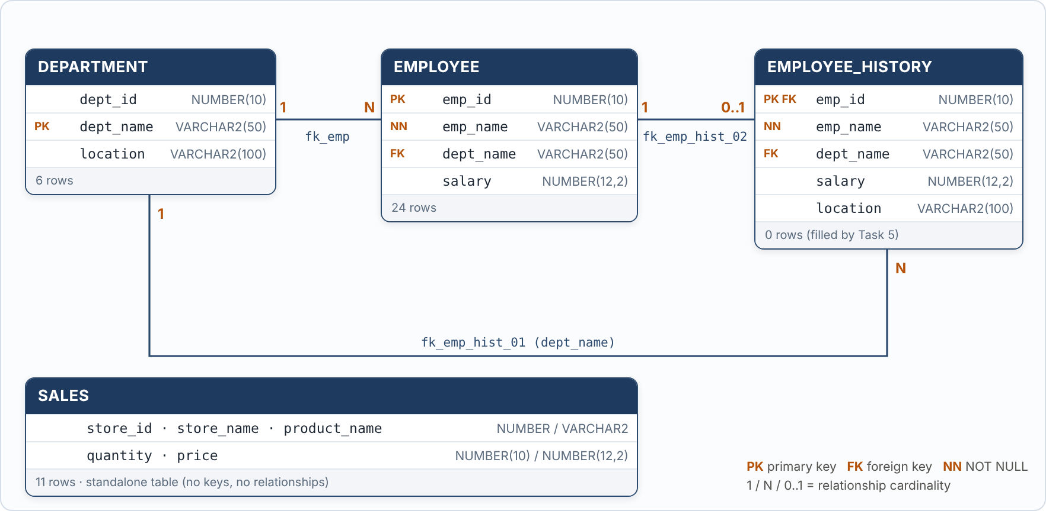
Figure 1 — Entity–Relationship diagram of the lab schema

3.2 Table definitions
Table | Purpose | Keys & constraints | Rows
DEPARTMENT | Departments and their city | PK dept_name | 6
EMPLOYEE | Employees, their department and salary | PK emp_id; FK dept_name → DEPARTMENT (fk_emp); emp_name, dept_name NOT NULL | 24
EMPLOYEE_HISTORY | Archive table, populated by Task 5 | PK emp_id; FK emp_id → EMPLOYEE (fk_emp_hist_02); FK dept_name → DEPARTMENT (fk_emp_hist_01) | 0
SALES | Product sales lines per store | No primary or foreign keys | 11
Table 1 — Tables, purpose and constraints

3.3 Design observations
Points worth noticing before running the tasks
- `dept_name` is the primary key of DEPARTMENT, not dept_id. EMPLOYEE therefore references a department by its name. This works, but in a production design a numeric surrogate key would normally be the primary key because names can change.
- Marketing and Sales have no employees. This is what makes the anti-join (Join 3) and the EXISTS checks (Task 3) meaningful, and it affects every "average of department totals" calculation (Tasks 5 and 8).
- `employee_history.emp_id` is both PK and FK, so an employee can be archived at most once (a 1 : 0..1 relationship).
- In SALES, `price` is the amount of the whole line (quantity already applied): e.g. 3 × MacBook Pro 14 = 6,000 while 1 × MacBook Pro 14 = 2,000. Therefore SUM(price) is the store revenue.

3.4 Data verification
After running the creation script, the tables were queried to confirm that the data loaded correctly.
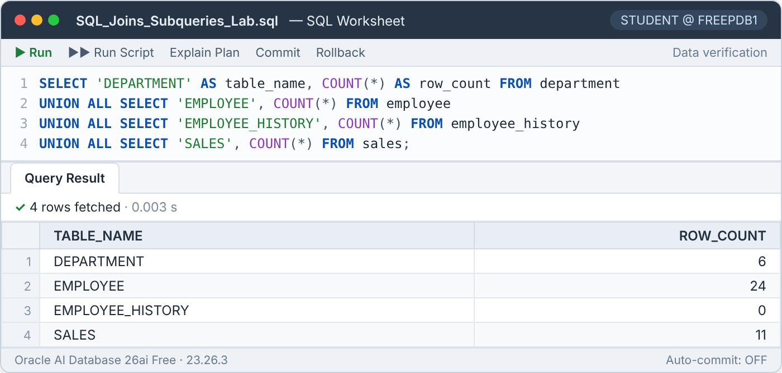
Figure 2 — Row count of every table after the setup script
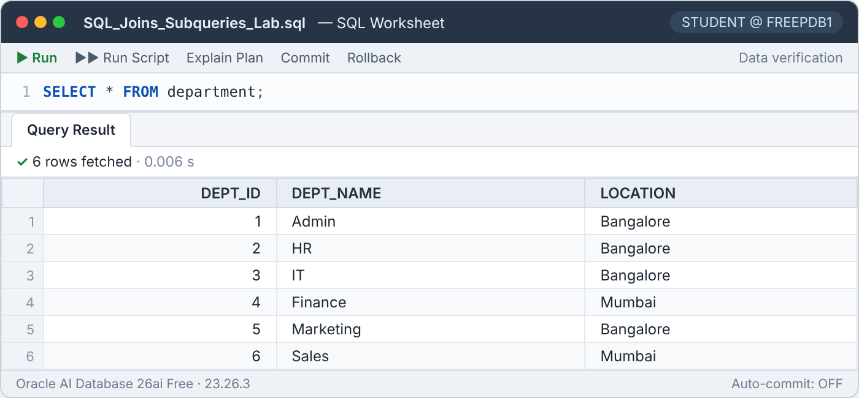
Figure 3 — Contents of the DEPARTMENT table
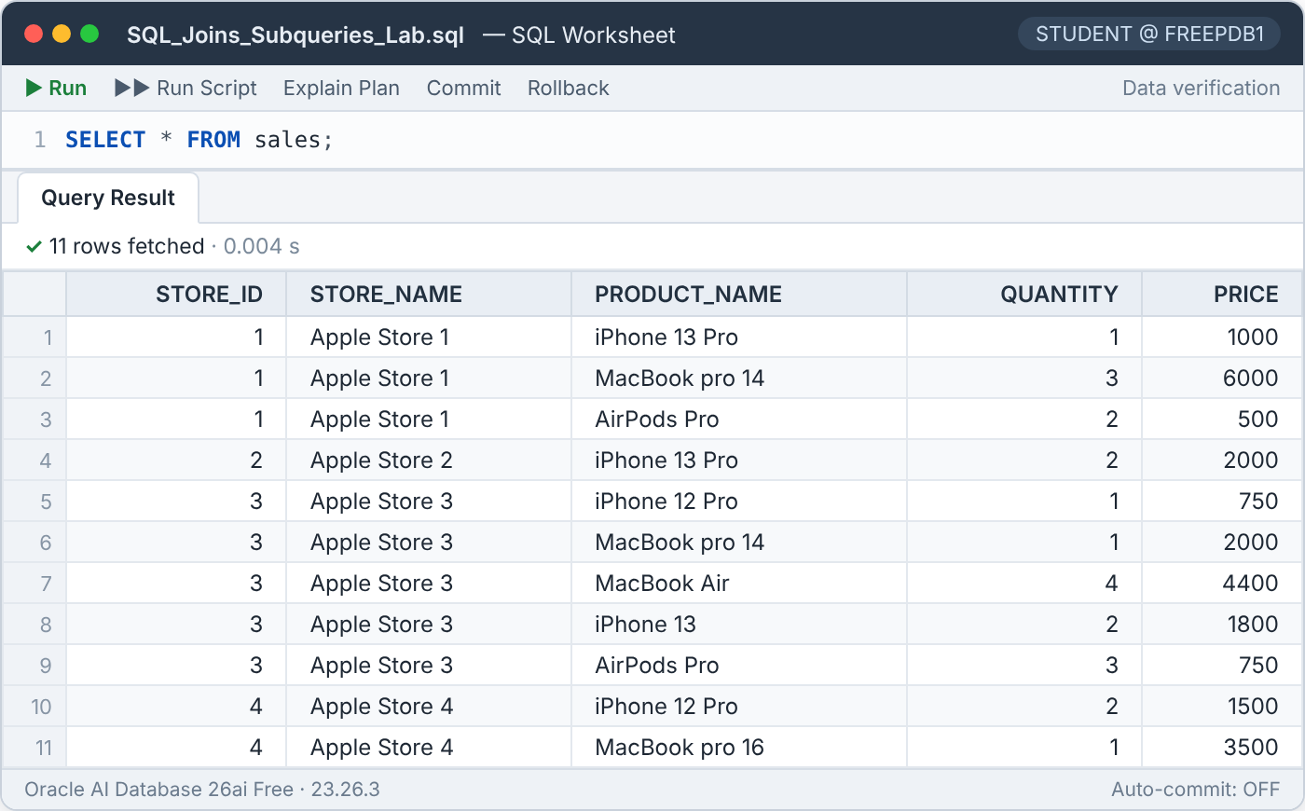
Figure 4 — Contents of the SALES table (used in Task 9)

3.5 Salary profile & reference values
Most tasks compare a salary with an average. The chart below shows every employee as a dot, the department averages as black bars, and the company-wide average as an amber line. It explains at a glance many of the results that follow — for example, why no Admin employee can pass a "greater than 5,775" test, and why IT dominates the "high total" tasks.
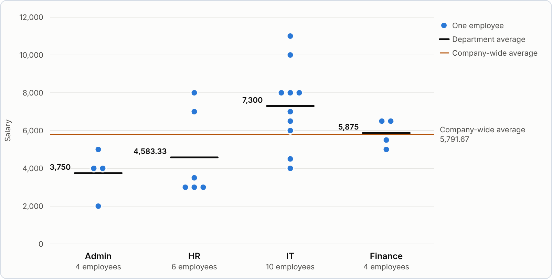
Figure 5 — Salaries by department, with department and company-wide averages (Marketing and Sales have no employees)
Department | Location | Employees | Average | Total | Min | Max
Admin | Bangalore | 4 | 3,750 | 15,000 | 2,000 | 5,000
HR | Bangalore | 6 | 4,583.33 | 27,500 | 3,000 | 8,000
IT | Bangalore | 10 | 7,300 | 73,000 | 4,000 | 11,000
Finance | Mumbai | 4 | 5,875 | 23,500 | 5,000 | 6,500
Marketing | Bangalore | 0 | — | — | — | —
Sales | Mumbai | 0 | — | — | — | —
Table 2 — Department statistics computed in Oracle
Reference value | Value | How it is computed | Used in
Company-wide average salary | 5,791.67 | 139,000 / 24 employees | Tasks 7, 8
Average salary in Bangalore departments | 5,775 | 115,500 / 20 employees (Admin, HR, IT) | Task 1
Average of department salary totals | 34,750 | 139,000 / 4 departments with staff | Tasks 5, 8
Average revenue per store | 6,050 | 24,200 / 4 stores | Task 9
Average quantity per store | 5.5 | 22 / 4 stores | Task 9
Table 3 — Constant thresholds produced by the non-correlated subqueries

4 Part 1 — Joins
A join combines rows from two tables using a matching condition. All three queries below join EMPLOYEE and DEPARTMENT on dept_name, the foreign-key column.

4.1 Join 1 — Employee salary with department location

Objective
Display every employee's name and salary together with the location of the department they work in.
SQL Part 1 · Join 1
SELECT e.emp_name, e.salary, d.location
FROM employee e
JOIN department d ON e.dept_name = d.dept_name;

How it works
- JOIN (an inner join) pairs each EMPLOYEE row with the DEPARTMENT row that has the same dept_name.
- Because dept_name in EMPLOYEE is NOT NULL and protected by a foreign key, every employee finds exactly one department, so no employee is lost.
- Departments without any employee (Marketing, Sales) have no partner row and therefore do not appear — an inner join keeps only matching pairs.

Result
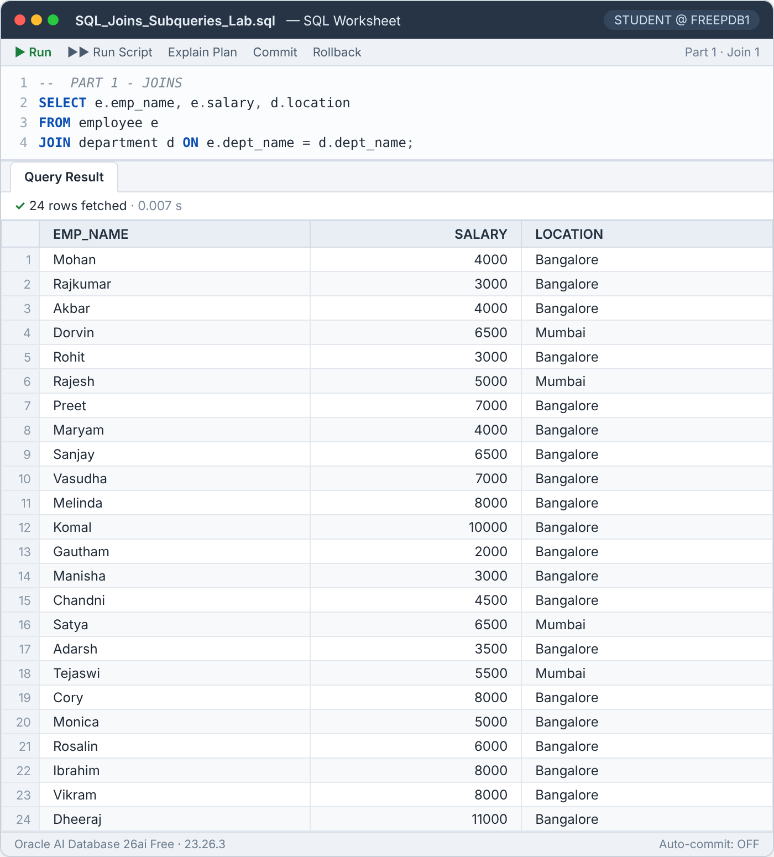
Figure 6 — Join 1 result — 24 rows

Result analysis
All 24 employees are returned: 20 work in Bangalore (Admin, HR, IT) and 4 in Mumbai (Finance). No ORDER BY was specified, so Oracle returned the rows in the order it read them; if a specific order is required it must be requested explicitly.

4.2 Join 2 — Employees working in Bangalore

Objective
List all details of the employees whose department is located in Bangalore.
SQL Part 1 · Join 2
SELECT e.*
FROM employee e
JOIN department d ON e.dept_name = d.dept_name
WHERE d.location = 'Bangalore';

How it works
- The inner join attaches the department location to each employee.
- The WHERE clause then keeps only the joined rows whose location is 'Bangalore'.
- SELECT e.* returns only the employee columns, even though department columns were available.

Result
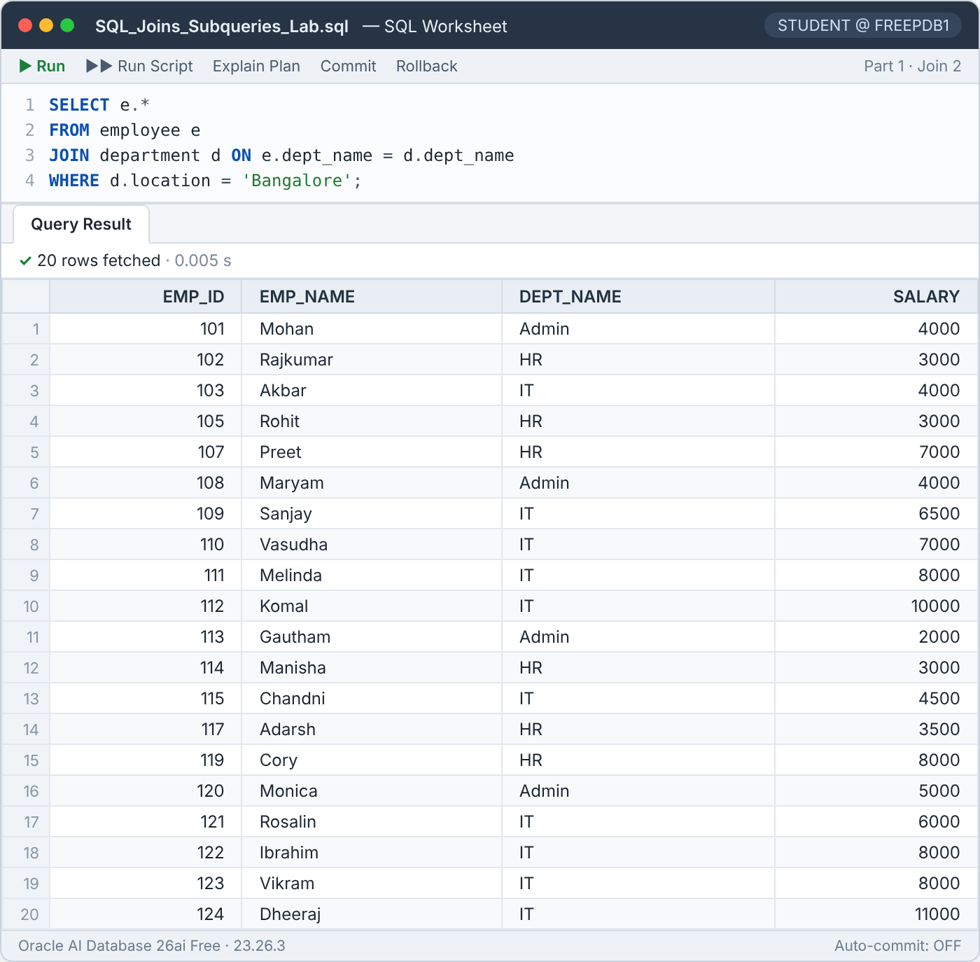
Figure 7 — Join 2 result — 20 rows

Result analysis
Department | Location | Employees returned | Reason
Admin | Bangalore | 4 | Bangalore department
HR | Bangalore | 6 | Bangalore department
IT | Bangalore | 10 | Bangalore department
Finance | Mumbai | 0 | Filtered out by WHERE
Marketing | Bangalore | 0 | Bangalore, but has no employees
Table 4 — Where the 20 rows of Join 2 come from

4.3 Join 3 — Departments without employees

Objective
Find the departments that currently have no employees.
SQL Part 1 · Join 3
SELECT d.*
FROM department d
LEFT JOIN employee e ON d.dept_name = e.dept_name
WHERE e.emp_id IS NULL;

How it works
- LEFT JOIN keeps every department, even those with no matching employee.
- For a department with no employee, Oracle fills all employee columns with NULL.
- WHERE e.emp_id IS NULL keeps only those padded rows. Because emp_id is the primary key, it is never NULL in a real employee row — so a NULL here can only mean "no match".

Result
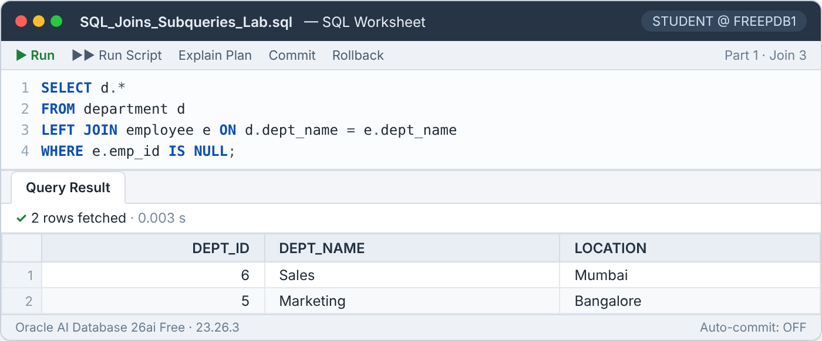
Figure 8 — Join 3 result — 2 rows

Result analysis
Sales and Marketing are returned — exactly the two departments that do not appear in EMPLOYEE. This pattern is called an anti-join. The IS NULL test must be placed in the WHERE clause; placing it in the ON clause would change the meaning and return all six departments. The same result can be written as WHERE NOT EXISTS (SELECT 1 FROM employee e WHERE e.dept_name = d.dept_name).

5 Part 2 — Subquery Tasks
Most tasks in this part rely on correlated subqueries. A correlated subquery refers to a column of the outer query (for example WHERE e2.dept_name = e.dept_name), so logically it is evaluated again for every outer row and answers a question about *that* row's group. A non-correlated subquery does not reference the outer query and produces the same value for every row (for example the company-wide average).
Logical vs. physical evaluation
The "once per outer row" description is the logical meaning. In practice the Oracle optimizer often rewrites (unnests) correlated subqueries into joins with pre-aggregated data, so performance is usually much better than the logical description suggests. The execution plans in Tasks 3 and 12 show this.

5.1 Task 1 — Above the department average and the Bangalore average

Objective
List the employees whose salary is higher than (a) the average salary of their own department and (b) the average salary of all employees who work in Bangalore-based departments.
SQL Task 1
SELECT *
FROM employee e
WHERE e.salary > (SELECT AVG(e2.salary)
FROM employee e2
WHERE e2.dept_name = e.dept_name)
AND e.salary > (SELECT AVG(e3.salary)
FROM employee e3
WHERE e3.dept_name IN (SELECT d.dept_name
FROM department d
WHERE d.location = 'Bangalore'))
ORDER BY e.dept_name, e.salary;

How it works
- The outer query reads each employee e.
- The first subquery is correlated (e2.dept_name = e.dept_name): it returns the average salary of the current employee's department.
- The second subquery is non-correlated. Its innermost query lists the Bangalore departments (Admin, HR, IT, Marketing); the middle query averages the salaries of employees in those departments, giving one constant: 5,775.
- An employee is returned only if both comparisons are TRUE; the rows are sorted by department and salary.

Result
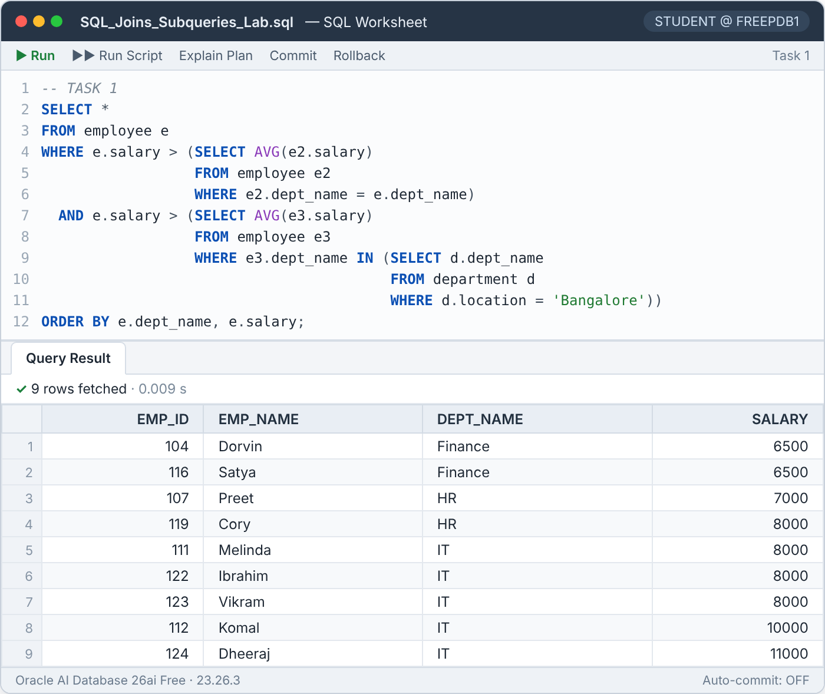
Figure 9 — Task 1 result — 9 rows

Result analysis
Department | Dept. average | Bangalore avg. | Above dept. average | Also above 5,775
Admin | 3,750 | 5,775 | Mohan 4,000 · Maryam 4,000 · Monica 5,000 | None
Finance | 5,875 | 5,775 | Dorvin 6,500 · Satya 6,500 | Dorvin, Satya
HR | 4,583.33 | 5,775 | Preet 7,000 · Cory 8,000 | Preet, Cory
IT | 7,300 | 5,775 | Melinda, Ibrahim, Vikram 8,000 · Komal 10,000 · Dheeraj 11,000 | All five
Table 5 — Both conditions evaluated per department
Admin employees beat their own low department average (3,750) but none of them reaches 5,775, so Admin contributes no rows. Finance, HR and IT contribute 2 + 2 + 5 = 9 rows, matching the result. Marketing is part of the Bangalore list but has no employees, so it does not influence the 5,775 average.

5.2 Task 2 — Above own average, below the top salary elsewhere

Objective
List the employees who earn more than the average salary of their own department but less than the highest salary paid in any other department.
SQL Task 2
SELECT *
FROM employee e
WHERE e.salary > (SELECT AVG(e2.salary)
FROM employee e2
WHERE e2.dept_name = e.dept_name)
AND e.salary < (SELECT MAX(e3.salary)
FROM employee e3
WHERE e3.dept_name <> e.dept_name)
ORDER BY e.dept_name, e.salary;

How it works
- The first correlated subquery computes the average salary of the employee's own department.
- The second correlated subquery uses e3.dept_name <> e.dept_name to look at all other departments and returns their maximum salary.
- Both conditions must hold. Note that < is strict: a salary equal to the outside maximum does not qualify.

Result
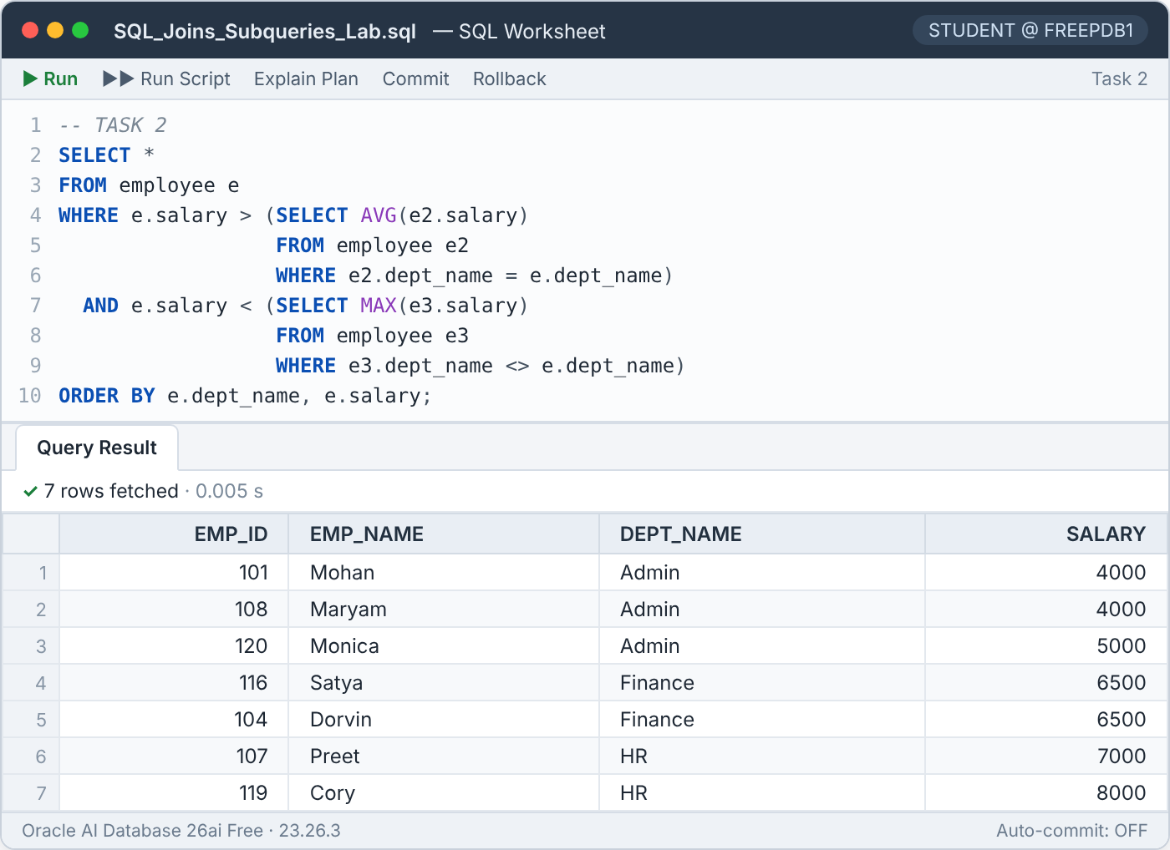
Figure 10 — Task 2 result — 7 rows

Result analysis
Emp ID | Name | Dept | Salary | Dept avg. | Max elsewhere | Outcome
108 | Maryam | Admin | 4,000 | 3,750 | 11,000 | Included
101 | Mohan | Admin | 4,000 | 3,750 | 11,000 | Included
120 | Monica | Admin | 5,000 | 3,750 | 11,000 | Included
116 | Satya | Finance | 6,500 | 5,875 | 11,000 | Included
104 | Dorvin | Finance | 6,500 | 5,875 | 11,000 | Included
107 | Preet | HR | 7,000 | 4,583.33 | 11,000 | Included
119 | Cory | HR | 8,000 | 4,583.33 | 11,000 | Included
123 | Vikram | IT | 8,000 | 7,300 | 8,000 | Excluded
122 | Ibrahim | IT | 8,000 | 7,300 | 8,000 | Excluded
111 | Melinda | IT | 8,000 | 7,300 | 8,000 | Excluded
112 | Komal | IT | 10,000 | 7,300 | 8,000 | Excluded
124 | Dheeraj | IT | 11,000 | 7,300 | 8,000 | Excluded
Table 6 — All 12 employees above their department average, tested against the maximum of the other departments
For every non-IT employee the highest salary elsewhere is Dheeraj's 11,000 (IT), so all seven pass. For IT employees, the highest salary outside IT is Cory's 8,000 (HR). The above-average IT salaries are 8,000, 10,000 and 11,000 — none is strictly below 8,000 — so the entire IT department is excluded.
Observation — ties and row order
Dorvin and Satya both earn 6,500. ORDER BY e.dept_name, e.salary does not decide between them, so Oracle is free to return them in any order: Task 1 listed Dorvin first, Task 2 listed Satya first. Adding a unique column as a final tie-breaker (ORDER BY e.dept_name, e.salary, e.emp_id) makes the output deterministic.

5.3 Task 3 — Departments with staff but nobody above 8,000 (NOT EXISTS vs NOT IN)

Objective
Find the departments that have at least one employee, but in which no employee earns more than 8,000. Write the query twice — with NOT EXISTS and with NOT IN — and explain how the two behave when NULLs are involved.
SQL Task 3 (1) — NOT EXISTS
SELECT d.*
FROM department d
WHERE EXISTS (SELECT 1
FROM employee e
WHERE e.dept_name = d.dept_name)
AND NOT EXISTS (SELECT 1
FROM employee e
WHERE e.dept_name = d.dept_name
AND e.salary > 8000);

SQL Task 3 (2) — NOT IN
SELECT d.*
FROM department d
WHERE d.dept_name IN (SELECT e.dept_name FROM employee e)
AND d.dept_name NOT IN (SELECT e.dept_name
FROM employee e
WHERE e.salary > 8000);

How it works
NOT EXISTS version. For each department, EXISTS checks that at least one employee belongs to it, and NOT EXISTS checks that no employee of that department earns more than 8,000. Both subqueries are correlated and stop scanning as soon as one matching row is found.
NOT IN version. The first subquery builds the list of departments that have employees (Admin, HR, IT, Finance). The second builds the list of departments with someone above 8,000 — {IT, IT} (Komal 10,000 and Dheeraj 11,000). A department is returned if it is in the first list and not in the second.
Department | Has employees? | Highest salary | Anyone > 8,000? | Outcome
Admin | Yes | 5,000 | No | Included
HR | Yes | 8,000 | No | Included
IT | Yes | 11,000 | Yes | Excluded
Finance | Yes | 6,500 | No | Included
Marketing | No | — | — | Excluded
Sales | No | — | — | Excluded
Table 7 — Evaluation of every department
HR is included because its top salary is exactly 8,000 and the condition is strictly "more than 8,000". Marketing and Sales fail the "has employees" test.

Result
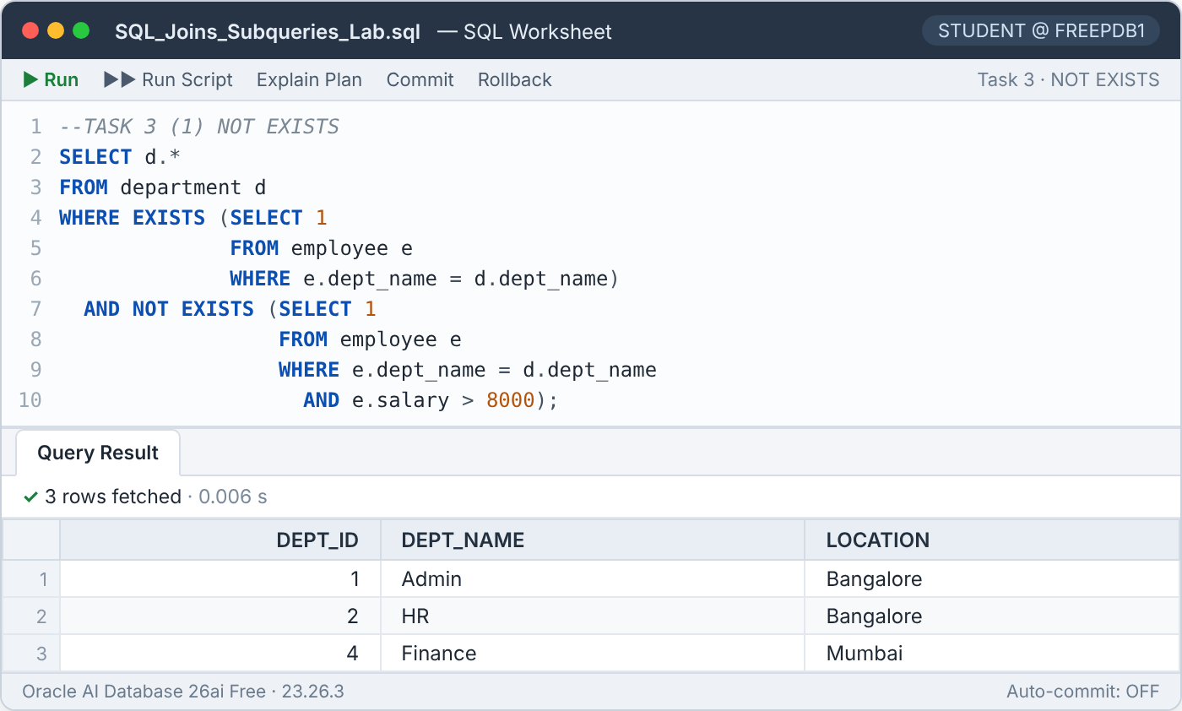
Figure 11 — Task 3 (1) NOT EXISTS result — 3 rows
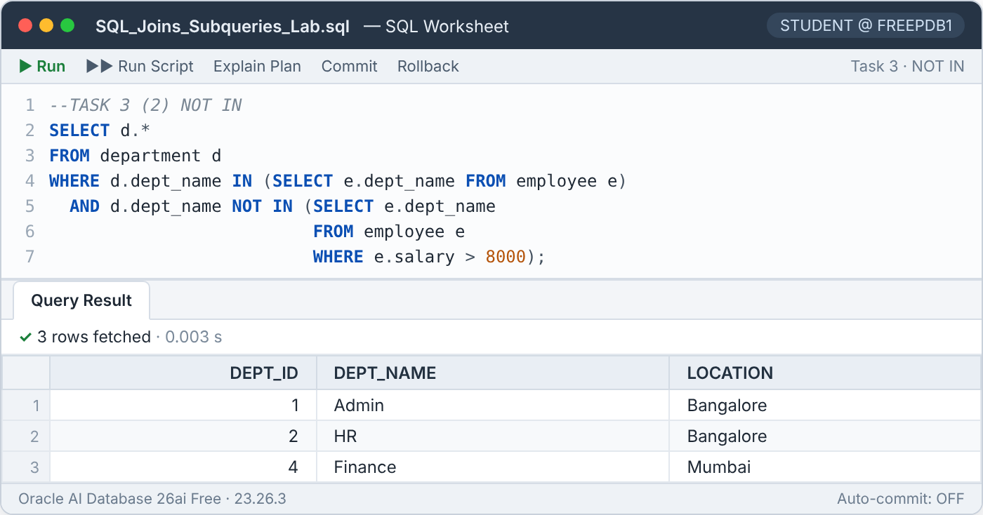
Figure 12 — Task 3 (2) NOT IN result — the same 3 rows

NOT IN vs NOT EXISTS when NULLs are present
SQL uses three-valued logic (TRUE, FALSE, UNKNOWN). x NOT IN (a, b, NULL) is evaluated as x <> a AND x <> b AND x <> NULL. Any comparison with NULL is UNKNOWN, so the whole condition can never be TRUE and NOT IN returns no rows at all. NOT EXISTS only asks whether a matching row exists; a NULL simply never matches, so it does not disturb the result.
In this schema employee.dept_name is declared NOT NULL, so both versions are safe and return Admin, HR and Finance. To demonstrate the difference, the same two predicates were run against a small list that contains 'IT' and a NULL:
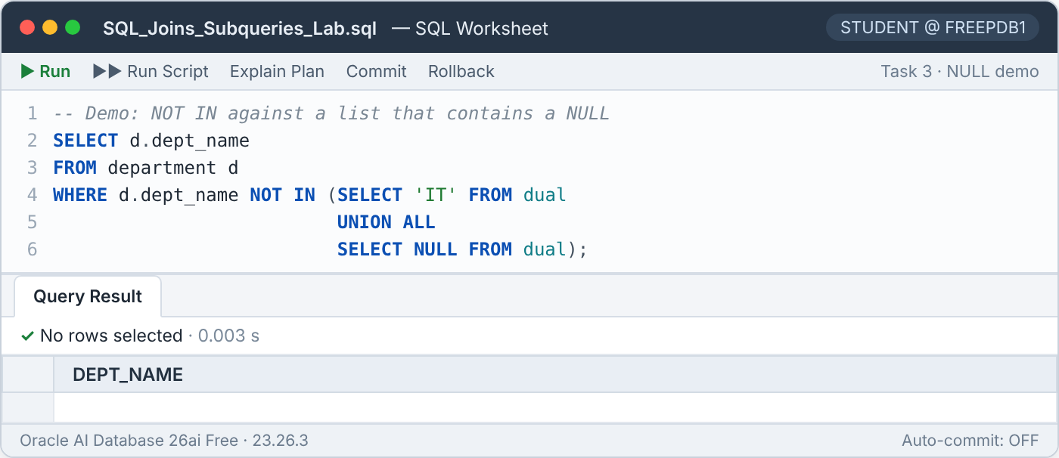
Figure 13 — NOT IN against a list containing NULL returns no rows
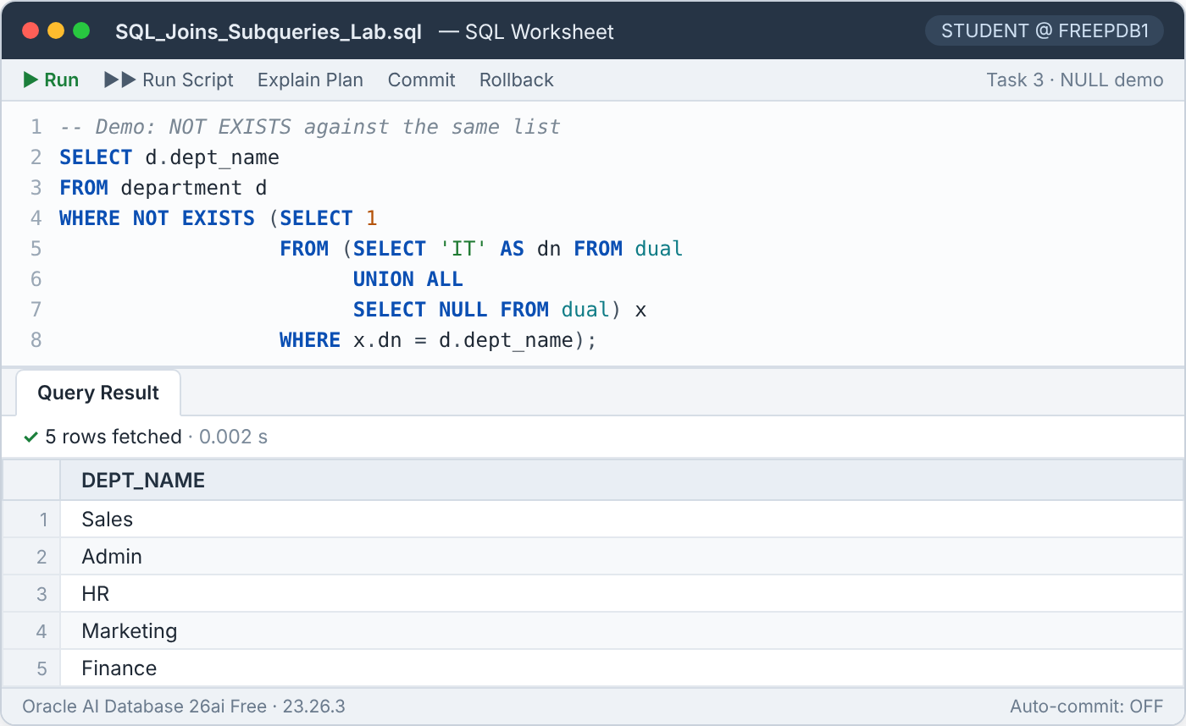
Figure 14 — NOT EXISTS against the same list returns the 5 expected departments

Execution plans
Both Task 3 queries were explained with EXPLAIN PLAN. Oracle produced the identical plan (same plan hash value 3851264149): a HASH JOIN SEMI for the EXISTS / IN part and a HASH JOIN ANTI for the NOT EXISTS / NOT IN part.
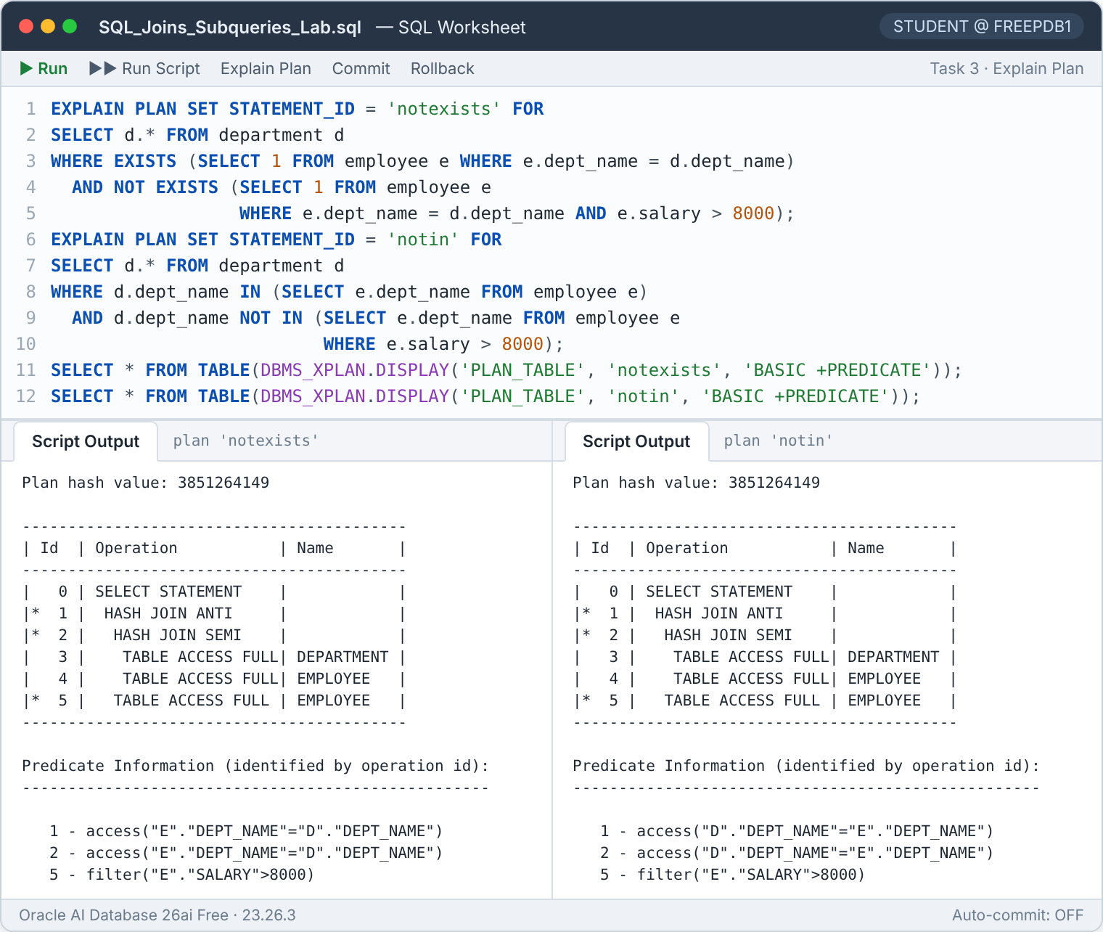
Figure 15 — Identical execution plans for the NOT EXISTS and NOT IN versions
Conclusion for Task 3
Oracle can turn NOT IN into an ordinary anti-join here only because both dept_name columns are guaranteed non-NULL (primary key and NOT NULL constraint). If the subquery column were nullable, Oracle would need a slower null-aware anti-join (HASH JOIN ANTI NA) and the query would return nothing if a NULL ever appeared.
Recommendation: prefer NOT EXISTS; if NOT IN is used, add WHERE e.dept_name IS NOT NULL inside the subquery.

5.4 Task 4 — Second and third highest salary in each department

Objective
List the employees whose salary is the 2nd or 3rd highest distinct salary within their department.
SQL Task 4
SELECT *
FROM employee e
WHERE (SELECT COUNT(DISTINCT e2.salary)
FROM employee e2
WHERE e2.dept_name = e.dept_name
AND e2.salary > e.salary) IN (1, 2)
ORDER BY e.dept_name, e.salary DESC;

How it works
- For each employee, the correlated subquery counts how many distinct salaries in the same department are higher than theirs.
- A count of 0 means the highest salary, 1 means the 2nd highest and 2 means the 3rd highest; IN (1, 2) keeps ranks 2 and 3.
- COUNT(DISTINCT …) makes equal salaries share a rank (dense ranking), so all employees who tie on a salary are returned together.

Result
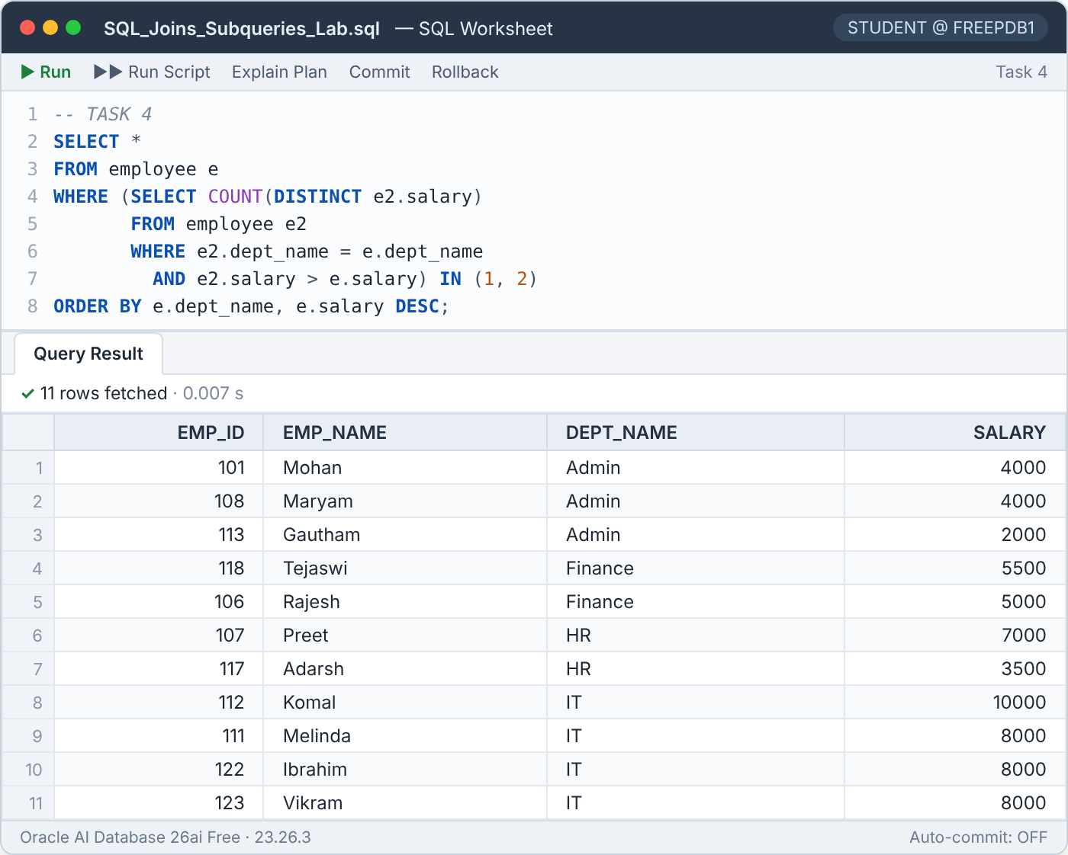
Figure 16 — Task 4 result — 11 rows

Result analysis
Department | Distinct salaries (high → low) | 2nd highest | 3rd highest
Admin | 5,000 · 4,000 · 2,000 | 4,000 — Mohan, Maryam | 2,000 — Gautham
Finance | 6,500 · 5,500 · 5,000 | 5,500 — Tejaswi | 5,000 — Rajesh
HR | 8,000 · 7,000 · 3,500 · 3,000 | 7,000 — Preet | 3,500 — Adarsh
IT | 11,000 · 10,000 · 8,000 · 7,000 · … | 10,000 — Komal | 8,000 — Melinda, Ibrahim, Vikram
Table 8 — Distinct salary ranking per department
2 + 2 + 2 + 4 = 11 employees are listed (Admin contributes 3 because Mohan and Maryam tie). Without DISTINCT, ties would push later salaries down the ranking: Gautham (Admin) and Rajesh (Finance) would each have three higher salaries and would disappear from the result — verified by running that variant, which returned only 9 rows.

Alternative using an analytic function
The same requirement can be written with DENSE_RANK(), which ranks all rows of a department in a single pass instead of running a subquery for every employee. Oracle returned the identical 11 rows:
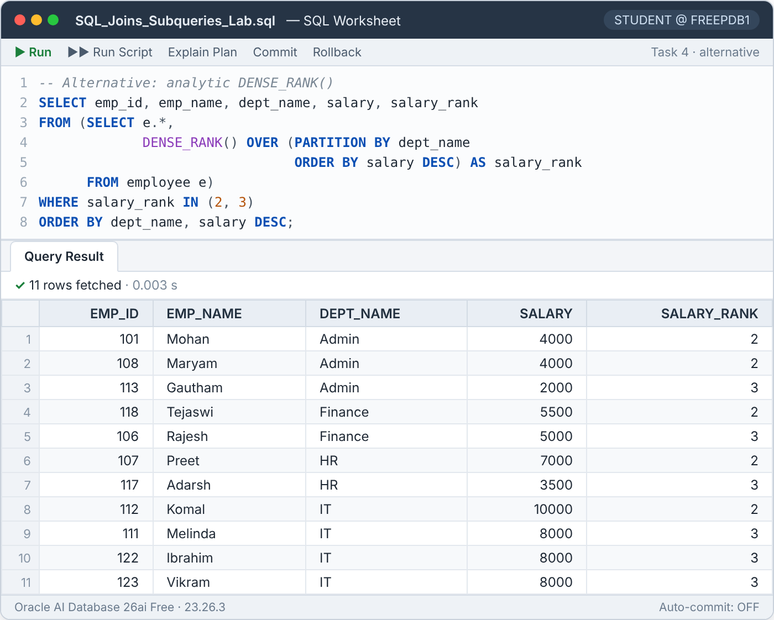
Figure 17 — DENSE_RANK() version returns the same 11 rows

5.5 Task 5 — Archive high earners of high-payroll departments (INSERT … SELECT)

Objective
Copy into EMPLOYEE_HISTORY (including the department location) every employee who earns more than their department average, but only for departments whose total salary is greater than the average of all department totals.
SQL Task 5
INSERT INTO employee_history (emp_id, emp_name, dept_name, salary, location)
SELECT e.emp_id,
e.emp_name,
e.dept_name,
e.salary,
(SELECT d.location FROM department d WHERE d.dept_name = e.dept_name)
FROM employee e
WHERE e.salary > (SELECT AVG(e2.salary)
FROM employee e2
WHERE e2.dept_name = e.dept_name)
AND (SELECT SUM(e3.salary)
FROM employee e3
WHERE e3.dept_name = e.dept_name)
> (SELECT AVG(t.dept_total)
FROM (SELECT SUM(salary) AS dept_total
FROM employee
GROUP BY dept_name) t);

SELECT * FROM employee_history ORDER BY emp_id;
ROLLBACK;

How it works
- INSERT INTO … SELECT inserts every row produced by the query — no VALUES clause is needed.
- The location is fetched by a scalar subquery on DEPARTMENT; it always returns exactly one value because dept_name is the primary key.
- Condition A (correlated): the salary must exceed the department average.
- Condition B: the department total (correlated SUM) must exceed the average of the department totals. The inline view t computes one total per department and the outer AVG averages them: 34,750.
- The SELECT verifies the inserted rows and ROLLBACK then undoes the insert.

Result
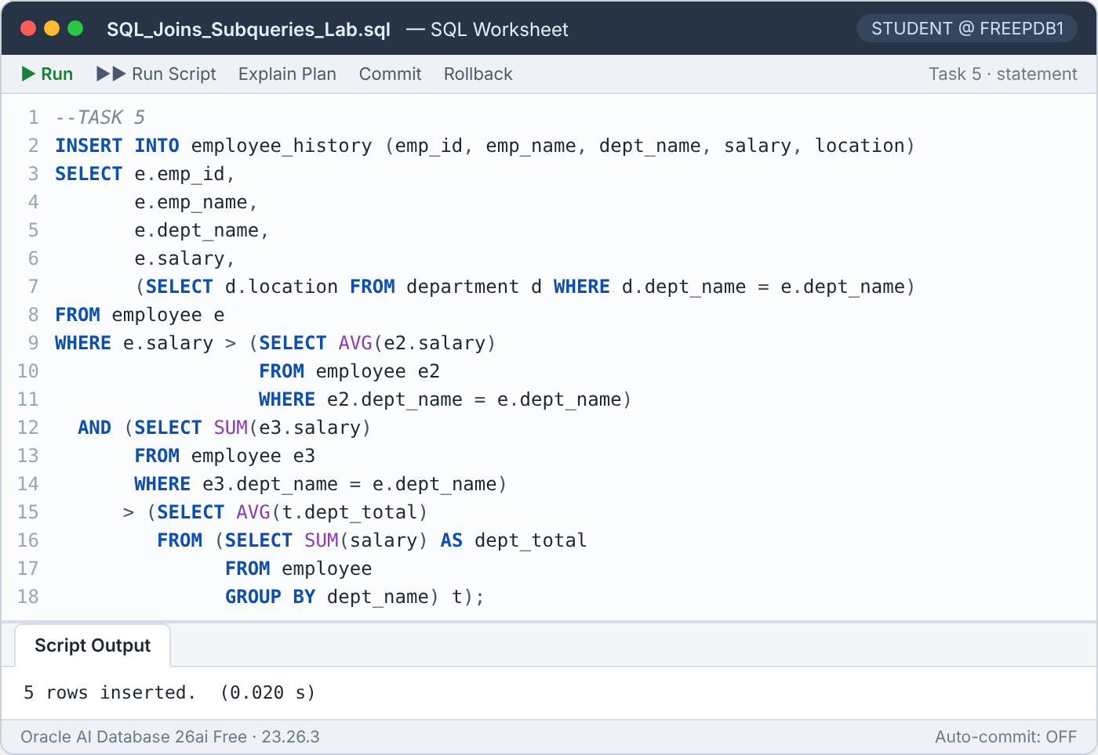
Figure 18 — Task 5 INSERT — 5 rows inserted
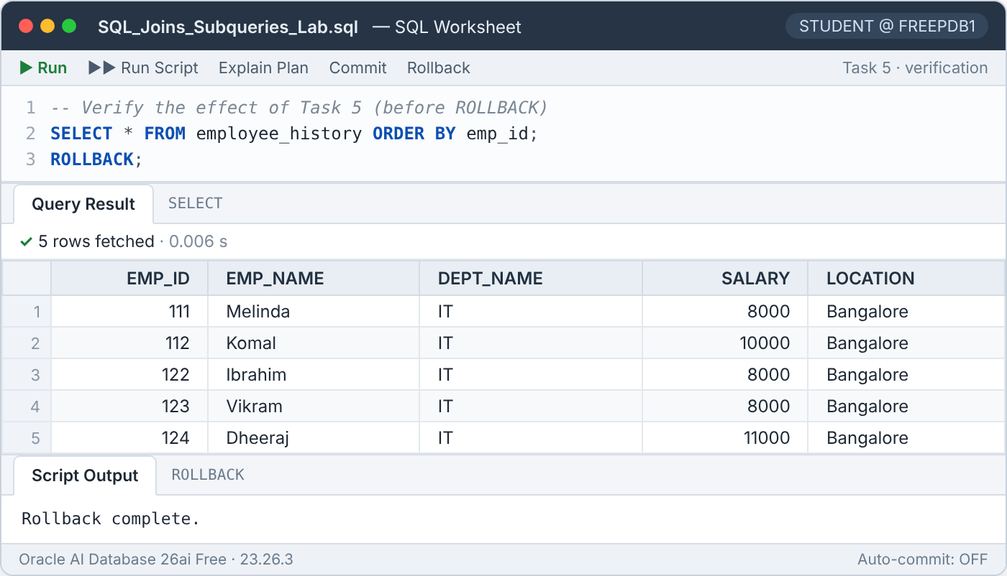
Figure 19 — Task 5 verification — EMPLOYEE_HISTORY before the ROLLBACK

Result analysis
Department | Total salary | Avg. of totals | Department qualifies? | Employees above dept. avg.
Admin | 15,000 | 34,750 | No | —
Finance | 23,500 | 34,750 | No | —
HR | 27,500 | 34,750 | No | —
IT | 73,000 | 34,750 | Yes | Melinda, Ibrahim, Vikram (8,000), Komal (10,000), Dheeraj (11,000)
Table 9 — Only IT passes the department-total condition
Only IT's payroll (73,000) exceeds 34,750, and within IT exactly five employees earn more than the IT average of 7,300 — the 5 rows inserted.
Design notes
- The average of totals is taken over the 4 departments that appear in EMPLOYEE. Marketing and Sales are not counted as zero. If they were (average 23,166.67), HR and Finance would also qualify — the requirement should state which interpretation is intended.
- Because emp_id is the primary key of EMPLOYEE_HISTORY, running the insert twice without the ROLLBACK would fail with ORA-00001 (unique constraint violated).

5.6 Task 6 — 15 % raise for below-average staff (UPDATE)

Objective
Increase by 15 % the salary of every employee who earns less than their department average, provided the department is located in Bangalore and has at least 4 employees.
SQL Task 6
UPDATE employee e
SET e.salary = e.salary * 1.15
WHERE e.salary < (SELECT AVG(e2.salary)
FROM employee e2
WHERE e2.dept_name = e.dept_name)
AND (SELECT COUNT(*)
FROM employee e3
WHERE e3.dept_name = e.dept_name) >= 4
AND e.dept_name IN (SELECT d.dept_name
FROM department d
WHERE d.location = 'Bangalore');

SELECT * FROM employee ORDER BY dept_name, emp_id;
ROLLBACK;

How it works
- Correlated AVG: the employee must earn less than their department average.
- Correlated COUNT(*): the department must have 4 or more employees.
- Non-correlated IN: the department must be in the list of Bangalore departments.
- Oracle evaluates every subquery against the data as it was when the statement started (statement-level read consistency). Raising one salary therefore never changes the average used for the next row.

Result
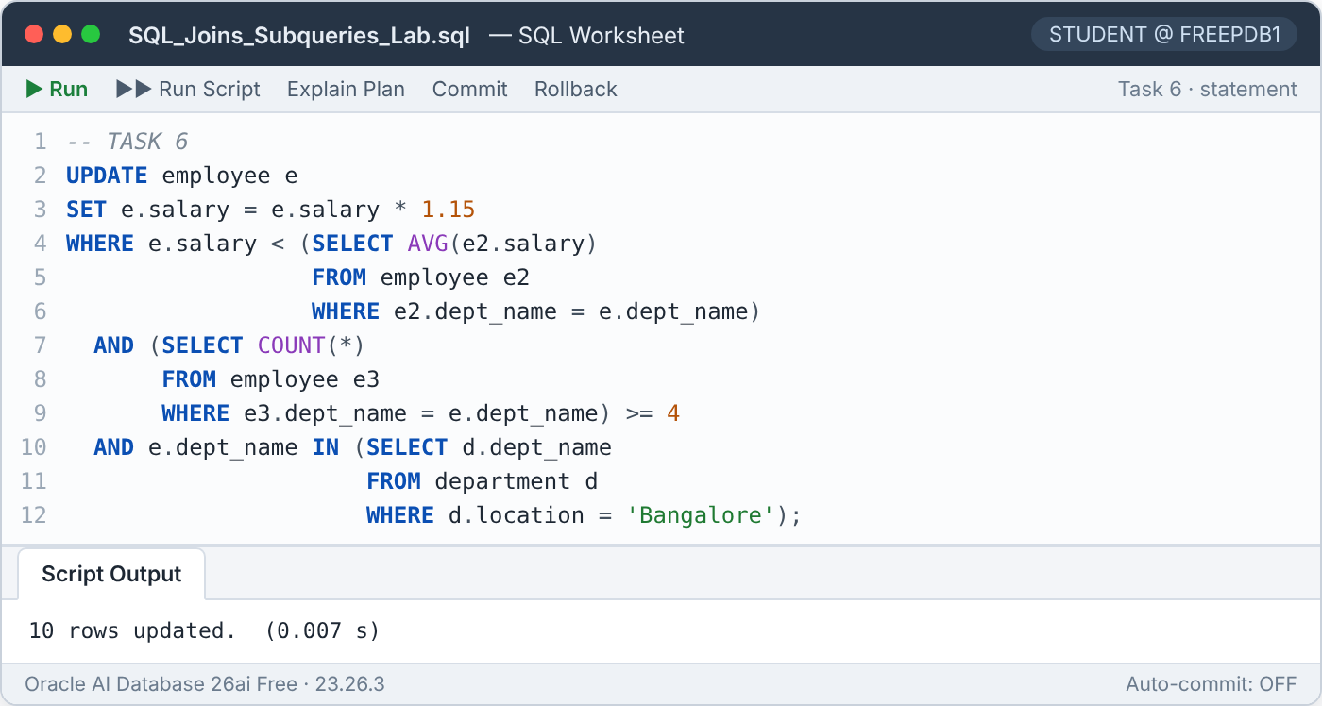
Figure 20 — Task 6 UPDATE — 10 rows updated
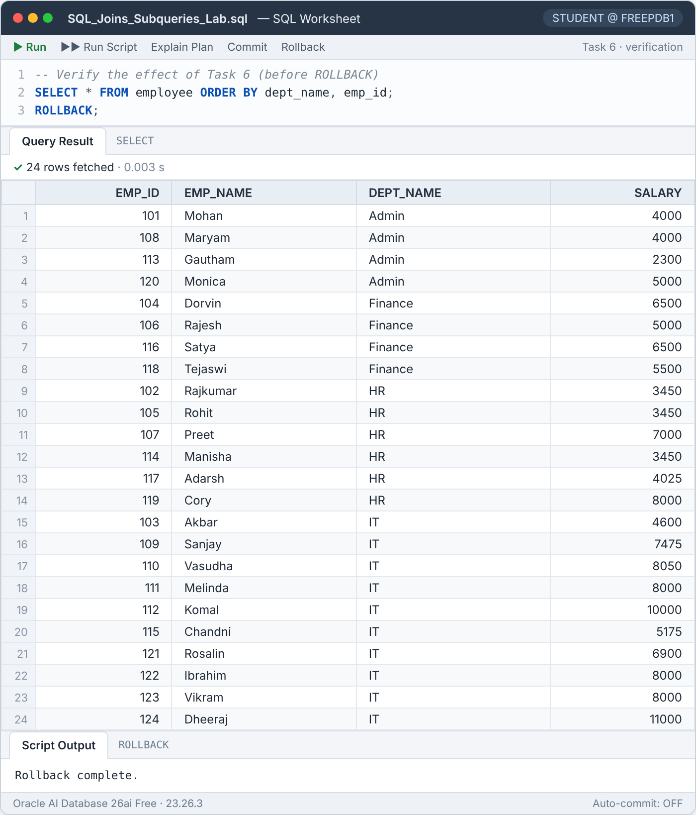
Figure 21 — Task 6 verification — EMPLOYEE after the update, before the ROLLBACK

Result analysis
Department | Location | Employees | Eligible? | Reason
Admin | Bangalore | 4 | Yes | Bangalore and 4 employees
HR | Bangalore | 6 | Yes | Bangalore and 6 employees
IT | Bangalore | 10 | Yes | Bangalore and 10 employees
Finance | Mumbai | 4 | No | Not in Bangalore
Marketing | Bangalore | 0 | No | No employees
Table 10 — Department eligibility
Emp ID | Name | Dept | Old salary | Dept avg. | New salary (+15 %)
113 | Gautham | Admin | 2,000 | 3,750 | 2,300
102 | Rajkumar | HR | 3,000 | 4,583.33 | 3,450
105 | Rohit | HR | 3,000 | 4,583.33 | 3,450
114 | Manisha | HR | 3,000 | 4,583.33 | 3,450
117 | Adarsh | HR | 3,500 | 4,583.33 | 4,025
103 | Akbar | IT | 4,000 | 7,300 | 4,600
109 | Sanjay | IT | 6,500 | 7,300 | 7,475
110 | Vasudha | IT | 7,000 | 7,300 | 8,050
115 | Chandni | IT | 4,500 | 7,300 | 5,175
121 | Rosalin | IT | 6,000 | 7,300 | 6,900
Table 11 — The 10 updated employees
Vasudha's new salary (8,050) is now above the old IT average — this is correct, because the average was calculated before any row changed. The ROLLBACK restores all salaries, as confirmed by the next task, which runs against the original values.

5.7 Task 7 — Delete below-average staff in high-salary departments (DELETE)

Objective
Delete the employees who earn less than the company-wide average, who work in a department whose highest salary exceeds 10,000, and who are not the lowest-paid employee of their department.
SQL Task 7
DELETE FROM employee e
WHERE e.salary < (SELECT AVG(salary) FROM employee)
AND (SELECT MAX(e2.salary)
FROM employee e2
WHERE e2.dept_name = e.dept_name) > 10000
AND e.salary > (SELECT MIN(e3.salary)
FROM employee e3
WHERE e3.dept_name = e.dept_name);

SELECT * FROM employee ORDER BY dept_name, emp_id;
ROLLBACK;

How it works
- Non-correlated AVG(salary) over the whole table: 5,791.67.
- Correlated MAX: the department's top salary must be above 10,000 — only IT (11,000) qualifies.
- Correlated MIN: the salary must be strictly greater than the department minimum, which protects the lowest-paid employee.

Result
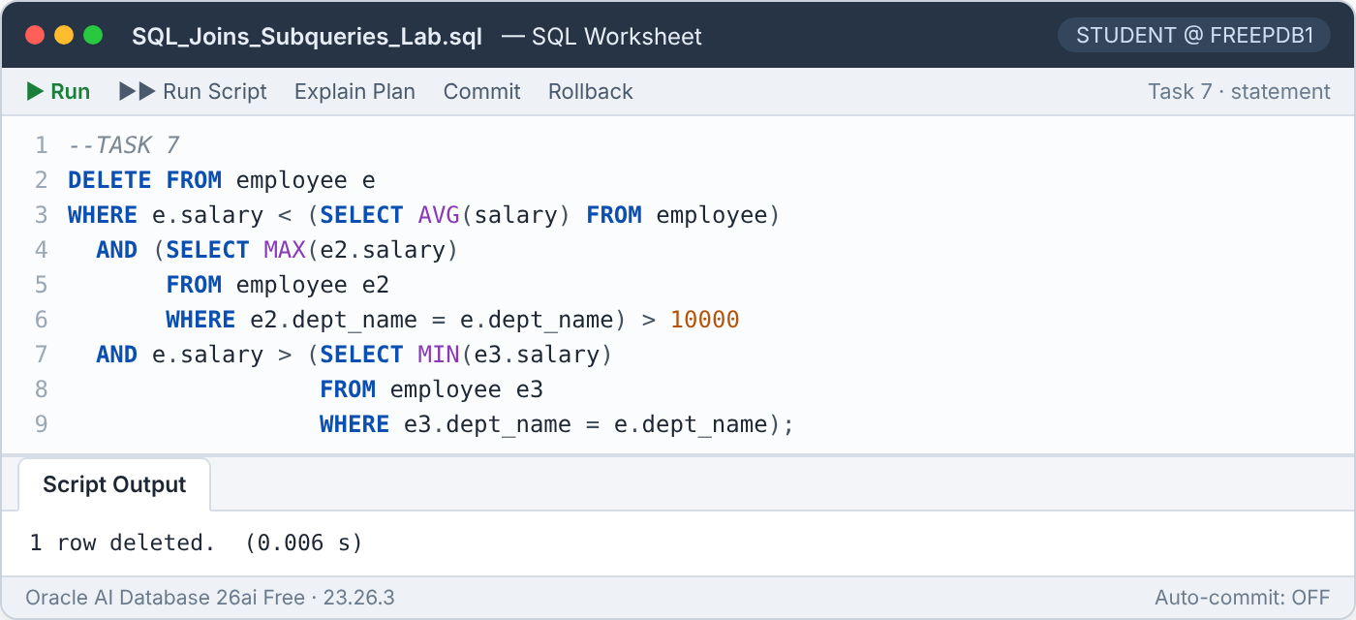
Figure 22 — Task 7 DELETE — 1 row deleted
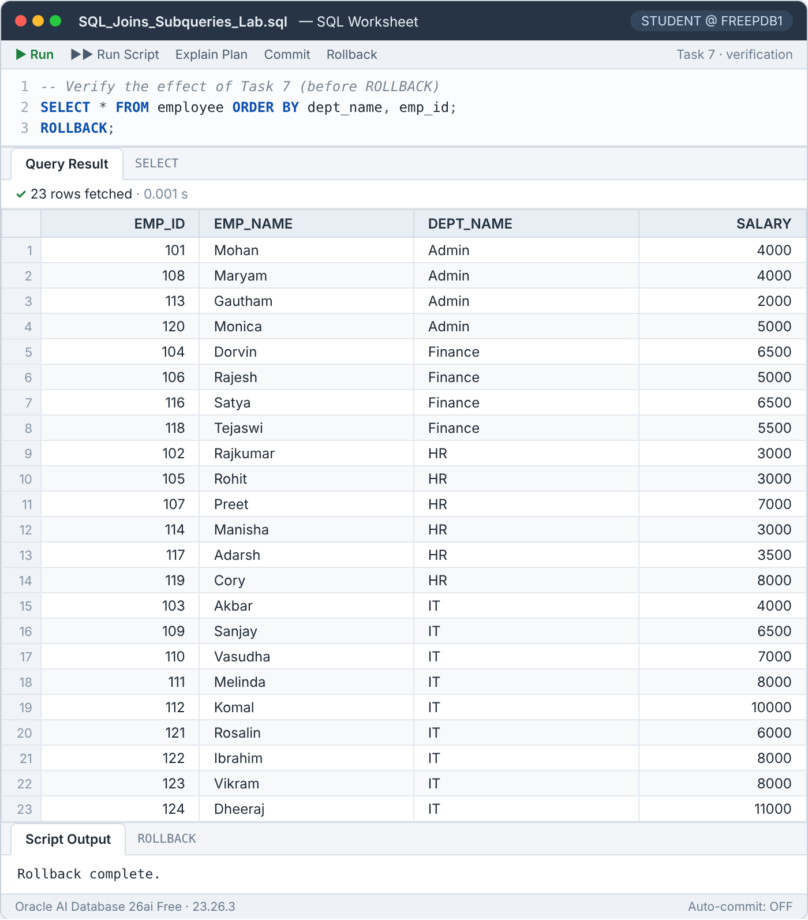
Figure 23 — Task 7 verification — 23 employees remain before the ROLLBACK (Chandni, 115, is gone)

Result analysis
Emp ID | Name | Salary | < 5,791.67? | > IT min (4,000)? | Outcome
103 | Akbar | 4,000 | Yes | No | Kept
115 | Chandni | 4,500 | Yes | Yes | Deleted
121 | Rosalin | 6,000 | No | Yes | Kept
109 | Sanjay | 6,500 | No | Yes | Kept
110 | Vasudha | 7,000 | No | Yes | Kept
111 | Melinda | 8,000 | No | Yes | Kept
122 | Ibrahim | 8,000 | No | Yes | Kept
123 | Vikram | 8,000 | No | Yes | Kept
112 | Komal | 10,000 | No | Yes | Kept
124 | Dheeraj | 11,000 | No | Yes | Kept
Table 12 — All IT employees tested against the two salary conditions
Akbar (4,000) is below the company average but is the lowest-paid IT employee, so the MIN condition protects him. Everyone from Rosalin (6,000) upwards earns more than the company average. Only Chandni (4,500) satisfies all three conditions.
Why the delete is not blocked by a foreign key
EMPLOYEE_HISTORY references EMPLOYEE through fk_emp_hist_02. If a history row existed for the employee being deleted, Oracle would raise ORA-02292: integrity constraint violated – child record found. Because Task 5 was rolled back, EMPLOYEE_HISTORY is empty and the delete succeeds.

5.8 Task 8 — Departments with a high payroll and a high top salary (HAVING)

Objective
Show the departments whose total salary is greater than the average of all department totals and whose highest salary is greater than the company-wide average salary, together with those two figures.
SQL Task 8
SELECT dept_name,
SUM(salary) AS total_salary,
MAX(salary) AS max_salary
FROM employee
GROUP BY dept_name
HAVING SUM(salary) > (SELECT AVG(t.dept_total)
FROM (SELECT SUM(salary) AS dept_total
FROM employee
GROUP BY dept_name) t)
AND MAX(salary) > (SELECT AVG(salary) FROM employee);

How it works
- GROUP BY dept_name produces one group per department with SUM(salary) and MAX(salary).
- HAVING filters the groups; WHERE cannot be used because the conditions refer to aggregates.
- The first scalar subquery averages the department totals (34,750); the second returns the company-wide average salary (5,791.67).

Result
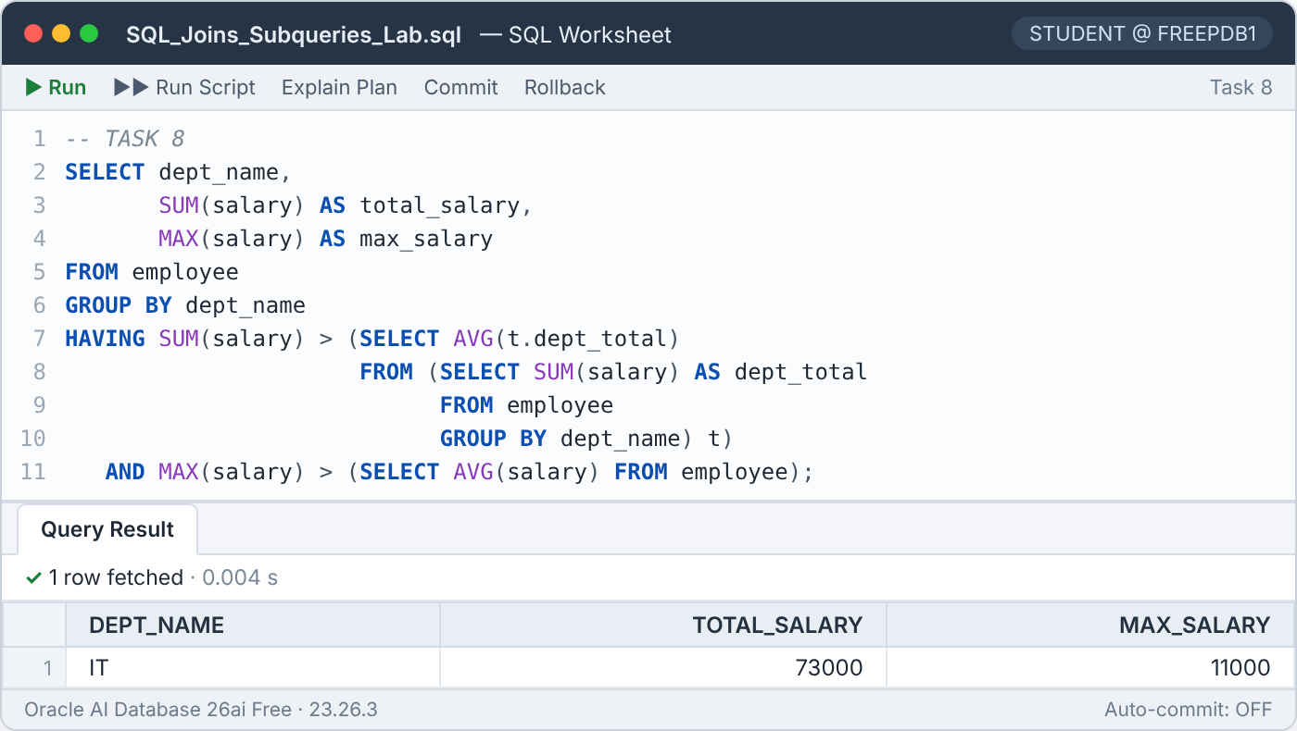
Figure 24 — Task 8 result — 1 row

Result analysis
Department | Total salary | > 34,750? | Max salary | > 5,791.67? | Outcome
Admin | 15,000 | No | 5,000 | No | Excluded
Finance | 23,500 | No | 6,500 | Yes | Excluded
HR | 27,500 | No | 8,000 | Yes | Excluded
IT | 73,000 | Yes | 11,000 | Yes | Included
Table 13 — Both HAVING conditions per department
Finance and HR have top salaries above the company average, but their payrolls are below 34,750. Only IT (73,000 / 11,000) satisfies both conditions.

5.9 Task 9 — The top-performing store (HAVING with a correlated subquery)

Objective
Find the stores whose total revenue and total quantity sold are both above the per-store averages, and whose highest single sale is greater than the highest sale of every other store.
SQL Task 9
SELECT s.store_name,
SUM(s.price) AS total_revenue,
SUM(s.quantity) AS total_quantity
FROM sales s
GROUP BY s.store_name
HAVING SUM(s.price) > (SELECT AVG(r.revenue)
FROM (SELECT SUM(price) AS revenue
FROM sales
GROUP BY store_name) r)
AND SUM(s.quantity) > (SELECT AVG(q.qty)
FROM (SELECT SUM(quantity) AS qty
FROM sales
GROUP BY store_name) q)
AND MAX(s.price) > (SELECT MAX(s2.price)
FROM sales s2
WHERE s2.store_name <> s.store_name);

How it works
- GROUP BY s.store_name creates one group per store with its revenue (SUM(price)) and quantity (SUM(quantity)).
- Two inline views compute the per-store totals, which are then averaged: revenue 6,050 and quantity 5.5.
- The third condition is a correlated subquery inside HAVING: it uses the group's s.store_name (allowed because it is a GROUP BY column) to find the maximum sale in all other stores.

Result
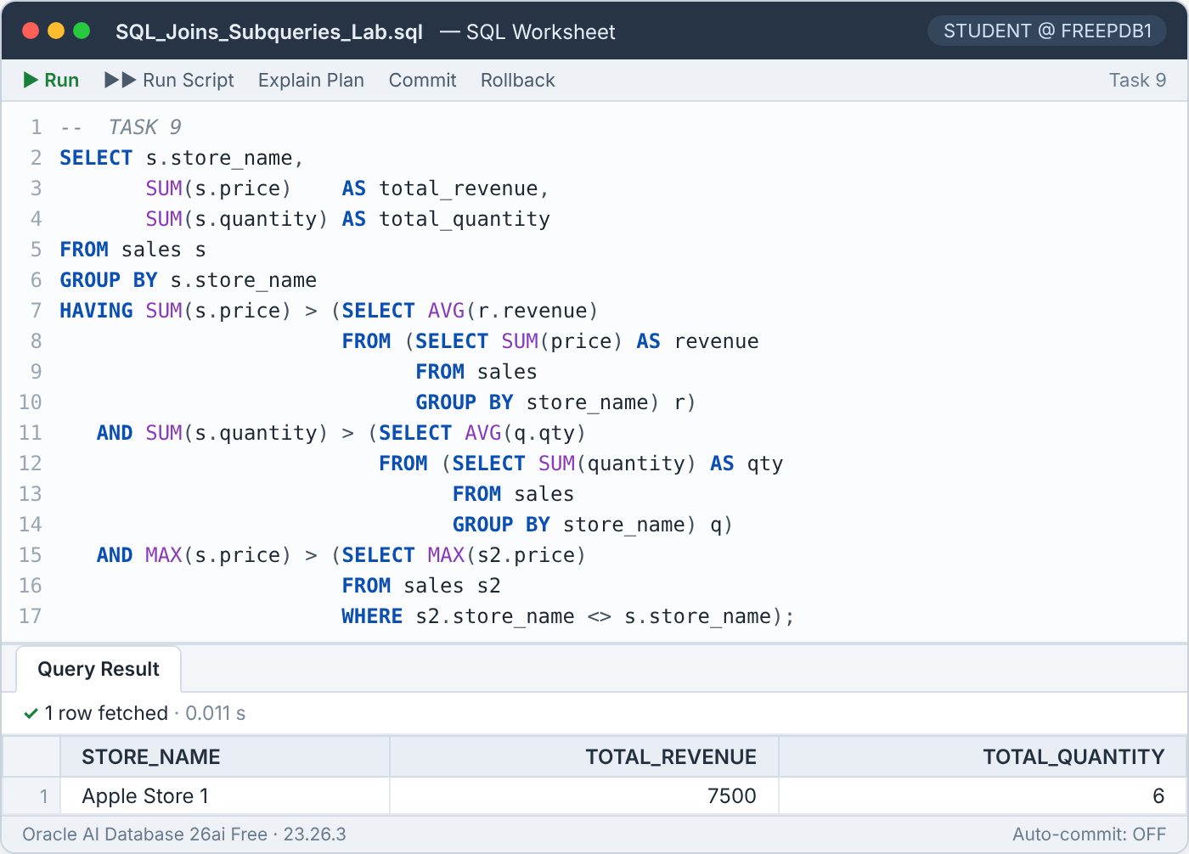
Figure 25 — Task 9 result — 1 row

Result analysis
Store | Revenue | > 6,050? | Qty | > 5.5? | Max sale | Max elsewhere | Higher? | Outcome
Apple Store 1 | 7,500 | Yes | 6 | Yes | 6,000 | 4,400 | Yes | Included
Apple Store 2 | 2,000 | No | 2 | No | 2,000 | 6,000 | No | Excluded
Apple Store 3 | 9,700 | Yes | 11 | Yes | 4,400 | 6,000 | No | Excluded
Apple Store 4 | 5,000 | No | 3 | No | 3,500 | 6,000 | No | Excluded
Table 14 — Store-level figures against the three conditions
Apple Store 3 has the largest revenue (9,700) and quantity (11), but its biggest single sale (4,400) is smaller than Apple Store 1's 6,000 MacBook sale, so it fails the third condition. Apple Store 1 is the only store that passes all three.

5.10 Task 10 — Employees earning more than at least 70 % of their department

Objective
List the employees whose salary is higher than the salary of at least 70 % of the employees in their department.
SQL Task 10
SELECT *
FROM employee e
WHERE (SELECT COUNT(*)
FROM employee e2
WHERE e2.dept_name = e.dept_name
AND e2.salary < e.salary)
>= 0.7 * (SELECT COUNT(*)
FROM employee e3
WHERE e3.dept_name = e.dept_name)
ORDER BY e.dept_name, e.salary;

How it works
- The first correlated subquery counts the employees of the same department who earn strictly less than the current employee.
- The second correlated subquery returns the department head-count; multiplying by 0.7 gives the threshold.
- The employee qualifies when "number of people I out-earn" ≥ 0.7 × head-count.

Result
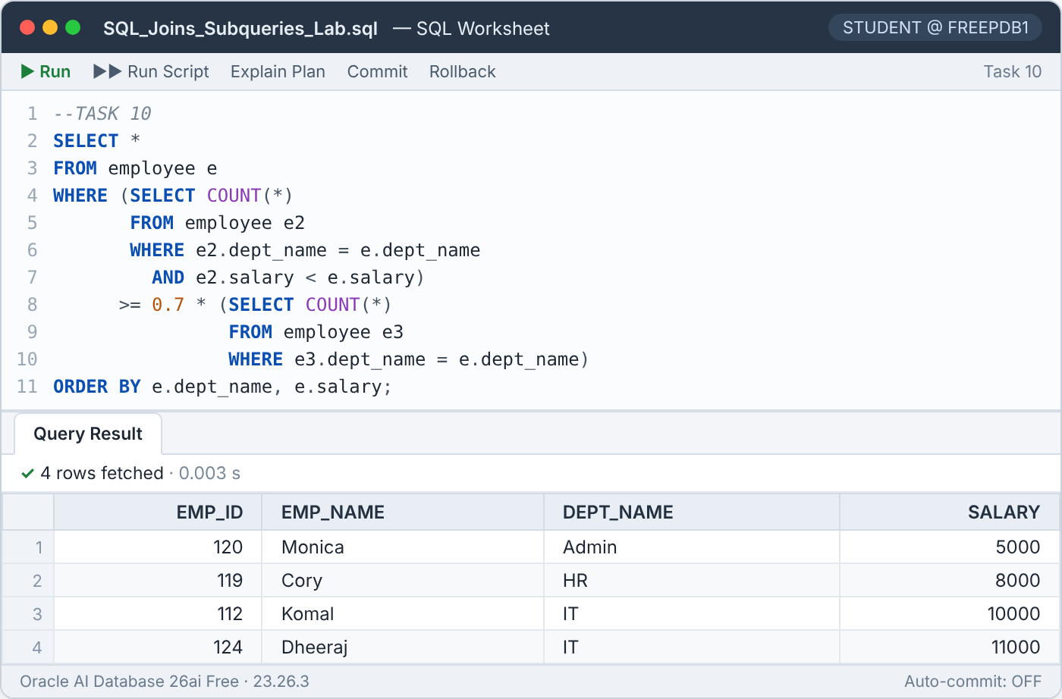
Figure 26 — Task 10 result — 4 rows

Result analysis
Department | Head-count | 70 % threshold | Top candidates (people they out-earn) | Qualify
Admin | 4 | 2.8 | Monica 3 · Mohan 1 · Maryam 1 | Monica
Finance | 4 | 2.8 | Dorvin 2 · Satya 2 · Tejaswi 1 | Nobody
HR | 6 | 4.2 | Cory 5 · Preet 4 · Adarsh 3 | Cory
IT | 10 | 7 | Dheeraj 9 · Komal 8 · Melinda / Ibrahim / Vikram 5 | Dheeraj, Komal
Table 15 — Threshold and best candidates in each department
In Finance the two top earners tie at 6,500, so each out-earns only 2 of 4 colleagues (50 %) and nobody qualifies. The result is therefore Monica, Cory, Komal and Dheeraj.
Interpretation note — "colleagues" vs. "department"
The head-count used as the denominator includes the employee themself. If the requirement means "at least 70 % of their *colleagues*" (everyone except themself), the threshold becomes 0.7 × (head-count − 1). With that reading Preet (HR) also qualifies, because she out-earns 4 of her 5 colleagues (80 %). Both versions were executed:

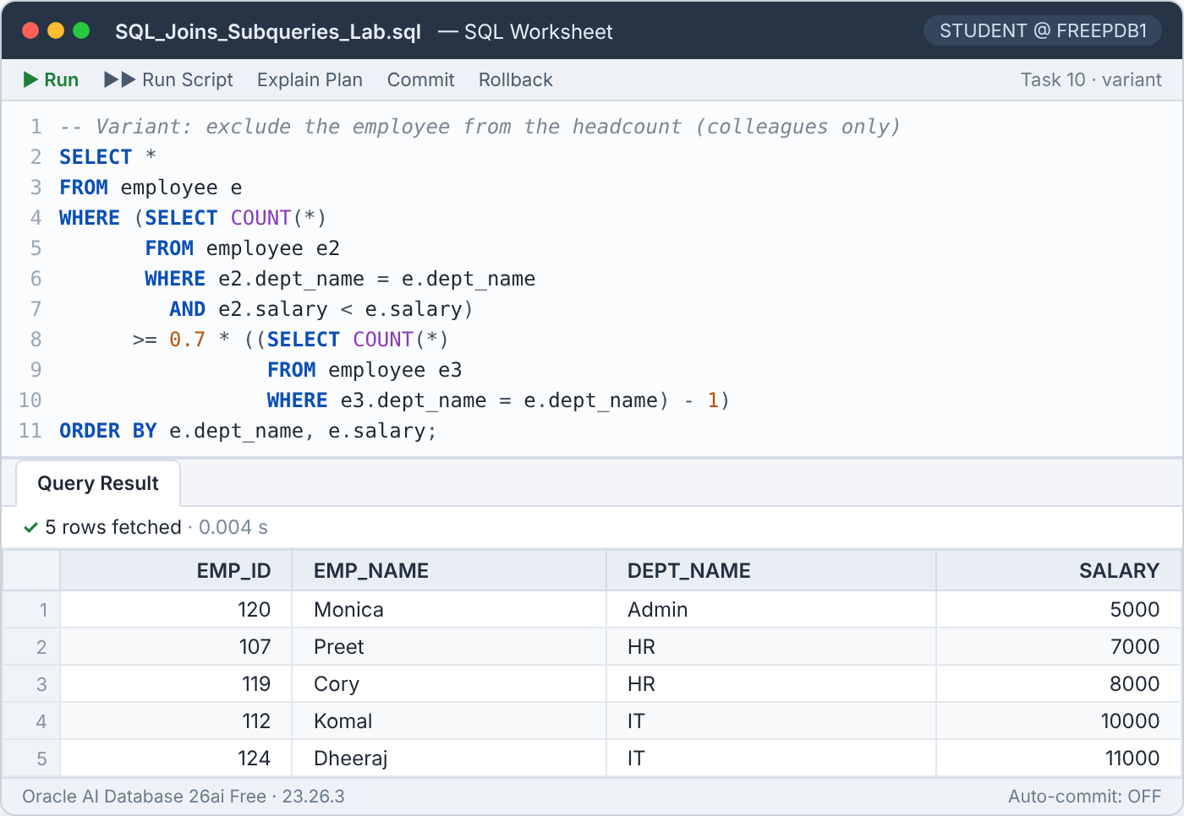
Figure 27 — Variant excluding the employee from the head-count — 5 rows (adds Preet)

5.11 Task 11 — Departments with more than two above-average earners

Objective
List the departments in which more than two employees earn more than that department's average salary.
SQL Task 11
SELECT emp.dept_name
FROM employee emp
GROUP BY emp.dept_name
HAVING (SELECT COUNT(*)
FROM employee e
WHERE e.dept_name = emp.dept_name
AND e.salary > (SELECT AVG(e2.salary)
FROM employee e2
WHERE e2.dept_name = emp.dept_name)) > 2;

How it works
- GROUP BY emp.dept_name forms one group per department.
- In HAVING, a subquery counts the employees of that group's department (e.dept_name = emp.dept_name) …
- … whose salary is above the department average, computed by a second, nested subquery that is also correlated to the group key.
- Groups with a count greater than 2 are kept. Because the subquery references only the group key, it is evaluated once per group (4 times), not once per employee.

Result
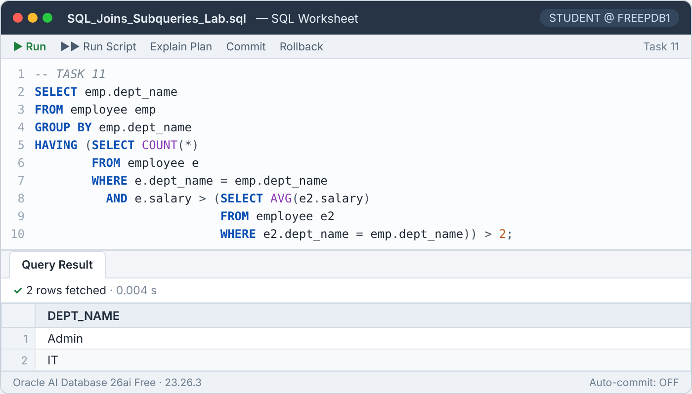
Figure 28 — Task 11 result — 2 rows

Result analysis
Department | Department average | Employees above average | Outcome
Admin | 3,750 | 3 | Included
Finance | 5,875 | 2 | Excluded
HR | 4,583.33 | 2 | Excluded
IT | 7,300 | 5 | Included
Table 16 — Above-average employees per department
Admin has 3 employees above its average of 3,750 (Mohan, Maryam, Monica) and IT has 5 above 7,300. Finance and HR have only 2 each, so they are excluded.

5.12 Task 12 — Rewriting IN as EXISTS: execution logic and performance

Objective
Rewrite a query that uses IN with a subquery so that it uses EXISTS instead, and compare the execution logic and performance of the two forms.
SQL Task 12 — original query (IN)
SELECT *
FROM employee
WHERE dept_name IN (SELECT dept_name FROM department);

SQL Task 12 — rewritten query (EXISTS)
SELECT *
FROM employee e
WHERE EXISTS (SELECT 1
FROM department d
WHERE d.dept_name = e.dept_name);

How it works
Aspect | IN | EXISTS
Subquery type | Non-correlated: does not reference the outer row | Correlated: d.dept_name = e.dept_name
Logical evaluation | Build the set of department names once, then test each employee for membership | For each employee, probe DEPARTMENT and stop at the first matching row
Value returned | A list of values that is compared with dept_name | Only TRUE / FALSE — the selected column (SELECT 1) is irrelevant
NULL behaviour | Positive IN is safe, but the negated form NOT IN returns nothing if the list contains a NULL | EXISTS and NOT EXISTS are never affected by NULLs
Typically better when | The subquery result is small | The inner table is large and indexed on the join column
Oracle optimizer | Both forms are transformed into a semi-join | Usually produce the same execution plan
Table 17 — IN vs EXISTS — execution logic

Result
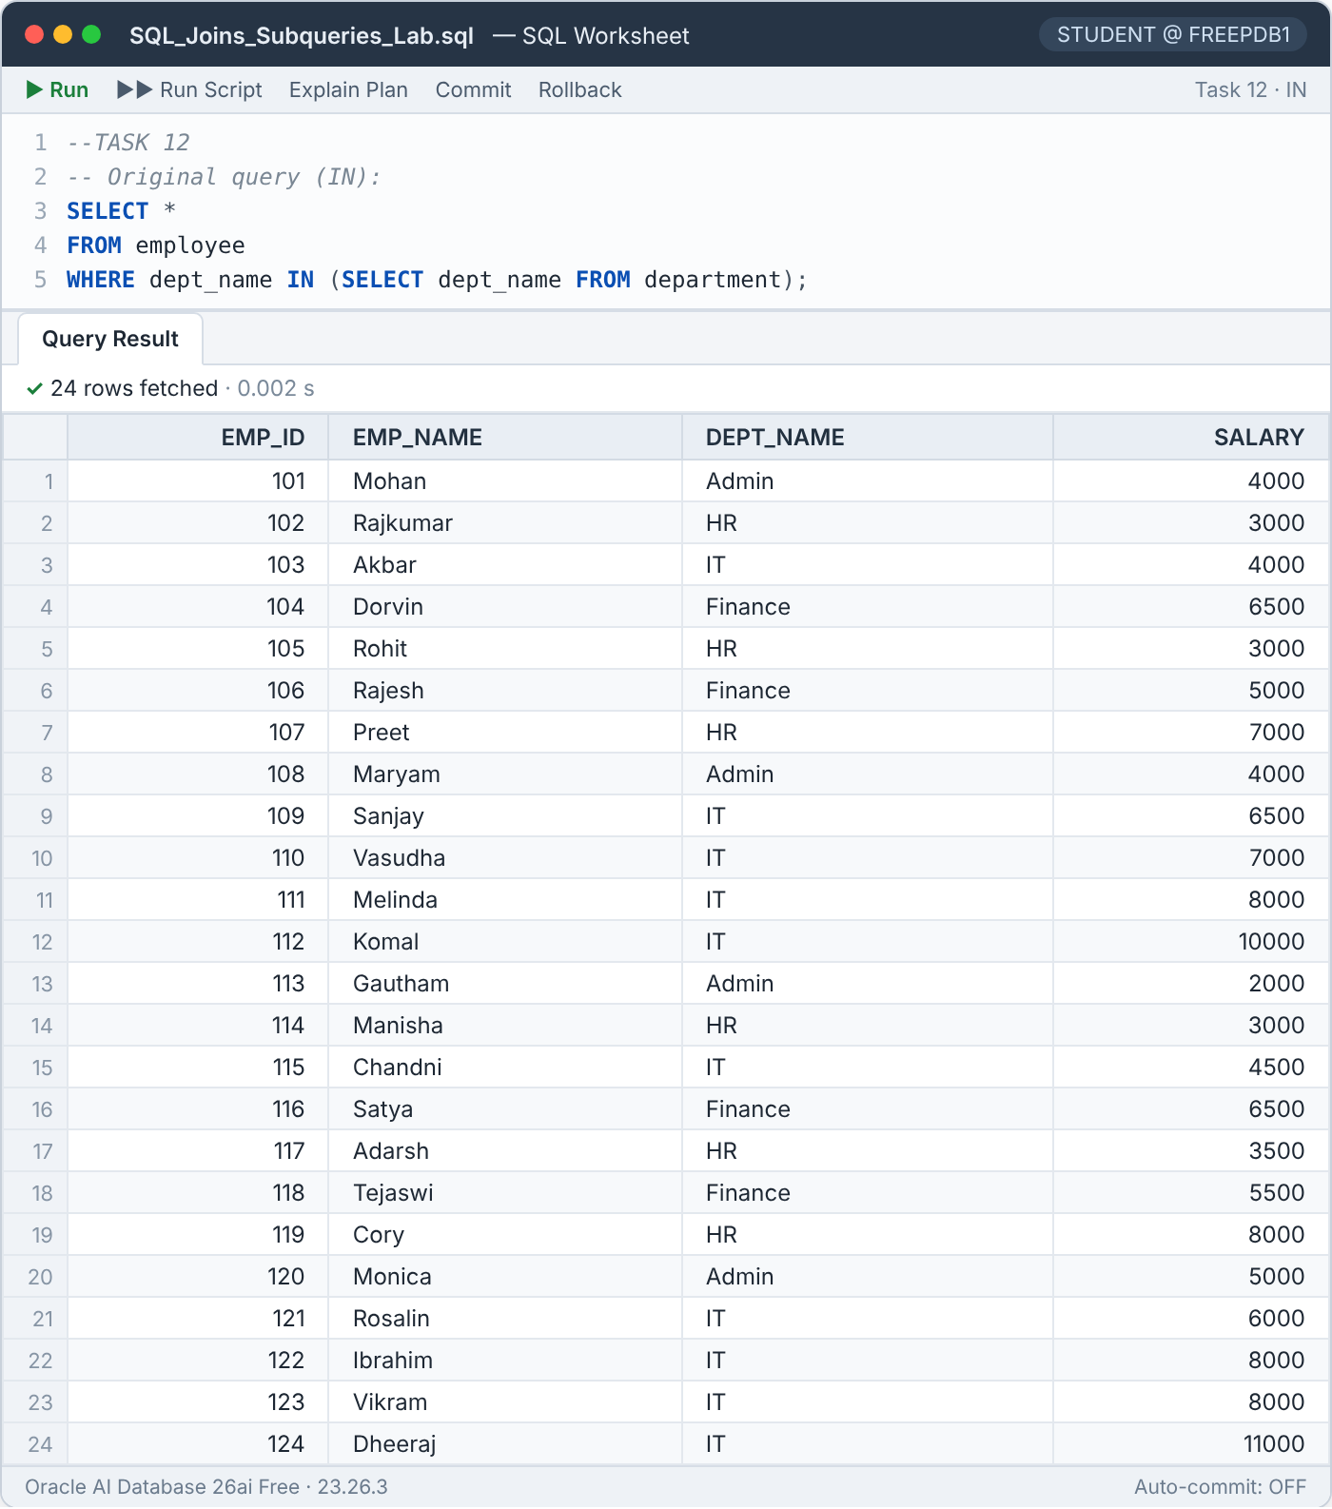
Figure 29 — Task 12 IN version — 24 rows
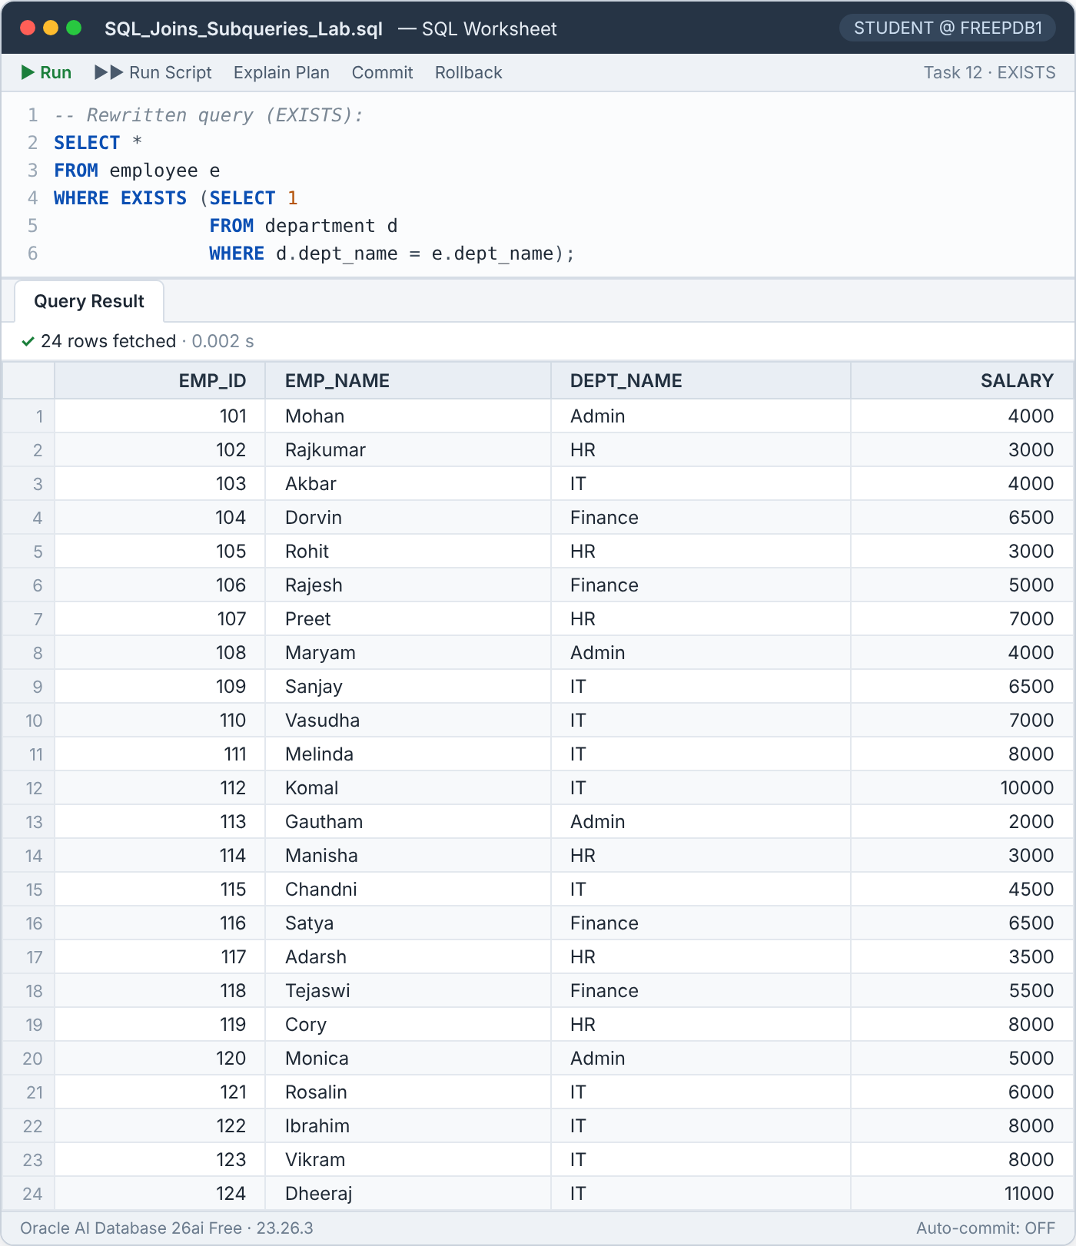
Figure 30 — Task 12 EXISTS version — the same 24 rows

Execution plan and performance
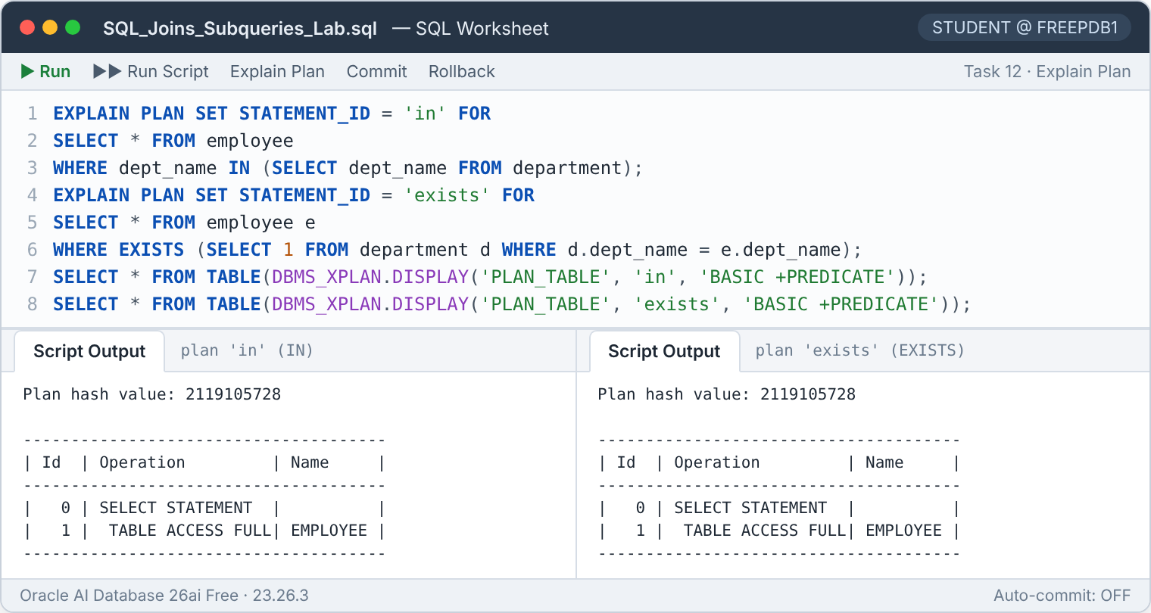
Figure 31 — Execution plans of the IN and EXISTS versions — identical
Both statements produced the same plan (plan hash value 2119105728), and the plan does not even touch DEPARTMENT: it consists of a single full scan of EMPLOYEE. Oracle applied join elimination — because employee.dept_name is NOT NULL and has a validated foreign key to the primary key of DEPARTMENT, every employee is guaranteed to have a matching department, so the semi-join cannot remove any row and the optimizer drops it entirely. Performance is therefore identical, and both queries return all 24 employees.
Conclusion for Task 12
In modern Oracle versions IN and EXISTS usually lead to the same plan, so the choice is mainly about clarity and safety. EXISTS is the better habit for correlated existence checks — above all in its negated form, NOT EXISTS, which is immune to the NULL problem that affects NOT IN.

6 Summary of Key Concepts

6.1 Techniques used
Technique | What it does | Used in
Inner join | Returns only rows that have a match in both tables | Joins 1, 2
Outer join anti-join | LEFT JOIN + IS NULL finds rows with no match | Join 3
Correlated subquery | Re-evaluated (logically) per outer row; compares a row with its own group | Tasks 1, 2, 4–7, 9–11
Non-correlated scalar subquery | Computed once; returns a single constant such as an average | Tasks 1, 5, 7, 8, 9
EXISTS / NOT EXISTS | Tests whether at least one matching row exists; NULL-safe | Tasks 3, 12
IN / NOT IN | Tests membership in a list; NOT IN fails with NULLs | Tasks 1, 3, 6, 12
Inline view | A subquery in FROM that acts as a temporary table (e.g. totals per department) | Tasks 5, 8, 9
INSERT … SELECT | Inserts the rows returned by a query | Task 5
UPDATE / DELETE with subqueries | Chooses the rows to change using conditions on other rows | Tasks 6, 7
GROUP BY / HAVING | Aggregates rows into groups and filters the groups | Tasks 8, 9, 11
Analytic function | DENSE_RANK() ranks rows within a partition in one pass | Task 4 (alternative)
Table 18 — SQL techniques practised in this lab

6.2 Results at a glance
Query | Oracle feedback | Outcome
Join 1 | 24 rows selected | Every employee with salary and department location
Join 2 | 20 rows selected | All employees of Admin, HR and IT (Bangalore)
Join 3 | 2 rows selected | Sales, Marketing — departments without employees
Task 1 | 9 rows selected | Dorvin, Satya, Preet, Cory, Melinda, Ibrahim, Vikram, Komal, Dheeraj
Task 2 | 7 rows selected | Mohan, Maryam, Monica, Satya, Dorvin, Preet, Cory (no IT employee)
Task 3 | 3 rows selected (×2) | Admin, HR, Finance — identical with NOT EXISTS and NOT IN
Task 4 | 11 rows selected | 2nd and 3rd highest distinct salary in every department
Task 5 | 5 rows inserted | IT employees above the IT average archived (then rolled back)
Task 6 | 10 rows updated | 15 % raise for below-average staff of Admin, HR, IT (then rolled back)
Task 7 | 1 row deleted | Chandni (IT, 4,500) deleted (then rolled back)
Task 8 | 1 row selected | IT — total 73,000, maximum 11,000
Task 9 | 1 row selected | Apple Store 1 — revenue 7,500, quantity 6
Task 10 | 4 rows selected | Monica, Cory, Komal, Dheeraj
Task 11 | 2 rows selected | Admin, IT
Task 12 | 24 rows selected (×2) | All employees; IN and EXISTS give identical results and plans
Table 19 — Summary of every query executed

6.3 Best practices learned
- Prefer NOT EXISTS over NOT IN whenever the subquery column could contain NULLs.
- Always end ORDER BY with a unique column when a deterministic row order matters (see the Dorvin/Satya tie in Tasks 1 and 2).
- Before running an UPDATE or DELETE, run its WHERE clause as a SELECT; then verify the change inside the transaction before COMMIT or ROLLBACK.
- State clearly whether "average of departments" should include departments without staff — it changes the result of Task 5.
- On large tables, consider analytic functions (DENSE_RANK, AVG(…) OVER (PARTITION BY …)) instead of repeated correlated subqueries.
- Oracle does not index foreign-key columns automatically; an index on employee(dept_name) would support every correlated subquery in this lab as the table grows.

7 Conclusion
All three join queries and all twelve subquery tasks were executed successfully on Oracle Database, and every result was confirmed by an independent calculation. The exercises show that most "compare a row with its group" questions can be expressed naturally with correlated subqueries, and that subqueries work equally well inside INSERT, UPDATE, DELETE and HAVING.
The execution plans gave an important practical insight: formulations that look very different — IN vs EXISTS, NOT IN vs NOT EXISTS — were turned into exactly the same plan by the Oracle optimizer, which even removed an unnecessary join thanks to the foreign-key constraint. The real differences between them are therefore about correctness with NULLs and readability rather than raw speed. Well-declared constraints (primary keys, foreign keys and NOT NULL) were shown to improve both data quality and query optimisation.

Appendix A Execution log
Feedback returned by Oracle for every statement of the script, in execution order. The schema set-up (4 × CREATE TABLE, 41 × INSERT and COMMIT) completed without errors.
# | Section | Statement | Oracle feedback | Time (s) | Status
1–45 | Set-up | DDL / INSERT | 4 tables created, 41 rows inserted | 0.092 | Success
46 | Set-up | COMMIT | Commit complete. | 0.001 | Success
47 | Join 1 | SELECT | 24 rows selected. | 0.007 | Success
48 | Join 2 | SELECT | 20 rows selected. | 0.005 | Success
49 | Join 3 | SELECT | 2 rows selected. | 0.003 | Success
50 | Task 1 | SELECT | 9 rows selected. | 0.009 | Success
51 | Task 2 | SELECT | 7 rows selected. | 0.005 | Success
52 | Task 3 (1) | SELECT | 3 rows selected. | 0.006 | Success
53 | Task 3 (2) | SELECT | 3 rows selected. | 0.003 | Success
54 | Task 4 | SELECT | 11 rows selected. | 0.007 | Success
55 | Task 5 | INSERT | 5 rows inserted. | 0.020 | Success
56 | Task 5 | SELECT | 5 rows selected. | 0.006 | Success
57 | Task 5 | ROLLBACK | Rollback complete. | 0.001 | Success
58 | Task 6 | UPDATE | 10 rows updated. | 0.007 | Success
59 | Task 6 | SELECT | 24 rows selected. | 0.003 | Success
60 | Task 6 | ROLLBACK | Rollback complete. | 0.001 | Success
61 | Task 7 | DELETE | 1 row deleted. | 0.006 | Success
62 | Task 7 | SELECT | 23 rows selected. | 0.001 | Success
63 | Task 7 | ROLLBACK | Rollback complete. | 0.001 | Success
64 | Task 8 | SELECT | 1 row selected. | 0.004 | Success
65 | Task 9 | SELECT | 1 row selected. | 0.011 | Success
66 | Task 10 | SELECT | 4 rows selected. | 0.003 | Success
67 | Task 11 | SELECT | 2 rows selected. | 0.004 | Success
68 | Task 12 (IN) | SELECT | 24 rows selected. | 0.002 | Success
69 | Task 12 (EXISTS) | SELECT | 24 rows selected. | 0.002 | Success
Table 20 — Statement-by-statement execution log

Appendix B EMPLOYEE sample data
Emp ID | Name | Department | Location | Salary
101 | Mohan | Admin | Bangalore | 4,000
102 | Rajkumar | HR | Bangalore | 3,000
103 | Akbar | IT | Bangalore | 4,000
104 | Dorvin | Finance | Mumbai | 6,500
105 | Rohit | HR | Bangalore | 3,000
106 | Rajesh | Finance | Mumbai | 5,000
107 | Preet | HR | Bangalore | 7,000
108 | Maryam | Admin | Bangalore | 4,000
109 | Sanjay | IT | Bangalore | 6,500
110 | Vasudha | IT | Bangalore | 7,000
111 | Melinda | IT | Bangalore | 8,000
112 | Komal | IT | Bangalore | 10,000
113 | Gautham | Admin | Bangalore | 2,000
114 | Manisha | HR | Bangalore | 3,000
115 | Chandni | IT | Bangalore | 4,500
116 | Satya | Finance | Mumbai | 6,500
117 | Adarsh | HR | Bangalore | 3,500
118 | Tejaswi | Finance | Mumbai | 5,500
119 | Cory | HR | Bangalore | 8,000
120 | Monica | Admin | Bangalore | 5,000
121 | Rosalin | IT | Bangalore | 6,000
122 | Ibrahim | IT | Bangalore | 8,000
123 | Vikram | IT | Bangalore | 8,000
124 | Dheeraj | IT | Bangalore | 11,000
Table 21 — All 24 employees (reference for every task)

