REAL-TIME SIGN LANGUAGE INTERPRETER
Turning hand signs into text and speech, live
// MediaPipe + PyTorch + Flask + React

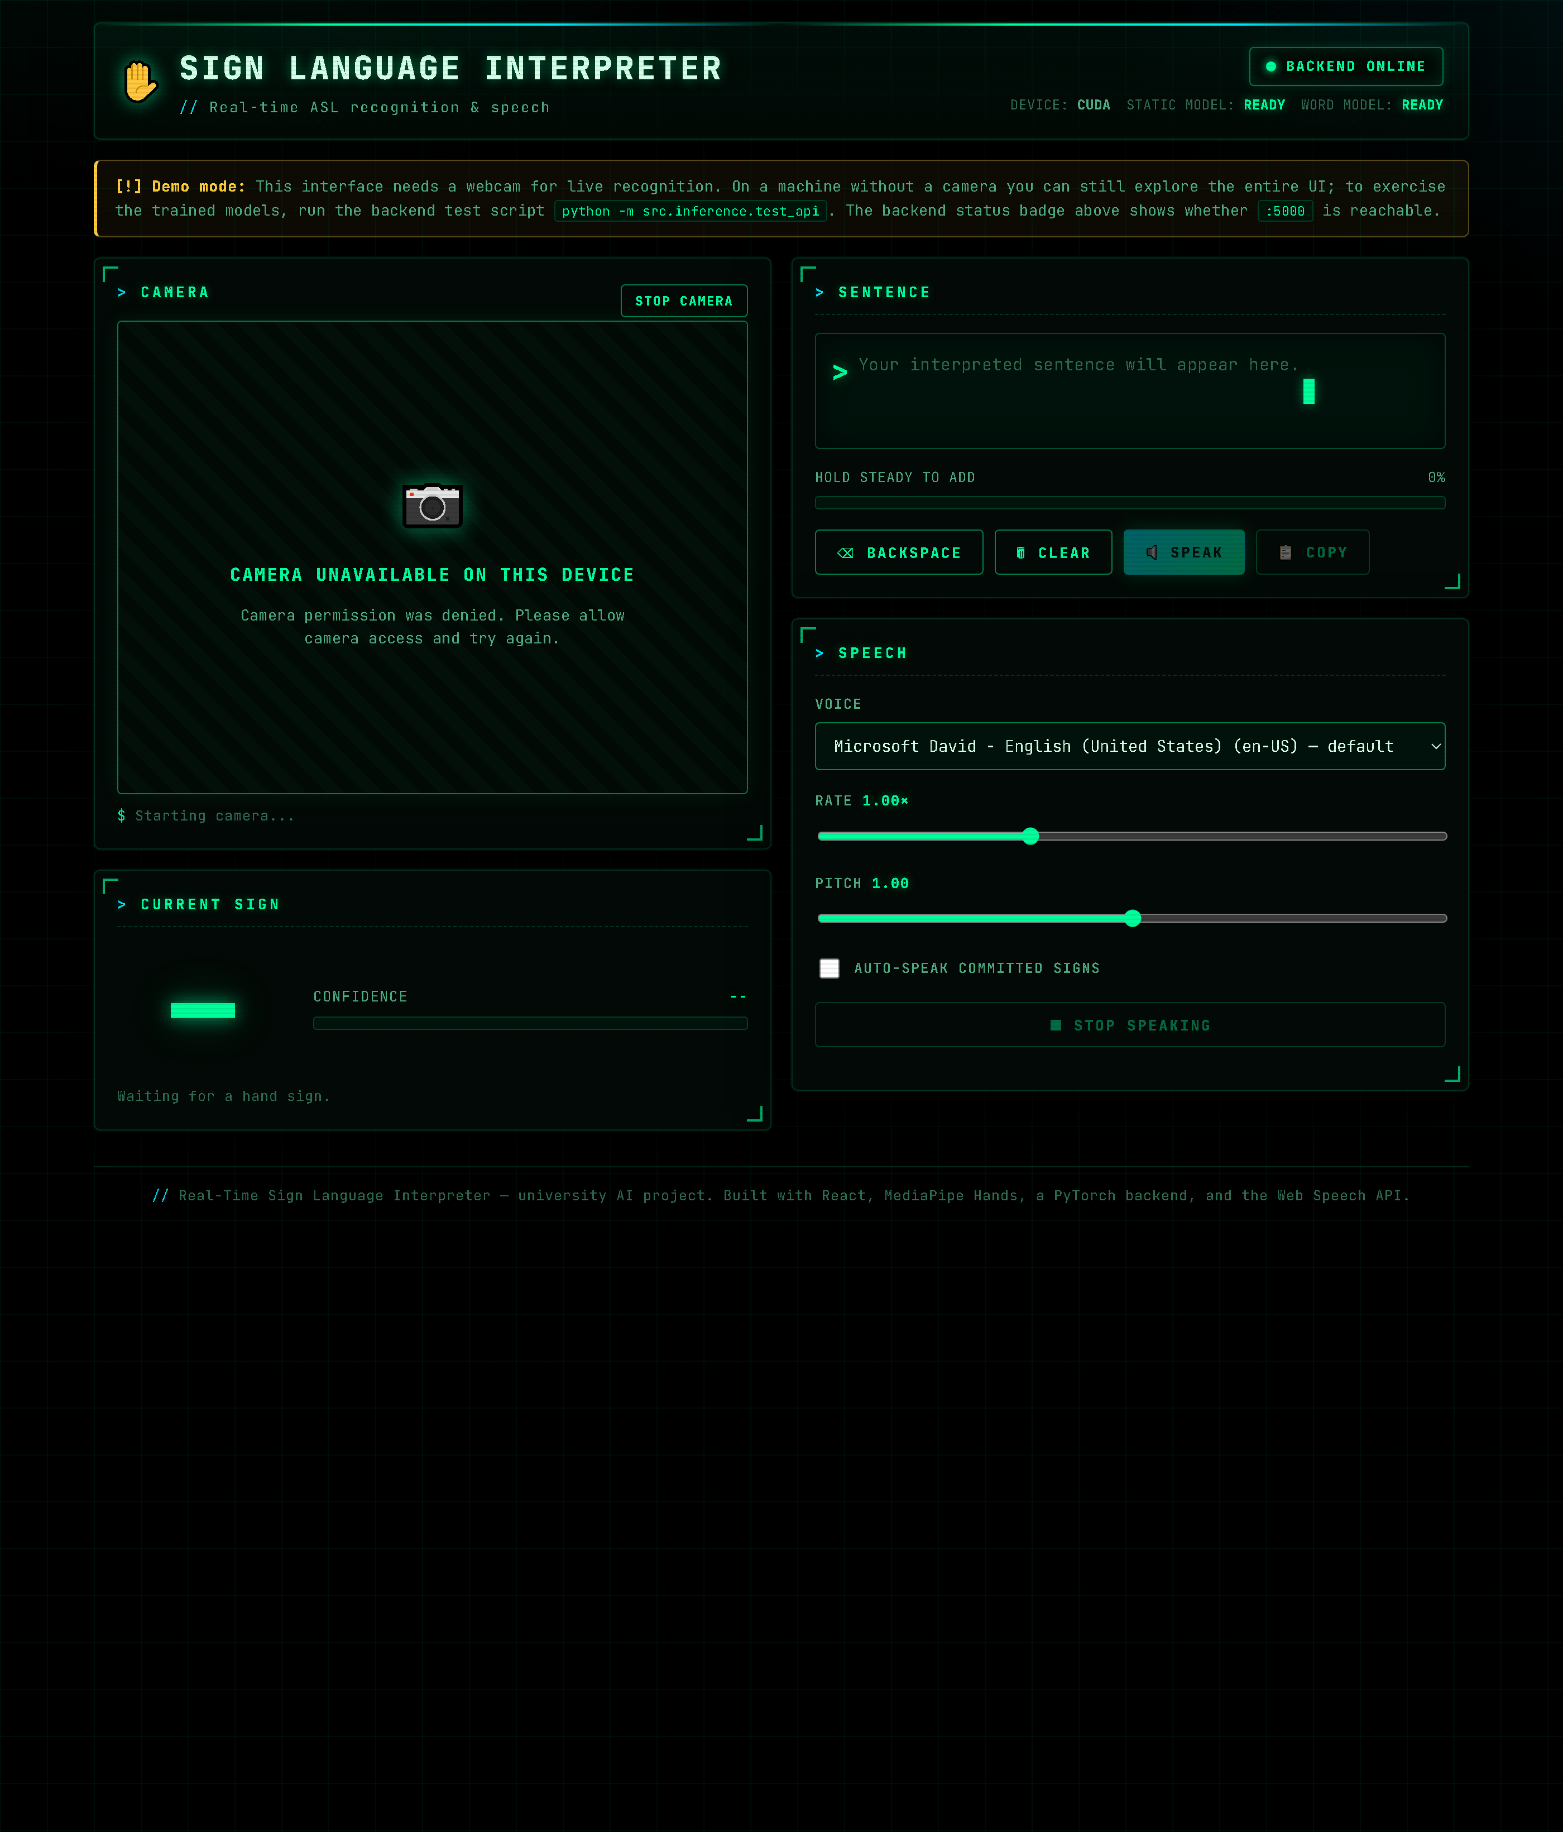

Project Documentation
Team: Ahmed Raza • Humdia Amjad • Hafsa Irfan
University Artificial Intelligence Project
Trained on NVIDIA GeForce RTX 4060 Ti (CUDA) • May 2026

1. What This Project Does
This project is a website that watches your hand through a webcam and tells you which sign you are making. It then shows the sign as text on the screen and says it out loud. The goal is to help people who use sign language talk more easily with people who do not know sign language.
It does two kinds of recognition:
- Letters (static signs) — single hand shapes for A to Z, plus space, delete, and nothing.
- Words (dynamic signs) — whole-word signs that involve movement, like "drink", "help", and "go".
Everything runs live: the camera reads your hand, the AI makes a guess many times per second, the sentence is built up word by word, and the browser reads the sentence aloud.
2. How It Meets the Project Requirements
The table below maps each requirement from the project brief to how we built it.
Requirement | How we did it | Done
Live webcam input, low latency | MediaPipe runs in the browser; only 63 small numbers are sent to the server, about 5 times a second. | Yes
Static gesture recognition (landmarks) | A neural network (MLP) reads 21 hand points and names the letter. 99.48% accuracy. | Yes
Dynamic gesture recognition (temporal) | An LSTM reads a 30-frame sequence of hand points to name a word. 83.87% accuracy. | Yes
Visual overlay on the video | The hand skeleton is drawn on the live feed; the current sign is shown on top. | Yes
Text output in the UI | A sentence box builds the text from steady predictions. | Yes
Speech output | The browser Web Speech API reads the text aloud (voice, speed, pitch). | Yes
Accessibility (WCAG) | High contrast, large text, keyboard focus, screen-reader live regions, reduced-motion support. | Yes
All four phases (MVP to polish) | Letters, then words, then the React UI + speech, then accessibility and styling. | Yes
One smart change: the brief suggested a CNN that reads raw image pixels. We instead feed the AI the 21 hand points from MediaPipe. This is lighter, trains faster on the GPU, ignores background and skin colour, and gives higher accuracy. We used PyTorch (instead of TensorFlow/Keras) for the same CNN+LSTM idea, because it is clean and fast on the RTX 4060 Ti.
3. The Datasets (What the AI Learned From)
Dataset 1 — ASL Alphabet (for letters)
- Size — 87,000 images, 29 classes (A-Z, space, delete, nothing), 3,000 images each.
- Use — teaches the static letter model.
Dataset 2 — WLASL (for words)
- Size — 2,000 word folders and 12,505 sign-language videos.
- Use — we picked the 10 best-filmed words (14-17 clips each) to teach the dynamic word model.
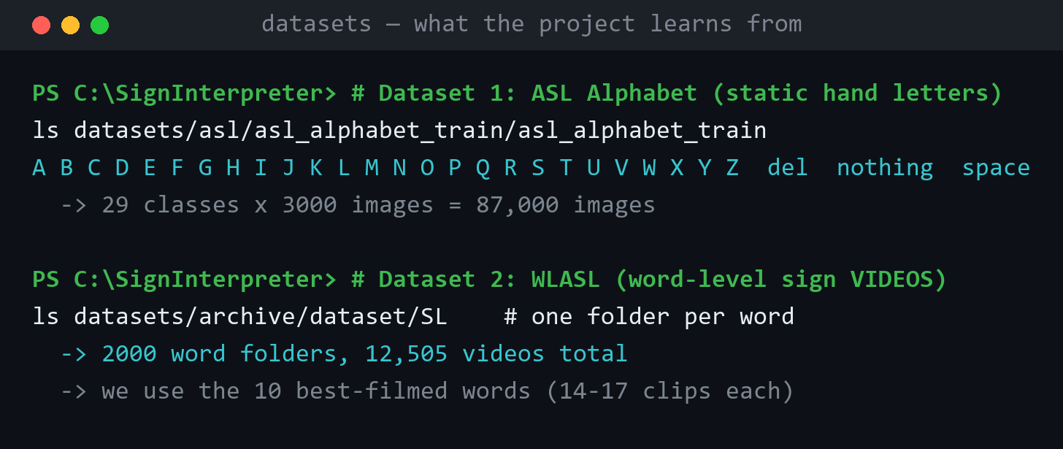
Figure 1. The two datasets on disk and their sizes.
Both datasets are public (Kaggle). They are not included in the shared folder because they are 6.4 GB; the trained models are included instead, so the app runs without downloading them.
4. How It Works (The Pipeline)
The same simple idea powers both models: do not look at raw pixels, look at hand points. MediaPipe finds 21 points on the hand (knuckles, finger tips, wrist). Each point has an x, y and z value, so one hand = 63 numbers.
Letters (static)
Webcam frame -> MediaPipe (21 points) -> 63 numbers -> MLP neural network -> a letter.
Words (dynamic)
Video -> 30 frames -> MediaPipe on each frame (2 hands = 126 numbers) -> a sequence of 30 x 126 -> LSTM neural network -> a word.
The hand points are always "normalized" (moved to the same spot and the same size) by ONE shared function, so training and live use match exactly. The MLP is good at single shapes; the LSTM is good at movement over time.
5. Training and Results
Both models were trained on an NVIDIA GeForce RTX 4060 Ti graphics card using CUDA (GPU acceleration) with PyTorch. The desktop has no webcam, so all training was done offline from the saved data files.
Model | Job | Classes | Training data | Validation accuracy
Static MLP | Letters | 29 | 35,907 hand-point samples | 99.48%
Dynamic LSTM | Words | 10 | 151 video sequences (30 x 126) | 83.87% (best)
The letter model is the headline result and is extremely accurate. The word model is strong given how few clips each word has (14-17). Below are the real training runs and accuracy graphs from the RTX 4060 Ti.
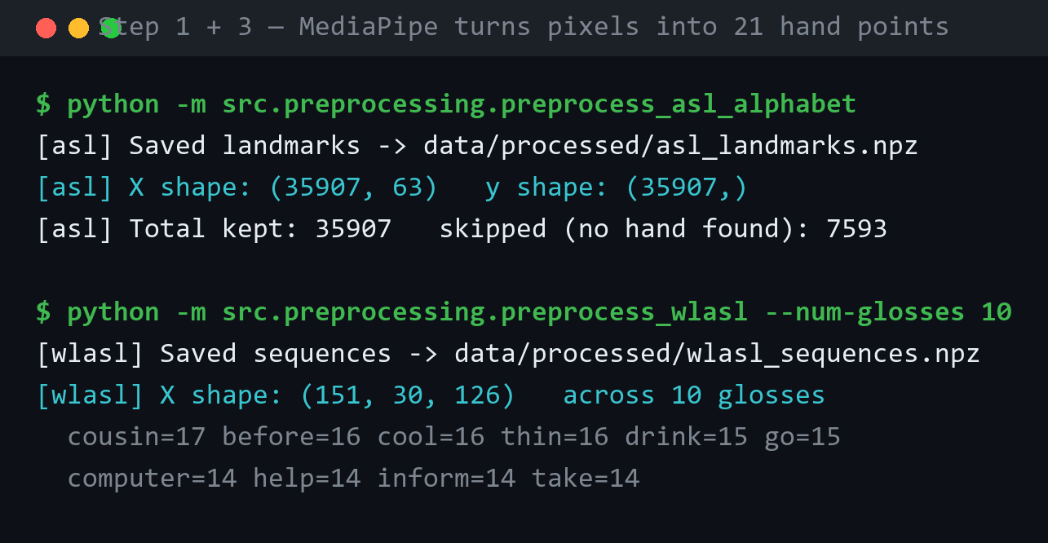
Figure 2. Step 1 and 3: MediaPipe turns images and videos into hand-point data.
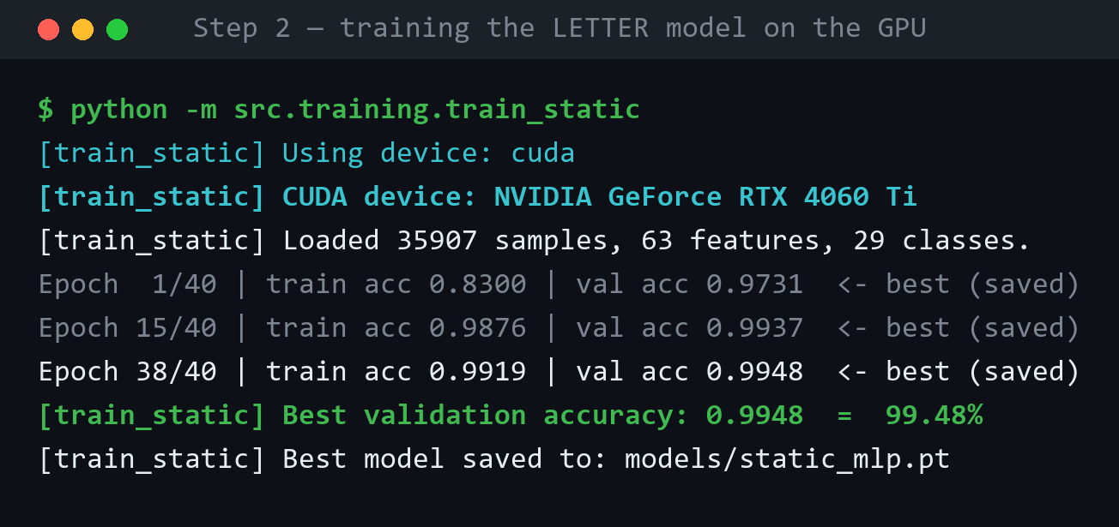
Figure 3. Step 2: training the letter model reaches 99.48% on the GPU.
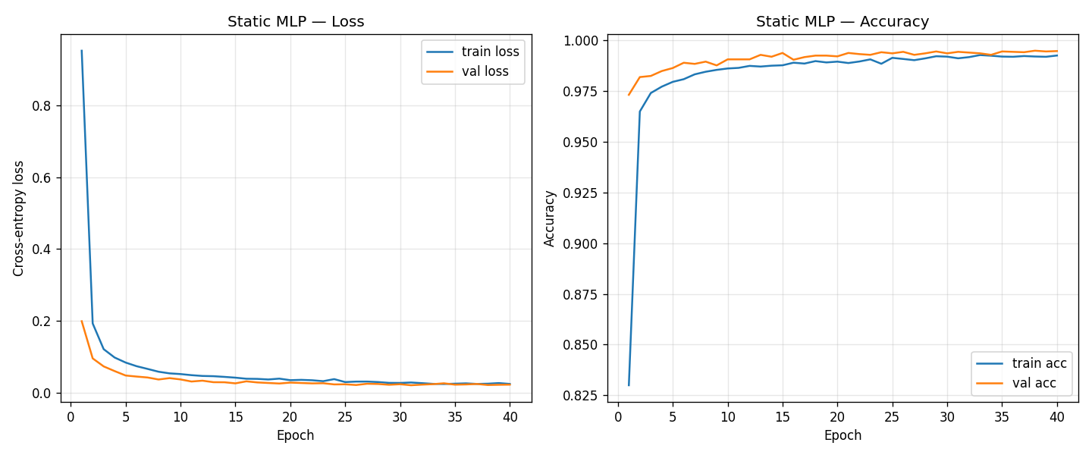
Figure 4. Letter model: loss falls and accuracy rises smoothly (no overfitting).
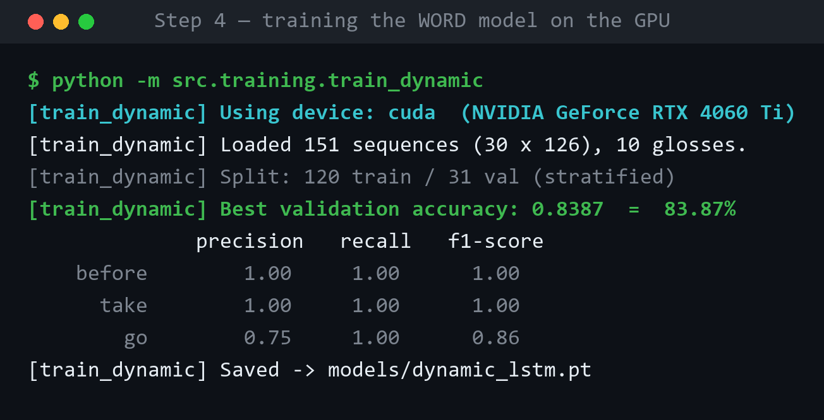
Figure 5. Step 4: training the word model reaches 83.87% on the GPU.
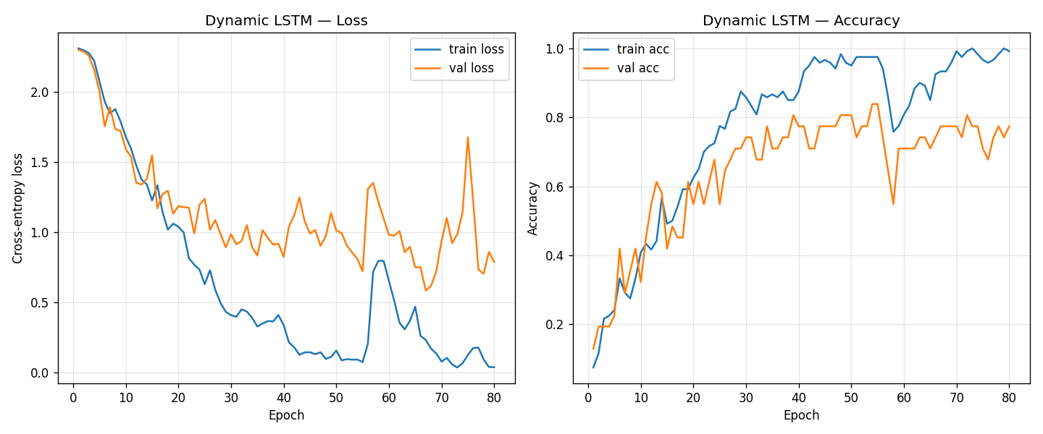
Figure 6. Word model training curves over 80 epochs.
6. The Backend (Flask API)
The backend is a small Python web server (Flask). It loads both trained models once and answers prediction requests. The website talks to it over these web addresses (endpoints):
Endpoint | What it does
GET /api/health | Says if the server is up, which device (CUDA), and which models are loaded.
GET /api/labels | Returns the list of letters and words the models know.
POST /api/predict/static | Takes 63 hand numbers, returns the letter + confidence + top 3.
POST /api/predict/dynamic | Takes a sequence of frames, returns the word + confidence.
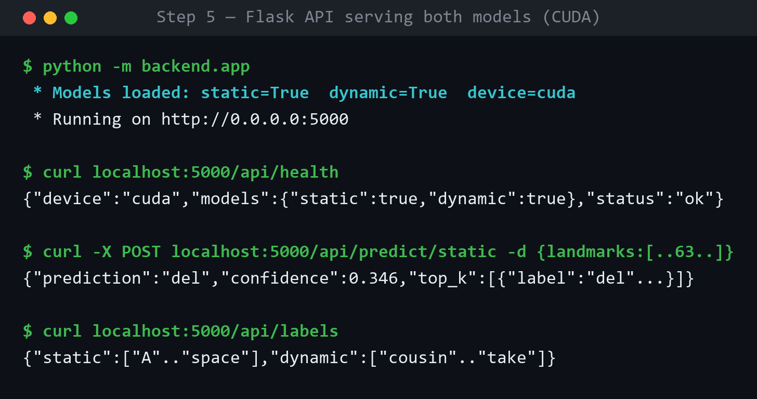
Figure 7. The Flask API running on CUDA and answering real requests.
7. The Website (React) and Its Features
The website is built with React and styled like a dark hacker terminal (black background, green text, glowing panels). Every feature:
- Live hand tracking — MediaPipe draws the hand skeleton on the camera in real time.
- Letter recognition — shows the current letter with a confidence bar and the top 3 guesses.
- Word recognition — the dynamic model can name whole-word signs.
- Sentence builder — only adds a sign held steady for a moment (no flicker); space, backspace, clear, copy.
- Speech output — reads the sentence aloud; choose voice, speed, pitch, and auto-speak.
- Live status badge — the header shows online/offline, the device (CUDA), and which models are ready.
- Accessible design — high contrast, large text, keyboard focus, screen-reader friendly, works even with no camera.

Figure 8. The live website: backend online, both models ready on CUDA, camera placeholder (no webcam on this PC).
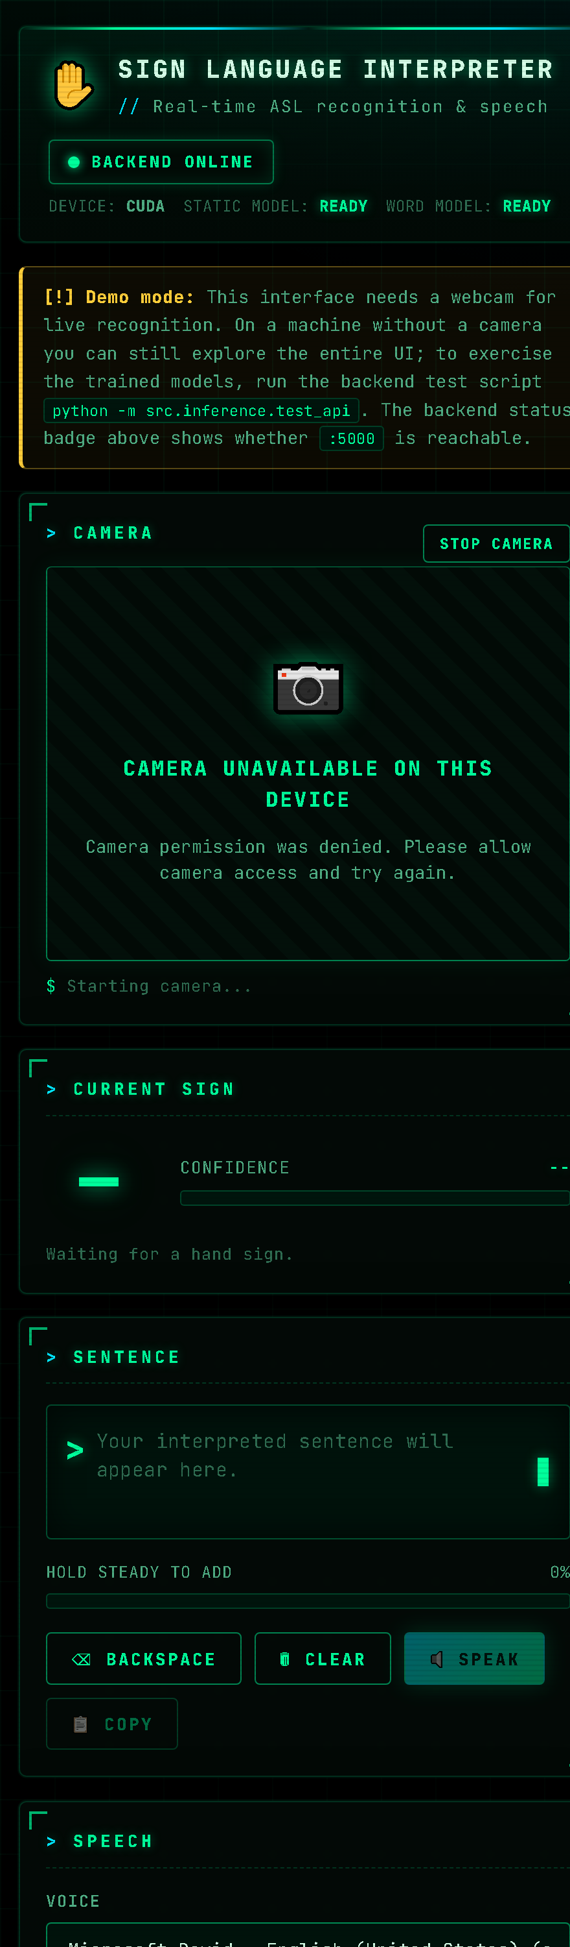
Figure 9. The same UI is responsive and collapses to one column on small screens.
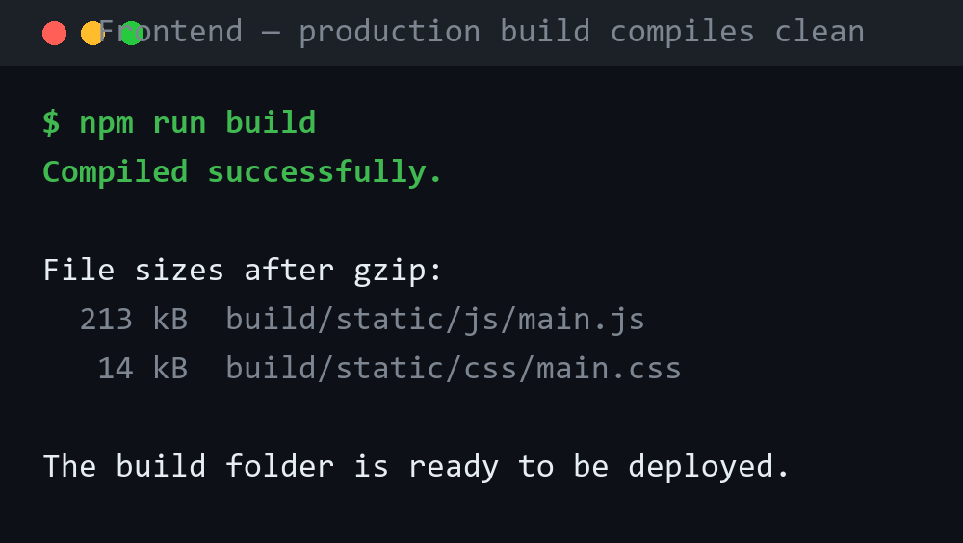
Figure 10. The website compiles cleanly into a production build.
8. Every File in the Project
Short description of every file, grouped by folder.
Root
File | What it does
config.py | Central settings: image size, number of hand points, all file paths. Used everywhere.
requirements.txt | The list of Python libraries to install.
README.md | Full technical readme.
HOW_TO_RUN.md | The simple, step-by-step run guide.
.gitignore | Files git should ignore (datasets, caches, models).
docs/
File | What it does
SETUP.md | How to install Python, the GPU PyTorch, and the frontend.
CUDA_GUIDE.md | How to turn on the NVIDIA GPU and check it works.
RUN_INSTRUCTIONS.md | The exact order of commands to build and run everything.
screenshots/ | All the images used in this document.
src/common/ (shared helpers)
File | What it does
landmarks.py | Uses MediaPipe to find 21 hand points; the ONE place that normalizes them.
utils.py | Small helpers: set random seed, save/load JSON, pad sequences to a fixed length.
src/preprocessing/ (turn data into numbers)
File | What it does
preprocess_asl_alphabet.py | Turns 87,000 letter images into hand-point data (.npz).
preprocess_wlasl.py | Turns sign-language videos into sequences of hand points (.npz).
src/models/ (the AI designs)
File | What it does
static_model.py | The letter model (a small neural network, MLP) plus save/load.
dynamic_model.py | The word model (an LSTM that understands movement) plus save/load.
src/training/ (teach the models)
File | What it does
train_static.py | Trains the letter model on the GPU; saves the best one + an accuracy graph.
train_dynamic.py | Trains the word model on the GPU; saves the best one + an accuracy graph.
src/inference/ (use the models)
File | What it does
static_predictor.py | Loads the letter model and predicts a letter from hand points.
dynamic_predictor.py | Loads the word model and predicts a word from a sequence.
webcam_demo.py | A standalone laptop webcam demo using OpenCV (no website needed).
test_api.py | Tests the backend WITHOUT a camera by sending sample data.
backend/ (Flask web server)
File | What it does
app.py | The Flask API with all the endpoints (health, labels, predict).
model_manager.py | Loads both models and runs predictions safely.
requirements.txt | Backend-only Python libraries.
README.md | How to run and test the backend.
frontend/ (React website)
File | What it does
package.json | Frontend libraries (React, MediaPipe) and run scripts.
.env.example | Setting for the backend address (http://localhost:5000).
public/index.html | The web page shell, title, and terminal fonts.
src/index.js | Starts the React app.
src/index.css | Global dark theme: black background, scanlines, neon colours.
src/App.js | The main screen; ties everything together and sends landmarks to the backend.
src/App.css | The hacker terminal styling for every part of the UI.
src/api.js | The functions that call the backend endpoints.
src/hooks/useWebcam.js | Runs MediaPipe in the browser and reads the hand points.
src/hooks/useSpeech.js | Controls the Web Speech API (text to speech).
src/components/Header.js | Title bar and live backend status badge.
src/components/CameraFeed.js | The video and hand-skeleton overlay (or the no-camera placeholder).
src/components/PredictionOverlay.js | Shows the current sign and confidence.
src/components/SentenceBuilder.js | Builds the sentence; space, delete, clear, speak, copy.
src/components/SpeechControls.js | Voice, speed, pitch, and auto-speak controls.
models/ and data/ (created by training)
File | What it does
models/static_mlp.pt | The trained letter model (99.48%).
models/static_labels.json | The 29 letter names.
models/dynamic_lstm.pt | The trained word model (83.87%).
models/dynamic_labels.json | The 10 word names.
models/*_history.png | The training accuracy graphs.
data/processed/asl_landmarks.npz | Processed letter hand-point data.
data/processed/wlasl_sequences.npz | Processed word sequence data.
9. How to Run It (Short Version)
The models are already trained and included, so you can run the app right away. Open two terminals in the project folder.
Terminal 1 — the AI server
pip install torch torchvision
pip install -r requirements.txt
python -m backend.app
Terminal 2 — the website
cd frontend
npm install
copy .env.example .env
npm start
The site opens at http://localhost:3000. Tip: if npm is blocked on Windows, run Set-ExecutionPolicy -Scope CurrentUser -ExecutionPolicy RemoteSigned , or use npm.cmd. Full details are in HOW_TO_RUN.md.
10. Technology Used
Area | Tools
Language | Python 3.11, JavaScript (React)
AI / ML | PyTorch (CUDA), MediaPipe Hands, scikit-learn, NumPy
Computer vision | OpenCV
Backend | Flask, Flask-CORS
Frontend | React 18, MediaPipe JS, Web Speech API
GPU | NVIDIA GeForce RTX 4060 Ti, CUDA 12.1
11. Limitations and Future Work
- Few clips per word — the word model learns from only 14-17 videos per word, so it knows 10 words. More clips would add more words.
- J and Z — these letters need movement in real ASL, but the image dataset stores them as still poses.
- Future ideas — more words, sentence grammar, Pakistani Sign Language, data augmentation, and a phone app.

Made by Ahmed Raza, Humdia Amjad and Hafsa Irfan • University AI Project • 2026

