Preparing a TERM
bottom-up regional database

by
Mark Horridge
Centre of Policy Studies
Monash University

Preliminary Draft
March 2006
6/03/2006 01:42:00 PM

Contents
1 Introduction 1
1.1 The example files 1
2 Overview 2
3 The starting point 4
3.1 Additional data 4
4 Stage 1: Input Checking and Setup 6
4.1 INIT job: check data; and produce template files for supplementary data 6
4.2 REG0 job: Simplify 6
4.2.1 Simplify national flows data 6
4.2.2 Check and revise supplementary regional data 6
5 Stage 2: Constructing the Bottom-up database 8
5.1 REG1 job: split users by destination 8
5.2 REG2 : Form TRADE matrix 10
5.3 RAS the trade matrices 11
5.4 PstRAS: cleanup after RAS 13
5.5 Premod: consolidate final format 13
6 Stage 3: Aggregation and Trial Simulation 13
6.1 Aggregate 13
6.2 Run the model 13

Tables
Table 1: Data in the RegSupp file 5
Table 2: Balance conditions 11
Table 3: Main batch file MkData.bat 14
Table 4: Programs and files of MkData.bat 15
Figures
Figure 1: Data process overview 3
Figure 2: National database in ORANIG format 5
Figure 3: Simplified database after REG0 job 7
Figure 4: Database after REG1 job 9
Figure 5: Final form of TERM database 12

Preparing a TERM bottom-up regional database

Introduction
This document desribes a process for constructing databases to use with the TERM multi-regional CGE model. Other TERM material may be found at:
http://www.monash.edu.au/policy/term.htm
As Figure 5 shows, a complete TERM database contains regional input-output tables and trade matrices. Such data is usually hard to find, or, if found, is of poor quality and lacks sectoral detail. The TERM data strategy is to construct the regional IO tables and trade matrices from less detailed (but more easily available) sources.
The TERM database is produced from very limited regional data in several steps. Key features of this strategy are:
- The process starts with a national input-output table and certain regional data. The minimum requirement for regional data is very modest: the distribution between regions of industry output and of final demand aggregates. Most of these regional data are already contained in ORANI-G databases which implement a "tops-down" regional extension.
- The database is constructed at the most disaggregated sectoral and regional level. This is useful when estimating missing data. The database may be aggregated prior to running the model (to reduce solution time).
- A number of simple or default assumptions are used – which might be replaced if more data became available.
Accompanying this document is a series of GEMPACK programs and batch files which implement the complete process of turning an ORANI-G database into a TERM database. Country-specific details have been omitted from the programs, to allow them to be applied easily to data from any country. If you adapted the programs for use with a particular country data-set, you could probably find additional data to replace some of the default assumptions.
The TAB files containing the GEMPACK programs will supply the most detailed documentation. This document is intended to give an overview of the process and to explain how the different programs are linked together.

The example files
Example files are supplied in a zip archive, which you should unpack into a new folder with a short name (eg, C:\termdat). To save space, the archive does not contain EXE files which are needed to run the data. To generate the EXE files, you would need a copy of source-code (Fortran) version 8 or later. Compilation (TABLO and LTG) occurs automatically the first time you run MKDATA.BAT.
Included for illustrative purposes is an example Chinese database, derived from GTAP version 6 data. At the time of writing (Feb 2006) CoPS is eagerly awaiting the issue of new Chinese IO tables which can be used to construct a better multi-regional database for China.

Overview
The data process is driven by a master batch file, MKDATA.BAT, reproduced in Table 3. This master script in turn invokes a number of shorter batch files and programs, described in Table 4.
Figure 1 shows a broad overview of the process, divided into 3 stages.
- Stage 1: input checking and setup
Checks the initial single country database and creates template files for additional data (if these files are not already present).
- Stage 2: constructing the bottom-up database
Uses regional production and final demand shares to split columns (users) of national database.
Deduces regional supply and demand for each good (domestic or imported)
Constructs a trial trade matrix
Scales the trial trade matrix so it adds to regional supply and demand
Formats the data as required by the TERM model
- Stage 3: aggregation and trial simulation
Aggregates regions and sectors, if necessary, so the model will run more quickly
Performs a trial simulation
Checks that updated data from the trial simulation is balanced.

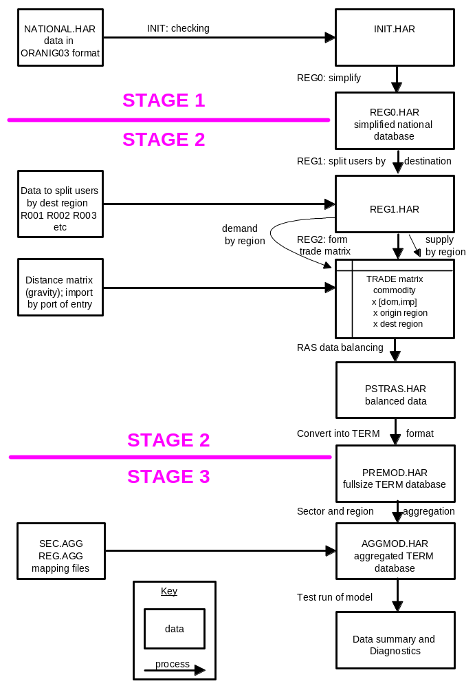

Figure 1: Data process overview

The starting point
The TERM data process starts with a national CGE database in the format used by the ORANI-G model. This format is depicted in Figure 2. The column headings in the main part of the figure (an absorption matrix) identify the following agents:
(1) domestic producers divided into I industries;
(2) investors divided into I industries;
(3) a single representative household;
(4) an aggregate foreign purchaser of exports;
(5) an ‘other’ demand category, broadly corresponding to government; and
(6) changes in inventories of domestically produced goods.
The entries in each column show the structure of the purchases made by the agents identified in the column heading. Each of the C commodity types identified in the model can be obtained locally or imported from overseas. The source-specific commodities are used by industries as inputs to current production and capital formation, are consumed by households and governments, are exported, or are added to or subtracted from inventories. Only domestically produced goods appear in the export and inventory columns. M of the domestically produced goods are used as margins services, for instance, trade and transport which are required to transfer commodities from their sources to their users. Commodity taxes are payable on the purchases. As well as intermediate inputs, current production requires inputs of three categories of primary factors: labour (divided into O occupations), fixed capital, and agricultural land. 'Production Taxes' covers various miscellaneous industry expenses, including production taxes or subsidies.
Each cell in the illustrative absorption matrix in Figure 2 contains the name of the corresponding data matrix. For example, V2MAR is a 4-dimensional array showing the cost of M margins services on the flows of C goods, both domestically produced and imported (S), to I investors.
In principle, each ORANIG industry is capable of producing any of the C commodity types. The MAKE matrix at the bottom of Figure 5.2 shows the value of output of each commodity by each industry. Finally, tariffs on imports are assumed to be levied at rates which vary by commodity but not by user. The tariff vector V0TAR represents the revenue obtained.
Databases for other national CGE models could also form a suitable starting point, especially if, like ORANI-G, they included a detailed treatment of margins.
The ORANI-G database also includes regional shares of national output and demand, ie, the proportions needed to split each column of Figure 2 into R regional columns. These are described in section 5.1.

Additional data
4 additional data files are needed:
- Regsupp.har contains additional regional data listed in Table 1.
- Sec.agg and reg.agg specify how regions and sectors are to be aggregated prior to running the model.
- DistGone.har shows average origin-destination distance of commodities used in each region.
If any of these files are missing, the procedure will create suitably formatted files to use instead (filled with arbitrary data). If Regsupp.har, Sec.agg or reg.agg are created automatically in this way, the user should edit them to insert her own data. For Distgone.har, a boot-strapping procedure is used: estimates of commodity trip distances are available when all data jobs are complete -- these are used to revise Distgone.har.

 |  | Absorption Matrix
 |  | 1 | 2 | 3 | 4 | 5 | 6
 |  | Producers | Investors | Household | Export | Other | Change in  Inventories
 | Size | ← I → | ← I → | ← 1 → | ← 1 → | ← 1 → | ← 1 →
Basic Flows | ↑  C×S  ↓ | V1BAS | V2BAS | V3BAS | V4BAS | V5BAS | V6BAS
Margins | ↑  C×S×M  ↓ | V1MAR | V2MAR | V3MAR | V4MAR | V5MAR | n/a
Taxes | ↑  C×S  ↓ | V1TAX | V2TAX | V3TAX | V4TAX | V5TAX | n/a
Labour | ↑  O  ↓ | V1LAB
Capital | ↑  1  ↓ | V1CAP | C =103: number of commodities,  I =97: number of industries,
Land | ↑  1  ↓ | V1LND | S =2: domestic and imported,  O =9: number of occupation types,
Produc-tion Tax | ↑  1  ↓ | V1PTX | M =8: number of commodities used as  margins.

 | Joint Production Matrix |  |  | Import Duty
Size | ← I → |  | Size | ← 1 →
↑  C  ↓ | MAKE |  | ↑  C  ↓ | V0TAR

Figure 2: National database in ORANIG format

Table 1: Data in the RegSupp file
Header | Size | Coefficient | Description | Read by
DIST | reg*reg | distance | shortest distance from r to d | reg0
MSHR | com*org | mshr | share of national imports, by port of entry | reg1
RLOC |  |  | set RLOC truly local commodities | reg0 reg2
MWGT | reg*mar | marwgt | margin weighting | reg1 reg2
DMAR |  |  | set DMAR distance related margins | reg1 reg2
DFAC | com*src | distfac | distance factor for gravity formula | reg2
LMAR | mar | locmar | tendency for margin to be locally sourced | reg2
PO01 | dst | pop | regional population (millions) | premod
SGDD | com | sigmadomdom | between-region armington | premod
SMAR | mar | sigmamar | Elast. Of sub between regions of margin production | premod

Stage 1: Input Checking and Setup

INIT job: check data; and produce template files for supplementary data
As shown in Table 4, the purpose of the INIT job is to:
- Check the initial ORANI-G database national.har and write a clean copy, init.har
- Create templates for the additional needed data files: regsupp.har, sec.agg and reg.agg.
The template or dummy files are created to help the user by providing examples of correctly formatted input data. However, pre-existing files called regsupp.har, sec.agg or reg.agg are not replaced.

REG0 job: Simplify

Simplify national flows data
REG0 simplifies the ORANI-G data format, and discards some detail not required by TERM. The arrays V1BAS, V2BAS, V3BAS, etc of Figure 2 are consolidated into a single BASIC array dimensioned COM*SRC*USR, where USR is a set consisting of the industries plus individual final demanders. Investment demands are consolidated into a single column. Similar consolidated arrays TAX and MARGINS are constructed.
Industry differences in investment technology are recorded in a matrix of investment at purchaser's values by industry and commodity (INVEST in Figure 3). The ORANI-G database allows for import shares in investment usage to differ across industries; TERM does not.
Tariffs (non-user-specific) import tax revenues are reallocated into the user-specific TAX matrix.
We also move domestic stocks (size COM) to an industry type vector. This means that we treat them as within-factory stores. We subtract stocks from MAKE to reconcile with domestic cost. We ignore imported stocks.
The re-organized national flows database is depicted in Figure 3.

Check and revise supplementary regional data
REG0 also checks and revises the regional shares (R001 etc). It reads in a matrix showing some distances between regions and computes (using Floyd's alogorithm) other, non-recorded, distances.
If the file DistGone.har is missing (it shows average origin-destination distance of commodities used in each region) REG0 produces such a file, containing roughly estimated distances. Revised estimates of commodity trip distances will be available when all data jobs are complete -- these are used to revise Distgone.har.

 |  | Absorption Matrix
 |  | 1 | 2 | 3 | 4 | 5
 |  | Producers | Investors | Household | Export | Government
 | Size | ← I → | ← 1 → | ← 1 → | ← 1 → | ← 1 →
Use  Flows | ↑  C×S  ↓ | V1USE | V2USE | V3USE | V4USE | V5USE
Taxes | ↑  C×S  ↓ | V1TAX | V2TAX | V3TAX | V4TAX | V5TAX
Margins | ↑  C×S×M  ↓ | V1MAR | V2MAR | V3MAR | V4MAR | V5MAR
Labour | ↑  O  ↓ | V1LAB
Capital | ↑  1  ↓ | V1CAP | C =80: number of commodities,  I =80: number of industries,
Land | ↑  1  ↓ | V1LND | S =2: domestic and imported,  O =9: number of occupation types
Production  Tax | ↑  1  ↓ | V1PTX | M =5: number of commodities used as margins

 | Joint Production Matrix |  |  | Investment Purchasers Values |  |  | Inventories
Size | ← I → |  | Size | ← I → |  | Size | ← I →
↑  C  ↓ | MAKE |  | ↑  C  ↓ | INVEST |  | ↑  1  ↓ | STOCKS

Figure 3: Simplified database after REG0 job

Stage 2: Constructing the Bottom-up database
Stage 2 contains the "meat" of the data jobs. It is divided into 3 main substages:
- REG1: split users by destination
- REG2: construct matrices of inter-regional trade for both domestic and imported commodities
- RAS: scale the trade matrices to agree with regional demands and supplies

REG1 job: split users by destination
ORANI-G data includes regional shares of national output and demand. These shares are R001, R002, R003, R004, R005, and R006. R001 and R002 show the industry and investment shares across regions. R001 is a matrix size IND x REG where, for example, R001 (i,r) shows the proportion of national industry i which is located in region r. If we were to sum the proportions across regions, we would get 1, i.e., ∑_{r} R001 (i, r) = 1.
Similarly R003 and R005 show household and government spending shares across regions: each is a matrix size COM x REG.Again, ∑ _{r} R003("Vegetables", r) = 1.
R004 shows regional export shares by commodity. For example R004(c,r) shows the proportion of national exports of good c which leave from region r. Again ∑ _{r} R004(c, r) = 1.
R006 shows inventory shares by industry across regions.
By applying the above user shares to the national CGE database, we are able to split the user columns of Figure 3 according to destination region. Each regional database has the same format as the national. Import/domestic shares and industry input proportions are assumed to be uniform across regions.
The simplified national database of Figure 3 distinguishes margins by commodity, source (dom/imp) and margin type (Road, Rail, etc). At this stage we distribute the margins between regional uses in proportion to
- the underlying basic flows
- the average distance travelled by the good to each region
- a weight (MARWGT) reflecting the need for particular regions (e.g., small islands) to rely on particular margin types (e.g., water transport).
We split MAKE following the cost split. Since we removed stocks from the national MAKE, the regional MAKE follows the revised share of industry output (R001) which excludes stock cost.
The regional supplies of imports -- by region of entry, and commodity -- are shown in Figure 5 as a separate box, IMPORT(c, r).
BASIC and MARGIN arrays are combined into a single USE array, containing flows at "delivered" (basic+margin) values. TERM assumes that, for a given good and region, the basic/margin ratio is the same for all users. Information about this ratio is preserved in the arrays BASIC_U and MARGIN_U, formed by adding up over users.
At this point we are able to deduce regional demand for and supply of each commodity, domestic or imported [Supply(c,s,r) and Demand(c,s,r)]. Differences between the two are accomodated by inter-regional trade, treated in the next (Reg2) stage.

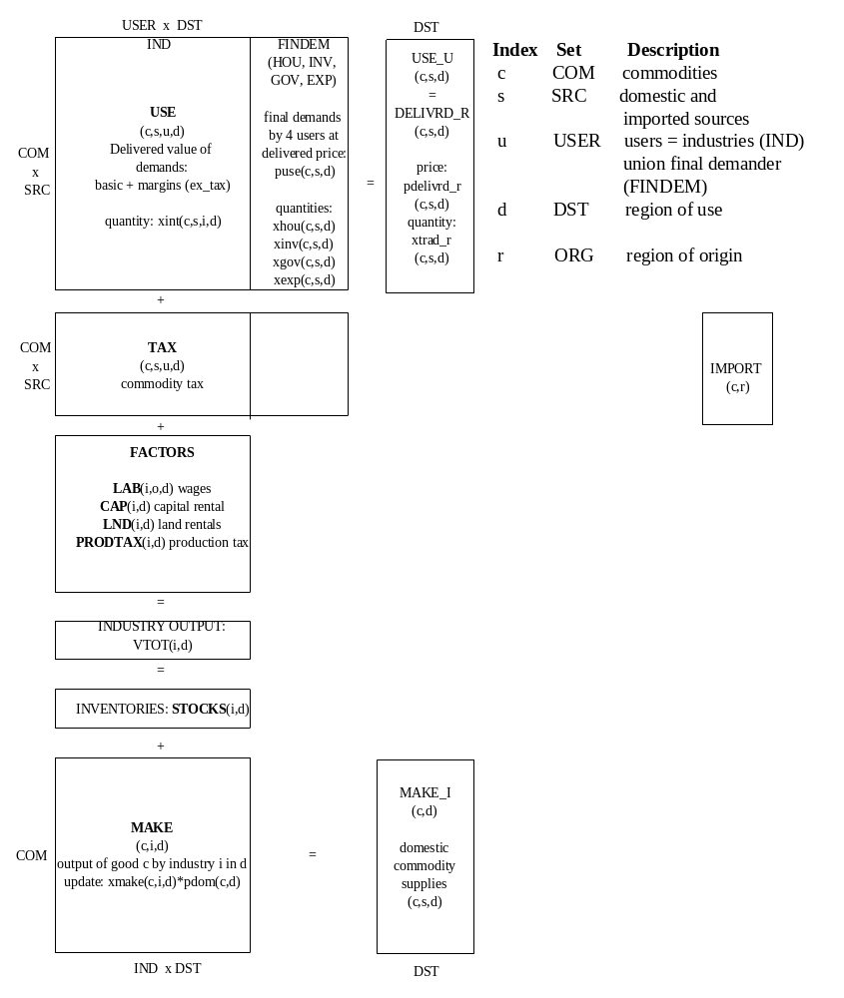

Figure 4: Database after REG1 job

REG2 : Form TRADE matrix
TERM requires a data array:
TRADE(c,s,r,d) = basic value of good c,s used in d and sourced from r
It is unusual to find such comprehensive data on inter-regional trade. Lacking this, the REG2 program estimates TRADE by a series of formulae, loosely based on a distance matrix and gravity approach.
As stated earlier, we already know 2 important control totals of TRADE:
ALLSUPPLY(c,s,r) = amount of c,s sourced from r = ∑d TRADE(c,s,r,d)
ALLDEMAND(c,s,d) = amount of c,s used in d = ∑r TRADE(c,s,r,d)
We aim in addition to guess:
SOURCESHR(c,s,r,d) = Share, of c to d, which comes from r
A conventional gravity formula would have the form:
SOURCESHR(c,s,r,d) = LAMBDA(c,s,d)*ALLSUPPLY(c,s,r)/[DISTANCE(r,d)^2]
where LAMBDA(c,s,d) is chosen to satisfy ∑r SOURCESHR(c,s,r,d) = 1
Such a formula requires an (arbitary) setting for DISTANCE(r,r), and for Australia, produced implausibly large amounts of inter-regional trade, particularly where small regions bordered large regions. So we applied a more complicated formula, as follows.
We start by estimating:
OWNSHARE(c,s,d) = Proportion of demand sourced locally = SOURCESHR(c,s,d,d)
via the formula:
OWNSHARE(c,s,d)= MIN[1, SUPPRATIO(c,s,d)]*[1 - (0.2^DISTFAC(c,s))];
where
SUPPRATIO(c,s,d) = ALLSUPPLY(c,s,d)/ALLDEMAND(c,s,d)
and
DISTFAC(c,s)= Distance factor for gravity formula,
normally 1, might be 2 for goods hard or unlikely to transport
That is, where local supply is sufficient to satisfy local demand, we guess that 80% of demand is locally sourced.
For the other (r<>d) elements of SOURCESHR(c,s,r,d) we guess:
SOURCESHR(c,s,r,d) = [ALLSUPPLY(c,s,r)^0.5]/[DISTANCE(r,d)^DISTFAC(c,s)]
*DEFREG(c,s,r)*LAMBDA(c,s,d)
where LAMBDA(c,s,d) is chosen to satisfy ∑r SOURCESHR(c,s,r,d) = 1
and DEFREG(c,s,r) = 0.1 for regions where SUPPRATIO(c,s,r) <1, and is otherwise 1.
For other countries, a different formula might produce more plausible results, or there might be some additional data which would reduce the load placed on the gravity formula.
By applying a share (SOURCESHR) we can infer TRADE values such that:
∑r TRADE(c,s,r,d) = ALLDEMAND(c,s,d)
but cannot be sure that:
∑d TRADE(c,s,r,d) = ALLSUPPLY(c,s,r)
To enforce both conditions at once, we must scale the TRADE matrix in subsequent RAS stages.

Similarly we calculate the trade margin matrix (TRADMAR in Figure 5)―the margin used to transfer commodity from r to d, using shares from the TRADE matrix and applying different margin weights (MARWGT) reflecting the need for particular regions (e.g., small islands) to rely on particular margin types (e.g., water transport).

RAS the trade matrices
We used a rassing method to reconcile the estimated TRADE matrix with accounting constraints. DELIVRD Flows (on the right hand side) must agree with USE Flows (on the left hand side). Both flows consist of basic and margin values but are indicated by different dimensions. Each should add to USE_U showing a summation of USE Flows.
DELIVRD is the sum of two sub-trade matrices, i.e. TRADE (showing basic value) and TRADMAR (showing margin value). A list of balancing conditions appears in Table 2 below:

Table 2: Balance conditions
Sum of TRADE over source regions should equal BASIC_U.
BASIC_U(c,s,d) = sum{r,REGSRC, TRADE(c,s,r,d)}
where
BASIC_U(c,s,d) Basic flows
TRADE(c,s,r,d) Trade matrix (basic values)
Sum of TRADMAR over source regions should equal MARGIN_U.
MARGINS_U(c,s,m,d) = sum{r,REGSRC,TRADMAR(c,s,m,r,d)}
where
MARGINS_U(c,s,m,d) Margins
TRADMAR(c,s,m,r,d) Margins on trade matrix
Sum of imported TRADE over source regions should equal IMPORT.
IMPORT(c,r) = sum{d,REGDST, TRADE(c,"imp",r,d)}
where
IMPORT(c,r) Imports, by port of entry
Sum of domestic TRADE over destinations should add to MAKE_I.
MAKE_I(c,r) = sum{d,REGDST, TRADE(c,"dom",r,d)} non-margin goods
MAKE_I(m,r) = sum{d,REGDST, TRADE(m,"dom",r,d)
+ sum{rr, REG, SUPPMAR(m,rr,d,r)}} margin goods
where
MAKE_I(c,d) Domestic supply
SUPPMAR(m,r,d,p) Margin m supplied by p on goods passing from r to d
Sum of SUPPMAR over margin producer regions should add to TRADMAR_CS,
which is also the sum of margins needed to transfer all goods from r to d.
TRADMAR_CS(m,r,d) = sum{c,COM, sum{s,SRC, TRADMAR(c,s,m,r,d)}}
TRADMAR_CS(m,r,d) = sum{p,REGPRD,SUPPMAR(m,r,d,p)}
where
TRADMAR_CS(m,r,d) Sum of margins on trade matrix

Two scaling approaches are used:
- TRDRAS: conventional scaling of one row or column at a time (traditional RAS)
- RASLIN: all cells are scaled at once (requiring us to solve a linear system).
In principle, both methods should give the same answer. In practice, the two methods have different strengths. Traditional RAS is simple and robust but sometimes is ineffective, eg, in scaling elements which form a very large share of more than one control total. The linear system approach, which uses more information, should be very efficient but can be difficult to set up correctly (eg, if some constraints are redundant, or if there are zero rows or columns). We apply three scales, in the order TRDRAS-RASLIN-TRDRAS.
The ChkRas program is before and after each RAS to measure how closely the balance conditions are satisfied, producing files named dgchkras?.HAR. The standard GEMPACK program cmbhar combines these files into one file (chkrasall.har), so you can see how errors reduced at different stages.
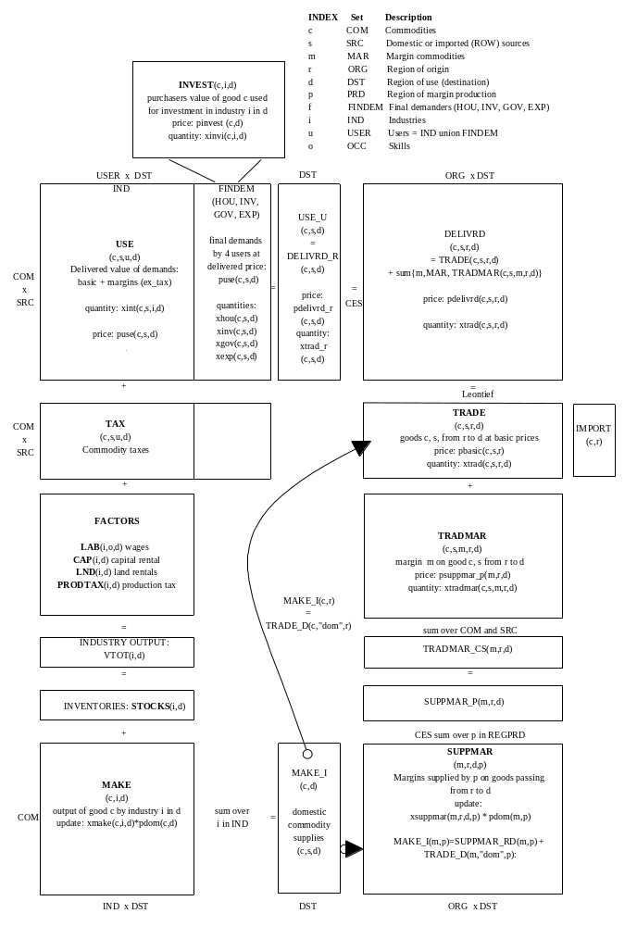

Figure 5: Final form of TERM database

PstRAS: cleanup after RAS
The PstRas program checks whether scaled trade data sums to targets and combine regional IO tables and trade data into one file. It also makes tiny changes to factor payments, MAKE and IMPORTS so that supply=demand.
The DistGone matrix is recomputed, and compared to the previous DistGone matrix. A flag value is writtten to the DIAG file to show if the values are nearly the same (flag=1 if the same else 0).
If old and new distances are not the same, the MkData batch file will pause, with the message:
Hit return to repeat average distance iteration
Average distance not yet converged
The user should press enter, and the procedure will return to the beginning of Stage 2. Normally 2 or 3 iterations are sufficient the first time MkData is run. Subsequent runs (which start with an optimized DistGone.Har) often require no repeat of Stage 2.

Premod: consolidate final format
The PreMod program is used to arrange the balanced regional data in the format required by TERM, and to include elasticity parameters, mostly drawn from original ORANI-G data.
TERM also requires two elasticity parameters not used in ORANI-G: SIGMAMAR(m), the constant elasticity of substitution (CES) between regions in supplying margin goods; and SIGMADOMDOM(c), the CES between goods from different regions of origin. Both are read from the REGSUPP file.

Stage 3: Aggregation and Trial Simulation

Aggregate
The AggHAR program uses files sec.agg and reg.agg to aggregate sectors and regions so that the model solves quicker and uses less RAM.

Run the model
The test simulation using the new data:
- Verifies that the model will run with the new data
- Calculates summary and diagnostic data from the input database, which may help check that the data is sensible (see file TermSum.har).

Table 3: Main batch file MkData.bat
rem TERM data process
rem inputs are: National.HAR (compulsory)
rem and optionally:
rem REGSUPP.HAR (additional regional data)
rem DISTGONE.HAR (average origin-destination distance of commodities)
rem SEC.AGG REG.AGG (used by preagg.cmf)
rem All optional files are created (if not present) by the procedure
:STAGE1
call rnInit
call rnREG0
:STAGE2
call rnReg1
call rnReg2
call rnchkrasa
call rnTrdRAS
call rnchkrasb
call rnRASLIN
call rnchkrasc
call rnTrdRAS2
call rnchkrasd
call rnPstras
REM rnPstRas creates a file repeat.dat
REM if the revised distance file distgone.har
REM is much different from the previous file distgone.old.
REM If repeat.dat exists, STAGE2 is restarted
dir repeat.dat
if not exist repeat.dat goto norepeat
echo Hit return to repeat average distance iteration
pause Average distance not yet converged
goto STAGE2
:norepeat
call rnPremod
:STAGE3
call rnChkmdA
call rnPreagg
call rnAgg
call rnAggset
call rnChkmdB
call rnTerm
call rnChkmdC

Table 4: Programs and files of MkData.bat
BAT file | Program | CMF file | Task STAGE 1 | Input | Output
rnInit | init.tab | Init.cmf | Checks initial ORANI-G database national.har; writes clean copy init.har  Creates dummy files of additional data needed to build TERM database:  dumsupp.har example of regsupp.har file of needed extra regional data  dumsec.agg example of sec.agg sector aggregation instructions  dumreg.agg example of reg.agg dummy region aggregation instructions | national.har | init.har  dumsupp.har  regsupp.har  dumsec.agg  dumreg.agg
rnreg0 | reg0.tab | reg0.cmf | Reformat ORANI-G style database init.har:  Aggregate investment columns; Move dom stocks to IND type vector; ignore imp stocks  Adjust R001 for truly local industries; Normalize distance matrix;  Store reformatted national database in reg0.har  Store elasticities to be used later in natelast.har  Store preliminary estimate of distgone(c,s,d) [Average distance travelled by goods] in distinit.har  [later, the pstras job works this out properly]. | init.har  regsupp.har | reg0.har  natelast.har  distinit.har  dgreg0.har
script |  |  | If file distgone.har does not exist, it is created as a copy of distinit.har
BAT file | Program | CMF file | Task STAGE 2 | Input | Output
rnReg1 | reg1.tab | reg1.cmf | Use regional shares to split user columns according to destination  Output: reg1.har !  Uses distances travelled by goods (from distgone.har) and regsupp headers:  Set dmar # Distance related margins # header "DMAR";!  Marwgt header "MWGT";!  Mshr header "MSHR" | reg0.har  distgone.har  regsupp.har | reg1.har  dgreg1.har
rnReg2 | reg2.tab | reg2.cmf | Construct trial trade matrices for later RASsing, using following headers from regsupp.har:  DISTFAC header "DFAC"; !  Set LOCAL # Truly local commodities # header "RLOC";!  Set DMAR # Distance related margins # header "DMAR";!  MARWGT header "MWGT";!  LOCMAR(m) # tendency for margin to be locally sourced # header "LMAR" | reg1.har regsupp.har | reg2.har  dgreg2.har
rnchkrasa | chkras.tab | chkrasa.cmf | used before or after RAS to check how closely conditions are satisfied; creates only diagnostic output | reg2.har | dgchkrasa.har
rnTrdRAS | TrdRAS.tab | TrdRAS.cmf | scale TRADE and margins TRADMAR and SUPPMAR to meet control totals using conventional scaling | reg2.har | trdras.har  dgtrdras.har
rnchkrasb | chkras.tab | chkrasb.cmf | check how closely RAS conditions are satisfied | trdras.har | dgchkrasb.har
rnRASLIN | raslin.tab | raslin.cmf | scale TRADE and margins TRADMAR and SUPPMAR to meet control totals, using linear system | trdras.har | raslin.har  dgraslin.har
rnchkrasc | chkras.tab | chkrasc.cmf | check how closely RAS conditions are satisfied | raslin.har | dgchkrasc.har
rntrdras2 | trdras.tab | trdras2.cmf | scale TRADE and margins TRADMAR and SUPPMAR to meet control totals, using conventional scaling | raslin.har | trdras2.har  dgtrdras2.har
rnchkrasd | chkras.tab | chkrasd.cmf | check how closely RAS conditions are satisfied | trdras2.har | dgchkrasd.har
rnPstras | pstras.tab | pstras.cmf | check whether rassed trade data sums to targets  combine regional IO tables and trade data into one file  make tiny changes to factor payments, MAKE and IMPORTS so that supply=demand!  Recompute distgone: write flag=1 to diag file if new distgone is very close to old distgone | trdras2.har  reg2.har  distgone.old | pstras.har  distgone.har  dgpstras.har
script |  |  | Note: rnPstRas creates a file repeat.dat if the revised distance file distgone.har differs from distgone.old.  Then, if repeat.dat exists, STAGE2 is restarted
rnpremod | premod.tab | premod.cmf | Assemble data in TERM format before simulation or aggregation  uses regsupp headers: sgdd (sigmadomdom); smar (sigmamar); po01 (pop). | pstras.har  regsupp.har  natelast.har | premod.har  orgsets.har  weights.har  dgpremod.har
BAT file | Program | CMF file | Task STAGE 3 | Input | Output
rnchkmda | chkmod.tab | chkmoda.cmf | Diagnostic only: Check/summarize TERM data file before aggregation | premod.har  orgsets.har | dgchkmda.har
rnpreagg | preagg.tab | preagg.cmf | Prepare AGGSUPP file for AGGHAR program | weights.har  orgsets.har  sec.agg  reg.agg | aggsupp.har  mapagg.har
rnagg | agghar.exe |  | Aggregate regions and sectors of TERM database | premod.har  aggsupp.har | aggmod.har
rnaggset | aggset.tab | aggset.cmf | Creates separate TERM sets file from main data file | aggmod.har | aggsets.har
rnchkmdb | chkmod.tab | chkmodb.cmf | Check/summarize TERM data file before simulation | aggmod.har  aggsets.har | dgchkmdb.har
rnterm | term.tab | term.cmf | Perform test simulation | aggmod.har  aggsets.har | termsum.har  term.upd
rnchkmdc | chkmod.tab | chkmodc.cmf | Check/summarize updated data from simulation | term.upd  aggsets.har | dgchkmdc.har
NOTES
(1) Process uses helper (non-TABLO) programs: later.exe seterr.exe diffhar.exe agghar.exe tsthar.exe
(2) Before running each TAB program, the batch file COMPILE is called. COMPILE.BAT runs TABLO and LTG for %1.TAB only IF NECESSARY. It uses helper programs LATER.EXE and SETERR.EXE.

For example, the Australian version of TERM recognizes 56 regions grouped into 8 states. Some data is available at the 8-state level but not for 56 regions.
TERM does not assume that wheat exported from region r is produced in region r. We emphasize that the R004 shares should show from which port goods leave the country.
The estimates of average distance are refreshed at the PstRas of the data process. Initially, arbitrary estimates are used.

