FortiGate-Based Multi-Site Network Design, Routing & Security
DETAILED PROJECT DOCUMENTATION
PROJECT TEAM
Ahmed Saeed • Mohamed Arafa
Kerolos Mosa • Alaa Sayed
FortiGate • VLANs • OSPF • HA • Firewall • NAT • IPS
Antivirus • Web Filter • Application Control • IPsec VPN
◈ CYBERSECURITY • NETWORK ENGINEERING ◈
ENTERPRISE NETWORK
SECURITY PROJECT

Executive Summary
AI-STYLE PROJECT SNAPSHOT | 3 SITES • FORTIGATE SECURITY • ROUTING • VPN • DEFENSE IN DEPTH
This document describes the implementation of a multi-site enterprise network built around FortiGate security gateways. The supplied topology contains a Headquarters (HQ), Branch 1 (BR1), Branch 2 (BR2), multiple ISP routers, redundant switching, internal servers, client endpoints, a DMZ, and a remote-user environment.
The project is not only a connectivity lab. It combines network design and cybersecurity controls. Internal networks are segmented into VLANs according to business function; FortiGate performs gateway and policy enforcement; HA improves availability; OSPF provides dynamic routing; firewall policies control traffic; NAT provides controlled Internet access; and security profiles inspect traffic for malware, intrusion attempts, and unwanted web content. IPsec tunnels provide encrypted communication between sites.

What was implemented
- Enterprise VLAN segmentation for Users, Servers, Management and DMZ.
- FortiGate VLAN interfaces and DHCP scopes.
- Redundant FortiGate HA at HQ.
- Point-to-point WAN addressing using /30 networks.
- OSPF routing with a dedicated router ID and configured networks/interfaces.
- Firewall policies for Internet, inter-branch and internal communication.
- NAT for Internet-bound user traffic.
- Antivirus, IPS, Web Filter and Application Control security profiles.
- Virtual IP (VIP) / static NAT for publishing the DMZ web server.
- IPsec VPN tunnels between HQ and BR1 and between HQ and BR2.
- Connectivity and configuration verification using FortiGate GUI and Cisco router CLI.

Table of Contents
1. Project Background and Goals
2. Complete Topology Explanation
3. IP Addressing and VLAN Plan
4. HQ Network Implementation
5. Branch 1 Implementation
6. Branch 2 Implementation
7. FortiGate Interfaces and DHCP
8. High Availability (HA)
9. WAN and Dynamic Routing
10. Firewall Policies
11. NAT and DMZ Web Publishing
12. Antivirus Profile
13. IPS Profile
14. Web Filter
15. Application Control
16. SSL/SSH Inspection and Certificates
17. IPsec VPN
18. Verification and Testing
19. Troubleshooting and Design Considerations
20. Security Architecture Summary
21. Conclusion
KEY TAKEAWAY • SEGMENT → CONTROL → INSPECT → ENCRYPT → VERIFY
Appendix A – Screenshot Evidence

1. Project Background and Goals
The main challenge in an enterprise network is to provide connectivity without making the entire environment one flat trusted network. A secure design therefore separates users, servers, management systems and publicly reachable services, then places security controls between those zones.

1.1 Main goals
- Create a scalable three-site topology.
- Separate endpoint categories into dedicated VLANs and IP subnets.
- Provide centralized security enforcement using FortiGate.
- Maintain availability through firewall redundancy at HQ.
- Use dynamic routing to exchange network reachability across the WAN.
- Protect Internet-bound traffic using firewall policy and security inspection.
- Publish the DMZ web service without directly exposing the internal server address.
- Secure inter-site traffic using IPsec.

1.2 Why segmentation matters
If all clients, servers and management devices share one broadcast domain, a compromise of one endpoint can make lateral movement easier. VLANs reduce that exposure. In this project, the Users VLAN is separate from Servers, Management and DMZ, allowing the firewall to enforce different rules for each traffic class.

2. Complete Topology Explanation
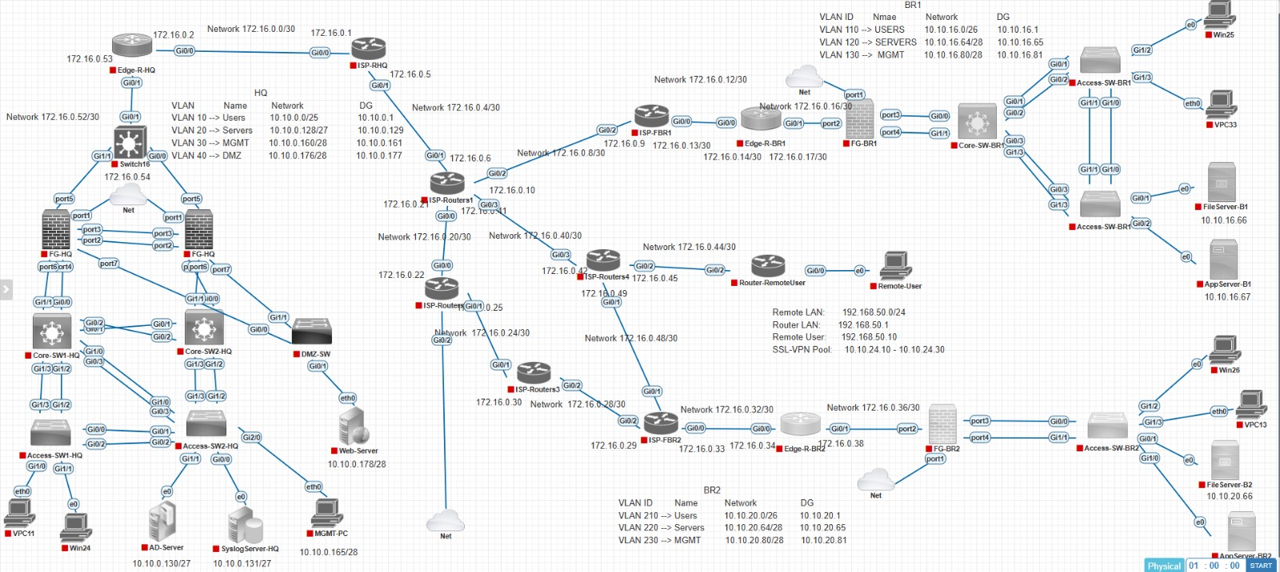
Figure 1. Complete supplied project topology
The topology is organized around three protected enterprise locations. HQ is the central site and contains the most extensive server and management infrastructure. BR1 and BR2 provide branch networks. The WAN contains multiple ISP routers and /30 point-to-point links, giving the environment a realistic routed backbone.

2.1 HQ
- Edge-R-HQ connects the HQ environment toward the ISP side.
- FG-HQ1 and FG-HQ2 form the FortiGate HA pair.
- Core-SW1-HQ and Core-SW2-HQ provide redundant core switching.
- Access-SW1-HQ and Access-SW2-HQ connect endpoints.
- A DMZ switch hosts the Web Server.
- AD Server, Syslog Server and management systems are present in the internal environment.

2.2 BR1
- Edge-R-BR1 connects the branch to the WAN.
- FG-BR1 provides the branch security gateway.
- Core-SW-BR1 and two access switches provide switching connectivity.
- BR1 contains Users, Servers and Management VLANs.
- File Server and App Server resources are shown in the branch.

2.3 BR2
- Edge-R-BR2 connects the branch to the WAN.
- FG-BR2 provides branch firewalling.
- Core-SW-BR2 and access switching connect endpoints.
- BR2 contains Users, Servers and Management VLANs.
- File Server and App Server resources are shown in the branch.

3. IP Addressing and VLAN Plan
The VLAN information visible in the topology is:
Site | VLAN | Role | Network | Gateway
HQ | 10 | Users | 10.10.0.0/25 | 10.10.0.1
HQ | 20 | Servers | 10.10.0.128/27 | 10.10.0.129
HQ | 30 | Management | 10.10.0.160/28 | 10.10.0.177*
HQ | 40 | DMZ | 10.10.0.176/28 | 10.10.0.177
BR1 | 110 | Users | 10.10.10.0/26 | 10.10.10.1
BR1 | 120 | Servers | 10.10.10.64/28 | 10.10.10.65
BR1 | 130 | Management | 10.10.10.80/28 | 10.10.10.81
BR2 | 210 | Users | 10.10.20.0/26 | 10.10.20.1
BR2 | 220 | Servers | 10.10.20.64/28 | 10.10.20.65
BR2 | 230 | Management | 10.10.20.80/28 | 10.10.20.81

*The supplied topology labels the HQ Management gateway as 10.10.0.81 in one visible table, while the FortiGate interface screenshot shows VLAN30-MGMT as 10.10.0.161/28. Because the screenshots contain this apparent inconsistency, the final implementation should be checked against the actual FortiGate interface configuration before treating the topology label as authoritative.

3.1 WAN addressing
The diagram uses /30 point-to-point networks in the 172.16.0.0 range. Examples visible in the topology include 172.16.0.0/30, 172.16.0.4/30, 172.16.0.8/30, 172.16.0.12/30, 172.16.0.16/30, 172.16.0.20/30, 172.16.0.24/30, 172.16.0.28/30, 172.16.0.32/30, 172.16.0.36/30, 172.16.0.40/30 and 172.16.0.44/30. The /30 size is appropriate for point-to-point router links because it provides two usable host addresses.

3.2 Remote user addressing
- Remote LAN: 192.168.50.0/24.
- Remote LAN gateway: 192.168.50.1.
- Remote user: 192.168.50.10.
- The topology also shows an SSL-VPN pool beginning at 10.10.24.10 and ending at 10.10.24.30.

4. HQ Network Implementation
HQ is the central and most security-sensitive site. The FortiGate pair sits between the WAN and the internal switching infrastructure. The core switches connect the access layer and the DMZ switch.

4.1 HQ VLANs
- VLAN 10 – Users: normal employee/client endpoints.
- VLAN 20 – Servers: internal server resources.
- VLAN 30 – Management: administration and infrastructure management.
- VLAN 40 – DMZ: services intended to be reachable from less-trusted networks.

4.2 HQ services
- Web Server is placed in the DMZ and is published using a FortiGate VIP.
- AD Server provides directory/authentication services.
- Syslog Server is used as a central log destination in the topology.
- Management PC and Windows endpoints are connected to internal switching.
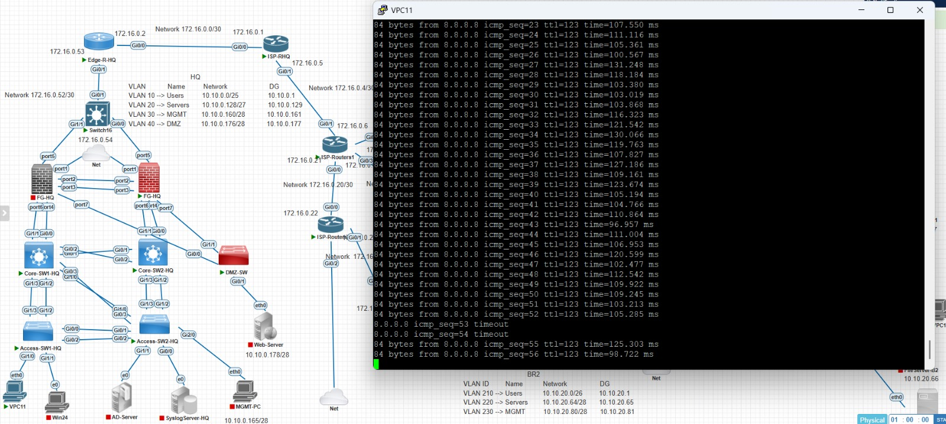
Figure 2. HQ HA and interface-related evidence from the supplied screenshots

5. Branch 1 Implementation
BR1 is designed as a protected branch with its own FortiGate and three functional VLANs. The branch uses VLAN 110 for users, VLAN 120 for servers and VLAN 130 for management.

5.1 BR1 VLANs
VLAN | Role | Subnet | Gateway
110 | Users | 10.10.10.0/26 | 10.10.10.1
120 | Servers | 10.10.10.64/28 | 10.10.10.65
130 | Management | 10.10.10.80/28 | 10.10.10.81

The firewall policy screenshots show a policy named Users-To-Internet for VLAN110-Users. The policy permits HTTP, HTTPS and PING and has NAT enabled, with Users-AV and WebFilter-BR1 security profiles attached.
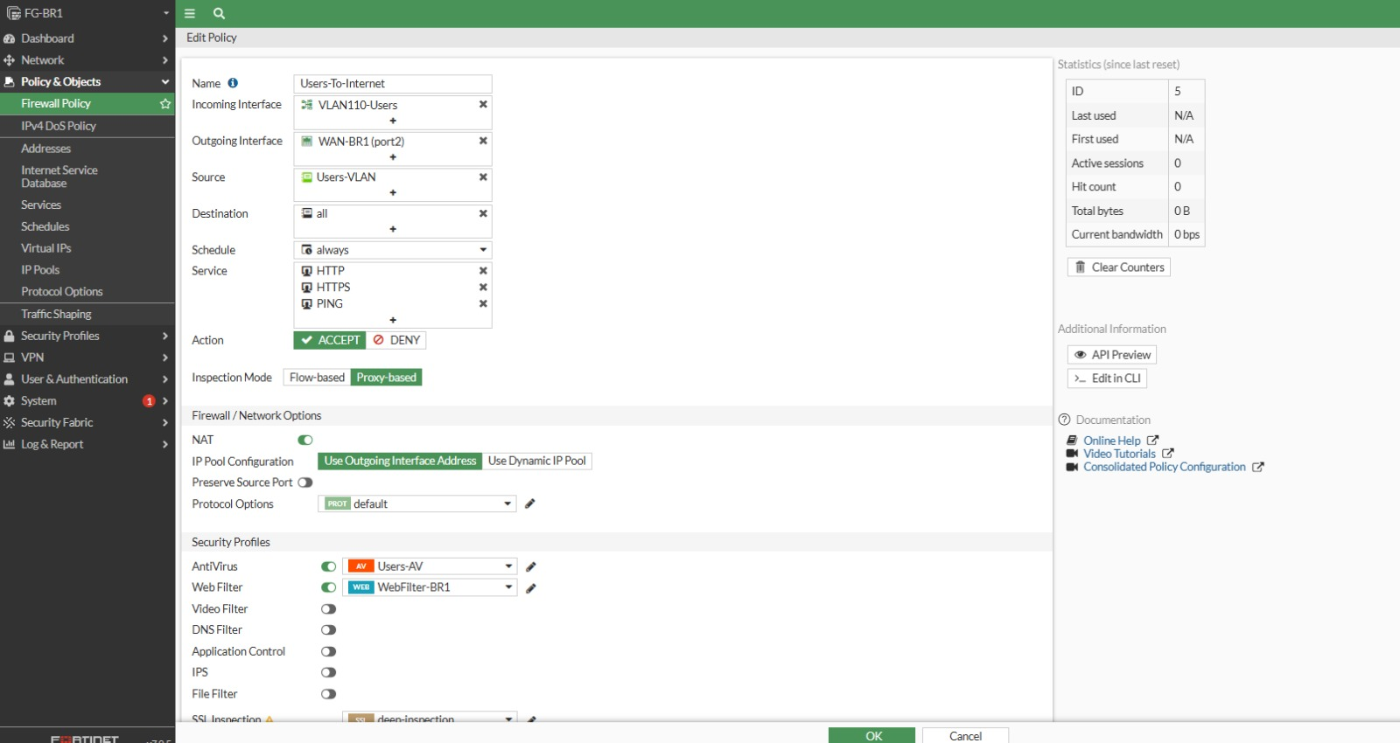
Figure 3. BR1 Users-To-Internet policy configuration
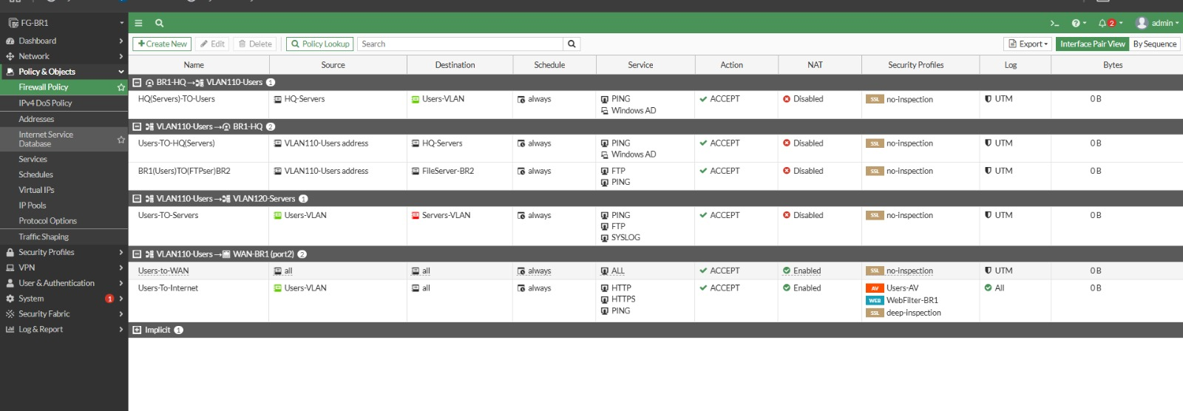
Figure 4. BR1/HQ and inter-network policy lookup

6. Branch 2 Implementation
BR2 follows the same segmentation principle while using a separate address space. Its user, server and management networks are isolated logically and routed through FG-BR2.
VLAN | Role | Subnet | Gateway
210 | Users | 10.10.20.0/26 | 10.10.20.1
220 | Servers | 10.10.20.64/28 | 10.10.20.65
230 | Management | 10.10.20.80/28 | 10.10.20.81

The supplied policy screenshot shows a BR2 Users-To-Internet rule with NAT enabled and the branch security profiles associated with the traffic. The branch also participates in the inter-site VPN design.
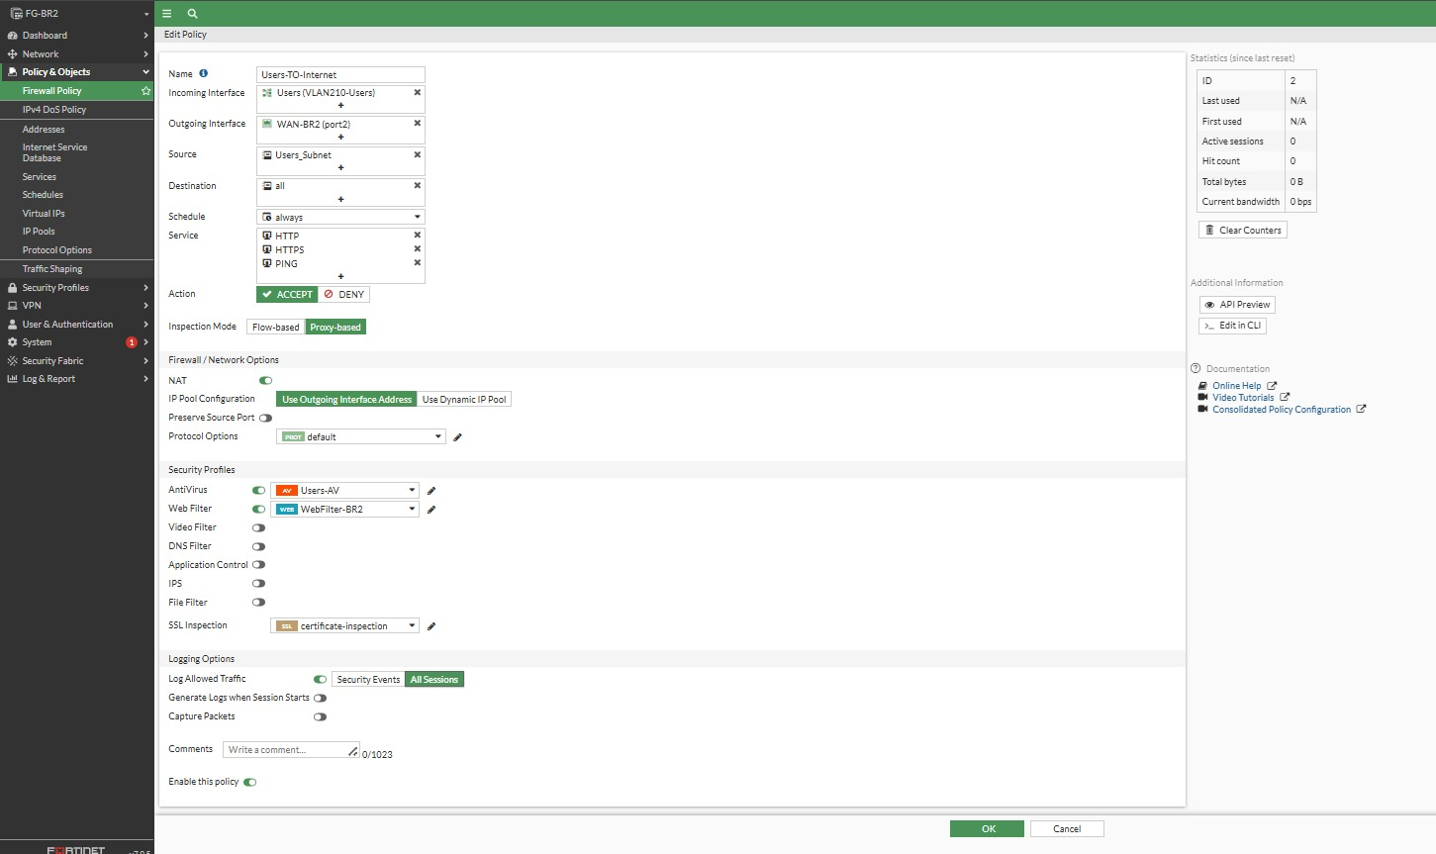
Figure 5. BR2 user policy/security settings

7. FortiGate Interfaces and DHCP

7.1 Aggregate interface
The HQ FortiGate interface list shows an 802.3ad aggregate used for the LAN side. An aggregate combines multiple physical links into one logical interface. In a switching environment this improves resilience and can provide additional capacity when correctly matched with the switch-side configuration.
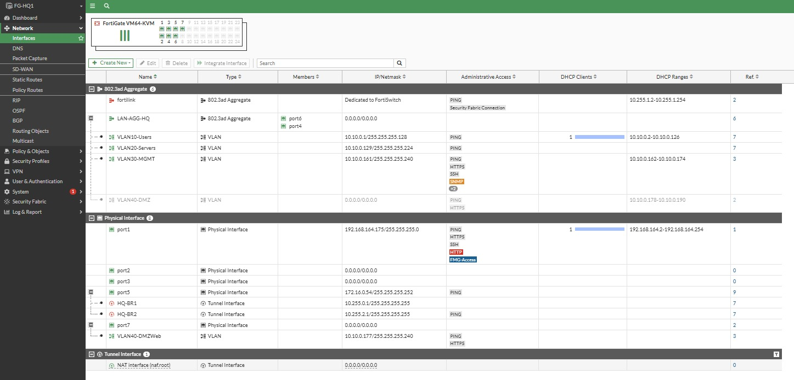
Figure 6. FortiGate interface list and aggregate/LAN configuration

7.2 HQ VLAN 10 interface
The screenshot identifies VLAN10-Users as a VLAN interface with address 10.10.0.1/25. PING administrative access is enabled. The DHCP client/range area shows a user scope starting at 10.10.0.2 and ending at 10.10.0.126, which matches the /25 subnet's usable range.
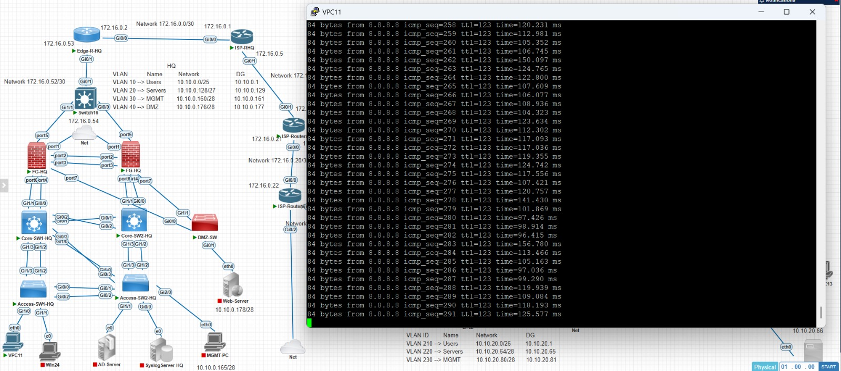
Figure 7. VLAN10-Users interface and DHCP information

7.3 Why DHCP is useful here
DHCP removes the need to manually configure every endpoint. The gateway is supplied by FortiGate, so a client can automatically obtain an address, mask and routing information. It also makes endpoint deployment more consistent and reduces addressing mistakes.

8. High Availability (HA)
HQ uses two FortiGate VM instances in an HA cluster. The screenshots explicitly identify a Primary and Secondary role and show both members as synchronized. The HA design is intended to prevent a single firewall failure from taking the whole HQ site offline.

8.1 Primary and secondary roles
The primary unit handles active traffic processing. The secondary unit maintains synchronized configuration and state information as supported by the configured HA mode. If the primary becomes unavailable, the secondary can assume the active role according to the HA election/failover configuration.

8.2 Heartbeat links
HA heartbeat traffic is used by cluster members to monitor one another. The heartbeat mechanism allows members to determine whether peers are alive and whether cluster synchronization is healthy.

8.3 What should be checked during HA verification
- Cluster status is healthy.
- Both members are synchronized.
- Primary/secondary roles are clearly identified.
- Heartbeat interfaces are up.
- Configuration synchronization is successful.
- Failover behavior is tested only in a controlled lab/maintenance window.
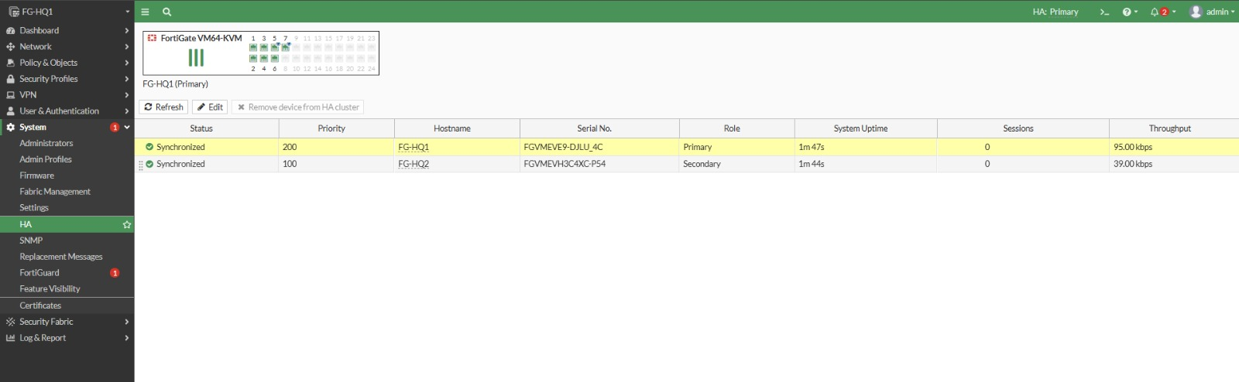
Figure 8. HA members and synchronization status
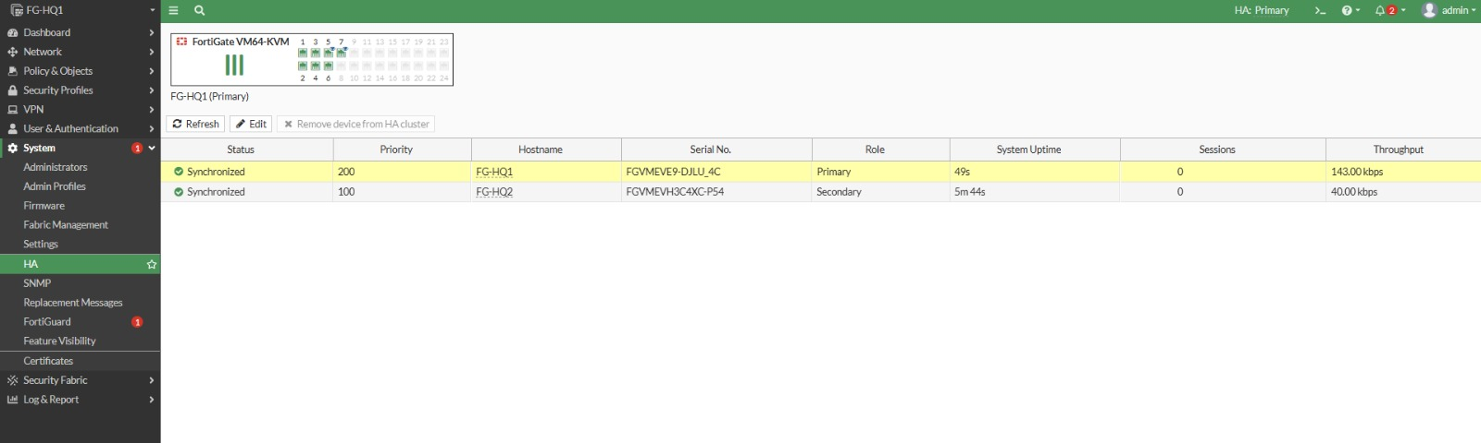
Figure 9. HA member details

9. WAN and Dynamic Routing
The WAN topology is intentionally more complex than a single router-to-router link. Multiple ISP routers form a routed backbone, while the site edge routers and FortiGate devices connect into this environment.

9.1 OSPF on FortiGate
The FortiGate OSPF page shows Router ID 1.1.1.1, Area 0, and networks including 10.10.0.0/25, 10.10.0.128/27, 10.10.0.160/28, 10.10.0.176/28, 10.255.0.0/30 and 10.255.2.0/30. Interfaces named HQ-BR1 and HQ-BR2 are also shown under OSPF.
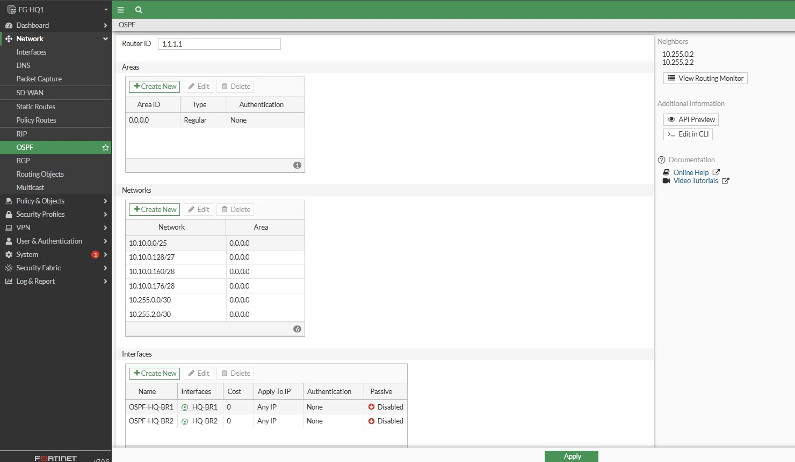
Figure 10. FortiGate OSPF configuration

9.2 OSPF on Cisco ISP router
The router CLI screenshot shows router ospf 1 and interface-level OSPF statements such as ip ospf 1 area 0. It also shows default-information originate, which can advertise a default route into OSPF when the router has a suitable default route.
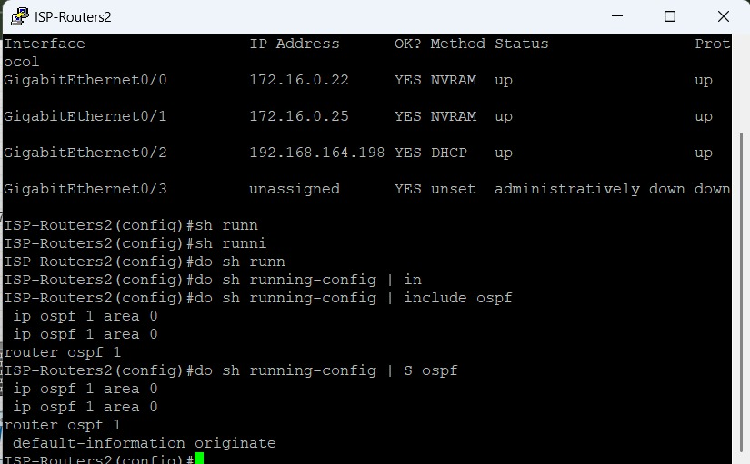
Figure 11. Cisco router OSPF configuration and interface status

9.3 Routing table verification
The routing-table screenshot contains OSPF route codes and a last-resort/default route. This is the key verification step: configuration alone does not prove that routing is working; the learned routes and next hops must be visible in the routing table.
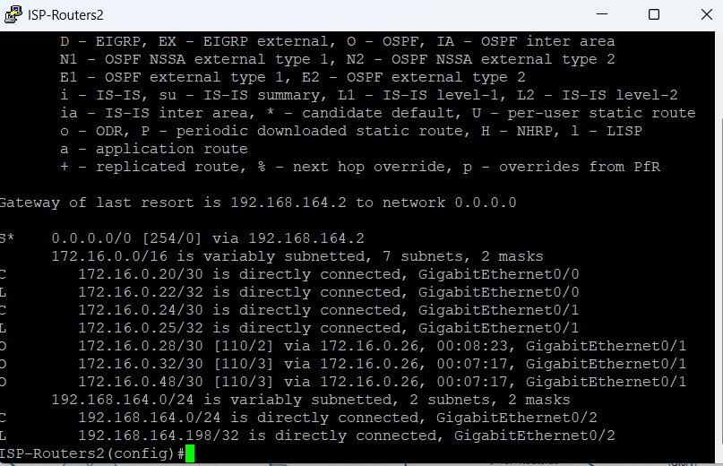
Figure 12. Routing table and OSPF route verification

10. Firewall Policies
FortiGate firewall policies are the main enforcement point. Each policy identifies the incoming interface, outgoing interface, source, destination, schedule, service, action and NAT behavior. Security profiles can then be attached to the allowed policy.

10.1 Users-To-Internet
The policy visible in the screenshots is designed for VLAN110-Users to reach the BR1 WAN. It includes HTTP, HTTPS and PING services, an ACCEPT action and enabled NAT. Users-AV and WebFilter-BR1 are attached.

10.2 Inter-site policies
The policy lookup shows rules for BR1-to-HQ, HQ-to-BR1, BR1-to-BR2 and HQ-to-BR2 style communication. These rules use specific source/destination objects and limited services rather than blindly allowing all traffic.

Figure 13. Policy Lookup showing inter-site and Internet policies
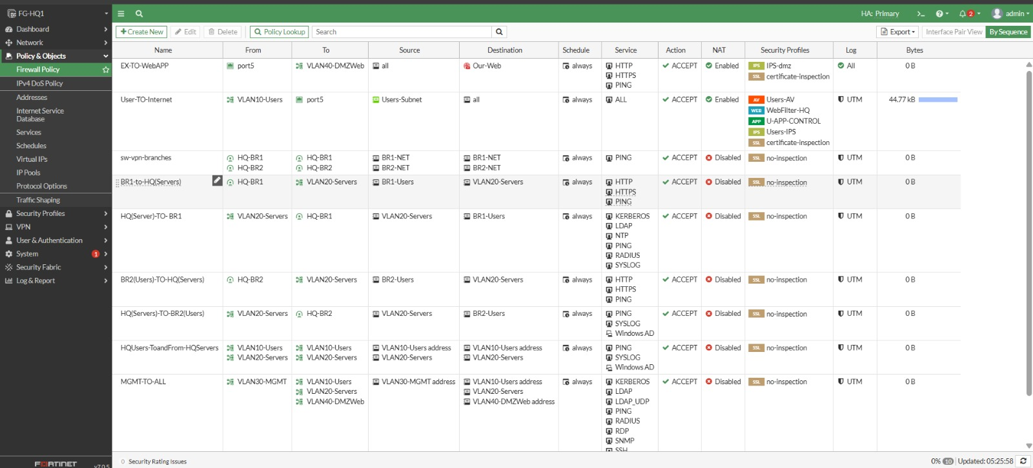
Figure 14. Main HQ policy table

10.3 Policy order
Policy order matters because FortiGate matches traffic against policies. A more specific rule should be placed appropriately so it is not shadowed by a broader rule. This is particularly important when combining Internet, VPN, server and management rules.

11. NAT and DMZ Web Publishing
The DMZ contains the Web Server at 10.10.0.178. A FortiGate Virtual IP object named Our-Web maps the external address 172.16.0.54 to the internal server address 10.10.0.178.
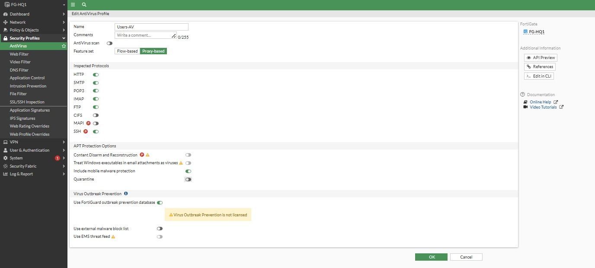
Figure 15. Virtual IP / Static NAT mapping for the DMZ web server
This is a safer design than assigning the public/external address directly to the server. The FortiGate owns the external address and decides which services are forwarded to the internal DMZ host.

11.1 Web publishing policy
The corresponding firewall policy is named EXT0-WebAPP in the screenshot. It uses the external interface as the incoming interface and VLAN40-DMZWeb as the outgoing interface. The destination is Our-Web and HTTP/HTTPS/PING are listed as services. The policy is configured with ACCEPT and deep inspection.
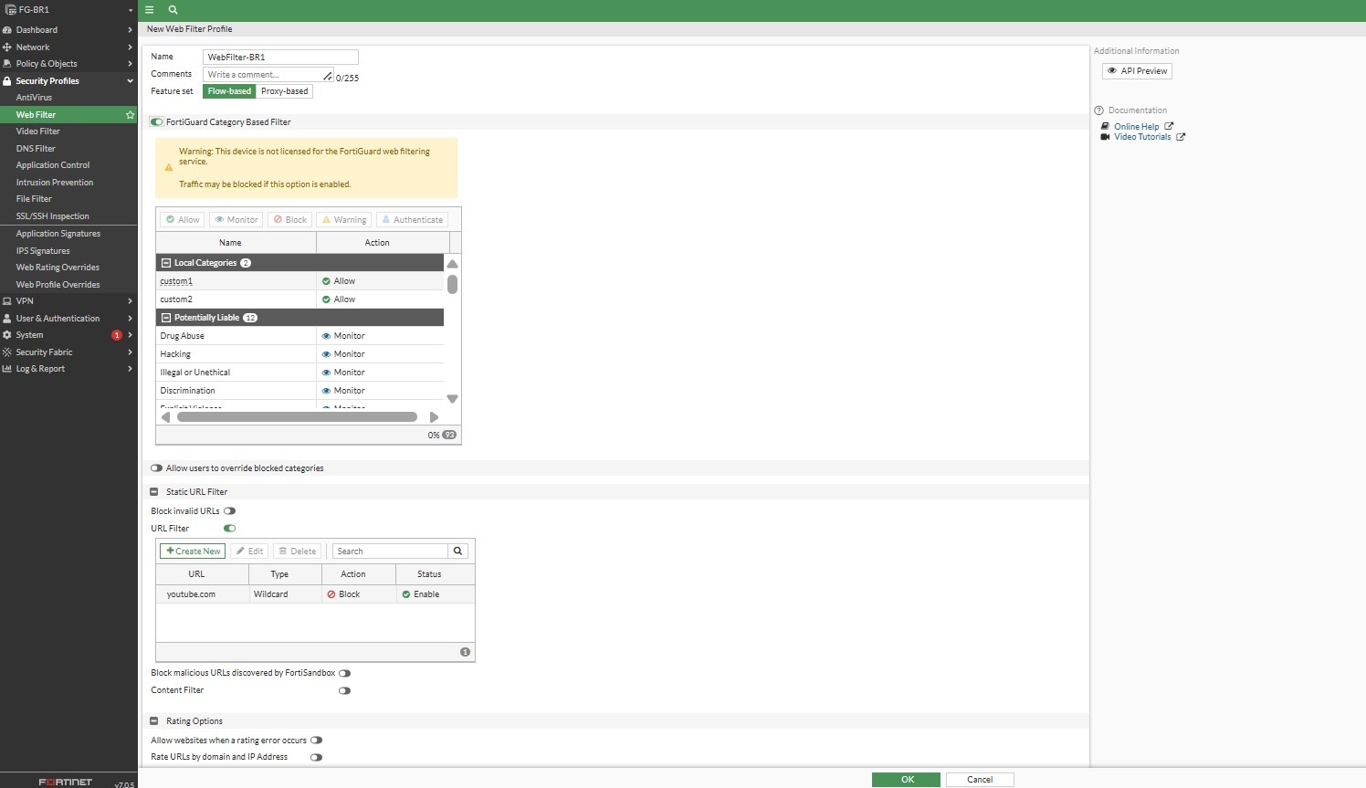
Figure 16. EXT0-WebAPP firewall policy

11.2 Security benefit
The DMZ creates a boundary between public-facing services and the internal Users/Servers networks. If the web server is compromised, the segmentation can reduce direct access to internal systems, provided that restrictive policies are maintained.

12. Antivirus Profile
The project includes a FortiGate Antivirus profile named Users-AV. The screenshot shows flow-based inspection and a set of inspected protocols including HTTP, SMTP, POP3, IMAP and FTP.
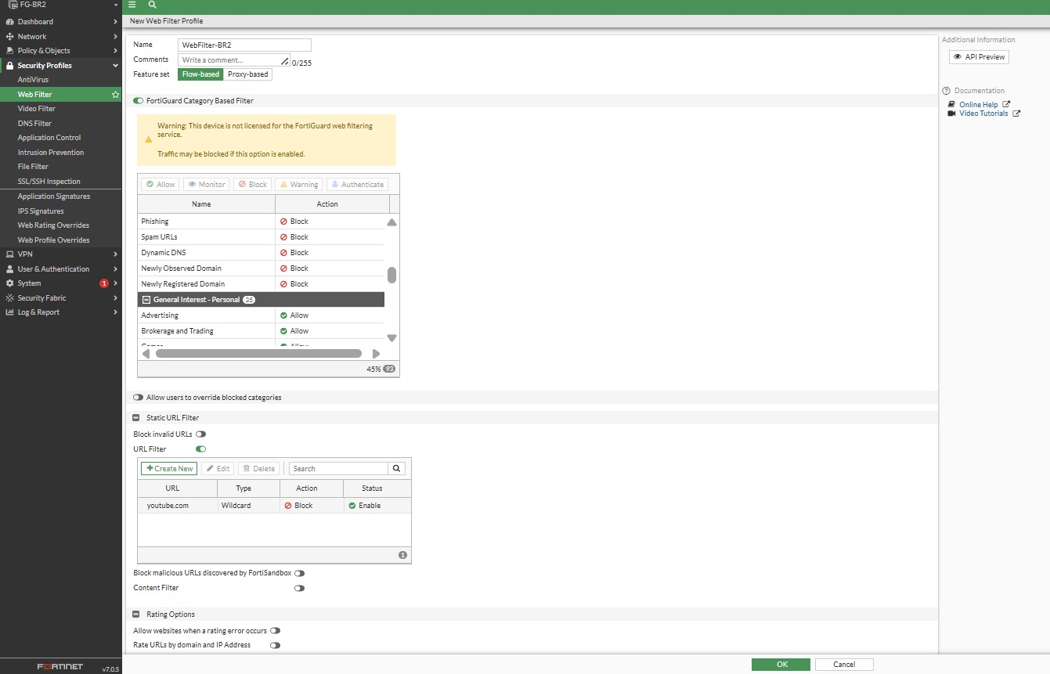
Figure 17. Users-AV Antivirus profile

12.1 Flow-based inspection
Flow-based inspection evaluates traffic as it passes through the firewall rather than waiting to reconstruct the complete session in the same way as proxy inspection. It is commonly used where performance and real-time inspection are important.

12.2 Additional protection options
- Content Disarm and Reconstruction (CDR) is shown as an available option.
- Windows executables in email attachments can be treated as viruses when the corresponding protection is enabled.
- Mobile malware protection is shown.
- Quarantine is shown as a configurable response.
- Virus Outbreak Prevention is shown, with a licensing warning in the supplied lab.
Important documentation note: a visible toggle or license warning in the lab screenshot should not be interpreted as proof that the commercial cloud service is fully licensed in production.

13. Intrusion Prevention System (IPS)
The project contains more than one IPS sensor, including IPS-dmz and Users-IPS. IPS is used to detect known attack signatures and apply actions such as block.
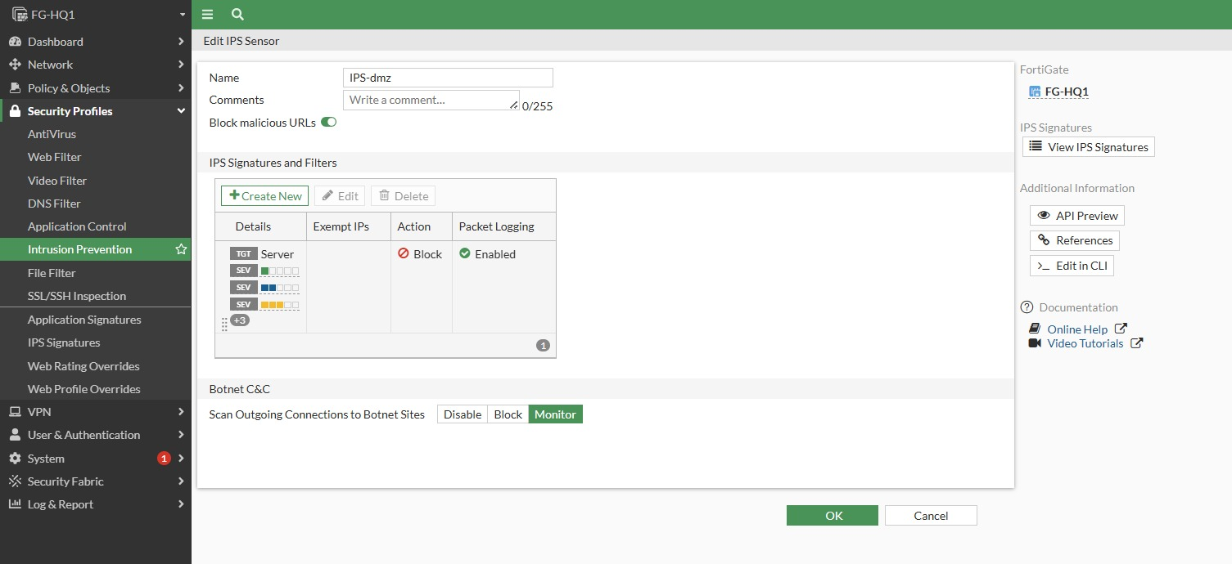
Figure 18. IPS-dmz sensor
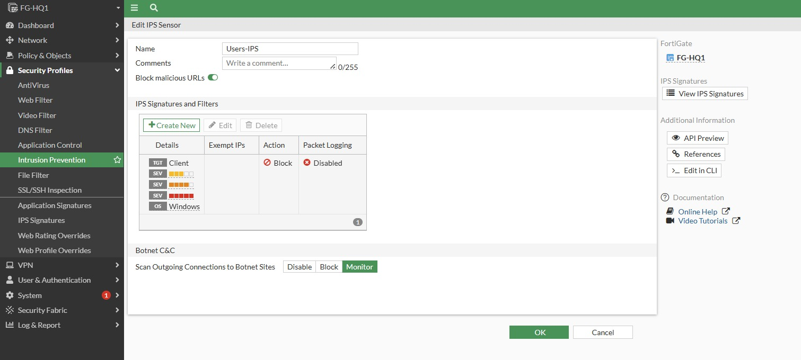
Figure 19. Users-IPS sensor

13.1 IPS signatures
The screenshots show signature filters and entries associated with botnet command-and-control activity. Examples visible include signatures targeting botnet names and server/client traffic. The action shown for these signatures is Block.
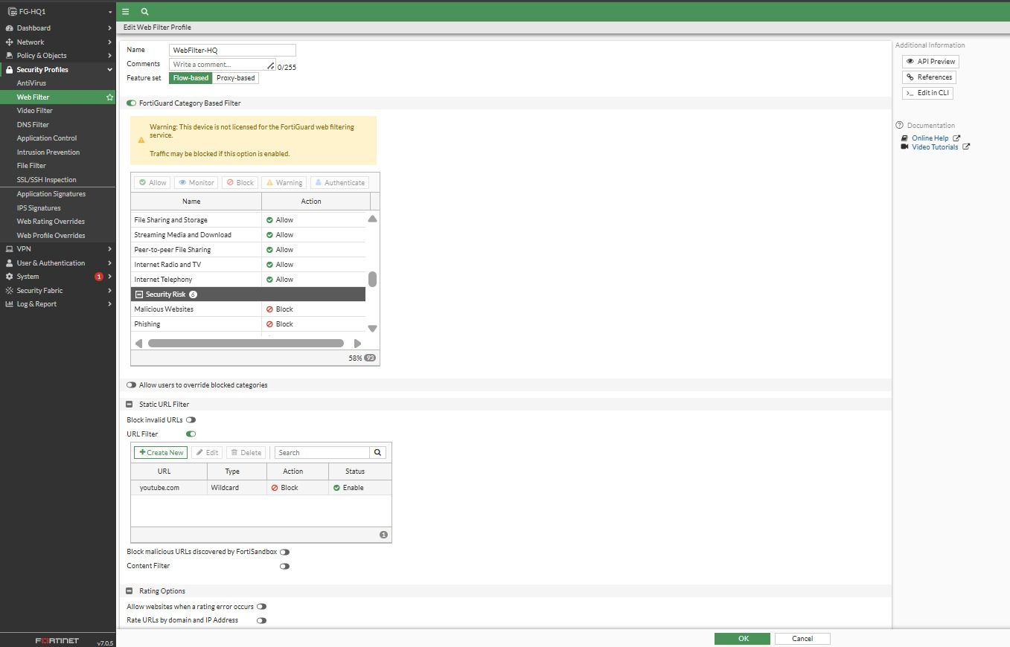
Figure 20. IPS signatures and block actions

13.2 Why IPS is different from a firewall rule
A firewall rule primarily makes a decision using network identity and service information such as source, destination, protocol and port. IPS goes deeper into traffic patterns and compares packets/session content against known malicious signatures.

14. Web Filter
A Web Filter profile named WebFilter-HQ is visible in the supplied screenshots. It uses FortiGuard category-based filtering and contains category actions such as Allow, Monitor or Block depending on the category.

Figure 21. Web Filter category configuration
The screenshot also contains a warning that the device is not licensed for FortiGuard web filtering. In the lab, the configuration demonstrates how the feature is designed, but live category lookups may require an active FortiGuard subscription.

14.1 Purpose
- Reduce exposure to malicious or risky websites.
- Control access according to business policy.
- Use category-based decisions instead of maintaining a large manual URL list.
- Provide another security layer in addition to firewall and IPS controls.

15. Application Control
The application sensor shown is named WAPP-CONTROL. It contains FortiGuard application categories and application signatures. The screenshot notes that some cloud applications may require deeper inspection.

Figure 22. Application Control profile

15.1 Why Application Control is useful
Port-based filtering cannot always distinguish between different applications using common ports. Application Control identifies applications and allows the administrator to create policies around application behavior or category.
- Control remote-access applications.
- Control storage/backup applications.
- Control proxy and unknown applications.
- Apply application-specific security decisions while keeping normal web access available.

16. SSL/SSH Inspection and Certificates
The policy screenshots show certificate inspection/deep inspection options. Encrypted traffic such as HTTPS cannot be fully inspected by a firewall if the payload remains encrypted. Deep inspection allows FortiGate to decrypt and inspect supported sessions and then re-encrypt them toward the destination.
Because deep inspection introduces certificate trust requirements, client devices normally need to trust the FortiGate inspection CA certificate. Without proper certificate deployment, browsers may report certificate warnings.

16.1 Security profiles and inspection
The project demonstrates the layered relationship: firewall policy decides whether the connection is allowed, certificate/SSL inspection can make encrypted traffic visible to inspection engines, and Antivirus/IPS/Web Filter/Application Control can then evaluate the traffic according to the attached profile.

Figure 23. Antivirus/inspection configuration used with security policies

17. IPsec VPN
The project includes site-to-site IPsec tunnels connecting HQ to BR1 and HQ to BR2. The supplied tunnel screenshots show the remote gateways and the Phase 1/Phase 2 configuration.

17.1 HQ–BR1 tunnel
The HQ-BR1 tunnel uses remote gateway 172.16.0.18 through port5. Authentication uses a pre-shared key. IKE Version 1 is selected with Main mode. The Phase 1 proposal shown is DES-SHA1 with Diffie-Hellman groups 14 and 5. XAUTH is disabled. The Phase 2 selector is shown as 0.0.0.0/0 on both sides in the supplied lab.
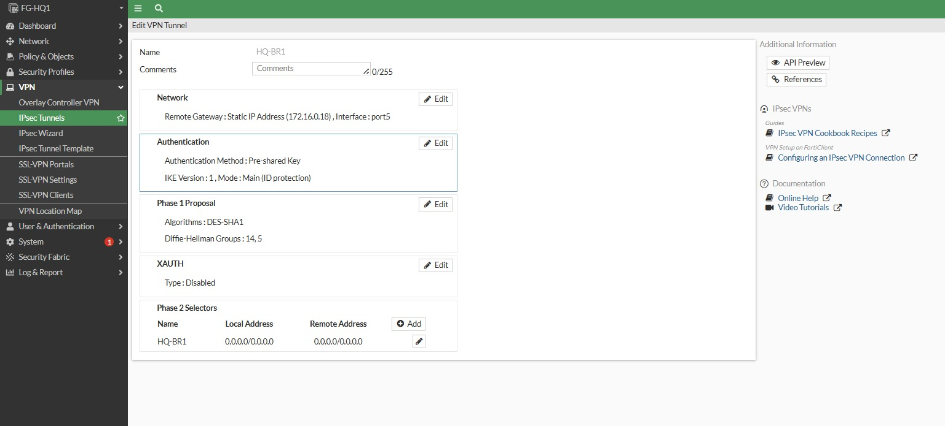
Figure 24. HQ-BR1 IPsec Phase 1 and Phase 2 configuration

17.2 HQ–BR2 tunnel
The HQ-BR2 tunnel uses remote gateway 172.16.0.37 through port5. It similarly uses a pre-shared key, IKEv1 Main mode, DES-SHA1 and DH groups 14 and 5, with XAUTH disabled. The Phase 2 selector is again shown as 0.0.0.0/0 on both sides in the lab screenshot.
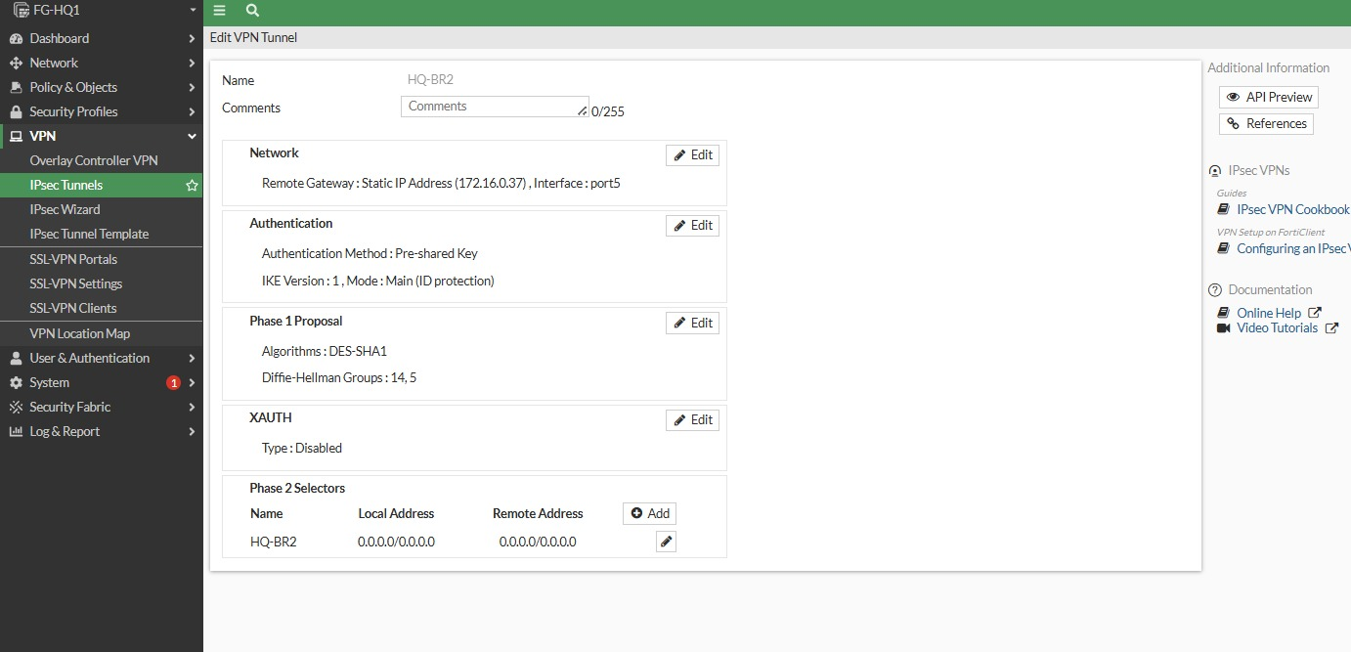
Figure 25. HQ-BR2 IPsec configuration

17.3 BR1–HQ tunnel
The branch-side tunnel screenshot shows remote gateway 172.16.0.54 through port2 and the same general IKE/Phase 1 structure. This is the branch endpoint of the HQ-BR1 VPN relationship.
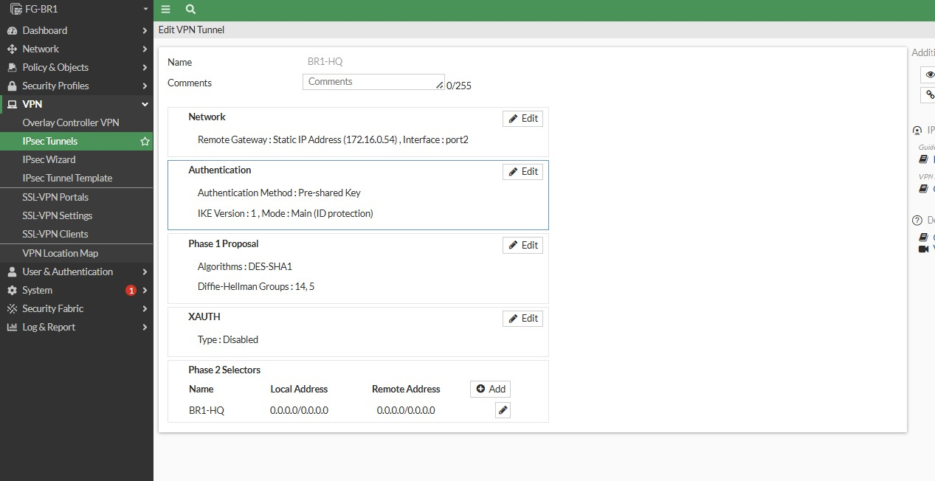
Figure 26. BR1-HQ IPsec configuration

17.4 Phase 1 vs Phase 2
Phase | Purpose | Important parameters visible in lab
Phase 1 | Builds the IKE security association | IKEv1, Main mode, PSK, DES-SHA1, DH 14/5
Phase 2 | Defines protected data traffic | Local/remote selectors, IPsec data protection

For a production deployment, stronger modern cryptographic suites should normally be selected instead of legacy DES/SHA1. The documentation records the lab configuration exactly as visible rather than silently changing it.

18. Verification and Testing
Verification is essential because a configuration page only proves that a value was entered. The project evidence also includes status pages, policy tables, routing tables and CLI outputs.

18.1 HA verification
- Both FortiGate members are visible.
- The cluster identifies Primary and Secondary roles.
- Synchronization status is shown.
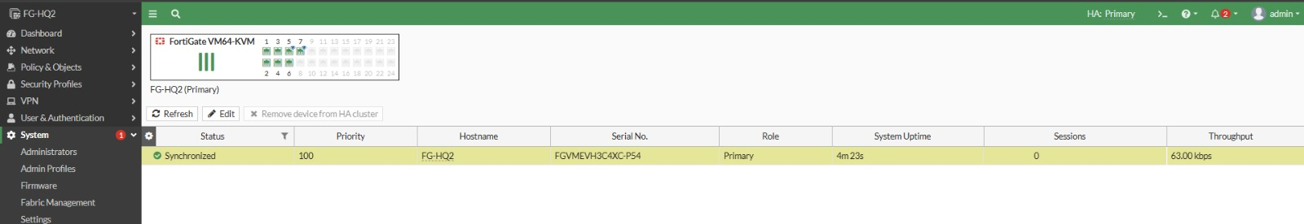
Figure 27. HA cluster verification

18.2 Interface verification
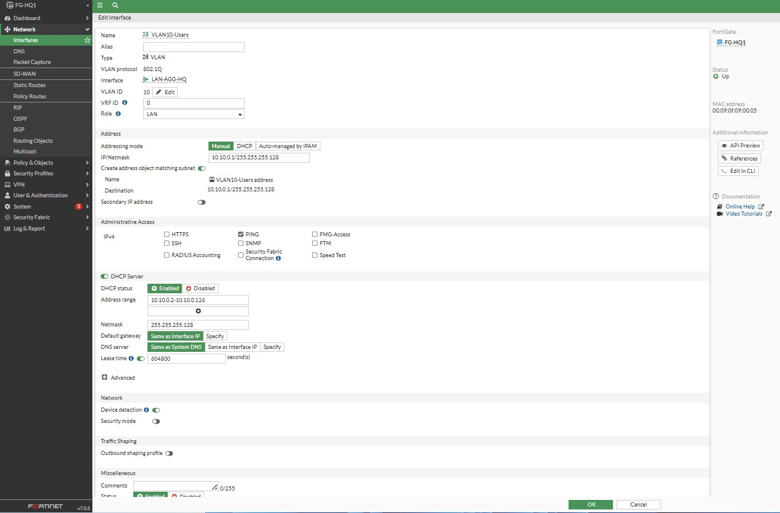
Figure 28. FortiGate interface verification

18.3 Policy verification

Figure 29. Firewall policy table and security profiles

18.4 VPN verification
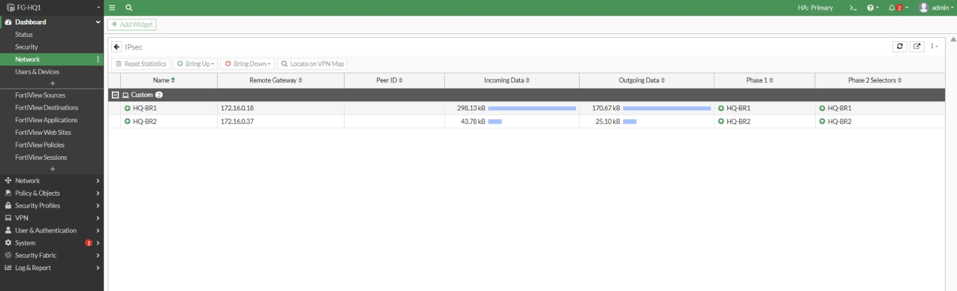
Figure 30. IPsec tunnel status / traffic counters
The VPN dashboard evidence shows tunnel entries and traffic information. Traffic counters are especially useful because they indicate whether encrypted traffic is actually passing rather than merely showing a configured tunnel object.

18.5 Routing verification

Figure 31. Routing table evidence

18.6 Cisco OSPF verification

Figure 32. OSPF learned routes and router status

19. Troubleshooting and Design Considerations

19.1 Client cannot reach the Internet
- Check that the client received the correct VLAN/subnet address.
- Check the default gateway.
- Ping the FortiGate VLAN gateway.
- Check the firewall policy source interface and destination interface.
- Check that HTTP/HTTPS services are included.
- Check NAT status.
- Check the routing table for a default route.
- Review policy logs and security-profile events.

19.2 IPsec tunnel is down
- Verify reachability of the remote gateway IP.
- Verify pre-shared key on both sides.
- Verify IKE version and mode.
- Verify Phase 1 proposal and DH group.
- Verify Phase 2 selectors.
- Verify firewall policies and routes for the protected networks.
- Check tunnel status and traffic counters.

19.3 OSPF route missing
- Verify the interface is up/up.
- Verify OSPF is enabled on the intended interface.
- Verify the correct area, here Area 0 is shown.
- Verify the advertised network is included.
- Check OSPF neighbors.
- Inspect the routing table for the expected OSPF route.

19.4 Web server cannot be published
- Verify the VIP external address and mapped internal address.
- Verify the incoming interface.
- Verify the DMZ VLAN and server gateway.
- Verify HTTP/HTTPS services in the policy.
- Verify the policy action is ACCEPT.
- Check that no earlier policy shadows the publishing rule.
- Check certificate/inspection behavior if HTTPS is used.

20. Security Architecture Summary
The project follows a defense-in-depth model. No single feature is expected to stop every threat.
Layer | Control | Role
Segmentation | VLANs | Separate Users, Servers, Management and DMZ
Availability | HA | Maintain firewall service if a unit fails
Routing | OSPF | Dynamic route exchange
Access control | Firewall policies | Permit/deny traffic based on defined rules
Address translation | NAT/VIP | Internet access and controlled service publishing
Malware defense | Antivirus | Inspect supported traffic for malicious content
Intrusion defense | IPS | Detect/block known attack signatures
Web security | Web Filter | Category-based web access control
Application security | Application Control | Identify/control applications
Encryption | IPsec | Protect inter-site traffic
Encrypted inspection | SSL/SSH inspection | Make supported encrypted traffic inspectable
Logging | Syslog/Logs | Centralized visibility and investigation

This layered approach is important in a real enterprise. For example, a malicious file may bypass a simple port rule because the connection itself is legitimate. Antivirus can inspect the content. A suspicious network pattern can be detected by IPS. A risky destination can be controlled by Web Filter. Segmentation and firewall policy then limit lateral movement.

21. Conclusion
The project demonstrates the design and implementation of a complete enterprise security environment rather than an isolated firewall configuration. HQ, BR1 and BR2 are connected through a routed WAN, while each site maintains logical separation of users, servers and management resources.
FortiGate provides the security control plane: VLAN gateways, firewall policies, NAT, security profiles, VPN and high availability. OSPF provides dynamic routing across the routed infrastructure. The DMZ isolates the public web service, while IPsec protects inter-site traffic.
The screenshots supplied with the project provide configuration evidence for the major components. For a production deployment, cryptographic algorithms, FortiGuard licensing, certificate deployment, logging, backup and monitoring should be reviewed before rollout.

Appendix A – Complete Screenshot Evidence
This appendix keeps the supplied screenshots as evidence. Each screenshot is included with a short description so that the evaluator can correlate the documentation with the actual implementation.

Screenshot 1
Topology/CLI evidence associated with the initial lab configuration.
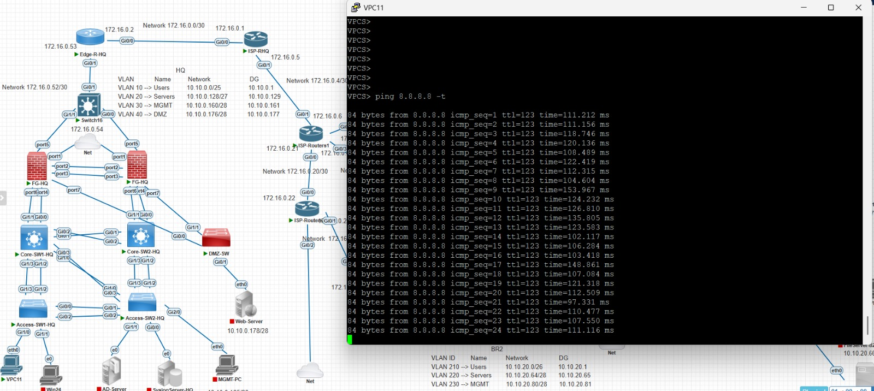
Figure A-1. Supplied project evidence

Screenshot 2
Additional topology and routing/CLI evidence.

Figure A-2. Supplied project evidence

Screenshot 3
FortiGate HA member table.

Figure A-3. Supplied project evidence

Screenshot 4
FortiGate HA primary/secondary synchronization.

Figure A-4. Supplied project evidence

Screenshot 5
HA member details.

Figure A-5. Supplied project evidence

Screenshot 6
FortiGate interface list and aggregate interface.

Figure A-6. Supplied project evidence

Screenshot 7
VLAN interface/DHCP details.

Figure A-7. Supplied project evidence

Screenshot 8
HQ VLAN10 interface and DHCP scope.

Figure A-8. Supplied project evidence

Screenshot 9
FortiGate network/interface evidence.
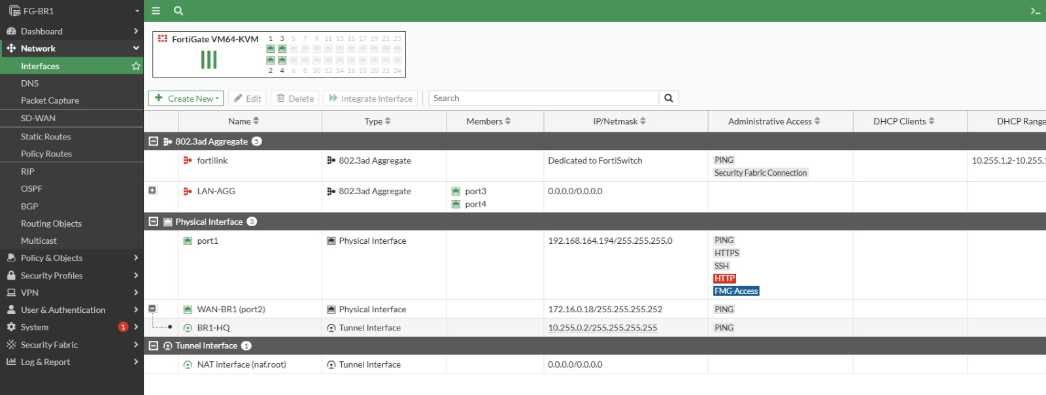
Figure A-9. Supplied project evidence

Screenshot 10
Interface configuration page.
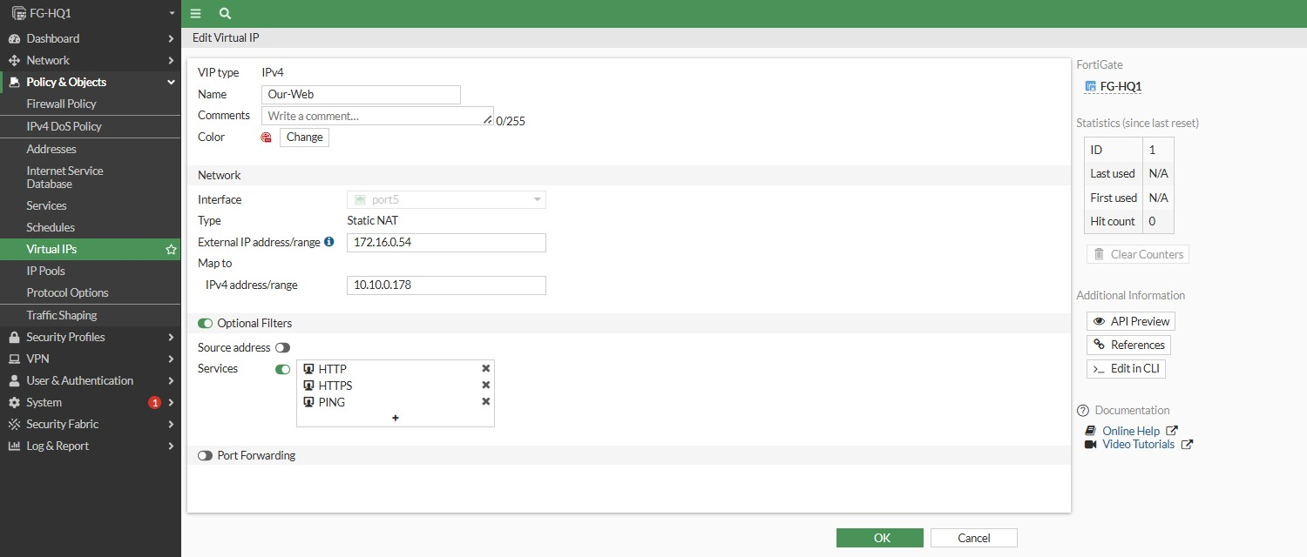
Figure A-10. Supplied project evidence

Screenshot 11
Interface/address object configuration.
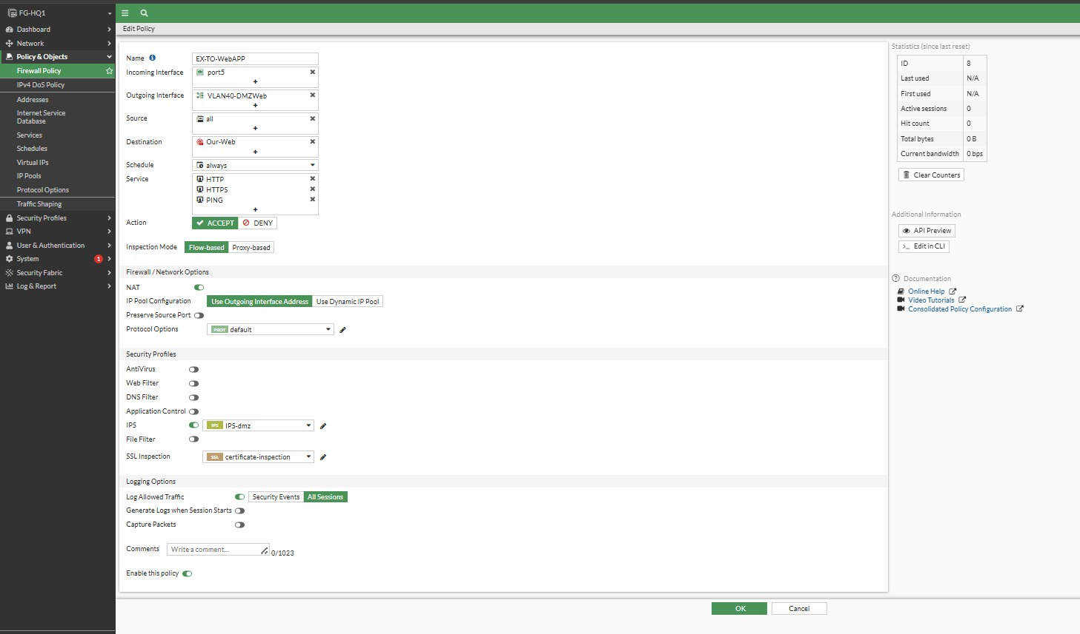
Figure A-11. Supplied project evidence

Screenshot 12
FortiGate policy/security configuration.
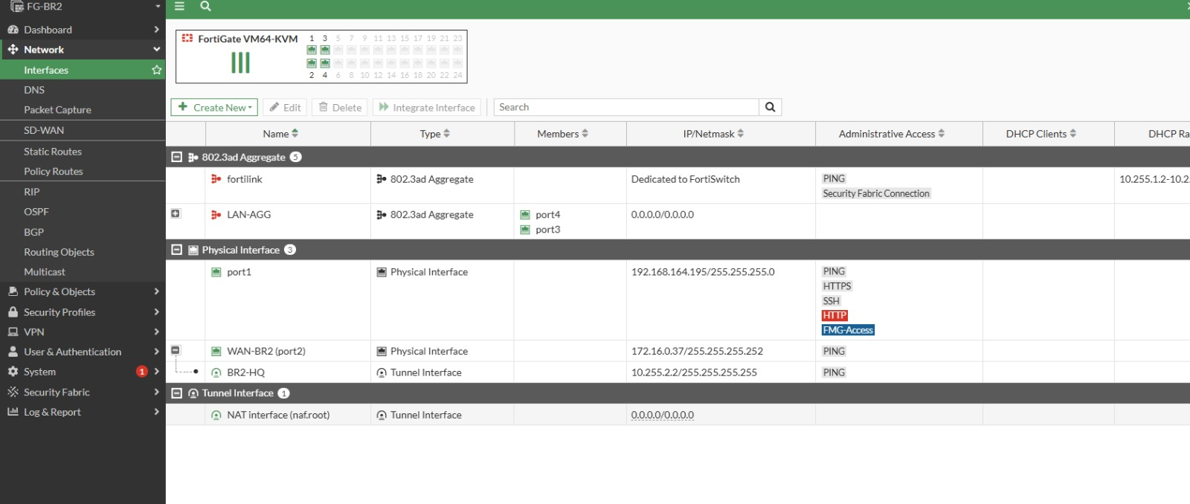
Figure A-12. Supplied project evidence

Screenshot 13
IPS-dmz configuration.

Figure A-13. Supplied project evidence

Screenshot 14
Users-IPS configuration.

Figure A-14. Supplied project evidence

Screenshot 15
IPS signature/filter list.

Figure A-15. Supplied project evidence

Screenshot 16
Security profile/signature view.
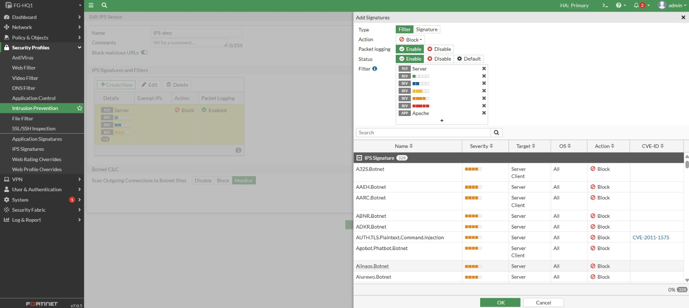
Figure A-16. Supplied project evidence

Screenshot 17
Security profile configuration.
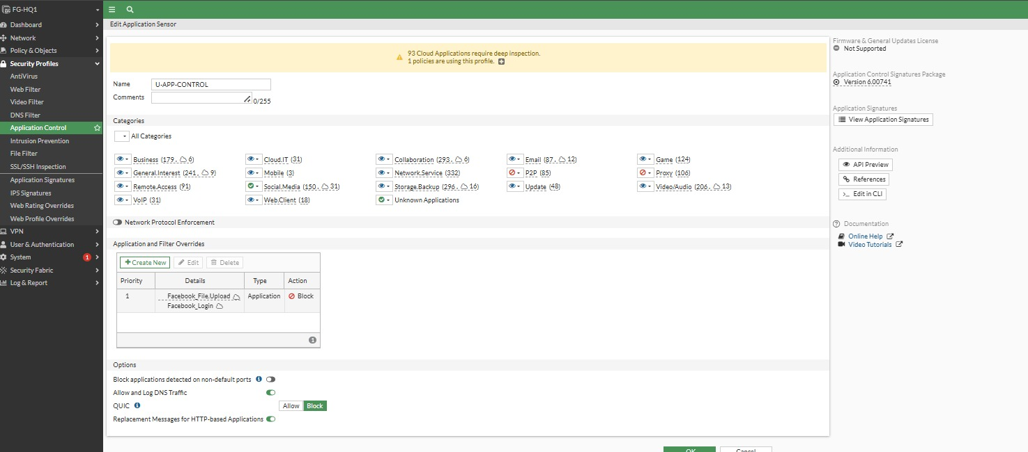
Figure A-17. Supplied project evidence

Screenshot 18
FortiGate network/interface information.
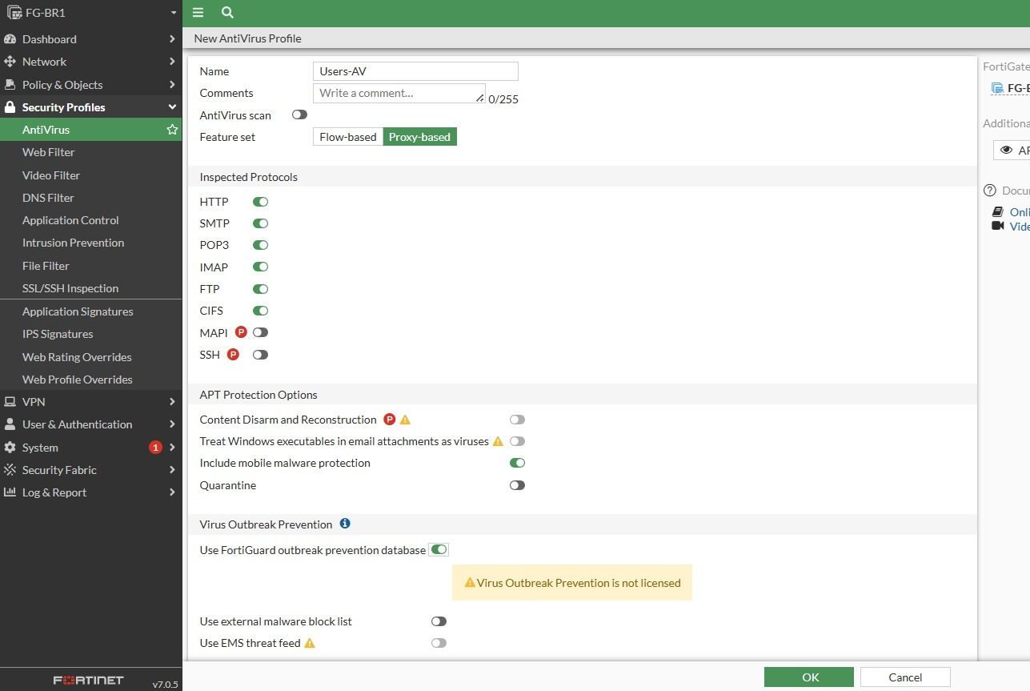
Figure A-18. Supplied project evidence

Screenshot 19
Virtual IP for DMZ web server.

Figure A-19. Supplied project evidence

Screenshot 20
External-to-DMZ web application firewall policy.

Figure A-20. Supplied project evidence

Screenshot 21
Antivirus profile.

Figure A-21. Supplied project evidence

Screenshot 22
Application Control profile.

Figure A-22. Supplied project evidence

Screenshot 23
BR1 Users-To-Internet firewall policy.
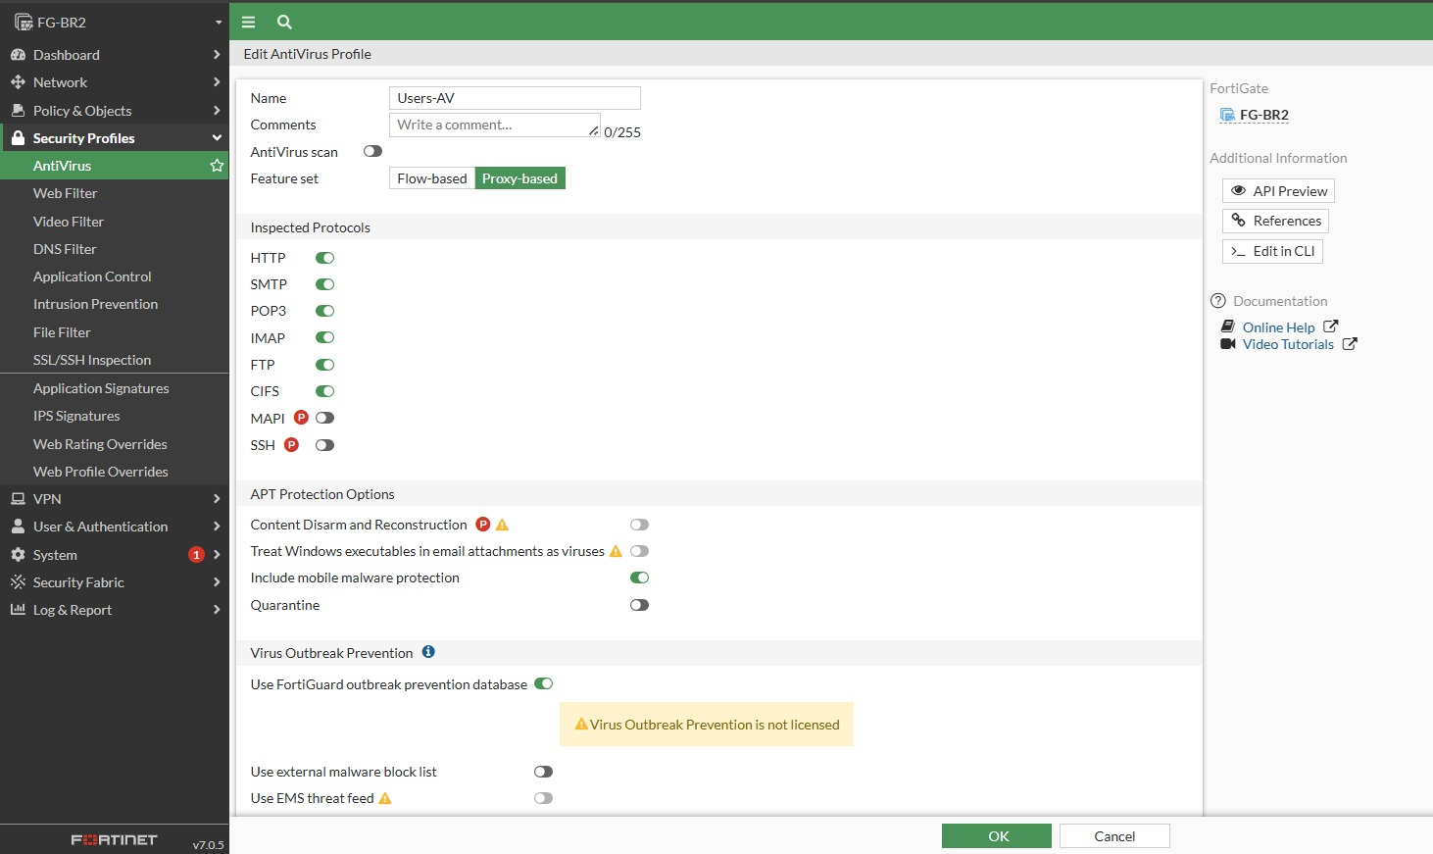
Figure A-23. Supplied project evidence

Screenshot 24
Policy Lookup showing inter-site and Internet rules.

Figure A-24. Supplied project evidence

Screenshot 25
Policy Lookup / security policy evidence.
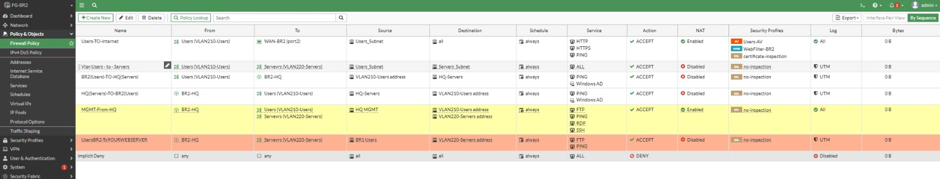
Figure A-25. Supplied project evidence

Screenshot 26
BR2 user Internet policy.

Figure A-26. Supplied project evidence

Screenshot 27
VPN interface binding / tunnel evidence.
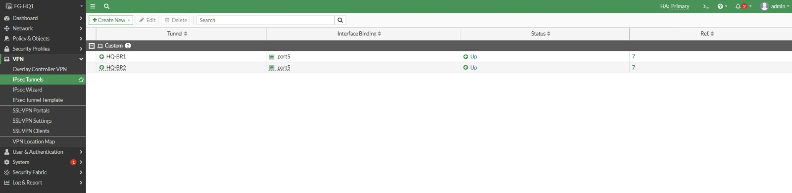
Figure A-27. Supplied project evidence

Screenshot 28
HQ-BR1 IPsec tunnel configuration.

Figure A-28. Supplied project evidence

Screenshot 29
HQ-BR2 IPsec tunnel configuration.

Figure A-29. Supplied project evidence

Screenshot 30
Main HQ firewall policy table.

Figure A-30. Supplied project evidence

Screenshot 31
IPsec tunnel status and traffic counters.

Figure A-31. Supplied project evidence

Screenshot 32
IPsec interface binding.
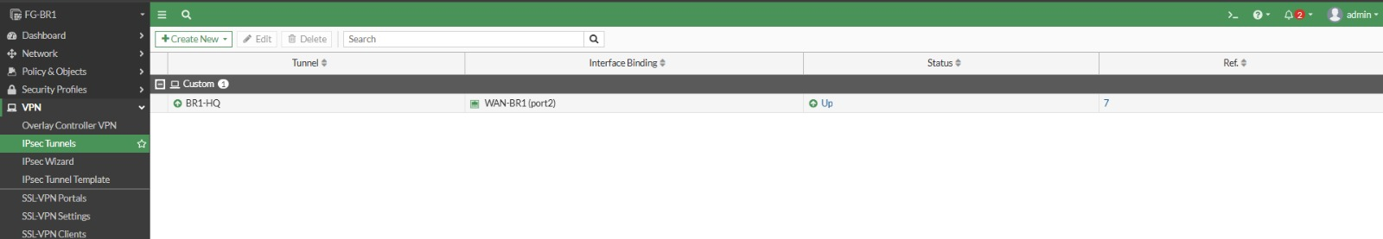
Figure A-32. Supplied project evidence

Screenshot 33
Additional VPN status/evidence.
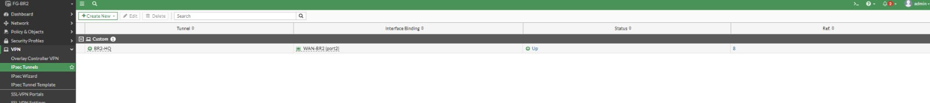
Figure A-33. Supplied project evidence

Screenshot 34
FortiGate OSPF configuration.

Figure A-34. Supplied project evidence

Screenshot 35
BR1-HQ IPsec tunnel configuration.

Figure A-35. Supplied project evidence

Screenshot 36
Cisco routing table / OSPF route evidence.

Figure A-36. Supplied project evidence

Screenshot 37
Cisco OSPF configuration and interface status.

Figure A-37. Supplied project evidence

Screenshot 38
Additional VPN/configuration evidence.
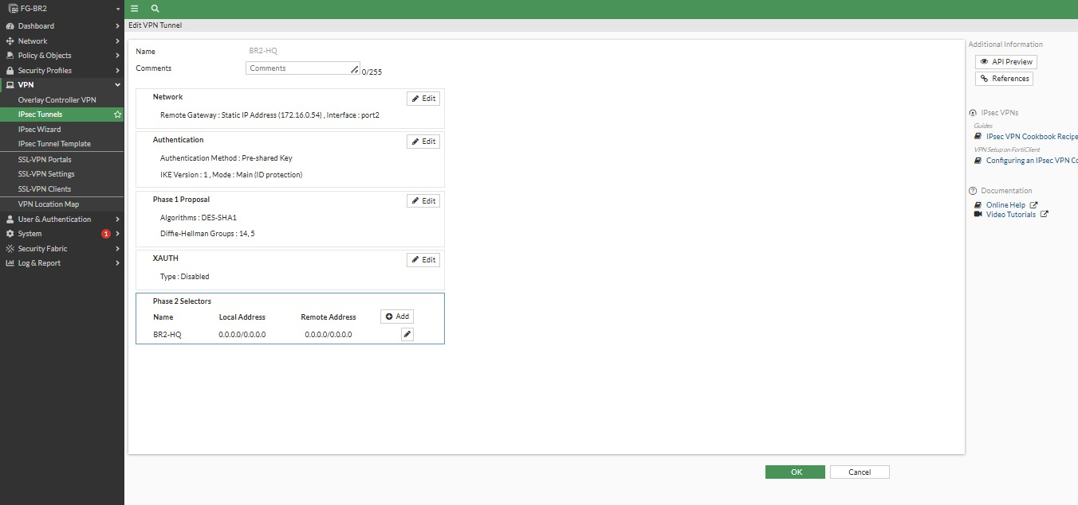
Figure A-38. Supplied project evidence

