# A- Software Requirements Specification (SRS)

## Functional Requirements

These define the core functionalities the system must provide.

|  |  |  |
| --- | --- | --- |
|  | **Requirement** | **Description** |
|  | User Authentication | Users (faculty, students) must log in with email & password. |
|  | Role-Based Access | Faculty and students should have different dashboards with specific functionalities. |
|  | Faculty Dashboard | Faculty should be able to see their assigned classes and mark attendance. |
|  | Student Dashboard | Students should be able to view their attendance history and percentage. |
|  | Attendance Marking | Faculty should be able to mark students as present, absent, or late for each class. |
|  | Attendance Editing | The faculty should be able to edit attendance records within a specified timeframe. |
|  | Attendance Notifications | Students should receive alerts if attendance falls below a certain threshold. |
|  | Attendance Reports | Students should be able to download attendance reports. |
|  | Logout | Users should be able to log out securely. |
|  | Error Handling | The system should handle invalid inputs and errors properly. |

## Non-Functional Requirements (NFRs)

These define system quality, performance, security, and external dependencies.

### A. Product Requirements

|  |  |  |  |
| --- | --- | --- | --- |
|  | **Requirement** | **Description** | |
|  | Performance | | The system should respond within 2 seconds for login and attendance actions. |
|  | Scalability | | The system should handle 100+ concurrent users without lag. |
|  | Security | | User data must be encrypted, and authentication should use JWT tokens. |
|  | Availability | | The system should be available 24/7 with 99.9% uptime. |
|  | Usability | | The system should have a user-friendly UI with clear navigation. |

### B. Organizational Requirements

|  |  |  |
| --- | --- | --- |
|  | **Requirement** | **Description** |
|  | Development Framework | The system should be built using MERN (MongoDB, Express.js, React.js, Node.js). |
|  | Hosting | The system should be deployed on AWS, Firebase |
|  | Compliance | The system should follow GDPR and local data protection laws. |

### C. External Requirements

|  |  |  |
| --- | --- | --- |
|  | **Requirement** | **Description** |
|  | Third-Party APIs | If real-time notifications are needed, Firebase/SendGrid should be used. |
|  | Data Backup | Attendance records should be backed up daily. |
|  | Browser Support | The system must work on Chrome, Firefox, Edge, and Safari. |

## Use Case Diagram

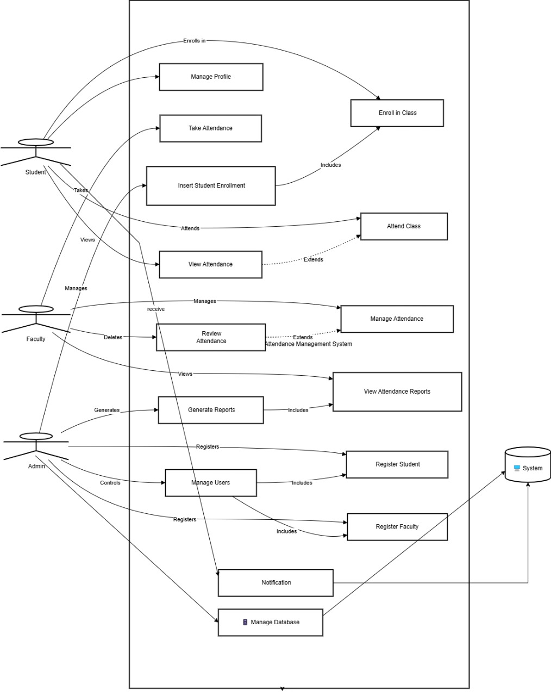

## User Story

## Pre and Post Conditions

## Sequence Diagram

## Class Diagram