PERTEMUAN KE-6

Bertujuan :
- Agar mahasiswa dapat memahami dan menerapkan perintah-perintah pada Visual Basic 6.0 yang sudah dipelajari sebelumnya
- Meningkatkan kemampuan logika sederhana untuk memahami visual basic 6.0

1.INPUTAN DATA

Langkah 1. Buatlah form seperti dibawah ini:

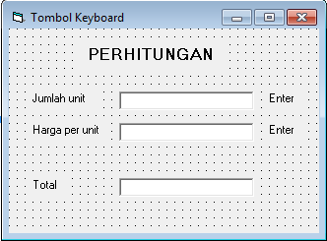

Langkah-2. Ketik Kode program dibawah ini:

'Selain menekan tombol TAB, Anda dapat
'mengakhiri data dengan menekan tombol Enter

Private Sub Text1_KeyDown(KeyCode As Integer, Shift As Integer)
If Text1 <> "" And KeyCode = 13 Then
Text2.SetFocus
End If
End Sub

Private Sub Text2_KeyDown(KeyCode As Integer, Shift As Integer)
If Text2 <> "" And KeyCode = 13 Then
Text3 = Val(Text1) * Val(Text2)
End If
End Sub

Langkah-3. Hasil pada saat di Run:

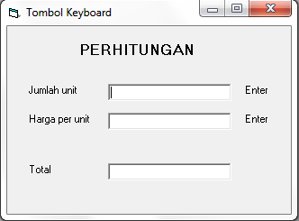

2.VALIDASI

Langkah 1. Buatlah form seperti dibawah ini:

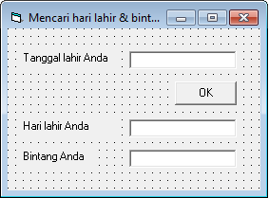

Langkah-2. Ketik Kode program dibawah ini:

Private Sub Form_Load()
Command1.Enabled = False
End Sub

Private Sub Text1_Change()
If IsDate(Text1) Then
Command1.Enabled = True
Else
Command1.Enabled = False
End If
End Sub

Private Sub Command1_Click()
'MENCARI HARI LAHIR
Dim KodeHari As Byte
Dim Hari As String
KodeHari = Weekday(Text1)
Select Case KodeHari
Case 1: Hari = "Minggu"
Case 2: Hari = "Senin"
Case 3: Hari = "Selasa"
Case 4: Hari = "Rabu"
Case 5: Hari = "Kamis"
Case 6: Hari = "Jumat"
Case 7: Hari = "Sabtu"
End Select
Text2 = Hari

'MENCARI BINTANG
Dim Tg, Bl As Byte
Dim Btg As String
Tg = Day(Text1): Bl = Month(Text1)
If (Tg >= 21 And Bl = 3) Or (Tg <= 20 And Bl = 4) Then Btg = "ARIES"
If (Tg >= 21 And Bl = 4) Or (Tg <= 21 And Bl = 5) Then Btg = "TAURUS"
If (Tg >= 22 And Bl = 5) Or (Tg <= 21 And Bl = 6) Then Btg = "GEMINI"
If (Tg >= 22 And Bl = 6) Or (Tg <= 22 And Bl = 7) Then Btg = "CANCER"
If (Tg >= 23 And Bl = 7) Or (Tg <= 22 And Bl = 8) Then Btg = "LEO"
If (Tg >= 23 And Bl = 8) Or (Tg <= 22 And Bl = 9) Then Btg = "VIRGO"
If (Tg >= 23 And Bl = 9) Or (Tg <= 22 And Bl = 10) Then Btg = "LIBRA"
If (Tg >= 23 And Bl = 10) Or (Tg <= 21 And Bl = 11) Then Btg = "SCORPIO"
If (Tg >= 22 And Bl = 11) Or (Tg <= 21 And Bl = 12) Then Btg = "SAGITARIUS"
If (Tg >= 22 And Bl = 12) Or (Tg <= 20 And Bl = 1) Then Btg = "CAPRICORN"
If (Tg >= 21 And Bl = 1) Or (Tg <= 19 And Bl = 2) Then Btg = "AQUARIUS"
If (Tg >= 20 And Bl = 2) Or (Tg <= 20 And Bl = 3) Then Btg = "PISCES"
Text3 = Btg
End Sub

Langkah-3. Hasil pada saat di Run:
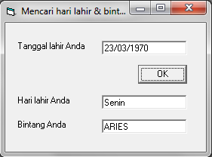
3.VALIDASI

Langkah 1. Buatlah form seperti dibawah ini:

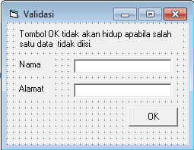

Langkah-2. Ketik Kode program dibawah ini:

Private Sub Form_Load()
Command1.Enabled = False
End Sub

Private Sub Text1_Change()
If Text1 = "" Or Text2 = "" Then
Command1.Enabled = False
Else
Command1.Enabled = True
End If
End Sub

Private Sub Text2_Change()
If Text1 = "" Or Text2 = "" Then
Command1.Enabled = False
Else
Command1.Enabled = True
End If
End Sub

Langkah-3. Hasil pada saat di Run:
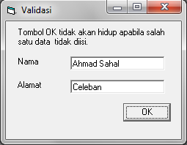
4.INPUT DATA

Langkah 1. Buatlah form seperti dibawah ini:
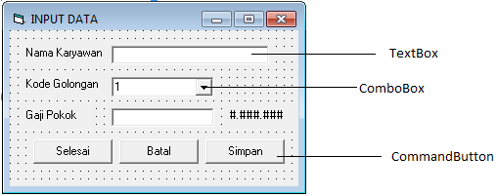

Langkah-2. Ketik Kode program dibawah ini:
Private Sub Form_Load()
Combo1.AddItem "1", 0
Combo1.AddItem "2", 1
Combo1.AddItem "3", 2
End Sub

Private Sub CmdBatal_Click()
TxtNama = ""
TxtGaji = ""
TxtNama.SetFocus
End Sub

Private Sub CmdSelesai_Click()
End
End Sub

Private Sub CmdSimpan_Click()
Dim DirAktif As String
If TxtNama = "" Or TxtGaji = "" Then GoTo AdaKosong
DirAktif = Left(CurDir, 3)
ChDir DirAktif
Open "C:\VB6\GAJI.DAT" For Append As #1
Write #1, TxtNama, Combo1.Text, TxtGaji
Close #1
TxtNama = ""
TxtGaji = ""
TxtNama.SetFocus
Exit Sub
AdaKosong:
Beep
If TxtNama = "" Then TxtNama.SetFocus
If TxtGaji = "" Then TxtGaji.SetFocus
End Sub

Langkah-3. Hasil pada saat di Run:
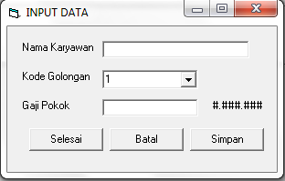

5.BACA DATA

Langkah 1. Buatlah form seperti dibawah ini:

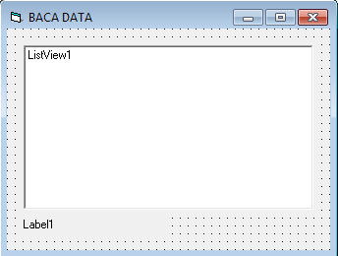

Langkah-2. Ketik Kode program dibawah ini:

Private Sub Form_Load()
Dim LI As ListItem
Dim Nama, Kode, Gaji As String
Dim TotalGaji As Currency

ListView1.View = lvwReport
ListView1.Sorted = True 'Menyortir data

'Membuat Judul Kolom (ColumnHeaders) serta mengatur lebar.
ListView1.ColumnHeaders.Add , , "NAMA", ListView1.Width / 3
ListView1.ColumnHeaders.Add , , "GOLONGAN", ListView1.Width / 3
ListView1.ColumnHeaders.Add , , "GAJI", ListView1.Width / 3
On Error GoTo Salah
Open App.Path & "\GAJI.DAT" For Input As #1
Do Until EOF(1)
Input #1, Nama, Kode, Gaji
'Masukkan item dan sub item ke dalam list.
Set LI = ListView1.ListItems.Add(, , Nama)
LI.SubItems(1) = Kode
LI.SubItems(2) = Gaji
TotalGaji = TotalGaji + Gaji
Loop
Close #1
Label1.Caption = "Total Gaji = " + Format(TotalGaji, "Currency")
Exit Sub
Salah:
MsgBox "File C:\VB6\GAJI.DAT tidak ditemukan!"
End
End Sub

'Jika garis-garis tipis seperti dalam Exel
'ingin dimasukkan, tambahkan perintah ini:
'ListView1.GridLines = True di bawah perintah
'ListView1.Sorted = True
Langkah-3. Hasil pada saat di Run:
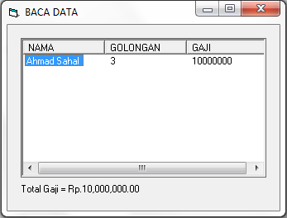
6.CARI DATA

Langkah 1. Buatlah form seperti dibawah ini:

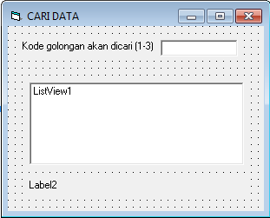

Langkah-2. Ketik Kode program dibawah ini:
Private Sub Form_Load()
Dim LI As ListItem
ListView1.View = lvwReport
ListView1.Sorted = True
'Membuat Judul Kolom (ColumnHeaders) dan mengatur lebar.
ListView1.ColumnHeaders.Add , , "NAMA", ListView1.Width / 3
ListView1.ColumnHeaders.Add , , "GOLONGAN", ListView1.Width / 3
ListView1.ColumnHeaders.Add , , "GAJI", ListView1.Width / 3
End Sub

Private Sub CariData()
Dim Nama, Kode, Gaji As String
Dim Ada As Integer
Dim TotalGaji As Currency
ListView1.ListItems.Clear
Open App.Path & "\GAJI.DAT" For Input As #1
Do Until EOF(1)
Input #1, Nama, Kode, Gaji
If Text1 = Kode Then
'Masukkan data ke dalam list.
Set LI = ListView1.ListItems.Add(, , Nama)
LI.SubItems(1) = Kode
LI.SubItems(2) = Gaji
'Jumlahkan gaji
TotalGaji = TotalGaji + Gaji
Ada = Ada + 1
End If
Loop
Close #1
If Ada = 0 Then MsgBox "Kode golongan tersebut tidak ada (1-3)!"
If Ada <> 0 Then
Text1 = ""
Label2.Caption = "Total Gaji = " + Format(TotalGaji, "Currency")
End If
End Sub

Private Sub Text1_KeyDown(KeyCode As Integer, Shift As Integer)
If Text1 <> "" And KeyCode = 13 Then CariData
End Sub

Langkah-3. Hasil pada saat di Run:

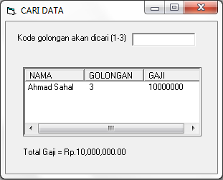
7.CARI DATA

Langkah 1. Buatlah form seperti dibawah ini:

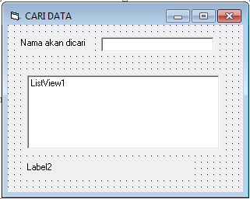

Langkah-2. Ketik Kode program dibawah ini:
Private Sub Form_Load()
Dim LI As ListItem
ListView1.View = lvwReport
ListView1.Sorted = True
'Membuat Judul Kolom (ColumnHeaders) dan mengatur lebar.
ListView1.ColumnHeaders.Add , , "NAMA", ListView1.Width / 3
ListView1.ColumnHeaders.Add , , "GOLONGAN", ListView1.Width / 3
ListView1.ColumnHeaders.Add , , "GAJI", ListView1.Width / 3
End Sub

Private Sub CariData()
Dim Nama, Kode, Gaji As String
Dim Ada As Integer
Dim TotalGaji As Currency
ListView1.ListItems.Clear
Text1 = UCase("*" & Text1 & "*")
Open App.Path & "\GAJI.DAT" For Input As #1
Do Until EOF(1)
Input #1, Nama, Kode, Gaji
If UCase(Nama) Like Text1 Then
'Masukkan data ke dalam list.
Set LI = ListView1.ListItems.Add(, , Nama)
LI.SubItems(1) = Kode
LI.SubItems(2) = Gaji
TotalGaji = TotalGaji + Gaji
Ada = Ada + 1
End If
Loop
Close #1
If Ada = 0 Then MsgBox "Nama tersebut tidak ada dalam file!"
If Ada <> 0 Then
Text1 = ""
Label2.Caption = "Total Gaji = " + Format(TotalGaji, "Currency")
End If
End Sub

Private Sub Text1_KeyDown(KeyCode As Integer, Shift As Integer)
If Text1 <> "" And KeyCode = 13 Then CariData
End Sub

Langkah-3. Hasil pada saat di Run:

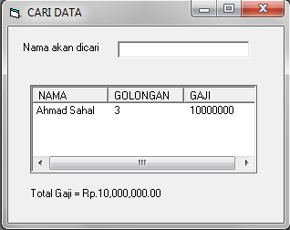

8.HAPUS DATA

Langkah 1. Buatlah form seperti dibawah ini:
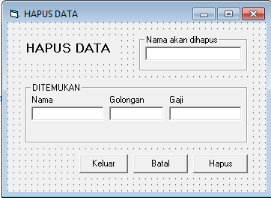

Langkah-2. Ketik Kode program dibawah ini:

Private Sub Form_Load()
CmdHapus.Enabled = False
End Sub

Private Sub CariData()
Dim Nama, Kode, Gaji As String
Dim Ada As Integer
Open App.Path & "\GAJI.DAT" For Input As #1
Do Until EOF(1)
Input #1, Nama, Kode, Gaji
If UCase(TxtNamaCari) = UCase(Nama) Then
TxtNama = Nama
TxtKode = Kode
TxtGaji = Format(Gaji, "Currency")
Ada = Ada + 1
CmdHapus.Enabled = True 'Hidupkan tombol Hapus
End If
Loop
Close
If Ada <> 0 Then TxtNamaCari.Enabled = False
If Ada = 0 Then
MsgBox "Nama '" & TxtNamaCari & "' tidak ada dalam file!"
Kosongkan
TxtNamaCari.SetFocus
End If
End Sub

Private Sub Kosongkan()
TxtNamaCari = ""
TxtNama = ""
TxtKode = ""
TxtGaji = ""
End Sub

Private Sub CmdHapus_Click()
Dim Nama, Kode, Gaji As String
Open "C:\VB6\GAJI.DAT" For Input As #1
Open "C:\VB6\TEMPORER.DAT" For Append As #2

LEWATKAN:
Do Until EOF(1)
Input #1, Nama, Kode, Gaji
If UCase(Nama) = UCase(TxtNamaCari) Then
GoTo LEWATKAN 'Jangan ditulis ke dalam file
End If
Write #2, Nama, Kode, Gaji
Loop
Close
Kill "C:\VB6\GAJI.DAT"
Name "C:\VB6\TEMPORER.DAT" As "C:\VB6\GAJI.DAT"
MsgBox "Data sudah dihapus, klik OK!"
Kosongkan
TxtNamaCari.Enabled = True
TxtNamaCari.SetFocus
CmdHapus.Enabled = False
End Sub

Private Sub CmdBatal_Click()
Kosongkan
TxtNamaCari.Enabled = True
TxtNamaCari.SetFocus
CmdHapus.Enabled = False
End Sub

Private Sub CmdKeluar_Click()
End
End Sub

Private Sub TxtNamaCari_KeyDown(KeyCode As Integer, Shift As Integer)
If TxtNamaCari <> "" And KeyCode = 13 Then CariData
If KeyCode = 27 Then End
End Sub

Langkah-3. Hasil pada saat di Run:

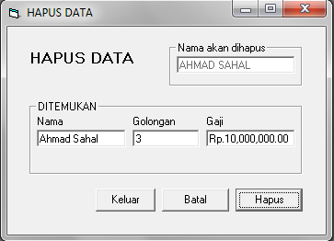

9.RUBAH DATA

Langkah 1. Buatlah form seperti dibawah ini:
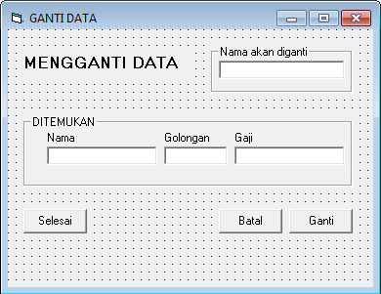

Langkah-2. Ketik Kode program dibawah ini:

Private Sub CariData()
Dim Nama, Kode, Gaji As String
Dim Ada As Integer

Open App.Path & "\GAJI.DAT" For Input As #1

Do Until EOF(1)
Input #1, Nama, Kode, Gaji
If UCase(TxtNamaCari) = UCase(Nama) Then
TxtNama = Nama
TxtKode = Kode
TxtGaji = Gaji
Ada = Ada + 1
CmdGanti.Enabled = True
End If
Loop
Close
TxtNama.SetFocus

If Ada = 0 Then
MsgBox "Nama '" & TxtNamaCari & "' tidak ada dalam file!"
Kosongkan
End If
End Sub

Private Sub Kosongkan()
TxtNamaCari = ""
TxtNama = ""
TxtKode = ""
TxtGaji = ""
TxtNamaCari.SetFocus
CmdGanti.Enabled = False
End Sub

Private Sub CmdBatal_Click()
Kosongkan
End Sub

Private Sub CmdGanti_Click()
Dim Nama, Kode, Gaji As String
Open App.Path & "\GAJI.DAT" For Input As #1
Open App.Path & "\TEMPORER.DAT" For Append As #2
Do Until EOF(1)
Input #1, Nama, Kode, Gaji
If UCase(Nama) = UCase(TxtNamaCari) Then
Nama = TxtNama
Kode = TxtKode
Gaji = TxtGaji
End If
Write #2, Nama, Kode, Gaji
Loop
Close
Kill App.Path & "\GAJI.DAT"
Name App.Path & "\TEMPORER.DAT" As App.Path & "\GAJI.DAT"
MsgBox "Data sudah diganti, klik OK!"
Kosongkan
End Sub

Private Sub CmdSelesai_Click()
End
End Sub

Private Sub Form_Load()
'Matikan tombol GANTI
CmdGanti.Enabled = False
End Sub

Private Sub TxtNamaCari_KeyDown(KeyCode As Integer, Shift As Integer)
If TxtNamaCari <> "" And KeyCode = 13 Then CariData
If KeyCode = 27 Then End
End Sub

Langkah-3. Hasil pada saat di Run:
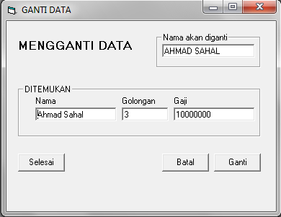

10.MENCETAK

Langkah 1. Buatlah form seperti dibawah ini:
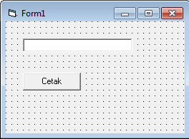

Langkah-2. Ketik Kode program dibawah ini:

Private Sub Command1_Click()
Printer.FontSize = 12
Printer.Print Tab(10); Text1
Printer.EndDoc
End Sub

Langkah-3. Hasil pada saat di Run:

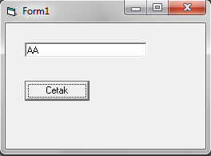

11.MENCETAK

Langkah 1. Buatlah form seperti dibawah ini:
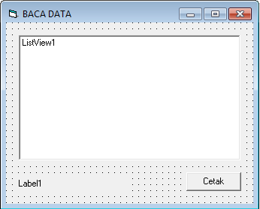
Langkah-2. Ketik Kode program dibawah ini:

Private Sub Command1_Click()
Dim Nama, Kode, Gaji As String
Dim TotalGaji As Currency
Printer.FontSize = 12
Open App.Path & "\GAJI.DAT" For Input As #1
'JUDUL
Printer.Print Tab(10); "NAMA"; Tab(40); "GOLONGAN"; Tab(60); "GAJI"
Printer.Print Tab(10); String(45, "=")
Do Until EOF(1)
Input #1, Nama, Kode, Gaji
TotalGaji = TotalGaji + Gaji
'ISI
Printer.Print Tab(10); Nama; Tab(40); Kode; Tab(60); Gaji
Loop
Printer.Print Tab(10); String(45, "=")
Printer.Print Tab(10); "TOTAL GAJI"; Tab(57); Format(TotalGaji, "Currency")
Close #1
Printer.EndDoc
End Sub

Private Sub Form_Load()
Dim LI As ListItem
Dim Nama, Kode, Gaji As String
Dim TotalGaji As Currency

ListView1.View = lvwReport
ListView1.Sorted = True

'Membuat Judul Kolom (ColumnHeaders) serta mengatur lebar.
ListView1.ColumnHeaders.Add , , "NAMA", ListView1.Width / 3
ListView1.ColumnHeaders.Add , , "GOLONGAN", ListView1.Width / 3
ListView1.ColumnHeaders.Add , , "GAJI", ListView1.Width / 3

Open App.Path & "\GAJI.DAT" For Input As #1
Do Until EOF(1)
Input #1, Nama, Kode, Gaji
'Masukkan item dan sub item ke dalam list.
Set LI = ListView1.ListItems.Add(, , Nama)
LI.SubItems(1) = Kode
LI.SubItems(2) = Gaji
TotalGaji = TotalGaji + Gaji
Loop
Close #1
Label1.Caption = "Total Gaji = " + Format(TotalGaji, "Currency")
End Sub

Langkah-3. Hasil pada saat di Run:
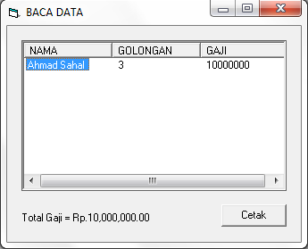

12.MENU

Langkah 1. Buatlah form seperti dibawah ini:
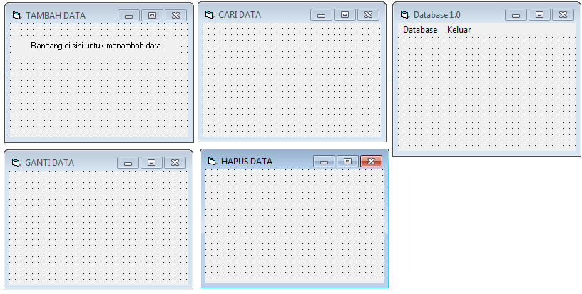

Langkah-2. Ketik Kode program dibawah ini:

Private Sub MenuCari_Click()
Form3.Show
End Sub

Private Sub MenuGanti_Click()
Form4.Show
End Sub

Private Sub MenuHapus_Click()
Form5.Show
End Sub

Private Sub MenuKeluar_Click()
End
End Sub

Private Sub MenuTambah_Click()
Form2.Show
End Sub

Langkah-3. Hasil pada saat di Run:
