**Lab 3 - Routing Protocol**

**NAME: SYED MUHAMMAD YAMIN GHARBI**

**MATRIC NUM.: A17CS5066**

**SECTION: 06.**

**Introduction**

You are given a Packet Tracer file, which requires some work IP addressing and routing protocol configuration. You must follow all the steps carefully and answer the given questions.

Figure 1

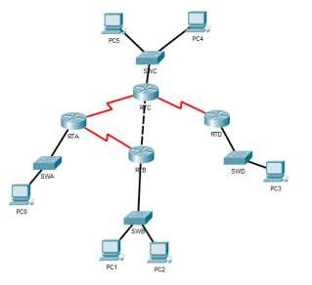

# Task 1: IP addressing

**Step 1:** Fill in Table 1 below with the correct information. Note: The information may be found under the ***Config*** tab of each router (refer to Figure2).

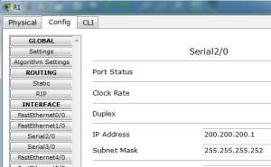

Figure 2

Table 1

|  |  |  |  |  |
| --- | --- | --- | --- | --- |
| **#** | **Device Name** | **Interface** | **IP Address** | **Subnet Mask** |
| 1 | RTA | Se2/0 | 172.16.230.5 | 255.255.255.252 |
| 2 | Se3/0 | 172.16.230.1 | 255.255.255.252 |
| 3 | Fa0/0 | 172.16.224.255 | 255.255.254.0 |
| 4 | RTB | Se2/0 | 172.16.230.2 | 255.255.255.252 |
| 5 | Fa0/0 | 172.16.230.9 | 255.255.255.252 |
| 6 | Fa1/0 | 172.16.226.11 | 255.255.254.0 |
| 7 | RTC | Se2/0 | 172.16.230.6 | 255.255.255.252 |
| 8 | Se3/0 | 172.16.230.13 | 255.255.255.252 |
| 9 | Fa0/0 | 172.16.230.10 | 255.255.255.252 |
| 10 | Fa1/0 | 172.16.228.11 | 255.255.255.0 |
| 10 | RTD | Se2/0 | 172.16.230.14 | 255.255.255.252 |
| 11 | Fa0/0 | 172.16.229.222 | 255.255.255.0 |

**Step 2:** Given the information in file, answer the following questions:

1. How many different subnets are there? __8__
2. What is the network address of each of these subnets? (*Hint: Given the IP address and the subnet mask, you can calculate the network address using AND operation*). Label the subnets in the topology given in Figure 1, and complete Table 2 below.

Table 2

|  |  |  |  |
| --- | --- | --- | --- |
| **Subnet**  **#** | **Network**  **Address** | **Broadcast Address** | **Range of usable addresses** |
| 1 | 172.16.224.0 | 172.16.225.255 | 172.16.224.1 - 172.16.225.254 |
| 2 | 172.16.230.0 | 172.16.230.3 | 172.16.230.1 - 172.16.230.2 |
| **3** | 172.16.230.4 | 172.16.230.7 | 172.16.230.5 - 172.16.230.6 |
| **4** | 172. 16.230.0 | 172.16.230.3 | 172. 16.230.1-172.16.230.2 |
| **5** | 172.16.226.0 | 172.16.227.255 | 172.16.226.1 - 172.16.227.254 |
| **6** | 172.16.230.8 | 172.16.230.11 | 172.16.230.9 - 172.16.230.10 |
| **7** | 172.16.230.0 | 172.16.230.3 | 172.16.230.1 - 172.16.230.2 |
| **8** | 172.16.230.12 | 172.16.230.15 | 172.16.230.13 - 172.16.230.14 |
| **9** | 172.16.228.0 | 172.16.228.255 | 172.16.228.1 - 172.16.228.254 |
| **10** | 172.16.229.0 | 172.16.229.255 | 172.16.229.1 - 172.16.229.254 |

1. Provided that all PC will use the last usable address in its subnet, fill in Table 3 below with the correct information.

Table 3

|  |  |  |  |  |
| --- | --- | --- | --- | --- |
| **#** | **Device Name** | **IP Address** | **Subnet Mask** | **Default**  **Gateway** |
| 1 | PCA | 172.16.225.254 | 255.255.254.0 | 172.16.224.255 |
| 2 | PCB | **172.16.227.254** | 255.255.254.0 | 172.16.226.11 |
| 3 | PCC | **172.16.228.254** | 255.255.255.0 | 172.16.228.11 |
| 4 | PCD | **172.16.229.254** | 255.255.255.0 | 172.16.229.222 |

**Step 3:** Complete the IP addressing information on all the PCs in the topology. (Hint: Click on the PC, choose the ***Desktop*** tab, then click ***IP Configuration***).

**Step 4:** Open the routing table for each router. *(Hint: you can use the ‘magnifying glass’ icon, then point to a router and choose ‘Routing Table’. See Figure 3 below.)*

fd

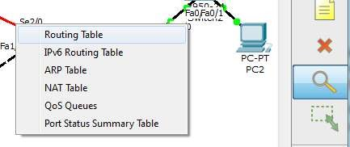

Figure 3

**Step 5:** Copy the image of the routing table for each router. *(Hint: You can use ‘Snipping Tool’ to copy the image.)*

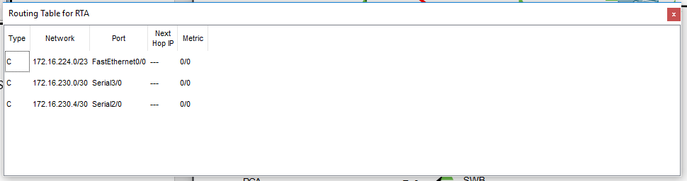

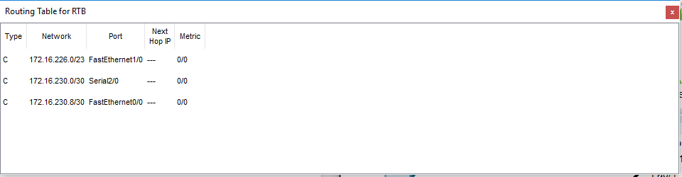

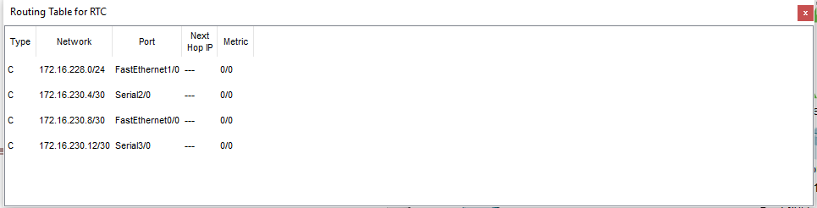

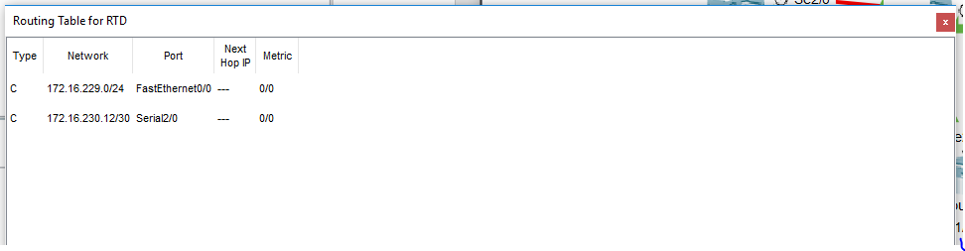

**Step 6:** Answer the questions below.

1. Do all the routers have the same information in its routing table? NO
2. What is the difference that can be seen? Number of interfaces.
3. Can all the PCs ping each other successfully?

Table 4

|  |  |  |  |
| --- | --- | --- | --- |
| **#** | **Ping between devices** | **Successful (**✓**)** | **Unsuccessful**  **(×)** |
| 1 | PCA-PCB |  |  |
| 2 | PCA-PCC |  |  |
| 3 | PCA-PCD |  |  |
| 4 | PCB-PCC |  |  |
| 5 | PCB-PCD |  |  |
| 6 | PCC-PCD |  |  |

1. Reflection: what is the reason for your answer in (c)?

# Task 2: Dynamic routing configuration – RIP

Dynamic routing allows the network to be more flexible to changes. It can help the routers adapt to the changes in the pathways without much intervention from network administrators.

In this part of the lab, you will learn how to configure RIP routing protocol, and see how changes happen in the routing tables. Routers R1 and R4 is already configured for you.

**Step 1:** Choose Router RTA. Click the CLI tab. Copy the following text into the command line interface.

|  |
| --- |
| RTA>enable  RTA#configure terminal  Enter configuration commands, one per line. End with CNTL/Z.  RTA(config)#router rip  RTA(config-router)#version 2  RTA(config-router)#network 172.16.0.0  RTA(config-router)#no auto-summary  RTA(config-router)#exit  RTA(config)#exit  RTA#  %SYS-5-CONFIG_I: Configured from console by console  RTA#copy running-config startup-config  Destination filename [startup-config]? When asked this Building configuration... just press ENTER [OK]  RTA# |

***Task 1.1:***

1. Copy (paste image) of the RTA and RTB routing table here.

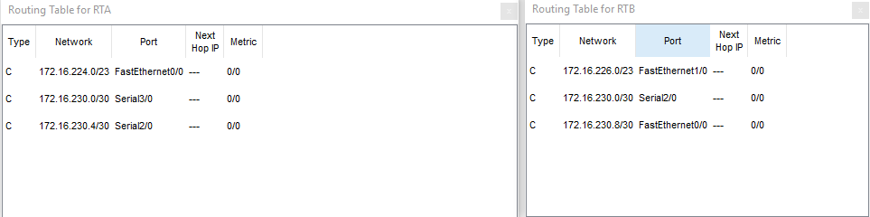

**Step 2:** Choose Router RTB. Click the CLI tab. Copy the following text into the command line interface.

|  |
| --- |
| RTB>enable  RTB#configure terminal  Enter configuration commands, one per line. End with CNTL/Z.  RTB(config)#router rip  RTB(config-router)#version 2  RTB(config-router)#network 172.16.0.0  RTB(config-router)#no auto-summary  RTB(config-router)#exit  RTB(config)#exit  RTB#  %SYS-5-CONFIG_I: Configured from console by console RTB#copy running-config startup-config Destination filename [startup-config]?  Building configuration...  [OK]  RTB# |

***Task 2.1:***

(a) Copy (paste image) of the RTA and RTB routing table here.

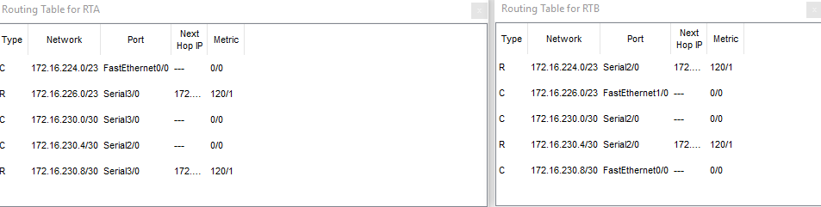 (b) **Reflection:** what difference do you see?

**Step 3:** Copy the same configuration instructions to RTC and RTD**Step 4:** Answer the questions below.

1. Do all the routers have the same information in its routing table?
2. Write down what RTC and RTD routing table information (Next Hop IP, Metric) to the network 172.16.224.0/24.
3. What is the difference that can be seen? Why is this?
4. Can all the PCs ping each other successfully?

Table 5

|  |  |  |  |
| --- | --- | --- | --- |
| **#** | **Ping between devices** | **Successful (**✓**)** | **Unsuccessful**  **(×)** |
| 1 | PCA-PCB |  |  |
| 2 | PCA-PCC |  |  |
| 3 | PCA-PCD |  |  |
| 4 | PCB-PCC |  |  |
| 5 | PCB-PCD |  |  |
| 6 | PCC-PCD |  |  |

1. Reflection: what is the reason for your answer in (d)?

**Step 5:** Switch off router RTA. What are the changes noted in the routing tables?

**Step 6:** Switch on router RTA. What are the changes noted in the routing tables?

**Step 7: Reflection:** What have you learned in this task?

# Task 3: Dynamic routing configuration – OSPF

Make sure that you have all the routing tables on display on one side (as before). As you go through the steps, look at the changes happening in the routing tables.

**Step 1:** On **all** the routers, do the following.

|  |
| --- |
| Router#configure terminal  Enter configuration commands, one per line. End with CNTL/Z.  Router(config)#no router rip  Router(config)#exit  Router#  %SYS-5-CONFIG_I: Configured from console by console Router#copy running-config startup-config Destination filename [startup-config]? |

**Step 2:** Copy the image of the routing table for each router.

**Step 3:** For Router RTA, Click the CLI tab. Copy the following text into the command line interface.

|  |
| --- |
| RTA# configure terminal  Enter configuration commands, one per line. End with CNTL/Z.  RTA(config)#router ospf 1  RTA(config-router)#network 172.16.224.0 0.0.1.255 area 0  RTA(config-router)#network 172.16.230.0 0.0.0.3 area 0  RTA(config-router)#network 172.16.230.4 0.0.0.3 area 0  RTA(config-router)#end  RTA# copy running-config startup-config Destination filename [startup-config]?  %SYS-5-CONFIG_I: Configured from console by console    Building configuration...  [OK]  RTA# |

**Task 3.1:** paste the image of RTA’s routing table here.

**Task 3.2:**

1. Does RTA have a path to ALL the different subnet?
2. Try pinging the different PCs and jot down your results.

Table 6

|  |  |  |  |
| --- | --- | --- | --- |
| **#** | **Ping between devices** | **Successful (**✓**)** | **Unsuccessful**  **(×)** |
| 1 | PCA-PCB |  |  |
| 2 | PCA-PCC |  |  |
| 3 | PCA-PCD |  |  |

**Step 4:** Configure the other routers with OSPF routing algorithm.

**Step 4.1:** For Router RTB, Click the CLI tab. Copy the following text into the command line interface.

|  |
| --- |
| RTB# configure terminal  Enter configuration commands, one per line. End with CNTL/Z.  RTB(config)#router ospf 1  RTB(config-router)#network 172.16.226.0 0.0.1.255 area 0  RTB(config-router)#network 172.16.230.0 0.0.0.3 area 0  RTB(config-router)#network 172.16.230.8 0.0.0.3 area 0  RTB(config-router)#end  RTB# copy running-config startup-config Destination filename [startup-config]?  %SYS-5-CONFIG_I: Configured from console by console Building configuration...  [OK]  RTB# |

**Step 4.2:** For Router RTC, Click the CLI tab. Copy the following text into the command line interface.

|  |
| --- |
| RTC# configure terminal  Enter configuration commands, one per line. End with CNTL/Z.  RTC(config)#router ospf 1  RTC(config-router)#network 172.16.228.0 0.0.0.255 area 0  RTC(config-router)#network 172.16.230.4 0.0.0.3 area 0  RTC(config-router)#network 172.16.230.8 0.0.0.3 area 0  RTC(config-router)#network 172.16.230.12 0.0.0.3 area 0  RTC(config-router)#end  RTC# copy running-config startup-config Destination filename [startup-config]?  %SYS-5-CONFIG_I: Configured from console by console Building configuration...  [OK]  RTC# |

**Step 4.3:** For Router RTD, Click the CLI tab. Copy the following text into the command line interface.

|  |
| --- |
| RTD# configure terminal  Enter configuration commands, one per line. End with CNTL/Z.  RTD(config)#  RTD(config)#router ospf 1  RTD(config-router)#network 172.16.229.0 0.0.0.255 area 0  RTD(config-router)#network 172.16.230.12 0.0.0.3 area 0  RTD(config-router)#end  RTD# copy running-config startup-config Destination filename [startup-config]?  Building configuration...  [OK]  RTD#  %SYS-5-CONFIG_I: Configured from console by console RTD# |

**Step 5:** Copy the image of the routing table for each router and paste it here.

**Step 6:** Switch off router RTA. What are the changes noted in the routing tables?

**Step 7:** Switch on router RTA. Wait a few minutes. What are the changes noted in the routing tables?

**Step 8: Reflection:** What have you learned in this task?

----END----