**Overview of our project**

Hype Beast Jo

Done by : osaid aghbar 20201027 Fares Abu Laila 20201124

Ammar Abohouseh 20210582

**main page**

where you can view the sneakers that are for sale with buttons for cart,log in , buy now option

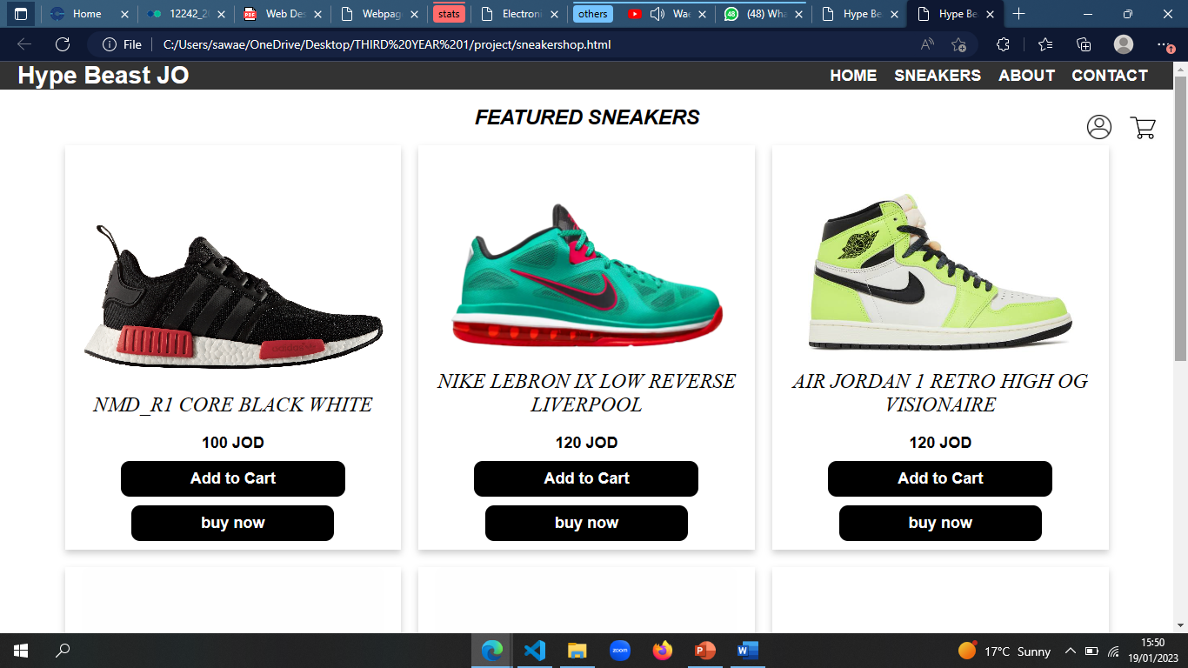

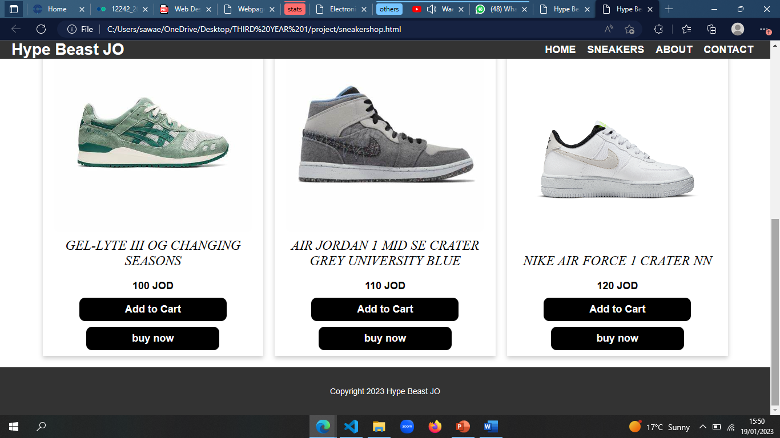

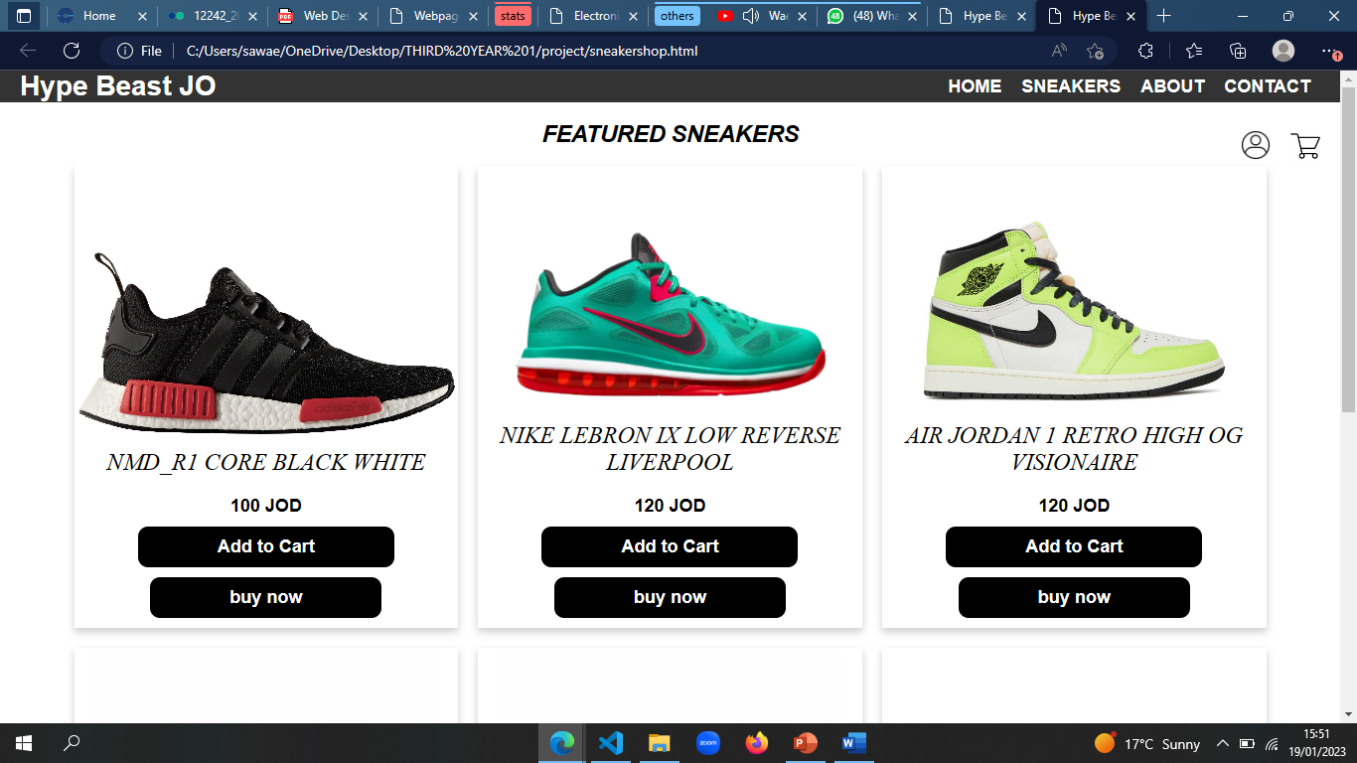**feature 1**

we used hovering so once the user drags the mouse on the shoes it scales up in size for more aesthetical appearance

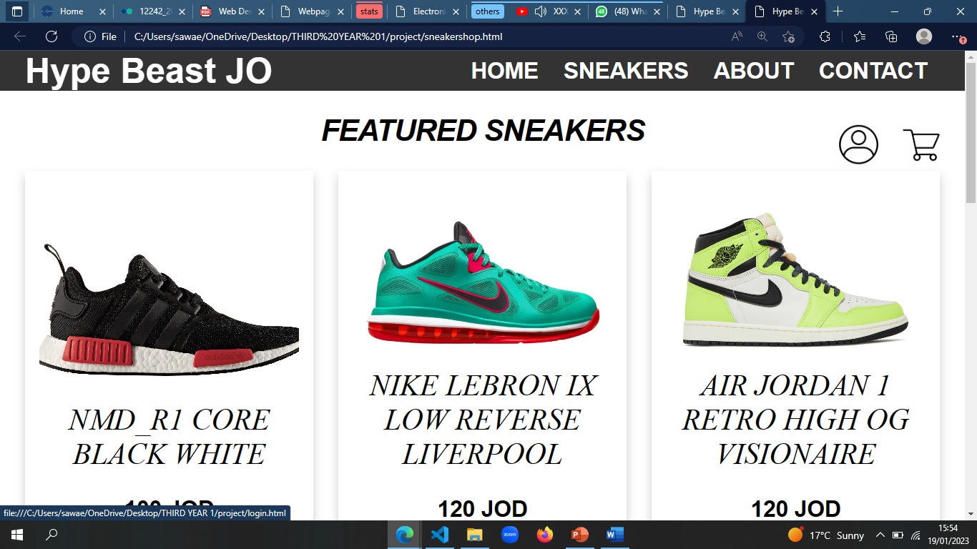

**feature 2**

we used icons for the log in and cart to look more professional with also a hovering option that enlarges the icon when u hover the mouse over it

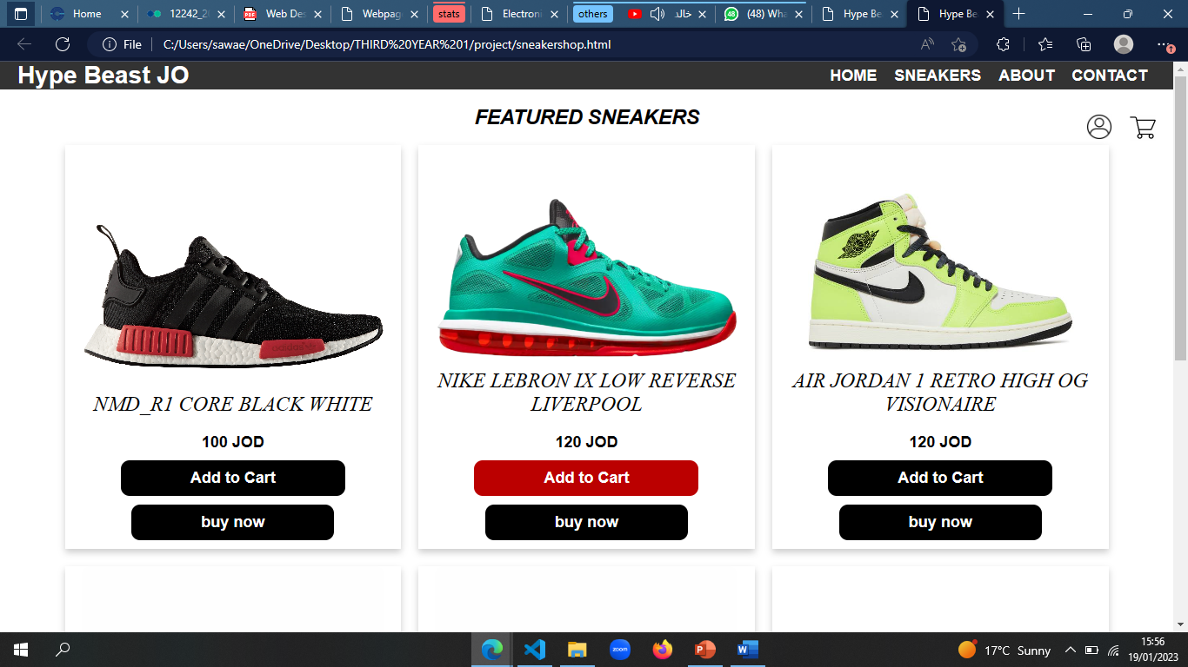

**Feature 3**

we also used the hovering property for the both buttons here to change the color from black to red when the user hovers over it

**cart page**

we mainly used javascript here to calculate the total price and the quantity .

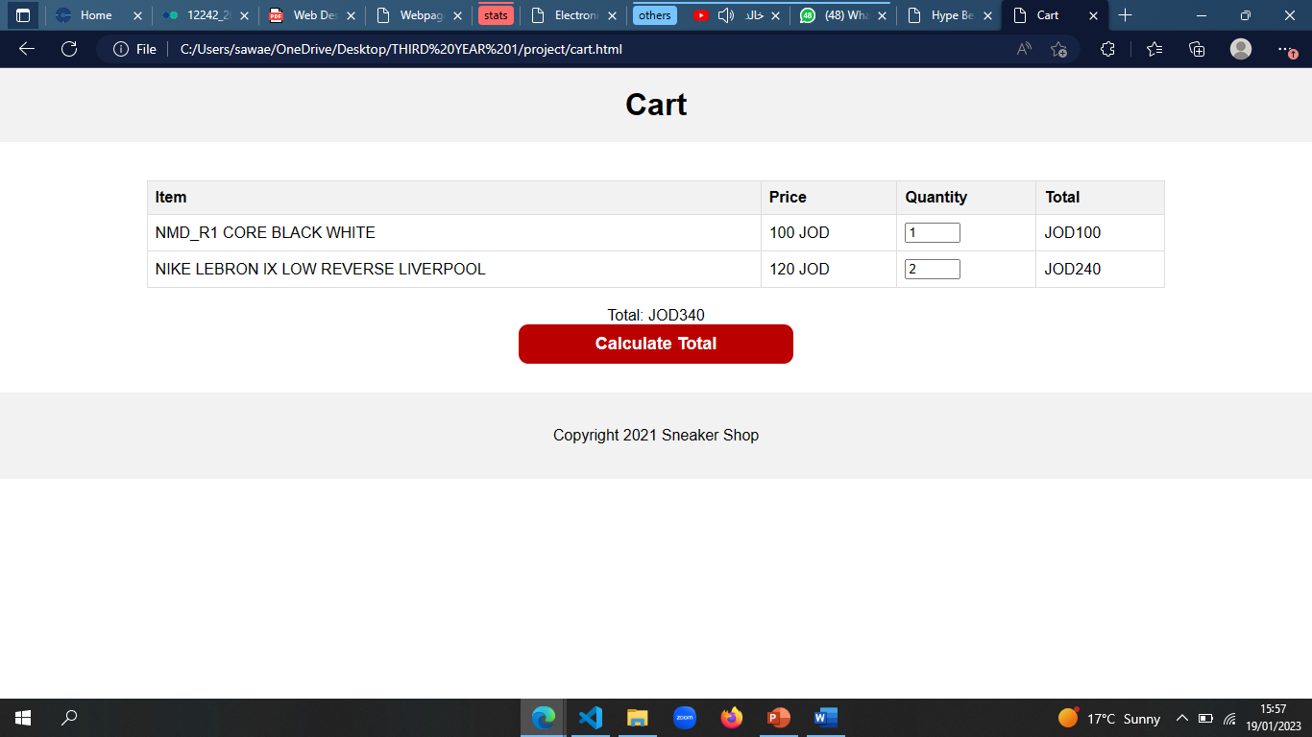

**Feature 4**

using javascript here we gave the user to choose the quantity and calculate the price accordingly and following the same theme for all the buttons the buttons turn red when u hover over it

**log in page**

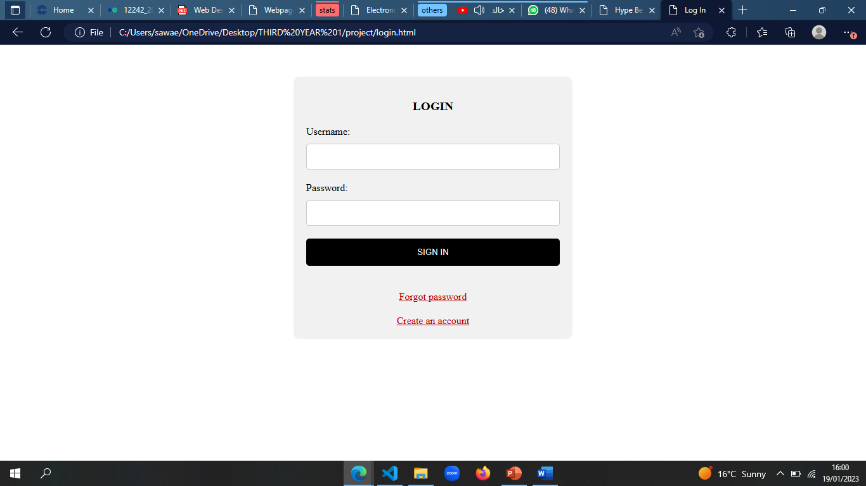simple log in page that also had an option to take you to register an account on the website

**register page**

username , password, email , phone number and we used validation by javascript to check if the email is in the correct format

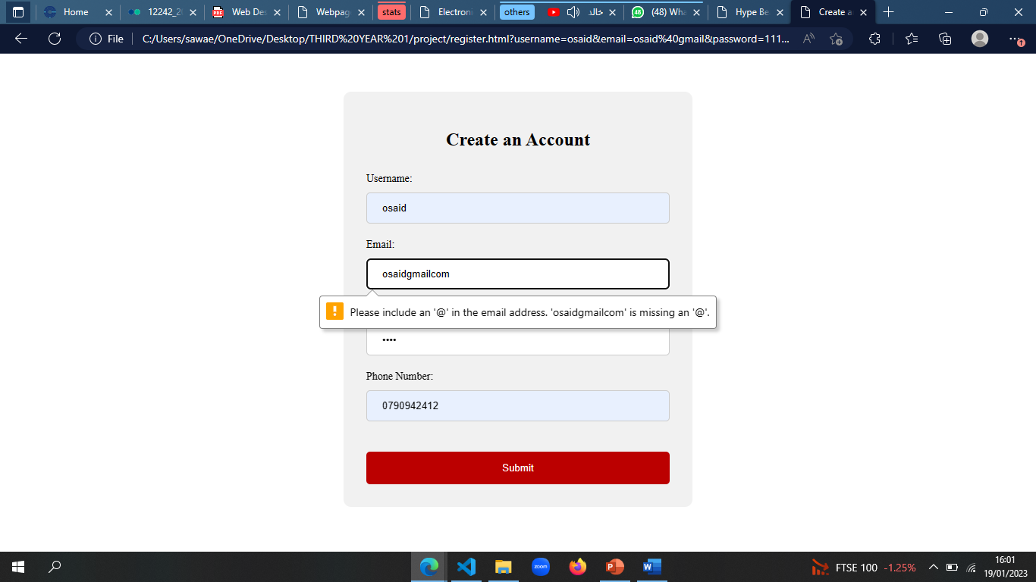

**Feature 5**

email validation

**forget password**

simple html page that requires your email to reset you password

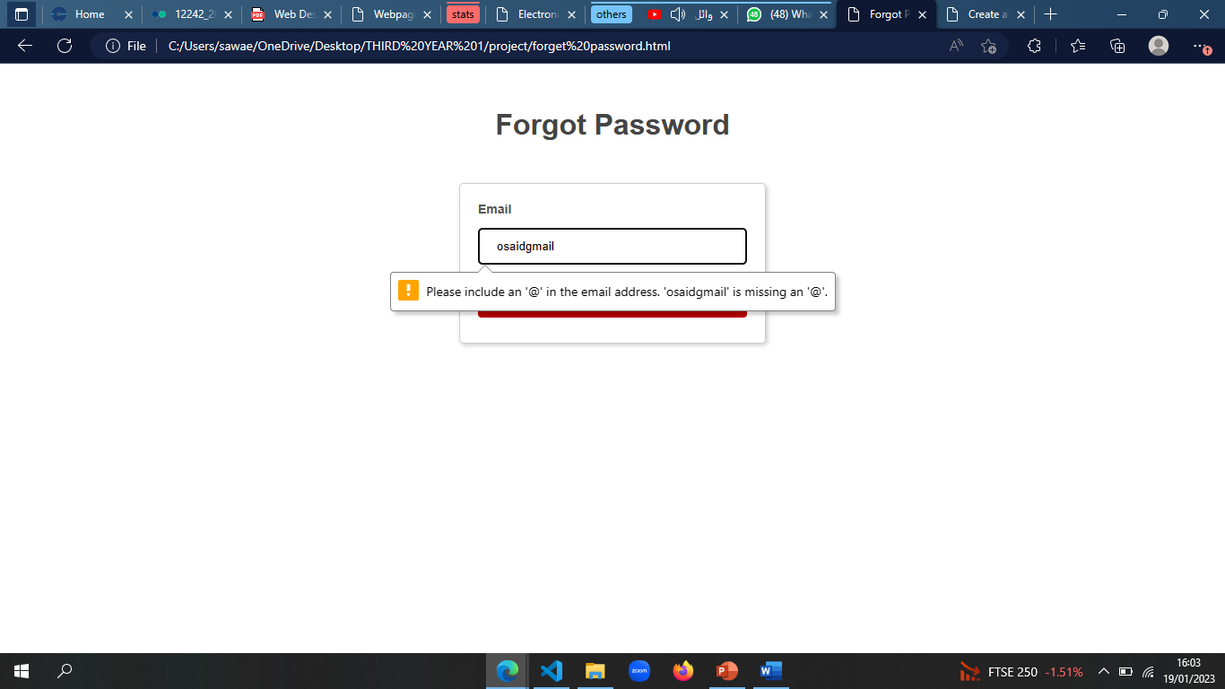

**Feature 5**

email validation

**buy now page**

a page if the user decided to buy at the same moment without adding to the cart that requires billing information from the user

