Key Milestone 1: Conceptual Schema

# Entity Description

The table below describes different entities in the database for a blogging platform. Timestamps attributes are included in every entity but not explicitly mentioned.

Table 1: Entity Description

|  |  |  |
| --- | --- | --- |
| **Entity Name** | **Attributes** | **Description** |
| **User** | user_id (PK), name, bio, email, password | Represents a user |
| **Post** | post_id (PK), title, content, user_id (FK) | Blog post created by a user |
| **Comment** | comment_id (PK), content, user_id (FK), post_id (FK) | Comment by a user on a post |
| **Category** | category_id (PK), name, description | Category to organize blog posts |
| **PostCategory** | post_id (FK), category_id (FK) | Junction table for Post–Category (M:N) |
| **Like** | like_id (PK), user_id (FK), post_id (FK), liked_at | User's like on a post |
| **Tag** | tag_id (PK), name | Tag for labeling posts |
| **PostTag** | post_id (FK), tag_id (FK) | Junction table for Post–Tag (M:N) |
| **Follow** | follower_id (FK), followed_id (FK), followed_at | Self-referencing user follow relationship |

# Detailed Business Rules

#### 1. **User Entity Rules**

* A user must have a unique user_id (primary key).
* A user must have a name, email, password, created_at, and updated_at.
* A user may have a bio, follower_count, and followed_count.
* follower_count and followed_count are derived attributes:
  + follower_count represents the total number of users following this user.
  + followed_count represents the total number of users this user follows.
* A user can follow other users through the Follow relationship.
* A user can be followed by other users through the Follow relationship.

#### 2. **Follow Relationship Rules**

* The Follow relationship connects two users: a follower (FK: follower_id) and a followed user (FK: followed_id).
* A user cannot follow themselves (i.e., follower_id cannot equal followed_id).
* The Follow relationship must record the followed_at timestamp.
* A user can follow multiple users, and a user can be followed by multiple users (many-to-many relationship).
* The combination of follower_id and followed_id must be unique to prevent duplicate follow relationships.

#### 3. **Post Entity Rules**

* A post must have a unique post_id (primary key).
* A post must have a user_id (foreign key referencing User), title, content, created_at, and updated_at.
* likes_count and comment_count are derived attributes:
  + likes_count represents the total number of likes on the post.
  + comment_count represents the total number of comments on the post.
* A post must be created by exactly one user (via user_id).
* A user can create multiple posts.

#### 4. **Like Relationship Rules**

* The Like relationship connects a User (FK: user_id) and a Post (FK: post_id).
* A user can like multiple posts, and a post can be liked by multiple users (many-to-many relationship).
* The Like relationship must record the liked_at timestamp.
* A user can like a post only once (the combination of user_id and post_id must be unique).
* The likes_count on a post is calculated as the total number of users who liked the post.

#### 5. **Comment Entity Rules**

* A comment must have a unique comment_id (primary key).
* A comment must have a user_id (FK referencing User), post_id (FK referencing Post), content, and commented_at.
* A user can comment on multiple posts, and a post can have multiple comments.
* The comment_count on a post is calculated as the total number of comments on the post.

#### 6. **Category Entity Rules**

* A category must have a unique category_id (primary key).
* A category must have a name and may have a description.
* posts_count is a derived attribute representing the total number of posts in the category.
* A category can be associated with multiple posts through the PostCategory relationship.

#### 7. **PostCategory Relationship Rules**

* The PostCategory relationship connects a Post (FK: post_id) and a Category (FK: category_id).
* A post can belong to multiple categories, and a category can include multiple posts (many-to-many relationship).
* The combination of post_id and category_id must be unique to avoid duplicate categorization.
* The posts_count on a category is calculated as the total number of posts associated with the category.

#### 8. **Tag Entity Rules**

* A tag must have a unique tag_id (primary key).
* A tag must have a name.
* A tag can be associated with multiple posts through the PostTag relationship.

#### 9. **PostTag Relationship Rules**

* The PostTag relationship connects a Post (FK: post_id) and a Tag (FK: tag_id).
* A post can have multiple tags, and a tag can be applied to multiple posts (many-to-many relationship).
* The combination of post_id and tag_id must be unique to avoid duplicate tagging.

#### 10. **General Constraints**

* All timestamps (created_at, updated_at, followed_at, liked_at, commented_at) must be valid dates and times.
* Derived attributes (follower_count, followed_count, likes_count, comment_count, posts_count) are not stored but computed dynamically:
  + follower_count: Count of users where this user is the followed_id in Follow.
  + followed_count: Count of users where this user is the follower_id in Follow.
  + likes_count: Count of users who liked a post in Like.
  + comment_count: Count of comments on a post in Comment.
  + posts_count: Count of posts in a category in PostCategory.

# Entity Relationship Diagram (ERD)

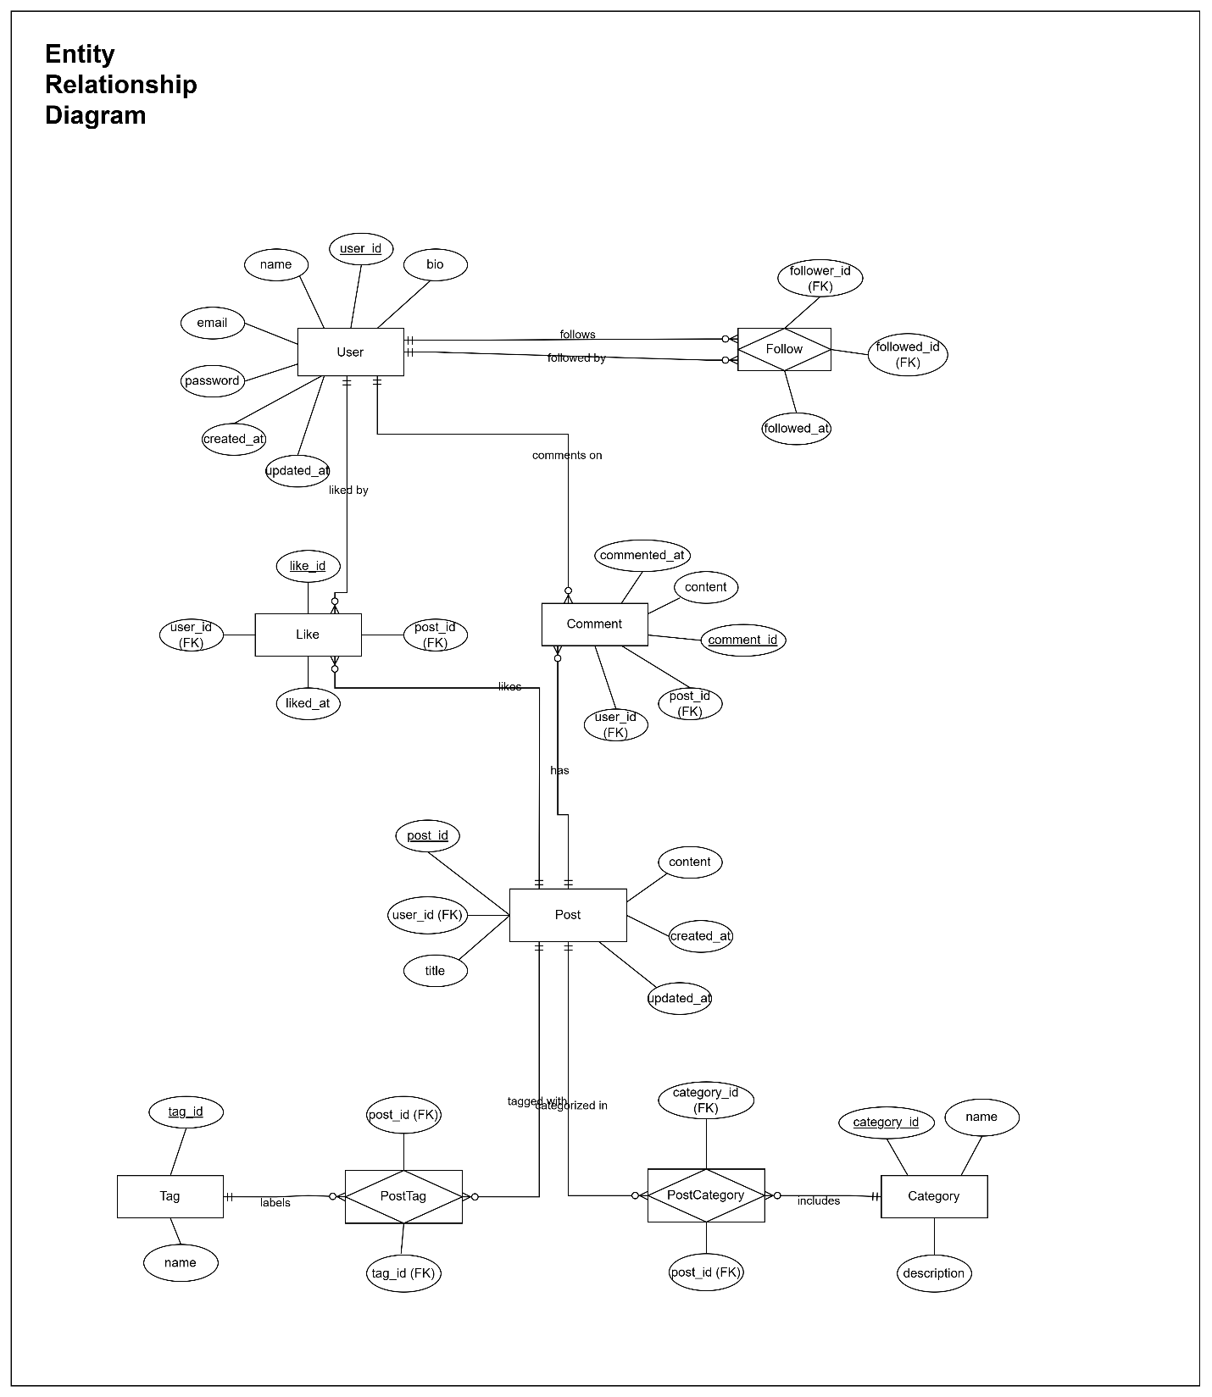

Figure 1: Entity Relationship Diagram (ERD)

# Enhanced Entity Relationship Diagram (EERD)

This EERD adds sections and aggregate/derived attributes to the original ERD.

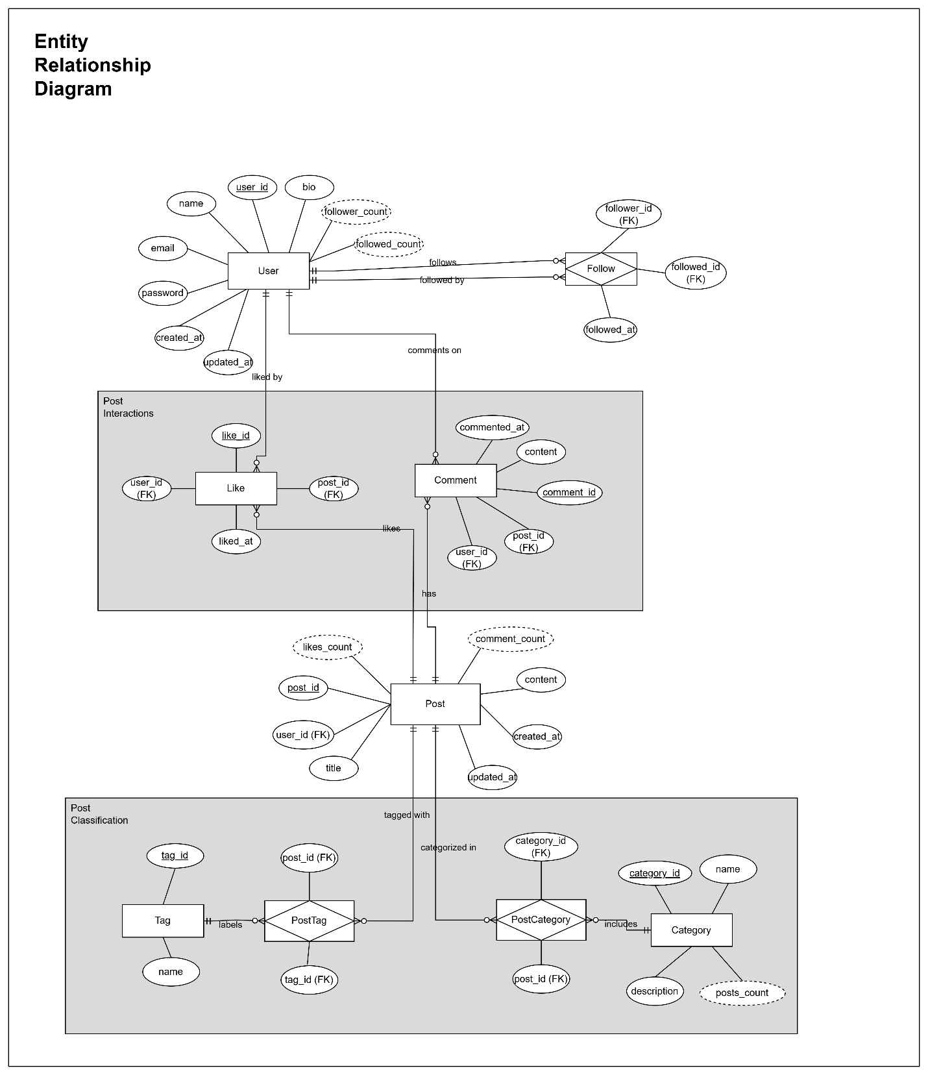

Figure 2: Enhanced Entity Relationship Diagram (EERD)

# References

1. [AI ER Diagram Generator - Free Online Tool](https://notegpt.io/er-diagram-generator): Entity Relationship Notation.
2. [ChatGPT](https://chatgpt.com/) and [Grok](https://grok.com/): Refining business rules.
3. [ER Diagram Symbols Explained | A Beginner’s Guide | Creately](https://creately.com/guides/er-diagram-symbols/) and [Crows Foot Notation Relationship Symbols](https://www.freecodecamp.org/news/crows-foot-notation-relationship-symbols-and-how-to-read-diagrams/): Crow’s foot notation.