**WeRateDogs Twitter**

**Data Act Report :-**

**Research Questions:**

1. Does the dog having a name or stage have anything to do with them having high rates?

We started this by observing the difference between mean of rates of dogs having either a name or a stage and those who don’t have both, we observed the difference in mean between those respectively is 0.85

Our hypothesis is as follow :-



Under assumption that null hypothesis is true , the position of the observed difference under the null distribution is illustrated in Figure 1

With a corresponding **P-value =**  **0**, which means that we reject the null, and dogs with either names or stages have higher rates than those without both.

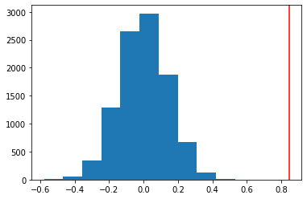

Figure 1

1. Are there any common names for dogs ?

As we see in Figure 2:- The most common name for dogs is charlie.

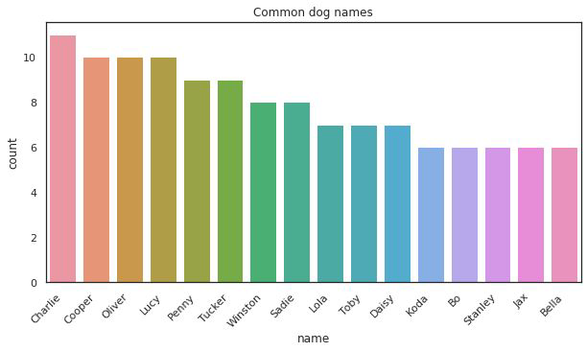

And here’s a photo with the highest ranked good boy Charlie ( with respect to Rate, Favorite Count and Retweets Count)



1. What are the most common words WeRateDogs say?

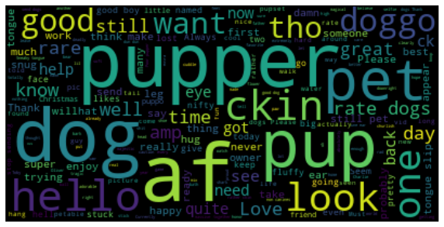

As we can see in the above Figure , the most common words said by WeRateDogs , We can say that they curse a lot .

1. Does Posting Time have anything to do with higher rates?

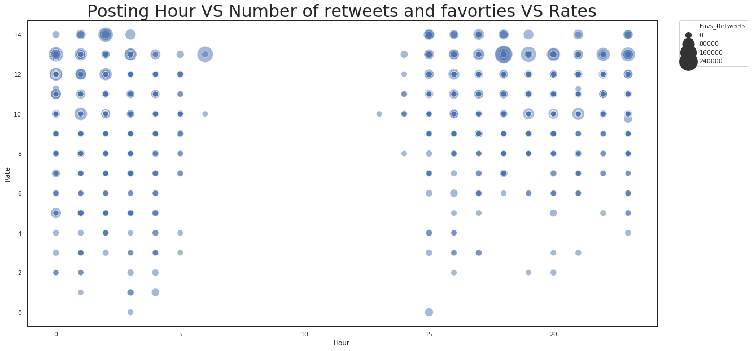

(Rate on y-axis, Hour of posting on x-axis, Favorite Count + Retweet counts is the size of point)

We can see from the above plot two things

1. There is no activity between 6 AM and 12PM
2. Tweets including higher rates is retweeted and favorited more
3. Does any dog stage have more rates than the others?

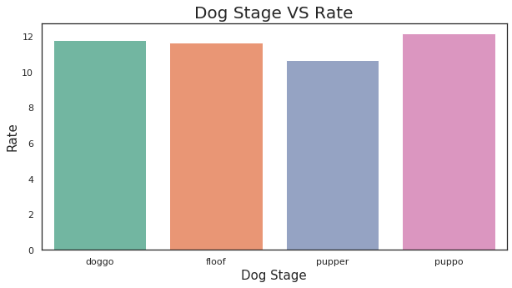

We can see from the above plots that puppos are rated slightly more than the others

1. TOP 5 retweeted and favorited tweets?

