

Regi Tech Website Development
End of Day Implementation Report
Report date 20 October 2026
Reporting scope Changes completed since pushed commit 1f52f81
Prepared for Client review
Current delivery status
The reviewed customer-facing corrections, plate configurator improvements, multi-plate cart, and Phase 4 order and payment architecture are implemented in the project. The TypeScript check and production build pass. Live payment, database, document-storage, and address-lookup testing now depends on client-controlled provider accounts and credentials.
READY FOR SOURCE CONTROL DELIVERY

Executive Summary
This implementation cycle resolves the latest client review comments while retaining the approved Figma hierarchy and the project rules for reusable components, shared types, JSON-managed copy, responsive behaviour, validation, and server-side security. The largest functional change is support for multiple independently configured plates within one order.
Workstream | Status | Outcome
Homepage and navigation | Complete | Client-requested hero, CTA, registration image and responsive updates are implemented.
Plate configurator | Complete | Plate geometry, UK registration font, borders, flags, logos, slogans, pricing and fixings are updated.
Multi-plate cart | Implemented | Orders can contain separate plate designs with independent quantities, editing and uploads.
Checkout and persistence | Implemented | Validated server routes, Supabase persistence, private uploads and dynamic confirmation are in place.
Hosted payment | Implemented | Stripe Checkout, retry handling and signed idempotent webhooks are coded.
Live provider verification | Client input required | Production credentials, migrations and provider account configuration remain outstanding.

Delivery Highlights
- The homepage now uses the approved yellow treatment for the second hero line, an Explore Our Plates call to action, and the AB99 CDE motorcycle image.
- The configurator uses the supplied UKNumberPlate typeface, plate-specific aspect ratios, contiguous single and double borders, exact country-flag lockups, border-aware legal markings, and measured registration fitting.
- The cart now supports several independently configured products while keeping each plate's quantity, pricing, artwork and road-legal documentation separate.
- Checkout validates and recalculates prices on the server before creating an order and hosted Stripe Checkout Session.
- Sensitive documents are designed for private Supabase Storage buckets and are never exposed through public URLs or browser storage.

Current Limitations
- The exact Chalkboard SE webfont for The Scribbler cannot be distributed without a suitable webfont licence and file from the client.
- The final Hand Crafted Show Plate product photograph is still required from the client.
- Live Stripe, Supabase and Ideal Postcodes verification cannot be completed until the client supplies account access and server-side credentials through a secure channel.

Customer Facing Corrections
The visual corrections follow the approved Figma composition and the supplied plate-reference documents. Existing spacing, component structure and responsive behaviour were preserved where the client did not request a change.

Homepage
- Changed the complete second hero line to the Regi Tech yellow accent while keeping the first line white with a yellow full stop.
- Removed the original hero Design Your Plate action and retained Explore Our Plates.
- Updated the desktop and mobile header call to action to Explore Our Plates.
- Updated the motorcycle registration shown in the hero artwork to AB99 CDE without changing the photograph's perspective or lighting.
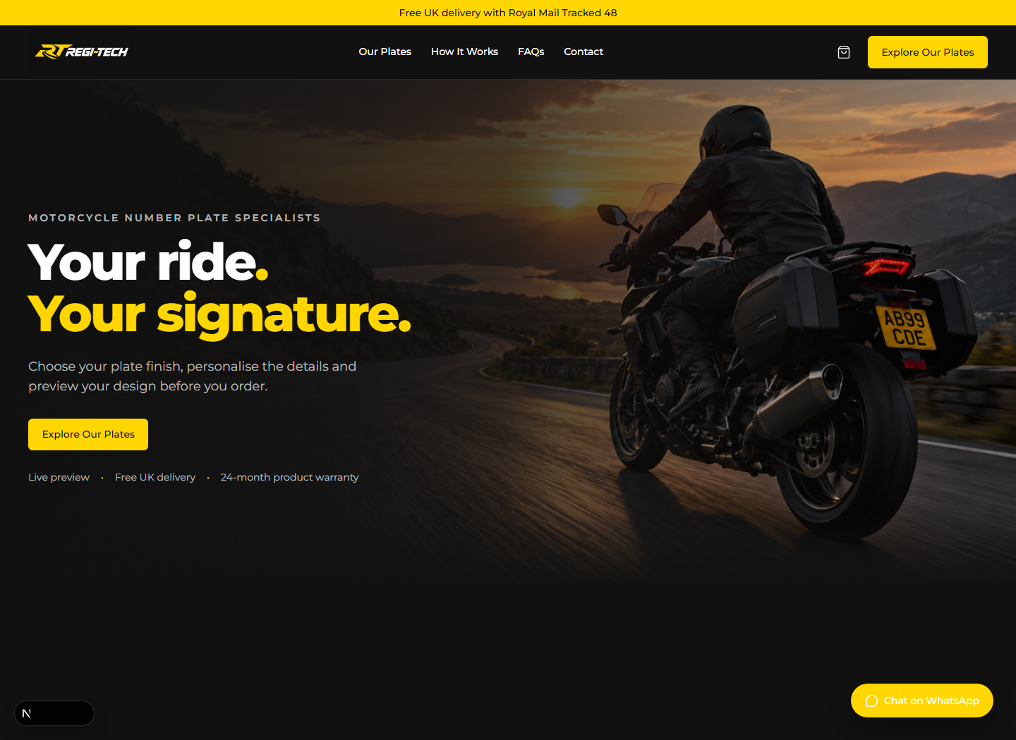
Homepage implementation at a 1440 pixel viewport

Plate Configuration and Preview

Registration and Plate Geometry
- Installed the supplied UKNumberPlate font and applied uppercase formatting throughout full and compact previews.
- Kept road-legal registration formatting at four characters plus three characters and enforced the seven-character alphanumeric limit.
- Kept the show-plate creative limit at 12 characters with shared frontend and server validation.
- Replaced content-based font shrinking with measured fitting so slogans and flags do not unnecessarily reduce registration lettering.
- Added inch and centimetre options for custom sizes with conversion, validation, persistence and summary display.

Borders Flags Logos and Slogans
- Rebuilt single and double borders as contiguous material bands. Matching materials merge into one frame, while mixed materials touch without a plate-coloured gap.
- Kept every displayed plate yellow and retained the squarer Figma corner geometry.
- Replaced previous flag artwork with the four supplied UK, ENG, CYMRU and SCO lockups and assigned each a plate-specific printable region.
- Positioned the manufacturer marking at the mathematical bottom centre and BS AU 145e at bottom right, including a border-aware safe area.
- Expanded draggable brand-logo placement across the plate with pointer, touch, pen and keyboard controls and normalized persisted coordinates.
- Enabled The Boss with Anita Semi-square and Rebel with New Rocker. The Scribbler remains visible but disabled pending licensed Chalkboard SE artwork.
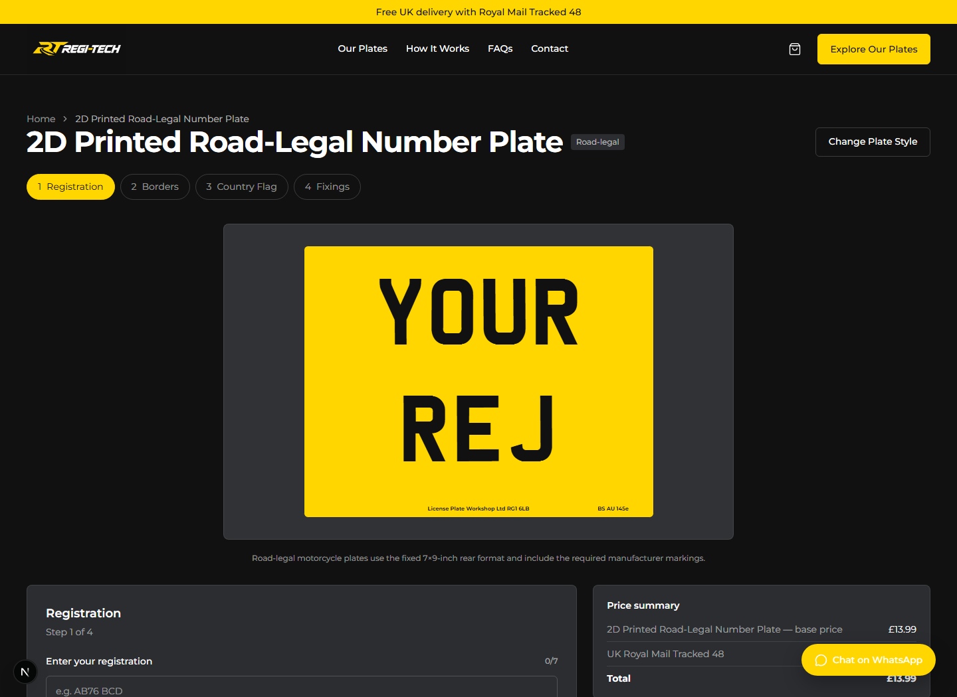
Road-legal configurator preview using the supplied registration typeface

Product Rules and Pricing
The product catalogue now determines which configuration steps and options each plate family supports. Unsupported combinations are removed when the customer changes product, and every total is calculated from the centralized rules rather than client-provided prices.
Product family | Base price | Configuration summary
Hand Crafted Show | £17.99 | Show sizes and custom size, inner and outer borders, logos, slogans and fixings.
2D Road Legal | £13.99 | Fixed 7 x 9 inch format, inner black border, country flag, fixings and legal markings.
2D Show | £14.99 | Supported show sizes, inner black border, logos, slogans and fixings.
Crystal 3D | £21.99 | Show Plate configuration pending confirmed road-legal rules.
Black 4D | £18.99 | Show Plate configuration based on the implementation handbook.

Confirmed Add Ons
Option | Price | Rule
Black inner or outer border | £2 each | Inner and outer charges are additive.
Mirror Silver inner or outer border | £5 each | Inner and outer charges are additive.
Brand or uploaded logo | £2 | Applied only to supported products.
Slogan | £2 | No Slogan remains available at no charge.
Country flag | £2 | Road-legal UK, ENG, CYMRU or SCO lockup.
Custom size | £3 | No further size-based price difference within the family.
Fixing kit | £1 | Four nylon screws and stainless-steel Nyloc nuts.
Adhesive fixing kit | £1 | Four 3M VHB adhesive strips.
Complete fixing bundle | £2 | Screws, nuts and adhesive strips.
Royal Mail Tracked 48 | Free | Free for every order.

Multi Plate Cart and Order Flow
The previous single-design cart has been replaced with a versioned multi-item draft. Each line preserves its own configuration, quantity, price and associated in-memory files. Existing single-item browser drafts are migrated into the new format when possible.
- Add to Cart appends a new configured plate, while editing replaces the selected line rather than duplicating it.
- Customers can edit, remove and change the quantity of every plate from the cart, review and checkout surfaces.
- Create Another Plate clears only the active editor and retains existing cart items.
- The cart badge shows total plate quantity across all lines, with a 20-plate order limit enforced in client and server validation.
- General notes now belong to the order, while special manufacturing requirements remain attached to each plate.
- Sensitive addresses, documents, credentials and raw files are never written to localStorage.

Checkout Payment and Confirmation
- The customer enters contact, delivery and optional billing details on the site, with Ideal Postcodes lookup and an always-available manual fallback.
- Road-legal lines require a V5C file, and Other Logo lines require their corresponding artwork file. Validation covers type, size and the applicable cart-line identifier.
- The server revalidates every product option and recalculates every price in integer pence before storing the pending order.
- Private files are uploaded to Supabase Storage and ordered line items are stored in the indexed order_items table.
- The server creates one hosted Stripe Checkout line item per configured cart line and returns only the hosted URL and non-sensitive reference.
- Only a verified Stripe webhook may mark the order as paid. The success redirect cannot change payment state.
- The confirmation page loads the persisted order and its ordered line items through the secure checkout-access cookie.

Database and Storage Delivery
- Added orders, order_items, order_files, payment_attempts and stripe_events data structures with indexed lookup paths.
- Enabled Row Level Security and revoked direct browser writes for order and payment records.
- Defined private v5c-documents and order-artwork buckets with no public URLs.
- Added webhook-event idempotency and checkout retry support for eligible unpaid orders.
- Retained legacy single-item columns as nullable compatibility fields rather than removing data destructively.

Security Privacy and Validation
- Stripe and Supabase secrets are server-only environment variables and are not exposed through NEXT_PUBLIC variables.
- The address lookup and checkout endpoints are rate limited, and provider failures return safe standardized responses.
- Every accepted string has a maximum length in shared Zod schemas, with matching server-side enforcement.
- The checkout server rejects unsupported product combinations, client-supplied price manipulation, missing mandatory files, invalid file types and oversized uploads.
- V5C and uploaded artwork files are limited to the confirmed supported formats and 10 MB per file.
- Payment events use raw-body signature verification and idempotent event processing.
- No credentials, payment details, addresses or private documents are tracked in Git or persisted in browser storage.

Verification Completed
Check | Result | Evidence
TypeScript | Passed | pnpm typecheck completed without errors.
Production build | Passed | Next.js 16.4.1 production build completed successfully.
Git whitespace | Passed | git diff --check completed without whitespace errors.
Homepage review | Passed | Hero colour, CTA, artwork and 1440 pixel composition verified.
Plate preview | Passed | Supplied UK font, plate ratio, markings, border behaviour and country-flag flow verified.
Reduced motion | Implemented | Motion wrappers preserve visibility and functionality when reduced motion is requested.
Live Stripe Supabase lookup | Client input required | Provider credentials and production account configuration are not yet available.

Source Control Scope
The delivery is based on commit 1f52f81 on the main branch. The source-control update includes the implementation, supplied and licensed assets, environment-variable examples, Supabase migrations, technical setup notes, and this report. Dependency folders, build output, local environment files and secrets are excluded.

Client Inputs Required for Launch
The implementation can be deployed for provider testing after the client supplies the following accounts, assets and operating decisions. Secrets should be shared through the hosting provider's encrypted environment settings or another approved secure channel, not through email, chat or GitHub.
Priority | Client input | Why it is required
Launch blocking | Stripe UK business account, sandbox and live server key, webhook signing secrets, payout setup and approved payment methods | Required to test and enable hosted payment and verified payment-status updates.
Launch blocking | Supabase project URL, server secret key, project region, migration approval and private bucket approval | Required for persistent orders, payment attempts and private V5C or artwork storage.
Launch blocking | Ideal Postcodes server API key, credits and confirmation of result-retention restrictions | Required for live postcode search. Manual address entry already works without it.
Launch blocking | Hosting account, final domain, DNS access and encrypted environment configuration | Required for deployment, HTTPS webhook registration and production URLs.
Asset | Licensed Chalkboard SE webfont file or approval of a licensed alternative | Required to enable The Scribbler without using an unlicensed substitute.
Asset | Final Hand Crafted Show Plate product photograph | Required to replace the current image with the client's approved photograph.
Policy | V5C and artwork retention and deletion period, authorised staff and document-review process | Required before production storage of customer identity and vehicle documents.
Policy | Final privacy, terms, refunds, warranty, VAT and company wording | Required for legal and customer-facing publication.
Operations | Dispatch targets, delivery exceptions, order-review responsibilities and support contacts | Required to align customer messaging with the client's fulfilment process.
Optional integration | Transactional email provider and authenticated sending domain | Required only if automated order or operational emails are requested.

Server Environment Names
The deployment currently expects NEXT_PUBLIC_SITE_URL, IDEAL_POSTCODES_API_KEY, SUPABASE_URL, SUPABASE_SECRET_KEY, STRIPE_SECRET_KEY and STRIPE_WEBHOOK_SECRET. Real values must remain outside the repository.

Database Migrations
- 202610160001_phase4_orders.sql creates the initial order, file, payment and event records plus private storage buckets.
- 202610200001_multi_plate_order_items.sql adds ordered multi-plate line items, file associations and compatibility backfill.

Recommended Next Actions
- Provision sandbox Stripe, Supabase and Ideal Postcodes credentials in a non-production deployment environment.
- Apply and verify both Supabase migrations, Row Level Security rules and private bucket configuration.
- Run end-to-end mixed show and road-legal orders through Stripe sandbox webhooks and dynamic confirmation.
- Confirm document-retention, refund, warranty, VAT and fulfilment wording before production launch.
- Supply the remaining licensed font and approved product image, then complete final Figma comparison and launch acceptance testing.

