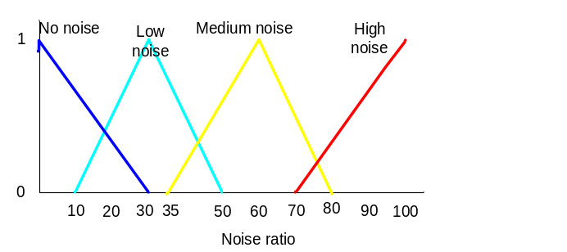

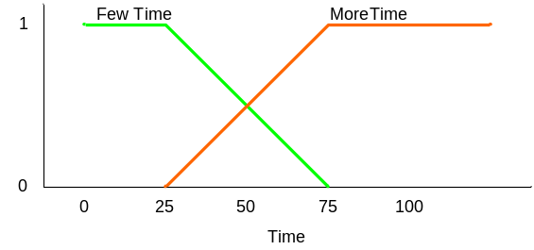

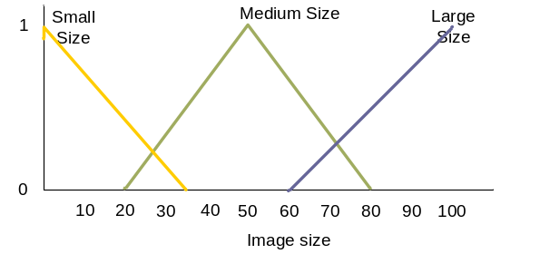

Figure 1: Membership function

IF Medium size AND No noise THEN Few Time
IF Small size AND Low noise THEN Few Time
IF Large size AND Low noise THEN Few Time
IF Large size AND Medium noise THEN More Time
IF Medium size AND High noise THEN More Time
Figure 2: Control rules

Figure 1 shows the membership function of fuzzy image processing systems and Figure 2 shows the system control rules. Using jFuzzyLogic tool, program the problems and find the time to process the image for an image with 35 noise scale and 80 Mb of size.

Print out the coding and the printscreen the solutions and submit it today before 4.00 pm

