

**ARTIFICIAL INTELLIGENCE**

**ASSIGNMENT 2**

**NAME: THAARENI A/P NARENDRAN**

**MATRIC ID: CB14024**

**CODING**

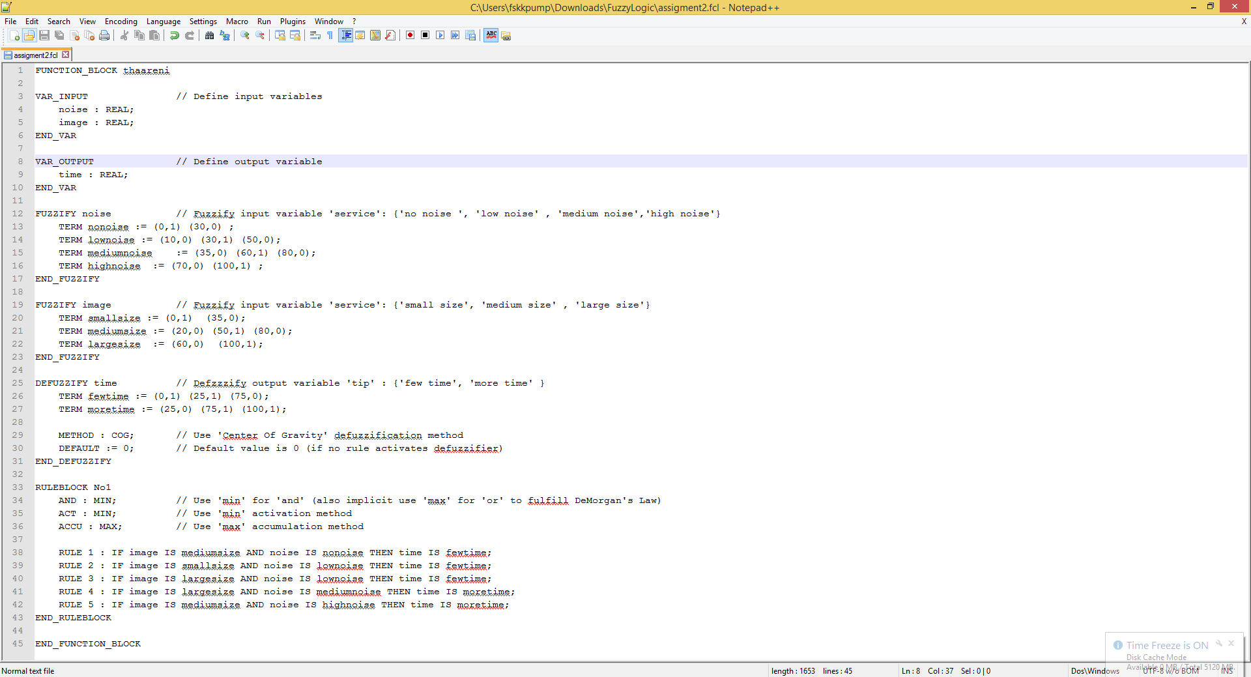

**OUTPUT**

