# **CHAPTER 2**

# **LITERATURE REVIEW**

# **Introduction**

The heart is the organ that responsible for pumping blood throughout the body. It

is located in the middle of the thorax, slightly offset to the left and surrounded by the

lungs basically; the human heart is composed of four chambers which are two atriums

and two ventricles. The right atrium receives blood returning to the heart from the whole

body. That blood passes through the right ventricle and is pumped to the lungs where it is

oxygenated and goes back to the heart through the left atrium, and then the blood passes

through the left ventricle and is pumped again to be distributed to the entire body through

the arteries.

A heart attack happens when there is a sudden complete blockage of an artery that

supplies blood to an area of your heart. A heart is a muscle, and it needs a good blood supply

to keep it healthy. As we get older, the smooth inner walls of the arteries that supply the

blood to the heart can become damaged and narrow due to the build up of fatty materials,

called plaque. When an area of plaque breaks, blood cells and other parts of the blood stick to

the damaged area and form blood clots.

A heart attack occurs when a blood clot completely blocks the flow of blood and

seriously reduces blood flow to the heart muscle. This also results in patients experiencing

chest pain. As a result, some of the heart muscle starts to die. The longer the blockage is left

untreated, the more the heart muscle is damaged. If the blood flow is not restored quickly,

the damage to the heart muscle is permanent. A heart attack is sometimes called a

myocardial infarction (MI), acute myocardial infarction, coronary occlusion or coronary

thrombosis.

# **Overview**

In this chapter, there had four subtopics that described the definitions about evaluation system. Subtopic 2.3 and 2.4 will discuss about review and compare the three existing systems that similar with this system and being reference for this system. Subtopic 2.5 and 2.6 will discuss about review and compare the three methodologies that can be model of methodology to develop this system.

# **Review of Existing System**

* + 1. **SurveyMonkey**

Surveymonkey is an online survey site by make a survey process easy and considerably. For asking a questions, Surveymonkey offers 17 formats in survey design phase. Multiple choice question is one of example formats in Surveymonkey. Another example of formats is true false and open-end question. Surveymonkey can change the appearance of the survey by provide a various color palette. Ability to track respondents helps user to re-contact a candidate that no respond to a survey and avoid pestering those who have already participated a survey. Surveymonkey can generate frequencies for each question and allows user to export data into programs for more complex analysis. The Surveymonkey webpage will convey the study and ensuing re-minders for client if client outfit a rundown of email addresses and will likewise furnish client with a connection to the overview which can then be posted on your site or incorporated into an email for you to send to members.

Figure 2.1 show the interface for creating a question. User need to insert the question and multiple answer.

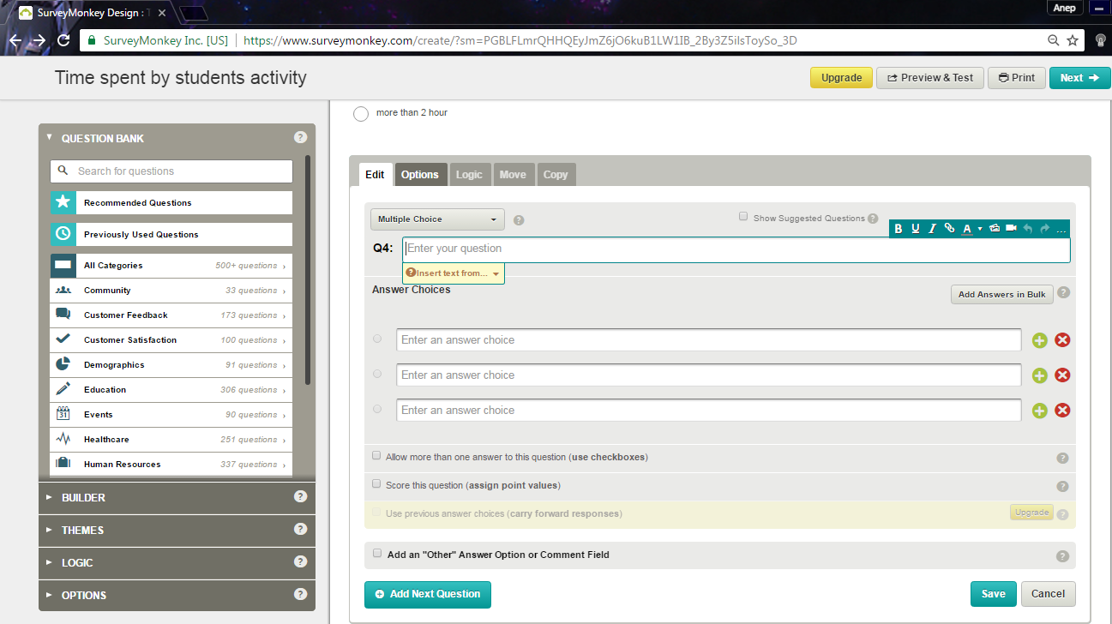

**Figure 2.1 Interface creating a question**

Figure 2.2 show the interface when the question shows at public.

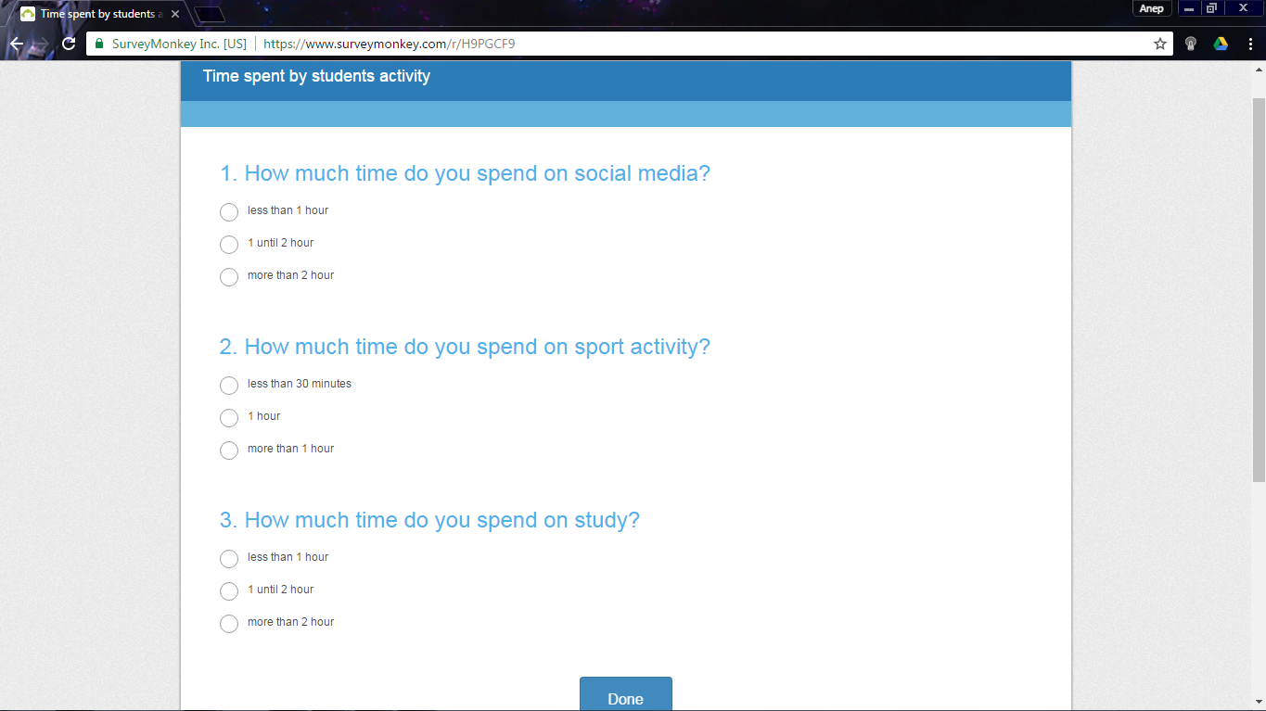

**Figure 2.2 Interface answering the question**

Figure 2.3 show the interface for statistic. User can view the statistic for responding survey by select type of provided graph.

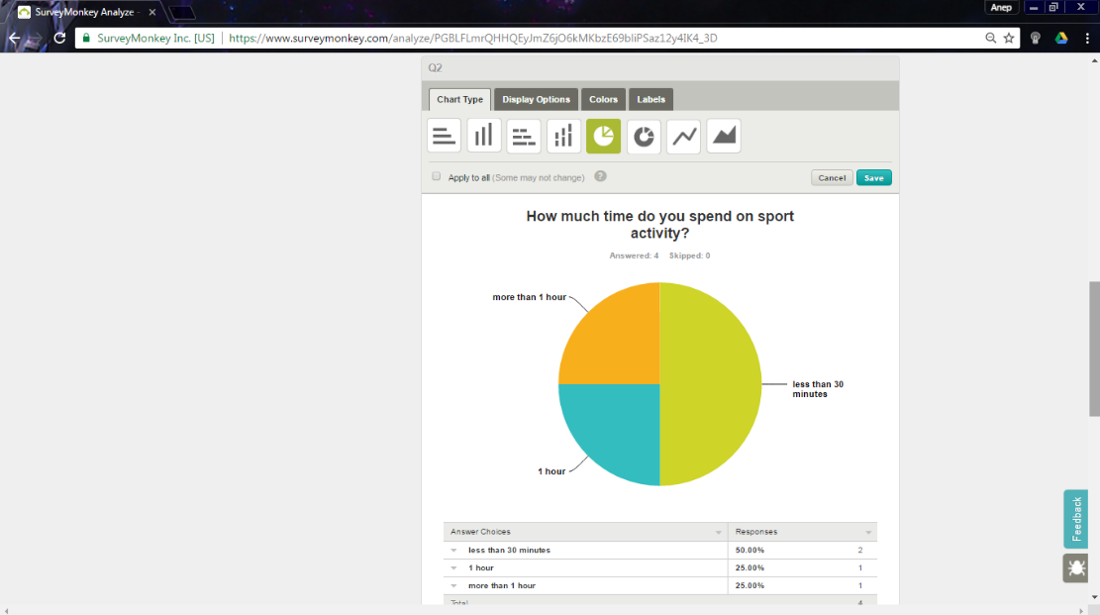

**Figure 2.3 Interface responses statistic**

* + 1. **WPS Online Evaluation System**

The WPS Online Evaluation System makes scoring assessments faster and more accurate. WPS Online Evaluation System likewise offering enhanced clinical effectiveness at the same per-utilize cost as customary printed frames. User need to register before be an admin for the assessments. For the registration, user need to purchase a license for each WPS assessment that need to use.

User can register their client before give an assessment. The assessment is a question that user will give to their client by using the email. User can view all their client report in graph form.

Figure 2.4 show the interface of creating a client. User need to register their client before do an evaluation by giving a client the assessment question.

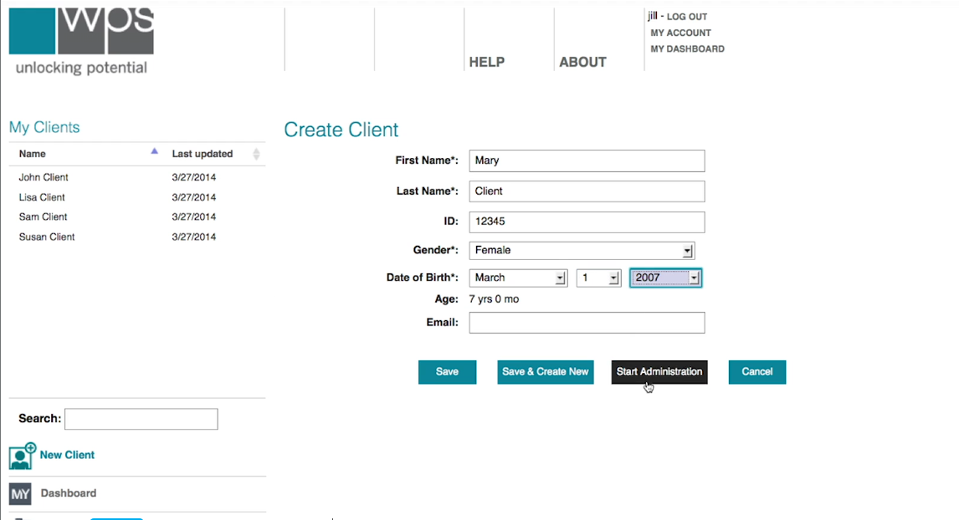

**Figure 2.4 Interface of creating a client**

Figure 2.5 show the interface of sending the assessment form. User will sent the assessment form by using the email address.

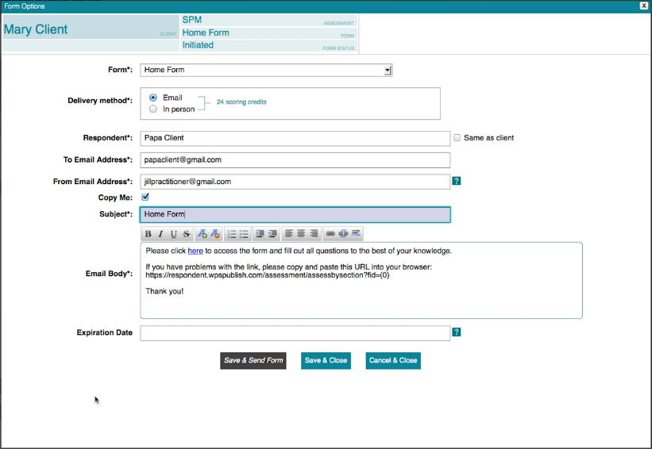

**Figure 2.5 Interface of sending assessment form**

Figure 2.6 show the interface of assessment question. Client will receive this assessment form through the email.

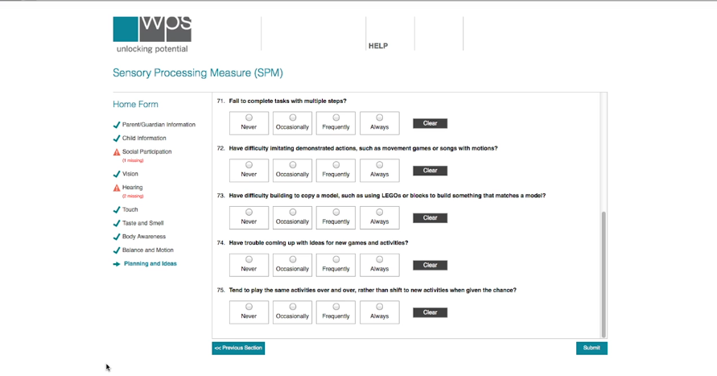

**Figure 2.6 Interface of assessment question**

Figure 2.7 show the interface of assessment report. User can view the statistic base on client respond.

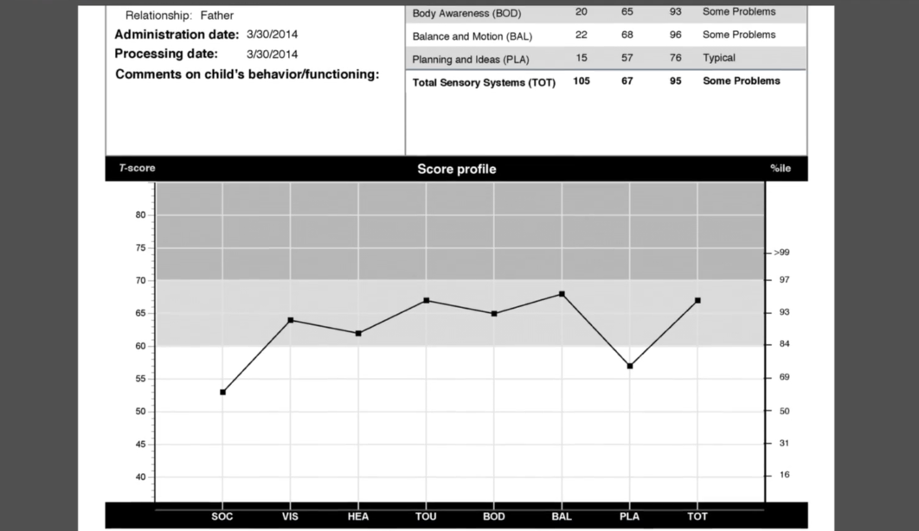

**Figure 2.7 Interface of assessment report**

* + 1. **Google Form**

Google Form is a free online instrument from Google that enables you to make a shape. Google Form can make and dissect overviews by utilizing web program without required extraordinary programming. During process creating a form, Google Form automatically save the form when the changes be made. User can outline their own frame to make the shape more appealing. The form has been made by user can be share work together by embed an email at sharing setting. User can view the analysis form at responses bar.

Figure 2.8 show the interface of creating form title.

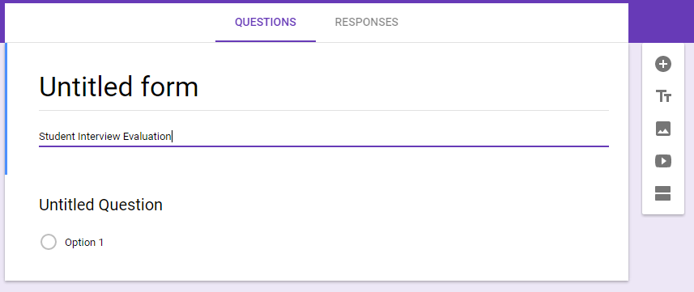

**Figure 2.8 Interface creating form title**

Figure 2.9 show the interface of create a question at the form. User can manage the question and answer at this form.

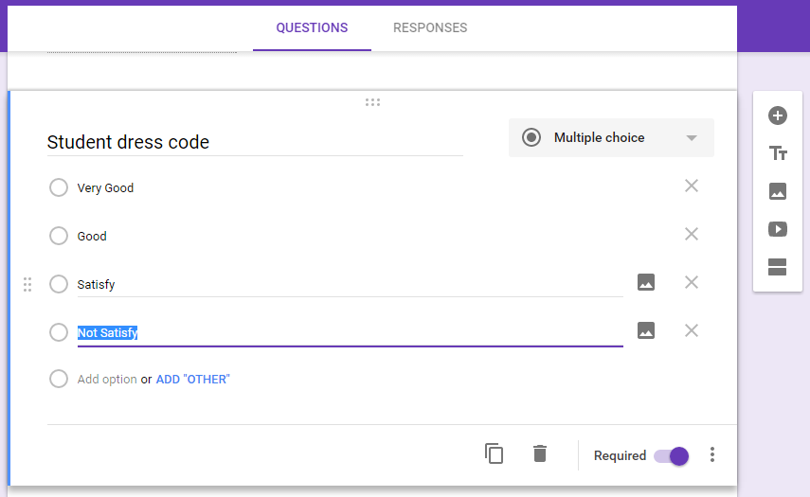

**Figure 2.9 Interface of create from question**

Figure 2.10 show interface of sending question form. User can share the question form to the person they want to share by using an email.

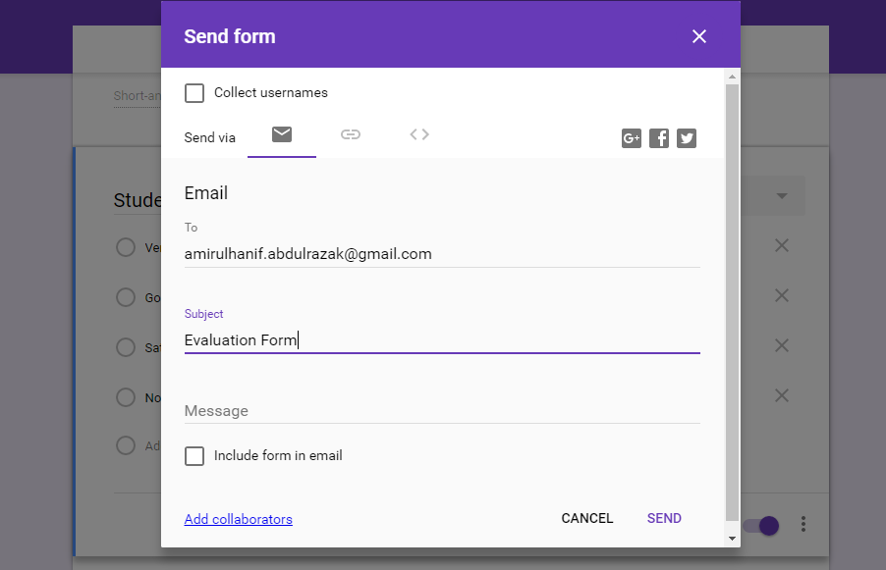

**Figure 2.10 Interface sending question form**

Figure 2.11 show the interface of analysis the responses. User can view total responses.

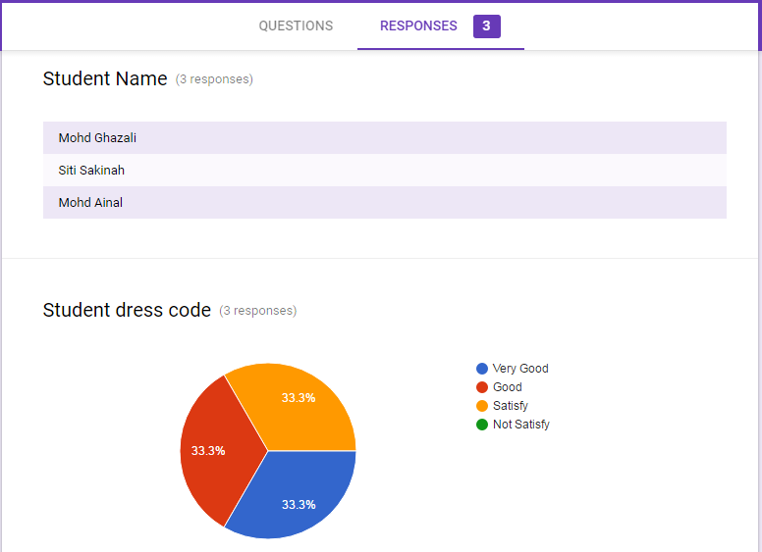

**Figure 2.11 Interface analysis the responses**

# **Comparison Feature Existing System**

|  |  |  |  |
| --- | --- | --- | --- |
| **Features** | **Surveymonkey** | **WPS Online Evaluation System** | **Google Form** |
| Security | * Require user to login into the web site. * Secure access by using https. | * Require user to login into the web site. * Secure access by using https. | * Require user to login into the web site * Secure access by using https. |
| Interoperability | Ability to view in window screen and mobile screen. | Ability to view in window screen. | Ability to view in window screen and mobile screen. |
| Support Form | Provide helps center to support user understanding. | Provide helps center to support user understanding. | Provide helps center to support user understanding. |
| Flexibility | Layout resolution not flexible. | Layout resolution not flexible. | Flexible layout resolution. |
| Security | * User can login by link with google account or facebook account. * User also can register as normal user. | * User need to register and purchase a license before use this system. | * Use google account as user profile. |
| Advantage | * Available to use as free user | * Private evaluation form. | * Auto save during editing the form. |
| Disadvantage | * Data responded not available to download for free user. | * Require user to make a payment during registration. | * Only user that have google account can use this form. |

**Table 2.1 Comparison of Features for three existing system**

# **Review of Methodology**

* + 1. **Waterfall Model**

Waterfall model is a traditional methodology since this model was first model in SDLC to be use in Software Engineering. Waterfall demonstrate comprises six stage and each stage must be finished before go to the following stage since waterfall model was outlining in programming advancement by direct successive stream. In waterfall model there are no overlapping phases.

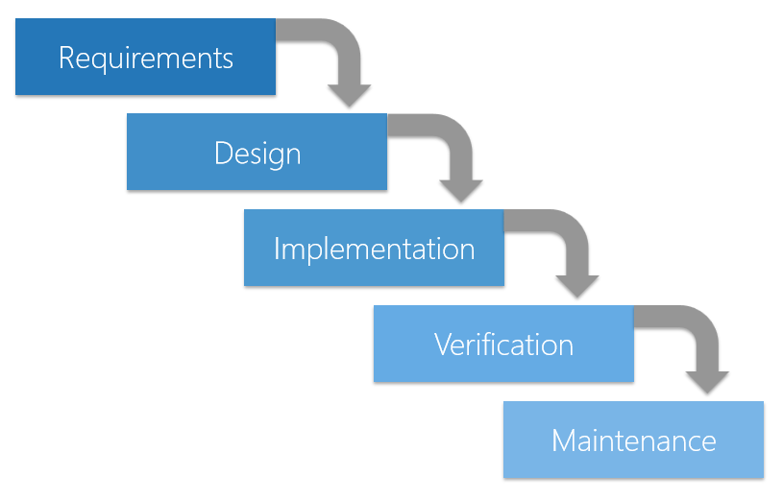

**Figure 2.12 Process Waterfall Model**

* + 1. **Agile Model**

Agile model is a combination of two process model which is iterative process and incremental process that focus on process adaptability and customer satisfaction by rapid delivery of working software product. Coordinated model isolated assignment into little time spans to convey particular components for a discharge. Iterative approach is taken and working programming construct is conveyed after every emphasis. Each form is incremental until the last form holds every one of the components required by the client.

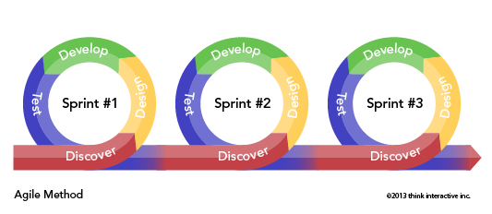

**Figure 2.13 Process Agile Model in Sprints Series**

* + 1. **RAD Model**

RAD (Rapid Application Development) model is based on prototyping and iterative development with no specific planning involved. Prototype in RAD is working model that functionally equivalent to a component of the product. RAD functional modules are develop in parallel as prototypes. RAD modules likewise are coordinated to make the total item for quicker item conveyance. This model simpler to fuse the progressions on the grounds that there are no subtle elements preplanning. RAD activities was take after the iterative model and incremental model. RAD extend working dynamically on their model by having a little groups involving engineers, space specialists, client agents and other IT assets.

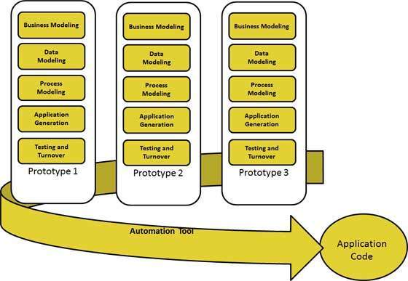

**Figure 2.14 Process Rapid Application Development**

# **Comparison of Three Methodologies**

|  |  |  |  |
| --- | --- | --- | --- |
| **Factor** | **Waterfall Model** | **Agile Model** | **RAD Model** |
| Scope | Works well as long the requirements is known. | Works well even the requirement not clear and available to make changes but expensive cost. | Work focused on speed to developed faster by using prototyping. |
| Customer Availability | Requires customer involvement at the beginning. | Prefers customer available throughout project. | Requires customer involvement at the beginning. |
| Direction | Linear and unidirectional. | Non-linear and some phase involve loops. | Non-linear and some phase involve loops. |
| Compatibility | Small project. | Larger project. | Larger project. |
| Pros | * Easy to manage and understand by completed a phase once time. * Works well for smaller projects where requirements are very well understood. | * Suitable model for fixed or changing requirements. * Give flexibility to developers. | * Reduced development time. * Changing requirements can be accommodated. |
| Cons | * Not suitable for the projects where requirements are at a moderate to high risk of changing. * Inappropriate for complex and object-oriented projects. | * Not suitable for handling complex dependencies. * Depends more on customer interaction. | * Dependency on technically strong team members for identifying business requirements. * Requires user involvement throughout the life cycle. |

**Table 2.2 Comparison three Methodology**

# **Conclusion**

In this chapter, we already discuss about three existing system that similar with evaluation system. Then, we discuss the details of three existing system and their features to making a comparison. Base on the advantage and disadvantage from three existing systems, there are some features that we can use to develop this system.

From the comparison of methodology, this system will be using RAD model as methodology of this project. This system can be develop rapidly by following RAD module.