# **CHAPTER 1**

# **INTRODUCTION**

# **Project Background**

Healthcare information systems refer to any system that captures, stores, manages or transmits

information related to the health of individuals or the activities of organizations that work within

the health sector. This definition incorporates things such as district level routine information

systems, disease surveillance systems, and also includes laboratory information systems, hospital

patient administration systems (PAS) and human resource management information systems

(HRMIS). Overall, a well-functioning HIS is an integrated effort to collect, process, report and

use health information and knowledge to influence policy and decision-making, programme

action, individual and public health outcomes, and research. Sound decision-making at all levels

of a health system requires reliable health statistics that are disaggregated by sex, age and

socioeconomic characteristics. At a policy level, decisions informed by evidence contribute to

more efficient resource allocation and, at the delivery level, information about the quality and

effectiveness of services can contribute to better outcomes.

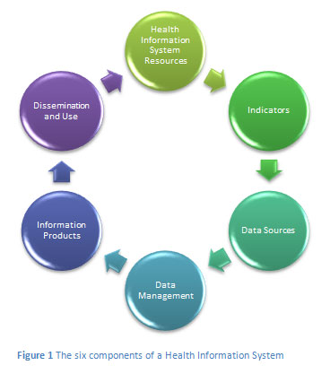

1. Health Information Systems Resources

These include the legislative, regulatory and planning frameworks required for a fully

functioning health information system, and the resources that are required for such a system to be

functional. Such resources involve personnel, financing, logistics support, information and

communications technology (ICT), and coordinating mechanisms within and between the six

components.

1. Indicators

A core set of indicators and related targets is the basis for a health information system plan and

strategy. Indicators need to encompass determinants of health; health system inputs, outputs and

outcomes; and health status.

1. Data Sources

These can be divided into two main categories; (1) population-based approaches (censuses, civil

registration and population surveys) and (2) institution-based data (individual records, service

records and resource records). A number of data-collection approaches and sources do not fit

into either of the above main categories but can provide important information that may not be

available elsewhere. These include occasional health surveys, research, and information

produced by community based organisations.

1. Data Management

This covers all aspects of data handling from collection, storage, quality-assurance and flow, to

processing, compilation and analysis.

1. Information Products

Data must be transformed into information that will become the basis for evidence and

knowledge to shape health action.

1. Dissemination and Use

The value of health information is enhanced by making it readily accessible to decision-makers

and by providing incentives for, or otherwise facilitating, information use.

**The benefits of health care information systems.**

Information systems can improve cost control, increase the timeliness and accuracy of patient

care and administration information, increase service capacity, reduce personnel costs and

inventory levels, and improve the quality of patient care. However, experience shows that most

of these benefits will not occur automatically following system implementation. Operational

problems may exist that diminish information timeliness, accessibility, and accuracy; policies

and procedures may not have been sufficiently tailored to reflect the realities and intents of the

systems; and personnel tasks may not have been adequately restructured. In order to realize the

full potential of information systems, health care organizations must plan for and implement

strategies that are designed to maximize such benefits.

**Example of healthcare records system electronic**

Makes patient care safer. Patient care is safest when it is standardized and delivered without

waste. Waste-free record keeping and communication free providers’ time to address patients’

needs. Information is available at the point of care and always legible.

Improves delivery of comprehensive services. Careful providers working with paper records in

fragmented systems typically manage to deliver 50 percent of recommended services for their

patients. Estimates indicate it would take an additional 7.4 hours per day for a provider to assure

that all recommended services were provided to a panel of patients. Computerized record

systems can solve this with high reliability.

Gives ability to learn from the care provided. Medicine is information-rich and knowledge-poor

when it comes to learning from experience. Capturing clinical information as searchable data

enables the application of business intelligence software to clinical care.

Reduces the burden for staff. Support staff is free to help with patients at hand when

standardized, simplified documentation of care is in place.

Saves costs and transforms health care. By providing just what is needed when it is needed, the

cost of care goes down and quality improves. Good medicine is good business.

# **Problem Statement**

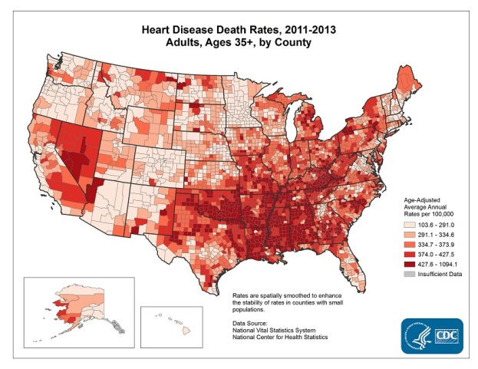

* Heart disease is the leading cause of death for both men and women. More thanhalf of the deaths due to heart disease in 2015 were in men. About 630,000 Americans die from heart disease each year that’s 1 in every4deaths.
* Coronary heart disease is the most common type of heart disease, killing about 366,000people in 2015
* In the United States, someone has a heart attack every 40 seconds. Each minute, more than one person in the United States dies from a heart disease-related event
* Heart disease is the leading cause of death for people of most racial/ethnic groups in the United States, including African Americans, Hispanics, and whites. For Asian Americans or Pacific Islanders and American Indians or Alaska Natives, heart disease is second only to cancer.
* Heart disease costs the United States about  **$**200 billion each year. This total includes the cost of health care services, medications, and lost productivity.

**Effect heart attack disease**

A heart attack always causes some permanent damage to your heart muscle, but the sooner treatment is given, the more muscle it is possible to save. If a heart attack damages a significant amount of your heart muscle, this can affect the pumping action of your heart. The term used to describe this is heart failure. Also, some people continue to get angina after they have had treatment for their heart attack, because there is still narrowing of one or more of their coronary arteries.

**How is a heart attack response?**

When the ambulance arrives, the ambulance staff will; examine you and monitor your heart rate and blood pressure, do an electrocardiogram (ECG) in the ambulance, assess your symptoms and medical history, give pain relief if needed and oxygen if your oxygen level is too low, give you aspirin if not given already, transfer you to the most suitable hospital.

**Heart attack prevention**

Living a healthy lifestyle can help prevent you from developing coronary heart disease and having a heart attack. If you have had a heart attack you can dramatically reduce the risk of having another heart attack and future heart problems by keeping your heart healthy and taking your medicines. If you're over 40 you should ask your doctor or nurse for a heart health check to assess your risk of having a heart attack in the next 10 years.

# **Objective**

1. To study the appropriate technique for emergency alert system.
2. To design and implement the prototype
3. To test the purpose emergency alert system on the electronic device.\

# **Scope**

In order to achieve the project objectives, there are two main parts of the scopes

which are hardware and software. For the hardware part, the scope of this project is a

circuit of microcontroller that place at the prototype designs is build. This circuit is

connecting with the connection from fingertip sensor, GSM modem, and LCD and

keypad which act as user interface. To determine and control the range of heart rate in

human body, the code of Arduino is need to program the sensor.

# **Report Organization**

There are five total chapter in this thesis:

1. **Chapter 1** discusses about this apps background. This chapter also explain about the reason this system need to be develop by discover the problem statement. From the problem statement, objective and scope for this system can be archive in this chapter.
2. **Chapter 2** (**Literature review)** discusses the basic theories applicable for this project. Discussion on these theories is based on the background studies or literature reviews. It covers mainly on concept of heart rate, Fingertip sensor and heart rate training zones.
3. **Chapter 3 (Methodology)** describes the general structure and operations of the system, including all assumptions and considerations for the system‘s operation.
4. **Chapter 4** **(Implementation and Testing)** this chapter is about the implementation and testing phase of the project and it constitutes the real work in order to achieve the project objectives.
5. **Chapter 5 (Conclusions and Recommendations)** contain conclusions of system performance and recommended future work, including the ethical issues involved.

• Appendix A: Source Code for Programming the microcontroller Arduino.

• Appendix B: includes snapshots for the implemented project.