INSTRUCTIONS:

- This task should be done in pair.
- You need to submit the hard copy of this task by Monday/3rd August 2009, before 12.00 noon.
- Any plagiarism and late submission will be penalized.

LEARNING OUTCOMES
Upon the completion of this lab session, students will have the ability to identify entity, attributes, relationship and construct business rules from the case study.

Exercise 1
The Matrix Company relational diagram shows the initial entities and attributes for the company stores, located in two regions of the country. Identify each relationship type and write all of the business rules by fill in the table below.

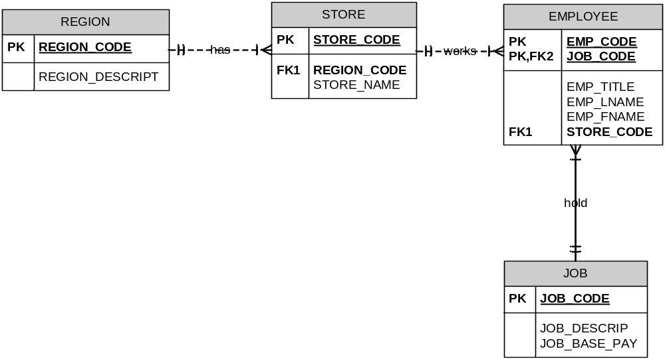

ENTITY | Relationship Type | ENTITY | Business Rules
REGION | One to many | STORE | One and only one REGION has one or many STORE
STORE | One to many | EMPLOYEE | One and only one STORE has one or many EMPLOYEE
EMPLOYEE | Many to one | JOB | Many to one EMPLOYEE has one and only one JOB

Exercise 2
Refer to your text book (8th edition) in Problems, answer the question #24, page 59.

